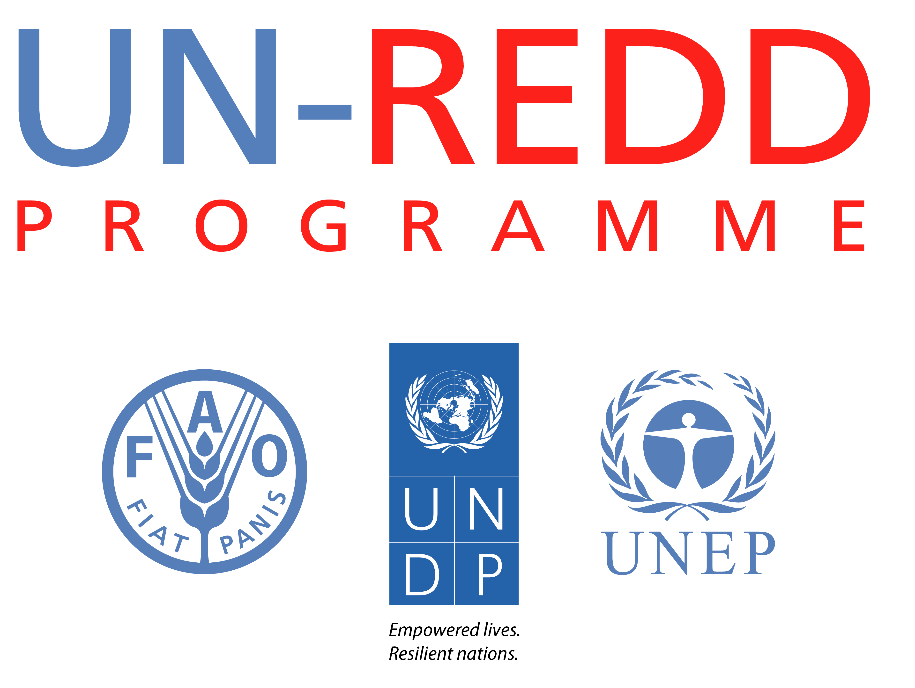

Ministry of Environment, Water and Natural Resources

SCOPING REDD+ GOVERNANCE IN KENYA

GOVERNANCE, CORRUPTION & BENEFIT SHARING ISSUES IN THE DESIGN & IMPLEMENTATION OF REDD+ IN KENYA

A Consultation Workshop with focus-group discussions

3-4 July 2013, Nairobi, Laico Regency Hotel

1. Background & Workshop Objective

The Kenya’s Ministry of Environment, Water and Natural Resources, supported by UNDP through targeted support from the UN-REDD Programme, has commissioned two complementary studies on crucial governance dimensions of REDD+: a study on the issues and risks of benefit-sharing mechanisms for REDD+; and a study on the corruption challenges for implementing REDD+ (the latter conducted by the U4 anti-corruption resource centre in Bergen, Norway). Both studies are based on stakeholder interviews and fieldwork in Kenya, conducted between April and July 2013, with the aim is to be finalized in late July or August.

As part of the process of finalizing these studies, the Ministry hosted on 22 April an inception workshop devoted to the theme of benefit-sharing and is now hosting a workshop more specifically on corruption and governance. This is intended in order to collate views and policy ideas from a range of governmental and non-governmental stakeholders. The outcomes of this discussion will be incorporated into the final publications from these two studies.

This workshop is integral to the support of the UN-REDD Programme , provided by UNDP and FAO, on the various inter-related governance issues for REDD+: how to concretely counter corruption risks in REDD+; establishing a framework for carbon rights and benefit-sharing, building on existing experiences and mechanisms; and clarifying the legal frameworks for carbon finance and REDD+.

2. Workshop approach & outcomes

The workshop is designed to give maximum time for participant discussions and group work. This will ensure that the meeting generates in-depth analysis and policy thinking that reflects the experiences and concerns of a diversity of REDD+ stakeholders.

The meeting and deliberations will result in a more robust final study report.

The deliberations will follow the Chatham-House rule of participants’ respect of confidentiality of whatever it is discussed in the event.

DRAFT AGENDA
Facilitators: Michael Gachanja & André Standing

9.00-10.00am | INTRODUCTION & GLOBAL CONTEXT
- Opening remarks & update on Kenya REDD+ readiness progress - Alfred Gichu, Ministry of Environment, Water and Natural Resources. (link)

- The key role of governance in the REDD+ mechanism:, and UN-REDD methods and experience to support it [Why and How this Kenya initiative] Josep Gari and Estelle Fach- UNDP & UN-REDD Programme (link)

- Participant introductions, methodology & ice breaker / Data crowd sourcing exercise

- A comparative overview of REDD+ policy and governance approaches across the Africa Region – Johanna Wehkamp, Mercator Fellow (Germany) (link)

10.00- 10.20am | COFFEE/TEA BREAK
10.20-12.30am | SESSION 1
Deforestation and forest degradation in Kenya:
Corruption& governance challenges

This session will be used to explore participants’ views and experiences on the actual role of corruption in contributing to deforestation and forest degradation in Kenya. Issues for discussion will include illicit encroachment and improper transfer of ownership of public and community forests, and collusion and rent-seeking by state officials in illegal logging and related charcoal trade. The session will explore the extent such challenges have been reduced through institutional and legal reforms, and what new actions and measures are required.

- Video on anti-corruption for REDD+ (link)

- Intro and key issues emerging from UNDP/MOFW study, Michael Gachanja (link)

Open discussion – 15 minutes
Group work – 1 hour
Reporting back with plenary discussions – 30 minutes
12.30-1.30pm | LUNCH
1.30  3.30pm | SESSION 2
Implementing REDD+: The Governance challenges

This session will consider the governance and corruption risks associated with the future implementation of REDD+ in the case of Kenya, including on decisions on land use planning, revenue management & benefit sharing and carbon measuring reporting and verification (MRV). Participants will be tasked to identify priority areas, which may require additional capacity building and policy development.

- Introduction: Key issues emerging from the current UNDP/MOFW study, including on benefit sharing - Michael Gachanja (link)

- Respondent on benefit sharing, Mwajuma Abdi, National Alliance of Community Forest Associations.

Open discussion (15 minutes)
Group work (1 hour)
Report back & plenary discussions
3.30-4.00pm | Summary of day 1 discussions and close
DAY 2

9.00-12.00pm | Session 3
Mitigating governance risks for REDD+: Policy priorities

Building on the discussions from day 1, this final session will reflect on the priority areas of concern and consider the key policy implications and recommendations, including for government and non-government stakeholders.

- Introduction by André Standing

- Efforts and challenges in preventing and punishing corruption in the forest sector, the Kenyan Ethics and Anti-Corruption Commission perspective, Nancy (link)

- Anti-corruption and the role of civil society in Kenya, Judy Ndichu , Transparency International. (link)

- How gaps in the forest related legal framework relevant to REDD+ can be conducive to corruption, Titus Wamae, Institute for Law and Environmental Governance (ILEG) (link)

- Transparency ,access to information and capacity development for anti-corruption in REDD+, Estelle Fach, (UNDP) (link)

15 minutes for open discussion
Group work (1 hour), rapport back and further open discussion.
Note : coffee and tea will be provided to participants during group work.

12.00-1pm | PRESENTATION OF NEXT STEPS, CONCLUSION, EVALUATION AND CLOSE, ALFRED GICHU
LUNCH

