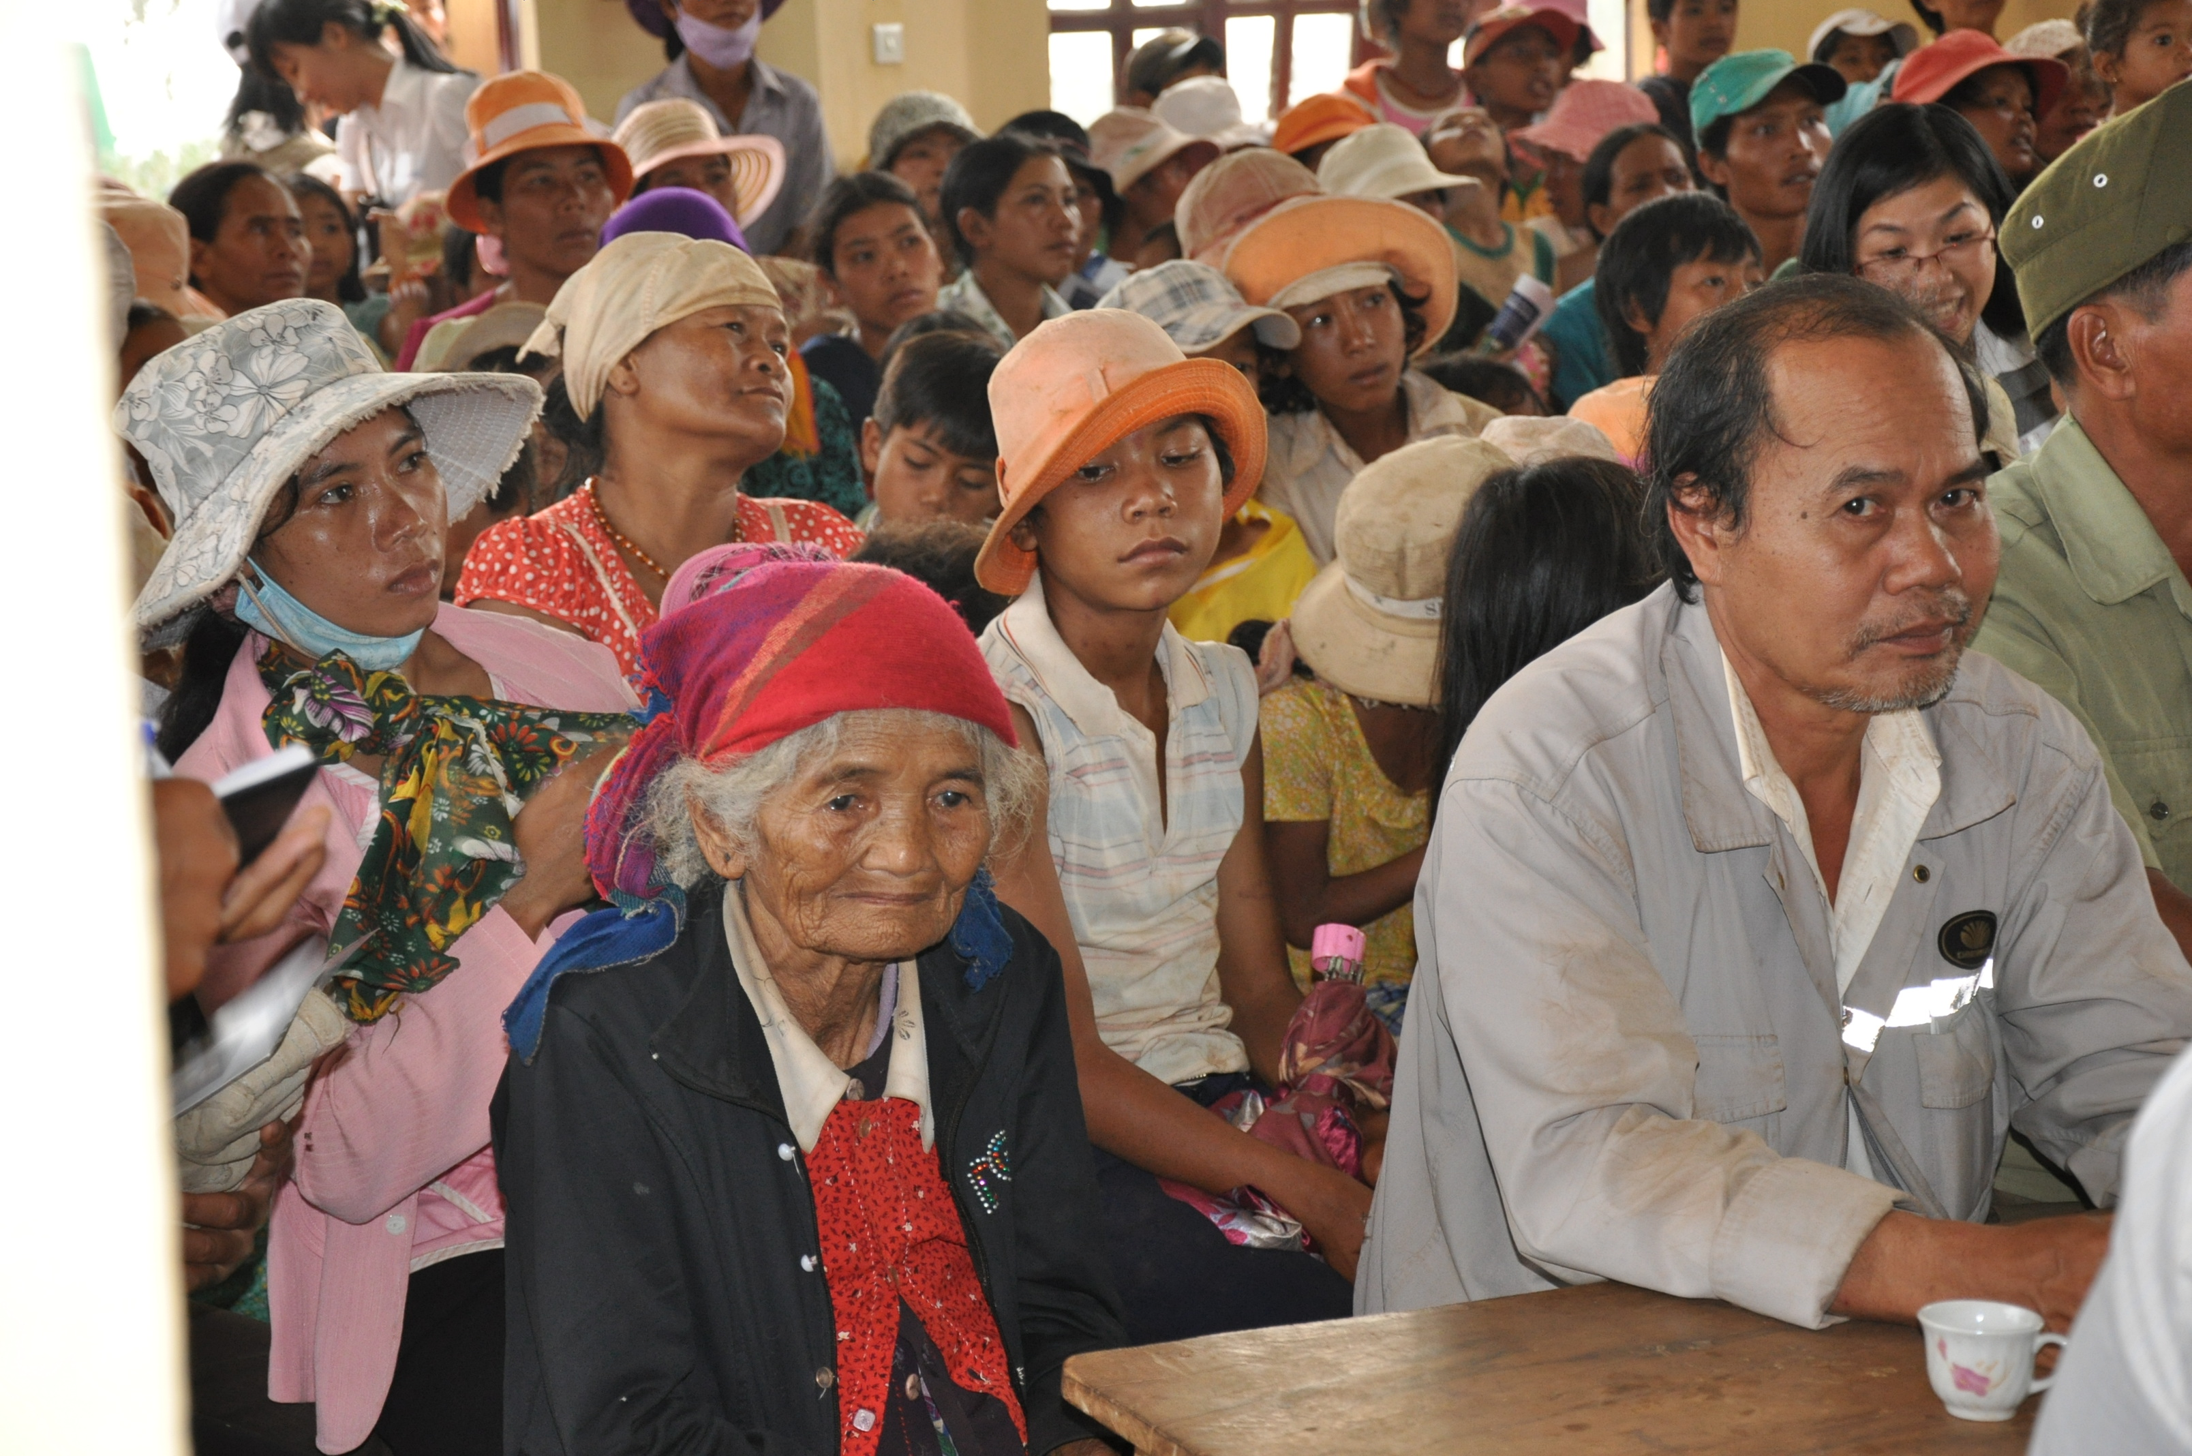

Applying the Principle of Free, Prior and Informed Consent in the UN-REDD Programme in Viet Nam
UN-REDD PROGRAMME
August, 2010

Table of Contents

Part I: Background and Introduction 4
Part II: Piloting FPIC for REDD+ in Viet Nam 9
Preparations for FPIC 12
Step 1: District, Commune and Village Level Awareness Raising 18
Step 2: Recruitment of Interlocutors 22
Step 3: Interlocutor Training 24
Step 4: Village Meeting Preparation 26
Step 5: Conducting village meetings 30
Step 6: Recording of Decision 36
Step 7: Documentation and Reporting 38
Step 8: Verification and Evaluation 40
Part III: Conclusions and Implications for Conducting FPIC for REDD+ 45
Annex 1: Complete results for pilot FPIC exercise in Lam Ha and Di Linh districts 50

Acronyms and Abbreviations
CBD | Convention on Biological Diversity
CEM | Central Committee of Ethnic Minority
CERD | International Convention on the Elimination of all Forms of Racial Discrimination
CSO | Civil Society Organization
DARD | Department of Agriculture and Rural Development
DONRE | Department of Natural Resources and Environment
 | Department of Planning and Investment
FAO | Food and Agricultural Organization of the United Nations
FPIC | Principles of Free, Prior, Informed and Consent
Lam Dong TV | Lam Dong Television
MARD | Ministry of Agriculture and Rural Development
PPC | Provincial People’s Committee
PS Consultant | Planning and Suppervision Consultant
REDD+ | Reducing Emissions from Deforestation and Forest Degradation, and the role of Conservation, Sustainable Forest Management and Enhancement of Forest Carbon Stocks
RSPO | Roundtable on Sustainable Palm Oil
Sub-CEM | Provincial Committee of Ethnic Minority
TC Consultant | Trainer for Interlocutors and Communications Consultant
TV DL | Television of Di Linh district
TV LH | Television of Lam Ha district
UN | United Nations
UNDG | United Nations Development Group
UNDP | United Nations Development Programme
UNDRIP | United Nations Declaration of the Rights of Indigenous Peoples
UNEP | United Nations Environment Programme
UN-REDD Viet Nam Programme | The United Nations Collaborative Programme on Reducing Emissions from Deforestation and Forest Degradation in Developing Countries in Viet Nam.

Part I: Background and Introduction

Participation and inclusion are among the human rights principles that guide the United Nations’ work at all levels. They include full and effective participation in, contribution to, and enjoyment of civil, economic, social, cultural and political development.

The UN Common Understanding on the Human Rights Based Approach to Development Cooperation identifies participation and inclusion as key human rights principles that should guide the programming process and development cooperation. Broad participation is required to promote the views of all stakeholders and ensure country ownership of programmes delivered under the Common Country Assessment and the United Nations Development Assistance Framework. It is also essential to the strategies for the achievement of the Millennium Development Goals.

The UN General Assembly’s Programme of Action for the Second International Decade of the World’s
Indigenous People (UN General Assembly Resolution 60/142), adopted in 2005, specifies that one of the five objectives of the Second Decade is “promoting full and effective participation of Indigenous Peoples in decisions which directly or indirectly affect their lifestyles, traditional lands and territories, their cultural integrity as Indigenous Peoples with collective rights or any other aspect of their lives, considering the principle of free, prior and informed consent.”

Likewise, in its General Recommendation XXIII on the Rights of Indigenous Peoples, the UN Committee on the Elimination of Racial Discrimination calls upon States parties to “ensure that members of Indigenous Peoples have equal rights in respect of effective participation in public life and that no decisions directly relating to their rights and interests are taken without their informed consent.”

The landmark United Nations Declaration of the Rights of Indigenous Peoples (UNDRIP), adopted by the UN General Assembly in September 2007, provides a universal framework for action for the international community and States concerning Indigenous Peoples. It sets out the rights that countries should aspire to recognize, guarantee and implement. In Article 19, UNDRIP requires States to “consult and cooperate in good faith with the Indigenous Peoples concerned through their own representative institutions in order to obtain their free, prior and informed consent before adopting and implementing legislative or administrative measures that may affect them.”

Respecting the rights of Indigenous Peoples and other forest dependent communities is vital for the UN‐REDD Programme to successfully carry out its activities. Indigenous Peoples’ participation as partners can contribute to and benefit from UN‐REDD Programme activities at both the national and international levels.

Indigenous Peoples and the UN-REDD Programme: United Nations Policies and Legal Framework

The UN‐REDD Programme partners, UNDP, UNEP, and FAO derive their mandates for engagement with Indigenous Peoples from the Charter of the United Nations, which states: ‘We the peoples ... reaffirm faith in fundamental human rights, in the dignity and worth of the human person... (and) promote social progress and better standards of life in larger freedom.’ This mandate was reaffirmed in the Millennium Declaration in 2000, and most recently and importantly, in the UNDRIP.

UNDP, as a partner to the UN‐REDD Programme, derives its corporate policy on Indigenous Peoples (2001) from its history of engagement with Indigenous Peoples at the country level. The key objectives of the policy are: i) to foster an enabling environment that: promotes Indigenous Peoples’ participation in all decision making levels; ensures the co‐existence of their economic, cultural, and socio‐political systems with others; and develops the capacity of Governments to build more inclusive policies and programmes; and ii) to integrate Indigenous Peoples' perspectives and concepts of development into UNDP work.

These policy objectives are reinforced by the United Nations Development Group’s Guidelines on Indigenous Peoples’ Issues (February 2008), which aim to assist the United Nations system in mainstreaming and integrating Indigenous Peoples’ issues in processes for operational activities and programmes at the country level. The UNDG Guidelines set out the broad normative, policy and operational framework for implementing a human rights based and culturally sensitive approach to development for and with Indigenous Peoples.

Furthermore, Article 42 of the UNDRIP states that: “The United Nations, its bodies, including the Permanent Forum on Indigenous Issues, and specialized agencies, including at the country level, and States shall promote respect for and full application of the provisions of this Declaration and follow up the effectiveness of this Declaration.”

In addition, the International Labour Organization’s Convention 169 concerning Indigenous and Tribal Peoples in Independent Countries (1989), ratified in twenty countries as of February 2009, provides guidance and overarching principles for engagement with Indigenous Peoples based on a human rights based approach. It is the main legally binding document entirely focused on the rights of Indigenous Peoples. The Convention on Biological Diversity (CBD) (1992) and the International Convention on the Elimination of all Forms of Racial Discrimination (CERD) (1965) are additional international standard‐setting instruments that provide provisions for the protection of Indigenous Peoples. For example, Article 8(j) of the CBD is the main instrument for the protection of traditional knowledge.

These documents provide a solid framework for ensuring proper respect and recognition of Indigenous Peoples’ rights in REDD initiatives, and for dialogue between the international community, States, Indigenous Peoples and their organizations, other forest dependent communities, local communities, the private sector, civil society actors, and other relevant stakeholders. In particular, the principle of Free, Prior and Informed Consent (FPIC) is key to ensuring that national REDD+ strategies and programmes are effective, sustainable and equitable in terms of sharing costs and benefits among all stakeholder of reducing emissions of greenhouse gases from forests.

FPIC in practice

The right of stakeholders to FPIC is not new. In 2000, the World Commission on Dams endorsed FPIC as one of 26 guidelines necessary to ensure effective implementation of its “New Framework for Decision Making”. In 2004, the Environmental Law Institute catalogued seven cases of the application of FPIC in the mining sector, some of the case studies dating back to a decade earlier, in the mid 1990s.

The United Nations’ Convention on Biological Diversity (CBD), adopted at the United National Conference on Environment and Development 1992, and coming into force in 1993, in Article 15, paragraph 5, dealing with access to genetic resources, states:

“Access to genetic resources shall be subject to prior informed consent of the Contracting Party providing such resources …”

Subsequently, at the 6th Meeting of the Conference of the Parties, in 2002, the CBD adopted the “Bonn Guidelines on Access to Genetic Resources and Fair and Equitable Sharing of the Benefits Arising out of their Utilization”. Although voluntary in nature, the Bonn Guidelines set out in some detail the steps that should be undertaken in ensuring prior informed consent in relation to access to genetic resources and fair and equitable sharing of the resulting benefits.

A number of countries have established clear legal frameworks establishing the right to FPIC. For example, under the Philippine “Indigenous Peoples Rights Act” (1997) the right of FPIC for Indigenous Peoples is recognized for all activities affecting their lands and territories including exploration, development and use of natural resources, bio-prospecting, displacement and relocation. Similar legislation exists in Peru and Australia.

Most practical examples of FPIC have emerged from the mining or oil and gas industries. However, there is some experience from the forest sector. For example, processes designed to secure FPIC were introduced in relation to a commercial logging concession for the community of Long Bagun, in the district of Kutai Barat, East Kalimantan province (Indonesia). The Roundtable on Sustainable Palm Oil (RSPO) has also endorsed the application of FPIC, and there are examples of FPIC processes in relation to oil palm development in Indonesia.

Challenges for FPIC for REDD+

Thus, although the principle of FPIC is long-established, and there is considerable practical experience in its application, FPIC for REDD+ introduces significant new challenges. The most important challenge in applying FPIC for REDD+ is scale. In the case of mining, logging, or oil palm development, there is a distinct and generally quite compact geographical area over which the activity will take place, typically ranging from thousands to tens of thousands of hectares. Consequently, the number of communities involved may also be limited. In contrast, REDD+ applies to the entire forest estate of a country which, in the case of Viet Nam, covers nearly 20 million hectares, and affects tens of thousands of communities.

A second challenge concerns how the potential benefits of REDD+ are communicated, as raising false expectations can be detrimental to future implementation of REDD+. Again, in the case of mining or similar activities, both the magnitude and timing of potential benefits are relatively clear (even in the case of prospecting, it is a relatively simple matter to communicate the potential benefits, the likelihood of there being no benefits, and the time scale over which results will be clear). In contrast, for REDD+ both the timing and magnitude of potential benefits is very difficult to communicate; the latter being further complicated by the performance-based nature of REDD+.

In the case of Viet Nam (and many others countries too) an additional challenge stems from the ethnological composition of most forest-dependent communities. Very few such communities in Viet Nam are ethnically homogeneous. Rather, a very large proportion of such communities are composed of households of one or more ethnic minorities and households of the Kinh (Vietnamese) ethnic majority. Furthermore, there may also be households of mixed ethnicity.

As discussed previously, the UNDRIP confers a clear right to FPIC for Indigenous Peoples, but there is no equivalently clear statement of such a right for those peoples which do not identify themselves as being “indigenous”. However, the UN Statement of Common Understanding on Human Rights-Based Approaches to Development Cooperation and Programming, adopted by the United Nations Development Group (UNDG) in 2003, states that “All programmes of development co-operation, policies and technical assistance should further the realisation of human rights …”, which include:

- Universality and inalienability: Human rights are universal and inalienable. All people everywhere in the world are entitled to them.

- Equality and Non-discrimination: All individuals are equal as human beings and by virtue of the inherent dignity of each human person. All human beings are entitled to their human rights without discrimination of any kind, such as race, colour, sex, ethnicity, age, language, religion, political or other opinion, national or social origin, disability, property, birth or other status as explained by the human rights treaty bodies.

- Participation and Inclusion: Every person and all peoples are entitled to active, free and meaningful participation in, contribution to, and enjoyment of civil, economic, social, cultural and political development in which human rights and fundamental freedoms can be realized.

Given that the right of Indigenous Peoples to FPIC derives from the right to self-determination, which is a right of all peoples, then by implication all peoples are entitled to the collective right to FPIC. The value of the UNDRIP is, firstly, in clarifying that this right applies to Indigenous Peoples, given historical discrimination against them in many parts of the world; and second, that the right to FPIC is enshrined in related rights, such as the rights to self-determination and to control their lands, territories and natural resources

In practice, therefore, decision-making based on respect for the right to FPIC need to be undertaken in such a way that they respect the rights of different persons and ethnic groups within individual communities and their wider areas. While all people have the same rights in principle it does not follow that all persons have rights to exactly the same properties and areas. Thus these need to be clarified, so FPIC as a right is exercised appropriately in relation to these other rights. Practitioners also need to ensure that rights-holders are able to understand REDD+, and consider, develop and deliver their decisions based on their right to FPIC in such a way that does not discriminate against any one group but takes account of their varied rights in lands and resources.

Part II: Piloting FPIC for REDD+ in Viet Nam

Country actions under the UN Collaborative Programme Programme on Reducing Emissions from Deforestation and Forest Degradation in Developing Countries (UN-REDD) are funded by the Norwegian Government. The initial “Quick Start” phase of UN-REDD involves programmes in nine pilot countries, one of which is Viet Nam. The UN-REDD program in Viet Nam is executed by the Ministry of Agriculture and Rural Development (MARD) and is implemented by Department of Forestry, MARD. A pilot province has been selected as the focus for sub-national capacity building. This is Lam Dong in the Central Highlands, where UN-REDD activities are implemented in collaboration with Lam Dong Provincial People’s Committee (PPC) through its provincial Department of Agriculture and Rural Development (DARD). As the first UN-REDD Country Programme to begin implementation, the UN-REDD Viet Nam programme has pioneered the application of FPIC in two districts, Lam Ha and Di Linh, of Lam Dong province (see Figure 1).

Figure 1: Location of Lam Dong Province, and Lam Ha and Di Linh Districts

Viet Nam has 53 minority ethnic groups, comprising approximately 16 million people, who speak languages belonging to eight distinctive language groups. Most of them live in and around forests in highlands. Due to high levels of internal migration in recent decades, there is now a far greater diversity of ethnic groups in many localities than was the case previously. This is certainly true in Lam Dong province, where 30 of the nation’s ethnic minority groups are now represented in the two pilot districts, among which only six are native to the districts, the others having moved from other parts of the country in the last generation.

The pilot FPIC process involved an eight-step programme; see Figure 2. These eight steps were implemented over a period of five months at the beginning of 2010; see Figure 3. Step 5, the village FPIC meetings, were divided into three phases. In the first phase, a total of 20 villages were covered; in the second phase a further 31 villages were visited, and in the third phase an additional 25 villages. The purpose of breaking the village meetings into three phases was to allow lessons from earlier phases to be incorporated into revised procedures for later phases.

The following sections describe each of the eight steps of the pilot FPIC process.

Figure 2: The 8-step process based FPIC principles
Figure 3: FPIC Implementation timeline
Jan.16 Jan. 30 Feb. 14 Feb. 28 Mar. 14 Mar. 28 Apr. 11 Apr 25 May 9 May 23 Jun 7 Jun 20

Preparations for FPIC

In preparation for the FPIC process, two analyses were undertaken. These were an analysis of Vietnam’s legal framework of land use planning relevant to ethnic minorities; and an analysis of the socio-ethnological status of the pilot districts, and Vietnam’s legal framework relevant to the participation of local communities and people.

The first analysis considered general provisions in the following legal documents:
- The Land Law (revised in 2003)
- The Law on Forest Protection and Development, 2004,
- National Assembly Resolution 57 2006/QH 11 on the Five Year Land Use Plan, 2006- 2011
- Decision 134/2004/QD-TTg relating to land use for production, residence, housing and drinking water supply for poor ethnic minorities facing with difficulties
- Decision 304/2005/QD-TTg on pilot forest allocation, forest protection contract with ethnic minority households and communities in Central Highlands
- Decision 07/2006/QD-TTg on socio-economic development program for ethnic minority and mountainous communes facing with extreme difficulties, 2006 – 2010 relating to supports given to their poverty reduction and socio-economic development promotion.

The report concluded: “Land use planning is a very important aspect of Vietnam’s land use policy and is clearly reflected in the Land Law, the National Assembly Resolution; Resolution, Decisions and Decrees issued by the Government of Vietnam, ministries and/or inter-ministries. These legal instruments directly or indirectly relate to land use plans of ethnic minorities”.

The report also indentified various constraints to effective and transparent land use planning. For example, “Viet Nam’s land use legal system addresses numerous issues that are related to ethnic minorities, but only indirectly” and “there remain issues that are inappropriate to specific conditions of the ethnic minorities in the existing land use planning process”.

While households and individuals are entitled to the right to trade in or transfer land use, which is viewed as a means to maximize the potential of land in many regions, in practice this may discriminate against ethnic minorities, as they typically live in areas such as the Central Highlands, where a market based economy has not yet fully developed. Land use history can lead to conflicts in the forest land allocation process. This is especially true in areas like the Central Highlands, where land ownership has passed through a number of historical phases, during which communities, state-owned enterprises and individual households have been recognized as owning the land. Allocation land and/or forest resources without taking into account the history of land use is likely to cause land use conflicts amongst ethnic minority communities, and between them and the state owned forestry or farming units, as well as amongst households and between them and the state owned forestry or farming units or other social organisations.

The report summaries several basic constraints found in the legal documents relating to the implementation of land use plans that are related to local ethnic minorities. For example, land use plans “do not satisfy poor households or households having insufficient land to meet their needs; and such plans do not highlight the responsibility of state owned forestry and/or farming units towards the local ethnic minorities; plans often include provisions that are inappropriate to some ethnic people’s land use historical contexts and practices”.

In the second analysis, the UN-REDD programme gathered and reviewed legal documents issued by the State of Vietnam and United Nations documents to which Viet Nam has ascribed. These include:
- Ordinance by the Standing Committee of the National Assembly on Implementation of Democracy in Communes; No. 34/2007/PL-UBTVQH11, 20 Apr 2007;
- The UN Declaration on the Rights of Indigenous Peoples (UNDRIP), adopted by the UN Assembly in September 2007;
- Operational guidance from the UN-REDD program related to Indigenous Peoples, which includes free prior informed consent of indigenous peoples and forest-dependent communities as a guiding principle, essential to ensure their adequate and effective participation in policy/decision making process in the implementation of the UN-REDD program.

The purposes of the Ordinance on Implementation of Democracy in Communes were to:
- Ensure public order and social stability;
- Respect the rights of people to know, comment, decide, implement and monitor decisions;
- Protect lawful interests of the State, organizations and individuals;
- Promote transparency and information disclosure; and
- Ensure the leadership of the Party and management role of the State

The Ordinance also established a list of issues on which people have a right to be informed. In the context of REDD+, this list importantly includes commune socio-economic development plans (SEDPs), and land use plans. Local communities have a right to comment on draft plans, and to be informed of the final decision. The Ordinance also establishes that people have the right to supervise all things for which they have the right to know, to decide, or to comment. Supervision may be exercised through a people’s supervision board, through complaints, denunciation, or other mechanisms. Concerning information dissemination, this should be done by posting at the commune peoples’ committee office, People’s Council’s building, through the use of loudspeakers, through village heads etc. The Ordinance establishes when and for how long information will be disseminated.

Clearly, there is substantial alignment of the issues covered by the Ordinance and both the UNDRIP and UN-REDD guidance. However, there are also several shortcomings in the Ordinance – for example, there is no monitoring mechanism nor provision for independent monitoring of implementation; there is no description of the consequences of non-compliance; and resources for implementation are not defined.

The second analysis also included an assessment of the demographic and ethnographic composition of the two pilot districts. Table 1 shows the total population and ethnic minority population of all communes in the two districts, while Table 2 identifies high poverty communes (poverty level over 10%).

Table 1: Numbers and percentage of ethnic minorities by commune in the two pilot districts

 | Area (ha) | Population | Ethnic minority population | Ethnic minority %
Lam Ha district | 93,957 | 137,354 | 27,958
Nam Ban district town | 2,031 | 10,990 | 55 | 0.5
Đinh Văn district town | 3,531 | 18,060 | 5,724 | 31.7
Phú Sơn commune | 17,522 | 8,098 | 699 | 8.6
Phi Tô commune | 7,660 | 3,844 | 3,095 | 80.5
Mê Linh commune | 4,282 | 6,938 | 1,688 | 24.3
Đạ Đờn commune | 7,361 | 13,024 | 4,831 | 37.1
Phúc Thọ commune | 10,899 | 6,469 | 1,976 | 30.6
Đông Thanh commune | 3,421 | 4,734 | 44 | 0.9
Gia Lâm commune | 1,990 | 5,164 | 11 | 0.2
Tân Thanh commune | 13,021 | 9,887 | 3,432 | 34.7
Tân Văn commune | 3,722 | 11,226 | 2,934 | 26.1
Hoài Đức commune | 3,193 | 9,389 | 244 | 2.6
Tân Hà commune | 3,194 | 10,816 | 376 | 3.5
Liên Hà commune | 5,199 | 9,388 | 2,198 | 23.4
Đan Phượng commune | 4,609 | 5,416 | 568 | 10.5
Nam Hà commune | 2,322 | 3,911 | 83 | 2.1
Di Linh district | 161,464 | 160,830 | 53,183
Di Linh District town | 1,827 | 20,507 | 726 | 3.5
Đinh Trang Thượng commune | 8,865 | 2,443 | 2,075 | 83.7
Tân Thượng commune | 11,524 | 12,330 | 5,932 | 48.1
Tân Châu commune | 4,478 | 10,560 | 5,922 | 56.1
Tân Nghĩa commune | 3,541 | 7,628 | 2,242 | 29.4
Gia Hiệp commune | 4,778 | 10,634 | 2,362 | 22.2
Đinh Lạc commune | 3,336 | 12,476 | 2,534 | 20.3
Tam Bố commune | 27,691 | 5,953 | 2,436 | 40.9
Đinh Trang Hòa commune | 5,355 | 14,370 | 7,242 | 50.4
Liên Đầm commune | 8,478 | 10,940 | 4,751 | 43.4
Gung Ré commune | 12,100 | 10,150 | 5,589 | 55.1
Bảo Thuận commune | 23,142 | 5,985 | 5,216 | 87.2
Hòa Ninh commune | 2,263 | 10,026 | 2 | 0.0
Hòa Trung commune | 1,908 | 3,482 | 12 | 0.3
Hòa Nam commune | 4,379 | 9,664 | 314 | 3.3
Hòa Bắc commune | 11,608 | 8,902 | 1,485 | 16.7
Sơn Điền commune | 11,924 | 2,313 | 2,291 | 99.0
Gia Bắc commune | 14,269 | 2,489 | 2,060 | 82.8

Table 2: High poverty communes

 | Total population |  |  | Ethnic population
 | Households | Population | Poverty rate (%) | Households | Population | Poverty rate (%)
Lam Ha district
Liên Hà commune | 2,175 | 9,388 | 33.8 | 400 | 2,198 | 30.0
Tân Thanh commune | 2,045 | 9,887 | 14.5 | 893 | 3,432 | 24.2
Phi Tô commune | 815 | 3,844 | 24.9 | 562 | 3,095 | 37.0
Di Linh district
Đinh Trang Thượng commune | 570 | 2,443 | 12.6 | 428 | 2,075 | 70.0
Sơn Điền commune | 433 | 2,313 | 15.5 | 433 | 2,291 | 15.5
Gia Bắc commune | 392 | 2,489 | 20.4 | 390 | 2,060 | 20.5
(Source: Lam Dong, Sub-CEMMA, 2009)

Production of communication materials
Communication materials were carefully prepared in order to carry simple but important messages for dissemination among the local people, many of whom are under-educated, accurately and effectively. The UN-REDD programme prepared draft materials and then collected comments made at meetings held with the Department of Forestry, and at awareness workshops and interlocutor training courses (see below), as well as during implementation of phases 1 and 2 of the village-level FPIC events.

Substantial use was made of international REDD+ communication products that were translated into Vietnamese and refined to be appropriate to specific conditions in Viet Nam. Additional materials prepared by the UN-REDD programme included leaflets, posters and banners and videos.

These activities resulted in a set of communication materials to serve awareness raising and FPIC implementation, see Figure 4 for examples. As requested, the materials were transferred to the commune and village officials to raise awareness among the villagers by themselves.

One issue that required careful analysis concerned the languages to be used in the communication materials. In addition to Vietnamese, there are numerous other languages spoken by stakeholders in the pilot districts. Due to the mixed ethnic nature of virtually all communities, due to internal migration dynamics in recent decades, virtually all villagers have a high level of aural and spoken fluency either in Vietnamese or the largest of the ethnic minority languages, K’ho. Literacy rates are relatively high, compared to remote regions in other countries, but even many K’ho people are more competent in reading Vietnamese than their own language; and this tendency is even more marked among the smaller ethnic groups. Consequently a decision was made to produce communication materials, specifically the FPIC leaflet and brochure describing the UN-REDD Programme, in two languages, Vietnamese and K’ho.

Figure 4: Communication products produced
Brochure: K’ho language, left; Vietnamese, right

Posters
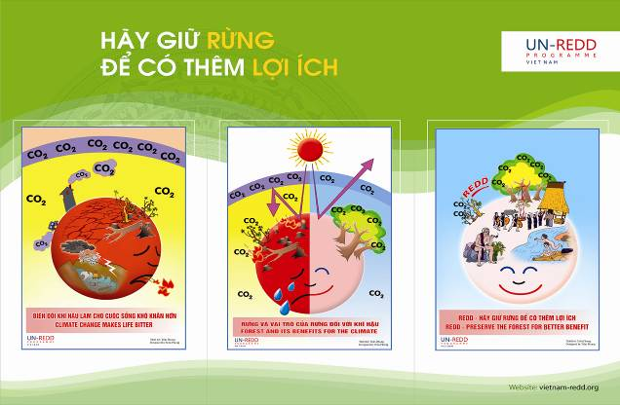

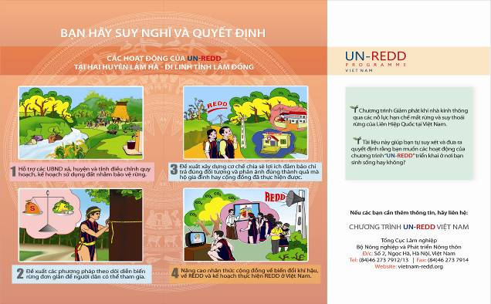

Step 1: District, Commune and Village Level Awareness Raising

The first step of the FPIC process involved consultations with relevant stakeholders at all levels (see Figures 5 and 6). These consultations began with the UN-REDD Local inception workshop in November 2009, and continued with a provincial work planning workshop on 18-19 March 2010. This was followed by district-level workshops on 1-2 April 2010 at Lam Ha and Di Linh district Peoples’ Committee headquarters in order to raise awareness among officials at all levels of districts, communes and villages involved in implementation of FPIC. The UN-REDD programme introduced its proposed village level FPIC plan for comments at these district-level workshops.

Based on feedback gained from these events, the UN-REDD programme refined its plans. Commune level awareness workshops were added with a view to further raising awareness of, and encouraging the participation in FPIC implementation among commune and village level officials, since it was clear that the district-level workshops were insufficient to introduce the plans effectively at all levels. These commune level events actually followed Step 2 (recruitment of interlocutors); consequently, interlocutors were able to participate in these later events. Table 3 provides a summary of all awareness raising events.

In addition to workshops, an innovation introduced at the start of phase 2 of the village-level FPIC events (see below) was mobile communication campaigns, launched one week before the village level FPIC took place.

Table 3: Summary of commune and village level awareness raising workshops during the 3 phases of FPIC
Event | FPIC 1 | FPIC 2 | FPIC 3
District level workshop | 2 workshops on 1-2 Apr. 2010 | n/a | n/a
Commune level workshop | 2 workshops at 2 pilot communes in Lam Ha district | 7 communes (Dinh Trang Thuong, Son Dien, Tam Bo - Di Linh Dist.; Da Don, Phu Son, Phi To, Dong Thanh – Lam Ha Dist.) | 3 commune (Hoa Bac & Hoa Nam – Di Linh Dist.; Gia Lam – Lam Ha Dist.)
Mobile communication | n/a | Launched at all communes & villages where FPIC is expected to take place | Launched at all communes & villages where FPIC is expected to take place
Number of district officials attending | 60 | 3 | 0
Number of commune officials attending | 60 | 178 | 39
Number of village officials attending | 55 | 30 | 20
Issues presented | Forests & CC, UN-REDD, FPIC | Forests & CC, UN-REDD, FPIC | Forests & CC, UN-REDD, FPIC
Presentation methods | Presentations with posters and overhead projector | Presentations with posters and overhead projector | Presentations with posters, UN-REDD film and overhead projector
Discussion methods | Plenary session | In group with presentations by participants | In group with presentations by participants

Figure 5: FPIC consultations with relevant authorities

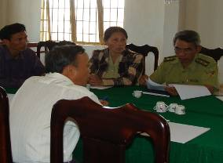
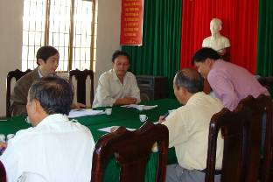

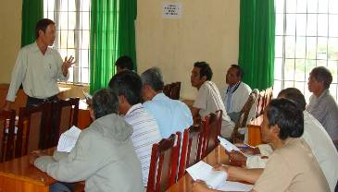

Figure 6: Awareness Workshops organized at district, commune and village levels
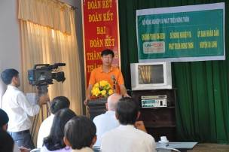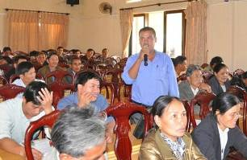

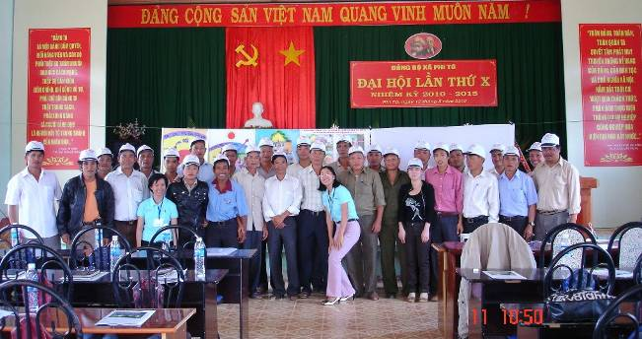

Lessons learned through the awareness raising events

Important lessons included:
- Raising awareness among officials at all levels plays an important role in facilitating the organization of FPIC implementation at village level but also serves as a factor to ensure the sustainability of programme activities in a long run.
- Basic issues relating to the materials presented, target participants, and methods to conduct workshops were refined through experiences during the various phases of the village-level FPIC events.

During the commune level workshops, a number of practices were adopted which proved to be beneficial in raising awareness effectively. These included:

1. Approaching local authorities
- A letter forwarded by the program to the District Peoples’ Committee (DPC) is an important start, as the DPC shall notify and direct relevant commune PCs to implement preparatory activities (such as invitations to the meeting, arrangement of venues and facilities);
- Contacting Commune Peoples’ Committee chair-persons to gather background information on the commune background (population, natural area, demographic structure, state of forests, livelihoods, telephone numbers of commune/village officials); and sharing of information among training experts are essential to facilitate commune level awareness training, and are necessary for organizing village meetings and follow-up activities of the program;
- Clear explanation of the purpose of training, and expected results of the training enhances the attention of participants and encourages their active participation;

2. Use of materials
- Posters were placed in the meeting rooms;
- Slides from Powerpoint presentations were also printed and distributed to participants;
- Leaflets in suitable languages were distributed among participants;
- Each issue (on forests and climate change, REDD+ and activities, FPIC) had been prepared in the form of a specific presentation and presented by an assigned expert;
- A REDD+ video was valuable in providing key information for target audiences.

3. Conducting discussions
- In addition to normal discussion (raising questions for comments/opinions from individual participants) there was an initiative to organize discussion groups and provide paper and pens for groups to prepare presentations on their views. Gifts were offered for those participants who expressed good comments/opinions; this encouraged their active participation;
- Information received from their presentations helped the group of experts to assess the level of understanding, refine and correct wrong information, improve their own presentations and collect further local information.

4. Interactions with local people during and after training
- Interactions took place during breaks to share information among participants, and help the interlocutors establish closer relations with local officials and establish liaison for village level FPIC activities;
- During interaction with village heads, the interlocutors discussed preparatory activities for organizing the village meetings, and helped village heads to have an image of activities to be performed, understand how to undertake outreach work when inviting the villagers to the meeting, and how to propose their requirements relating to the village level FPIC meetings to commune leaders;
- Offering gifts for participants and taking photographs with them before parting have generated good feelings among the participants.

5. Feedback from participants
- Participants received evaluation sheets and were guided how to complete them;
- The completed evaluation sheets were gathered and analyzed;
- Results showed that, in general, all the participants were interested in and satisfied with information provided and presentations given by experts; use of local pictures and language in their presentations were recommended;

As a result of these awareness raising activities, subsequent local activities, particularly village level FPIC meetings were greatly facilitated. A network has now been established of commune officials and village heads who are active in supporting FPIC and the programme.

Step 2: Recruitment of Interlocutors

The use of “interlocutors” was planned as a way of conducting the FPIC process so as to emphasize independence from government control. In some countries, local CSOs may be used for this purpose, but independent CSOs are only weakly developed in Viet Nam.

Key activities in this step were to identify recruitment criteria, advertise for applicants, conduct of interviews, and selection.

The recruitment criteria decided on were:

- Demonstrated forestry and environmental knowledge
- Experience in teaching and directly working with communities
- Fluency in an ethnic minority language and understanding of their customs
- Good listening and open-minded attitudes
- Having good communication capability
- Friendly and sincere manner.

After seeking applicants through advertising with local district authorities, and local research, education and training institutes, candidates were interviewed on 21- 22 March 2010 in Da Lat by a board of examiners who had participated in the design and implementation of these activities (see Figure 7).

Figure 7: Recruitment of Interlocutors
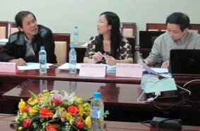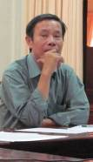

Interviews were implemented through a 3-step process:

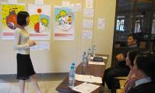
Step 1: Candidates get acquainted with posters
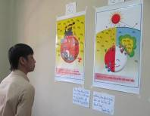
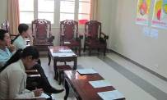

Step 2: Candidates introduce their knowledge, skills and experiences
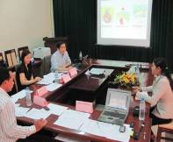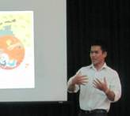
Step 3: Candidates present posters and answer some questions put by examiners
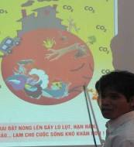
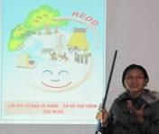

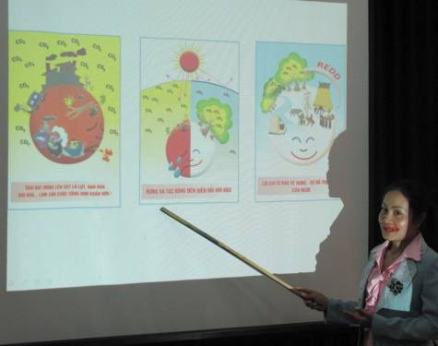

The results of the interviews were that 24 interlocutors were selected from a total of 35 candidates. Of the successful candidates, 30% are members of ethnic minority peoples, and 46% (11 out of 24) are women. One third of the recruited interlocutors had experience working in the actual pilot districts. Half of the interlocutors are lecturers from the local university, while 17% work for a local protected area.

The activity was completed in a short time through the effective support and involvement of local authorities. This resulted in a high quality of interlocutors, which helped to reduce risks in subsequent implementation and to increase sustainability of FPIC in Lam Dong province.

Step 3: Interlocutor Training

Even if, in some countries, independent CSOs can be used as a convenient source of interlocutors, the staff of selected CSOs will still require training in FPIC, climate change, and REDD+.

The key activities in this step (see Figure 8) involved:

- Introduction to FPIC and preliminary training in consultation methods through participation in the two district-level awareness raising events, April 1-2, 2010
- Basic training and consultation practice through participation in two-village FPIC trial events: Lam Bo of Phuc Tho commune, Da Sa of Lien Ha commune, Lam Ha Dist. on 10- 11 April 2010;
- Improvement training delivered before the start of village-level FPIC events; between 2nd and 16th May 2010;
- Continuous experience learning and sharing of lessons after each working day and each FPIC event.

Figure 8: Interlocutors during their training

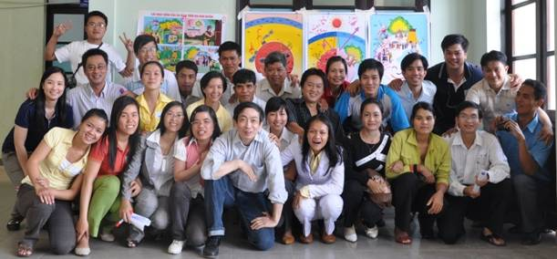

Basic training was provided through various modules:
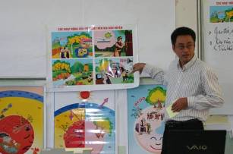

- Direct communication;
- Ability to present with visual aids;
- Ability to facilitate participatory group working;
- How to use the program’s set of posters and materials to support FPIC activities.

Training methods involved practice and role playing (see Figure 9) to help clarify appropriate roles before implementing work in the field. Continuously consolidation of skills was emphasized.

Results: a strong and sustainable brigade of interlocutors was created; groups were able to work independently and help each other. Of particular importance were the great efforts made by ethnic minority interlocutors. The brigade was able to prepare issues and present them at commune/village level awareness workshops.
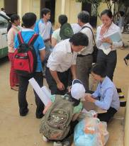
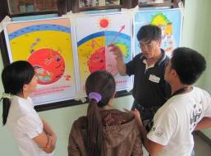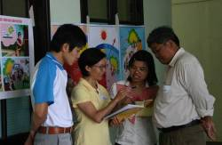

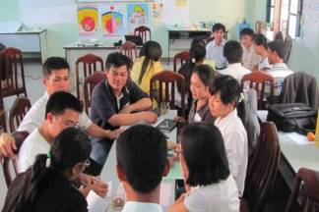
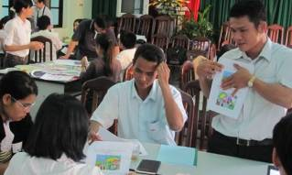

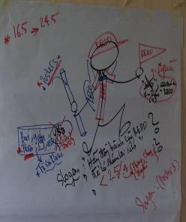
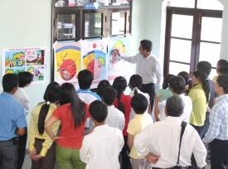

Figure 9: Interlocutors eagerly learning to perform
the challenging tasks of FPIC

Step 4: Village Meeting Preparation

As mentioned previously, the village-level FPIC events (Steps 4, 5 and 6) were split into three phases so that lessons learnt in earlier phases could be incorporated into subsequent phases. Figure 10 shows the location of villages in each of the three phases.

Figure 10: Map of the three phases of village-level FPICs events; red = phase 1; green = phase 2; blue = phase 3

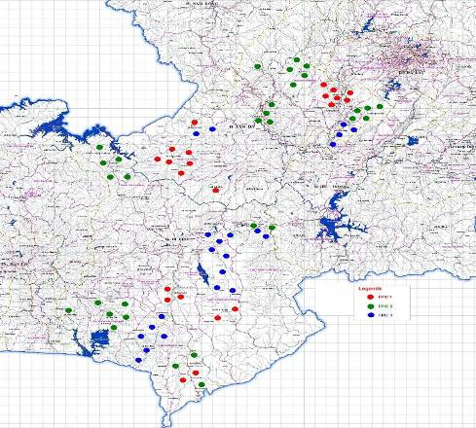

Prior to phase 1, relatively little attention was paid to preparation for village FPIC events - a meeting was held with village heads during the district workshop, but there was no pre-check of the site for meeting, the arrangements being left largely up to the village heads. However, upon completion of phase 1, greater attention was paid to village meeting preparatory activities. More time and effort was spent by the programme on the village meeting preparation, including checks of the suitability of the proposed location.

The awareness raising workshops at the commune level facilitated effective implementation of FPIC at the village level, as commune officials and village heads had improved awareness of the principles, understood the requirements for implementing FPIC at the village level, and really wished to be involved in this activity. Furthermore, good relationships between interlocutors and commune officials and village heads were established, which further facilitated the performance of preparatory activities.

The basic process used in phase 1, and improved upon thereafter, involved the following key activities, undertaken by, or guided by interlocutor groups:

- Identification of local people having ‘position’ in the community and roles in the village meeting;
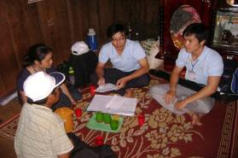
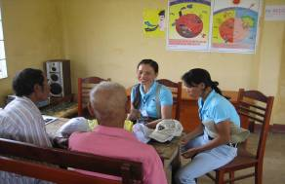

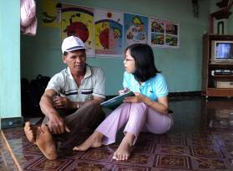
- Discussion with village heads about the meeting venue, timing, necessary arrangements and announcement;
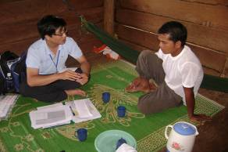

3. Following phase 1, mobile communication was carried out one week before the village meeting
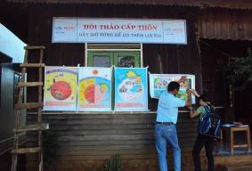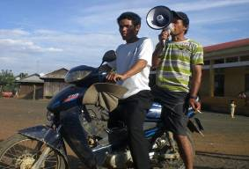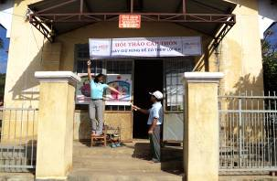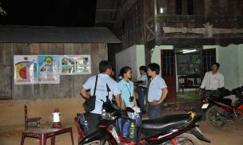

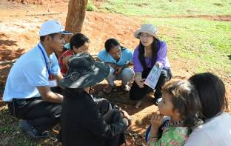
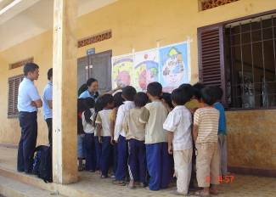

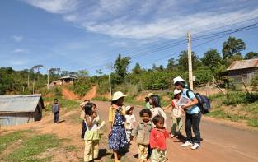
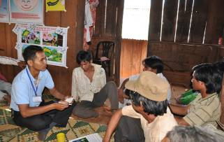

Lessons learnt from the preparatory activities:

- The meeting timing should be defined on the basis of local seasonal crops in order to increase the percentage of the villagers’ participation;
- An advance survey is essential to ensure high quality of the FPIC meeting;
- During the advance survey, approaching those who have an important voice in the locality is very important;
- A study of local communities (including, for example, the proportion of Kinh and ethnic minorities) in advance is necessary so that appropriate meeting plans can be prepared;
- Interlocutors should be clearly assigned to roles identified in the meeting plan, and trained to handle unexpected situations during FPIC implementation;
- Information about the programme should be designed and presented according to villagers’ level of understanding;
- Mobile communication is part of the advance survey that is carried out shortly before the village meeting as part of the preparations. The current state of the village can be ascertained through this process.
- The best practice is to interview households selected by the village head. In advance of meetings for each village, ten households were selected based on following criteria:
- Households with members who understand the village organization, customs, and so on; for example, those of the village head, party secretary, headed by women, those with a recognized patriarch, etc.
- Have potential to benefit directly from the program; i.e., those households with forest management contracts (2-4 households)
- Those with the closest interactions with forests; for example, those with cultivated land nearby forests (3-4 households)
- Most important is to understand the village’s customs and culture (what they are interested in, or which taboos need to be avoided) and production patterns (local weather patterns, the state of cultivation, etc.) in order to improve the efficiency of communication during the meeting;
- The timing of a contact with local people is very short and therefore the fastest way to come into contact with them is through the mediation of local authorities or prestigious figures;
- It is essential to show respect for the villagers and to treat them as equals;
- Collected information should be noted down in a scientific way for reporting and storing purposes
- Liaison with the village head and villagers should be maintained so as to regularly inform them of the programme, and create confidence in future interactions.

Step 5: Conducting village meetings

This is the critical step and the one that has been most subject to testing, adjusted and improvement so as to ensure all requirements with respect to the number of participants, gender and ethnic balance, and principles of FPIC are met.

The key activities in conducting village meetings, as they evolved through practical experience, involved:

- Opening session - typically, the village head opened the meeting, introducing the objectives, participants and steps of meeting;
- Presentation of such issues as climate change, REDD, and UN-REDD activities by the interlocutors (see Figures 11 to 13);
- Discussion session, including questions and answers (see Figure 14);
- A session to allow decisions to be made on consent or non-consent;
- Recording of the results by the interlocutors;
- A review meeting with the village head to review experiences and for the village head to sign the minutes of the meeting.

Following phase 1, major changes were introduced, including the following:

- The quality of discussions and exchange of information was improved, for example by encouraging group discussions in an open atmosphere that encouraged a greater number of villagers to participate in discussions and express their views.
- The process of decision-making on consent or non-consent was improved by substituting signature of sheets by voting by show of hands, and finally by secret balloting using colour ballot sheets. This ensured closer adherence to FPIC principles, the effect of pressure of a majority is avoided, and recording of votes by the interlocutors is simplified.
- The review meeting with the village head was introduced to learn experiences and to sign the minutes of the meeting so as to ensure the authenticity and community representativeness of reports made by the interlocutors.

As a result of the introduction of these improvements and modifications, the rate of household representation increased; villagers became much more active in participating in discussion groups and plenary sessions; and were more confident in expressing their opinions and in voting. More comments were received on, and contributions made to the programme; and effective relationships with the village head and villagers were established and strengthened for future cooperation.

Table 4 provides a summary of changes undertaken in the village meeting process over the three phases of the pilot FPIC exercise.

Figure 11: The interlocutors giving presentations and coordinating discussions
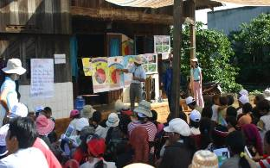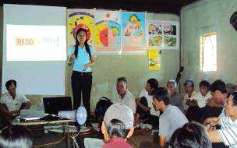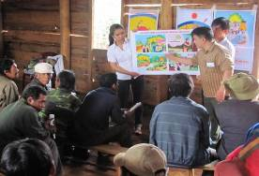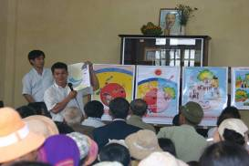

Figure 12: Villagers reading and studying documents
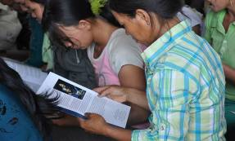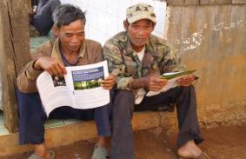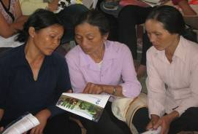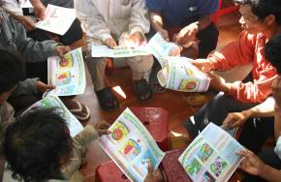

Figure 13: The interlocutors solicitously explaining materials
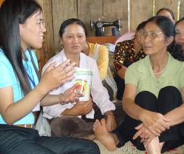
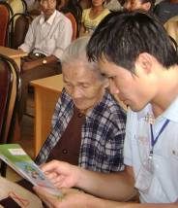

Figure 14: Encouraging villagers’ comments to improve the quality of the meeting
Initially, only some individuals spoke out

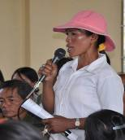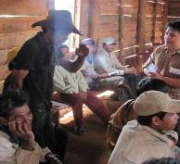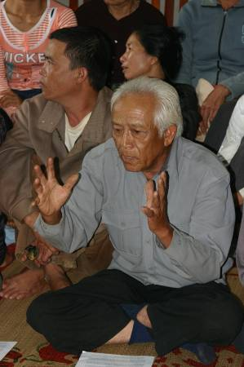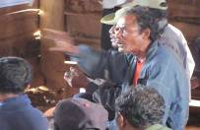

This led to the introduction of effective and attractive discussion groups

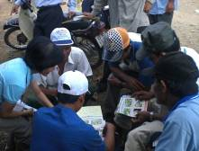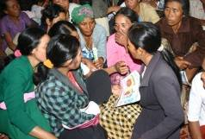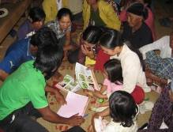
Table 4: Summary of changes in the village meeting preparatory and conducting activities
Activities | FPIC 1 | FPIC 2 | FPIC 3
Mobile communication | Not carried out | Carried out | Carried out
Commune level awareness raising | Only carried out in some communes | More thoroughly carried out | More thoroughly carried out
Advance survey, working with commune officials and village heads | Not carried out | Carried out with more time spent | Carried out with more time spent
Decoration of meeting room and reception of the villagers | Relatively simple | More methodically prepared | More methodically prepared
Presentation of issues | Disorderly | In a well organised structure | In a well organised structure
Discussions | In plenary session | In groups and with prepared questions | In groups and with prepared questions
Voting for consent | By show of hands | Colour votes | Ballot with colour votes
Review meeting with village officials to learn experience | Not organised | Organized by some groups | Organised by all the groups
Meeting minutes | Not made | Not made | Made by almost groups

Figure 15: Maintaining good relations after the meeting
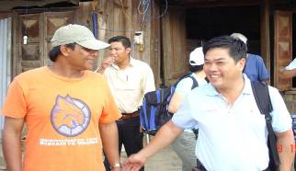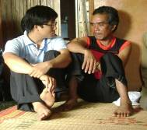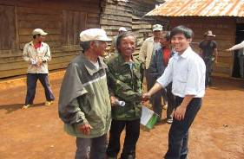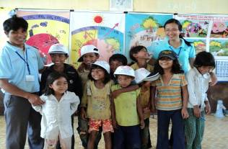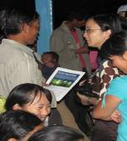

Lessons learnt from conducting the village events are summarized in Table 5, below. The key points were:
- To create a positive atmosphere of the meeting that interests participants;
- Presentations need to be structured in a simple and general way that connect all sections and is understandable by the villagers;
- Active persons need to be encouraged to involve the whole villagers to participate;
- Discussion by the villagers should be facilitated in order to avoid digressions (prepared questions for specific groups, advance explanations, felt pens);
- Performance and rewards need to be combined;
- Ethnic minority interlocutor’s ability should be brought into full play;
- Each succeeding section of the meeting needs to be logically linked to the preceding;
- Voting and gift offering need to be organized in a clear and orderly fashion.

Lessons learnt from the completion of the village events:
- Take advantage of a review meeting with village officials to complete the minutes of the meeting, and to formalize the results;
- Offer gifts: speakers, banners, posters and others for the locality to keep on raising awareness;
- Evaluate and learn experiences by each group after each FPIC
- Hold a review meeting for the whole team to exchange and learn experiences for improvement;
- Maintain effective liaison with the localities in order to improve cooperation for the cause of forest protection and development;
- Update information on the program (when follow up activities take place);
- Local people are interested in benefits such as sustainable livelihoods;
- Having developed a local contingent of facilitators and interlocutors; make good use of them!
Table 5: The Village Meeting Lessons and Experiences Learnt
Prior-meeting |  | During meeting |  | Post-meeting
- Collaborate with District and Communal PCs to notify villages of meeting schedules, purposes and agenda  - Establish communication channels | - Make site visits to familiarize with villages and primarily collect data on local forests and relevant issues  - Interlocutors directly raise awareness among selected target households | - Define roles of communal representatives and/or village- heads in meeting arrangements | - Bring into full play the village patriarch’s prestige in giving the orientation of the meeting and facilitating its discussions to gain participants’ consent | - Interlocutors arrange a photograph opportunity with all the stakeholders | - Establish liaison with village’s representatives and selected villagers
 |  | - Coordinate specific tasks of, and maintain the flexibility of the interlocutor team. Collaborate with local people partners  - Arrange interpretation from local ethnic languages into the Kinh one | - Take advantage of local people’s knowledge to illustrate arguments in lectures | - Interlocutors interact and/or exchange comments with selected local people and officials to further collect relevant information
- Site check: meeting venue, participant number and compositions, arrangement of seats |  | Presentation/dialogueTrình bày và đối thoại  Climate Change ???  Forests ??  REDD??? |  | - Hand set of posters and leaflets over to villagers to further use for raising awareness  - Interlocutors define schedules and local targeted audiences for talk next visits  - Interlocutors’ knowledge and skills are improved and provided with relevant documentation and field tools
- Identify places to stick posters on and locate where interlocutors stand and where materials and equipment are kept  - Test sound and lighting systems, and others | - Prepare scenarios to receive and welcome local people:  - A reception room;  - How to register by signing;  - How to distribute leaflets; and  - How to offer gifts

Step 6: Recording of Decision

The key activities in this step consisted of:

- Guiding local people in understanding the requirements to express their opinions about consent or non-consent to taking part in the programme implementation; and to speak out benefits, difficulties and challenges that are likely to be faced during the participation;
- Giving a presentation on voting methods and procedures to express consent or non-consent;
- Counting the votes and publicizing the result during the meeting with the village head and officials.

There were several adjustments to the way of expressing consent or non-consent. During FPIC 1, signing of a consent sheet was tried initially and then replaced by show- of- hands voting due to some fears being expressed by local people that signing their names might leave them open to recriminations if viewed to have made the “wrong” decision (see Figure 16). However, with voting by show of hands is impossible to avoid the effect or pressure of a majority, and is also difficult to record accurately.

Consequently, starting in phase 3, the interlocutors started using ballot papers with different colours for male and female participants and two ballot boxes for consent and/or non-consent ballot papers (see Figure 17). Participants were able to deposit their paper in the desired ballot box in secret (ballot boxes were located behind curtains). This method enabled villagers to freely express their opinions.

Voting results were certified by the village head who was involved in the process, working alongside the interlocutor group.

Figure 16: From voting by show of hands

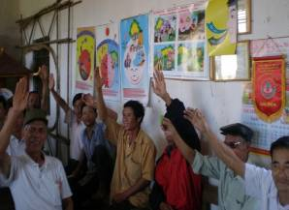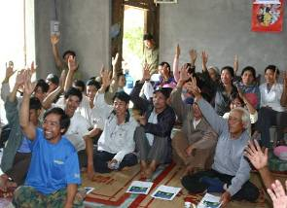

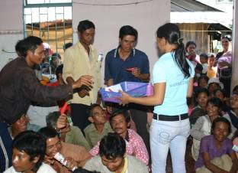
Figure 17: The use of ballot boxes
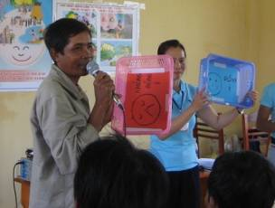

Step 7: Documentation and Reporting

The key activities in this step consisted of:

- Through ballots (or, in phase 1, a show of hands), the villagers expressed their decisions on consent or non-consent;
- The interlocutor group documented the voting results that were witnessed and certified by the village head;
- The decision (consent or non-consent) of each village was forwarded to the UN-REDD programme office;
- Local people’s opinions about specific issues raised by interlocutors were included in personal reports made by individual interlocutors.

The compiled and documented results of the pilot FPIC exercise are shown in Table 6, overleaf. Complete results are recorded in Annex 1.

Table 6: Synthesis of Villages in Lam Ha and Di Linh Districts
Village | Total households | Number/ % of participants | Age group |  |  | Sex |  | Ethnic minority |  | Voting
 |  |  | 15-25 | 26-45 | >46 | Male | Female | Kinh | K'Ho, Ma, others | Consent votes | Non-consent votes | No voting
Lam Ha Phase 1 (*) | 2,192 | 935 | * | * | * | 516 | 419 | 285 | 650
 |  | 42.7% | 11% | 49% | 40% | 55.2% | 44.8% | 30.5% | 69.5% | 92.0% | 4.0% | 4.0%
Lam Ha phase 2 | 2,304 | 1,295 | 103 | 711 | 476 | 620 | 675 | 672 | 623 | 1,197 | 6 | 57
 |  | 56.2% | 8.0% | 54.9% | 36.8% | 47.9% | 52.1% | 51.9% | 48.1% | 92.4% | 0.5% | 4.4%
Lam Ha phase 3 | 818 | 523 | 49 | 267 | 207 | 272 | 251 | 382 | 141 | 488 | 15 | 20
 |  | 63.9% | 9.4% | 51.1% | 39.6% | 52.0% | 48.0% | 73.0% | 27.0% | 93.3% | 2.9% | 3.8%
Di Linh phase 1(*) | 811 | 454 | 46 | 149 | 132 | 132 | 322 | 60 | 394
 |  | 56.0% | 10.1% | 32.8% | 29.1% | 29.1% | 70.9% | 13.2% | 86.8% | 95.0% | 2.0% | 3.0%
Di Linh phase 2 | 1,605 | 1,014 | 165 | 523 | 326 | 538 | 476 | 31 | 981 | 902 | 41 | 71
 |  | 63.2% | 16.3% | 51.6% | 32.1% | 53.1% | 46.9% | 3.1% | 96.7% | 89.0% | 4.0% | 7.0%
Di Linh phase 3 | 2,982 | 1,642 | 233 | 848 | 563 | 762 | 880 | 388 | 1,254 | 1,527 | 45 | 70
 |  | 55.1% | 14.2% | 51.6% | 34.3% | 46.4% | 53.6% | 23.6% | 76.4% | 93.0% | 2.7% | 4.3%
Total 2 districts for 3 phases | 10,712 | 5,863 | 596 | 2,498 | 1,704 | 2,840 | 3,023 | 1,818 | 4,043 | 4,114 | 107 | 218
Rate for 3 phases |  | 54.7% | 10.2% | 42.6% | 29.1% | 48.4% | 51.6% | 31.0% | 69.0% | 70.2% | 1.8% | 3.7%
(*Note: lack of data on age groups from FPIC 1)

Step 8: Verification and Evaluation

An independent agency (The Centre for People and Forests, RECOFTC) was contracted by the global component of the UN-REDD Programme to prepare a methodology for verification and evaluation of the FPIC process. The methodology was developed through an expert workshop held in Chiang Mai, Thailand, in May, 2010. RECOFTC was subsequently invited to apply this methodology in order to verify and evaluate the results of the FPIC process under the UN-REDD Programme in Viet Nam.

The verification and evaluation process involved a team of four independent experts, all Vietnamese nationals, to facilitate travel in the field and to allow effective discussion with local people. The team spent the period June 11th – 17th in Lam Dong, overlapping with phase 3 of FPIC implementation. Although this compromised their ability to verify the results of phase 3, it was valuable in allowing a ore thorough evaluation of the process.

The main conclusions of the verification and evaluation process are presented below. The full report is available at www… ???

Conclusions of FPIC Verification and Evaluation Report
Based on the findings from the evaluation and verification discussed above, it is concluded that the FPIC process under UN-REDD Vietnam adhered to major parts of the guiding steps from UN-REDD regional office and the principles of FPIC. The Vietnam Program took into account the country specific circumstances and the local contexts in Lam Dong province throughout the whole FPIC process. However, there are three major weaknesses of the process that need to be highlighted here:

- Insufficient information provided to local people: although UN-REDD Vietnam tried various means to communicate with local people necessary information about climate change, REDD and the Program, the information provided was not sufficient, particularly that on risks and costs associated with participation in REDD program for local people.
- Lack of time for internal discussion in the village: the timeframe of the village meeting was very short (2 hours) and only 45 minutes were allocated for questions and answers after the awareness raising activities and before the villagers had to make the decision. There was in fact no time for the discussion within the villagers about the issues introduced by the facilitation team.
- Lack of a grievance and review mechanism: although it is not a very common practice in Vietnam that local people file their complaints through such a mechanism, it is still necessary to have it ready and publicly known to villagers in case any problem happens.

The following immediate actions are recommended to UN-REDD Vietnam Program (see the discussion that follows on recommendations for improvement of FPIC process design and implementation):
- First of all, UN-REDD Vietnam Program should discuss the E-V mission findings with FPIC facilitation team members and check if these findings or most of them apply to villages not covered by the mission. Although the number of villages that the E-V team visited was limited, the team has an impression that the findings presented in this report largely represent the situation in other villages, including those in the third phase of FPIC. The facilitators were the ones that involved in the FPIC process in all villages and will be able to confirm if the issues brought up by the E-V team were also the case in all other villages or they remained relevant only to the villages visited by the E-V team (or a small number of villages). In the former case, no further field evaluation and verification of FPIC process will be needed. In the latter, the facilitators will need to indicate in which other villages that the situations were different from the findings of the E-V team and how different they were. Field evaluation and verification of the FPIC in selected number of these villages will then be needed in order to achieve a good picture of the issues that arose during the FPIC process.

- To address the missing information, it is recommended that UN-REDD Vietnam Program review all the information that need to be provided to local people (see discussion in Section 2) and compare with that already given to villagers. The missing information, particularly that on risks and costs associated with implementation of UN-REDD Program at the local level, will need to be prepared. If such information is not readily available within the Program, a desk review will be necessary to come up with a set of information relevant for local people. On the basis of which, communication materials will need to be developed for awareness raising of local people.

- Once proper set of information is prepared, it is recommended that further awareness raising / dissemination of information about UN-REDD Program for villagers, particularly information on risks and costs, be undertaken in all villages covered in FPIC process. Depending on the available resources, this should be done in phased approach and prior to any further activity that will take place in the respective villages. Various means can be used, including but not limited to radio and TV broadcast, printed materials dissemination and direct training/ awareness raising event at the village level.

- Together with and on the occasion of the awareness raising events, it is recommended that UN-REDD Vietnam check if there was any complaint or concern about the FPIC process (or the FPIC team) that remained unspoken or unaddressed among villagers. Such complaint/ concern need to be addressed properly. If necessary, ensure that complaint can be made autonomously.

For future FPIC process, the following recommendations are made:
Preparation for the FPIC process:
- FPIC facilitation team:
  - Age profile: The age profile of the FPIC facilitation team members was a bit young. While this did not seem to be a major problem so far, local people, particularly the elderly, still preferred to speak with older facilitators. It is recommended that there should be a better balance of age in the facilitation team to meet the variation of ages among villagers.
  - Facilitation skills: the experience from UN-REDD Vietnam showed that facilitators were able to learn the facilitation skills very quickly through two major arrangements: 1) training at the beginning of the process and refresher session before the field FPIC in the later phases, and 2) working in a mixed team of skilled and less skilled facilitators. It is recommended that this lesson should be taken into account for future FPIC process.
  - Use of civil society organizations: it is advisable that UN-REDD Program proactively involve local civil society organizations (CSO) as part of the facilitation team. The experiences and skills that CSOs have in working with local people will be of important contribution to the process.

- FPIC process design:
  - International legal framework: there was a lack of reference to the international legal framework and country’s obligations with regard to FPIC in the process design document, it is necessary that such information be presented as background in the FPIC design in order to align the national process with international contexts.
  - National guidelines related to FPIC: similar to the international legal framework, the national guidelines related to FPIC were not incorporated nor were they even referred to in the process design. For the future, any legal documents related to FPIC at the national level should be reviewed and fully incorporated in the design to create synergy between international principles and national contexts. It should include also any barrier that may come from the national legal framework to the FPIC process.
  - Governance contexts: while it may be too ambitious to expect local facilitators to have full understanding of the governance context in the villages that they would undertake the FPIC, it is advisable that in the process design document, the major governance issues be elaborated. This includes but is not limited to description (including the discussion on strengths and weaknesses) of the local informal governance structure versus the formal one, and the traditional decision making process versus the formal system, and an analysis of the power relations in practice.
  - Limitations to the process: though limitations to the UNREDD Vietnam FPIC process were, to a certain extent, foreseen and addressed, it is recommended that this should be dealt with in a more systematic way and should be integrated in the design process. Limitations should be discussed with local facilitators well in advance of the FPIC process to identify limitations and possible measure the most possible extent. Limitations should be listed in the design document along with measures to address them. Note that limitations may be found in the areas of time, financial and human resources, information, and availability of capacity building.
  - Feedback and documentation mechanism: The process and feedback received from the villagers in the meeting was poorly documented so far, mainly because it was not directly requested in the design document. It is advised that the process design foresee this issue. The whole process of FPIC at the village level should be fully documented, particularly any issues raised by the villagers and the responses given by the team so that the process of discussion can be followed by anyone reading through the documentation. The documentation should be done publicly in the meeting; that is, local people should be informed at the beginning of the process that their views and concerns about the Program as well as the answers from the team will be fully documented. If possible, documentation should be done on large paper so that villagers can read from the back of the room. At the end of the meeting, it should be read out aloud to all people and check if there is anything missing or anything needs to be changed. All the documentations can be transcribed on A4 paper and a copy should be left in the village.
  - Time for internal discussion: it is highly recommended that the process design include adequate time for internal discussion among villagers. Put it differently, an additional step (Step 4b) in the process is suggested. That is, after the awareness raising in Step 4, villagers have time to discuss among themselves and local facilitators should be available to help in case of need.
  - Capacity building for villagers: while it may be too ambitious to have a comprehensive assessment of the needs of local people for capacity building to fully undertake the FPIC at the village level, it is advisable that FPIC design process identify the major supports needed (e.g. facilitation, information, and communication materials) to provide to local people to facilitate their internal discussion. In addition and as mentioned above, facilitators should be on standby to help villagers at need.

Implementation of the FPIC process:
  - Initiation of consultation process:
    - Involvement of local people: Local people should be involved in the FPIC process as early and as much as possible. It is recommended that they are involved in the selection of date and time for any activities related to FPIC at the village level, e.g. awareness raising, internal discussion, village meeting to provide consent or non-consent.

  - Decision-making processes:
    - Involvement of local people: Local people should be involved in the FPIC process as early and as much as possible. It is recommended that they are involved in the selection of date and time for any activities related to FPIC at the village level, e.g. awareness raising, internal discussion, village meeting to provide consent or non-consent. They should also be involved in the discussion on how much time is needed for them to discuss and come up with the decision.
    - Intra-community consultation: it is suggested that in the implementation process local facilitators apply no pressure on villagers to speed up the process. Local people should be given adequate time to discuss among themselves and come up with a decision.
    - Documentation: It is necessary that local facilitators take full documentation of the whole process. See also recommendation under ‘Feedback and documentation mechanism’ above.

  - Information and communication strategy:
    - UN-REDD information dissemination: UN-REDD tried a variation of media to provide outreach to local people. Nevertheless, it is still necessary that the use of these media be monitored (e.g. how often the information is broadcasted on TV/ radio and at what time) so that any problem that occurs can be addressed timely.
    - Contents of the information: see recommendation for immediate action above on mission information.
    - Sources of information: It is highly advisable that related information be provided by not only UN-REDD Program. (Local) civil society organizations should be involved in the dissemination of information to provide alternatives to local people as well as the different view-points on REDD and UN-REDD Program.
    - Time allowed: as mentioned above, it is necessary that local people have sufficient time to understand the information provided and to discuss among themselves. Facilitators should apply no pressure on them to move up to the decision.

  - Transparency and “good faith”:
    - Balance of the information: As mentioned above, information should be balanced between opportunities/ benefits and challenges/ costs for local people to participate in UN-REDD Program. In addition, information on risks should be provided to local people to consider before making up their mind whether or not to give consent.
    - Public announcement of outcome: It is recommended that the outcome of village level process should be publicly announced to the whole village soon after the meeting so that people who did not have the chance to involve in the process are well informed and may make any complaint about the outcome if needed.
    - Information about the Program: so far villagers have associated UN-REDD Program activities mainly with forest protection. While there is no problem with it at this stage, it is recommended that information be provided in full so that villagers have a good understanding of what the Program is about before making decision.
    - Engineering consent: to avoid powerful figures in the village making any influence on the final decision, it is recommended that small group discussions be held in the intra-community discussion process (Step 4b recommended above). Powerful actors in the village should be in one sub-group so that they do not influence discussion in the other sub-groups. At the end of the step, outcomes of all sub-group should be compiled and equal weight should be given for each group.

  - Grievance and review mechanism:
    - It is recommended that a grievance and review or similar mechanism be established, publicly known to and accessed by all villagers throughout the process. The mechanism should reflect the gender, ethnic, religious and political balance within the area under the FPIC process. It will not be linked to FPIC team or any other forces in anyway and any decision made from the mechanism must be enforceable.

The outcome of FPIC process:
  - Public announcement of the outcome: as mentioned above, as soon as the process is completed, the outcome of village level process should be publicly announced to all people in the respectively village, particularly to those who did not have chance to be involved in the process.

Part III: Conclusions and Implications for Conducting FPIC for REDD+

The UN-REDD Programme in Viet Nam moved quickly to pilot an FPIC process in Lam Dong province, partly to comply with the provisions of the UNDRIP with respect to its own activities, but more importantly in order to generate lessons on how to conduct FPIC for REDD+.

Such a process had never been attempted before – although there are numerous examples of FPIC processes, including some from the forest sector, these have always dealt with rather narrow issues with clear and direct economic and social implications (e.g., oil palm development, mining and prospecting, etc.). In contrast, REDD+ is a broad, complex, and as yet not fully defined concept, dealing with a commodity that cannot be seen (reduced emissions of greenhouse gases) and benefits and risks that are difficult to describe, let alone quantify. Furthermore, FPIC for REDD+ will need to deal with geographic and social scales far beyond previous FPIC exercises. The 80 villages involved in this pilot exercise represent a tiny fraction of those which will need to be involved in FPIC for REDD+

Without a lot of previous experience on which to design the process, the UN-REDD Programme made a conscious decision to try to implement FPIC, honouring the well-established principles as far as was possible, and accepting that the process would not be perfect, and errors would be made. For this reason, the independent evaluation and verification of the process was organized as soon as possible after the exercise (in fact, even before completion of phase 3) precisely in order to identify lessons, including errors made during the pilot FPIC process.

Based on experiences gained and the feedback provided by the independent evaluation, some clear conclusions and lessons can be drawn regarding implementation of FPIC for REDD+.

Cost

The costs of the FPIC exercise in the two pilot districts are shown in Table 7, below.

Table 7: Itemized cost of FPIC exercise in Lam Ha and Di Linh districts
Item | Cost (US$)
Awareness raising workshops | 11,000
Design, refinement, translation and production of communications materials | 20,000
Salaries of interlocutors (20 people, employed on an as-needed basis for an average of 30 days each, @ VND 500,000/day) | 15,000
Consultancy fees (initial analyses; recruitment and training of interlocutors; resource people for awareness raising events, etc.) | 30,000
Village FPIC events | 20,000
Travel (Hanoi – Lam Dong and local travel) | 19,000
TOTAL | 115,000

This works out as an average of about $1,400/village. As only two of Lam Dong province’s 12 districts were covered, the cost of applying FPIC to the entire province would appear to be very high. However, in order to estimate the costs of FPIC for REDD+, it is important to note that a significant amount of the total costs are “fixed” costs, associated with the design and initiation of the FPIC process – these costs would not be incurred in scaling up the pilot to a full FPIC process for REDD+. For example, the costs associated with initial design and refinement of communications materials would not be further incurred. Most of the consultancy fees would be avoided, and cost savings could be anticipated in the awareness raising events by applying lessons from the pilot. Also, the travel costs for the pilot were higher than would be experienced in an operational exercise, due to the interest of numerous Hanoi-based personnel in witnessing the pilot.

A “typical” REDD+ relevant province in Viet Nam might consist of 9 districts (58 provinces, and 556 rural districts nationally), with each district composed of 16 communes (9121 communes in rural districts nationally). However, some districts, particularly those near urban centres, may contain little or no forest, and within forested districts, some communes might likewise be bare of forest. Therefore, assuming 8 forested districts and 8 forested communes per district, with each commune consisting of 10 villages, an estimate of operational costs to apply the same 8-step FPIC process at an operational level in a new location might be as shown in Table 8.

Table 8: Estimated costs of an operational FPIC exercise, based on lessons learned through the pilot
Item | Unit Cost (US$) | Units | Total Cost (US$)
One provincial, four district, and 10 commune-level awareness raising workshops (see note 1) | 20,000 | 1 | 20,000
Production and, where necessary, new translations of communications materials (see note 2) | 8,000 | 1 | 8,000
Salaries of interlocutors on a per village basis (3 people, for 3 days each, @ VND 500,000/day) | 225 | 640 | 144,000
Consultancy fees (initial analyses; recruitment and training of interlocutors; resource people for awareness raising events, etc.) | 20,000 | 1 | 20,000
Village FPIC events on a per village basis | 250 | 640 | 160,000
Travel | 10,000 | 1 | 10,000
TOTAL per province |  |  | 362,000
Note 1: Assumes an average of 8 forested districts per province; and 8 communes per district; but 2 districts per district-level event, and all communes combine for commune-level events
Note 2: Figure for the entire province

This estimate is probably slightly on the high side, as further cost savings could probably be made as scaling-up proceeds (for example, streamlining of the awareness raising events; transfer of unused communications materials from one province to another; combining travel to more than one province, etc.) However, an estimate of $350,000 per province would seem to be appropriate.

Other lessons or conclusions emerging from the pilot exercise include:

Preparatory phase

Education and awareness raising at all levels is essential, and is more difficult than might be assumed. The concept of climate change, the role of forests in climate change, and the potential to generate income from reducing emissions from forests are all difficult to grasp, even for well-educated government officials, and much harder for under-educated local officials. The pilot FPIC process in Viet Nam recognized this and substantially increased awareness raising efforts, but should have invested even greater levels of effort.

A detailed analysis of the social, ethnological and linguistic status of the target province and the spatial distribution of forest and forest-dependent communities is essential in planning an efficient and effective FPIC exercise. For large-scale FPIC, good linkages to authorities holding such information need to be established.

Languages are important, but this does not mean that every language needs to be addressed. Ethnic minorities living among larger ethnic groups may be adequately fluent in another minority language. This was the case in some parts of the pilot districts, where K’ho was the lingua franca, spoken by other ethnic minorities who might use their own language in the home. In some locations, even K’ho were more literate in Vietnamese, but appeared to appreciate having materials in their own language.

Human Resources for FPIC

Eventually, the FPIC process will need to be institutionalized, and this should logically be mainstreamed into the socio-economic development and land use planning processes in Viet Nam and other countries having similar processes. The Ordinance on Implementation of Democracy in Communes establishes the right of local communities to be consulted on these and other processes (though their right to provide or withhold consent is not enshrined in the Ordinance). Therefore, since REDD+ is merely one issue to be considered in socio-economic development and land use planning, FPIC for REDD+ should be encompassed in FPIC for these broader processes. In the context of Viet Nam, this means a significant role for the Ministry of Planning and Investment and its provincial Departments of Planning and Investment.

However, while this is a long-term goal, in the immediate future FPIC for REDD+ will need to rely on specially convened teams of interlocutors – either recruited directly for the purpose, as in Viet Nam, or under the auspices of selected local independent CSOs. Recruitment of individuals who are intellectually and emotionally suited to the exercise is critical. Furthermore, experience in the pilot exercise demonstrated that natural variation in the capacities and experience of individual interlocutors meant that the training process needed to be more closely tailored to the needs of individuals than was achieved in the pilot.

Local FPIC Events

In Viet Nam, as in many other countries, local communities tend to be distrustful of new initiatives, especially if viewed as having government support. Similarly, not having had real experience of genuine consultation or the right to provide or withhold consent, it is difficult to build the necessary trust in a new process with regard to a new and complex issue. In the pilot FPIC exercise there was a suspicion at the outset that the time planned for local events would prove to be insufficient, and the external evaluation confirmed this. It is clear that local FPIC events need to be multi-phased, with an introductory session, followed by an opportunity for the community to reflect, followed by another consultation to allow any new questions or uncertainties to be addressed, and after another period of reflection, a decision-making process. Thus, at least three visits to each village should be planned – obviously by the same interlocutors – meaning that logistics planning needs to be done very carefully.

For similar reasons, the method of reaching and recording a decision proved to be complicated, with three different methods tried in the three phases of the pilot. Members of local communities are wary of signing a document. In the case of Viet Nam, where literacy is high, even in remote areas, this simply reflects a fear that a documentary record of a decision deemed by “authorities” as being “wrong” might leave individuals at risk of retribution; but in other countries, literacy rates also need to be considered. However, the initially selected alternative, namely a show of hands was also clearly not democratic, since there was evidence of peer pressure over-riding individual feelings as large numbers of hands were raised. Some form of secret ballot, if necessary using colour-coded ballots, with the results publically tallied and endorsed by the village head seems to be the best option. The results also need to be publicized after the meeting.

In the ethnically heterogeneous communities of Viet Nam, managing multiple ethnic groups proved to be problematic. There was some evidence that ethnic minorities attended FPIC events in lower proportions than Kinh and/or participated less readily in the discussion. Organizing discussion groups along ethnic lines, with members of the groups able to reach group decisions in secret, and then vote accordingly, and with interlocutors providing support to individual discussion groups would seem to offer the best solution.

The independent evaluation revealed that villagers often were not clear about what they had agreed to. Most believed that they were agreeing to the concept of forest conservation – which is certainly part of the implications of REDD+, but not the whole story. During initial village events, interlocutors may find it useful to pose the question (more than once) as to what the villagers understand they are being asked about. This would then allow further explanation or correction of inaccurate impressions.

Follow-up actions

These fall under two categories. Firstly, there is a need to ensure that communities are kept informed of the entire process, and the final conclusions. In an operational REDD+ setting, the final conclusion would consist of a commune, district, and provincial socio-economic development and land use plan that reflects each community’s expressed desires regarding REDD+.

However, the other category of follow-up actions deals with the expectations of the villagers. Villagers in Viet Nam and elsewhere tend to focus on short-term benefits. One of the most commonly asked questions in the pilot exercise was “when will we see some benefits” (and “how much”). This makes the timing of the FPIC process – and interpretation of the “Prior” in FPIC awkward. The process should be sufficiently in advance of any decisions or actions to honour the principle of “Prior”, but not so much in advance that the villagers lose interest and commitment. When REDD+ and FPIC are effectively mainstreamed into planning, this issue will disappear, but for starting up FPIC and REDD+, expectations of benefits will need to be carefully managed. In the REDD+ programme in Viet Nam, the concept of “participation payments” is being considered – for example, for inputs on participatory monitoring – and this might be a useful approach to generate modest but rapid benefits to local communities.

Annex 1: Complete results for pilot FPIC exercise in Lam Ha and Di Linh districts

Note: Phase 1 villages in light and dark red; phase 2 villages in light and dark green; phase 3 villages in light and dark blue. Some data fields were not recorded in phase 1
Location |  | Total households | Number of participants and % of total households | Age group numbers and % of all participants |  |  |  | Sex numbers and % of all participants |  |  | Ethnic minority numbers and % of all participants |  |  |  |  | Voting numbers and % of all participants
 |  |  |  | 15-25 | 26-45 | >46 |  | Male | Female |  | Kinh |  | K'Ho, Ma, others |  |  | Consent votes |  |  | Non-consent votes |  | No voting
LAM HA DISTRICT
Commune Phuc Tho
Village Lam Bo |  | 95 | 86
 |  |  | 90.5% |  |  |  |  |  |  |  |  |  |  |  |  | 90%
Phu Cat |  | 138 | 99 | 13 | 67 | 19 |  | 68 | 31 |  | 3 |  | 96 |  |  | 94 |  |  | 0 |  | 5
 |  |  | 71.7% | 13.1% | 67.7% | 19.2% |  | 68.7% | 31.3% |  | 3.0% |  | 97.0% |  |  | 94.9% |  |  | 0.0% |  | 5.1%
Phu Hoa |  | 103 | 62 | 8 | 36 | 18 |  | 49 | 13 |  | 18 |  | 44 |  |  | 47 |  |  | 13 |  | 2
 |  |  | 60.2% | 12.9% | 58.1% | 29.0% |  | 79.0% | 21.0% |  | 29.0% |  | 71.0% |  |  | 75.8% |  |  | 21.0% |  | 3.2%
Commune Lien Ha
Village Da Sa |  | 164 | 79
 |  |  | 48.2% |  |  |  |  |  |  |  |  |  |  |  |  | 90%
Me Linh Commune
Village No. 2 |  | 116 | 41 |  | 3 | 38 |  |  | 22 |  |  |  | 0
 |  |  | 35.3% |  |  |  |  |  | 53.7% |  |  |  |  |  |  | 100%
Village No. 3 |  | 109 | 38 | 3 | 25 | 10 |  |  | 25 |  |  |  | 0
 |  |  | 34.9% |  |  |  |  |  | 65.8% |  |  |  |  |  |  | 100%
Village No. 9 |  | 118 | 54 | 5* | 20* | 25* |  |  | 24 |  |  |  | 0
 |  |  | 45.8% |  |  |  |  |  | 44.4% |  |  |  |  |  |  | 100%
Village Hang Hớt |  | 101 | 75 | 11 | 31 | 20 |  |  | 38 |  |  |  | 73
 |  |  | 74.3% |  |  |  |  |  | 50.7% |  |  |  | 97% |  |  | 95%
Village Buon Chuoi |  | 125 | 60 | 13 | 24 | 21 |  |  | 33 |  |  |  | 55
 |  |  | 48.0% |  |  |  |  |  | 55.0% |  |  |  | 92% |  |  | 90-95%
Village Cong Troi |  | 134 | 37 |  |  |  |  |  | 4 |  |  |  | 33
 |  |  | 27.6% |  |  |  |  |  | 10.8% |  |  |  | 89% |  |  | 95%
Village No. 1 |  | 128 | 32 |  | 17 | 15 |  |  | 20 |  |  |  | 0
 |  |  | 25.0% |  |  |  |  |  | 62.5% |  |  |  |  |  |  | 100%
Commune Tan Thanh
Village Phi To (3) |  | 142 | 52 | 7 | 27 | 18 |  |  | 13 |  |  |  | 52
 |  |  | 36.6% |  |  |  |  |  | 25.0% |  |  |  | 100% |  |  | 100%
Village KonPang (5) |  | 155 | 74 | 5 | 55 | 14 |  |  | 22 |  |  |  | 55
 |  |  | 47.7% |  |  |  |  |  | 29.7% |  |  |  | 74% |  |  | 90%
Village Tan Binh (6) |  | 129 | 103 |  |  |  |  |  | 38 |  |  |  | 75
 |  |  | 79.8% |  |  |  |  |  | 36.9% |  |  |  | 73% |  |  | 100%
Village Dong Thanh (7) |  | 155 | 54 | 2 | 21 | 31 |  |  | 26 |  |  |  | 17
 |  |  | 34.8% |  |  |  |  |  | 48.1% |  |  |  | 31% |  |  | 100%
Village Bang Son (8) |  | 144 | 80 | 6 | 17 | 14 |  |  | 29 |  |  |  | 79
 |  |  | 55.6% |  |  |  |  |  | 36.3% |  |  |  | 99% |  |  | 100%
Village Tan Hop (10) |  | 166 | 70 | 9 | 41 | 21 |  |  | 23 |  |  |  | 66
 |  |  | 42.2% |  |  |  |  |  | 32.9% |  |  |  | 94% |  |  | 95%
 | Commune Da Don
 | Village 5 (group 1) | 81 | 81 | 12 | 54 | 15 |  | 54 | 27 |  | 25 |  | 56 |  |  | 61 |  |  | 1 |  | 19
 |  |  | 100.0% | 15% | 67% | 18.52% |  | 67% | 33% |  | 31% |  | 69% |  |  | 75% |  |  | 1% |  | 23%
 | Village 5 (group 2) | 133 | 133 | 34 | 69 | 30 |  | 43 | 90 |  | 65 |  | 68 |  |  | 121 |  |  | 2
 |  |  | 100% | 26% | 52% | 22.56% |  | 32% | 68% |  | 49% |  | 51% |  |  | 91% |  |  | 2% |  | 0%
 | Tan Lam | 55 | 55 | 1 | 14 | 30 |  | 22 | 33 |  | 2 |  | 53 |  |  | 48 |  |  |  |  | 7
 |  |  | 100.0% | 2% | 25% | 54.55% |  | 40% | 60% |  | 4% |  | 96% |  |  | 87% |  |  | 0% |  | 13%
 | An Phuoc | 345 | 58 | 6 | 16 | 36 |  | 48 | 10 |  | 58 |  | 0 |  |  | 51 |  |  | 0 |  | 7
 |  |  | 17% | 10% | 28% | 62.07% |  | 83% | 17% |  | 100% |  | 0% |  |  | 88% |  |  | 0% |  | 12%
 | Village 10 | 54 | 54 | 2 | 29 | 23 |  | 32 | 22 |  | 49 |  | 5 |  |  | 51 |  |  |  |  | 3
 |  |  | 100.0% | 4% | 54% | 42.59% |  | 59% | 41% |  | 91% |  | 9% |  |  | 94% |  |  | 0% |  | 6%
 | Phu son/ Rteng | 101 | 66 | 1 | 34 | 31 |  | 40 | 26 |  | 18 |  | 48 |  |  | 61 |  |  |  |  | 5
 |  |  | 65% | 2% | 52% | 46.97% |  | 61% | 39% |  | 27% |  | 73% |  |  | 92% |  |  | 0% |  | 8%
 | Commune Phi To
 | Quang Bang | 76 | 76 | 5 | 47 | 24 |  | 39 | 37 |  | 30 |  | 46 |  |  | 76
 |  |  | 100.0% | 7% | 62% | 31.58% |  | 51% | 49% |  | 39% |  | 61% |  |  | 100% |  |  | 0% |  | 0%
 | Village 5 | 257 | 97 | 13 | 62 | 22 |  | 34 | 63 |  | 1 |  | 96 |  |  | 90 |  |  |  |  | 7
 |  |  | 38% | 13% | 64% | 22.68% |  | 35% | 65% |  | 1% |  | 99% |  |  | 93% |  |  | 0% |  | 7%
 | Lam Nghia | 51 | 51 | 2 | 33 | 16 |  | 17 | 34 |  | 14 |  | 37 |  |  | 50 |  |  |  |  | 1
 |  |  | 100.0% | 4% | 65% | 31.37% |  | 33% | 67% |  | 27% |  | 73% |  |  | 98% |  |  | 0% |  | 2%
 | Village 6 | 145 | 106 | 14 | 66 | 26 |  | 52 | 54 |  | 0 |  | 106 |  |  | 89
 |  |  | 73% | 13% | 62% | 24.53% |  | 49% | 51% |  | 0% |  | 100% |  |  | 84% |  |  | 0% |  | 0%
 | Lien Hoa | 121 | 78 | 1 | 50 | 27 |  | 42 | 36 |  | 13 |  | 65 |  |  | 78
 |  |  | 64% | 1% | 64% | 34.62% |  | 54% | 46% |  | 17% |  | 83% |  |  | 100% |  |  | 0% |  | 0%
 | Phu Hoa | 168 | 67 | 2 | 52 | 13 |  | 39 | 28 |  | 28 |  | 39 |  |  | 67
 |  |  | 40% | 3% | 78% | 19.40% |  | 58% | 42% |  | 42% |  | 58% |  |  | 100% |  |  | 0% |  | 0%
 | Commune Dong Thanh
 | Thanh Tri | 106 | 61 | 1 | 22 | 38 |  | 30 | 31 |  | 61 |  |  |  |  | 53 |  |  |  |  | 8
 |  |  | 58% | 2% | 36% | 62.30% |  | 49% | 51% |  | 100% |  | 0% |  |  | 87% |  |  | 0% |  | 13%
 | Tien Lam | 141 | 60 | 4 | 26 | 30 |  | 24 | 36 |  | 59 |  | 1 |  |  | 49 |  |  | 3
 |  |  | 43% | 7% | 43% | 50.00% |  | 40% | 60% |  | 98% |  | 2% |  |  | 82% |  |  | 5% |  | 0%
 | Trung Ha | 108 | 100 | 1 | 55 | 49 |  | 24 | 76 |  | 100 |  |  |  |  | 100
 |  |  | 93% | 1% | 55% | 49.00% |  | 24% | 76% |  | 100% |  | 0% |  |  | 100% |  |  | 0% |  | 0%
 | Dong Anh | 150 | 54 | 3 | 32 | 19 |  | 27 | 27 |  | 53 |  | 1 |  |  | 54
 |  |  | 36% | 6% | 59% | 35.19% |  | 50% | 50% |  | 98% |  | 2% |  |  | 100% |  |  | 0% |  | 0%
 | Tam Xa | 212 | 98 | 1 | 50 | 47 |  | 53 | 45 |  | 96 |  | 2 |  |  | 98 |  |  | 0 |  | 0
 |  |  | 46% | 1% | 51% | 47.96% |  | 54% | 46% |  | 98% |  | 2% |  |  | 100% |  |  | 0% |  | 0%
 | Commune Gia Lam
 | Village 1 | 97 | 65 | 17 | 24 | 24 | 31 |  | 34 |  | 65 |  | 0 |  |  |  | 65 |  | 0 |  |  | 0
 |  |  | 67.0% | 26.2% | 36.9% | 36.9% | 47.7% |  | 52.3% |  | 100.0% |  | 0.0% |  |  |  | 100.0% |  | 0.0%
 | Village 3 | 210 | 111 | 2 | 51 | 58 | 50 |  | 61 |  | 111 |  | 0 |  |  |  | 103 |  | 0 |  |  | 8
 |  |  | 52.9% | 1.8% | 45.9% | 52.3% | 45.0% |  | 55.0% |  | 100.0% |  | 0.0% |  |  |  | 92.8% |  | 0.0% |  |  | 7.2%
 | Village 5 | 150 | 85 | 3 | 37 | 45 | 31 |  | 54 |  | 84 |  | 1 |  |  |  | 83 |  | 2 |  |  | 0
 |  |  | 56.7% | 4.6% | 56.9% | 69.2% | 47.7% |  | 83.1% |  | 129.2% |  | 1.5% |  |  |  | 127.7% |  | 3.1%
 | Village 6 | 120 | 101 | 6 | 52 | 43 | 43 |  | 58 |  | 101 |  | 0 |  |  |  | 96 |  | 0 |  |  | 5
 |  |  | 84.2% | 5.9% | 51.5% | 42.6% | 42.6% |  | 57.4% |  | 100.0% |  | 0.0% |  |  |  | 95.0% |  | 0.0% |  |  | 5.0%
DI LINH DISTRICT
Commune Gia Bac
Village Ka Sa |  | 94 | 55 | 7 | 25 | 23 |  |  | 34 |  |  |  | 54
 |  |  | 58.5% |  |  |  |  |  | 61.8% |  |  |  | 98% |  |  | 95%
Village Da Hong |  | 98 | 58 | 1* | 3* | 4* |  |  | 43 |  |  |  | 58
 |  |  | 59.2% |  |  |  |  |  | 74.1% |  |  |  | 100% |  |  | 100%
Bo Be |  | 108 | 75 | 17 | 41 | 17 |  | 30 | 45 |  | 1 |  | 74 |  |  | 68 |  |  | 7 |  | 0
 |  |  | 69.4% | 22.7% | 54.7% | 22.7% |  | 40.0% | 60.0% |  | 1.3% |  | 98.7% |  |  | 90.7% |  |  | 9.3%
Nao Se |  | 88 | 57 | 12 | 29 | 16 |  | 26 | 31 |  | 1 |  | 56 |  |  | 53 |  |  | 0 |  | 4
 |  |  | 64.8% | 21.1% | 50.9% | 28.1% |  | 45.6% | 54.4% |  | 1.8% |  | 98.2% |  |  | 93.0% |  |  | 0.0% |  | 7.0%
Ha Giang |  | 29 | 28 | 3 | 17 | 8 |  | 8 | 20 |  | 0 |  | 28 |  |  | 27 |  |  | 0 |  | 1
 |  |  | 96.6% | 10.7% | 60.7% | 28.6% |  | 28.6% | 71.4% |  | 0.0% |  | 100.0% |  |  | 96.4% |  |  | 0.0% |  | 3.6%
Commune Gung Re
Village Hang Lang |  | 203 | 77 |  |  |  |  |  | 60 |  |  |  | 77
 |  |  | 37.9% |  |  |  |  |  | 78% |  |  |  | 100% |  |  | 100%
Village Lang Cu |  | 91 | 68 | 9 | 30 | 29 |  |  | 54 |  |  |  | 56
 |  |  | 74.7% |  |  |  |  |  | 79.4% |  |  |  | 82.4% |  |  | 100%
Village Hang Hai |  | 124 | 47 | 3 | 15 | 29 |  |  | 14 |  |  |  | 1
 |  |  | 37.9% |  |  |  |  |  | 29.8% |  |  |  | 2.1% |  |  | 100%
Commune Son Dien
Bo Nom |  | 46 | 44 | 4 | 29 | 11 | 29 |  | 15 |  | 0 |  |  | 44 |  | 43 |  |  | 1 |  | 0
 |  |  | 95.7% | 9.1% | 65.9% | 25.0% | 65.9% |  | 34.1% |  | 0.0% |  |  | 100.0% |  | 97.7% |  |  | 2.3% |  | 0.0%
Dang Gia |  | 52 | 43 | 7 | 22 | 14 | 36 |  | 7 |  | 0 |  |  | 43 |  | 31 |  |  | 6 |  | 6
 |  |  | 82.7% | 16.3% | 51.2% | 32.6% | 83.7% |  | 16.3% |  | 0.0% |  |  | 100.0% |  | 72.1% |  |  | 14.0% |  | 14.0%
Lang Bang |  | 107 | 96 | 20 | 53 | 23 | 43 |  | 53 |  | 1 |  |  | 95 |  | 85 |  |  | 11 |  | 0
 |  |  | 89.7% | 20.8% | 55.2% | 24.0% | 44.8% |  | 55.2% |  | 1.0% |  |  | 99.0% |  | 88.5% |  |  | 11.5% |  | 0.0%
Bo Cau |  | 52 | 44 | 6 | 22 | 16 | 35 |  | 9 |  | 0 |  |  | 44 |  | 39 |  |  | 1 |  | 4
 |  |  | 84.6% | 13.6% | 50.0% | 36.4% | 79.5% |  | 20.5% |  | 0.0% |  |  | 100.0% |  | 88.6% |  |  | 2.3% |  | 9.1%
Ha Giang |  | 46 | 44 | 9 | 22 | 13 | 25 |  | 19 |  | 0 |  |  | 44 |  | 43 |  |  | 1 |  | 0
 |  |  | 95.7% | 20.5% | 50.0% | 29.5% | 56.8% |  | 43.2% |  | 0.0% |  |  | 100.0% |  | 97.7% |  |  | 2.3% |  | 0.0%
Con So |  | 86 | 68 | 15 | 40 | 13 | 35 |  | 33 |  | 3 |  |  | 65 |  | 61 |  |  | 5 |  | 2
 |  |  | 79.1% | 22.1% | 58.8% | 19.1% | 51.5% |  | 48.5% |  | 4.4% |  |  | 95.6% |  | 89.7% |  |  | 7.4% |  | 2.9%
Klieng |  | 107 | 61 | 14 | 24 | 23 | 28 |  | 33 |  | 0 |  |  | 61 |  | 59 |  |  | 0 |  | 2
 |  |  | 57.0% | 23.0% | 39.3% | 37.7% | 45.9% |  | 54.1% |  | 0.0% |  |  | 100.0% |  | 96.7% |  |  | 0.0% |  | 3.3%
Commune Tam Bo
Village 4 |  | 296 | 111 | 8 | 46 | 57 | 55 |  | 56 |  | 7 |  |  | 104 |  | 108 |  |  | 3
 |  |  | 37.5% | 7.2% | 41.4% | 51.4% | 49.5% |  | 50.5% |  | 6.3% |  |  | 93.7% |  | 97.3% |  |  | 2.7%
Village 5 |  | 186 | 125 | 9 | 75 | 41 | 65 |  | 60 |  | 4 |  |  | 121 |  | 98 |  |  | 2 |  | 25
 |  |  | 67.2% | 7.2% | 60.0% | 32.8% | 52.0% |  | 48.0% |  | 3.2% |  |  | 96.8% |  | 78.4% |  |  | 1.6% |  | 20.0%
Commune Dinh Trang Thuong
Village 1 |  | 132 | 87 | 18 | 46 | 23 | 54 |  | 33 |  | 0 |  |  | 87 |  | 73 |  |  | 3 |  | 11
 |  |  | 65.9% | 20.7% | 52.9% | 26.4% | 62.1% |  | 37.9% |  | 0.0% |  |  | 100.0% |  | 83.9% |  |  | 3.4% |  | 12.6%
Village 2 |  | 125 | 63 | 16 | 24 | 23 | 42 |  | 21 |  | 8 |  |  | 55 |  | 45 |  |  | 4 |  | 14
 |  |  | 50.4% | 25.4% | 38.1% | 36.5% | 66.7% |  | 33.3% |  | 12.7% |  |  | 87.3% |  | 71.4% |  |  | 6.3% |  | 22.2%
Village 3 |  | 108 | 69 | 10 | 37 | 22 | 18 |  | 51 |  | 0 |  |  | 69 |  | 69 |  |  | 0 |  | 0
 |  |  | 63.9% | 14.5% | 53.6% | 31.9% | 26.1% |  | 73.9% |  | 0.0% |  |  | 100.0% |  | 100.0% |  |  | 0.0% |  | 0.0%
Village 4 |  | 143 | 85 | 18 | 38 | 29 | 32 |  | 53 |  | 1 |  |  | 84 |  | 81 |  |  | 4 |  | 0
 |  |  | 59.4% | 21.2% | 44.7% | 34.1% | 37.6% |  | 62.4% |  | 1.2% |  |  | 98.8% |  | 95.3% |  |  | 4.7% |  | 0.0%
Village 5 |  | 119 | 74 | 11 | 45 | 18 | 41 |  | 33 |  | 7 |  |  | 67 |  | 67 |  |  | 0 |  | 7
 |  |  | 62.2% | 14.9% | 60.8% | 24.3% | 55.4% |  | 44.6% |  | 9.5% |  |  | 90.5% |  | 90.5% |  |  | 0.0% |  | 9.5%
 | Commune Hoa Bac
 | Village 14 | 121 | 121 | 14 | 55 | 52 |  | 81 |  | 40 |  | 0 |  |  | 121 |  |  | 107 |  | 14 |  |  | 0
 |  |  | 100.0% | 11.6% | 45.5% | 43.0% |  | 66.9% |  | 33.1% |  | 0.0% |  |  | 100.0% |  |  | 88.4% |  | 11.6% |  |  | 0.0%
 | Village 13 | 217 | 165 | 25 | 107 | 33 |  | 145 |  | 20 |  | 8 |  |  | 157 |  |  | 161 |  | 2 |  |  | 2
 |  |  | 76.0% | 15.2% | 64.8% | 20.0% |  | 87.9% |  | 12.1% |  | 4.8% |  |  | 95.2% |  |  | 97.6% |  | 1.2% |  |  | 1.2%
 | Village 8 | 120 | 59 | 1 | 27 | 30 |  | 29 |  | 30 |  | 58 |  |  | 1 |  |  | 53 |  | 0 |  |  | 6
 |  |  | 49.2% | 1.7% | 45.8% | 50.8% |  | 49.2% |  | 50.8% |  | 98.3% |  |  | 1.7% |  |  | 89.8% |  | 0.0% |  |  | 10.2%
 | Village 11, group 1 | 70 | 40 | 3 | 22 | 15 |  | 25 |  | 15 |  | 29 |  |  | 11 |  |  | 34 |  | 0 |  |  | 6
 |  |  | 57.1% | 7.5% | 55.0% | 37.5% |  | 62.5% |  | 37.5% |  | 72.5% |  |  | 27.5% |  |  | 85.0% |  | 0.0% |  |  | 15.0%
 | Village 10 | 120 | 98 | 3 | 55 | 40 |  | 75 |  | 23 |  | 98 |  |  | 0 |  |  | 92 |  | 3 |  |  | 3
 |  |  | 81.7% | 3.1% | 56.1% | 40.8% |  | 76.5% |  | 23.5% |  | 100.0% |  |  | 0.0% |  |  | 93.9% |  | 3.1% |  |  | 3.1%
 | Commune Hoa Nam
 | Village 10 | 75 | 68 | 4 | 36 | 28 |  | 38 |  | 30 |  | 38 |  |  | 30 |  |  | 59 |  | 0 |  |  | 9
 |  |  | 90.7% | 5.9% | 52.9% | 41.2% |  | 55.9% |  | 44.1% |  | 55.9% |  |  | 44.1% |  |  | 86.8% |  | 0.0% |  |  | 13.2%
 | Commune Bao Thuan
 | Village Bao Tuan | 125 | 75 | 12 | 38 | 25 |  |  |  | 66 |  |  |  |  | 74
 |  |  | 60.0% |  |  |  |  |  |  | 88% |  |  |  |  | 98% |  |  | 100%
 | Village Ta Ly | 76 | 74 | 14 | 38 | 22 |  |  |  | 61 |  |  |  |  | 74
 |  |  | 97.5% |  |  |  |  |  |  | 82.4% |  |  |  |  | 100% |  |  | 100%
 | Hang Ung | 93 | 77 | 22 | 35 | 20 |  | 35 |  | 42 |  | 0 |  |  | 77 |  |  | 71 |  |  |  |  | 6
 |  |  | 82.8% | 28.6% | 45.5% | 26.0% |  | 45.5% |  | 54.5% |  | 0.0% |  |  | 100.0% |  |  | 92.2% |  | 0.0% |  |  | 7.8%
 | Ka la tang gu | 195 | 164 | 15 | 93 | 56 |  | 0 |  | 164 |  | 14 |  |  | 150 |  |  | 160 |  | 4
 |  |  | 84.1% | 9.1% | 56.7% | 34.1% |  | 0.0% |  | 100.0% |  | 8.5% |  |  | 91.5% |  |  | 97.6% |  | 2.4% |  |  | 0.0%
 | Ka la to rieng | 139 | 103 | 14 | 52 | 37 |  | 37 |  | 66 |  | 0 |  |  | 103 |  |  | 100 |  | 3 |  |  | 0
 |  |  | 74.1% | 13.6% | 50.5% | 35.9% |  | 35.9% |  | 64.1% |  | 0.0% |  |  | 100.0% |  |  | 97.1% |  | 2.9% |  |  | 0.0%
 | Hang Piorr | 129 | 92 | 23 | 38 | 31 |  | 14 |  | 78 |  | 0 |  |  | 92 |  |  | 87 |  | 5 |  |  | 0
 |  |  | 71.3% | 25.0% | 41.3% | 33.7% |  | 15.2% |  | 84.8% |  | 0.0% |  |  | 100.0% |  |  | 94.6% |  | 5.4% |  |  | 0.0%
 | Krọt dong | 161 | 161 | 37 | 89 | 38 |  | 65 |  | 96 |  | 0 |  |  | 161 |  |  | 130 |  | 1 |  |  | 30
 |  |  | 100.0% | 23.0% | 55.3% | 23.6% |  | 40.4% |  | 59.6% |  | 0.0% |  |  | 100.0% |  |  | 80.7% |  | 0.6% |  |  | 18.6%
 | Ko Net | 80 | 58 | 8 | 26 | 24 |  | 27 |  | 31 |  | 0 |  |  | 58 |  |  | 57 |  | 0 |  |  | 1
 |  |  | 72.5% | 13.8% | 44.8% | 41.4% |  | 46.6% |  | 53.4% |  | 0.0% |  |  | 100.0% |  |  | 98.3% |  | 0.0% |  |  | 1.7%
 | Krojt Sot | 119 | 62 | 12 | 23 | 27 |  | 23 |  | 39 |  | 0 |  |  | 62 |  |  | 60 |  | 0 |  |  | 2
 |  |  | 52.1% | 19.4% | 37.1% | 43.5% |  | 37.1% |  | 62.9% |  | 0.0% |  |  | 100.0% |  |  | 96.8% |  | 0.0% |  |  | 3.2%
 | Bo Sut | 125 | 66 | 9 | 34 | 23 |  | 27 |  | 39 |  | 10 |  |  | 56 |  |  | 60 |  | 6
 |  |  | 52.8% | 13.6% | 51.5% | 34.8% |  | 40.9% |  | 59.1% |  | 15.2% |  |  | 84.8% |  |  | 90.9% |  | 9.1% |  |  | 0.0%
 | Hiep Thanh 1 | 487 | 67 | 3 | 35 | 29 |  | 33 |  | 34 |  | 52 |  |  | 15 |  |  | 67 |  | 0 |  |  | 0
 |  |  | 13.8% | 4.5% | 52.2% | 43.3% |  | 49.3% |  | 50.7% |  | 77.6% |  |  | 22.4% |  |  | 100.0% |  | 0.0% |  |  | 0.0%
 | Hiep Thanh 2 | 506 | 81 | 8 | 34 | 39 |  | 44 |  | 37 |  | 79 |  |  | 2 |  |  | 81 |  | 0 |  |  | 0
 |  |  | 16.0% | 9.9% | 42.0% | 48.1% |  | 54.3% |  | 45.7% |  | 97.5% |  |  | 2.5% |  |  | 100.0% |  | 0.0% |  |  | 0.0%

Participation and Inclusion: Every person and all peoples are entitled to active, free and meaningful participation in, contribution to, and enjoyment of civil, economic, social, cultural and political development in which human rights and fundamental freedoms can be realized. United Nations Development Group (UNDG) (2003).
UNDG 2003. The Human Rights Based Approach to Development Cooperation: Towards a Common Understanding Among UN Agencies.
The United Nations Development Assistance Framework (UNDAF) is the strategic programme framework for the UN Country Team (UNCT). It describes the collective response of the UNCT to the priorities in the national development framework ‐ priorities that may have been influenced by the UNCT’s analytical contribution. The Common Country Assessment (CCA) is a tool used for strengthening the country analysis. The CCA/UNDAF guide the UN’s intervention in the programme country. Therefore, the UN‐REDD Programme should ensure it is aligned to the priorities outlined in these documents.
The UN Committee on the Elimination of Racial Discrimination is a body of human rights experts tasked with monitoring the implementation of the International Convention on the Elimination of Racial Discrimination, adopted by the UN General Assembly resolution 2106 of 21 December 1965.
UNEP and FAO are currently finalizing corporate policies of engagement with Indigenous Peoples.
http://www.cbd.int/traditional/
World Commission on Dams, Dams and Development: A New Framework for Decision- Making (2000)
Environmental Law Institute. 2003. Prior Informed Consent and Mining: Promoting the Sustainable Development of Local Communities
COP 6 Decision VI/24: http://www.cbd.int/decision/cop/?id=7198
Office of the President, National Commission on Indigenous Peoples, Administrative Order No. 1, Rules and Regulations Implementing Republic Act No. 8371, otherwise known as, “The Indigenous Peoples’ Rights Act of 1997.”
Yoga Sofyar, Pius Nyompe, Faisal Kairupan, Sigit Wibowo, Didin Suryadin and Carolus Tuah. 2007. ‘Can’t see the people for the trees’: Assessment of the free, prior and informed consent agreement between Sumalindo and the community of Long Bagun, district of Kutai Barat, East Kalimantan province (Indonesia). Pokja Hutan Kaltim and Forest Peoples Programme, Moreton-in-Marsh
Free, Prior and Informed Consent and the Roundtable on Sustainable Palm Oil: A guide for Companies. , Moreton-in-Marsh
http://hrbaportal.org/?page_id=2127
The contribution of Marcus Colchester of the Forest Peoples’ Programme to the preceding two paragraphs is gratefully acknowledged
Report prepared by Associate Prof. PhD. Vuong Xuan Tinh, Vice Director, Institute of Ethnology
Report prepared by Dr. Le Duc Chung
The text below was prepared and provided by the Verification and Evaluation team convened by RECOFTC

