USING SPATIAL INFORMATION TO SUPPORT DECISIONS ON SAFEGUARDS AND MULTIPLE BENEFITS FOR REDD+

Step-by-step tutorial:
running an analysis using the un-redd spatial decision support framework tool in qgis 2.14.x
To aid the prioritization of land areas for REDD+, based on
potential economic gain and additional benefits

The UN-REDD Programme is the United Nations Collaborative initiative on Reducing Emissions from Deforestation and forest Degradation (REDD) in developing countries. The Programme was launched in September 2008 to assist developing countries prepare and implement national REDD+ strategies, and builds on the convening power and expertise of the Food and Agriculture Organization of the United Nations (FAO), the United Nations Development Programme (UNDP) and the United Nations Environment Programme (UNEP).
The United Nations Environment Programme World Conservation Monitoring Centre (UNEP-WCMC) is the specialist biodiversity assessment centre of the United Nations Environment Programme (UNEP), the world’s foremost intergovernmental environmental organisation. The Centre has been in operation for over 30 years, combining scientific research with practical policy advice.
Prepared by Corinna Ravilious, Ralph Blaney, Lera Miles, Rebecca Mant and Charlotte Hicks.

Copyright: 2017 United Nations Environment Programme
Copyright release: This publication may be reproduced for educational or non-profit purposes without special permission, provided acknowledgement to the source is made. Re-use of any figures is subject to permission from the original rights holders. No use of this publication may be made for resale or any other commercial purpose without permission in writing from UNEP. Applications for permission, with a statement of purpose and extent of reproduction, should be sent to the Director, UNEP World Conservation Monitoring Centre, 219 Huntingdon Road, Cambridge, CB3 0DL, UK.
Disclaimer: The contents of this report do not necessarily reflect the views or policies of UNEP, contributory organisations or editors. The designations employed and the presentations of material in this report do not imply the expression of any opinion whatsoever on the part of UNEP or contributory organisations, editors or publishers concerning the legal status of any country, territory, city area or its authorities, or concerning the delimitation of its frontiers or boundaries or the designation of its name, frontiers or boundaries. The mention of a commercial entity or product in this publication does not imply endorsement by UNEP.
We welcome comments on any errors or issues. Should readers wish to comment on this document, they are encouraged to get in touch via: ccb@unep-wcmc.org.

Citation: Ravilious, C., Blaney, R., Miles, L., Mant, R. and Hicks, C. (2017) Using spatial information to support decisions on safeguards and multiple benefits for REDD+. Step by Step Tutorial Version 1.0: Running an analysis using the UN-REDD spatial decision support framework tool in QGIS 2.14.x. Prepared on behalf of the UN-REDD Programme. UNEP World Conservation Monitoring Centre, Cambridge, UK.

Acknowledgements: These training materials have been produced from materials developed for working sessions held in various countries, to aid the production of maps and analyses using open-source GIS software to inform REDD+ planning and safeguards policies.

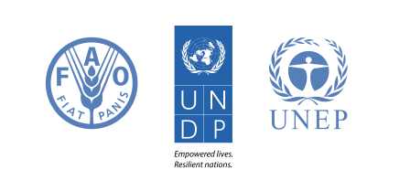
Contents
1. Introduction 1
2. What is the UN-REDD Spatial Decision Support Framework Tool 2
2.1 Overview 2
2.2 Assumptions 3
2. Setup 1
2.1 Installing QGIS 2.14.x 1
2.2 Installing 3rd Party Plugins 1
2.3 Installing the UN-REDD Global REDD+ Spatial Decision Support Tool 3
4. Step-by-step Instructions for running the Tool 5
4.1 STEP 1: Reading the help document 5
4.2 STEP 2: Prepare analysis SnapRaster and VectorResultsGrid 7
4.3 STEP 3: Define area for driver of landcover change and REDD+Action response 8
4.4 STEP 4: Calculate Potential Carbon savings under REDD+ scenario 9
4.5 STEP 5: Convert potential carbon savings to economic values 11
4.6 STEP 6: Subtract location specific costs from potential carbon savings under REDD+ Scenario 12
4.7 STEP 7: Add Economic Values to Vector summary grid 14
4.8 STEP 8: Calculate Summary Statistics of Economic Values 15
4.9 STEP 9: Create Overlays with additional benefits 17
4.10 STEP 10: Sum additional benefits to create combined 18
4.11 STEP 12: Calculate Summary Statistics of Economic Values with multiple benefits 19

1. Introduction

REDD+ is a voluntary climate change mitigation approach that has been developed by Parties to the UNFCCC. It aims to incentivize developing countries to reduce emissions from deforestation and forest degradation, conserve forest carbon stocks, sustainably manage forests and enhance forest carbon stocks. This will involve changing the ways in which forests are used and managed, and may require many different actions, such as protecting forests from fire or illegal logging, or rehabilitating degraded forest areas.

REDD+ has the potential to deliver multiple benefits beyond carbon. For example, it can promote biodiversity conservation and secure ecosystem services from forests such as water regulation, erosion control and non-timber forest products (NTFPs). Some of the potential benefits from REDD+, such as biodiversity conservation, can be enhanced through identifying areas where REDD+ actions might have the greatest impact using spatial analysis and other approaches.

The purpose of this tutorial series is to help participants in technical working sessions, who are already skilled in GIS, to undertake analyses that are relevant to REDD+. The tutorials have been used to build capacity in a number of countries to produce datasets and maps relevant to their spatial planning for REDD+, and to develop such map products. Maps developed using these approaches appear in a number of publications whose aim is to support planning of strategy options that enhance biodiversity and ecosystem services as well as delivering climate change mitigation (see http://bit.ly/mbs-redd for country materials). There is of course no requirement for countries to use the approaches described in these tutorials.
This Spatial Decision Support Framework Tool is a flexible tool that has been developed in QGIS using Graphical Modeler and a third party plugin that adds workflow functionality to Processing. The graphical modeler allows you to create complex models using a simple and easy-to-use interface, whilst the workflow plugin allows you to string the processing tasks together and provide step-by-step instructions within the user interface.
This tutorial provides instructions on how to install and use the tool, as well as providing instructions on how to modify it so that it can be adapted to country specific purposes. It also provides example workflows to illustrate how to approach developing some of the required input layers.

2. What is the UN-REDD Spatial Decision Support Framework Tool

2.1 Overview
REDD+ has a clear role in the evolution towards a Green Economy, by increasing the value of standing forest. As such, countries implementing REDD+ may aim to maximize the financial gains to the economy whilst also securing bio-physically-derived socio-economic benefits (i.e. forest ecosystem services that support the livelihoods and well-being of both the local and national population).
To support decisions on where REDD+ actions could be undertaken, this tool has been developed to help GIS technicians undertake a series of analysis steps that will help to identify and prioritize land areas for potential inclusion in REDD+. It provides example workflows, which countries can easily build on and adapt to country specific purposes.
The tool requires a number of spatial datasets as inputs, which it does not generate itself. Often these datasets are likely to be already developed as part of REDD+ readiness (e.g. forest/landcover), and will be very specific to national circumstances. However, UN-REDD technical staff may be able to work with country teams to develop these pre-requisites if there are no existing plans to generate them.
Spatial inputs required are:-
- A ‘business as usual’ carbon layer for each driver and a REDD+ carbon layer for each associated REDD+ intervention (also known as REDD+ action, or REDD+ measure). (These should draw on existing scenarios describing the context for REDD+ actions, making use of the country reference scenario for emissions in the generation of the spatial layers). For a REDD+ action of restoration a different approach may be needed to develop the REDD+ carbon scenario to show potential carbon stocks if forest is generated over the course of n years.
- Viable areas for different REDD+ interventions in response to each driver (taking into account biophysical suitability and existing designations). A separate tutorial has been developed focusing on how to use spatial analysis workflows to help identify potential areas where a REDD+ intervention could be undertaken.
- Cost layers (using data on opportunity costs as well as implementation and transaction costs) associated with each driver and potential REDD+ action²
- Layers on additional benefits of forest retention, such as biodiversity and ecosystem services. Various tutorials have been developed to help with the generation of such layers³.
The tool will also:-
- Use a carbon price, which can be varied to explore different scenarios (for the REDD+ carbon scenario versus Business as Usual (BAU))
- Account for location specific costs
- Produce outputs that allow users to interactively select areas suitable for different REDD+ actions and explore which are the most ‘profitable’ when taking into account cost and additional benefits (note: profitable does not necessarily mean just in monetary terms)
- Allow users to see changes in potential financial gain when the choice of areas for inclusion is modified to protect or enhance the delivery of a range of additional benefits (note: it may be possible to attribute a monetary value to some but not all of these benefits)

2.2 Assumptions
It is not possible to include all the complexities of economic markets and the natural world within simple tools. We also cannot be certain about the value of all different variables (such as carbon price or crop yields) in the future. Therefore, in order to carry out assessments we need to make assumptions about how the world works and the likely value of certain variables. These assumptions can impact on the final results of the assessment so they need to be reviewed and considered before undertaking the assessment.

The main assumptions that are made within this tool are:

- How much people will pay for preventing carbon dioxide emission in the future. The value of carbon in the future is likely to have a large impact of the profitability of REDD+ actions so it can be useful to carry out the assessment with a range of prices to explore the impact of different carbon prices.
- That leakage will not occur. Leakage is where actions to prevent a driver in one location displace that drive to another location rather than stopping the emissions from that driver. If leakage occurs then the REDD+ action will not cause the same level of emissions reductions at the country level and so may not result in the same level of national REDD+ payments.
- The price of products that are driving deforestation and how these will change in the future. As the tool is designed to assess the potential costs and benefits of REDD+ within a small area, assumes that preventing a driver (such as rubber production) occurring within the area will not have an impact on the price of the product.
- The yield of different products that are driving deforestation.
- The tool assumes that there is a certain ‘discount rate’ for economic returns received in the future (i.e. to reflect the lower value that money has in the future compared with having it available now).

Default values are used in relation to the above assumptions including:
VARIABLE ASSUMPTIONS (An example for Cambodia taken from an example spreadsheet tool which generates non-spatial cost benefits analysis)
Economic values:
Discount rate | 5 | % | (suggested range 1% - 10%)
Carbon price | 5 | US$/t CO2 | (suggested range $3 - $30)

Alternative land uses:
Large-scale rice yield | 6 | t/ha
Small-scale rice yield | 2.5 | t/ha
Cassava yield | 11 | t/ha
Rubber yield (max at maturity) | 1,500 | kg/ha
Oil Palm price | 140 | US$/tonne
Cashew price | 1 | US$/kg
Rubber price | 3.5 | US$/kg
Rice price (plantation) | 400 | US$/tonne
Rice price (small scale) | 360 | US$/tonne
Pepper price | 390 | US$/tonne
Cassava price | 30 | US$/tonne
Charcoal price | 180 | US$/tonne
Standard timber price | 500 | US$/m3
Luxury timber price | 2,000 | US$/m3
Average size of land concession plantation | 30 | ha
Average size of small-scale farm | 5 | ha
For other potential default economic values see associated economics spreadsheet tool.

2. Setup

2.1 Installing QGIS 2.14.x

- The first step is to download and install QGIS version 2.14.x (the installer can be downloaded from http://www.qgis.com/). Check which installer you need:
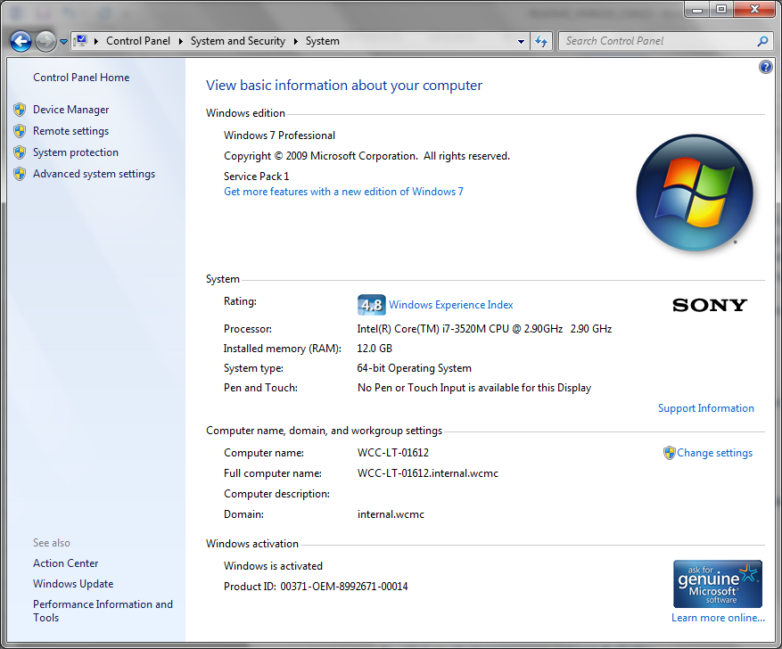
- QGIS standalone Installer Version 2.14 32 bit
or
- GIS standalone Installer Version 2.14 64 bit

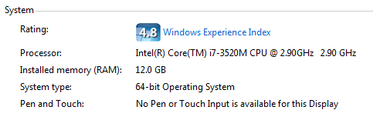
To find this information from the Start menu click on Computer then on the system properties tab)

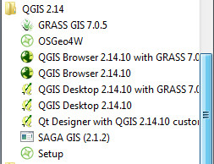

- Double click on the installer to install QGIS
- Once installed, open QGIS; from the Start menu click on All Programs>>QGIS 2.14 to open QGIS

2.2 Installing 3rd Party Plugins

The next step is to install 3rd party plugins. As well as the processing Workflows plugin which provide the graphical user interface functionality for the REDD+ spatial decision support tool, there are a number of other plugins that are useful. These are:
- Qnote - Save notes in QGIS projects
- GroupStats – A tool that provides statistics functions for vector data layers, similar to the pivot table function in Excel.
- Value Tool – a useful tool that displays in a table or plot the values from the visible raster layers at the current mouse position
To install the plugins:-
- Click on plugins>>manage and install plugins
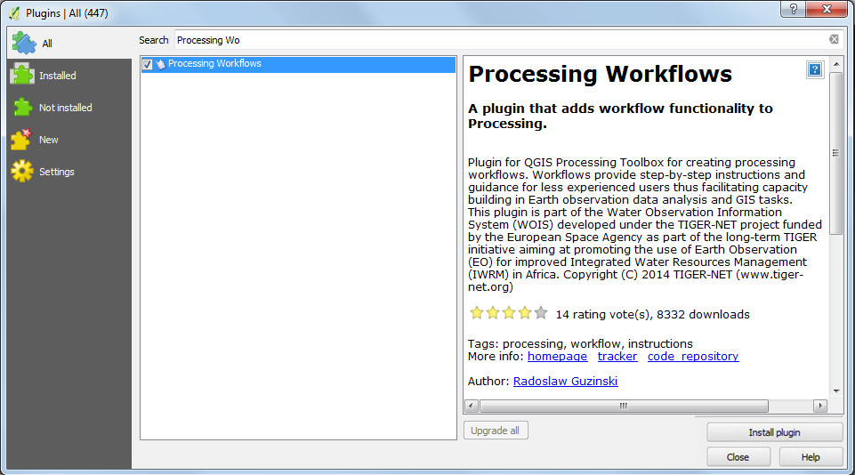
- In the search tab type processing workflow

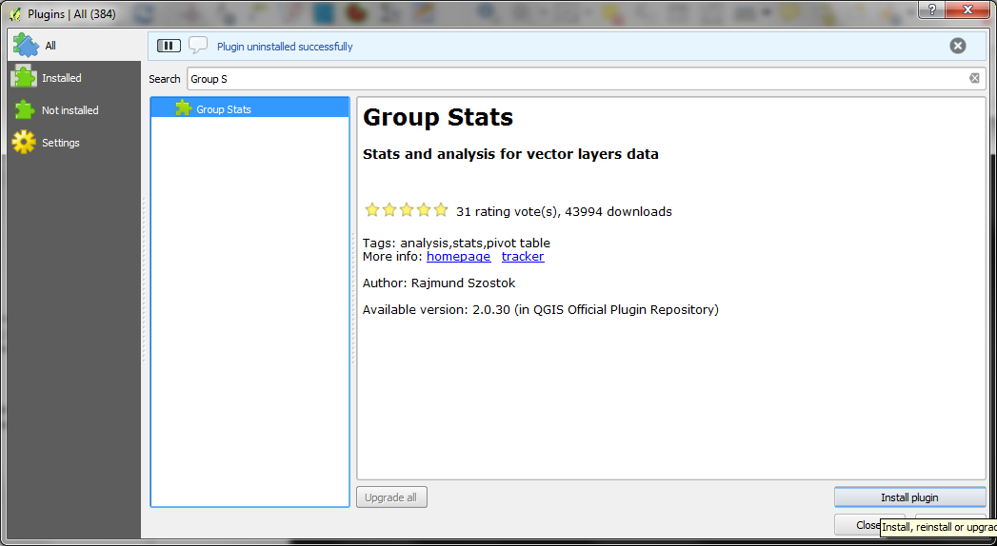
- Click on the plugin Processing Workflows plugin in the left hand panel and then on the install plugin button
- Search for Group Stats

- Click on the plugin Group Stats plugin in the left hand panel and then on the install plugin button
- Search for Value T

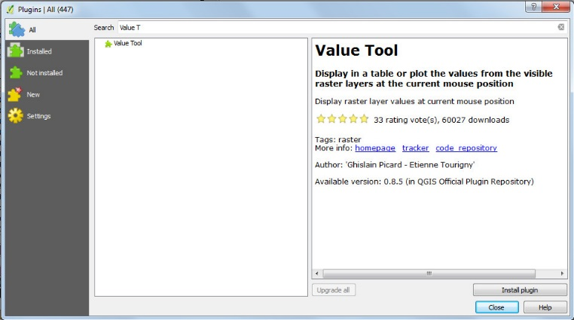
- Click on the plugin Value Tool plugin in the left hand panel and then on the install plugin buttons

- Close QGIS 2.8.2

2.3 Installing the UN-REDD Global REDD+ Spatial Decision Support Tool

- Download the zip file (UN-REDD_QGIS_Tools.zip) containing the UN-REDD Spatial Decision Support Framwork Tools the UN-REDD.net workspace http://bit.ly/GIStools-redd

- Unzip the file to a folder called UN-REDD_QGIS_Tools
- Go into the folder UNREDD_SP_Tool\QGIS_toolcomponents
- Copy the UNREDD_SP_Tool_Models folder to the C:\Users\corinnar*\.qgis2\processing\models folder
(*Note: replace ‘corinnar’ with your own username)
- copy UNREDD_workflows_for_spatialplanning.workflow to C:\Users\corinnar*\.qgis2\python\plugins\processing_workflow\workflows
- copy the UN-REDDWorkflowsForREDD+SpatialPlanningHelpDoc.html file to C:\Users\corinnar*\.qgis2\python\plugins\processing_workflow\workflows
(*Note: replace ‘corinnar’ with your own username)
- To run the tool with some example data (to help understand the tool)
  - copy the ToolDevelopmentData folder to a chosen folder on your computer

- Open QGIS 2.14.x
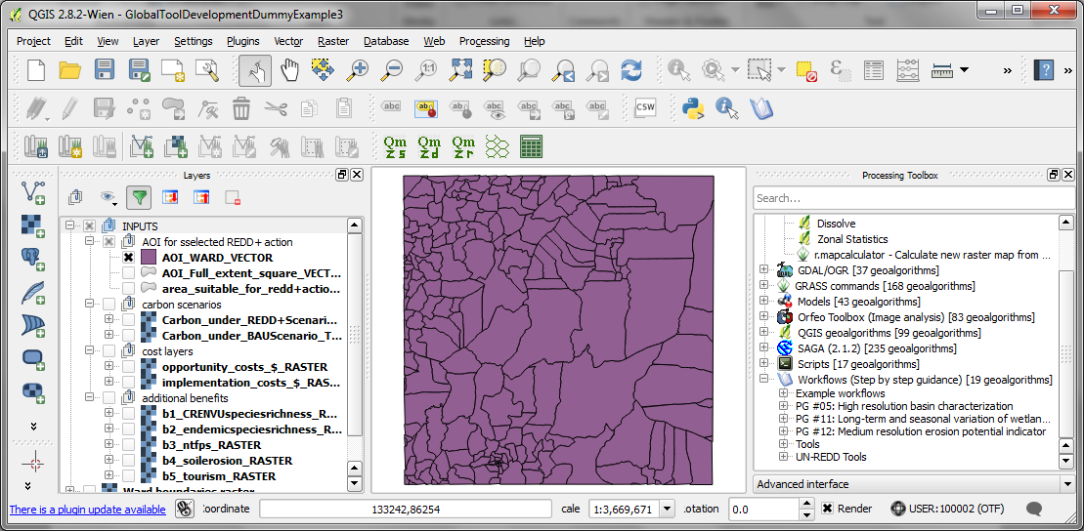
- Click on Project>>open to open the QGIS project called \ToolDevelopmentData\Example_Inputs\Example.qgs
- Click open
- If you can’t see the processing toolbox (it will be a right hand panel) click Processing>>Toolbox
- If it says Simple interface click here to change to Advanced
- To activate the processing workflows plugin click on Processing>>>options
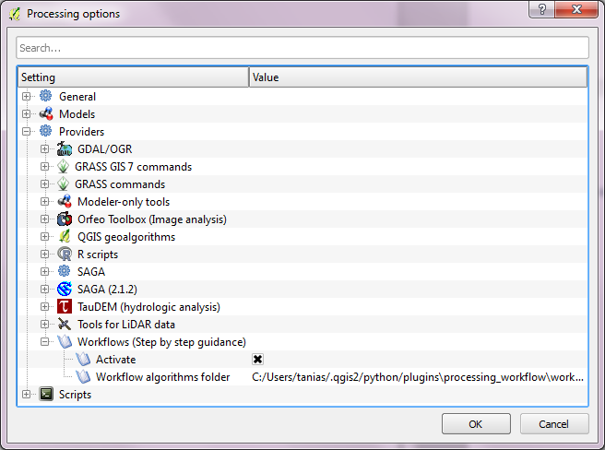
- Click on the + to expand Providers and the + to expand Workflows. Click to put a x in the Activate box

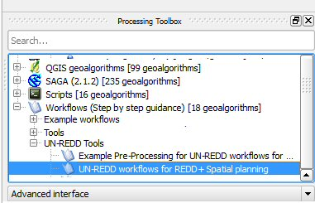
- In the processing Toolbox in click on Workflows and expand UN-REDD tools

or click on the icon in the QGIS tool panel

- Double click on UN-REDD workflows for REDD+ Spatial planning to run the tool.
- Follow the instructions on each screen to run the workflows

4. Step-by-step Instructions for running the Tool

4.1 STEP 1: Reading the help document
This first step simply presents the user with an introduction to the tool and advises the user to read the tool help document that appears when the user presses run. The help document contains the same information that is presented in this tutorial.
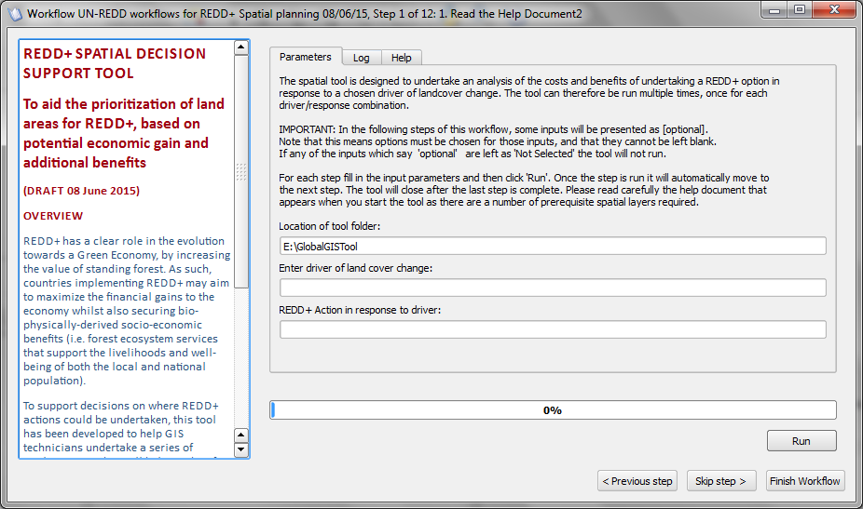

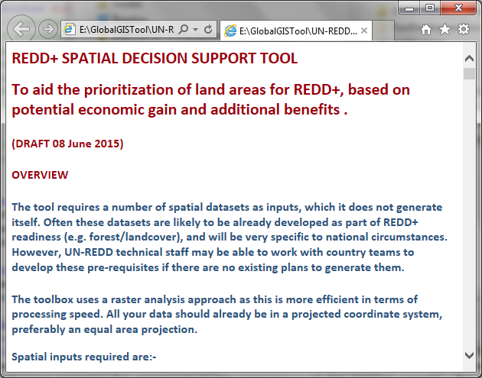
- Check the drive and path to the Tool folder is correct.
- Enter a Driver and REDD+ Action in reponse to the driver
- Click Run to start the Tool and run the 1st step
- The help document will open in a web browser. Once you have read the help document, return to the REDD+ spatial decision support tool. The tool will have automatically moved to the next step

Left hand panel text:
(same as text in section 3.1 above –1st + 2nd paragraphs )

Right Hand Panel Tool text:

The spatial tool is designed to undertake an analysis of the costs and benefits of undertaking a specific REDD+ option in response to a chosen driver of landcover change. The tool can therefore be run multiple times, once for each driver/response combination.

IMPORTANT: In the following steps of this workflow, some inputs will be presented as [optional].
Note that this means options must be chosen for those inputs, and that they cannot be left blank.
If any of the inputs which say 'optional' are left as 'Not Selected' the tool will not run.

For each step fill in the input parameters and then click 'Run'. Once the step is run it will automatically move to the next step. The tool will close after the last step is complete. Please read carefully the help document that appears when you start the tool as there are a number of prerequisite spatial layers required.

Location of tool folder:

E:\GlobalGISTool

(folder on the USB stick, ensure the drive and path are correct)

Enter driver of land cover change:
Land concession: Rice
Land concession: Rubber
Land concession: Oil palm
Land concession: Cashew nuts
Luxury timber logging
Standard timber clear-felling
Small-scale use: Rice
Small-scale use: Charcoal
Small-scale use: Pepper
Small-scale use: Cassava

REDD+ Action in response to driver:
PA management
Community forest
Forest restoration
Sustainable forestry
Reforestation afforestation

4.2 STEP 2: Prepare analysis SnapRaster and VectorResultsGrid
This step sets up the analysis environment. The data should have all been projected to a chosen equal area projection before running the tool. This step creates a raster called SnapRaster which will be used to prevent misalignment of cells throughout the analysis. An equivalent VectorGrid is created which contains unique id’s for each grid cell and will be used to attach results to later in the analysis.

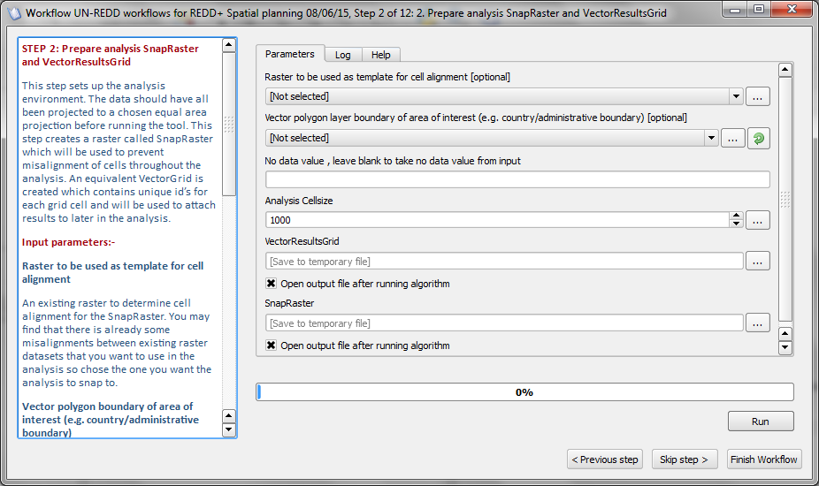

  - Fill in the input and output parameters (right hand panel). The left hand panel provides a description of what is required for each of the parameters.

Input parameters:-
Raster to be used as template for cell alignment
An existing raster to determine cell alignment for the SnapRaster. You may find that there is already some misalignments between existing raster datasets that you want to use in the analysis so chose the one you want the analysis to snap to.
Vector polygon boundary of area of interest (e.g. country/administrative boundary)
This will be used to set the extent (bounding box) for the analysis
No data value, leave blank to take no data value from input
This should be left blank
Analysis cellsize
Choose an appropriate size for the analysis. The default value is 1000m but can be changed by the user*.

Outputs:-
VectorResultsGrid
This is a new output vector grid to which results will be attached in later steps.
SnapRaster
Name the new output raster 'SnapRaster' to be used in all subsequent steps to ensure cell alignment.
*Note: When considering which raster dataset to use for cell alignment it is also important to understand that the degree of cell alignment will also depend on the cellsize the user chooses for the analysis. If the cellsize matches or is a whole integer division of the template raster the cells will fully align, e.g. a template raster with a cellsize of 500 and an analysis cellsize of 1000m. However if the cellsize of the template raster is 450m and the analysis cellsize is 1000m, then the cells will start aligned in the bottom left hand corner but as you move across the raster it will gradually become more misaligned.
  - Click Run to run the 2nd step

Once the step is run the outputs will appear in the QGIS project and the tool will automatically moved to the next step

4.3 STEP 3: Define area for driver of landcover change and REDD+Action response
This step requires a pre-prepared vector layer defining the area suitable for a chosen REDD+ action in response to a particular driver. The pre-prepared layer should include only those areas at risk from the chosen driver and where the chosen REDD+ action could potentially be undertaken. The user adds this pre-prepared layer to QGIS and the tool converts it to a Raster layer to be used in the subsequent analysis steps.
Note: If the REDD+ action layer is already in raster format this step can be skipped, but make sure the raster has the same resolution, projection and cell alignment as your SnapRaster.
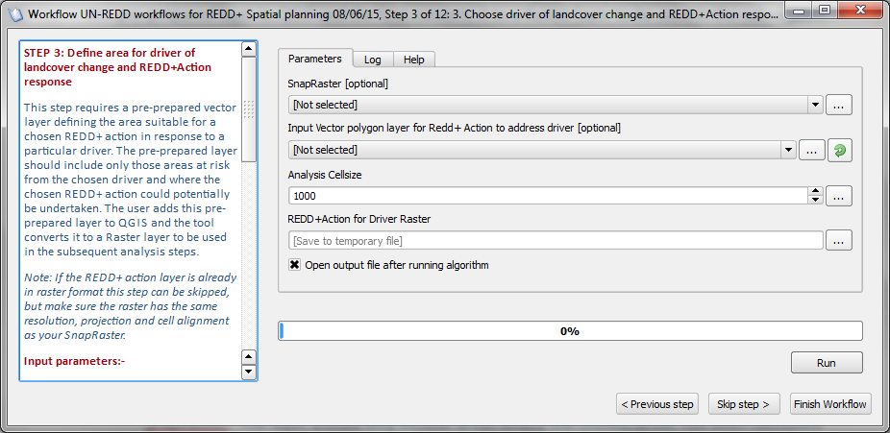
  - Fill in the input and output parameters (right hand panel). The left hand panel provides a description of what is required for each of the parameters.
Input parameters:-
SnapRaster
Pick up the SnapRaster you created in Step 2
Input vector polygon layer for REDD+ action to address driver
The tool can only be run for one REDD+ action for one driver at a time.
The input layer should be a pre-processed vector layer in the same projection as the SnapRaster. The layer should only include areas where the chosen driver has been identified as a potential driver of landcover change and exclude areas where the chosen REDD+ action would not be a suitable option. For example, if the REDD+ action was “Protected Areas Management” and the chosen driver “Rubber plantations” , the REDD+ Action AOI (Area of interest) layer might be current areas of natural forest within the existing protected area network, and which are within or adjacent to areas where there is an intent to expand rubber in a BAU scenario.
Analysis cellsize
Chose the same size that you entered in Step 2. The default value is 1000 m but can be changed by the user.
Outputs:-
Redd+ Action AOI for Driver Raster
Name of the new output raster layer defining the Area of Interest (AOI) for the REDD+ action

  - Click Run to run the 3rd step

Once the step is run the outputs will appear in the QGIS project and the tool will automatically moved to the next step

4.4 STEP 4: Calculate Potential Carbon savings under REDD+ scenario
The next step is to calculate the potential carbon saving under a REDD+ scenario for the chosen REDD+ action in response to the driver, compared to the BAU scenario for that driver, running over a chosen time period (e.g. 25 years). This tool relies on two pre-prepared raster datasets, the REDD+ scenario and the BAU scenario containing carbon values in tonnes/ha. This step makes a simple calculation (REDD+ scenario - BAU scenario). The results have the same units as the input datasets carbon in tonnes/ha.
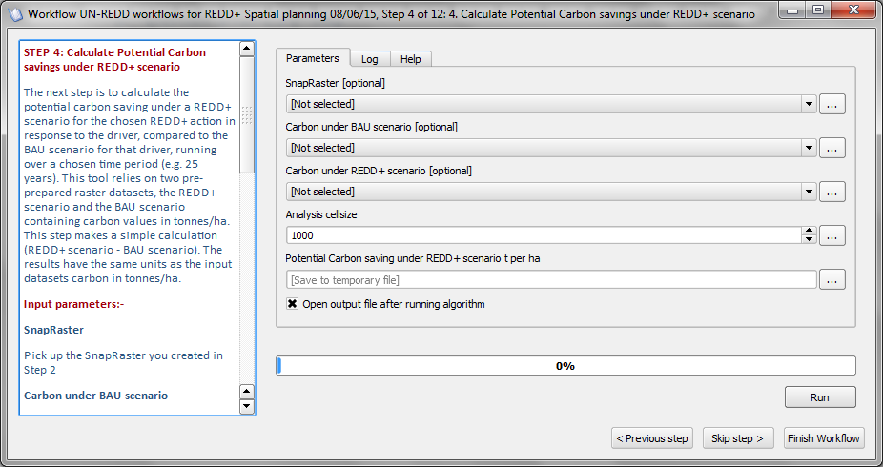
  - Fill in the input and output parameters (right hand pael). The left hand panel provides a description of what is required for each of the parameters.

Input parameters:-
SnapRaster
Pick up the SnapRaster you created in Step 2
Carbon under BAU scenario
Select the pre-prepared carbon raster representing BAU scenario for the chosen driver*
Carbon under REDD+ scenario
Select the pre-prepared carbon raster representing REDD+ scenario for the chosen driver and action response**
Analysis cellsize
Chose the same size that you entered in Step 2. The default value is 1000 m but can be changed by the user.
Outputs:-
Potential Carbon saving under REDD+ scenario t per ha
New output raster dataset for potential carbon savings under REDD+ scenario for the chosen REDD+ action to address the driver (tonnes/ha).

*Note: To generate a basic layer for the BAU scenario, values of carbon content of landcover following conversion could be applied to areas identified at risk from the particular driver (applying the average over 25 years, including clearing at end of crop cycle).
**Note: To generate a basic layer for the REDD+ scenario (in relation to a specified REDD+ action in response to a specified driver), information on the current carbon content (i.e. of the forest) can be combined with information on how effective the the REDD+ option may be in protecting or restoring the forest (over 25 year) (e.g. nearly completely effective for protected areas, a small decrease in carbon content for sustainable forest management or potentially an increase in carbon content for restoration).

  - Click Run to run the 4th step

Once the step is run the outputs will appear in the QGIS project and the tool will automatically move to the next step

4.5 STEP 5: Convert potential carbon savings to economic values
The next step is to convert the potential carbon saving under a REDD+ scenario to dollar values. We need to convert carbon to carbon dioxide emissions, and then times this by price for avoided carbon dioxide emissions.
The formula is as follows: [Carbon savings raster in tonnes/ha] * [Emissions factor to convert tonnes to CO₂E which is 3.667] * [dollar value for carbon payments per tonne CO₂e]. The result is a new raster dataset with dollar values per ha for each grid cell.
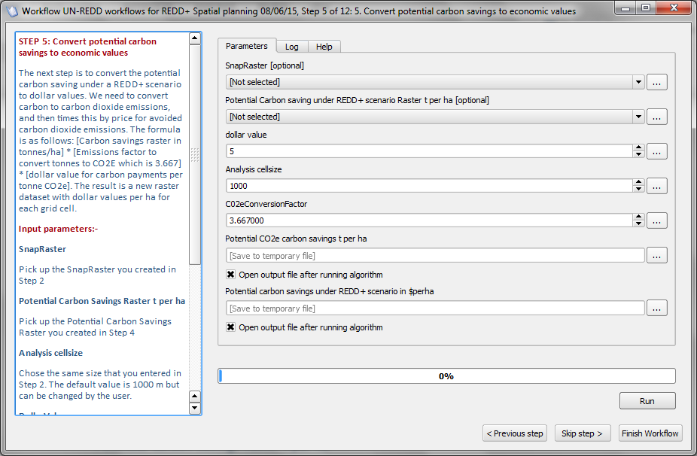

  - Fill in the input and output parameters (right hand panel). The left hand panel provides a description of what is required for each of the parameters.

Input parameters:-
SnapRaster
Pick up the SnapRaster you created in Step 2
Potential Carbon Savings Raster t per ha
Pick up the Potential Carbon Savings Raster you created in Step 4
Dollar Value
Set an appropriate realistic value for carbon payments per tonne CO₂e
Analysis cellsize
Chose the same size that you entered in Step 2. The default value is 1000 m but can be changed by the user.
CO2e Conversion factor
Set as the default value of 3.667
Outputs:-
Potential CO2e carbon savings t per ha
New output raster dataset for Co2e savings under REDD+ scenario (t/ha)

Potential carbon savings under REDD+ scenario in $perha
New output raster dataset for carbon savings under REDD+ scenario ($/ha)

  - Click Run to run the 5th step

Once the step is run the outputs will appear in the QGIS project and the tool will automatically move to the next step

4.6 STEP 6: Subtract location specific costs from potential carbon savings under REDD+ Scenario
Now that the potential carbon saving under a REDD+ scenario has been converted to $/ha values other location specific costs need be taken into account. The tool requires that calculations have been made for these costs over the time period, i.e. Net Present Value (NPV) in US$ per hectare for the total opportunity cost of not adopting this land use over the next 25 years, discounted back to a current value (minus the input costs required to undertake that activity).
This tool relies on two pre-prepared costs raster datasets: 1) opportunity costs (which has already had the input costs subtracted); and 2) implementation costs. The formula is “Potential Carbon Savings raster layer” – “Opportunity Cost Raster Layer” – “Implementation Costs Raster layer”. The final output is a raster dataset of economic gains and losses.
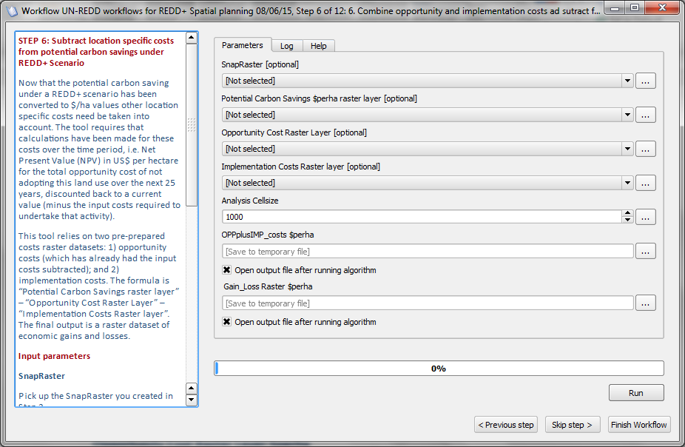
  - Fill in the input and output parameters (right hand panel). The left hand panel provides a description of what is required for each of the parameters.

Input parameters:-
SnapRaster
Pick up the SnapRaster you created in Step 2
Potential Carbon Savings raster layer $perha
This is the Potential Carbon layer in $/ha created in the previous step.
Opportunity Cost Raster Layer $perha
This should be an opportunity costs (which has already had the input costs subtracted containing values in $/ha.
Implementation Costs Raster layer $perha
This should be an implementation costs raster layer containing values in $/ha.
Analysis cellsize
Chose the same size that you entered in Step 2. The default value is 1000 m but can be changed by the user.
Outputs:-
OPPplusIMP_Costs $perha
New output raster dataset for combined opportunity costs (minus input costs) and implementation costs ($/ha)
Gain_Loss Raster
New output raster dataset for economic gains and losses under REDD+ scenario ($/ha)

  - Click Run to run the 6th step

Once the step is run the outputs will appear in the QGIS project and the tool will automatically move to the next step

4.7 STEP 7: Add Economic Values to Vector summary grid
The economic calculations can now be added to the vector summary grid that was created in step 2. This will allow users to more easily interactively query the results of the analysis once all the steps are complete.
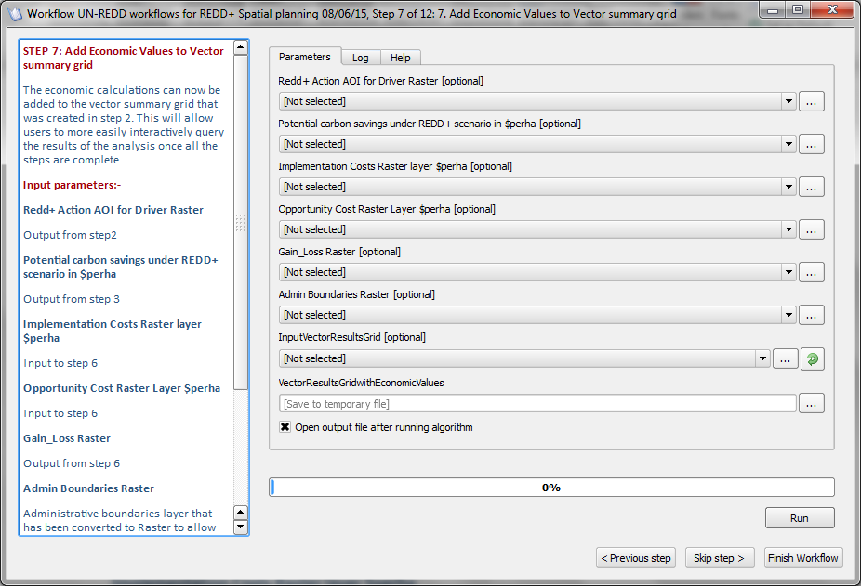
  - Fill in the input and output parameters (right hand panel). The left hand panel provides a description of what is required for each of the parameters.

Input parameters:-
Redd+ Action AOI for Driver Raster
Output from step 2
Potential carbon savings under REDD+ scenario in $perha
Output from step 3
Implementation Costs Raster layer $perha
Input to step 6
Opportunity Cost Raster Layer $perha
Input to step 6
Gain_Loss Raster
Output from step 6
Admin Boundaries Raster
Administrative boundaries layer that has been converted to Raster to allow summaries at the administrative unit level as well as at the pixel (cell) level.
InputVectorResultsGrid
Output from step1
Outputs:-
VectorResultsGridwithEconomicValues
New vector summary grid containing the economic values
  - Click Run to run the 7th step

Once the step is run the outputs will appear in the QGIS project and the tool will automatically move to the next step

4.8 STEP 8: Calculate Summary Statistics of Economic Values

Some basic statistics are calculated for areas identified as ‘profitable’ (i.e. by selecting any areas not making a loss under the REDD+ scenario).
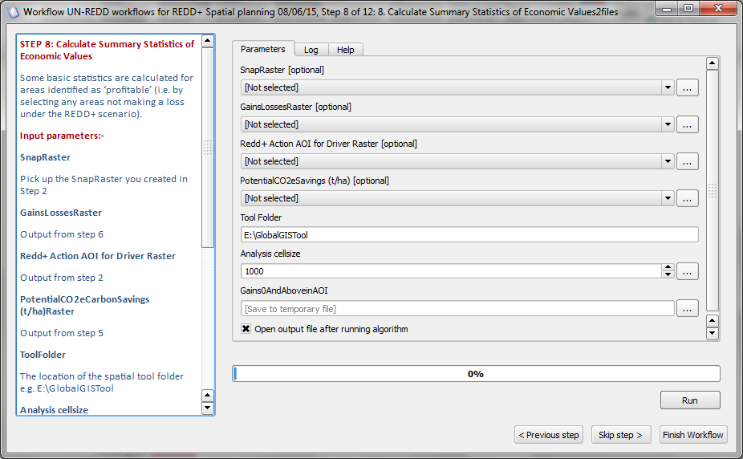

  - Fill in the input and output parameters (right hand panel). The left hand panel provides a description of what is required for each of the parameters.

Input parameters:-
SnapRaster
Pick up the SnapRaster you created in Step 2
GainsLossesRaster
Output from step 6
Redd+ Action AOI for Driver Raster
Output from step2
Analysis cellsize
Chose the same size that you entered in Step 2. The default value is 1000 m but can be changed by the user.
Outputs:-
Gains0AndAboveinAOI
New Raster dataset containing only those areas not making a loss under the REDD scenario
Summary Statistics of Economic Values CSV
New CSV file containing summary statistics of total area where the specified REDD+ action may provide a positive economic return and the potential carbon savings and economic returns in these areas. The results will also appear on the screen.
  - Click Run to run the 8th step

Once the step is run the summary statistics will be displayed in the QGIS project and the tool will automatically move to the next step

SUMMARY OF ANALYSIS RESULTS
-------------------------------------------------------------------
DRIVER OF LAND COVER CHANGE : xxxxxxxxxxxxxxxxxxxxxxxxxxxxxxxxxx
CHOSEN REDD+ ACTION IN RESPONSE : xxxxxxxxxxxxxxxxxxxxxxxxx

In areas where this REDD+ action may provide a positive economic return in response to the driver (over the whole 25 year period):-

Total area : xxx,xxx ha
Average gains : xxx $/ha
Maximum total gains : $xxx,xxx,xxx

Total carbon savings : xx tonnes CO2/ha

Note: This does not mean you would definitely choose to undertake REDD+ in all of these areas or that you would never chose to undertake REDD+ where it is not profitable in that one location.
Analysis run: xx/xx/xx xx:xx:xx

4.9 STEP 9: Create Overlays with additional benefits
Additional benefits of forest retention such as biodiversity and ecosystem services can now be incorporated into the analysis. The additional benefits layers should be pre-prepared in raster format. In this step the layers are converted into Boolean (1-0) raster layers that identify where the benefit does and does not occur. This enables the number of overlapping additional benefits present at a particular location to be counted within the tool. For each layer the user must define the threshold above which the benefit is considered present. (Although it may be possible to attribute a monetary value to some but not all of these benefits, this has not currently been implemented in this version of the tool). This step is run in batch mode so that multiple benefits layers can be processed at once.
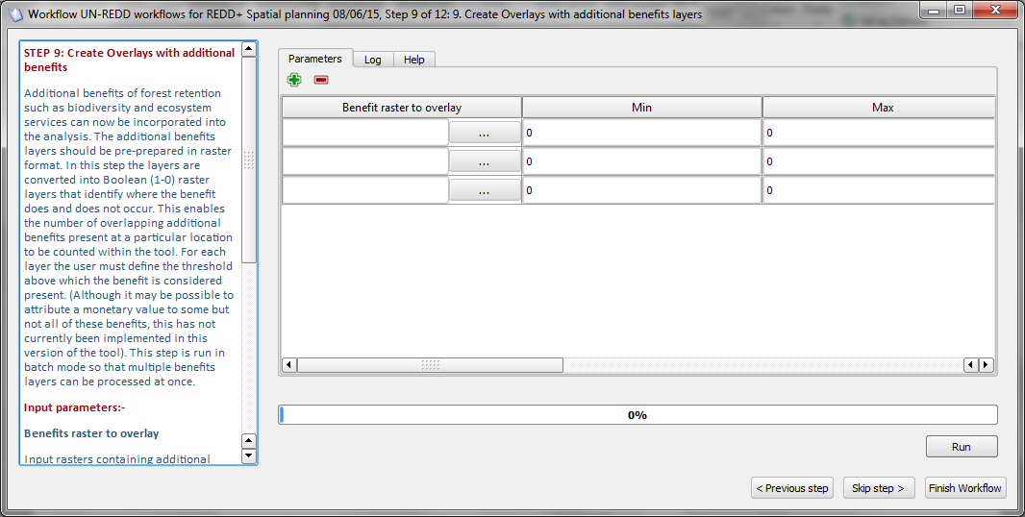
  - Fill in the input and output parameters (right hand panel). The left hand panel provides a description of what is required for each of the parameters.
Input parameters:-
Benefits raster to overlay
Input rasters containing additional benefits. In the current version of the tool no economic values are assigned to these. They will be used to indicate presence/absence of a particular benefit.
Min
Minimum value in the benefits layer used to define threshold for inclusion of the benefit
Max
Maximum value in the benefits layer used to define threshold for inclusion of the benefit
Outputs:-
Boolean benefits raster
Additional benefit layer where 1 represents presence and 0 represents absence of the benefit.

  - Click Run to run the 9th step

Once the step is run the summary statistics will be displayed in the QGIS project and the tool will automatically move to the next step

4.10 STEP 10: Sum additional benefits to create combined
This step sums the additional benefits layers created in step 9 to produce a raster layer which can indicate where there are 1 or more additional benefits in a location in addition to the other economic benefits.
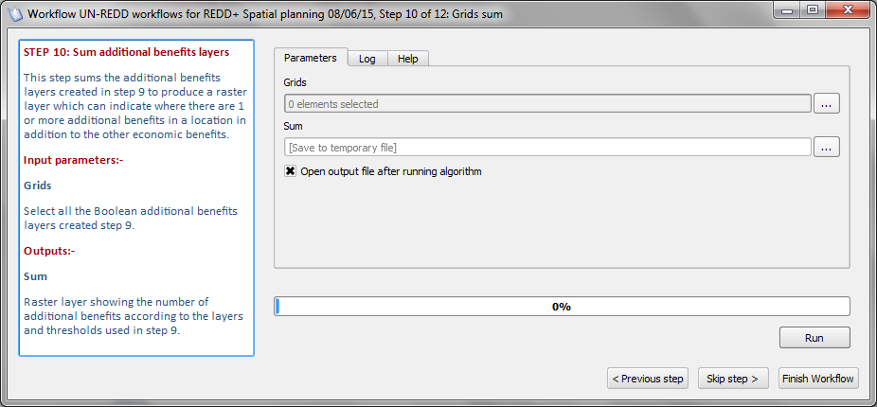

  - Fill in the input and output parameters (right hand panel). The left hand panel provides a description of what is required for each of the parameters.

Input parameters:-
Grids
Select all the Boolean additional benefits layers created step 9.
Outputs:-
Sum
Raster layer showing the number of additional benefits according to the layers and thresholds used in step 9.

  - Click Run to run the 10th step

Once the step is run the summary statistics will be displayed in the QGIS project and the tool will automatically move to the next step

4.11 STEP 11: Add Additional benefits to Vector summary grid

The additional benefits can now be added to the vector summary grid that contains the economic summaries created in step 7. This will allow users to more easily interactively query the results of the analysis once all the steps are complete.

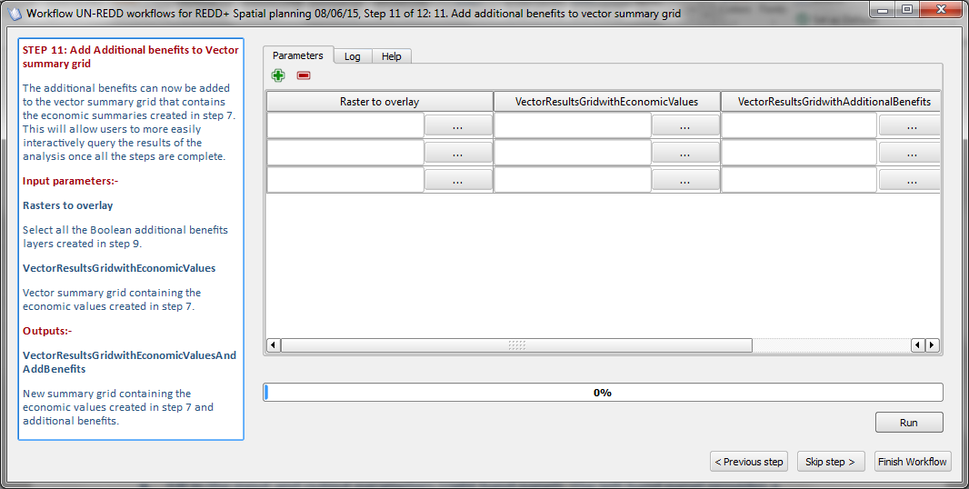
  - Fill in the input and output parameters (right hand panel). The left hand panel provides a description of what is required for each of the parameters.

Input parameters:-
Raster to overlay
Select all the Boolean additional benefits layers created in step 9.
VectorResultsGridwithEconomicValues
Vector summary grid containing the economic values created in step 7.
Outputs:-
VectorResultsGridwithAdditionalBenefits
New summary grid containing the economic values created in step 7 and additional benefits.

  - Click Run to run the 11th step

Once the step is run the summary statistics will be displayed in the QGIS project and the tool will automatically move to the next step

4.11 STEP 12: Calculate Summary Statistics of Economic Values with multiple benefits

Some basic statistics are calculated for areas identified as ‘profitable’ in step 8 (i.e. by selecting any areas not making a loss under the REDD+ scenario) and summarized based on the number of additional benefits.

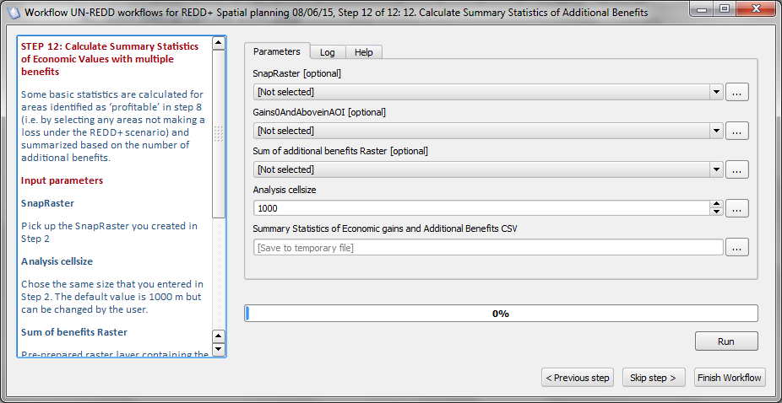

  - Fill in the input and output parameters (right hand panel). The left hand panel provides a description of what is required for each of the parameters.

Input parameters:-
SnapRaster
Pick up the SnapRaster you created in Step 2
Gains0AndAboveinAOI
Raster dataset containing only those areas not making a loss under the REDD scenario, from step 8.
Sum of additional benefits Raster
Raster containing the number of additional benefits created in step 10
Analysis cellsize
Chose the same size that you entered in Step 2. The default value is 1000 m but can be changed by the user.
Outputs:-
Summary Statistics of Economic gains and Additional Benefits CSV
New CSV file containing summary statistics of total area where the specified REDD+ action may provide a positive economic return and the potential carbon savings and economic returns in these areas as well as additional benefits. The results will also appear on the screen.

  - Click Run to run the last step

Once the step is run the summary statistics will be displayed in the QGIS project and the tool will automatically close

SUMMARY OF ANALYSIS RESULTS
-------------------------------------------------------------------
DRIVER OF LAND COVER CHANGE : xxxxxxxxxxxxxxxxxxxxxxxxxxxxxxxxxx
CHOSEN REDD+ ACTION IN RESPONSE : xxxxxxxxxxxxxxxxxxxxxxxxx
In areas where this REDD+ action may provide a positive economic return in response to the driver (over the whole 25 year period):-

Total area : xxx,xxx ha
Average gains : xxx $/ha
Maximum total gains : $xxx,xxx,xxx

Total carbon savings : xx tonnes CO2/ha

Average number of additional benefits: X

In areas where this REDD+ action may provide a positive economic return in response to the driver (over the whole 25 year period) and number of additional benefits > 3:-

Total area : xxx,xxx ha
Average gains : xxx $/ha
Maximum total gains : $xxx,xxx,xxx
Total carbon savings : xx tonnes CO2/ha

Note: This does not mean you would definitely choose to undertake REDD+ in all of these areas or that you would never chose to undertake REDD+ where it is not profitable in that one location.

Analysis run: xx/xx/xx xx:xx:xx

In areas where this REDD+ action may provide a positive or negative economic return in response to the driver (over the whole 25 year period) and number of additional benefits
>= 4:-

Total area : xxx,xxx ha
Average gains : xxx $/ha
Maximum total gains : $xxx,xxx,xxx
Total carbon savings : xx tonnes CO2/ha

Note: This does not mean you would definitely choose to undertake REDD+ in all of these areas or that you would never chose to undertake REDD+ where it is not profitable in that one location.

Analysis run: xx/xx/xx xx:xx:xx
Thank you for using the UN-REDD spatial decision support framework tool.
If you require further help in running or modifying the tool or wish to provide feedback.

Please contact Corinna.Ravilious@UNEP-WCMC.ORG
DRAFT jan2017

The plugin is part of the Water Observation Information System (WOIS) developed under the TIGER-NET project funded by the European Space Agency as part of the long-term TIGER initiative aiming at promoting the use of Earth Observation (EO) for improved Integrated Water Resources Management (IWRM) in Africa. Copyright (C) 2014 TIGER-NET (www.tiger-net.org)
Some example workflows are provided in the Annex 1 of this tutorial to illustrate how to approach developing some of the required input layers.
A list and descritption of additional tutorials to help with the generation of some of these layers is provided in Annex 2.
Guidance notes on how to interactively select areas suitable for different REDD+ actions and explore which are the most ‘profitable’ when taking into account cost and additional benefits are provided in Annex 3.

