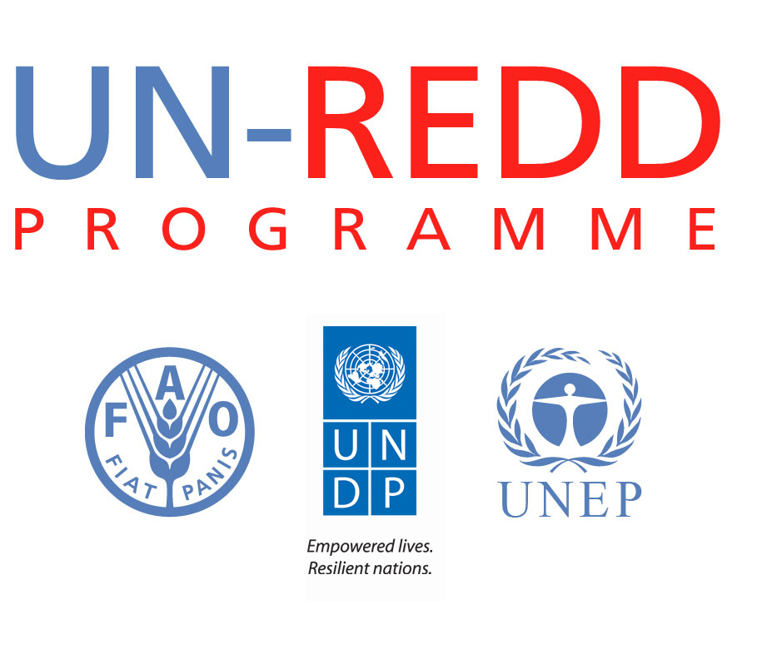
UN-REDD SEPC Workshop
February 8-9 2012
Geneva, Switzerland
Agenda

Day 1 - Wednesday 8 February

Session | Item
9.00-9.30 | Welcome, Participant introductions.  Meeting objectives and purpose
SESSION 1: Background, Consultation, Taking stock
9.30-10.30 | a) History, objectives of SEPC/BeRT  - History and objectives of the SEPC/BeRT  b) Current version overview  - Presentation of current version of the SEPC/BeRT: description of structure/overview of content  c) Overview of comments received in the recent consultation  - Presentation of comments: content & application  Questions & discussion
10.30-11.00 | Tea break
11.00- 11.30 | Taking stock: Country needs and roles for SEPC/BeRT
SESSION 2: Addressing social and environmental issues in the design, implementation and review of UN-REDD programmes
11.30-12.30 | a) Brief introduction on UN-REDD National Programme cycle and possible role of SEPC/BeRT  b) Possible roles of SEPC in the National UN REDD Programme cycle: Country experiences  c) Exploring relationships with other initiatives:  - REDD+SES  Comments and Questions
12.30-13.30 | Lunch
13.30-15.00 | c) Breakout Groups on possible roles of SEPC / BeRT in UN REDD National Programme cycle.
15.00 -15.30 | Tea Break
15.30-17.30 | Plenary: feedback on group work. Questions & Discussion  Wrap up

Day 2- Thursday 9 February

9.00-9.30 | Introduction to Day 2 & Feedback
SESSION 3: The role of the UN-REDD Programme and the SEPC/BeRT in supporting countries approaches to safeguards
9.30-10.30 | a) Experiences from countries in relation to country approaches to safeguards (panel)  Questions & discussion  b) The role of UN-REDD in supporting countries’ approaches to safeguards : questions and options (presentation)  Questions and discussion
10.30-11.00 | Tea break
11.00-12.00 | c) Breakout Groups on the role of UN-REDD in supporting country approaches to safeguards.
12-00-13.00 | d) Plenary: Reporting back from Break-out groups. Plus questions & discussion
13.00-14.00 | Lunch
Session 4: Seeking input on specific aspects of the SEPC/BeRT content that emerged in the consultations
14.00-14.15 | a) Quick overview of content-related challenges that emerged in the consultations
14.15-15.15 | b) Breakout session : discussing social and environmental principles  - Input on how to resolve challenges
15.15-16.00 | c) Plenary : feedback from 2 groups.
16.00-16.30 | Tea break
16.30-17.30 | Wrap up: final comments, summing up & next steps.  Proposed actions following the workshop.

