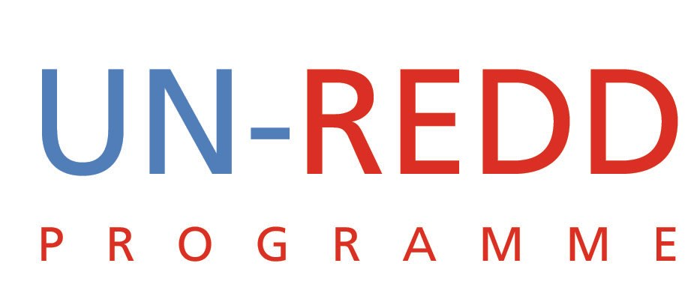 | UN-REDD/PB3/7

Harmonization of Readiness Components
UN-REDD PROGRAMME
Note by the Secretariat
October 2009

Background
An update on the harmonization between the UN-REDD Programme and the FCPF on support to national REDD readiness processes was provided to the second Policy Board meeting (PB2), Montreux, Switzerland, 14-15 June 2009. In the same week, a revised R-PP format was presented to the FCPF Participants Committee.
While the efforts to establish commonly agreed components of readiness was welcomed, the explanation of how the components fit with the National Programme was perceived to be unclear.
As set out in the Report of the second Policy Board meeting (available in English, French and Spanish at www.un-redd.org/PolicyBoard/2ndPolicyBoard/tabid/603/language/en-US/Default.aspx), the Policy Board requested the process of harmonization to continue with the FCPF on the components of readiness.
On 23rd September 2009, the United Nations Secretary-General Ban Ki-moon convened leaders and dignitaries from developed and developing countries to dialogue and publicly support REDD. The event marked the largest gathering of Heads of State and Heads of Government to date on the issue of REDD. A call was heard at the event for greater coordination between the UN-REDD Programme and the FCPF (and the Forest Investment Programme - FIP) to increase efficiency and reduce costs.
UN-REDD Programme - FCPF Readiness Partnership
The UN-REDD Programme – FCPF readiness partnership is already advanced, building from the technical cooperation note agreed in 2008. Since then numerous joint missions have been undertaken to REDD countries and more continue to be planned. Joint presentations and discussions have been taken place at a variety of international fora and further jointly hosted learning events are planned for Forest Day 3, Copenhagen in December. In addition, there is good cooperation on developing guidance for issues such as MRV and stakeholder engagement.
On 28th September 2009, representatives of the UN-REDD Programme met with members of the FCPF’s Facility Management Team (FMT) and the FIP to discuss further harmonization efforts. A number of additional partnership elements were discussed.
Consistent Readiness Components
Recognizing the level of substantive agreement on the components of the readiness process and the joint cooperation between the UN-REDD Programme and the FMT in developing the R-PP format, it was agreed to adopt the R-PP structure as the joint and common framework of readiness for the two initiatives. This will allow for direct and easy cross-referencing of the contributions the two initiatives make to national readiness processes.
The first four components of the R-PP will be reflected in the Results Framework of future UN-REDD National Programmes. Figure 1 sets out these agreed harmonized framework of readiness. The remaining two components of the R-PP (workplan/budget and monitoring/evaluation) correspond directly to existing sections of the National Programme document.
Where possible, the agreed framework of readiness will be reflected in the UN-REDD National Programmes still to be submitted to the Policy Board for funding approval.
The Annotated National Programme Document template has been updated and is now available on the UN-REDD Programme workspace. It reflects the agreed components of readiness in the Results Framework and sets out how the UN-REDD National Programme document cross-references to the R-PP template.
For National Programmes already approved or finalized, the country pages on the UN-REDD workspace are currently being revised to reflect the existing information in the harmonized framework. Policy Board workspace members can see more at www.unredd.net, under Programme Countries.
Figure 1: Agreed UN-REDD/FCPF Framework of Readiness
Coordination of Country Support
The FMT has approached the UN-REDD Programme regarding the possibility of transferring some R-PP grants to the UN-REDD Programme – when so requested by country governments.
A number of circumstances could lead to such a request:
- Countries that are members of both the UN-REDD Programme and FCPF wishing to increase efficiency and reduce transaction costs
- Countries where, for whatever reason, the World Bank is not active in the relevant sector(s)
- Countries where, for whatever reason, the World Bank faces significant barriers to signing a Grant Agreement.
This demonstrates the utility of having two coordinated readiness initiatives. The possibility of integrating the FCPF preparatory grant of $200,000 for Viet Nam into the approved UN-REDD National Programme is being considered.
UN-REDD Programme Implementation Principles
The UN-REDD Programme principles will continue to apply to the harmonized readiness process. The aims of the UN-REDD Programme are:
- To assist developing countries ‘get ready’ to participate in a future REDD+ mechanism. By doing so, to build confidence in the establishment of such a mechanism
- To support the national REDD+ Readiness process and contribute to the development of one national REDD+ strategy
- To promote REDD+ financing as an opportunity for countries to develop low carbon growth, energy access, and adaptation strategies – and to place them at the heart of their national development plans
- To apply the Paris and Accra principles of country ownership and leadership in order to build confidence in the establishment of a REDD+ mechanism
- To be at the forefront of UN Agency joint programming, in terms of delivering truly coordinated and harmonized National Programmes that limit transaction costs for recipient countries and maximize delivery benefits. Efforts will be in accordance with the approaches developed and agreed by the UN Development Group (UNDG)
The Role of the UN-REDD National Programme Document
The UN-REDD ‘Quick Start’ National Programme Document serves two purposes:
- Sets out the UN-REDD Programme contribution to a national REDD+ readiness process. It specifies the strategy and expected results of the UN Agencies’ inputs.
- It is the vehicle through which the UN Agencies provide financial and technical support to achieve these results. As a consequence, the National Programme Document specifies the cooperation or assistance agreements that form the legal basis for the relationships between the Government and each of the participating UN organizations.
The UN-REDD Programme was established with the view that for “Quick Start” – which corresponds to what is now often referred to as “Initial Readiness” or “Phase 1” – barriers to entry should be kept as low as possible. Speed and the flexibility to respond to an evolving understanding of REDD+ readiness requirements were (and still are) considered important for this phase. Having one document that serves two purposes is therefore considered by the UN-REDD Programme as particularly appropriate for the “Quick Start” phase. It is estimated this could save up to 18 months in getting initial readiness funds to developing countries (see Annex 1).
It is important to keep in mind the dual purpose of the UN-REDD National Programme Document when making comparisons to the FCPF. The World Bank/FCPF process involves two documents each serving a singular purpose:
- R-PP: a document designed to assist a country prepare itself for reducing emissions from deforestation and forest degradation (REDD), in order to become “ready for REDD”. It provides a framework for taking stock of the national situation and setting out the work to be undertaken in a range of areas and funded from a variety of sources.
- Grant Agreement: legal agreement between the World Bank and client country for the areas of work to be supported by the FCPF readiness grant.
Therefore, the UN-REDD National Programme Document cannot be compared only with the R-PP. It must be compared with the R-PP plus the World Bank Grant Agreement. Consequently, there are some requirements of the UN-REDD National Programme Document that are additional to the R-PP. The basic structure of the document is consistent with the minimum requirements developed by the UNDG to ensure it is accepted as the legal basis for the relationships between the Government and each of the participating UN organizations.

Annex 1: Processing Times for Initial Readiness (Phase 1) Support

The UN Development Group (UNDG) unites the UN funds, programmes, agencies, departments, and offices that play a role in development. The group’s common objective is to deliver more coherent, effective and efficient support to countries seeking to attain internationally agreed development goals, including the Millennium Development Goals. See www.undg.org
Such as the Standard Basic Assistance Agreement for UNDP and other applicable agreements for other participating UN organizations.

