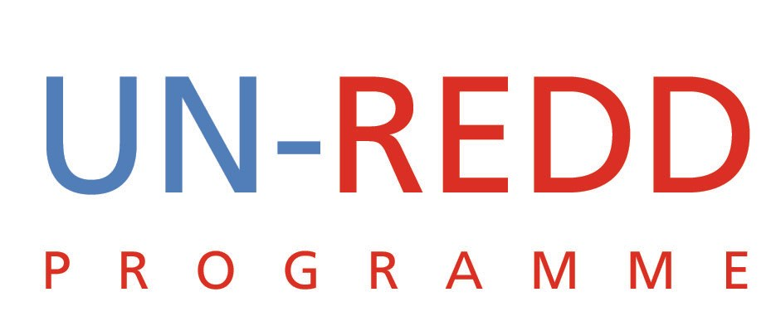 | UN-REDD/PB3/4

Requests to Join the UN-REDD Programme
UN-REDD PROGRAMME
October 2009

Introduction
In the past six months national representatives from nearly twenty countries have indicated a desire to join the UN-REDD Programme. Of these, the Programme has received formal requests to join from Argentina, Cambodia, Ecuador, Nepal and Sri Lanka.
Most of these requests indicate a growing awareness of the importance of REDD and the need to start putting readiness plans in place immediately. Some of the countries have been successful in mobilizing national financial resources to embark on their readiness plans and can bring this valuable experience to the Programme. These requests further point to an expanded role for the UN-REDD Programme in the future and its responsive approach in support of countries’ REDD readiness efforts.
Current UN-REDD Programme funds for the Quick Start national programmes (Readiness phase 1) have been fully committed to the initial nine participating countries. Additional funds will need to be secured in the UN-REDD Multi-Donor Trust Fund for any new countries. In the meantime, new countries can proactively participate in the UN-REDD Programme in a range of ways:
  - Become observer members of the Policy Board, subject to approval by the boards. This would enable them to observe all Policy Board Meetings until such time that additional funding has been mobilized. Regrettably countries would have to observe meetings at their own costs due to funding constraints.
  - Benefit from the UN-REDD Global Programme knowledge management activities to access, build and share knowledge on REDD, and more specifically:
  - Participate in regional and global workshops.
  - Become members of the UN-REDD Programme online collaborative workspace Community of Practice. The Workspace provides its members access to UN-REDD Programme documents, reports, technical notes and lessons learned, dedicated country pages to contribute updates on the progress of national REDD readiness, a large repository of REDD publications and papers, a daily news feed with the latest REDD news, progress on the activities of our partners, and the ability to network with a large community of REDD stakeholders.
New countries wishing to join the UN-REDD Programme are requested to submit a short form that is available on the www.un-redd.org website, or go directly to: www.unredd.net/index.php?option=com_docman&task=doc_download&gid=898%Itemid=53.
In response to this rapidly changing external environment and increasing demand for REDD readiness, the UN-REDD Programme has embarked on a strategic planning process that will include a fund raising strategy.

Decision sought
The Policy Board is asked to approve the following:
That Argentina, Cambodia, Ecuador, Nepal and Sri Lanka be granted membership to the UN-REDD Programme Policy Board with observer status. This will enable them to observe all Policy Board Meetings and participate in and benefit from global activities, until such time that additional funding has been mobilized.

