Stakeholder consultation workshop on REDD+ Roadmap in Taunggyi, Shan State
City Hall, Taunggyi
AGENDA
Opening Session | Opening Speech delivered by H.E. Sai Aung Myat, Chief Minister, Shan State
 | Key Note Presentation about REDD+ by Dr. Thaung Naing Oo, Deputy Director, Forest Department
Presentation Session | The REDD+ Readiness Roadmap Development Process  Roadmap Session 1: Management of REDD+ Readiness | Dr. Thaung Naing Oo  UN-REDD Programme Focal Point  Deputy Director, Forest Department
 | Roadmap Session 3: Development and selection of REDD+ Strategies | Dr. Rosy Ne Win, Staff Officer, Forest Department
 | Roadmap Section 2: Stakeholder Consultation and Participation  Roadmap Section 4: Implementation Framework and Safeguards | Mr. Nanda Win Aung, Staff Officer, Forest Department
 | DISCUSSIONS
Group discussion Session | Group Discussion (Two Groups)
 | Presentation of results of Group Discussion
CLOSING SESSION | Closing Speech by U Win Zaw, Director, Shan State, Forest Department

Introduction
With the support of the UN-REDD Programme Targeted Support, Forest Department organized two National Workshops and four Stakeholder Consultation Workshops in four State and Regions. The support aims to cover the extra cost of organizing the national consultation process. The objective of UN-REDD Targeted Support is to help in reviewing and validation Myanmar’s draft REDD - Plus Readiness Roadmap through a multi-stakeholder national consultation process.
Due to time constraints and the logical challenges linked to the start of the raising season, four (4) Regional Workshops were organized within two months (May – June 2013) as follow: -
- Bago Region at Bago on 30th May, 2013 attended (63) participants and opening address by Regional Minister of Mining and Forestry.
- Shan State at Taungyi on 5th June, 2013 attended (71) participants and opening address by Chief Minister of Shan State.
- Ayeyarwady Region at Bogalay on 11th June, 2013 attended (65) participants and opening address by Regional Minister of Mining and Forestry.
- Sagaing Region at Kather on 18th June, 2013 attended (71) participants and opening address by Regional Minister of Mining and Forestry.

OPENING SESSION: Opening Ceremony
The opening and welcome speech was delivered by H.E. U Sai Aung Myat, Chief Minister, Shan State. The Chief Minister expressed his appreciation to all participants from line Ministries, representatives from political parties, and representatives of parliament members, NGOs, civil societies, media, forest user groups, and local communities for participating this Regional Workshop. Excellency also thanks to the Forest Department for organizing Stakeholder consultation workshop in Shan State. In his speech, he emphasized on the contributions of forests to watershed conservation, biodiversity conservation, soil erosion control and economic development of the people. He also indicated that sustainability of Inlay Lake, which is the second largest inland lake and ASEAN heritage, is totally dependent on forests in the watershed areas of the Lake. He also reminded the experiences of prolong drought in Shan State in 2010 due to the climate change, which caused serious socio-economic impacts to the people. It is mainly due to the rapid rate of deforestation and forest degradation in the Shan State. Therefore, Excellency warmly welcomed REDD+ as an innovative approach for forest conservation and sustainable forest management. In conclusion, he congratulated the REDD+ roadmap technical working group for the successful formulation of REDD+ roadmap as well as for organizing stakeholder consultation workshops in States and Regions.
Key Note Presentation was made by Dr. Thaung Naing Oo, Deputy Director, Forest Department after the Opening Speech addressed by Regional Minister. Dr. Thaung Naing Oo briefly explained about the climate change and its impacts, the role of forests in mitigating climate change, background of REDD+, its objectives, concepts, mechanisms and elements of REDD+ framework. The purpose of this key note presentation was to make policy brief about REDD+ expecting to receive political supports for the implementation of REDD+ readiness activities.
The Regional Consultation Workshop was attended by (81) participants; Roadmap (draft) presented by Resource Persons and received initial feedback on the first draft of the Roadmap. List of participants can been seen in ANNEX 1.

PRESENTATION SESSION

Presentation session was Chaired by U Sai Aik Paung, Regional Minister for Ministry of Mining and Forestry, Shan State. There were three presentations in the Regional Consultation Workshop. The Roadmap is composed of 6 Sessions and detailed power point presentation files are attached in ANNEX 2. Due to the limited time, Session 5 REL/RL and Session 6 MRV were not presented. The following sessions of REDD+ Roadmap were presented:

No. | Presentation Topic | Resource Persons
1. | The REDD+ Readiness Roadmap Development Process  Roadmap Session 1: Management of REDD+ Readiness | Dr. Thaung Naing Oo  UN-REDD Programme Focal Point  Deputy Director, Forest Department
2 | Roadmap Session 3: Development and selection of REDD+ Strategies | Dr. Rosy Ne Win, Staff Officer, Forest Department
3 | Roadmap Section 2: Stakeholder Consultation and Participation  Roadmap Section 4: Implementation Framework and Safeguards | Mr. Nanda Win Aung, Staff Officer, Forest Department

At the end of the Presentation sessions, the floor was open for Q&A as well as for discussions. The followings are the major discussion points for the above mentioned presentations:

DISCUSSION SESSION
Questions and Answers
- Questions for Dr. Thaung Naing Oo

Q: How can carbon credit benefit to all different stakeholders such as private sector and local community? Will the law come up for different stakeholders?

A: Benefit sharing is an interesting part of REDD+. It cannot be understood fully at the moment but it should be mainly on performance based. There is a need to do research who has contributed to what extent. There is also a need to find out traditional practices and it can be varied depend on the regions. If policy is needed more there can have new one or if not revised policy is also possible. It is too early to say now but all those who take part in REDD+ should have benefits.

Q: Indigenous people’s culture is different in regions and if safeguards strategy can adapt to the different culture, it would be great.

A: Thanks for the advice. There are pilot experience in forest depart for supporting community social needs by providing school and establishing school garden program in Taungoo. In addition, agro forestry is also encouraged to replace shifting cultivation. There are example of a type of benefit sharing to communities.

Q: What kind of criteria do you use?
A: We have a set of criteria that we use such as places of high deforestation. We will also invite regional participants to confirm our road map in final national workshop.

- Questions for Dr. Rosy Nay Win

Q: Minister of Ethnic Minority: It is not enough with policy alone to control deforestation, it is important to take of the livelihoods of local communities. The very basic need is their food, clothing and housing. In other neighboring countries, every household can access to gas stove for cooking and there is no need to worry for energy need for cooking. Therefore, in order to conserve the forest, it is best to provide gas with proper price to local communities.

A: This is related to Ministry of Energy and they also came and took part in the road map process.

U Myint Hlaing mentioned that there are many institutions now discussing on energy issue of Myanmar such as ADB, WB, JICA, UN, MOEP and thus there will have upcoming plan on both grid expansion and promotion of renewable energy.

Discussion of Minster of Mining and Forestry said that the department has arrested illegal logging as much as they can. However, the areas where transportation is difficult and where there is no peach and security, illegal logging cannot be stopped since people from China can reach to those areas even to dig the whole trees including the roots. This should be handled at national level to come up with law enforcement and appropriate measures.

REDD+ can consider measure to stop illegal logging for national interest. We have shortage of technical skills on some occasions, however, we will try to get assistance on this and do our best of what we can.

Director of the Forest Department, Shan State expressed that we have to awareness of border market for illegal logging and thus in addition to arresting the smugglers; we have to find out ways to know the market in border areas of Thailand and China of our logs.

- Questions for U Nanda Win Aung

Comments: For effective participation, stakeholders should take part in system design and policy decision. For choosing representation as well, it would be better for self selection of communities rather than top down selection.

A: There is enough awareness and information given to REDD+ pilot communities. Not only forest department, but also the government will work together with NGOs for awareness raising. We will also make sure of self selection and communities’ volunteer to take part in REDD+ implementation.

Afternoon Session (1pm – 4 pm)
For afternoon session, groups discussion on Stakeholder Consultation and safeguards is led by Naw Ei Ei Min from 1 pm to 3pm. The suggestion for the three discussion points are as follow;
1. How can we ensure effective consultation and participation of 1) Women and 2) Ethnic Minority Groups?
- To give awareness to women to take part in REDD+. They are familiar to the forest and sometimes they can even give good ideas for the program.

- To study the culture of respective ethnic minority first before implementation of REDD+.

- Use of tradition saying or proverbs to do awareness will be good as well.

- Providing awareness and community mobilizing is also important.

- Provide alternative fuel such as A1 stove, electricity or gas is also important for housewife who has to rely on fuel wood for daily cooking.

- To give enough time for training, not only one day, may be up to 3 days for enough understanding.

- Even women and ethnic minorities are not educated; please find way to explain them well.

2.Who should be able to benefit from REDD+ ( Where does the money go) ?

- Those who depend on forest, local communities and relevant stakeholders should benefit from REDD+.

- There should have relevant policy on benefit sharing.

- Will there be benefits before carbon credit since the market will only start in 2020, how about for preparation and pilot stage??

- Those who will suffer from REDD+ implementation should also get benefits.

- Benefits should share among those who take part for implementation.

- There should also have benefit for the community own efforts for forest conservation practices.

3. What are the potential risks of REDD+ implementation in Myanmar?
- Since REDD+ is long term project, if there is no short term benefit, people will doubt about it.

- Communities sometimes are busy for farming, so it is important to give time such as visiting and meeting them at night time is needed.

- To study potential risks more in depth

- Wood and bamboo are needed for the development of the communities, so this can be resulted in conflict of interests over resources.

- There is a need to link national plan of holistic development or poverty reducing with REDD+ implementation for better management.

- To use bottom up approach to avoid risks.

- It is good to discuss, but what is important is to bring the comments and suggestion into real implementation.

- Without proper land use planning, it is difficult to get successful REDD+ implementation.

- If there is no trust building between government and local communities there is a risk for REDD+ implementation.

- The relationship between local communities and private sector should be at peace as well to avoid risk.

- Language can be a barrier.

- To have grievance mechanism in case of disputes.

After discussion there was a short tea break for 15 minutes and the closing ceremony follow until 4 pm. The minister of Forestry and Minning, U Sai Aik Paung give the closing remarks and the summary of the closing remarks is as follows;

CLOSING SESSION
The closing remark was addressed by U Sai Aik Paung, Regional Minister, Ministry of Mining and Forestry. In his Closing Speech, he expressed his sincere thanks to all participants for very active participation in consultation workshop. He also urged line ministries, NGOs, civil societies, FUG and local communities to participate forest conservation together with Forest Department. He stressed that strengthening law enforcement, combat illegal logging, scaling up reforestation and watershed conservation. Last but not least, he committed to implement all possible measures for forest conservation and sustainable forest management as well as REDD+ as an performance-based payment system.

ANNEX I
List of participants at Regional Consultation Workshop at Taunggyi, Shan State

Participants from Ministry of Environmental Conservation and Forestry
No. | Name | Position | ဌာန
1. | U Win Zaw | Director | Forest Department (Shan State)
2. | Dr.Thaung Naing Oo | Deputy Director | Forest Department, H.Q.
3. | U Khin Maung Cho | Deputy Director | Forest Department (Watershed Conservation Division)
4. | U Maung Maung Soe | Assistant Director | Forest Department (Taunggyi District)
5. | U Kyi Htun | Assistant Director | Forest Department (Inlay Lake Greening Project)
6. | U Khin Maung Sint | Assistant Director | Forest Department(Loinlin Township)
7. | U Kyaw Zin Ha | Manager | MTE
8. | U Soe Win Naing | Staff Officer | Forest Department (Taunggyi Township)
9. | U Tin Maung Win | Staff Officer | Forest Department (Naung Shwe Township)
10. | U Aung Thu | Staff Officer | Forest Department (Kalaw Township )
11. | U Win Myint(6) | Staff Officer | Forest Department (Yetsauk Township)
12. | U Paw Maung | Staff Officer | Forest Department (Sesi Township)
13. | U Nay Myo Win | Staff Officer | Forest Department (Loinlin Township )
14. | U Htun Nyunt Hlaing | Staff Officer | Forest Department (Taungyi Township)
15. | Dr.Rose Ney Win | Staff Officer | Forest Department
16. | U Zaw Zaw Naing | Staff Officer | Forest Department
17. | U Nandar Win Aung | Staff Officer | Forest Department
18. | U Zaw Naing | Staff Officer | Forest Department (Ywar Ngan Township)
19. | U Sein Htun | Administrator(Inlay) | Nature and Wildlife Conservation Department
20. | U Myint Thein | Range Officer | Forest Department (Naung Shwe Township)
21. | U Kyaw Kyaw Oo | Range Officer | Forest Department (Yetsauk Township)
22. | U Maung Maung Zin | Range Officer | Forest Department
23. | U Win Myint | Range Officer | Forest Department (Kalaw Township)
24. | U Pyae Phyo Maung | Range Officer | Forest Department. H. Q
25. | U Nay Lin Tun | Range Officer | Forest Department, H.Q
26. | U Myint Oo | Range Officer | Forest Department(Sesi Township)

Participants from line Ministries
No. | Name | Position | ဌာန
1. | U Naing Win | Region Minister for Ethnic Ministry | Ethnic Ministry, Shan State
2. | U That Htun | Chairman | Literature and Culture, Shan State
3. | U Soe Than | Member | Inlay Lake Water Purification Association
4. | Daw Khin San | Deputy Director | Department of Information and Public Relation
5. | U Sein Htay | Deputy Director | Department Of Higher Education (State)
6. | U Kyaw Soe | Staff Officer(State) | Department of Meteorology and Hydrology
7. | U Soe Yu Lwin | Deputy Staff Officer(State) | Department of Border Area Development
8. | U Kyaw Min Naung | Chief Engineer | Municipal (Shan State)
9. | U Kyaw Kyaw Oo | Assistant Engineer | Irrigation Department
10. | U Aung Myo Win | Assistant Engineer | Department of Electric Power
11. | U Tin Aung | Assistant Director | Planning Department (District)
12. | Dr. Lin Htay Oo | Group Leader Doctor | Department of Health (State)
13. | Dr. Aye San | Professor (Geology) | University Of Taungyi
14. | Dr. Aye Aye Win Kyi | Professor (Physiology) | University Of Taungyi
15. | Dr. Than Sein | Professor (Geology) | University Of Taungyi
16. | Dr. Nu Nu San | Professor (Zoology) | University Of Taungyi
17. | U L Bway Kar | Professor (History) | University Of Taungyi
18. | U Yu | Administrator | Taungpodgyi (Naungshwe)
19. | U Saw Lwin | Head of Village | Taungpodgyi (Naungshwe)
20. | U Win Naing | Administrator | Paung Pain (Naungshwe)
21. | U Win Naing | Head of Village | Paung Pain (Naungshwe)
22. | U Myo Htun | Head of Village | Lwenyein (Naungshwe)
23. | U Sat Swin Saing | Assistant Director | Agriculture Department
24. | U Thein Win | Assistant Director | Survey Department
25. | U Kyi Soe | Assistant Director | No(4)Hilly Field
26. | Daw Soe Soe Tun | Staff Officer | Department of Information and Public Relation (State)
27. | U Win Soe | Staff Officer | Agricultural Mechanizaton Development
28. | Dr.Than Htun Oo | Staff Officer | Department of Health
29. | U Win Swe | Deputy Staff Officer | Settlement and land Record Department
30. | U Moe Khaing Htun | Administrator | General Administrative Department
31. | U Zaw Myint Thein | Township Administrator | General Administrative Department (Taunggyi)
32. | U Kyaw Saw Hla | Township Administrator | General Administrative Department (Nyaung Shwe)
33. | U Aung Kyaing | District Administrator | General Administrative Department (Taunggyi)
34. | Dr.Nan Ne Ne Lin | Deputy Staff Officer | Liverstock Breeding and Veterinary Departmemt
35. | U That Naing Oo | Deputy Staff Officer | General Administrative Department (Pintaya)
36. | Daw Khin Mar Aye | Assistant Staff Officer | Department of Fisheries

Participants from NGOs, Civil Society, Political Party and Media
No. | Nane | Position | ဌာန
1. | U Saing Wunna | Chairman | Community Forestry (Ywar Ngan)
2. | U Taw Mi Aung | Chairman | Community Forestry (Kalaw)
3. | U San Tun | Chairman | Community Forestry (NaungShwe)
4. | U Chit Swe | Chairman | Community Forestry (Taungpodgyi)
5. | U Myint Zaw | Agroculturist | United Nations Development Programme (UNDP) (NaungShwe)
6. | U That Win Tun | Socio Economist | United Nations Development Programme -UNDP (NaungShwe)
7. | U Than Aung | Administrator | Pway Hla (village)
8. | Daw Tin Tin yi | Chairman | Inlay Hotel(NaungShwe)
9. | U Tin Aung Cho | Retired (UNDP) | Kyone village

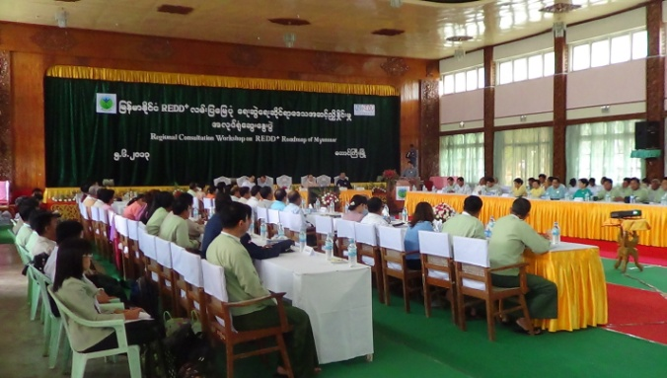
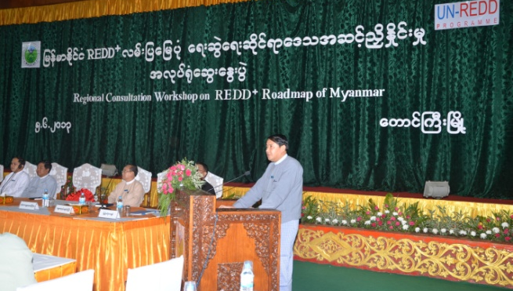
Opening Speech by H. E. U Sai Aung Myat, Chief Minister, Shan State
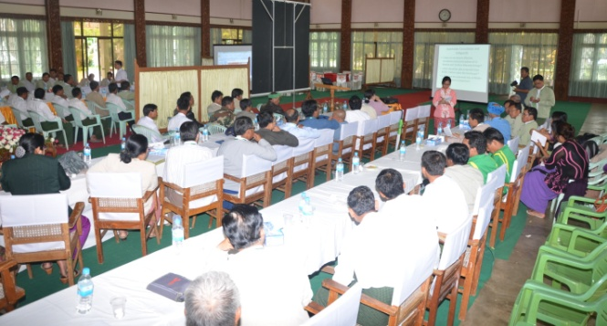
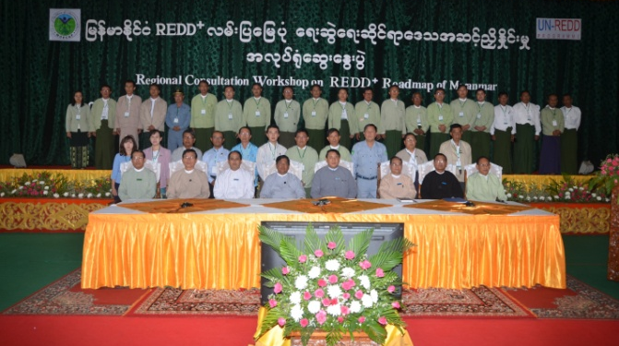
Group photo (left) and group discussion (right)

