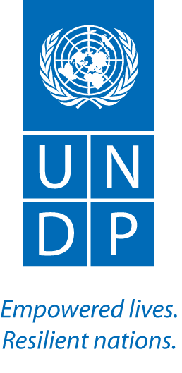
19 June 2012
Mr. Syed Mahmood Nasir
Inspector General of Forests, Ministry of Environment
Government of Pakistan
Subject: Request for UN-REDD Programme targeted support for national REDD+ readiness
I am writing in response to your request for Targeted Support “Developing Options for Addressing Social Impacts of REDD+”, received 20 March 2012. As you know, Targeted Support addresses specific technical and capacity needs of UN-REDD partner countries as part of the UN-REDD Programme’s “Support to National REDD+ Actions – Global Programme 2011-2015”. While your request is consistent with the programme, unfortunately we do not have sufficient funds this year to meet all requests. I am sorry to inform you that we are currently not able to support Pakistan’s request.
I sincerely apologise for the time it has taken to respond to your request. It has taken some time to establish procedures for prioritizing Targeted Support and to review the requests we have received. I hope we will be able to revisit your request in 2013, pending the availability of sufficient funds in next year’s budget.
Please continue to engage with Mr. Timothy Boyle, UNDP Regional Technical Advisor for REDD+, as UNDP remains committed to the successful implementation of the Government of Pakistan’s REDD+ readiness efforts. We are at your disposal for policy and technical advice as part of the UN-REDD Programme.
Should you have any concerns or questions, please do not hesitate to contact me.
Yours sincerely,

Mr. Tim Clairs
Principle Policy & Technical Advisor, REDD+
Environment and Energy Group
Bureau for Development Policy

cc: Mr. Timo Pakkala, UN Resident Coordinator, Pakistan
Mr. Toshihiro Tanaka, Country Director, UNDP Pakistan
Mr. Tarik Rafique, Environment Unit Focal Point, UNDP Pakistan
Mr. Vineet Bhatia, RBAP Environment Focal Point, UNDP
Mr. Timothy Boyle, Regional Technical Advisor, REDD+, Asia-Pacific Regional Centre, UNDP
Mr. Leo Peskett, Programme Consultant, EEG, UNDP
Ms. Thais Linhares-Juvenal, Senior Officer for Global Programme, UN-REDD Programme Secretariat
Ms. Clea Paz, Senior Officer for National Programmes, UN-REDD Programme Secretariat
Ms. Mette Løyche Wilkie, Principle Officer, Forest Assessment, Management and Conservation Division, FAO
Mr. Mario Boccucci, Chief Terrestrial Ecosystems Unit, Division of Environmental Policy Implementation, UNEP

