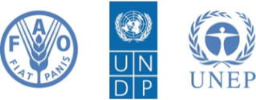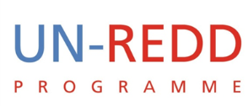
Strengthening Accountability in REDD+ in Africa: Awareness Raising and Training Sessions

proposed dates: 19-21 March 2012 (or 20-22 March)

Background
As the international community and member states strive to work out a concrete deal to address climate change issues in Rio, the initiative to reduce emissions from the forestry sector is gaining impetus. The REDD+ mechanism (Reducing Emissions from Deforestation and Forest Degradation in Developing Countries) will potentially offer significant financial incentive designed to encourage forest-rich countries to cut carbon emissions from their forest sector, through the conservation of standing forests and more sustainable forest activities. These activities are supported by multilateral partnerships such as the UN-REDD Programme and the FCPF, as well as bilateral initiatives.
Climate change is already high on the agenda of almost all African governments. During several of the high-level forums, including the recent gathering in Addis on ‘Green Economy and Structural Transformation’, African leaders showed a firm commitment to dealing with climate change challenges and chart a low-carbon development trajectory. The significant forest reserves and carbon stocks offered in Africa’s forest-rich countries could benefit from financial compensation through REDD+. As these countries work towards expanding sustainable livelihood options and better economic opportunities to many of their citizens, the REDD+ mechanism could greatly contribute to the achievement of national development goals, including the MDGs.
As of November 2011, the number of UN-REDD partner countries in Sub-Saharan Africa has reached eleven. The Democratic Republic of Congo, Nigeria, Tanzania and Zambia receive direct UN-REDD funding support for implementing national UN-REDD Programmes, while the eleven other countries (Benin, Cameroon, Central African Republic, Republic of Congo, Côte d'Ivoire, Ethiopia, Gabon, Ghana, Kenya, South Sudan and Sudan) are UN-REDD partners. Please see annex 1 for details of partner countries receiving direct UN‐REDD funding support and other partner countries.
In spite of the enormous potential benefit of REDD+, the underlying political and socio-economic vulnerabilities in many of the UN-REDD partner countries in Africa pose a significant challenge to the realization of REDD+ objectives. Although vulnerabilities such as weak institutional capacity, underdeveloped legal and accountability systems, fragility, exclusion, etc. affect almost all sectors of the economy, the forestry sector in particular is believed to fare worse. A recent study by TI asserts the poor quality of forest governance around the world and how the sector suffers from illegal and corrupt practices. The oft-cited estimate of the World Bank estimates the amount of revenue lost from illegal logging and tax evasion in this sector at around $5 billion a year.
Why corruption?
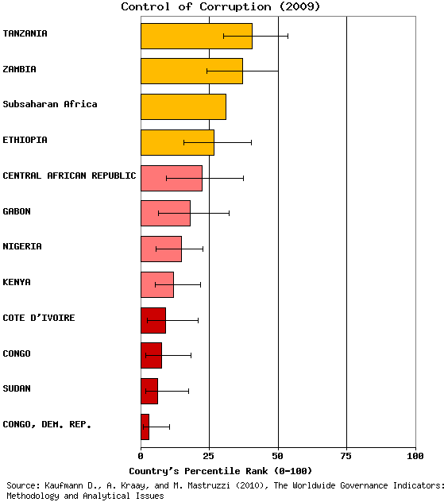
As it is true with many extractive sectors, forest resources and lands are considered key for economic development and, with a surge in global demand for commodities they are becoming increasingly lucrative. Yet many of the countries where these forest resources are found tend to have the weakest legal and institutional frameworks. For instance, as can be seen in this graph, the average score on controlling corruption in those countries participating in UN-REDD programmes in Sub-Saharan Africa is (17.4) only about half of that of the Sub-Saharan Africa average (31%). This makes these countries vulnerable to corruption and to the mismanagement of resources, compromising not only the potential gains from implementing REDD+ programmes, but also the very sustainability of the mechanism.
Considering the centrality of good and fair governance of forest resources and the distribution of benefits to the success of REDD+ policies and measures, UNDP is leading in developing a comprehensive approach to support effective and inclusive national governance systems in REDD+ partner countries. By drawing on its expertise on anti-corruption, UNDP offers support to promote transparency and accountability in REDD+ systems by helping countries identify and mitigate potential corruption risks in the design, implementation and payment distribution processes of REDD+ as one of its priorities.
The UN-REDD Programme has integrated activities on anti-corruption as a core element of its five-year Programme Strategy, supported by its Global programme Framework Document 2011-20154, with UNDP the lead agency. These activities are implemented together with the Global Programme on Anti-Corruption for Development Effectiveness (PACDE) of UNDP’s anti-corruption unit. They include guidance on institutional frameworks for equitable, transparent and accountable benefit distribution systems in REDD+; strengthening the integrity of fiduciary systems for receiving and disbursement of funds, coordinating anti-corruption activities at the national, regional and international level; and supporting the capacity of multiple stakeholders to jointly mitigate corruption risks.
The PACDE workplan for 2011/2 has made capacity building for UN staff and UN-REDD programme management units a priority. In this context PACDE, in partnership with the UN-REDD Programme has organized two awareness raising and training sessions in Nepal and Thailand for Asia-Pacific region. Similarly, this planned workshop in Africa is part of the capacity development effort of PACDE and UN REDD programme and will build upon the findings and lessons from the Asia-Pacific experience.
What is the main goal of this event?
The main goal of this event is to sensitize participants on why and how to address corruption risks in REDD+. Considering that some UN-REDD partner countries might have advanced in REDD+ readiness than others, such forum will also serve as a useful knowledge exchange and peer learning opportunity.
This goal will be achieved by:
- Discussing the foundation for addressing corruption risks in REDD+
- Identifying tools exist to do so (anti-corruption provisions, measures) for the different phases of REDD+, including through a reflection on existing anti-corruption measures in the forestry sector that could also affect REDD+
- Sharing progresses and lessons learned on existing activities initiated in UN-REDD African partner countries
- Highlighting linkages between anti-corruption for REDD+ and on-going governance activities supported by UNDP and the UN-REDD programme, and
- Providing incentives for collaborating and networking on the anti-corruption agenda for REDD+.

Who are the target participants?
- Government REDD+ focal points from the REDD partner countries in the region
- Members of Programme Management Unites (PMUs) in countries where a national UN-REDD programme is under implementation
- Representatives from Anti-corruption bodies (ACAs, Audit bureau, law enforcement bodies, etc.)
- Civil society and media stakeholders who are active in REDD+ and anti-corruption
- UNDP country office delegates supporting the UN-REDD process
- Regional and global partners (AU, UNECA, COMIFAC, SADC, TI, WB, Norway, …)
- Maximum number 60

Inputs:
- UNDP guidance to programming on AC and REDD + (for COs)
- results of online poll on corruption risks in countries
- distribution of relevant studies and fast facts (on PGA)
Agenda
Sessions | Topics | Facilitation/ Presentation | Goals and outputs
Opening Session | Why Governance and REDD+  Overview of UN-REDD governance programme, including stakeholder engagement (and FPIC), safeguards, legislative frameworks.  Understanding corruption risks in REDD+ (re: findings from Staying on Track and other sources) |  | Participants realize the importance of tackling corruption to a successful REDD+;  Participants see that this body of work is coherent with existing support by UN-REDD (including stakeholder engagement)
Session 1 | What are the building blocks for preventing corruption  - Anti-corruption norms, strategies, institutions and tools  - Legal instruments to curb corruption (e.g., access to information act, whistle-blower protection laws, conflict of interest protection laws, investigative journalism on corrupt practices , Use of IT to track and report corruption (e.g., ‘Ushahidi’ (Kenya), ‘I Paid a Bribe’ (India), etc.) |  | Participants have an understanding of the tools and realize that existing systems, regulations and laws can be built upon, and if possible how these have been applied in the forest sector
Session 2 | Approach, tools and resources to determine specific corruption risks and priority actions  - Participatory governance assessments including corruption risks in REDD+ (e.g., Nigeria)  - Political Economy Analysis in REDD+: findings and lessons from DRC (Norad/UNDP/PWC study, World Bank’s political economy study | Presentations by :  Marie Laberge on PGA  Nigeria  and DRC’s CN | Participants are aware that some countries are already tackling the issue and hear it directly from them
Session 3 | Group exercise:  - Potential corruption risk identification |  | Based on result of the poll, participants think about what to do in each situation.  Alternative is to give them a fake country profile and ask to brainstorm on what can be done and by whom.
Session 4 | REDD+ as an opportunity to establish transparent systems : Technology opening a new frontier to promote transparency in development programmes: any lessons for REDD+  - Engagement of stakeholders could mean establishing or building on citizens policy and budget monitoring (PETS, CRCs, etc.)  - Benefit distribution systems portal (e.g., BolsaFamilia (Brazil)) |  | Participants realize that REDD+ does not only bring in risk, but also opportunities to create systems that are transparent. The idea is that REDD+ is not forest sector activities as usual, since by its very nature it has to be predicated upon participatory systems
Session 5 | How to integrate anti-corruption into REDD+ programming  - Linkages with on-going governance/anti-corruption initiatives at global, regional and country levels
Session 6 | Group exercise:  - Anti-corruption entry points in REDD+: opportunities and challenges
Session 7 | Capacity development of Civil Society for anti-corruption in REDD+  - UNDP’s approach to assessing CSOs’ capacity gaps and assets  - TI’s Manual for Assessing Integrity in the Development and Implementation of National REDD+ Strategies
Closing

Annex 1 - Details on UN-REDD partner countries in Sub-Saharan Africa
 | UN-REDD Partner Country | Expression of interest | Validation Meeting | NP approved | NP signed | NP under implementation | Member of FCPF
1 | Central African Republic | 29 Apr 2010
2 | Côte d’Ivoire | 19 Oct 2010
3 | DRC | 18 Sep 2008 | Initial: 30 Jan 09  Full: 19 Jan 10 | Initial: 10 Mar 09  Full: 18 Mar 10 | Initial: July 09  Full: 13 Oct 10
4 | Ethiopia | 15 Apr 2011
5 | Gabon | 9 July 2010
6 | Kenya | 12 Jan 2010
7 | Nigeria | 3 Nov 2009 | 22 Feb 2011
8 | Republic of Congo | 11 Feb 2009
9 | Sudan | 23 Dec 2009
10 | Tanzania | 22 Sep 2008 | N/A | 10 Mar 2009 | 22 Dec 2009
11 | Zambia | 5 Aug 2008 | 3 Feb 2010 | 18 Mar 2010 | 20 Sep 2010

TI (2010) Global Corruption Report: Climate Change (link)
Five Year Strategy, UN-REDD Programme, 2011-2015. Available at http://www.unredd.net/index.php?option=com_docman&task=doc_download&gid=4598&Itemid=53
«Support to National REDD+ Action: Global Programme Framework Document – 2011-2015», UN-REDD Programme, 2011, http://www.unredd.net/index.php?option=com_docman&task=doc_download&gid=5534&Itemid=53

