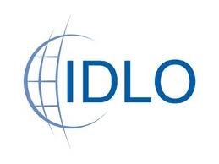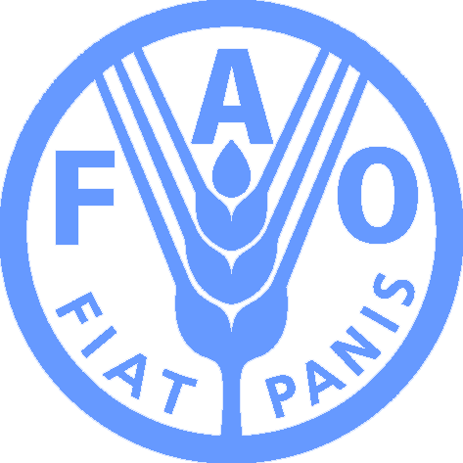

Roundtable on REDD+ Legislation Initiatives

Sunday 4th December 2011
13:00-14.30pm
Conference on Climate Change Law and Governance in the Global South
At the University of KwaZulu-Natal, Faculty of Law, Howard College
King George V Avenue, Durban, South Africa

Hosted by FAO, IDLO, UN-REDD Programme
& University of KwaZulu-Natal Faculty of Law

Summary
The aim of this Roundtable was for leading experts on REDD+ to present and discuss their respective initiatives on domestic REDD+ legislation. As the REDD+ process advances, the central role of domestic laws and regulations in REDD+ implementation is becoming increasingly evident. Several initiatives have responded to the call to strengthen legal and institutional capacity for REDD+ in countries such as Mexico, Zambia, Vietnam, Indonesia and the DRC. This Roundtable brought together representatives of those initiatives with a view to identifying synergies and areas of future collaboration. The Roundtable was open to the public and persons belonging to similar initiatives encouraged to attend.
Speakers and Participants
Chair: Alberto Sandoval (UN-REDD/FAO)
Speakers: Sarah Mason-Case (IDLO), Chris Stephens (GLOBE Forest Legislators Initiative), John Costenbader (IUCN), Florence Daviet (WRI Governance of Forests Initiative), Daniela Rey Christen (ClientEarth)
Discussion Facilitator: Rosalind Reeve (Chatham House & Ateneo School of Government)
Key Participants (see full list at Annex 1): Annie Petsone & Alex Hanafi (Environmental Defence Fund), Markus Gehring (Centre for International Sustainable Development Law & Cambridge University), Joss Saunders (Oxfam Great Britain), Abdi Omar Farah (Action Aid International), Martijn Wilder (Baker & McKenzie), Mark Purdon (Gold Standard), Yaw Osafo (Ghana Delegation), Cleo Mashini Mwatha (UN-REDD Focal Point DRC)

Outreach
The Roundtable was advertised with the attached leaflet (Annex 2) through hardcopy distribution at the International Conference Center in Durban, the official COP17 site; the Conference on Climate Law and Governance in the Global South; as well as through several announcements on the Climate-L listserv leading up to and during COP17.
Roundtable Presentations and Discussion
After a brief introduction by the Chair, Alberto Sandoval (UN-REDD/FAO), the Roundtable commenced with the Speakers providing a brief introduction to their respective initiatives as follows:

- Sarah Mason-Case: FAO, IDLO, UN-REDD Programme Legal Preparedness for REDD+ Project with (a) 3 country studies providng review and analysis of existing laws and institutions in Zambia, Mexico and Vietnam and (b) 1 legal brief on crosscuting issues identified in the 3 country studies and international expert consultations.

- John Costenbader: GLOBE International and IUCN Environmental Law Centre (IUCN-ELC) Climate and Forest Legislation Studies reviewing existing laws and REDD+ strategies in Mexico, Brazil, DRC and Indonesia.

- Chris Stephens: GLOBE Forest Legislators Initiative with (a) progress update on the legal recognition of environmental services in Mexico and (b) the GLOBE Cape Town Legislators Forum.

- Florence Daviet: WRI Governance of Forests Initiative in Brazil, Indonesia and Cameroon to strengthen forest governance through the GFI Framework of Indicators and country engagement with a civil society organizations focus.

- Daniela Rey Christen: ClientEarth initiative focused on the implementation of REDD+ Safeguards in international agreements at the country level.

The Discussion Facilitator, Rosalind Reeve (Chatham House & Ateneo School of Government), then identified areas of synergy and overlap among the different initiatives including, inter alia:

- Geographical focus: there was overlap in the geographical focus of a number of the initiatives in Mexico, Brazil and Indonesia with other countries only benefitting from one initiative, such as Vietnam, Zambia, DRC and Cameroon.

- Scope and initial findings: all of the initiatives identified key areas for legislative review as including: land, forest and carbon tenure; land-use planning; forest governance; sectors concerned with the drivers of deforestation and forest degradation (e.g. agricultural, energy and timber); and environmental and natural resource management.

- Capacity-building approach: each of initiatives had a different capacity-building approach. For instance, whereas the Legal Preparedness for REDD+ Project ultimately seeks to identify generic legal options with a view to enabling country-level action, the GLOBE Forest Legislators Initiative engages directly with parliamentarians to see draft legislation through the enactment process and the WRI GFI primarily targets forest governance among civil society organizations.

- Methodology: further to Ms Reeve’s comments, each of the Speakers identified their methodologies to review, analyze and/or assess existing legal and institutional frameworks. For instance, the GLOBE and IUCN Climate and Forest Legislation Studies employ a “gap analysis” methodology based on each country’s own REDD+ strategy, if available; the Legal Preparedness for REDD+ Project employs a “gap analysis” with a Reference Tool based on the Cancun Agreements and prior legal REDD+ literature and the WRI GFI uses an indicator toolkit tailored to each country context.

Following Ms Reeve’s comments and facilitated by open questions led by the Chair, Mr. Sandoval, the Speakers continued to identify other issue areas and key challenges in discussion with the public participants, including:

- Iterative process of supporting countries to become REDD+ ready while the international regime for REDD+ continues to evolve
- Importance of the development of reference levels and REDD+ activities at various domestic levels depending on factors such as country size and capacity (e.g. local, national, subnational)
- Security of land, forest and carbon tenure and whether community allocation is a benchmark for development benefit rather than individual or other rights
- How broader political instability, such as elections, can inhibit investor confidence
- Apprehesion of some countries toward foreign investment and ownserhip of carbon and the possible advantages of domestic and/or horizontal REDD+ actvities
- Conflicts between trade and investment rules under the World Trade Organization or related domestic ministries with respect to the design of benefit distribution systems

In a concluding session, the Discussion Facilitator summarized the entirety of the Roundtable discussion and the Speakers provided last thoughts emphasizing prior insightful comments by the participants, such as those highlighted above.

Annex 1 : List of Participants

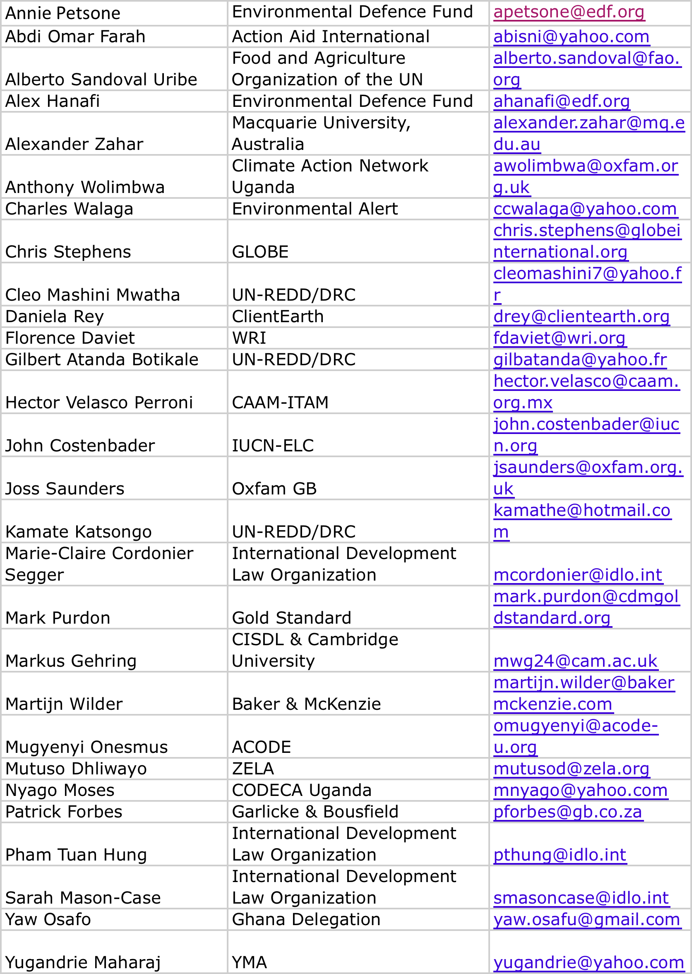
Annex 2 : Roundtable Outreach Leaflet

(See attached)

