USING SPATIAL INFORMATION TO SUPPORT DECISIONS ON SAFEGUARDS AND MULTIPLE BENEFITS FOR REDD+

DRAFT: Step-by-step tutorial:
Installing and running the framework tool

The UN-REDD Programme is the United Nations Collaborative initiative on Reducing Emissions from Deforestation and forest Degradation (REDD) in developing countries. The Programme was launched in September 2008 to assist developing countries prepare and implement national REDD+ strategies, and builds on the convening power and expertise of the Food and Agriculture Organization of the United Nations (FAO), the United Nations Development Programme (UNDP) and the United Nations Environment Programme (UNEP).
The United Nations Environment Programme World Conservation Monitoring Centre (UNEP-WCMC) is the specialist biodiversity assessment centre of the United Nations Environment Programme (UNEP), the world’s foremost intergovernmental environmental organisation. The Centre has been in operation for over 30 years, combining scientific research with practical policy advice.
Prepared by Corinna Ravilious

Copyright: UNEP
Copyright release: This publication may be reproduced for educational or non-profit purposes without special permission, provided acknowledgement to the source is made. Re-use of any figures is subject to permission from the original rights holders. No use of this publication may be made for resale or any other commercial purpose without permission in writing from UNEP. Applications for permission, with a statement of purpose and extent of reproduction, should be sent to the Director, UNEP-WCMC, 219 Huntingdon Road, Cambridge, CB3 0DL, UK.
Disclaimer: The contents of this report do not necessarily reflect the views or policies of UNEP, contributory organisations or editors. The designations employed and the presentations of material in this report do not imply the expression of any opinion whatsoever on the part of UNEP or contributory organisations, editors or publishers concerning the legal status of any country, territory, city area or its authorities, or concerning the delimitation of its frontiers or boundaries or the designation of its name, frontiers or boundaries. The mention of a commercial entity or product in this publication does not imply endorsement by UNEP.
We welcome comments on any errors or issues. Should readers wish to comment on this document, they are encouraged to get in touch via: ccb@unep-wcmc.org.

Citation: Ravilious, C (2015) Using spatial information to support decisions on safeguards and multiple benefits for REDD+. Step-by-step Tutorial: Installing and running the framework tool. Prepared on behalf of the UN-REDD Programme. UNEP World Conservation Monitoring Centre, Cambridge, UK.

Acknowledgements: With thanks to feedback provided by colleagues from spatial analysis working sessions in Cambodia.

These training materials have been produced to aid the production of multiple benefits maps to inform REDD+ planning and safeguards policies using open source GIS software.
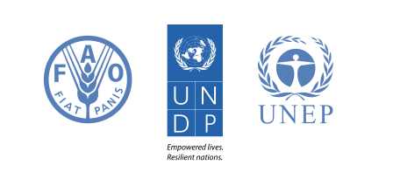
Contents
1. Introduction 1
2. Installing and Running the Global Tool 1

1. Introduction

REDD+ has the potential to deliver multiple benefits beyond carbon. For example, it can promote biodiversity conservation and secure ecosystem services from forests such as water regulation, erosion control and non-timber forest products. Some of the potential benefits from REDD+, such as biodiversity conservation, can be enhanced through identifying areas where REDD+ actions might have the greatest impact using spatial analysis.

Open Source GIS software can be used to undertake spatial analysis of datasets of relevance to multiple benefits and environmental safeguards for REDD+. Open-source software is released under a license that allow software to be freely used, modified, and shared (http://opensource.org/licenses). Therefore, using open source software has great potential in building sustainable capacity and critical mass of experts with limited financial resources.
This tutorial guides you through installing the first version of the framework tool for spatial analysis of the costs and benefits of individual REDD+ options.

2. Installing and Running the Global Tool

- Open QGIS 2.8
- Click on plugins>>manage and install plugins
- Search for processing workflows
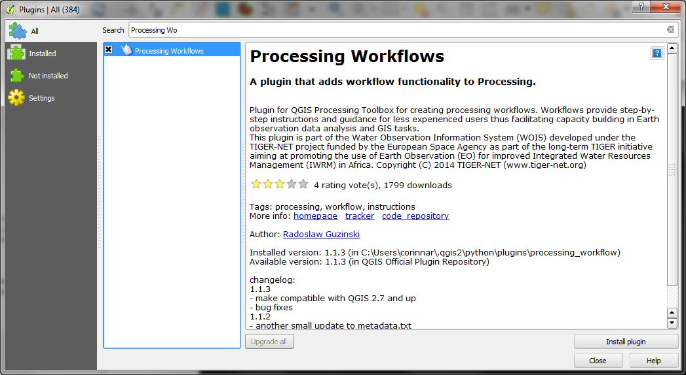

- Click on the plugin Processing Workflows plugin in the left hand panel and then on the install plugin button
- Search for Group S
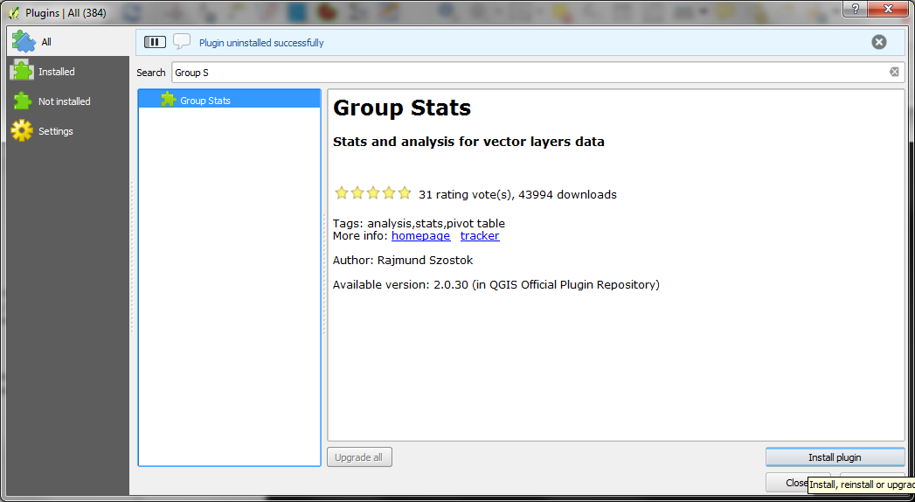

- Click on the plugin Group Stats plugin in the left hand panel and then on the install plugin button
- Close QGIS 2.8

- From the P-drive P:\programs\PROJECTS\2600s\2650G UN-REDD 2014\Work in progress\8 0 generic GIS materials\GlobalGISTool

- copy GlobalToolDevelopment_150310 folder to C:\Users\corinnar\.qgis2\processing\models
  - if you have an old version delete the old version e.g. C:\Users\corinnar\.qgis2\processing\models\GlobalToolDevelopment_141112_bkup

- copy UNREDD_workflows_for_spatialplanning_150310.workflow to C:\Users\corinnar\.qgis2\python\plugins\processing_workflow\workflows
  - delete the old version if you have it e.g.C:\Users\corinnar\.qgis2\python\plugins\processing_workflow\workflows\UN-REDD_workflow1.workflow

- Delete old copies of the following and replace with the new versions:-
  - copy the Example_Square_DummyInputs folder to a chosen folder on your computer
  - copy the GlobalToolOutputStyles folder to the same folder on your computer
  - copy the UN-REDDWorkflowsForREDD+SpatialPlanningDocumentation_150310 HTML to the same folder on your computer
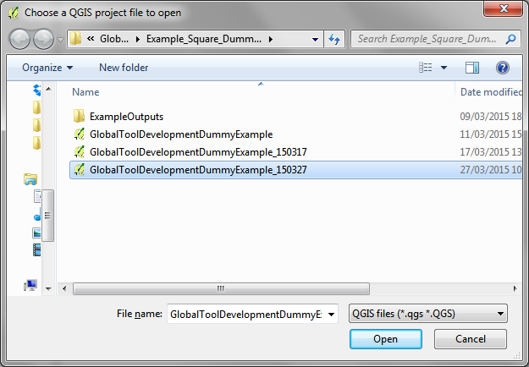

- Open QGIS 2.8
- Click on Project>>open to open the QGIS project called GlobalToolDevelopmentDummy Example_150327
- Click open
- If you can’t see the processing toolbox (it will be a right hand panel) click Processing>>Toolbox
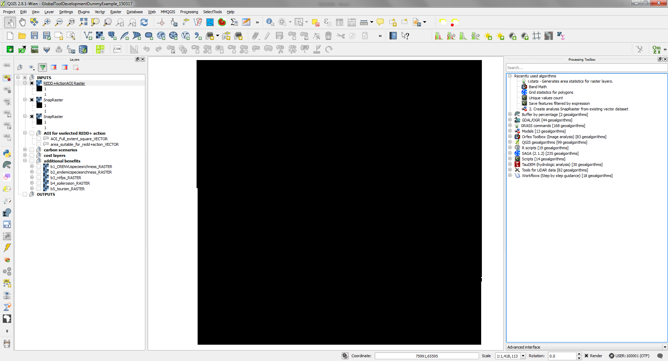

- If it says Simple interface click here to change to Advanced
- To activate the processing workflows plugin click on Processing>>>options
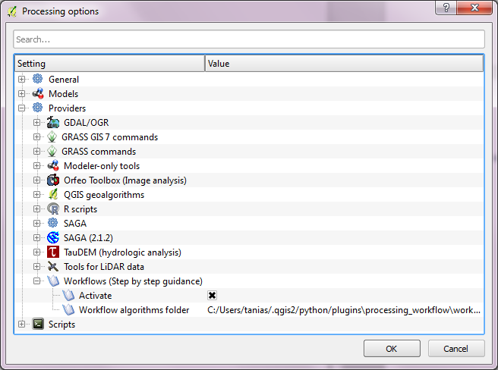
- Click on the + to expand Providers and the + to expand Workflow. Click to put a x in the Activate box

- Click on Workflows and expand UN-REDD tools
- Double click on UN-REDD workflows for REDD+ Spatial planning to run the tool.
- Follow the instructions on each screen to run the workflows

