ABRIDGED REPORT

PARTICIPATORY GOVERNANCE ASSESSMENT (PGA) PILOT RESEARCH
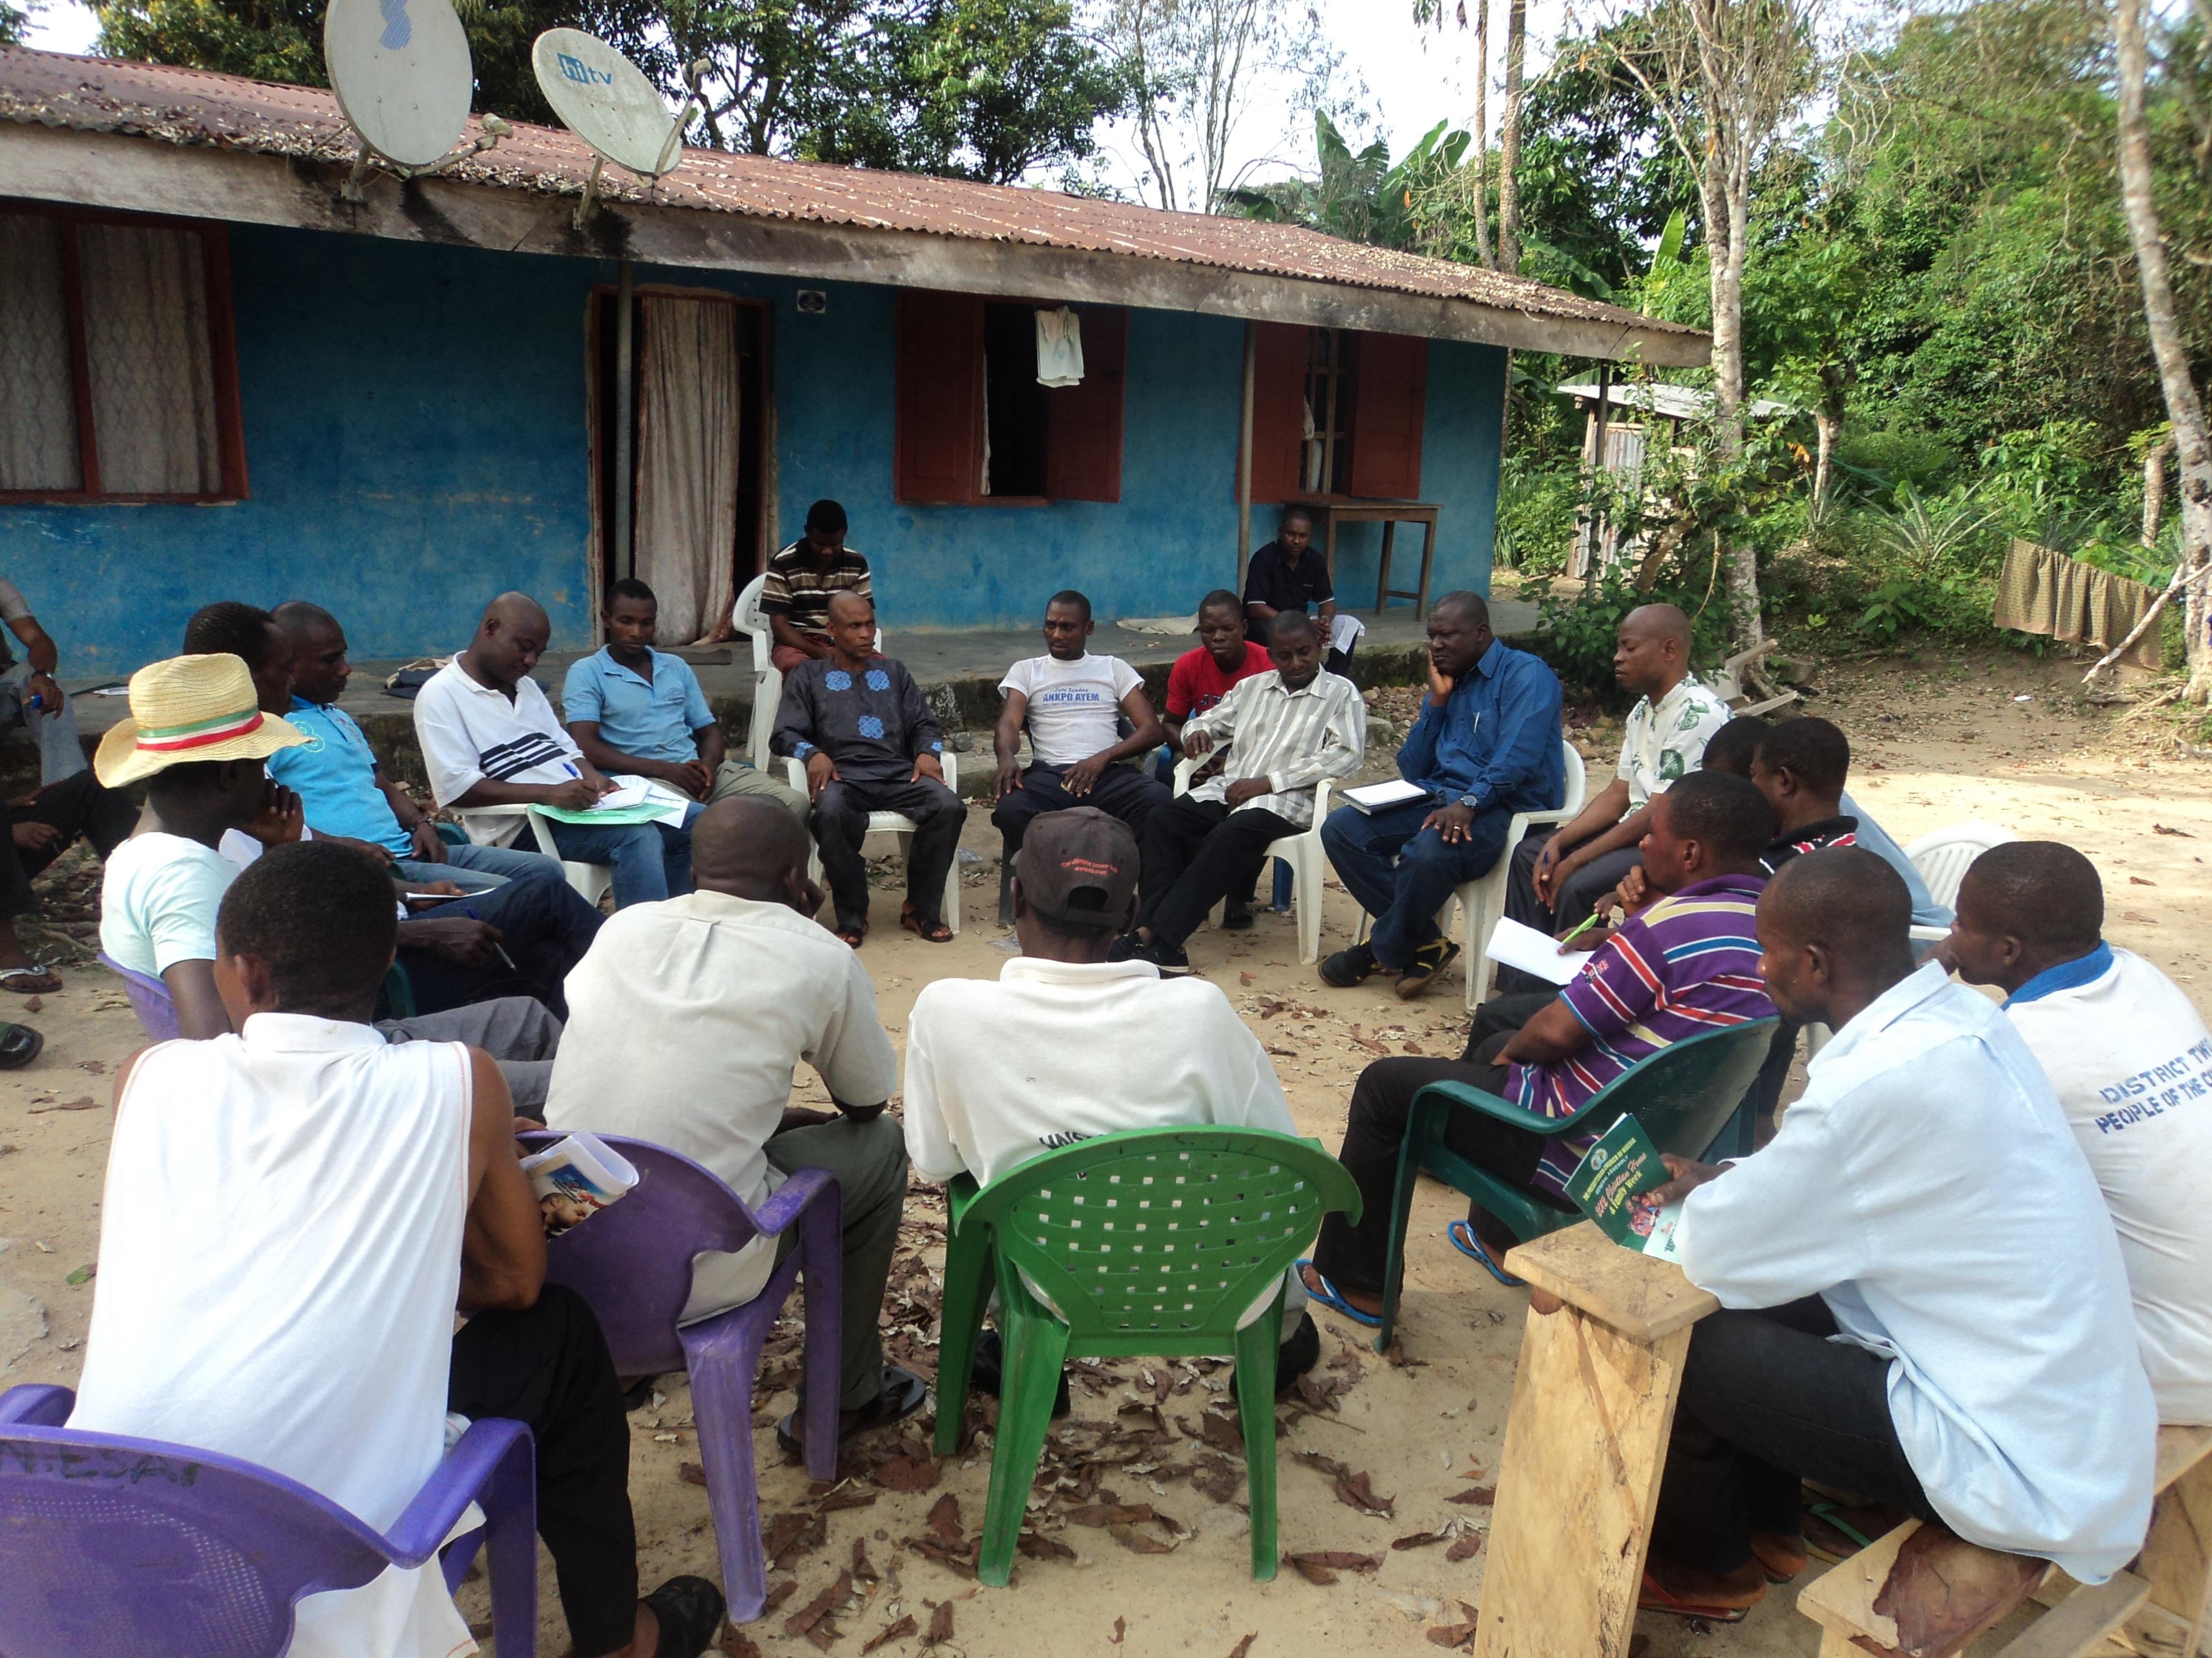
IN THE CROSS RIVER STATE, NIGERIA.

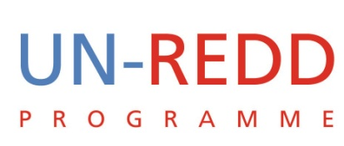

DECEMBER 2012

1. Introduction

The intent of this report is to present a brief synthesis of the findings from a preliminary participatory governance assessment (PGA) in Cross River State (CRS), a pilot state for REDD+ implementation in Nigeria. The mapping exercise was carried out in the three pilot communities of Esuk Mbah in Akpabuyo Local Government Area (LGA) from 20th to 21st November 2012; Iko Esai (Akamkpa LGA) from 24th to 25th November 2012 and Baunchor (Boki LGA) from 28th to 30th November 2012.
The entire PGA process for Nigeria is designed to help achieve the following objectives:
- To assess the existence and implementation of adequate policies and legislations necessary for the effective implementation of REDD+ and more generally, for the sustainable management of forests;
- To assess the institutional capacity of government agencies at federal, state and local levels to implement the REDD+ Programme and sustainable forest management (SFM) policies;
- To assess the existence and effectiveness of an anti-corruption strategy specifically designed for REDD+;
- To assess the existence and effectiveness of mechanisms established for meaningful participation by forest-dependent communities in the implementation of REDD+;
- To assess the existence and implementation of the benefit distribution system for REDD+ in terms of its transparency and fairness in distribution of benefits to the concerned stakeholders.
The report is based on a study of four key topics identified by UN-REDD as crucial to understanding of governance within the context of REDD+. The topics explored during the research exercise are: a) stakeholders perceived gains and losses; b) governance risks and possible safeguards; c) the role of the private sector and; d) existing communication systems. The findings presented in this report will enable design of PGA methodology, its implementation and adaptation of REDD+ implementation to local reality.
The rest of the report is organized as follows:
- Section 2 provides some background to the PGA process;
- Section 3 presents a summary of the PGA methods;
- Section 4 outlines key findings and;
- Section 5 provides some recommendations to guide implementation of REDD+ and the rest of the PGA process in Nigeria.

2. Background and Context

REDD+ has been designed with the assumption that a sound governance system will be central to the success of the policies and financing of REDD+. This can be so because REDD+ takes place in forest governance contexts characterized by illegal logging, corruption, corporate and elite capture of forest lands, displacement of forest communities, and other social and governance issues. In many countries, the lack of appropriate policies on forest management, weak law enforcement, ambiguous land tenure as well as poor regulation on the use of forest have all increased the vulnerability of forests and their communities.
As a response to these concerns, the UN-REDD Programme developed global Social & Environmental Principles and Criteria (SEPC) to guide national programmes and efforts, so as to ensure that its activities promote social and environmental benefits, and reduce unintended risks from REDD+. Principle 1 on Democratic Governance states that REDD+ programmes should ‘comply with standards of democratic governance’, and proposes the following three criteria:
- Criterion 1 – Ensure integrity of fiduciary and fund management systems
- Criterion 2 – Implement activities in a transparent and accountable manner
- Criterion 3 – Ensure broad-based stakeholder participation
Principle 2 on Stakeholder livelihoods states that the Programme should ‘carefully assess potential adverse impacts on stakeholders’ long-term livelihoods and mitigate effects where appropriate.’ The following criteria are proposed:
- Criterion 4 – Promote gender equality
- Criterion 5 – Avoid involuntary resettlement
- Criterion 6 – Respect traditional knowledge
- Criterion 7 – Develop equitable benefit distribution systems
The social and environmental principles and criteria are central to the PGA process, ensuring overall success of REDD+ and local benefits. Design and implementation of the participatory governance assessment (PGA) process hinges on this set of SEPC.

3. Methodology

The PGA Team
The PGA team had eight members with a wide range of background in the social and environmental sciences. Team members represent key stakeholders including the Climate Change Working Group at the University of Calabar and civil society organisations (CSOs). Given the need for coordination of logistics, the team was expanded to include staff of Cross River State Forestry Commission. The team had four sub-teams, with two members covering each of the sub-themes identified above. Pairing up of team members ensured gender balance as well as interest in, and familiarity with the different subject matters.

Organization and Schedule of Fieldwork
Prior to fieldwork, CRSFC staff conducted community sensitisation across the 3 pilot communities for REDD+. During sensitisation, staff provided information on purpose of the study and agreed schedule of FGD meetings with community leaders, men, women and youth. Given that the PGA was designed to involve stakeholders from the three pilot communities, the study communities were preselected.

Data collection in the study communities spanned a total of 7 days, with intermittent schedule beginning on 20th November and 30th November 2012 as shown in Table 1 below. In addition to fieldwork, the team spent a total of 3 days reviewing the literature and gathering data from state-level stakeholders outside the pilot communities.

Table 1: Fieldwork Schedule
Study community | LGA | Fieldwork Duration
Esuk Mbah | Akpabuyo LGA | 20th to 21st November 2012
Iko Esai | Akamkpa LGA | 24th to 25th November 2012
Baunchor | Boki LGA | 28th to 30th November 2012

At the community level, the team engaged a wide range of stakeholders, including village authorities, resource user groups and community groups including men, women and youth.

Study Approach and Methods
Overall, the study team adopted a mix of participatory research methods to elicit information from the target population. Data collection was based on predesigned templates covering the four sub-topics as identified above. The templates for data collection are presented in Annex A at the end of the report. The study adopted the following methods: focal group discussion, in-depth interviews, stakeholders’ survey, key informant interviews and desk review.

Focal group discussion was used to engage community groups like men, women, and youth to enable the team obtain more detailed information about governance issues based on their perspective. A checklist was developed based on REDD+ PGA key principles of accountability, participation, transparency and legitimacy to guide the focal group discussions held with the various community groups. The communities were initially shared into three groups (males, female, and council of elders) except in Esuk Mbah (Akpabuyo LGA) where meeting with the youth was organized separately. The initial separation into groups was to permit freedom of speech for each of the groups. Afterwards all the groups were brought together for the purpose of verifying data gathered during meetings with each group.

The team used in-depth interview to probe for more information, as well as triangulate the various sources of information for the purposes of clarity and authenticity.

The team also used key informant interview to obtain relevant information from selected individuals from the communities. In addition to key informant interviews, stakeholders’ survey focusing on perceived gains and losses was held with stakeholders at the state level. In this case, survey forms were distributed to representatives of the stakeholder groups, including government ministries for completion and submission to team members responsible for stakeholders’ analysis. Information from such individuals provided more insight into governance issues identified at the community level.

In order to gather data on stakeholders’ perceived gains and losses, a standard survey questionnaire was prepared and circulated among selected stakeholders, particularly representatives of government ministries and civil society organisations. Annex B at the end of the report presents the survey form designed for this purpose. Data gathered through the stakeholders’ survey were integrated with data from the communities.

Finally, some aspects of the PGA study required assessment of the situation at the state and federal levels. For this reason, team members reviewed existing documents, gathering appropriate data for integration with data from the field. Desk review focused on governance risks and safeguards as well as private sector-related drivers of deforestation at the state level.

4. Findings from the Preliminary PGA

4.1 Stakeholders’ Perceived Gains and Losses
REDD+ stakeholders identified by the research team include relevant Ministries, Departments and Agencies (e.g. Ministry of Environment, Ministry of Agriculture) at the federal and state levels; elected representatives; the academia particularly the Department of Geography and Environmental Science, Forestry and Wildlife, Marine Science, etc. At the local level, REDD+ stakeholders include the local government authority, law enforcement agencies such as the Nigeria Police Force (NPF) and Civil Defence Corps, network of CSOs concerned with natural resource management, Council of Chiefs and Elders, women and youth, community-based private sector including farmers, fishermen, loggers, hunters and carpenters.
The potential gains for both the state and local government include conservation of forest/habitat, less risk of environmental hazards, ecotourism potentials, carbon credit facility, participatory agro forestry practices, aforestation/reforestation while the potential losses include loss of economic potentials, reduced land for agricultural projects, conflict/insecurity due to incompatible interest and loss of revenue from non-exploitation of timber. From the research, elected representatives expect to see improvement in conservation of forest resources for future use while the academia expected to find opportunities for collaboration in the management of various aspect of REDD+ programme.
The PGA provided oportunities for stakeholders to identify and analyse their perceived “gains” and “losses”. Overall, most of the gains relate to biodiversity conservation, social empowerment, income from carbon credit, enhancement of tourism potentials, provision of alternative means of livelihoods, opportunities for collaboration with a wide range of actors, capacity building and CSOs fulfilment of their development and environmental management mandate. Gains perceived by stakeholders at the community level rested solely on the expectation that UN REDD+ will invariably attract some social economic benefits to the area. These included financial benefits for carbon credit, an expectation to achieve sustainable management of forest, alternative livelihoods and harnessing ecotourism potentials. The stakeholders at this level envisaged more losses than gains, claiming that they would lose their access to natural resources, income, shortage of food, employment in the forest, etc.
As potential losses, stakeholders identified the following issues: reduced access to natural resources, including farmlands; loss of livelihoods, food shortages due to controlled access to farmlands, and disputes, which may arise from competing uses.
Given stakeholders’ current level of awareness, it was recommended that awareness raising oportunities should target all the different stakeholders.

Governance Risks
Guided by the SEPC, the team identified governance risks linked to the 13 criteria under the four principles. The main governance issues relate to:
- access to funds, lack of funds management capacity;
- lack of transparency and accountability;
- weak mechanism for giving and receiving feedback;
- bribery and corruption;
- lack of data related to forest governance;
- ineffective engagement of stakeholders as well as stakeholders’ limited capacity to participate effectively;
- interagency rivalry;
- slow decision making processes;
- lack of confidence in the justice system and cost of access to justice;
- lack of clarity of land and carbon rights;
- gender issues that women’s effective participation;
- improper community entry – i.e. without seeking and receiving free, prior and informed consent (FPIC);
- Unwillingness of community members to be resettled;
- Poor documentation of traditional knowledge and cultural heritage;
- Poor understanding of benefits as well as lack of appropriate benefits sharing mechanism in relation to REDD+;
- Widespread poverty, which can undermine the development process and;
- Poor accessibility can undermine economic as well as social growth;

For each governance issues, the team identified safeguards and indicators of success in implementing the safeguards to address the issues identified. The team identified a total of 99 indicators (30 at federal level, 29 at state and 40 at local level).

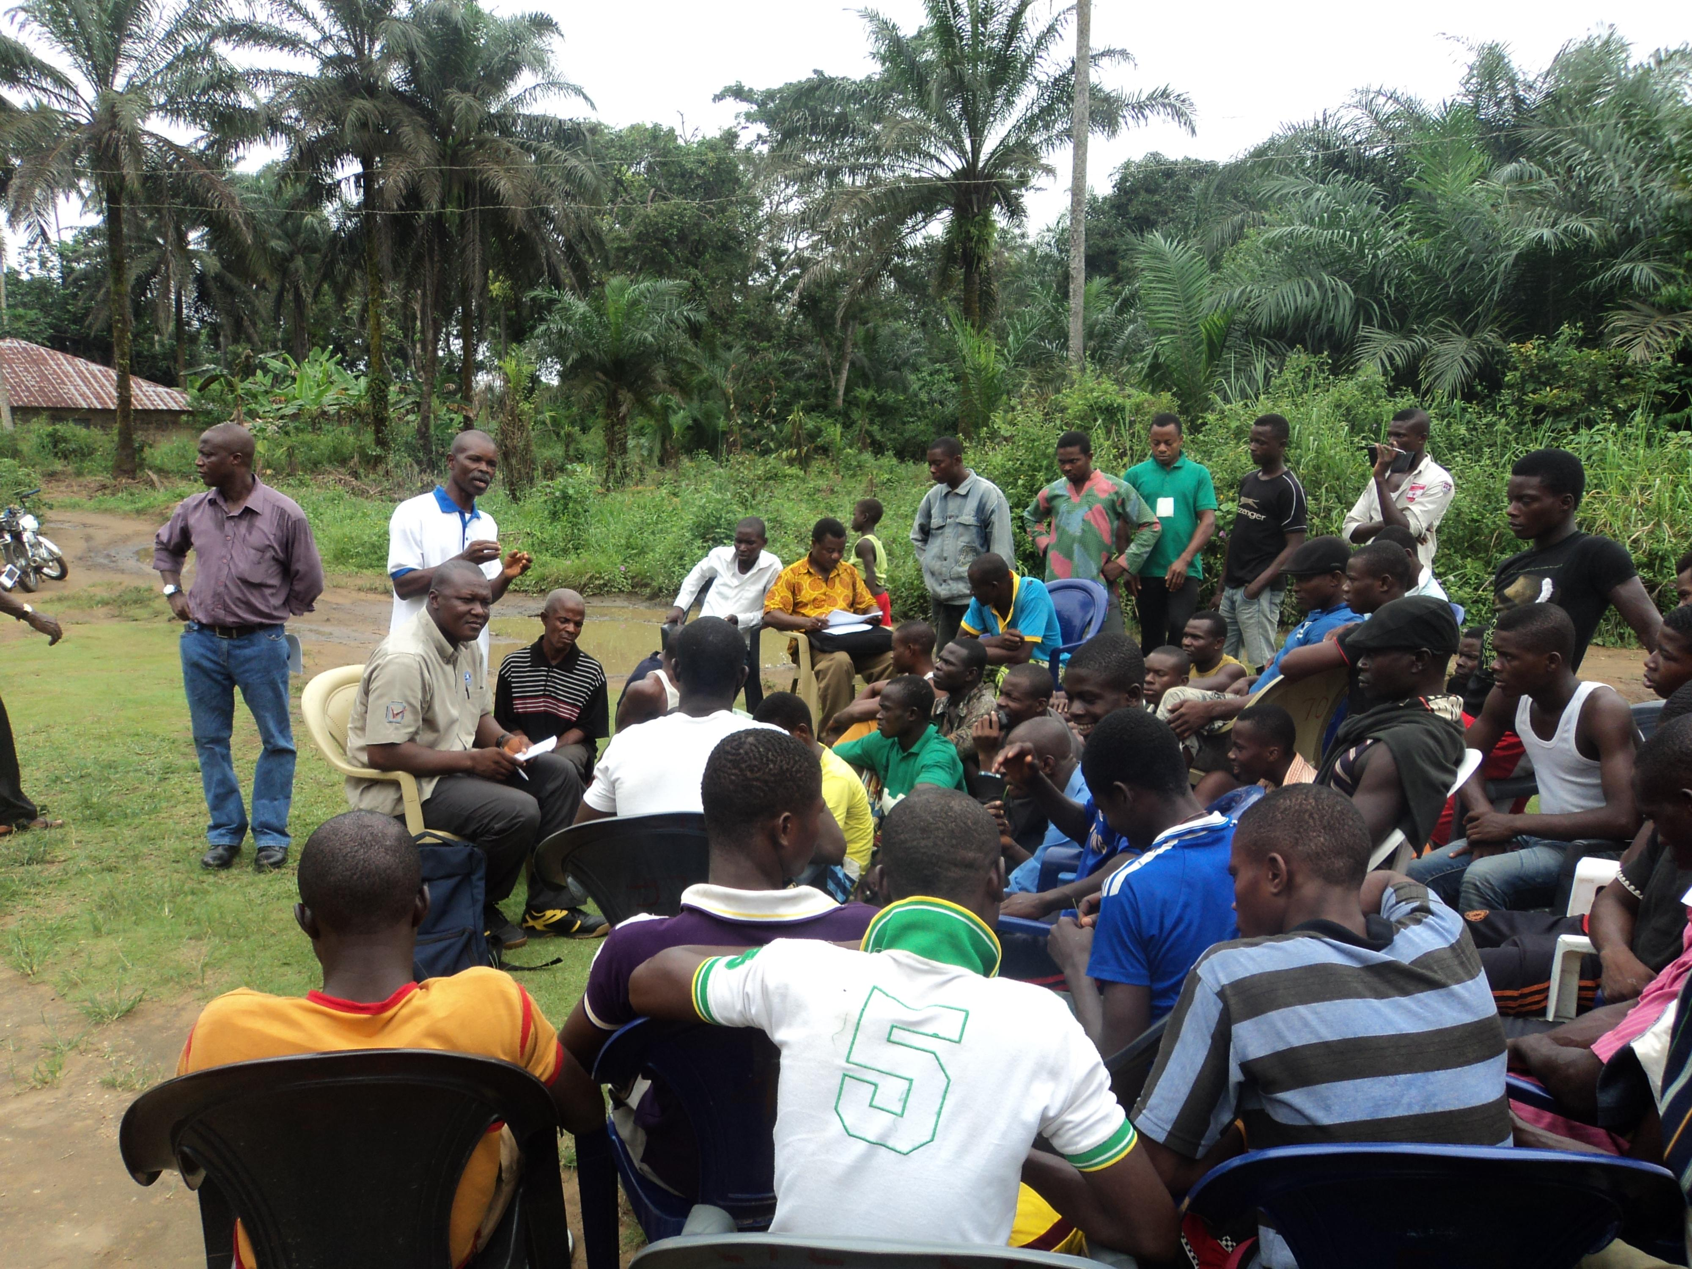

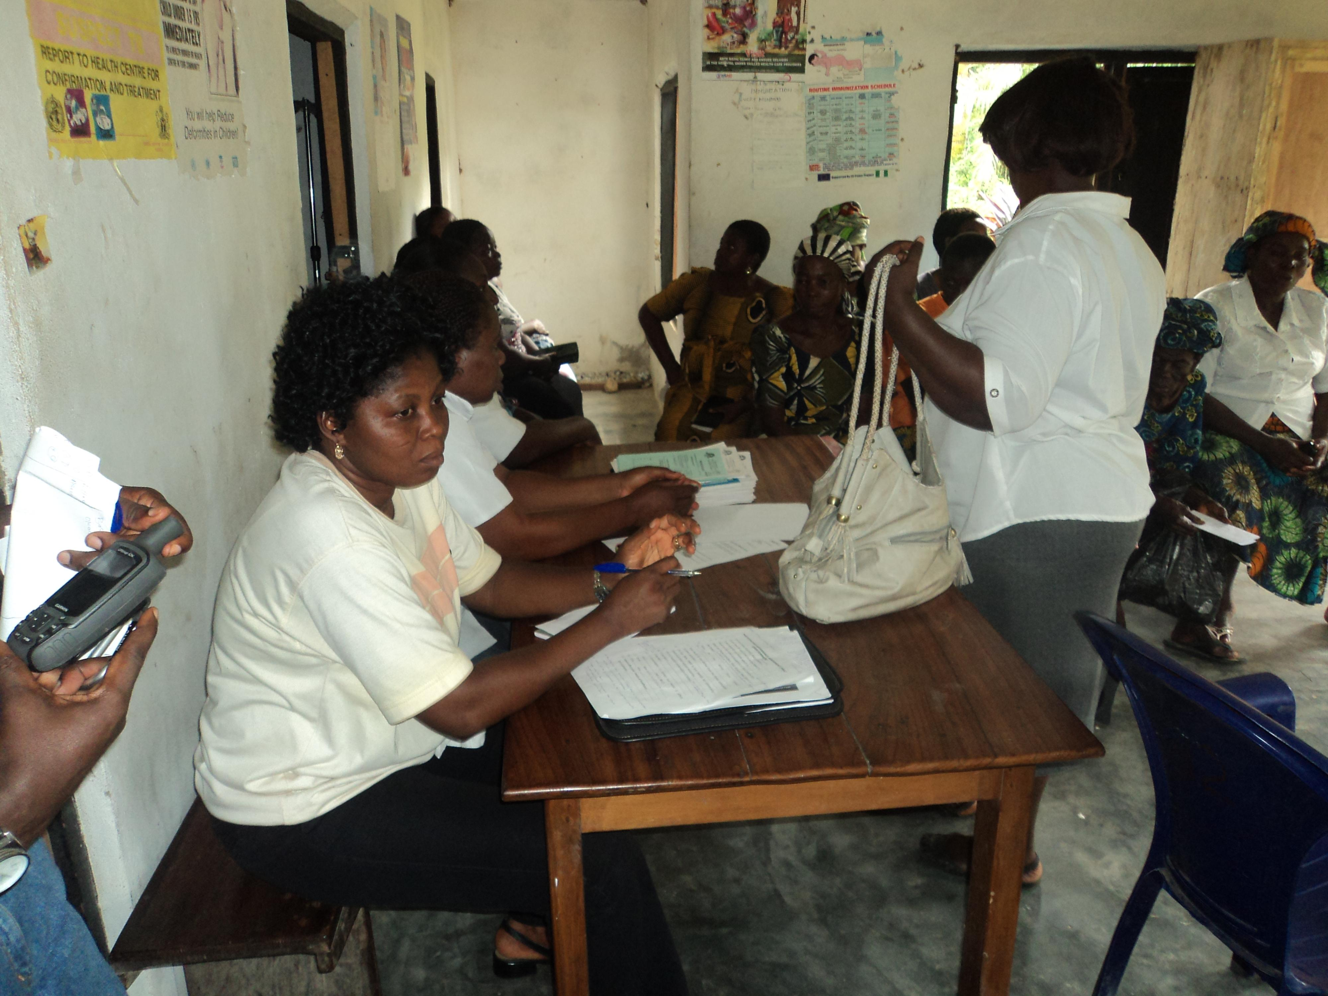

4.3 Private Sector Drivers of Deforestation
In the context of REDD+,- “private sector activities” are economic activities and establishments that directly or indirectly degrades the forest significantly. Within the study communities, economic activities that fit into this definition would include logging, building/construction, fuel wood extraction, agriculture or farming, etc. However, considering the small-scale of operation of peasant farmers in the forest communities selected for the UN-REDD+ implementation in Cross River State (contrasted to large-scale agriculture or agri-businesses), the impact of the former on the forest (i.e. their capacity to cause deforestation) is viewed as minimal to low.
Ongoing enforcement of law banning logging made it difficult to elicit information from respondents about how much violation of illegal logging is occurring underground. However, there is evidence that large quantities of wood logged in the state are used for construction,
It was reported that persistence of CRS Government law banning logging in force since 2010s forced loggers out of Iko Esai to operate in nearby communities such as Iko-Ekperem, Owai, etc.
The study identfiied four key drivers of deforestation. These are:
- Fuelwood extraction
- Logging/timber extraction
- Oil bunkering and associated oil spillage and;
- Commercial farming

4.4 Communication System
The study team identified the apparent ineffectiveness of modern means of communication in the pilot communities that were studied. Some community members had battery-operated radios. Also, few households own television sets which are powered by generators that they used for watching home videos more than local programs from nearby stations. This was due to the poor reception of signals from both local and national stations (Cross River State Broadcasting Corporation, Nigerian Television Authority and others). While many of the young people within the communities own mobile phones, the problem of poor signal still persists. The poor network connection points to the absence of an active or functional telecommunication system.
As a result, there is greater dependence on traditional means of communication. These include:
1. Use of the services of a town crier: The town crier uses a bell, whistle and/or the wooden gong to draw the community’s attention before passing on any message. In all the study communities, town criers were men.

2. Religious Meetings: The meetings of Churches and other faith-based groups in the communities are also good channels for communicating messages. In each of the study communities, religious leaders were identified among trusted figures.
3. Notice Board: Notice boards are positioned at strategic locations with information targeting specific population within the community. For example, a notice board in Iko Esai provided advice about conservation or rare and endangered species.

In addition to these means, the respective communities use town hall meetings to disseminate information to a larger population, particularly when urgent action is required.

5. Recommendations

Based on the findings from the assessment, the research team offered the following recommendations for implementation of the Nigeria PGA in particular, and the Nigeria REDD+ in general.

1. Adapt the PGA methodology to the local context: The team observed that the templates designed for the study are more generic, and to be more effective need to be adapted to the local situation. For example, the template for gathering data on governance risks require information gathering about the national, state and local situation. While focus group discussions are most appropriate for gathering information on the local situation, the absence of existing data on governance limit data collection on the national and state levels.

2. A more detailed documentation of the Nigeria PGA methodology will ensure better and more effective replication of the process in other parts of the state.

3. Design the programme strategy based on the findings of the study. For example, the findings that most modern means of communication are less effective imply that the programme could take advantage of traditional means of communication during implementation of PGA and REDD+. The REDD+ programme could also be more effective if the programme targets the drivers of deforestation that the study identified.

4. It might be necessary to prioritise the list of governance issues in order to focus the intervention more appropriately. Governance issues the team identified is quite numerous, and it might be more effective to focus on the most crucial issues that require intervention. A consensual process (e.g. stakeholders’ meeting or workshop) of prioritization of the governance issues is recommended.

Nigeria PGA:
Mapping of information needs at all levels (Fed/State/Local) &
suggestions for a multi-level communication strategy around the PGA and REDD+

- At local level:

- What are traditional means of communication in use at community level?
They are;
- Town Crier
- Community Engagements
- Religious Meetings
- Notice Board
STUDY CONCERNS ON MODERN MEANS OF COMMUNICATION
The study team identified the apparent absence of modern means of communication within the communities. However, there is the existence of individually owned battery operated radios. Also, few houses were seen to own television sets which are powered by generators and better served the purpose of watching home videos in place of local programs from nearby stations due to the poor reception of signals from both local and national stations (Cross River State Broadcasting Corporation, Nigerian Television Authority and others). While many of the young people within the communities own mobile phones, the problem of poor signal still persists. The poor network connection points to the absence of an active or functional telecommunication system.
- TOWN CRIER: The town crier deploys a bell, whistle and or the wooden gong to draw attention before passing on any message. None of the communities appoints a woman as a town crier. The community town crier is appointed from among the men.
ii) COMMUNITY ENGAGEMENTS: Other communication channels used for disseminating information in the communities are; town council meetings, town hall meetings, youth sessions, women groups and age grade meetings.
*Town Council Meeting – is a gathering of the Village Chiefs, Elders and Women and Youth Leaders who meet regularly to discuss matters concerning the day to day running of the community. The Chiefs and Elders who come from various families or lineages which constitute the community will later hold meetings to further spread the message. Same applies to the Women and Youth leaders.
*Town Hall Meeting – is a meeting of the entire community (Chiefs, Elders, Women, Youths, Stranger Elements, Interest groups etc). It usually takes place at a central meeting point (Village Square or a Hall). Salient matters are usually deliberated during such convergence.
*Youth Sessions – This is a session of a very active and indispensable segment of the community (Young Men and Young Women).
*Women Groups – In the communities you have various women groups who project and represent various interests. They are a very strong reach out group.
*Age Grade – this is a group of people who fall within the same age bracket. Specifically, the age grade meet regularly mostly at weekends. The age grade is a strong communication channel.
iii) RELIGIOUS MEETINGS – The meetings of Churches and other faith based groups in the communities are also veritable channels utilized in communication at the community level. Members of the community hold the leaders of these groups in high esteem and they are very convincing.
- NOTICE BOARD – This is another effective channel of communication at the local level. Notice boards are positioned at strategic locations with information that require the needful for community members. A good instance is at Iko Esai, there is a notice board at the village that has information on the good and bad on the environment.
CHALLENGES OF COMMUNICATION
The study team noted that there are challenges associated with communication in the communities. These include the absence of community radio stations for centralized information dissemination, gross effectiveness of communication between community and government. Also, there is the existing challenges of communication means such as distance and travel time to and between communities and the, time of info rely to the appropriate quarters, absence of liaison officers mediating between community and government, and the poor response time from government.

RECOMMENDATIONS
The study recommends the following:

- Free flow of information at every stage of the UN- REDD+ program

- Establishment of community radio stations

- Strengthening the communication ties within communities and government

- Sourcing of alternative energy sources to power communication means

- Establishment of enlightenment campaigns and awareness programs

- The setting up of a committee regulating the various programs to embrace poverty alleviation programs

- Regular incorporation of conservation talks in community meetings

- How could we actively engage trusted figures local level (elders, village chiefs, social clubs, legislators at local government level, etc.) in the PGA process?
They (Elders, Village Chiefs, Social Clubs and Legislators at local level) can best be engaged in the PGA process by adopting either one or three of Interactive Participation, Functional Participation and Self Mobilization approach.

*INTERACTIVE PARTICIPATION: This approach allows the people to participate in joint analysis, development of action plans and formation or strengthening of local institutions. Participation is seen as a right, not just as a means of achieving project goals. It entails formalized decision making structures such as management councils involve local stakeholders and meet on regular basis. Local people in this model take control over local decisions and determine how local resources are used.

*FUNCTIONAL PARTICIPATION: Peoples participation is viewed by external agents as a means of achieving project goals, especially reduction in cost. The people may form groups to meet pre-determined objectives. Functional participation may be interactive and may also involve shared decision making but tends to arise only after major decisions have been made by the external agents. Local people may only be co-opted to serve external agents goals.

*SELF MOBILIZATION: In this approach, the local people participate by taking initiatives, independently of external institutions to change systems. They develop contacts with external institutions and there is primary transfer of authority and responsibility for the resources.

- At all levels (Fed/State/Local):
Stages in the PGA process
Element | First PGA | General awareness-raising about REDD+ / PGA | Local consultations to provide feedback on first draft of methodology | Data collection | Verifying PGA data (quality control) | Discussing PGA results & finding solutions
What message(s) need to be communicated? | *Preliminary PGA exercise has been completed, and there are findings to share with stakeholders | *REDD+ has potential benefits and losses, but the benefits outweigh the losses  *The primary objective of REDD+ is provision of financing mechanism | *We will be seeking feedback from stakeholders through experience sharing on the REDD+ process | *We need to gather more data on governance towards implementing REDD+ | *Stakeholders input is needed to verify the PGA data collected  *This verification is important in ensuring quality of the data collected from the field | *We need to review findings from the PGA preliminary exercise and also brainstorm on solutions to governance issues identified
Who should communicate this message? | *PGA Coordinator | *REDD+ Project Team | *PGA Research Team | *PGA Research Team | *PGA Research Team | PGA Coordinator
Who is the target audience (s) of this message(s)? | *Representative of Governments and Relevant MDA’s  *Local Communities  *CSO’s  *All Stakeholders | *The General Public and all stakeholders | *Local Communities  *CSO’s  *Multi Stakeholders  *Drivers of Deforestation | *REDD+ Technical Team  *REDD+ Project Team*Academia (Climate Change Working Group)  *CSO representatives | *Community Stakeholders and interviewed respondents | *Representative of Government and Relevant MDA’s  *Local Communities  *CSO’s  *All Stakeholders
What is the best means of communicating this message? (i.e. through what channel) | *Research Briefs  *Invitation letters and email | *Leaflets  *Short takes(jingles)  *Radio/TV announcements  *Panel discussion  *Flyers  *Bill Board  *Social Media(Facebook news feed) | *Email communication  *Presentation during workshop with plenary | *Letters to communities  *Information disseminated through Forests Officers | *Workshop presentation and plenary  *Email communication seeking inputs | *Invitation letter and Email  *Workshop presentation and plenary

Mapping of Key Governance Risks and Possible Safeguards

Criterion | Federal |  |  | State |  |  | Local
Criterion | Risks | Possible Safeguards | Possible indicators | Risks | Possible Safeguards | Possible indicators | Risks | Possible Safeguards | Possible indicators
1.Fiduciary & fund management systems | -Difficulty in local communities accessing funds.  -Leakage in the system, including corrupt practices (i.e. diversion of funds )  -Fund transfer  -Delay in release of funds | -Project implementation unit comprising of federal, State and Community representatives  -Set out guidelines for benefit sharing  -Set specific timelines for the release of funds  -Set up committees  -Joint account should be operated | -Extent to which access to funds and other benefits to all stakeholders is timely.  -Number of activities completed by federal government according to predefined timelines | -Difficulty in access by Local community.  -Leakage in the system.  -Diversion of funds  .Difficulty with funds transfer  -Low capacity of State Government institutions to effectively manage funds;  -Corruption – i.e. mismanagement of funds, misallocation of funds, misapplication of funds, misappropriation of funds  -Low institutional capacity & inadequate policy framework to guide against corruption | -Open a joint state & community account for REDD+  -Timely information on REDD+ benefit made available to host communities  -Establish robust monitoring and evaluation framework that will include capacity building of State Government institutions in effective funds management | -Extent to which access to funds and other benefits to communities is timely.  -Level of satisfaction expressed by beneficiaries on funds management | -Inadequate local capacity for record keeping and financial accountability;  -Undocumented guidelines and lack of clarity in financial guidelines and procedure;  -Absence of a local development plan and budget to guide expenditure; | -Design a framework for inclusion of key stakeholders in fund management (accounts opening, composition of signatories, joint identification of projects, project implementation team);  -Capacity building through training and hands-on support with regards to funds management  -Define expenditure guidelines for all stakeholders  -Develop legal framework for compliance;  -Support stakeholders in developing annual budget linked to implementation of community development plans | -Number of democratic decision-making processes focusing on the use of funds for community projects;  -Extent of involvement of the different community level stakeholders in decision-making about funds management;  -Number of books/records created and managed to improve accountability
2.Responsive feedback and grievance mechanisms | -Lack of clarity in the implementation of feedback and grievance mechanism;  -Corruption in implementing grievance mechanism;  Bureaucracy delaying responses; | Develop a clear responsive feedback and grievance mechanism;  -Establish levels of reporting to promote checks and balances;  -Response mechanism should include time frame within which grievances will have been addressed; | -Degree of promptness and appropriateness of feedback received;  -Extent to which grievances are managed successfully;  -Number of measures addressing corrupt practices investigated and prosecuted | -Reprisal by blacklisting community with respect to other development projects  -Lack of clarity in grievance procedure;  Insufficient capacity in managing feedback and implementing grievance procedure;  -Exclusion of Local Governments | -Develop guidelines on access to and management of funds  -Develop a clear grievance procedure; | Level at which stakeholders appropriately use grievance procedure; | -Lack of grievance procedure  - Lack of clarity in grievance procedure  -Investigation procedure not thorough sometimes  -Unwillingness to give feedback to, or receive feedback from other stakeholders; | -Conduct capacity assessment with respect to feedback and grievance mechanism;  -Conduct institutional capacity building through community level training;  -Develop a participatory feedback/  grievance management protocol;  -Communicate grievance management protocol | -Number of feedback received  -Level of quality of two-way feedback received;  -Number of grievances addressed;  -Extent to which grievances addressed are satisfactory.
3.Accessibility of information & active dissemination amongst stakeholders | -Potential grievance from non- benefiting states;  -Lack of data to analyse into relevant statistics and required information;  -Poor documentation of available information;  -Absence of, or lack of clarity in information management procedure;  -Inadequate stakeholders’ identification and engagement;  -Appropriateness and timeliness of information dissemination | -Develop a robust monitoring, evaluation and reporting system to support effective information dissemination;  -Develop a clear information management procedure through a participatory process;  -Conduct stakeholders’ analysis that will enable identification of stakeholders’ levels of influence and engagement | -Quality and relevance rating of data that have been analysed into usable information;  -Number of stakeholders having access to and making use of relevant information in a timely manner; | -Potential grievance from non- benefiting LGAs  -Non availability of information;  -Stakeholders’ low level capacity in data collection and analysis;  -Intermittent nature of information dissemination;  -Limited understanding of stakeholders’ capacity;  -Use of inappropriate medium of information dissemination; | -Identify capacity gaps to be addressed through training;  -Replicate safeguards at Federal level to encourage harmonisation between State and Federal levels | -Percentage of government staff or relevant stakeholders with demonstrable skills in information gathering, analysis and dissemination;  -Quality and relevance rating of data that have been analysed into usable information;  -Number of stakeholders having access to and making use of relevant information in a timely manner; | -Inadequate knowledge of type of information available;  -Lack of documentation of information at community level;  -Distortion of information as they are passed on from various media (Village Head, Town Council, Town Crier, Churches, Schools, Health Posts, person to person)  -Poor electronic media and telecom coverage  -Timeliness of message delivery  -Poor representation of the community with change agencies  -Wrong interpretation of information by the recipient;  -Appropriateness of language used;  -Relevance of information | -Train community level institutions on information documentation and effective dissemination;  -Present or translate information into appropriate language;  -Use of mixed transmission media (e.g. town hall meetings, town crier etc) to limit information loss or distortion;  -Create information management protocol to include classification, medium, timeliness, and language of information dissemination;  -Create a liaison office in community to engage with government and other change agencies;  -Improve telecom mast coverage; | -Degree to which information is clearly documented;  -Extent to which primary stakeholders (i.e. community groups) are aware of, and use information;
4.Active participation of all stakeholders, incl. vulnerable groups | -Extensive bureaucratic process  -Delays in planning, implementation & funds release  -Poor stakeholder identification & engagement;  -Sometimes participation remains a rhetoric, rather than reality;  -Stakeholders’ capacity to participate;  -Effectiveness of coordination of activities;  -Disagreement among stakeholders;  -Institutional exclusion of some stakeholders | -Develop and enforce timelines for each activity;  -Conduct comprehensive analysis of stakeholders from start;  -Develop working definitions of concepts like participation with input from stakeholders;  -Identify capacity gaps and train stakeholders for effective participation;  -Establish a coordination mechanism that will support stakeholders’ participation;  -Establish dispute management mechanism;  Carry out institutional analysis to address exclusion of some stakeholders | -Number of action points completed within deadlines;  -Number of systems and structures in place to encourage active participation of all stakeholders, including vulnerable groups;  -Level of capacity of stakeholders to participate;  -Number of stakeholders actively participating; | -Extensive bureaucracy.  -Unwillingness to review existing structures that discourage participation;  -Poor dissemination of information;  -Stakeholders’ capacity to participate;  -Lack of trust and confidence | -Develop and enforce timelines for each activity;  -Conduct comprehensive analysis of stakeholders from start;  -Develop working definitions of concepts like participation with input from stakeholders;  -Identify capacity gaps and train stakeholders for effective participation;  -Establish a coordination mechanism that will support stakeholders’ participation;  -Establish dispute management mechanism;  Carry out institutional analysis to address exclusion of some stakeholders | -Number of action points completed within deadlines;  -Number of systems and structures in place to encourage active participation of all stakeholders, including vulnerable groups;  -Level of capacity of stakeholders to participate;  -Number of stakeholders actively participating; | -Poor stakeholders identification and analysis;  -Withholding information that can encourage participation;  -Overdependence on a single stakeholder;  -Unmanaged expectations and suspicion;  -Inconsistent engagement with stakeholders;  -Groupthink resulting in lack of independent critical thinking or alternate solutions;  -Willingness of all stakeholders, including vulnerable groups to participate  -Community level decision making structure that excludes certain groups;  -Perception of economic relevance (benefits) of participation (i.e. unclear direct outcomes of participation) | -Conduct stakeholders analysis;  -Engage stakeholders from start;  -Empower stakeholders through information and roles sharing;  -Expected benefits should be clearly defined from start | -Number of interest groups at all levels involved in the PGA and REDD+ process  -Level of community engagement of vulnerable groups;  -Extent to which all stakeholders have access to and make use of relevant information
5.Inter-agency coordination | -Bureaucratic bottleneck.  -Duplication of functions.  -Delays in decision making and action implementation and release of funds  -Inter agency rivalry | -Develop and enforce timelines for each activity.  -Specification of each agency roles  -Create a coordinating agency | Number of agencies sharing information with the coordinating agency;  -Extent of appropriateness and timelines of information made available by the coordinating agency;  -Number of activities facilitated or overseen by the coordinating agency | Bureaucracy that undermines efficiency;  -Lack of confidence in coordination system;  -Duplication of institutions with conflicting roles;  -Insufficient capacity to coordinate;  -Corruption  -Non-inclusive policies processes  -Poor planning and implementation due to lack of training/capacity building; weak institutions; bureaucracy; poor funding and Poor monitoring and evaluation; & poor budget performance  -Weak and inconsistent policy framework | -Set up Anti-Corruption Task Force  -Mainstream good governance (transparency and accountability) during REDD+ implementation | - Number of agencies sharing information with the coordinating agency;  -Number of activities facilitated or overseen by the coordinating agency | -Duplicity of institutions and functions;  -Unclear roles;  -Unclear levels of authority;  -Unhealthy competition for authority/recognition | -Profile existing agencies;  -Clearly define roles of agencies;  -Establish inter-agency reporting protocol;  -Establish a central coordination system e.g. a government institution; | -Number of partnerships between government agencies addressing governance issues related to REDD+;  -Extent of effectiveness of information disseminated from agencies;
6.Rule of law, access to justice & effective remedies | -Corruption and  bribery  -Inadequate awareness of citizens’ rights and responsibilities; | -Conduct citizenship education with stakeholders to raise awareness and commitment;  -Apply safeguards from responsive feedback and grievance mechanism in (2) above | -Extent to which stakeholders respect the rule of law;  -Number of stakeholders seeking or willing to seek for justice | -Corrupt social and political system;  -Lack of patriotism;  -Lack of awareness of the existence of remedies;  -Complex system that may increase cost of access to justice;  -Unfavourable past experiences | -Set up Anti-Corruption Task Force  -Mainstream good governance (transparency and accountability) during REDD+ implementation | -Extent to which stakeholders respect the rule of law;  -Number of stakeholders seeking or willing to seek for justice | -Weak institutions unable to enforce rule of law or ensure access to justice & effective remedies;  -External, more powerful influences;  -Undocumented procedures;  -Some stakeholders (e.g. youth) not respecting the rule of law;  -Lack of confidence in the justice system and process;  -Cost of access to justice and effective remedies when ultimate access lies outside the community | -Strengthen institutions;  -Document processes including reward and penalty as well as enforcement systems;  -Make access to justice and effective remedies simple and affordable;  -Link with relevant external (formal) institutions e.g. the Police, Courts etc.  -Reform justice and process for greater access, ownership and accountability to local people. | -Number of community groups seeking justice;  -Number of decisions made that are consistent with established procedures;  -Extent of wide-spread respect for rule of law.
7.Rights of local communities to land & to carbon | -Dual system of land tenure: that is, statutory and customary tenure;  -Poor land management plans;  -Unclear boundaries and land fragmentation; | -Clarify rights of local communities to land and to carbon;  -Improve land documentation and management procedures;  -Establish clear boundaries between community lands and institutionally managed lands | -Extent to which the rights of local communities to land and to carbon is recognised;  -Extent to which local communities benefit from their rights to land and to carbon; | -Dual system of land tenure: that is, statutory and customary tenure;  -Poor land management plans;  -Unclear boundaries and land fragmentation; | -Clearly establish rights of local communities to land and to carbon;  -Improve land documentation and management procedures;  -Establish clear boundaries between community lands and institutionally managed lands | -Extent to which the rights of local communities to land and to carbon is recognised;  -Extent to which local communities benefit from their rights to land and to carbon; | - Land use and tenure issues, including land access, problem of shared resources (tragedy of the commons), multiple/complex land tenure regimes; Lack of legal recognition of customary land rites  -Marginalisation of some stakeholders (e.g. women)  -Forest tenure and management regime are not very clear;  -No capacity to measure carbon;  -Exclusion of less conspicuous yet important resource users e.g. traditional medicine practitioners;  -Natural disaster destroying parts of community forests;  -Government policy;  -Unclear land boundaries  -Other (external) competing interventions e.g. Pandrillus taking over community forest lands. | -Conduct community profiling to include resource use tenure systems;  -Use knowledge and skills gap analysis to identity needs and build capacity;  -Build capacity on climate change adaptation  -Cluster land user groups who will have responsibility for community forest management in Cross River State. | -Number of community bylaws regarding access to forest resources and carbon stock;  -Extent to which boundaries are clearly defined and maintained between different forest management regimes;  -Number of policies in place that respect the rights of access and ownership by indigenous population
8.Gender equality & women’s empowerment | -Interpreting “gender” to mean women  -Perception of gender and equality;  -Availability & willingness of women for involvement in empowerment programmes;  -Cultural norms;  -Insufficient policy framework; | -Provide equal opportunities for representation of both women and men in designing REDD+ benefits sharing mechanisms  -Ensure equal access by women and men to REDD+ benefits  -Develop a working definition of concepts like gender, gender roles. Empowerment, etc;  -Catalogue gender and women empowerment needs;  -Explore policies that could promote sound gender practices and women’s inclusiveness | -Extent to which REDD+ responds to the different  gender needs of women and men;  -Extent to which initiatives and actions address women’s empowerment | -Interpreting “gender” to mean women  -Perception of gender and equality;  -Availability & willingness of women for involvement in empowerment programmes;  -Cultural norms;  -Insufficient policy framework; | -Provide equal opportunities for representation of both women and men in designing REDD+ benefits sharing mechanisms  -Ensure equal access by women and men to REDD+ benefits  -Develop a working definition of concepts like gender, gender roles. Empowerment, etc  -Catalogue gender and women empowerment needs;  -Explore policies that could promote sound gender practices and women’s inclusiveness | -Extent to which REDD+ responds to the different  gender needs of women and men;  -Extent to which initiatives and actions address women’s empowerment | -Misunderstanding of gender and women’s empowerment needs/issues;  -Address gender inequality through REDD+  -Lack of recognition of gender and women’s empowerment needs/issues;  -Local governance structure;  -Biased livelihoods priorities (preference for male dominant forest based activities to female’s) | -Create awareness based on location-specific issues;  -Establish systems for inclusion of women in decisions/activities that affect them; | -Number of decisions and actions taken that reflect gender considerations;  -Extent of involvement of women in decision making processes  -Number of measures of gender equity promoted through the REDD+ process
9.Free, prior & informed consent by local communities | -Improper approach at entry point;  -Poor understanding of cultural context;  -Inappropriate means of disseminating information;  -Lack of inter-agency coordination | -Develop entry point strategy  -Conduct community profiling  -Use developed communication protocol to identify appropriate means of disseminating information | -Level of awareness in communities;  -Number of communities that are aware;  -Quality and relevance rating of information available for dissemination to communities;  -Number of appropriate institutions engaging with communities | -Assumptions that undermine effective engagement with communities from start;  -Low capacity of project proponents to engage with communities;  -Nature, manner and timelines of information dissemination;  -Image portrayed by project proponents seeking communities’ consent;  -Politicising the process | -Collect baseline data;  -Build capacity of project proponents and representatives of local communities;  -Develop appropriate message;  -Use the right, or a combination of right institutions or agencies (establish strong and appropriate partnerships and networks); | -Quality rating of information available to support engagement with communities;  -Number of communities giving free and informed consent  -Level of satisfaction among community groups of their community’s consent to participate. | -Threat to available land and forests;  -Disrespect for local tradition;  -Exclusion of sections of the community during consultation and decision making;  -Unclear benefits;  -Unwillingness of outsiders to sign up MOU with clear implementation plan. | -Early engagement of local communities in the process;  -Broad-based community mobilization;  -Clear and honest information dissemination;  -Respect for communities’ voices;  -Trust and partnership building;  -Adopt participation to develop and communicate future actions | -Number of communities signing FPIC with appropriate implementing agencies  -Degree of community ownership of the REDD+ process;
10.Involuntary resettlements |  |  |  |  |  |  | -Cultural relevance of new location;  -Low household income level to support resettlement;  -Unwillingness of community members to be resettled | -Involve communities in considering need for resettlement and available options; | -Number of avoided resettlement  -Number of options to resettlement considered before eventual resettlement, if applicable  -Average amount/value of compensation for involuntary resettlement  -Distance of new settlements to previous location  -Extent to which resettled communities are well settled and adapt to their new settlement;
11.Traditional knowledge & cultural heritage | -Inadequate baseline information;  -Poor documentation of traditional knowledge and cultural heritage;  -Absence of or inadequate policy addressing preservation of traditional knowledge and cultural heritage; | -Establish a catalogue of traditional knowledge and cultural heritage;  -Establish or implement policy framework to preserve traditional knowledge and cultural heritage | -Level of awareness of traditional knowledge and cultural heritage;  -Extent to which traditional knowledge is applied;  -Level of protection of cultural heritage | -Inadequate baseline information;  -Poor documentation of traditional knowledge and cultural heritage;  -Absence of or inadequate policy addressing preservation of traditional knowledge and cultural heritage; | -Establish a catalogue of traditional knowledge and cultural heritage;  -Establish or implement policy framework to preserve traditional knowledge and cultural heritage | -Level of awareness of traditional knowledge and cultural heritage;  -Extent to which traditional knowledge is applied;  -Level of protection of cultural heritage | -Change in belief system systems affecting perceptions and behavior (Local connotation suggests cultural heritage sites as evil e.g. evil forest);  -Inter-generational knowledge gap  -Poor documentation of traditional ecological knowledge  -Unwillingness to share information about indigenous technical knowledge | -Use of positive nomenclature in communication strategy e.g. use of sacred or religious grove to evil forest;  -Documentation and knowledge sharing;  -Protection of heritage sites | -Size of catalogue of traditional knowledge produced and accessible;  -Number of cultural heritage sites protected due to increased knowledge about REDD+  -Stakeholders’ level of knowledge about traditional issues;  -Extent to which traditional knowledge/cultural heritage are integrated in forest management initiatives;
12.Equitable & transparent benefit sharing | -Poor understanding of benefits;  -Absence of benefit sharing formula;  -Corruption and improper coordination of benefits;  -Disputes over ownership of assets;  -Discrimination against non-indigenous but resident population in an area | -Define benefits and beneficiaries;  -Identify source of benefits;  -Develop benefit management system and sharing formula; | -Number of documents articulating benefits and sharing formula and evidence of implementation;  -Level of satisfaction over benefits sharing;  -Number of categories of beneficiaries | -Poor understanding of benefit;  -Absence of benefit sharing formula;  -Corruption and  improper coordination of benefits;  -Disputes over ownership of assets;  -Discrimination against non-indigenous but resident population in an area | -Define benefits and beneficiaries;  -Identify source of benefits;  -Develop benefit management system and sharing formula; | -Number of documents articulating benefits and sharing formula;  -Level of satisfaction over benefits sharing;  -Number of categories of beneficiaries | -Weak local institutional framework to support benefit sharing;  -Ensure benefits sharing is sensitive to environmental compliance by the communities;  -Ensure effective compliance  -Ensure equitable distribution of benefits to all groups (i.e. women, widows, youth and vulnerable groups);  -Limited knowledge of benefits  -Poor communication  -No existing benefit sharing formula, except investment in community development projects;  -Land tenure (ownership) | -Strengthen institutions for more equitable sharing of benefits and management of conflicts that may ensue;  -Disseminate information on available benefits;  -Establish equitable and transparent benefit sharing formula and mechanisms;  -Establish clear boundary demarcation of forest management regimes (e.g. PAs, Community & Private forests etc) | -Extent to which stakeholders are aware and use benefit sharing formula;  -Incidence of grievances reported;  -Stakeholders’ level of satisfaction with benefit sharing formula and mechanisms;
13.Economic & social well-being of all, incl. vulnerable groups | -Poor enterprise development skills;  -Unfavourable government policy discouraging investment;  -High inflation rate;  -Limited access to improved markets;  -Poor input support system (loans, equipment, etc);  -Inappropriate skills and technology;  -Poor adaptation to climate change issues  -absence of social safety nets, especially for women, youth and children | -Build capacity in enterprise development;  -Implement policies to support small scale enterprises;  -Establish systems to support enterprise development (by way of providing inputs)  -Create and implement policies on carbon trade  -Put in place social safety net for vulnerable groups | -Extent of improvement in living standards in the different states of the country;  -Average household income;  -Extent to which REDD+ responds to the gender needs of women and men | -Poor enterprise development skills;  --Unfavourable government policy discouraging investment;  -High inflation rate;  -Limited access to improved markets;  -Poor input support system (loans, equipment, etc);  -Inappropriate skills and technology;  -Poor adaptation to climate change issues | -Build capacity in enterprise development;  -Implement policies to support small scale enterprises;  -Establish systems to support enterprise development (by way of providing inputs) | -Extent of improvement in living standards in the different LGAs in the respective states  -Average household income; | -Poverty can undermine the development process;  -Natural disaster e.g. flood, land slide, can affect the well-being of all groups;  -Poor accessibility can undermine economic as well as social growth;  -Undefined benefit management system;  -Inadequate infrastructure  - Limited access to credit facilities  - Crude production & processing processes  - Limited & low level economic activity engendering poverty  - Complex and extended value chains (lack of value chain approach)  -Limited access to credit facilities  - Poor organisational arrangement for local cooperatives  - Poor organisational arrangement for local cooperatives  - Limited livelihoods options;  - Limited access to markets  - Low capacity for sustainable development | -Support improvement and/or diversification of livelihoods (support for increased productivity and marketing);  -Improve access road;  -Establishment disaster risk reduction measures (early warning and response systems) | -Average household cash income  -Number of farmers and resource users adopting improved productivity techniques;  -Extent of improvement in access to markets;
Group One: Yellow Highlight
Group Two: Green Highlight
Group Three: Pink Highlight
Group Four: Blue Highlight

