

FIRST DRAFT REPORT

CAPACITY BASED NEED ASSESSMENT

National Forest Monitoring System (NFMS) for REDD+ MMRV in Pakistan

**Lead Author:**

Kamran Hussain

**Contributing Authors:**

Mohammad Ibrahim Khan (WWF-Pakistan)

Mohammad Afrasiyab (WWF-Pakistan)

This report is based on quick desk review of available literature, interviews and focus group discussions with provincial governments and other relevant organizations. This report gives (i) past and current REDD+ initiatives in Pakistan, (ii) historic overview of NFMS of Pakistan and (ii) an overview of capacity gaps to establish a robust National Forest Monitoring System for REDD+ MRV implementation both at provincial and national level in Pakistan. The findings help to assess the systematic, institutional, financial and individual requirements to establish NFMS as per guidelines of UNFCCC and IPCC.

**ACKNOWLEDGEMENT**

All praise goes to Almighty Allah who is most gracious and the most beneficent. Sincere thanks to the Office of Inspector General Forests and World Wide Fund for Nature – Pakistan for their patience, proper guidance and technical supervision provided during the course of work and compilation of this report. I am highly indebted to UN-REDD of Food and Agriculture Organization (FAO) of the United Nations for providing technical and financial support from its target support fund to accomplish this task to take Pakistan further towards implementation of robust and transparent National Forest Monitoring System. High appreciation goes to all the provincial REDD+ focal persons for their efforts and cooperation in arranging provincial meetings with concerned government departments and officials. I am also grateful to all the participants for their active participation and valuable inputs during provincial consultative meeting. I am also thankful to the members of a national technical working group on SLMS for their valuable feedback.

**LIST OF ABBREVIATIONS**

**ADP**  Annual Development Plan

**AFN**  All Foresters Network

**AJK** Azad Jammu o Kashmir

**AWG-LCA** Adhoc Working Group on Long Term Cooperative Actions

**CCD** Climate Change Division

**CDA**  Capital Development Authority

**CEGD** Community Extension and Gender Development

**CIFOR**  Centre for International Forestry Research

**CKNP**  Central Karakorum National Park

**COP**  Conference of Parties

**DBH** Diameter at Breast Height

**DFO** Divisional Forest Officer

**DGPS** Differential Global Positioning System

**EPA** Environmental Protection Agency

**FAO** Food and Agriculture Organization of United Nations

**FATA**  Federally Administered Tribal Areas

**FCPF** Forest Carbon Partnership Facility

**FRA** Forestry Resource Assessment

**FSMP**  Forestry Sector Master Plan

**GB**  Gilgit-Baltistan

**GCISC** Global Change Impact Study Centre

**GEF** Global Environmental Facility

**GFRA**  Global Forest Resource Assessment

**GHG-I**  Green House Gas Inventory

**GIS**  Geographical Information System

**GLCF** Global Land Cover Facility

**GPS** Global Positioning System

**HKH**  Hindu Kush Himalayan

**HRD** Human Resource Development

**ICIMOD**  International Centre for Integrated Mountain Development

**INGO** International Non Governmental Organization

**IPCC** Intergovernmental Panel on Climate Change

**ISESCO** Islamic Educational, Scientific and Cultural Organization

**IUCN**  International Union for Conservation of Nature and Natural Resources

**JPE** Joint Program on Environment

**KPK**  Khyber Pakhtunkhwa

**LCCS**  Land Cover Classification System

**LULUCF**  Land Use Land Use Change and Forestry

**MMRV**  Monitoring and Measurement, Reporting and Verification

**MMU**  Minimum Mapping Unit

**MoCC** Ministry of Climate Change

**MoE**  Ministry of Environment

**NARC**  National Agriculture Research Council

**NESPAK**  National Engineering Services of Pakistan

**NFI** National Forest Inventory

**NFMS**  National Forest Monitoring System

**NFRRAS**  National Forest and Rangelands Resource Assessment Study

**NLUP** National Land Use Planning

**NPP** Net Primary Productivity

**NRM**  Natural Resource Management

**OBIA**  Object Based Image Analysis

**OIGF**  Office of Inspector General of Forests

**PFI** Pakistan Forest Institute

**PFRI** Pakistan Forestry Research Institute

**PKR** Pakistani Rupee

**RELs**  Reference Emissions Levels

**REDD+** Policy Approaches and Positive Incentives in Reducing Emissions from Deforestation, Forest Degradation; and the Role of Conservation, Sustainable Management of Forest and Enhancement of Forest Carbon Stocks in Developing Countries

**RLs**  Reference Levels

**RPP**  Readiness Preparation Proposal

**SDPI** Sustainable Development Policy Institute

**SLMS** Satellite Land Monitoring System

**SoP** Survey of Pakistan

**SUPARCO** Space and Upper Atmosphere Research Commission

**UNFCCC** United Nations Framework Convention on Climate Change

**UNDP** United Nations Development Program

**UoP** University of Peshawar

**USGS** United States Geological Survey

**WG** Working Group

**WWF** World Wide Fund for Nature

TABLE OF CONTENTS

1. Background and Introduction 7

2. Methodology 8

3. The Past and Current REDD+ Initiatives in Pakistan 11

4. An Overview of Forests of Pakistan 13

5. Capacity Gaps in National Forest Monitoring System in Pakistan 14

**5.1** **Satellite Based Forest Inventories** 15

5.1.1 Data Availability and Accessibility 20

5.1.3 Human Capacity to Process and Analyse Information related to SLMS 24

5.1.4 Human Capacity for Preparation of Reports from SLMS 26

5.1.5 Capabilities related to Data Verification 27

5.1.6 Training Facilities 27

**5.2** **Field Based Forest Inventories** 28

5.2.1 Data Availability and Accessibility 29

5.2.2 Technical Capabilities (Equipment and Logistics) 32

5.2.3 Human Capacity to Process and Analyse Forest Inventory Data 34

5.2.4 Human Capacity for the Preparation of Reports from NFI 36

5.2.5 Capabilities related to Data Verification (Quality Control and Quality Assurance) 36

**5.3** **Green House Gas Inventories** 40

6. Level of Communication 42

7. Capacity Based Need Assessment for REDD+ NFMS 44

8. Areas of Improvement and Recommendations 45

**8.1** **Institutional Arrangements for NFMS Coordination and Data Management** 45

**8.2** **Standard Methodology for Spatial Analysis** 45

8.2.1 National Forest Definition for REDD+ 45

8.2.2 National Reference Emissions Level/ Reference Levels 46

8.2.3 Use of Existing Satellite Data and Methodological Approach 47

8.2.4 Land Use Classification 47

8.2.5 National Web Portal for Forest Monitoring System 48

**8.3** **Capacity Building and Training** 49

**8.4** **Role of NGO’s and Private Sector** 49

**8.5** **Information on Safeguards** 50

**8.6** **Data Verification (Quality Control)** 50

References: 50

Annexure – I: Participants Attendence Sheet of Provincial Meetings 54

Annexure – II: Checklist for CBNA for NFMS for REDD+ MMRV 62

Annexure – III: Provincial Need Assessment for National Forest Monitoring System for REDD+ MMRV 73

Annexure – IV: Pictures of Provincial Meetings and Provincial GIS laboratories 78

Annexure – V: Capacity Assessment of other Relevant Government and Private Sector Institutions for REDD+ MMRV 84

Annexure – VI: List of National Satellite Data Available in WWF-Pakistan’s GIS Lab 87

1. Background and Introduction

Pakistan joined UN-REDD as a partner in 2011 and is set to operationalize and mainstream REDD+ in its forest management practices. Following this, Pakistan has initiated REDD+ preparedness activities in the country and potential REDD+ demonstration sites for the future have also been identified (MoE, 2012). The inputs acquired through this process are being utilized to develop the REDD+ National Strategy and Implementation Plan. In July, 2013 Pakistan also became a member of Forest Carbon Partnership Facility (FCPF) and submitted its REDD+ Readiness Preparation Proposal (R-PP) to FCPF in November, 2014 and secured USD 3.4 million from its readiness fund for the next five years. Presently a project titled “Preparation of Action Plan and Capacity Building for a National Forest Monitoring System (NFMS) for REDD+” is being implemented by WWF-Pakistan under the overall supervision and guidance of the OIGF to take the REDD+ preparation further and help Pakistan to develop a robust National Forest Monitoring System. The UN-REDD Program is providing both financial and technical support under its Target Support Fund. The project has two outputs i.e. 1) development of the NFMS Action Plan and 2) development of capacities of stakeholders for forest monitoring, Greenhouse Gas Inventory (GHG-I) and overall implementation of NFMS Action Plan. Under its output-1 the project intends to conduct 1) detailed mapping of existing NFMS capacity, gaps and needs of both national and provincial forest administrations and other relevant government organizations, 2) developing standard methodology for spatial analysis of forest cover change, 3) assessment of data availability for LULUCF GHG inventory and 4) develop draft NFMS action plan.

The success of REDD+ implementation in Pakistan depends on the sound and effective policies and consistency with international relevant agreements and guidelines. National forest monitoring systems for REDD+ need to be designed in such a way that it is suitable for the national circumstances of each participating country (UNFCCC, 2010). Under the UN-REDD Programme approach, an NFMS can serve simultaneous functions: a ‘monitoring’ function and a ‘Measurement, Reporting and Verification (MRV)’ function. The “monitoring” function of the NFMS is primarily a domestic tool to allow countries to assess a broad range of forest information, including in the context of REDD+ activities. The monitoring function can be implemented through a variety of methods and serve a number of different purposes, depending on national circumstances, but in the UN-REDD Programme context it focuses on the impacts and outcomes of 1) demonstration activities carried out during the second phase of REDD+ and 2) national policies and measures for REDD+ in the third phase of REDD+. On the other hand, the MRV function refers to the measurements taken for estimation of national or sub-national emissions by sources and removals by sinks in an accurate and standardized reporting format easily available for public review. It is built on three basic components i.e. the satellite land monitoring system (SLMS), the national forest inventory (NFI) and the national GHG inventory. The SLMS and the NFI pillars are used to provide inputs into the third pillar – the forest sector component of the GHG inventory. Countries must progressively develop and operationalize these three pillars over the three phases of REDD+, and align them with the monitoring function, so that by the third phase of REDD+ they have a fully functional NFMS.

The purpose of this report is “to identify the capacity gaps for the implementation of different elements of National Forest Monitoring System (NFMS) as it relate to REDD+ under the UNFCCC (Decision 4/CP.15) and to the UN-REDD Programme approach to Monitoring and Measurement, Reporting and Verification (M & MRV) requirements (UN – REDD 2013).

# Methodology

This report is based on a quick desk review of REDD+ MRV related literature following field visits, individual and key informant interviews, focused group discussions, working group meeting and a national consultative workshop (yet to be planned). The target groups focused for retrieving the information using the above mentioned approach are:

1. Federal and Provincial relevant government organizations/ authorities (forest, wildlife, environment, planning)
2. Relevant Non-Government Organization having interest with varying degrees of capacity building (WWF - Pakistan, IUCN etc)
3. Forestry/ GIS Experts
4. Researchers
5. Academia

A quick desk review of available literature was conducted to assess the information regarding capacity gaps/ issues in NFMS for REDD+ MMRV at national, provincial and local level in Pakistan. Over the past four years, Pakistan and some other countries have produced a number of reports, articles related to REDD+ MRV. Key documents that were reviewed include:

1. Existing guidelines and information related to REDD+ MRV in the documents of UNFCCC COP Decisions, IPCC, UN-REDD and World Bank)
2. FAO’s Forest Resource Assessment (2006, 2010)
3. FAO’s Asia Pacific Forestry Outlook (2009)
4. Government policy documents and background studies (A key source would be the reports and analyses around Government of Pakistan’s Readiness Preparation Plan – RPP (2013) and National Communication Document to UNFCCC (2007)
5. Documents of some previous REDD+ related projects in Pakistan (such as ICIMOD, WWF etc)
6. Scientific papers and articles related to REDD+ MMRV in Pakistan.
7. Documents on REDD+ MRV produced in other countries or by other international organizations related to REDD+ MRV and capacity building in developing countries (such as those produced by WWF International, CIFOR, ICIMOD etc).
8. MRV methodologies adopted by other leading countries; (India, Indonesia, Brazil, Nepal, Costa Rica)

Most of the documents reviewed were between 2010 and 2014. This is because during this period, the UNFCCC through its COP decisions (COP 16, 2010; COP 17, 2011; COP 18, 2012; COP 19, 2013), enhanced and improved the guidelines on the data requirements and the methodological procedures for NFMSs for REDD+ MMRV. Since Pakistan also started REDD+ activities in 2010 and organized several REDD+ related awareness and capacity building workshops that partly enabled the country to realise its national circumstances and to understand the international guidance on data and methodological requirements, human capacities, institutional arrangements, technical capabilities and financial needs. The consultation activities during the past four years produced several important outcomes which helped to identify the capacity gaps in NFMS for REDD+ MMRV in Pakistan. These outcomes include:

1. Identification of range of stakeholders with varying capacities to implement NFMS (systematic, institutional, technical, human and financial etc) both at national and provincial level.
2. Identification of capacity building needs both at national and provincial level as reflected in the proceedings of workshops and working group meetings, national and provincial progress reports on REDD+ implementation.
3. Research reports and newspaper articles related to policy and institutional gaps in the context of Pakistan’s REDD+
4. Reports and studies conducted by academic and national institutions working on REDD+ such as PFI, provincial forest departments, and research universities.
5. Various REDD+ reports and papers on different REDD+ perspectives in Pakistan published by other INGO’i.e. FAO, ICIMOD, Leads – Pakistan, WWF – Pakistan.
6. Pakistan’s REDD+ ‘‘Readiness Preparation Proposal (RPP)” which is approved by FCPF in December 2013.

The above documents were found mostly using internet web search engines (Google, academia.com). All Foresters Network [AFN¹], a unique initiative of LEAD Pakistan, was also helpful to identify national and international documents partly reflecting capacity gaps in NFMS for REDD+ MMRV of Pakistan. The proceedings of working group meetings and workshop were collected from WWF – Pakistan Islamabad and Lahore offices. An overview of past and current REDD+ initiatives in Pakistan and a brief history of national forest inventories in Pakistan is also reflected in this review to show the trends of capacity improvement in NFMS and REDD+ MMRV in Pakistan.

In 2013, Provincial REDD+ Management Committees have been formed in Punjab, Sindh, Balochistan, Khyber Pakhtunkhwa, Gilgit Baltistan and Azad Jammu and Kashmir and four working groups have also been formed i.e. (i) Governance and management of REDD+; (ii) Stakeholders’ engagement and safeguards; (iii) National Forest Monitoring System and MRV and (iv) Drivers of Deforestation and Forest Degradation. The questionnaire was shared with the Office of Inspector General Forests Pakistan and working group members (National Forest Monitoring System and MRV) to get their feedback. After finalizing the questionnaire, provincial consultative meetings were held both at federal and provincial level from 18th August, 2014 to 2nd September, 2014 (Annex-I). For this, a list of REDD+ MMRV relevant government institutions, experts, groups, and key informants was prepared with the help of WWF-Pakistan’s REDD+ working team and the Office of Inspector General of Forests Pakistan. The consultation process helped significantly to generate insights into the realities and need for the capacity development in REDD+ MMRV in the country. The consultative meetings also helped to reflect on the need for developing a broad and coordinated strategy for capacity building intervention for REDD+ MMRV implementation in Pakistan.

______________________________________

¹In 2005, LEAD created ‘a bulk-email list’ to initiate a debate on the root-causes of deforestation in Pakistan. The list was an instant hit and very soon turned into a big network. , AFN is now a platform for different national and international individual professionals (Forestry, Climate Change, REDD+) and institutions (FAO, WWF – Pakistan, Climate Change Division etc) that come up with policy recommendations.

Based on the quick review of above mentioned documents, a questionnaire (annex – II) was developed to assess the existing capacities, gaps and needs of the target groups. The capacity gaps were identified by summarizing different performance indicators for different assessment categories. These assessment categories were taken from the guiding criteria for components and elements of capacity assessment provided in UN-REDD NFMS Action Plan template 2013. According to the mentioned UN-REDD’s guiding criteria, the NFMS capacity mapping and needs assessment consists of both quantitative and qualitative assessments including future comparative assessments of capacity development. For quantitative assessment of current capacity a simple approach based on a scoring of 1 to 3 has been used as follows.

1. **Low capacity:** Expertise, systems and tools in the country do not exist and/or are not well developed or used regularly;
2. **Average capacity:** Human and/or technical capacity exists but does not correspond to the real needs for an NFMS and an update and/or enhancement of the existing capacities is required;
3. **Advanced capacity:** Adequate capacity is available and can be used with minimal updating and/or additional work.

The qualitative assessment also consists of description of the capacities including status of the activities implemented under NFMS (whether fully implemented or partially) along with the details of the implementing organizations and geographic coverage (national, provincial, local etc.).

The capacity mapping and needs assessment is done keeping in view each of the component elements of the NFMS i.e. Satellite Land Monitoring System (SLMS), National Forest Inventory (NFI) and GHG Inventory of the country. While conducting the capacity mapping and needs assessment following aspects were considered:

* 1. Data availability and accessibility
  2. Technical capabilities (equipment and logistics)
  3. Human capacity for processing or analyzing the information related to the SLMS, NFI and GHGI
  4. Human capacity for the preparation of reports
  5. Capabilities related to data verification (quality control and quality assurance)
  6. Training facilities
  7. Analysis of areas for improvement
  8. Level of communication (Preparation method and regularity, Task Force, Analysis of areas for improvement)

# 3. The Past and Current REDD+ Initiatives in Pakistan

Despite the fact that Pakistan is member of the Coalition of Rain Forest Nations, the group that started the REDD+ debate, and signatory to the initial REDD+ proposal submitted by 23 countries from Rain Forest Coalition through Ad hoc Working Group on Long Term Cooperative Actions [AWG-LCA] (2008), unfortunately, Pakistan has been a bit late in joining the global efforts under REDD+. Pakistan started REDD+ initiatives in 2010 (MoCC, 2010) in an effort to create a financial value for the carbon stored in forests, offering incentives for forest dependent communities to reduce emissions from forest lands. The REDD+ initiatives were started with the inclusion of REDD+ in draft Climate Change Policy of Pakistan, which has now been approved, followed development of a Project Investment Fund (PIF) by the then Ministry of Natural Disaster Management for tapping GEF grant out of the REDD+ or SFM window. Soon after the introductory phase, capacity building workshops started at national level in collaboration and financial assistance of the national and international NGO’s having interest and working in the relevant thematic areas. A list of REDD+ capacity building workshops so far organized at national and provincial level can be seen in Table 3.1. The Office of the Inspector General of Forests (OIGF), designated as the National REDD+ Focal Point, has been building inter-provincial coordination and inter-institutional linkages on REDD+ implementation.

The Office of Inspector General of Forests Pakistan has taken the initiative and has been discussing with the provincial forests departments to initiate the process of REDD+ in Pakistan because forestry has become the provincial subject in June 2012 due to devolution of the Environment Ministry. A National REDD+ Steering Committee has also been established in 2010 and provincial REDD+ focal points from respective forest departments have also been designated (Table 3.2). Pakistan also developed Voluntary REDD+ Database (VRD) and joined REDD+ Partnership that was formed in Oslo in May 2010 and serves as an interim platform for its partner countries to scale up actions and finance for REDD+ initiatives. Pakistan joined UN-REDD as a partner in 2011 and is set to operationalize and mainstream REDD+ in its forest management practices. These efforts are intended to control the deforestation, increase forest cover and comprehend other associated benefits of REDD+ including opportunities of employment to native and other forest dependent communities to ensure balance between society, environment and economy. Pakistan also succeeded in securing funds through GEF allocation of worth US$ 10 million under Clean Development Mechanism and Climate Change which also address REDD+ (LEAD, 2011). Pakistan formally became member of Forest Carbon Partnership Facility (FCPF) in July, 2013. Due to heavy costs involved and limited availability of public funds to run REDD+ initiatives, Pakistan submitted its REDD+ Readiness Proposal to FCPF of the World Bank that was approved in December 2013 enabling Pakistan to secure USD 3.4 million for the next five years.

**Table 3.1: *List of REDD+ training and consultative Workshops at National and Provincial Level in Pakistan since 2010***

|  |  |
| --- | --- |
| **S. No.** | **Training Details** |
| 1 | Training Workshop on “NRM and Climate Change Mitigation, Adaptation and REDD/ REDD+” from 15th to 18th September 2010 in Islamabad Pakistan Facilitated by Intercooperation and sponsored by Swiss Development Corporation and Ministry of Environment Pakistan |
| 2 | One week Training Workshop on “ Forest Carbon Stock Assessment ” 14-18 January 2011, with the support of ISESCO, SDPI, Terra Global Capital |
| 3 | one day training workshop for NGO’s, Community representatives and Line Departments on “Climate Change and REDD” jointly organized by Ministry of Environment, Gilgit Baltistan Forest Department and Program for Mountain Area Conservation on March 18, 2011 at Gilgit Conservation and Information Centre Gilgit. |
| 4 | One Day Training Workshop on Climate Change and REDD+ on June 07, 2011 in Holiday Inn Lahore jointly organized by Punjab Forest Department and Punjab Forestry Research Initiative (PFRI) |
| 5 | Three days Training Workshop on “REDD+ in Pakistan” jointly organized by United Nations and Government of Pakistan from 19-21 October 2011 |
| 6 | One day training workshop on “Social and Environmental Principles and Criteria for REDD+ safeguards” on January 12, 2012 in Hill view Hotel at Islamabad jointly organized by Sustainable Land Management Project (Pakistan) and Ministry of Natural Disaster Management. |
| 7 | Training and Visit of Forestry delegates from Pakistan to REDD+ Demonstration sites in Nepal, January 2012, with the support of FAO, ICIMOD |
| 8 | 10 consultative workshops jointly organized by forestry wing ministry of climate change, ICIMOD, UNDP and WWF in all provinces including AJK and GB from October 2012 to January 2013 |
| 9 | National workshop on provincial views and inputs to Doha outcomes on 21st February 2013 at Hill View Hotel Islamabad jointly organized by Ministry of Climate Change, CIMOD and One UN Joint Program on Environment. |
| 10 | Working Group Meeting 1, 2013 |
| 11 | Working Group Meeting 2, 2013 |
| 12 | National Consultative Workshop on National Forest Monitoring System FAO Office Islamabad, 2014 |

**Table 3.2: *List of National and Provincial Focal Points for REDD+ Pakistan***

|  |  |
| --- | --- |
| **National Focal Point Designated** | |
| Syed Mahmood Nasir, Inspector General Forests, MOCC, Pakistan | |
| **Name of Designated Provincial Focal Points Province/ Region** | |
| Dr. Shafiqur Rahman | Azad Jammu-o-Kashmir |
| Alamgir Khan Gandapur | Khyber Pakhtunkhwa |
| Shahid Rasheed Awan | Punjab |
| Abdus Sattar Khatri | Sind |
| Syed Ali Imran | Balochistan |
| Kamran Hussain | Gilgit Baltistan |

In 2012-13 the Forestry Wing of the Climate Change Division (then Federal Ministry of Climate Change), ICIMOD and WWF-Pakistan jointly implemented a project titled “REDD+ Preparedness Phase in Pakistan”. The project was funded by the One UN Joint Program on Environment and the UN-REDD providing USD 200,000 and 57500 respectively. The project had three objectives of (i) capacity building, (ii) development of a road map for preparing a national REDD+ strategy and (iii) developing a national REDD+ project proposal enabling the Climate Change Division to seek additional funding for the REDD+ processes. A series of consultative workshops (Table 3.3) under this project were organized jointly by the implementing partners in all provinces. These workshops were organized for communities and other stakeholders (Local forest community members, forest contractors, local NGOs, academia, media personnel, and officials from various government departments) to identify the drivers of deforestation and forest degradation in their respective areas through their valuable feedback.

**Table 3.3: *List of District Level Consultative Workshops for the Identification of Drivers of Deforestation and Forest Degradation in Pakistan***

|  |  |  |
| --- | --- | --- |
| **S. No** | **Venue** | **Date** |
| 1 | Muzaffarabd, AJK | 18 October, 2012 |
| 2 | Kalar Kahar, Punjab | 23 October, 2012 |
| 3 | Abbotabad, KPK | 06 November, 2012 |
| 4 | Mingora, KPK | 08 November, 2012 |
| 5 | Sukkur Sind | 11 December, 2012 |
| 6 | Karachi Sind | 13 December, 2012 |
| 7 | Ziarat Baluchistan | 18 December, 2012 |
| 8 | Zhob Baluchistan | 20 December, 2012 |
| 9 | Gilgit, Gilgit-Baltistan | January 2013 |
| 10 | Chilas, Gilgit-Baltistan | January 2013 |

Source: Pakistan’s R-PP, 2013

During the 3rd week of November 2012, UN-REDD mission for Asia and Pacific also visited Pakistan for the first time on the invitation of national REDD+ focal point at Climate Change Division Pakistan, and held several meetings with REDD+ implementing partners in Pakistan. The output of these meetings was a proposal that was developed to extend UN-REDD technical and financial support to the current REDD+ project initiatives in Pakistan. Presently a project titled “Preparation of Action Plan and Capacity Building for a National Forest Monitoring System (NFMS) for REDD+” is being implemented by WWF-Pakistan under the overall supervision and guidance of the OIGF to take the REDD+ preparation further and help Pakistan to develop a robust National Forest Monitoring System.

# 4. An Overview of Forests of Pakistan

Forest Departments were created around 1870 by the colonial administration. They had the mandate of demarcating and preserving the forests and of earning revenues for the state from timber production. Much has changed in terms of their job assignment since then. Now they are responsible for wildlife and biodiversity protection as well, but for all practical purposes, their focus is still on forest protection, forest harvesting, revenue collection, reforestation, and soil and water conservation (Hasan, 2008). Since independence in 1947, Pakistan is comparatively poor in vegetation growth and the forests are mostly limited to its northern parts in the provinces of Khyber Pakhtunkhwa (KP), Gilgit Baltistan (GB) and Azad Jammu-o-Kashmir (AJK). Despite of limited area, the forests of Pakistan are classified into various types based on the climatic variations within the country. These climatic variations support the growth of different tree species in different climatic regions and divide Pakistan into nine distinct ecological zones, that is, Littoral and Swamp Forests (mangroves), Arid Sub-Tropical Forests, Dry Sclerophylous and Dry Deciduous Forests, Tropical Thorn Forests, Sub-Tropical Pine Forests, Moist Temperate Forests, Dry Temperate Forests, Steppe Forests and Alpine Dry Steppe, Sub-Alpine Scrub and Alpine Meadows (Khan & Akbar, 2005). Most of these forests are naturally regenerated and almost 80% are located in the northern highland watersheds of Khyber Pakhtunkhwa, Gilgit Baltistan region and independent parts of Kashmir (i.e. Azad Jammu-o-Kashmir) and rest of the 20% are planted forests including irrigated plantation, farm plantation, linear plantation and road side and railway plantations and mangroves found in coastal areas of Karachi and Balochistan (FAO, 2010).

Unfortunately, the socio-ecological status of Pakistan’s forests is being retreating because of massive deforestation during the last few decades. These forests were destroyed at an alarming rate of 27000 hectares per annum from 1990 to 2010 placing Pakistan at 2nd among the countries with highest deforestation rates in the world (FAO, 2010). The alarming trends in the extent of Pakistan’s forests during last two decades can be seen from the following figures given in Table 3.1:

***Table 4.1: Trends in Extent of Forests of Pakistan from 1990 to 2010***

|  |  |  |  |  |  |  |  |  |  |
| --- | --- | --- | --- | --- | --- | --- | --- | --- | --- |
| **Forest Area (1000 ha)** | | | | **Annual Change Rate** | | | | | |
|  | | | | **__1990-2000__** | | **__2000-2005__** | | **__2005-2010__** | |
| **1990** | **2000** | **2005** | **2010** | **1000 ha/ year** | **%** | **1000 ha/ year** | **%** | **1000 ha/ year** | **%** |
| 2527 | 2116 | 1902 | 1687 | -41000 ha | -1.36 | -43000 ha | -2.11 | -43000 ha | -2.37 |

Source: FAO Global Forest Resource Assessment 2010

# 5. Capacity Gaps in National Forest Monitoring System in Pakistan

National forest monitoring systems for REDD+ need to be designed in such a way that it is suitable for the national circumstances of each participating country (UNFCCC, 2010). Each country has a different situation with respect to the amount of forest left, the rate of deforestation and the deforestation threats, and therefore needs to design a monitoring system to tackle its particular REDD+ challenges. Being signatory to UNFCCC and obligatory to report to UNFCCC the greenhouse gases from various sectors including forestry sector, Pakistan has to follow the methodological approaches for REDD+ monitoring as outlined at the COP 15 in December 2009 (Decision 4/CP.15). The decision emphasized that the national forest monitoring system should use a combination of remote sensing and ground based forest carbon inventory approaches for measuring forest area changes and forest carbon stocks and changes (UNFCCC, 2009a). Also, MRV of greenhouse gas (GHG) emissions should be done in accordance with requirements from the Intergovernmental Panel on Climate Change (IPCC) guidance of 2006 and guidelines of 2003 for LULUCF Sector (UNFCCC, 2009b). However, the understanding and knowledge of UNFCCC decisions and IPCC’s guidelines is limited both at national and provincial level.

Most of the forest policies in Pakistan lack consistency in their action plans due to non participatory approach, duplication of past authoritarian policies setting impractical and aggressive targets (Shahbaz et. al., 2006). The forest policies in Pakistan are being implemented through forest legislation (Hasan, 2008). Whereas, the current forest laws/ acts are mostly outdated (Javed, 2012) and lack modern management requirements of changed scenarios in forestry sector such as REDD+, Carbon Trade (CT), or resulting Access and Benefit Sharing Mechanism (Pakistan’s RPP, 2013), community participation, social institutionalization, research and planning, innovative technologies and programme approach to address the forestry based livelihood demands without compromising the social and environmental integrity (Hussain, 2013; Asia Pacific Forestry Outlook, 2009)

To get result based finance, the Cancun and Durban decisions recommended developing country parties, aiming to undertake REDD+ activities, should report on forest carbon emissions and / or removals at national scale (Pakistan’s RPP, 2013). However, the institutional arrangements and powers in the forestry sector at national level are not clear as forestry became provincial subject after 18th amendment in the Constitution of Pakistan in 2012.

Capacities and knowledge of UNFCCC decisions on REDD+ and IPCC Guidelines for GHG inventories are also limited both at federal and provincial level in Pakistan. Erika et.al., 2012 evaluated individual indicator scores for “national engagement”, “monitoring capacities”, “REDD+ challenges”, “Forest area affected by fire”, ‘‘proportion of forest area with high soil carbon content’’ and the summarized scores for the RS technical challenges for non-annex I countries. The scores given to Pakistan in the above mentioned study are given in table 5.1 below that clearly shows the low capacity of the country especially in GHG inventories and forest area change monitoring. However, Pakistan has some limited capacities in forest inventories and carbon pool reporting.

***Table 5.1: Individual Indicator Scores for Pakistan on Different NFMS Categories by Erika et.al., 2012***

|  |  |  |  |  |  |  |  |
| --- | --- | --- | --- | --- | --- | --- | --- |
| **Engagement in UNFCCC REDD+ Process** | **Completeness of GHG Inventory** | **Forest Area Change Monitoring Capacity** | **Forest Inventory Capacity** | **Carbon Pool Reporting Capacity** | **Forest Area affected by Fire** | **Proportion of Forest Area with high soil carbon content** | **RS Technical Challenges (Summarized)** |
| Low | Low | Low | Limited | Limited | Medium | Low | Medium |

The most important issue is lack of technical capacities and skills required for successful implementation of REDD+ in Pakistan. Institutional capabilities, somehow, do exist but their understandings and capacities regarding technical aspects of REDD+ (e.g. Satellite Land Monitoring System to assess activity data on forest area and forest area changes and National Forest Inventory to assess emission factors on carbon stocks and carbon stock changes) need to be enhanced and strengthened (Husain, 2013). The capacity gaps regarding technical aspects of REDD+ MMRV are described below:

## **5.1 Satellite Based Forest Inventories**

In view of the country’s problems relating to forest resources, including the difficulty of meeting fuel wood and timber demands, the Government decided to prepare a Master Plan for Forestry Development, covering the 25-year period from 1993 to 2018. This constitutes the first forest assessment at national level based on Satellite Imagery interpretation and Field work. The interpretation was done in 1990/91 using 54 Land Satellite Images at a scale of 1:250,000 covering almost whole of the country except few areas of Northern Pakistan (FSMP, 1992). This assessment was carried out by using one time satellite data using on screen digitization method. The land use classes were divided into two broad categories i.e. Forest land and Other Land which were further sub-divided into different categories. According to this assessment, the total forest area of Pakistan is 4.8%. Within the Forestry Sector Master Plan (FSMP) it was possible to compile data for 1.3 million ha area of working plans in several provinces (29 in KP Province, 3 in Punjab and 4 in AJK) as well as 3 working schemes in Gilgit - Baltistan. A tree growth inventory of farm lands was also conducted in KPK and Punjab in 1992 by PFI (Proceedings of NFMS National Consultation Workshop, 2014).

The 2nd Inventory was carried out in 2004 to prepare a National Land Use Plan (NLUP). This inventory also used one time (1998 – 1999) satellite images (Land Sat – 5 TM) with on screen digitization method and reported the total forest area of Pakistan as 5.4%. The study divided the country into ten land use classes (PFI, 2012). During the same year another satellite based inventory was carried out by Pakistan Forest Institute (PFI) i.e. National Forest and Range Land Resource Assessment Study (NFRRAS) and used bi-temporal satellite data (land Sat TM with 30 meter spatial resolution) using on screen digitization method. This was the first study to track temporal changes in the country from 1997 - 2001. Land sat satellite images of 1997 and 2001 were interpreted and the study was carried out in 2003-04. According to the statistics of the study, forest cover area of Pakistan in 1997 was 3.6 million ha that had been reduced to 3.32 million ha in 2001. According to this study, the deforestation rate of Pakistan was 27000 ha per annum. NFRRAS resorted to the assumption that field data collected in 2003-04 represents the situation of 2001 (NFRRAS, 2004).

In 2004, Pakistan Forest Institute (PFI) launched a project “Forestry Sector Resource and Development Sector with GIS/RS component and established GIS/ RS centre. Recently in 2012 the PFI produced satellite based Forest Atlas of Pakistan. The study used Spot – 5 images of 2007 - 2008 (for KPK, GB and AJK) with 2.5 meter spatial resolution and Google Earth Images (for Sindh, Baluchistan and Punjab). The methodology adopted was on screen digitization following ground truthing with stratified random sampling. According to the study, the total forest area of Pakistan is 5.1%. Besides government conducted studies, some other non-governmental organizations also conducted satellite based forest inventories covering different geographical areas in the country. The details are given as under:

**(a) Studies conducted by WWF – Pakistan**

In 2007, a land cover mapping was done for Central Karakorum National Park (CKNP) situated in Gilgit – Baltistan. Previously there was no comprehensive information available on the Land Cover of the CKNP. The Park was not covered even under the national level Land Cover mapping initiatives in 1992 and 2004. To accomplish the Land Cover mapping of the area, ASTER satellite images of 15 meter spatial resolution for the year 2006 were acquired. FAO’s LCCS was adopted and adjusted and improved to incorporate the local circumstances through field surveys to collect samples (57 sample plots, 209 GPS-linked descriptive data points and photographs). This was the first ever application of OBIA in Pakistan and was found to be very efficient and highly reliable (WWF, 2014).

In 2010, WWF – Pakistan conducted a study “Forest Cover Change Assessment using Satellite Images in Swat and Shangla Districts”. The study used satellite images with different spatial and spectral resolution. The study examined spatial and temporal land cover changes in Swat and Shangla to understand the deforestation patterns and extent using Land Sat satellite images of 2001 – 2009 (eight years) with 30 meter spatial resolution. High spatial resolution (2.5 m) SPOT satellite images were also used for areas of forest damage during conflict year (Oct. 2007 – Oct. 2008).

In 2013, Land Cover Change Analysis of Murree Forest Division was conducted. This study also used satellite images of SPOT - 5 with varying temporal and spatial resolutions. This was first study with pixel based classification of images.

The WWF – Pakistan in 2013, conducted another study i.e. “District Wise Forest Cover Assessment of Pakistan”. A standardized legend based on the FAO’s Land Cover Classification System (LCCS) is used for this study. The study is primarily based on remote sensing and GIS technologies. The satellite data used in the research includes 30 meter spatial resolution Land sat Thematic Mapper (TM) images acquired in 2009-2010. In addition, the pixel based classification scheme i.e. 30 X 30 meter and a block of 3 x 3 pixels has been used to achieve ~ 1ha Minimum Mapping Unit (MMU) for forest mapping. The Land sat images were accessed freely from GLCF, University of Maryland, USA <http://glcf.umiacs.umd.edu/> and USGS data portal. Extensive ground reference data was collected for image interpretation and post processing accuracy assessment was also performed and documented. Ancillary information on forest compartments and their relevant statistics were provided by the Forest Department to correlate the results of the study.

**(b) Studies Conducted by ICIMOD - Nepal**

In 2011, ICIMOD – Nepal conducted a study “Time Series (1990 – 2000 - 2010) Forest Cover Change Assessment in GB, KPK and AJK”. The study investigated spatial and temporal distribution of Land Cover classes and change trends in Hindu Kush - Himalayans (HKH) region in Pakistan, which comprises of three provinces of Pakistan, Gilgit – Baltistan, Khyber Pakhtunkhwa, and Azad Jammu and Kashmir. Bi-temporal Land sat TM and ETM+ images have been used to assess the historical and current Land Cover of the area. The results reveal an overall decrease in all of the forest cover/vegetation classes of the selected HKH area in Pakistan. This document significantly provides baseline information of the land cover status and change pattern of the study area. However, it was a desk based job and not any specific field survey was conducted to collect sampling points.

One of the important study (still under review for publication) conducted by ICIMOD (Qamer et.al, 2014). The study covers three administrative units i.e. Gilgit-Baltistan (GB), Khyber Pakhtunkhwa (KP) and Azad Jammu and Kashmir (AJK) containing approximately 67% of the total forest cover in the country. The KP also includes areas under the Federally Administered Tribal Area (FATA) to keep the statistics comparable with the previous national forest cover assessment studies (GoP 2002, GoP 1992). Level-one-terrain corrected product (L1T) temporal Landsat data from USGS EROS (http://eros.usgs.gov/) were chosen for the land cover assessment. Images were selected to represent the years 1990, 2000 and 2010, using the best image from within two years (±2) of the given date. Earlier studies were reviewed to ensure that the land cover classes would, as far as possible, be comparable with those reported previously. The studies included the Forestry Sector Master Plan (GoP 1992), National Forest and Range Resource Assessment (GoP 2004), the Provincial Forest Resource Inventory (PFRI) for Khyber Pakhtunkhwa then North West Frontier Province – Pakistan (Häusler et al. 2000), and the Ecological Mapping and Monitoring for the Mountain Areas Conservancy Project (Ashraf et al. 2002). A minimum mapping unit (MMU) of ~1ha (3x3 pixels) was chosen to quantify the forest cover. The land cover was classified into 13 classes i.e. six forest cover classes (dense and sparse coniferous forest, dense and sparse mixed forest, dense and sparse broadleaved forest), and seven non-forest cover classes (grasses/shrubs, alpine grassland, Peatland, agriculture (cropped plus fallow), bare soil/rock, snow/glaciers/ice, water bodies). Transition from forest to non-forest was taken as deforestation and from dense forest to sparse forest was taken as degradation. The time series forest cover maps (1990-2000- 2010) revealed the extensive deforestation with a loss of 161, 556 ha of forest over twenty years with a rate of 0.36% per year. A further 43,922 ha had become severely degraded. A significant increase was observed in the rate of deforestation in the second half of the study period, with a substantial proportion along the western borders, which have faced security conflicts for at least a decade. This study is the first systematic effort to carry out wall-to-wall cover change mapping of forest over the greater part of the forest area of Pakistan. Deforestation hotspots identified at a sub-district level provide important insights into the deforestation patterns, and will facilitate the development of forest conservation and management strategies

Beside above mentioned studies, there are several Land Cover/Land Use mapping/ carbon stock assessment and change analysis studies conducted by different organisations (SUPARCO, IUCN) and researchers (Nizami, 2010). Most of the studies have been conducted at micro level mainly covering a valley, wetland, Protected Area or any other small area of interest. An over view of above satellite based studies are summarised in table 5.2 below.

***Table 5.2: An Overview of Satellite Based Forest Inventories in Pakistan***

|  |  |  |  |  |
| --- | --- | --- | --- | --- |
| **Name of Inventory** | **Source** | **Time that the data represents** | **Methodology Used** | **Output Document** |
| Forestry Sector Master Plan - FSMP (1992) | Government of Pakistan | 1990 - 1991 | * Used 54 Land satellite images of scale 1:250000 * Assessment was carried out by using one time (1990-1991) satellite data using on screen digitization method. * The land use classes were divided into two broad categories i.e. Forest land and Other Land which were further sub-divided into different categories. | Forest cover maps of Pakistan |
| National Land Use Plan - NLUP (2004) |  | 1998 – 1999 | * Used satellite images of Land Sat – 5 TM * Assessment was carried out by using one time (1998-1999) satellite data using on screen digitization method. * This study divided whole country into ten land use classes. | Land Use Maps |
| National Forest and Range Land Resource Assessment Study – NFRRAS (2004) | Pakistan Forest Institute (PFI) | 1997 – 2001 | * Used satellite images of Land sat 30 metre resolution. * Assessment was carried out by using bi-temporal satellite data (1997-2001) using on screen digitization method. | Land and forest cover maps |
| Land Cover Mapping of Central Karakorum National Park (2007) | WWF-P | 2006 | * Used ASTER satellite images of 15 meter spatial resolution of the year 2006 * Object based Image Analysis (OBIA) method was adopted * LCCS standards were developed and used with extensive field surveys (57 sample plots) * This was the first ever application of OBIA in Pakistan and was found to be very efficient and highly reliable (WWF, 2014). | Land Cover map of central Karakorum national park |
| Forest Cover Change Assessment in Swat and Shangla Districts (2010) | WWF-P | 2001 - 2009 | * Used satellite images with different spatial and spectral resolution i.e. Land sat (30 meter spatial resolution) and SPOT (2.5 meter spatial resolution) * Assessment was carried out by using bi-temporal satellite data (2001-2009) using on screen digitization method. * Object based Image Analysis (OBIA) method was adopted | Forest cover change maps of Swat and Shangla districts |
| Time series (1990 – 2000 - 2010) forest cover assessment for GB, KPK an AJK (2011) | ICIMOD | - | * Bi-temporal Land sat TM and ETM+ images have been used * Object based Image Analysis (OBIA) method was adopted | Land cover change maps of Hindukush Himalayan Regions in Pakistan i.e. (GB, AJK and KPK) |
| Forest Atlas of Pakistan (2012) | Pakistan Forest Institute (PFI) | 2007- 2008 | * Spot – 5 images of 2007 - 2008 (for KPK, GB and AJK) with 2.5 meter spatial resolution and Google Earth Images (for Sind, Baluchistan and Punjab) were used. * On screen digitization method was adopted followed by ground truthing with stratified random sampling. | Forest Atlas of Pakistan |
| Land Cover Change Analysis of Murree Forest Division (2013) | WWF-Pakistan | - | * Used satellite images of SPOT - 5 with varying temporal and spatial resolutions * Aerial photographs and Geoeye data was also used in classification * OBIA method was adopted | 60 years Land Cover Change Maps of Murree |
| District Wise Forest Cover Assessment of Pakistan (2013) | WWF-Pakistan | 2009 – 2010 | * FAO’s Land Cover Classification System (LCCS) is used * Satellite data of 30 meter spatial resolution Land sat Thematic Mapper (TM) of 2009-2010. * Pixel based classification scheme i.e. 30 X 30 meter and a block of 3 x 3 pixels has been used to achieve ~ 1ha Minimum Mapping Unit (MMU) for forest mapping * Consultative sessions and ground truthing with provincial forest departments were carried out (not in KPK) | District Wise Forest Cover Maps of 52 districts |
| Patterns and processes of forest cover change in the Upper Indus Basin, western  Himalaya, Pakistan (2014) | ICIMOD (Qamer et.al., 2014) | 1990 – 2000 – 2010 | * Level-one-terrain corrected product (L1T) temporal Landsat data from USGS EROS (http://eros.usgs.gov/) were chosen for the land cover assessment. * Images were selected to represent the years 1990, 2000 and 2010, using the best image from within two years (±2) of the given date. * A minimum mapping unit (MMU) of ~1ha (3x3 pixels) was chosen to quantify the forest cover. * The land cover was classified into 13 classes * Transition from forest to non forest was taken as deforestation and from dense forest to sparse forest was taken as degradation. | The time series forest cover maps (1990-2000- 2010) disintegrated at sub-district level for UIB of Pakistan. |

### 5.1.1 Data Availability and Accessibility

The above studies reveal that the satellite based forest monitoring system has been used in Pakistan for the last two decades in Pakistan. The data that is currently used for SLMS in the country includes satellite images i.e. medium (30 metre to high resolution 0.5 metre), general topographic sheets, aerial photographs and landuse/ forest cover map. But the data is scattered, inconsistent and incomplete among the provinces. The availability and accessibility is very limited within the respective forest departments except Gilgit-Baltistan and Khyber Pakhtunkhwa provinces. The data is accessible in both digital and analogue formats mostly owned by non-government, semi government and other relevant government organizations such as WWF, ICIMOD, SUPARCO, PFI and Land Use Planning etc that have been working in close coordination with the respective forest departments in provinces and territories. The data is mostly acquired from freely available web domains at global level i.e. USGS, Earth Explorer etc. High resolution data is procured from both national and international institutions i.e. SUPARCO, JEXA etc. There are no country specific definitions available for REDD+ relevant satellite land monitoring and the existing definitions adopted for different Land use mapping and forest cover assessments are not clear.

So far, the SLMS related studies and inventories conducted in the country by different government and other related organizations are not harmonized in terms of use of forest definition, land use classification scheme, methodology, interpretation procedures and final results (Proceedings of National Consultation Workshop on SEPC for REDD+ Safeguards, 2012). Agreement on a standard methodology for satellite based land and forest monitoring is still lacking at national level. The uncertainties such as ground truthing, data pre-processing and verification of accuracy through error matrix have also not been properly addressed. The most common constraints faced by the national expertise, in their existing capacity, while processing the satellite images are relief shadow effect (WWF – P, 2013), two dimensional geometric corrections and errors related to area calculations in hilly terrains (PFI, 2012). The SLMS related inventories conducted by national organizations, mostly used satellite images with spatial resolution of 30 meters while the international organizations like FAO and ICIMOD have used NOAA ANHHR at 1.1 km to monitor Pakistan’s forest and land cover changes (FAO, 2007). Qamer et. al. 2010 reported that a systematic base line data was missing to accurately measure the forest cover extent and deforestation rate at District or Tehsil level. However, Qamer et. al., 2014 developed a baseline data for 67% of the Pakistan’s forests covering three provinces, namely GB, KPK and AJK and measured the forest cover extent and deforestation rate at sub-union level. The following SLMS related data is currently being used in the country (Proceedings of 1st and 2nd NFMS Working Group Meetings, 2012)

1. Satellite Images (Landsat 8, Spot 5 (2.5m), ASTER, SRTM, ASTERDAM, ALOS, Quick bird, Spot, Geoeye, Orbveiw, Pleaicles, PERI (KPK 1998) of both historic and current years are being used.
2. Topographic sheets (1:250 k & 1:50 k)
3. Forest Atlas of Pakistan (PFI, 2012)
4. FSMP (1992)
5. NFRRAS (2006 - 07)
6. Administrative boundaries
7. Survey of India Topographic Maps (1870’s)
8. NRM database (2013), LCCS (Sindhi & Punjabi, SUPARCO ongoing), NFA (52 Districts, LS Maps WWF 2014), NEIMS, Aerial Photographs (1952 - 1962), PRISM
9. Working Plans, History Files, Stock Maps
10. Revenue Maps, Boundary Pillars (State and Private Lands)
11. Survey data of various sites available at different organization such as SUPARCO, Forest Department, WWF etc.
12. Inconsistent visual interpretation, unsupervised classification, supervised (pixel based, sub pixel and object based) image analysis are being used by different organizations (WWF-P, ICIMOD, SUPARCO) for the forest mapping and analysis.

The existing provincial capacities and identified gaps regarding data availability and accessibility for SLMS for REDD+ are highlighted in table 5.3 below.

***Table 5.3 Existing provincial capacities and identified gaps regarding data availability and accessibility for SLMS for REDD+***

|  |  |  |  |  |
| --- | --- | --- | --- | --- |
| **Province/ Territory** | | **Existing Capacity** | **Gaps Identified** | **Ranking** |
| Gilgit-Baltistan | | * 0.5 m resolution image of quick bird eye covering the whole Gilgit-Baltistan purchased from SUPARCO worth Rs. 10.2 million available in digital raw format * 30 m resolution images of land sat are accessible free of charge at global web domains * General Topographic Sheets are available in analogue format | * Most of the RS based studies are done with medium resolution satellite data by external sources on project bases. * Rely on external sources for forest cover maps. * Lack of regular satellite based land monitoring * IPCC standard methodology for SLMS not followed. * Trees outside of forest areas are not considered * Lack of stratification | 2 |
| Khyber Pakhtunkhwa | | * 2.5 m and 10 m resolution images of SPOT 5 with spectral resolution of 4 bands available for whole province. The data is procured from national institutions i.e. SUPARCO * 30 m resolution images of land sat are accessible free of charge at global web domains * GT sheets of scale 1:50000 and 1: 250000 are available in digital format * Aerial Photographs of 1967 of scale 1:10000 available in analogue form for specific forest areas * Land cover mapping at district level was conducted by forest department and data base is developed at PFI Land use forest cover maps of 2006-2007 and 2012-2013 * FAO standard definitions on forest, other land uses and the land use classification scheme has been used for forest cover maps of 2006-2007 and 2012-2013. * PFRI has developed a standard methodology for SLMS which is being followed in the province. * The above data is accessible within the department and with PFI both in digital and analogue forms. | * Lack of regular satellite based land monitoring * High resolution i.e. 0.5 m resolution images not available * Country specific definitions on forest and other land uses for SLMS are missing * IPCC standard methodology for SLMS not followed. * Uncertainties are not addressed properly * Ground truthing has not been done for 2012 - 2013 district level forest cover maps i.e. Forest Atlas of Pakistan except for few selected sites. * Land use forest cover maps of 2006-2007 and 2012-2013 prepared using visual interpretation (object based) and on screen digitization method. * Methodology used for each periodic   inventory differs, making them  incompatible with other inventories   * Trees outside of forest areas were not considered * Lack of stratification | 2 |
| Azad Jammu o Kashmir | | * 2.5 m resolutions images of SPOT 5 with 4 bands and 0.5 m resolution image of Quick Bird Eye are available for whole AJK. The data is procured from national institutions i.e. SUPARCO * 30 m resolution images of land sat are accessible free of charge at global web domains * GT sheets of scale 1:50000 before 2000 are available in analogue format acquired from Survey of Pakistan * Aerial Photographs of 1978 of scale 1:30000 available with Land Use Planning Unit of Planning and Development Department of AJK in analogue form for specific forest areas * Land cover maps before 2000 are partially available with Land Use Planning Unit of Planning and Development Department of AJK in analogue form * The land use classification scheme is adopted from Pakistan Forest Manual. | * Lack of regular satellite based land monitoring * IPCC standard methodology for SLMS not followed * Country specific definitions on forest and other land uses for SLMS are missing * The data is not owned by the forest department and is accessible with other government organization i.e. Land Use Planning Unit of Planning and Development Department of AJK * There is no agreement on standard methodology for SLMS * Uncertainties are not addressed properly * Trees outside of forest areas were not considered * Lack of stratification | 1 |
| Punjab | | * 2.5 m resolutions images of SPOT 5 (2014) with 4 bands and 0.5 m resolution images of Pleiades (2014) are available for specific forest areas. The data is procured from national institutions i.e. SUPARCO * 30 m resolution images of land sat are accessible free of charge at global web domains * Land use/forest cover maps of 2013 are available in digital format within the forest department. * Country specific definitions on forest and other land uses adopted * Uncertainties have been addressed * The data is accessible within the forest department as well as with WWF | * Lack of regular satellite based land monitoring * GT sheets not available * There is no agreement on standard methodology for SLMS * Trees outside of forest areas were not considered * Lack of stratification * IPCC standard methodology for SLMS not followed * Historic data is missing | 2 |
| Baluchistan | | The data is not available within the forest department. However, private organizations like WWF-P and IUCN have some data on Coastal Forest areas, Juniper Forests of Ziarat and Chilgoza Forests of Balochistan | * Satellite images not available for the whole province * GT sheets not available * Ariel photographs not available * Land use/ forest cover maps are available with external sources only for some Coastal Forest areas, Juniper Forests of Ziarat and Chilgoza Forests of Balochistan. | 1 |
| Sindh | | The data is not available within the forest department. However, private organizations like WWF have some satellite data on coastal forest areas of Sindh | * Satellite images not available for the whole province * GT sheets not available * Land use/ forest cover maps are available with external sources only for some coastal Mangroves of Sindh. | 1 |
| FATA | | No existing capacity on SLMS | * Satellite images not available * GT sheets not available * Land use/ forest cover maps are available with external sources only i.e. PFI and WWF-P. | 1 |
| Federal | CCD (Foretry Wing) | No existing capacity on SLMS | * Satellite Images are not available * GT sheets not available * Land use/ forest cover map are acquired from provinces/ NGOs on request. | 1 |
| CDA | * Land use/ forest cover maps of federal territory developed by external sources are available within the organization. * GT sheets of federal territory are available within the organization | * Satellite images not available | 1 |

The key gaps in Pakistan’s SLMS with respect to REDD+ MMRV and IPCC guiding principles are highlighted in table 5.4 below.

***Table 5.4: Pakistan’s SLMS Status with respect to REDD+ MMRV and IPCC Indicators***

|  |  |
| --- | --- |
| **IPCC Indicators** | **Pakistan’s Satellite Land Monitoring Status** |
| **Consistency** | The available satellite based studies show that the systematic approaches and methods used for the spatial analysis of forest cover and forest cover change assessments are inconsistent. There is lack of regular forest monitoring in Pakistan. |
| **Comparability** | Since methods and approaches used for past satellite based forest inventories are inconsistent, the data is not comparable. |
| **Completeness** | The data is not complete as it did not meet the following IPCC and UNFCCC guidelines:   * Consistent land representation * Data uncertainty management * Clarity of definitions, methods and procedures |
| **Transparency** | The transparency is partially ensured in the past satellite based inventories as some of the studies are available for public review and lacks clarity of data verification (quality control). |
| **Accuracy** | Sources of errors and uncertainty issues are not properly addressed. |

**5.1.2 Technical Capabilities (Equipment and Logistics)**

The technical capabilities (equipment and logistics) for SLMS are not well developed and/ or established. However, several measures are being taken both at federal and provincial level to comply with the requirements of NFMS for REDD+ MMRV. The technical potential of remote sensing and operational tools (high definition computer machines, high speed internet connection, licensed software, web hosting service, web domain, high accuracy handled GPS system, field equipment for ground truthing etc) for project monitoring at local scale partially exists within the forest departments of some of the provinces. The national and/ or provincial policies relevant to SLMS for REDD+ MMRV are not developed yet. Some provinces are in a process of revision of forest policies and subsequent acts and rules to incorporate the legality of various components of REDD+ MMRV including SLMS and have also taken measures for institutional arrangements relevant to SLMS and committed to ensure continuity of satellite observation. The provincial departments have GIS Laboratories being funded by different projects, but unfortunately, the budgets of the forest departments (Except GB and KPK) do not incorporate the cost of the satellite images in their ADP. Once project is withdrawn the effective use of the equipment and man power cannot be sustained due to lack of funds problem. Latest software and equipments are available with only few organisations and departments due to the expensive licenses. Delineation of forest Boundaries is being carried out by Survey of Pakistan (SoP), Provincial Forest Departments and various organisations using single frequency Global Positioning System (GPS), Differential GPS (DGPS) and total stations. Standardised field data forms are not available. The existing provincial capacities and identified gaps regarding technical capabilities related to SLMS for REDD+ MMRV is highlighted in table 5.5 below.

***Table 5.5 Existing provincial capacities and identified gaps regarding technical capabilities related to SLMS for REDD+ MMRV***

|  |  |  |  |  |
| --- | --- | --- | --- | --- |
| **Province/ Territory** | | **Existing Capacity** | **Gaps Identified** | **Ranking** |
| Gilgit-Baltistan | | * A GIS Lab established with in the forest department (Gilgit) with required GIS/ RS facility and is currently functional * Relevant Forest Policies, Laws and Rules are being revised to mainstream SLMS procedures for regular forest monitoring. * The lab has a high definition computer machines but low internet speed * All the relevant equipment for field data collection including high accuracy handled GPS system is available * WWF and Karakorum International University are the potential government and private sector organizations respectively with relevant technical capabilities. | * An Archive system has not yet been developed * The storage capacity of the computers need to be enhanced * Licensed software not available * Web hosting service is not developed | 2 |
| Khyber Pakhtunkhwa | | * Two GIS/ RS labs established one each in the Planning and Monitoring Circle of KP Forest Department (Peshawar) and Pakistan Forest Institute. * Both labs have high definition computer machines to store heavy data and high internet speed. * Both labs have licensed software of Arc View and Erdas Imagine * All the relevant equipment for field data collection including GPS system are available but outdated. * Wildlife Department, Environmental Protection Agency, SUPARCO and Geology and Geography Department of University of Peshawar are the potential private sector organizations with relevant technical capabilities | * Web hosting service not developed * GPS system is outdated * Legal procedures for satellite based regular forest monitoring are not defined | 2 |
| Azad Jammu o Kashmir | | * GIS Lab has been established in Forest department (Muzaffarabad) but it is not functional. * Strong coordination has been established with Planning and Development Department of AJK. Currently, the technical capabilities are being provided by Land Use Planning unit of Planning and Development Department of AJK. | * Web hosting service not developed * All the relevant equipment for field data collection including GPS system are available but outdated * The GIS/ RS experts lack understanding of forestry and REDD+ concepts. There are no foresters working in the unit. * Legal procedures for satellite based regular forest monitoring are not defined * No internet connection * Licensed software not available | 1 |
| Punjab | | * A GIS Lab has been established in Forest department (Lahore) and is currently functional. * The lab has high definition computer machines (core i 7) and high speed (4 mb) internet connection * Licensed software (Arc GIS 10.1) is available * Web hosting service developed * All the relevant equipment for field data collection including high accuracy handled GPS system (2D GPS) available. * Strong coordination has been developed with other potential institutions like Urban Unit, SUPARCO, PITB, WWF, University of Punjab and University of Engineering and Technology Lahore having relevant technical capabilities. | * Legal procedures for satellite based regular forest monitoring are not defined | 2 |
| Baluchistan | | * GIS Lab has been established in Forest department (Quetta) but it is not functional. * Strong coordination has been developed with other potential institutions like IUCN having relevant technical capabilities. The technical capabilities are being provided by IUCN on project need basis. | * Web hosting service not developed * The relevant equipment for field data collection including GPS system is not available * Legal procedures for satellite based regular forest monitoring are not defined * No internet connection * Licensed software not available | 1 |
| Sindh | | * GIS Lab has been established in Forest department (Hyderabad) but it is not functional. * Strong coordination has been developed with other potential institutions like WWF, IUCN and SUPARCO having relevant technical capabilities. The technical capabilities are being provided on project need basis. | * Web hosting service not developed * The relevant equipment for field data collection including GPS system are not available * Legal procedures for satellite based regular forest monitoring are not defined * No internet connection * Licensed software not available | 1 |
| FATA | | * Technical capabilities do not exist | * Technical capabilities for SLMS do not exist | 1 |
| Federal | CCD (Forestry wing) | * Technical capabilities do not exist | * Technical capabilities for SLMS do not exist | 1 |
| CDA | * Technical capabilities do not exist. | * Technical capabilities for SLMS do not exist | 1 |

### 5.1.3 Human Capacity to Process and Analyse Information related to SLMS

Current human capacities within the forest departments for analysis of satellite imagery, forestry information management, socio-economic analysis and projection are partially available but none of these is specific to the development of RELs/RLs. At provincial level, human capacity with the knowledge and understanding of IPCC guidance and REDD+ relevant national and international negotiations and decisions is very limited. The expertise and human resources on accessing, processing and interpretation of multi-data remote sensing imagery for forest changes (GIS/ RS experts), dealing with technical challenges of image interpretation (cloud cover, geo referencing, missing data, topographic and elevation factors etc.) are either scarce or unavailable within the forest departments. However, the expertise to use GPS system in the field for ground truthing is adequate. Satellite image analysts in different organizations use different software algorithms for atmospheric and geometric rectification, image enhancement, classification schemes, image classification and post-classification refinement. Usually pros and cons of alternative mathematical and statistical algorithms are not given due consideration by the concerned organizations. Furthermore, level of ground truthing and accordingly accuracy vary widely from case to case. None of the organizations concerned with forest assessment and monitoring report on the statistically reliable accuracy of remote sensing results (FAO, 2007). The expertise to use SRS data is limited and scattered. The capacities to use satellite images vary in different departments. Expertise in image interpretation is limited and generally On Screen Digitisation and ISODATA classification are being used which leads to compromising on accuracy of forest area estimation. In Pakistan, limited knowledge on the utilization of SAR and LIDAR data is a major constraint for the total carbon stock assessment of an area (Proceedings of the 1st and 2nd WG Meeting, 2013). Furthermore, the institutional capacities to conduct such studies are limited both at Government Level and other relevant non-governmental organizations except WWF-Pakistan. Following are the institutions that have the relevant human capacity for SLMS:

1. GCISC
2. SUPPARCO
3. NARC
4. NESPAK
5. Universities (NUST, UET Lahore, Hamdard University & Punjab University)
6. IUCN
7. WWF-Pakistan
8. Pakistan Forest Institute(PFI)
9. KP Forest Department

Organizations like SUPARCO (Islamabad), WWF (Lahore), NARC (Islamabad), and private companies like NESPAK (Lahore) and Halcrow (Karachi) are equipped with satellite-based facilities for the assessment of forest resources. They lend their services on commercial basis to clients such as Climate Change Division Islamabad, Forest Departments or international agencies like IUCN and UNDP. The existing provincial human capacity and gaps to process and analyse information related to SLMS for REDD+ MMRV is given in table 5.6 below.

***Table 5.6 Existing provincial human capacity and gaps to process and analyse information related to SLMS for REDD+ MMRV***

|  |  |  |  |  |
| --- | --- | --- | --- | --- |
| **Province/ Territory** | | **Existing Capacity** | **Gaps Identified** | **Ranking** |
| Gilgit-Baltistan | | * Very limited i.e. one non-forester GIS expert hired on contract basis and placed at GIS lab | * Expertise on dealing with technical challenges of image interpretation (cloud cover, geo referencing, missing data, topographic and elevation factors etc) is missing * Limited knowledge of IPCC guidelines/ UNFCCC decisions on SLMS for REDD+ MMRV * No forestry background | **1** |
| Khyber Pakhtunkhwa | | * Adequate relevant human capacity with expertise in spatial and temporal analysis and use of modelling tools available both in forest department and PFI. * Expertise on dealing with technical challenges of image interpretation (cloud cover, geo referencing, missing data, topographic and elevation factors etc) is available | * Limited knowledge of IPCC guidelines/ UNFCCC decisions on SLMS for REDD+ MMRV | **2** |
| Azad Jammu and Kashmir | | * Very limited i.e. one forest official with GIS expertise | * Expertise on dealing with technical challenges of image interpretation (cloud cover, geo referencing, missing data, topographic and elevation factors etc) is missing * The Land Use Planning Unit established in the Planning and Development Department does not have any forester. | **1** |
| Punjab | | * Not available within forest department. However, services are acquired from external sources (WWF, Urban Unit etc) on project need bases. | * Expertise in spatial and temporal analysis and use modelling tools not available | **1** |
| Baluchistan | | * Not available within forest department. However, services are acquired from external sources (WWF, IUCN etc) on project need bases. | * Expertise in spatial and temporal analysis and use of modelling tools not available | **1** |
| Sindh | | * Not available within forest department. However, services are acquired from external sources (WWF, IUCN etc) on project need bases. | * Expertise in spatial and temporal analysis and use of modelling tools not available | **1** |
| Fata | | * Not available | * Expertise in spatial and temporal analysis and use of modelling tools not available | **1** |
| Federal | CCD (Forestry Wing) | * One GIS expert having PhD degree in GIS currently serving as DIG forest |  | **1** |
| CDA | * Not available | * Expertise in spatial and temporal analysis and use of modelling tools not available | **1** |

### 5.1.4 Human Capacity for Preparation of Reports from SLMS

The human capacities for preparation of reports from SLMS are also limited and available only with the organizations that have been involved in such inventories. Provincial forest departments lack such expertise. The existing provincial capacities and gaps identified regarding human capacity for preparation of reports from SLMS is highlighted in table below 5.7 below.

***Table 5.7 Existing provincial capacities and gaps identified regarding human capacity for preparation of reports from SLMS***

|  |  |  |  |  |  |
| --- | --- | --- | --- | --- | --- |
| **Province/ Territory** | | **Human resource with professional report writing skills** | **Capacity to review consolidate and integrate data and information on SLMS into reports** | **Understanding of UNFCCC and IPCC reporting requirements** | **Ranking** |
| Gilgit-Baltistan | | Adequate i.e. 10 and above in numbers | Limited i.e. 4-6 in numbers. | Very Limited i.e. 1-3 in numbers | 1 |
| Khyber Pakhtunkhwa | | 6-9 in numbers | 4-6 in numbers | Not available | 2 |
| Azad Jammu and Kashmir | | Limited i.e. 4-6 in numbers | Not available | Not available | 1 |
| Punjab | | Adequate i.e. 10 and above in numbers | Currently not available | 4-6 in numbers | 1 |
| Baluchistan | | Not available | Not available | Not available | 1 |
| Sindh | | Adequate i.e. 10 and above in numbers | Not available | Very Limited i.e. 1-3 in numbers | 1 |
| FATA | | Not available | Not available | Not available | 1 |
| Federal | CCD (Forestry Wing) | Limited i.e. 4-6 in numbers | Limited i.e. only 1 GIS expert | Limited i.e. 4-6 in numbers | 2 |
| CDA | Adequate i.e. 10 and above in numbers | Not available | Not available | 1 |

### 5.1.5 Capabilities related to Data Verification

Furthermore, capabilities related to data verification are also limited. There is no mechanism for public or any other expert review and feedback. Most of the provinces, except few (i.e. GB, KP and Punjab) have no expertise on the application of statistical methods to quantify, and analyse uncertainties for all relevant information (i.e. area change, change in carbon stocks etc) using ideally a sample of higher quality information. Data infrastructure, information technology and human resources to maintain and exchange data and quality control are limited among the provinces. The exiting provincial capabilities and identified gaps regarding data verification is highlighted in table 5.8 below.

***Table 5.8 Exiting provincial capabilities and identified gaps regarding data verification***

|  |  |  |  |  |  |
| --- | --- | --- | --- | --- | --- |
| **Province/ Territory** | | **Capabilities related to Data Verification** | | | **Ranking** |
| **Expertise on the application of statistical methods and understanding of error sources and uncertainties in assessment process** | **Internal and/ or public review system** | **External Review System (If any)** |
| Gilgit-Baltistan | | Very Limited i.e. 1-3 persons/professionals | Not established yet | Not Established Yet | 1 |
| Khyber Pakhtunkhwa | | Limited i.e. 4-6 persons/professionals | Not established yet | Not Established Yet | 1 |
| Azad Jammu and Kashmir | | Not available | Not established yet | Not Established Yet | 1 |
| Punjab | | Very limited i.e. 1-3 persons/professionals | Not established yet | Not Established Yet | 1 |
| Balochistan | | Not available | Not established yet | Not Established Yet | 1 |
| Sindh | | Not available | Not established yet | Not Established Yet | 1 |
| FATA | | Not available | Not established yet | Not Established Yet | 1 |
| Federal | CCD (Forestry Wing) | Very Limited i.e. 1-3 persons/professionals | Not Established Yet | Not Established Yet | 1 |
| CDA | Not available | Not established yet | Not Established Yet | 1 |

### 5.1.6 Training Facilities

There are very few short term/on job or long term training courses available for the capacity enhancements of the professionals working in the field of Remote Sensing. Training to the right persons is an issue so far (Proceedings of NFMS Consultative Workshop, 2014). Recently three officials from Gilgit-Baltistan, AJK and Baluchistan have been trained on SLMS from Brazil through FAO’s financial support. The existing provincial capacities and identified gaps regarding training facilities on SLMS for REDD+ MMRV are given in table 5.9 below.

***Table 5.9 Existing provincial capacities and identified gaps regarding training facilities on SLMS for REDD+ MMRV***

|  |  |  |  |  |
| --- | --- | --- | --- | --- |
| **Province/ Territory** | | **Existing Capacity** | **Gaps Identified** | **Ranking** |
| Gilgit-Baltistan | | * Training hall and training equipment is available | * No training unit/ cell * Local experts/ trainers on SLMS are very limited i.e. 1-3 in numbers * Lack of budget allocations for staff training | **2** |
| Khyber Pakhtunkhwa | | * Human Resource Development Unit within the forest department and Pakistan Forest Institute are providing trainings on SLMS on project need basis. * Training hall and training equipment are available | * Local experts/ trainers on SLMS are very limited i.e. 1-3 in numbers * Lack of budget allocations for staff training | **2** |
| Azad Jammu o Kashmir | | * Not available | * No training unit/ cell * Local experts/ trainers on SLMS are very limited i.e. 1-3 in numbers * Lack of budget allocations for staff training * training equipment are available but non-functional | **1** |
| Punjab | | * Training hall and training equipment are available | * No training unit/ cell * Lack of local experts/ trainers * Lack of budget allocations for staff training | **1** |
| Baluchistan | | * Not available | * No training unit/ cell * Local experts/ trainers on SLMS are not available * Lack of budget allocations for staff training * training equipment are available but non-functional | **1** |
| Sindh | | * Not available | * No training unit/ cell * Local experts/ trainers on SLMS are not available * Lack of budget allocations for staff training * Training equipment are available but non-functional | **1** |
| Fata | | * Not available | * No training unit/ cell * Lack of local experts/ trainers on SLMS. * Lack of budget allocations for staff training * Lack of training equipment. | **1** |
| Federal | CCD (Forestry Wing) | * OIGF being a coordinating body arranges resources to organize tranings on SLMS in different organizations with relevant training facilities | * No training unit/ cell * Lack of training equipment | **1** |
| CDA | * Not available | * No training unit/ cell * Lack of experts and trainers on SLMS. * Lack of budget allocations for staff training * Lack of training equipment. | **1** |

## **5.2 Field Based Forest Inventories**

Forest inventories in Pakistan have been carried out for each designated forest located in a specific area since 1948. They are mainly done on the basis of compartments² allotted to a specific working circle³ based on species (FAO, 2007). The inventories that were carried out before 1990s were mainly based on field inventories and did not use any satellite monitoring to track total forest area changes (FSMP, 1992). Furthermore, the field inventories were mostly carried out for commercial forests and non-commercial natural forest were ignored (PFI, 2012). Two types of management systems prevail at present. Forests located at higher elevations (moist temperate forests) are managed under the selection system, based on long rotations of 100-120 years and regeneration periods of 20-30 years. Forests at lower elevations (sub-tropical forests) are managed under uniform shelter-wood system in which canopy is opened up uniformly over an area (Hasan, 2008). The forests departments in the respective provinces conduct continuous forest inventories of commercial private forests and selected species having commercial value in various forest types for preparation of forest working schemes⁴ and forest working plans⁵. These inventories are aimed at estimation of growing stocks in the existing forests and projecting these stocks for the coming years for economic purposes. The sampling design most commonly used for inventories in forest divisions was simple random sampling with a sampling intensity of 0.01%.

### 5.2.1 Data Availability and Accessibility

The information collected from different literature, provincial visits, interviews and observations revealed that field based forest inventories are only carried out in commercial/ private forests to give estimates of extractable timber volumes for commercial purposes based on yield calculation and projection models. The complete forest inventories covering all the forest areas and types have never been carried out at national level however provincial forest administrations have carried out forest inventories of specific forest areas at different time intervals mostly with purposes of commercial and sustainable management of forest resources.

The data collection methods (sampling techniques, field plot configuration, information from the plot) are not harmonized at national level. Simple random sampling technique with fixed area plots of square or rectangular configuration is most common in the provinces except KP where cluster sampling is being practiced. The information from these plots is mostly limited to DBH, tree hieght, tree volume and forest area density based on number of trees of different diameter classes. Howeever, KP forest department, since 1988 – 1990, collects information on under growth, vegetation cover, soil depth and soil cover at each 10th field sampled plot in addition to above mentioned variables. The only forest inventory data for commercial forests of GB lacks information on the trees with diameter below selected minimum threshold and trees with diameter above selected maximum threshold. Moreover, information is limted to specific diameter classes on interest (GB revised working plan, 2014) . Generaly, local volume tables for each specie are developed and used to compare the secies-wise diameter recorded during the field inventory to estimate growing stock, species-wise timber volumes and timber yield on annual basis. The diameter thresholds for growing stock and commercial stocks also vary among the provinces. The forest inventory information is collected and reported in the form of working schemes and working plans which are prepared every ten or more years depending on the availability of funds (FAO, 2007). Carbon based forest inventories have never been carried out (except for few academic research studies at micro level) in these forests.

__________________________________________

²A permanent, geographically recognisable unit of forest land forming the basis of prescription and permanent record of all forest operations.

³One or more parts of a working plan area, not necessarily adjoining, having the same objectives, silvicultural system and prescriptions (FAO definition, <http://www.fao.org/docrep/w8212e/w8212e07.htm>).

⁴A Working Scheme is a document which specifies scientific measures for management of a forest on short term basis (Gilgit Private Forest Regulation, 1970).

⁵A Working Plan is a document which specifies scientific measures for management of a forest on long term basis (Gilgit Private Forest Regulation, 1970).

Allometirc equations and biomass expansion factors have never been developed in the country for any forest specie and forest type. Time series data on biomass growth for most of the species is not available. The data is scattered and there is not a single platform to collect and display the data at national level. Most of the field data is available in hard format and not digitized which restrain the availability of information and its use by anyone concerned with the forests. The inventory data is currently available and accessible in the form of printed reports i.e. working plans and/ or working schemes except few provinces that have digital formats of the working plans/ working schemes. Unfortunately, the Working Plans are not being updated and Forest Departments have either low or limited capacity and facilities to undertake forest monitoring on regular basis. The existing provincial capacities and identified gaps regarding forest inventory data availability and accessibility for NFMS for REDD+ MRV are highlighted in the table 5.10 below.

***Table 5.10 Existing provincial capacities and identified gaps regarding forest inventory data availability and accessibility for NFMS for REDD+ MMRV***

|  |  |  |  |
| --- | --- | --- | --- |
| **Province/ Territory** | **Existing Capacities** | **Gaps Identified** | **Ranking** |
| Gilgit-Baltistan | * Forest inventory data is available within the department for two time series i.e. Forest Working Scheme 2000 and Forest Working Plan 2002 * The inventories are available both in the form of digital and published reports. * The data represents the commercial forests of Diamer District * The data collection method adopted is complete forest inventory of the commercial forests which are divided into different management compartments. * Permanent sample plots established in commercial forests. | * The existing data is based on the past inventories that were carried out only for commercial purposes in the private forests of District Diamer. * The data is limited to specific diameter classes of interest and the measurements taken during the inventory are limited to specific variables i.e. DBH, Height, Tree Volume). * Allometric equations and/ or biomass expansion factors are not available for any forest type or forest tree species in the province. * Data of state owned forests is not available as no inventories ever carried out for these forests * Forest carbon based inventories never carried out in the province. * The data collection methods are not clear and/ or missing and uncertainties related to design and configuration of field sample plots, measurements errors, compilation of data and application of statistical procedures and data propagation from plot to strata and whole area not addressed * IPCC/ UNFCCC guidance not followed * Data on firewood removals and harvested wood products is not clear. However, permits are being issued for firewood transportation and respective forest divisions might have data on it | 1 |
| Khyber Pakhtunkhwa | * Forest inventories of Malakand and Hazara Divisions were carried out in ------- and available both in digital and published forms. * Destructive sampling is being carried out from 200 sample plots in Malakand and Hazara to develop Allometric Equation for Coniferous Forests. | * Provincial forest inventories are available both in digital and published forms only for specific forest types i.e. Malakand and Hazara * Forest carbon inventories never carried out in the province. * The data is limited to specific diameter classes of interest and the measurements taken during the inventory are limited to specific variables i.e. DBH, Height, Tree Volume, Basal Area and Tree Crown Cover). * Allometric equations and/ or biomass expansion factors are not available for any forest type or forest tree species in the province. * The data collection methods are not clear and/ or missing and uncertainties related to design and configuration of field sample plots, measurements errors, compilation of data and application of statistical procedures and data propagation from plot to strata and whole area not addressed * IPCC/ UNFCCC guidance not followed * Data on firewood removals and harvested wood products missing | 1 |
| Azad Jammu o Kashmir | * Complete forest inventory data on timber producing trees was collected for preparation of working plans of different forest divisions of AJK from 1883 to 1997 (Rawlakot and Bagh, 1983 – 1985; Shadra and keran 19987-1989; Muzaffarabad Division, 1993; Jehlum Division, 1994; Mirpur, Kotli and Bimbur Division,1996 – 1997) which is available only in published form. * All the working plans were developed for the period of ten years and now being implemented as an extended plans. | * Forest carbon inventories never carried out in the province. * The data is limited to specific diameter classes of interest and the measurements taken during the inventory are limited to specific variables i.e. DBH, Height, Tree Volume, and Tree Crown Cover). * Allometric equations and/ or biomass expansion factors are not available for any forest type or forest tree species. * The data collection methods are not clear and/ or missing and uncertainties related to design and configuration of field sample plots, measurements errors, compilation of data and application of statistical procedures and data propagation from plot to strata and whole area not addressed * IPCC/ UNFCCC guidance not followed * Data on firewood removals and harvested wood products missing however, monitoring of some NTFP species like Kut (Sasoria Lappa) and others is carried ou through issuing of harvesting and transportation permits | 1 |
| Punjab | * Few inventories have been carried out for specific forest types with the purpose of sustainable management of forests. * The data is available in the form of a report “Forest Regeneration and Afforestation Plan and accessible both in digital and published form. | * Complete Forest Inventories have never been carried out. However, forest carbon inventories have been carried out recently in Chicha Watni Plantation and Murree Forest Division. * The data is limited to specific diameter classes of interest the measurements taken during the inventory are limited to specific variables i.e. DBH, Height and Density based on number of trees. * Allometric equations and/ or biomass expansion factors are not available for any forest type or forest tree species. * The data collection methods are not clear and/ or missing and uncertainties related to design and configuration of field sample plots, measurements errors, compilation of data and application of statistical procedures and data propagation from plot to strata and whole area not addressed * IPCC/ UNFCCC guidance not followed * Data on firewood removals and harvested wood products is not clear. However, permits are being issued for firewood transportation and respective forest divisions might have data on it. | 1 |
| Baluchistan | * Forest inventory data not available | * Forest inventories have never been carried out in Baluchistan except by 1. WWF-Pakistan which conducted forest inventory in Kaisa Ghar area of the Chilghoza forest in Suleiman Range and 2 by PFI and IUCN for the Juniper forests in Ziarat. | 1 |
| Sindh | * Forest inventory was carried out all over the province in 2000 for commercial purposes using area based calculations. The data is available within the department both in digital and published forms. | * The data is limited to specific diameter classes of interest the measurements taken during the inventory are limited to specific variables i.e. DBH, tree volume, age and density. * Allometric equations and/ or biomass expansion factors are not available for any forest type or forest tree species. * The data collection methods are not clear and/ or missing and uncertainties related to design and configuration of field sample plots, measurements errors, compilation of data and application of statistical procedures and data propagation from plot to strata and whole area not addressed * IPCC/ UNFCCC guidance not followed * Data on firewood removals and harvested wood products missing |  |
| FATA | * Forest inventory data not available | * Forest inventories have never been carried out in FATA. | 1 |
| Federal | * Forest inventory data of Margalla Hills National Park is available with Regional Environment Directorate of CDA. | * Forest carbon inventories never carried out in the territory. * Allometric equations and/ or biomass expansion factors are not available for any forest type or forest tree species. | 1 |

The key gaps in Pakistan’s SLMS with respect to REDD+ MMRV and IPCC guiding principles are highlighted in table 5.11 below.

***Table 5.11: Pakistan’s NFI Status with respect to REDD+ MMRV and IPCC Indicators***

|  |  |
| --- | --- |
| **IPCC Indicators** | **Pakistan’s NFI Status** |
| **Consistency** | There is lack of regular forest monitoring in Pakistan, hence the data is not consistent. To keep the data and methodologies consistent, there is the forest manual of Pakistan, which provides guidance to all the FDs of provinces. |
| **Comparability** | Though the existing forest inventory data is comparable among the provinces due to use of same approaches and methods for the development of traditional working plans, however it cannot be compared with respect to the UNFCCC/ IPCC guidelines for carbon based forest inventories. |
| **Completeness** | The data is not complete as it did not meet the IPCC and UNFCCC guidelines and lacks:   * Carbon based biomass inventory i.e. data on emission factors * Statistical procedures to identify sources of errors and uncertainties |
| **Transparency** | The transparency is not ensured in the past forest inventories as these inventories are not available for public review and lacks clarity of data verification (quality control). |
| **Accuracy** | Sources of errors and uncertainty issues are not properly addressed. |

### 5.2.2 Technical Capabilities (Equipment and Logistics)

Except for Forest Departments, monitoring and assessment of forests is not a regular mandated function of any organizations. There is not any regular authority for the national forest cover assessments on regular basis. The institutional arrangements at federal level for NFI are only limited to the role of coordination and policy advise after 18th amendment in constitution of Pakistan in 2012. However, at provincial level separate circles/ divisions i.e. working circles/ working divisions with a dedicated team have been established with in the respective forest departments to carry out forest inventories. The working plan circles are headed by conservator of forests while working plan divisions are headed by divisional forest officers. Under the rules, the field supervision in forest inventories is provided by trained forest officers preferably by the DFO himself, and in his absence, a forest officer not below the rank of Range Forest Officer (BPS-16) or Sub Divisional Forest Officer (BPS-17) on his behalf. There are no other government, NGO’s or academic institutions with relevant technical capabilities to carry out intensive forest inventories. However, few academic institutions (PFI, Arid Agriculture University Rawalpindi, and Arid Agriculture University Faisalabad) carry out forest inventories at small scale for research purposes. Furthermore, there exists no mechanism for coordination, sharing information on methodologies within the provinces (Ahmad et.al. 2011; FAO, 2007; ICIMOD, 2013). They often compete in bidding for projects, work in isolation of others, and conceal all information in suspicion of misuse by others. The logical result of these monopolistic attitudes is the duplication of activities, absence of consistencies, lack of standardized techniques and finally non-acceptance of findings by majority of users including planners and policy makers. The existing provincial capacities and identified gaps in the technical capabilities required for forest inventories for REDD+ MMRV are highlighted in table 5.12 below.

***Table 5.12 Existing provincial capacities and identified gaps regarding technical capabilities required for forest inventories for REDD+ MMRV***

|  |  |  |  |
| --- | --- | --- | --- |
| **Province/ Territory** | **Existing Capacity** | **Gaps Identified** | **Ranking** |
| Gilgit-Baltistan | * Two additional posts of conservators i.e. Conservator Forests Baltistan Region and Conservator Parks and Wildlife were created in 2011 vide --------. Initially there was only one conservator of forest to look after forests, parks and wildlife at whole GB level. Recently, a summary for the creation of post of chief conservator of forests of GB has also been approved by the chief minister of GB and in a process of its creation under finance division. Linked to the creation of this post, a separate division “Working Plan Division” has also been approved with its mandate to develop, implement and monitor the forest working plan in consultation with the local communities and other relevant stakeholders. * The Gilgit Baltistan government in collaboration with forestry wing of the climate change division Islamabad has initiated readiness activities under the approved project of “REDD+ Readiness Phase in Gilgit Baltistan” of worth Pakistani Rupees (PKR) 30 million and now at the forefronts to take REDD+ further ahead as compared to other provinces. * A REDD+ cell has been established and REDD+ focal person has been nominated and notified for coordination with other provincial and national relevant entities to keep the updated track of REDD+ activities. * The REDD+ cell and Working Plan Division have recently been equipped with all the relevant tools and equipment required for forest carbon based inventories. * Required equipment available for field based inventory * There are no other government or private institutions with relevant technical capabilities except forest department. | * Forest carbon based inventory has not yet done even on pilot basis. * Proper work plan for piloting of forest carbon inventory is not yet developed. | 2 |
| Khyber Pakhtunkhwa + Azad Jammu o Kashmir | * REDD+ focal person has been nominated and notified for coordination with other provincial and national relevant entities to keep the updated track of REDD+ activities. * Required equipment available for field based inventory * There are no other government or private institutions with relevant technical capabilities except forest department. | * Forest carbon based inventory has not yet done even on pilot basis. * Proper work plan for piloting of forest carbon inventory is not yet developed. | 2 |
| Punjab | * To carry out forest inventories, three forest working circles have been established for northern, southern and central Punjab respectively under Planning, Monitoring and Evaluation Unit of Punjab Forest Department. * Required equipment available for field based inventory * There are no other government or private institutions with relevant technical capabilities except forest department. | * Forest carbon based inventory has not yet done even on pilot basis. * Proper work plan for piloting of forest carbon inventory is not yet developed. | 2 |
| Baluchistan and FATA | * Technical capabilities do not Exist * REDD+ focal person has been nominated and notified for coordination with other provincial and national relevant entities to keep the updated track of REDD+ activities. * There are no other government or private institutions with relevant technical capabilities except forest department. | * Forest carbon based inventory has not yet done even on pilot basis. * Proper work plan for piloting of forest carbon inventory is not yet developed. * Field equipment for forest inventory is not available | 1 |
| Sindh | * Though a separate working circle has been established within the department in ------ to carry out forest inventories in the province and has required field equipment and tools (GPS, Base Maps, Tools for plot configuration and measurement of tree parameters etc) for forest inventories. * A Provincial REDD+ focal point has also been notified by the provincial forest department of Sindh to keep liaison and coordination with other provincial forest departments and at federal level to discuss the progress and lessons learned. * Required equipment available for field based inventory * There are no other government or private institutions with relevant technical capabilities except forest department. | * The working circle has never been involved in any kind of forest carbon based inventory. * Proper work plan for piloting of forest carbon inventory is not yet developed. | 2 |
| Federal | * The environment directorate of the CDA is divided into two divisions i.e. (i) forest division and (ii) soil conservation division. The forest division has given a status of Margalla Hills National Park (MHNP) in 1980. The major activities of MHNP are conservation, protection, forest fire conrol,afforestation of blank areas and managemen of view points. | * Proper work plan for piloting of forest carbon inventory is not yet developed. * Required equipment is not available for field based inventory | 1 |

### 5.2.3 Human Capacity to Process and Analyse Forest Inventory Data

Human capacity to process and analyse forest inventory data is adequate enough with the provinces including expertise on understanding of factors and drivers of deforestation and degradation, in-situ data collection of all required parameters and data processing, approach for dealing with technical challenges of sample design and plot configuration and use of GPS in the field. However, the knowledge and understanding of IPCC guidance and REDD+ relevant national and international negotiations and decisions as well as understanding of processes influencing terrestrial carbon stocks is very limited. The existing provincial capacities and identified gaps regarding human capacity to analyse and process forest inventory data for REDD+ MMRV are highlighted in table 5.13 below.

***Table 5.13 Existing provincial capacities and identified gaps regarding human capacity to analyse and process forest inventory data for REDD+ MMRV***

|  |  |  |  |
| --- | --- | --- | --- |
| **Province/ Territory** | **Existing Capacity** | **Gaps Identified** | **Ranking** |
| Gilgit-Baltistan | * All the professional forestry staff of recently created working plan circle is being trained in conventional forest inventories and adequate in numbers | * Knowledge about carbon pools and understanding of processes influencing terrestrial carbon stocks is very limited. * Expertise on forest carbon stock assessment is very limited i.e. 1-2 in numbers * Expertise dealing with technical challenges of sample design and plot configuration is limited * The knowledge and understanding of IPCC guidance and REDD+ relevant national and international negotiations and UNFCCC decisions is very limited. | 2 |
| Khyber Pakhtunkhwa | * All the professional forestry staff of working plan circles and working plan divisions/ units are well trained in conventional forest inventories and adequate in numbers | * Knowledge about carbon pools and understanding of processes influencing terrestrial carbon stocks is limited. * Expertise on forest carbon stock assessment is very limited i.e. 1-2 in numbers * Expertise dealing with technical challenges of sample design and plot configuration is limited * The knowledge and understanding of IPCC guidance and REDD+ relevant national and international negotiations and UNFCCC decisions is missing. | 2 |
| Azad Jammu o Kashmir | * All the professional forestry staff of working plan circles and working plan divisions are **not** well trained in conventional forest inventories and limited in numbers | * Knowledge about carbon pools and understanding of processes influencing terrestrial carbon stocks is limited. * Expertise on forest carbon stock assessment is **missing** * Expertise dealing with technical challenges of sample design and plot configuration is limited * The knowledge and understanding of IPCC guidance and REDD+ relevant national and international negotiations and UNFCCC decisions is missing. * Human capacity for in-situ data collection of all required parameters is limited | 1 |
| Punjab | * All the professional forestry staff of working plan circles and working plan divisions/ units are well trained in conventional forest inventories and adequate in numbers | * Knowledge about carbon pools and understanding of processes influencing terrestrial carbon stocks is **limited.** * Expertise on forest carbon stock assessment is **missing** * Expertise dealing with technical challenges of sample design and plot configuration is **limited**. * The knowledge and understanding of IPCC guidance and REDD+ relevant national and international negotiations and UNFCCC decisions is **limited.** |  |
| Baluchistan | * The professional forestry staff of recently created research circle are **being** trained in conventional forest inventories and very limited in numbers | * Knowledge about carbon pools and understanding of processes influencing terrestrial carbon stocks is **limited.** * Expertise on forest carbon stock assessment is **missing** * Expertise dealing with technical challenges of sample design and plot configuration is **limited** * The knowledge and understanding of IPCC guidance and REDD+ relevant national and international negotiations and UNFCCC decisions is **missing.** * Human capacity for in-situ data collection of all required parameters is **limited** | 1 |
| Sindh | * All the professional forestry staff of working plan circles and working plan divisions/ units are well trained in conventional forest inventories and adequate in numbers | * Knowledge about carbon pools and understanding of processes influencing terrestrial carbon stocks is **missing** * Expertise on forest carbon stock assessment is **missing** * Expertise dealing with technical challenges of sample design and plot configuration is **limited** * The knowledge and understanding of IPCC guidance and REDD+ relevant national and international negotiations and UNFCCC decisions is limited.. | 2 |
| FATA | * The professional forestry staff has knowledge of conventional forest inventories but never involved in practice of such inventories. | * Knowledge about carbon pools and understanding of processes influencing terrestrial carbon stocks is **limited.** * Expertise on forest carbon stock assessment is **missing** * Expertise dealing with technical challenges of sample design and plot configuration is **limited** * The knowledge and understanding of IPCC guidance and REDD+ relevant national and international negotiations and UNFCCC decisions is **missing.** * Human capacity for in-situ data collection of all required parameters is **limited** | 1 |
| Federal Territory | * The professional forestry staff of **CDA** has knowledge of conventional forest inventories but never involved in practice of such inventories. | * Knowledge about carbon pools and understanding of processes influencing terrestrial carbon stocks is **limited.** * Expertise on forest carbon stock assessment is **missing** * The knowledge and understanding of IPCC guidance and REDD+ relevant national and international negotiations and UNFCCC decisions is **missing.** * Human capacity for in-situ data collection of all required parameters is **limited** | 1 |

### 5.2.4 Human Capacity for the Preparation of Reports from NFI

Human capacity to transform field data and information into forest inventory reports is also limited. Though professional report writing skills are adequate enough but understanding of UNFCCC and IPCC reporting requirements for REDD+ relevant inventories (e.g. prescribed guidelines, formats and procedures of reporting to designated organization) are almost missing. Other organizations dealing with reporting and interpretation of forest-related information depend upon the data provided by Forest Departments. Majority of NFMS related organizations are interested in reporting only on the area converge of forests. Forest Departments are required to assess, monitor and report on the status of forests periodically. The existing provincial capacities and identified gaps regarding human capacity for preparation of reports from NFI is highlighted in table 5.14 below.

***Table 5.14 Existing provincial capacities and identified gaps regarding human capacity for preparation of reports from NFI***

|  |  |  |  |  |
| --- | --- | --- | --- | --- |
| **Province/ Territory** | **Human resource with professional report writing skills** | **Capacity to review consolidate and integrate the field inventory data and information into forest inventory reports** | **Understanding of UNFCCC and IPCC reporting requirements** | **Ranking** |
| Gilgit-Baltistan | Adequate i.e. 10 and above persons/ prefessionals | Limited i.e. 4-6 persons/ prefessionals | Very Limited i.e. 1-3 persons/ prefessionals | 2 |
| Khyber Pakhtunkhwa | 6-9 persons/ professionals | 6-9 persons/ prefessionals | Not available | 2 |
| Azad Jammu o Kashmir | Limited i.e. 4-6 | Not available | Not available | 1 |
| Punjab | Adequate i.e. 10 and above persons/ prefessionals | Adequate i.e. 10 and above persons/ prefessionals | 4-6 persons/ prefessionals | 2 |
| Baluchistan | Not available | Not available | Not available | 1 |
| Sindh | Adequate i.e. 10 and above persons/ prefessionals | Very Limited i.e. 1-3 persons/ prefessionals | Very Limited i.e. 1-3 persons/ prefessionals | 2 |
| FATA | Not available | Not available | Not available | 1 |
| Federal Territory  (CCD, CDA) | Adequate i.e. 10 and above persons/ prefessionals | Very Limited i.e. 1-3 persons/ professionals in CCD | Very Limited i.e. 1-3 persons/ professionals in CCD | 1 |

### 5.2.5 Capabilities related to Data Verification (Quality Control and Quality Assurance)

The internal verification (Quality Control) of the forest inventory data i.e. working plans/ working schemes follows a hierarchical order by the authorities of the respective forest departments. The field inventories are carried out by working plan circles/ working plan divisions under the overall supervision of chief conservator/ conservator of forest of the respective provinces. The DFO verifies the field inventory data and countersigns over the inventory lists prepared by the authorized forest officer to endorse and confirm satisfactory marking in the forest. The concerned DFO prepares a draft working plan/ working scheme and sends to the office of Conservator of Forests for further ratification of the competent authority. The conservator also verifies the field inventory data through random cross-checking of field sampled plots. The final approval of the working plan/ working scheme is given by the Chief Conservator of Forests. The CCF also verifies the field inventory data through random cross-checking of field sampled plots before his approval. There exists no mechanism for public or any other expert review and feedback. The technical capability of the verification mechanism with in the forest departments for REDD+ MRV is very limited. Most of the provinces, except few like AJK, Balochistan, FATA and Sindh, have no expertise on the application of statistical methods to quantify, and analyse uncertainties for all relevant information (i.e. plot configuration, use of equipment, data compilation, error estimation and data propagation etc) using ideally a sample of higher quality information. Data infrastructure, information technology and human resources to maintain and exchange data and quality control are limited among the provinces. The existing provincial capacities and identified gaps regarding capabilities related to data verification are given in table 5.15 below.

***Table 5.15 Existing provincial capacities and identified gaps regarding capabilities related to data verification***

|  |  |  |  |  |
| --- | --- | --- | --- | --- |
| **Province/ Territory** | **Capabilities related to Data Verification** | | | **Ranking** |
| **Expertise on the application of statistical methods and understanding of error sources and uncertainties in assessment process** | **Internal and/ or public review system** | **External Review System (If any)** |
| Gilgit-Baltistan | Very Limited i.e. 1-3 persons/ professionals | Internal verification within the department is done by the high ranked officials in an hierarchical order but not available for public review | Not Established Yet | 1 |
| Khyber Pakhtunkhwa | Very Limited i.e. 1-3 persons/ professionals | Internal verification within the department is done by the high ranked officials in an hierarchical order but not available for public review | Not Established Yet | 1 |
| Azad Jammu o Kashmir | Not available | Internal verification within the department is done by the high ranked officials in an hierarchical order but not available for public review | Not Established Yet | 1 |
| Punjab | Limited i.e. 4-6 persons/ professionals | Internal verification within the department is done by the high ranked officials in an hierarchical order but not available for public review | Not Established Yet | 2 |
| Baluchistan | Not available | Not available | Not Established Yet | 1 |
| Sindh | Limited i.e. 4-6 persons/ professionals | Internal verification within the department is done by the high ranked officials in an hierarchical order but not available for public review | Not Established Yet | 2 |
| FATA | Not available | Not available | Not Established Yet | 1 |
| Federal Territory | Limited i.e. 4-6 persons/ professionals | Internal verification of relevant reports within the CCD, CDA and EPA is done by the high ranked officials in an hierarchical order but not available for public review | Not Established Yet | 1 |

**5.2.6 Training Facilities**

The importance of forestry education and training is also being fully recognized by the government. A lack of technical capacity within government agencies, in terms of quality and quantity, and a tendency for short-term planning constrains the implementation of forestry inventories. Keeping in view these constrains, the Pakistan Forest Institute (PFI), located in Peshawar, was established in 1964 for forestry research, training and education in the country with a mission to improve the quality of life through providing support of effective research and trained manpower for scientific management of forests, rangelands, wildlife, watersheds, environment protection, and biodiversity conservation in Pakistan The PFI is affiliated with the University of Peshawar (UOP) and offers the degree of Bachelor’s and Master's degrees in the field of forestry. PFI also offers on-job trainings for in-service forestry professional from time to time on different forestry related capacity issues. Moreover there are forestry schools for capacity building of lower carrier field staff in some of the provinces. There are some other academic institutions offering forestry education in the country i.e. University of Arid Agriculture Rawalpindi, University of Agriculture Faisalabad and Shaheed Benazir Bhtto University Shiringal. The training facilities for forest inventories in some provincial forest departments are quite satisfactory. The existing provincial capacities and identified gaps regarding training facilities for forest inventories for REDD+ MMRV are highlighted in table 5.16 below.

***Table 5.16 Existing provincial capacities and identified gaps regarding training facilities for forest inventories for REDD+ MMRV***

|  |  |  |  |
| --- | --- | --- | --- |
| **Province/ Territory** | **Existing Capacity** | **Gaps Identified** | **Ranking** |
| Gilgit-Baltistan | * A REDD+ Cell and working plan circle has recently been established within the forest department and being equipped with required facilities for forest inventories * Local Experts/ Trainers on conventional forest inventories are adequate i.e. 10 and above. * Training Hall/ Conference Room with all required facilities (Multimedia, sound system etc) available * Field training equipment is also available * Normally the training budgets are allocated in regular and development projects on need bases. | * Local trainers/ experts on forest carbon accounting are very limited i.e. 1-3 in numbers * Training to the right person and retention of trained person due to transfer and postings is a big issue * REDD+ relevant trainings are being delivered to non-regular project staff (hired on Adhoc basis) and future availability and sustainability of the relevant experts and trainers could be an issue. | 2 |
| Khyber Pakhtunkhwa | * The Forest Department has created two units i.e. Human Resource Directorate (HRD) and Community Extension and Gender Development Directorate (CEGD) for capacity building and social mobilization * Local Experts/ Trainers on conventional forest inventories are adequate i.e. 10 and above in numbers * PFI and Thai Forest School with mandate of training forest managers and technicians are available. * Training Hall/ Conference Room with all required facilities (Multimedia, sound system etc) available * Field training equipment is also available * Normally the training budgets are allocated in regular and development projects on need bases. | * Local trainers/ experts on forest carbon accounting are very limited i.e. 1-3 in numbers * Training to the right person and retention of trained person due to transfer and postings is a big issue | 2 |
| Azad Jammu o Kashmir | * A forestry training school has been established at Muzaffarabad which is being used to train the lower staff on conventional forest inventories. * Local Experts/ Trainers on conventional forest inventories are available in adequate numbers i.e. more than 35 * Normally the budgets are allocated in regular and development projects on need bases. * Field training equipment is available | * Local trainers/ experts on forest carbon accounting are not available * Training to the right person and retention of trained person due to transfer and postings is a big issue | 2 |
| Punjab | * Punjab Forest **Research** Institute (PFRI), headed by the Punjab Forest department, established in 1986 is being used as training unit that promotes sustainable forest management and the optimal use of forest resources through the knowledge and technology generated from the various researches conducted. It has two sub-research enters at Bahawalpur and Ghora Gali. * Local Experts/ Trainers on conventional forest inventories are available in adequate numbers i.e. more than 35 * Normally the budgets are allocated in regular and development projects on need bases. * Field training equipment is available | * Local trainers/ experts on forest carbon accounting are not available * Training to the right person and retention of trained person due to transfer and postings is a big issue | 2 |
| Baluchistan | * Normally the training budgets are allocated in regular and development projects on need bases. | * Field training equipment is not available * Training Hall/ Conference Room is not available * Local trainers/ experts on forest carbon accounting are not available * Training to the right person and retention of trained person due to transfer and postings is a big issue | 1 |
| Sindh | * Local experts/ trainers are adequate i.e. the professional forestry staff of working plan circle * Normally the budgets are allocated in regular and development projects on need bases. * Field training equipment is available | * Local trainers/ experts on carbon accounting are not available * Training to the right person and retention of trained person due to transfer and postings is a big issue | 2 |
| FATA | * Not Available | * Field training equipment is not available * Training Hall/ Conference Room is not available * Local trainers/ experts on forest carbon accounting are not available * Mostly ignored at national level relevant trainings | 1 |
| Federal Territory | * Normally the training budgets are allocated in regular and development projects on need bases * Training Hall/ Conference Room with all required facilities (Multimedia, sound system etc) available in CDA Training Academy and in OIGF at CCD | * Field training equipment is not available * Local trainers/ experts on forest carbon accounting are not available * Training to the right person and retention of trained person due to transfer and postings is a big issue |  |

## **5.3 Green House Gas Inventories**

No formal Green House Gas Inventories have ever been carried out in Pakistan except the Initial National Communication to UNFCCC in 2003 along with the only national Green House Gas Inventory that carried out in 1993-1994 and prepared during the period 1999 – 2003 by a consultant followed by IPCC guidelines of 1996. The preparation was financially supported by Global Environmental Facility through UNEP. The guidelines cover five significant GHG source categories, i.e., the energy, industrial processes, livestock and agriculture, forestry and land-use change, and waste sector (Pakistan’s Initial Communication to UNFCCC, 2003). The methodology covers three land use management practices that may result in net emissions, as well as changes in soil carbon. The practices considered include changes in forest and other woody biomass stocks, forest and grassland conversion and abandonment of managed lands. Of these, only emissions from changes in forest and other woody biomass stocks have been estimated in this inventory, as other emission source categories were judged not to be applicable to Pakistan. The total above ground dry woody forest biomass in different forest ecosystems, after correction for commercial and non-commercial harvest, is estimated at 223.50 million tons. The total carbon stored in this biomass is 111.75 million tons (calculated using a carbon fraction conversion factor of 0.5). The average Net Primary Productivity (NPP) increase of different biomes, over the base year of 1990 is estimated as 12% in the year 2020 and 19% in the year 2040-50 (calculated) under the climate change scenarios. Therefore, the carbon stored in the dry woody forest biomass is expected to increase to 125.16 million tons in the year 2020 and to 132.98 million tons in the year 2050. The summary of National Green House Gas emissions from agriculture, forestry and other land use sectors reported in Pakistan’s initial national communication is given below in table 4.1:

**Table 4.1: Summary report of National Green House Gas Inventories from Agriculture and Forestry Sectors**

|  |  |  |  |  |  |  |  |  |  |  |
| --- | --- | --- | --- | --- | --- | --- | --- | --- | --- | --- |
| Greenhouse Gas Source and Sink Cateegories | CO2 Emissions | CO2  Removal | CH₄ | N2O | NOx | CO | NMVOC | SO2 | Halocarbons | |
| P | A |
| Agriculture | - | - | 2,509.9 | 29.916 | 0.349 | 10.254 | - | - | - | - |
| * + - * 1. Enterric fermentation | - | - | 2,093.0 | - | - | - | - | - | - | - |
| B. Manure management | - | - | 191.8 | - | - | - | - | - | - | - |
| C. Rice cultivation | - | - | 222.6 | - | - | - | - | - | - | - |
| D. Agriculture soils | - | - | - | 29.907 | - | - | - | - | - | - |
| E. Prescribed burning of savannas | - | - | - | - | - | - | - | - | - | - |
| F. Field burning of agriculture residues | - | - | 0.5 | 0.010 | 0.349 | 10.254 | - | - | - | - |
| Forestry and Land Use Change | 6,527.1 | - | - | - | - | - | - | - | - | - |
| 1. Changes in forest and other woody biomass stocks | 6,527.1 | - | - | - | - | - | - | - | - | - |
| 1. Forest and grassland conversion | - | - | - | - | - | - | - | - | - | - |
| 1. Abandonment of managed lands | - | - | - | - | - | - | - | - | - | - |
| 1. Emissions from Soils | - | - | - | - | - | - | - | - | - | - |

**Source: Pakistan’s Initial National Communication to UNFCCC, 2003, Exhibit 3.6, Pp 39.**

The above table clearly shows that CO2  emissions and removals from agriculture sectors were not reported while only CO2 emissions from forestry sector are reported. The CO2 removals from forestry sector are not reported.

There was another national GHG inventory carried out in 1989-1990 which was prepared by the consltant during the period 1995-1998 following IPCC guidelies of 1995. This inventory was prepared under ALGAS project funded by Asian Development Bank.

Pakistan 2nd National Communication to UNFCCC is still due which will be submitted along with the recent GHG inventory carried out in 2007 -2008 and was prepared by ASAD and PAEC during the year 2009 followed by IPCC guidelines of 2006. The UNFCCC’s GHG software version 1.3.2 and IPCC default values for Tier-1 methodology were used for this inventory (Pakistan Economic Survey, 2009 – 2010). The total CO2 emissions reported for the year 2008 were 166.6 million tonns where forestry only contributes 5% to the total CO2 emissions that were reported. The share of LULUCF sector in total GHG emissions of 1993-1994 (181.7 million tonns) was 3.6% while in total GHG emissions of 2007-2008 (309.4 million tonns), its share is reduced to 2.9%. The GHG inventory results for the year 2008 are given in table 4.2 below:

***Table 4.2: GHG Inventory Results for the Year 2008***

Thousand tonns (CO2 equivalent)

|  |  |  |  |  |  |
| --- | --- | --- | --- | --- | --- |
| **Sector** | **CO2** | **CH₄** | **N2O** | **CO** | **NMVOC** |
| Energy Related | 140,160 | 11,838 | 2,440 | 1,706 | 675 |
| Fuel Combustion | 140,160 | 7,128 | 2,440 | 1,704 | 623 |
| Power sector | 44,310 | 30 | 63 | 21 | 16 |
| Manufacturing | 42,408 | 69 | 120 | 93 | 46 |
| Transport | 30,693 | 243 | 496 | 1,533 | 508 |
| Other sectors | 22,750 | 6,786 | 1,761 | 57 | 53 |
| Fugitive emissions | - | 4,710 | - | 2 | 52 |
| Non – Energy Related | 26,471 | 99,369 | 26,098 | 322 | 315 |
| Industrial processes | 17,551 | - | - | - | 315 |
| Agriculture | - | 94,636 | 25,326 | 322 | - |
| Forestry | 8,920 | - | - | - | - |
| Waste | - | 4,733 | 772 | - | - |
| **Total** | **166,631** | **111,208** | **28,538** | **2,028** | **990** |

Source: http://www.cdredd.org/sites/default/files/users/common/2011_workshop_durban/presentations/11_Pakistan.pdf

According to the FAO FRA 2005–2010 the current REDD+ capacity building efforts have no major impact on national reporting to the UN-FAO due to the fact that no large improvements in monitoring capacities could be seen. It is important to mention that the data utilized to report under FRA are usually reflecting the country status of 2–3 years earlier, i.e., the capacities reported for 2010 are actually representing the country capacities of 2007–2008 and thus do not allow for measuring an actual effect of REDD+ for the FRA. The forest assessment studies never incorporated information of GHG fluxes. Bieng a member of group of 12 countries conducting ALGAS study, Pakistan developed its first emission inventory as part of its national communication. In 2005, the FAO has prepared a report known as The Global Forest Resources Assessment (GFRA) through expert consultation and organized ten regional and sub regional workshops to estimate Pakistan`s forest growing stock. It was reported that the country’s forests contain 213 million metric tons of carbon in their living biomass (GFRA, 2005). Nevertheless, no scientific study was executed on actual measurements regarding biomass and carbon stocks estimation in any forest type of Pakistan and the GFRA (2005) estimates are established on remote sensing and may be error prone (Nizami, 2010). Moreover, these studies are based on extrapolation of quite outdated information. There is a need to check the “alarming destruction rate”, also to recall that Pakistan needs to have an FAO FRA correspondent to provide latest numbers of its forests to the international community. “In 1989- 90, CO2 emissions in the country due to land use change and other woody biomass stock were reported to be 9,830 Gigagram (Gg) of CO2 equivalents. It was also noted that cumulative CO2 reduced by mitigation options like forest plantation on agricultural lands, agro-forestry and forest protection in coniferous forests could be up to 877, 1153 and 1226 million tonnes of CO2, respectively” (Pakistan’s REDD+ RPP, 2013). The activities like afforestation, reforestation and sustaimable management of forests could potentially enhance the carbon stocks in degraded lands. It is estimated that 300 to 400 million tons of CO2eq could potentially be reduced in Pakistan from 2012 – 2022 if all eligible five activities for REDD+ are implemented in the country (OIGF, 2011). All these figures need to be verified by more detailed analysis, which will require good coordination between the departments holding the relevant data.

# Level of Communication

The FAO, under its National Forest Program Facility, developed National Forest Communication Strategy for Pakistan in 2008. Under this study, relevant stakeholders for forest communication were identified and divided into three groups i.e. (i) Forest Sector Core which included authorities, organizations, institutions, and departments which are directly engaged in forest related policy development, research, management and execution at any geographic scale in the country (figure 6.1), (ii) Forest Sector Cluster which included companies, departments and organizations that sell, buy or use commercial timber, NTFPs, impart education (professional or general), involved in tree plantations, beutification, conduct research research and work through community based organizations (figure 6.2) and (iii) society at large which includes general public comprising of both urban and rural goups like men, youth, women, ifluentials, religious and political leaders etc (figure 6.3).

 

Figure 6.1: Forest Sector Core Figure 6.2: Forest Sector Cluster



Figure 6.3: Sociey at Large

Source (Figure 6.1, 6.2 and 6.3):FAO’s National Forest Communication Strategy for Pakistan, 2008

Different communication approaches (both internal and external) used by these stakeholders at institutional and individual level were also reported. According to the study, the formal communication strategy was lacking at government level and proper institutional arrangements and regulatory frameworks at national level did not exist for the preparation of forest inventories in Pakistan. Four types of gaps were identified namely;

1. Policy gaps: lack of awareness about environmental issues at government and policy level and non-existence of reverse (from grass root to policy level) communication and feedback mechanism.
2. Communication gaps: Absence of internal communication mechanisms causing confusion, mistrust and hesitation between bossing and sub-ordination.
3. Knowledge gaps: Lack of research, information sharing, training and resources.
4. Demand and supply gaps: lack of effective communication results in demand and supply gaps and increase pressure on naural resources.

Based on the findings of the above mentioned study, the following indicators were identified and assessed to find the current level of communication (internal and external) and gaps regarding NFMS for REDD+ MMRV.

1. **Capacity building and training on forest communication skills**

Forestry sociology and extention is one of the modules that is being taught at academic institutions offering forestry dgrees (bechelor’s and master’s level) in the country. The subject is mostly focused on building both institutional and individual’s exernal communication skills to promote environmental awareness among the communities and to ensure their engagement and participation at various levels of decision making. However, these skills are not effectively used in practice while on job due to lack of focus and approaches towards communication. Furthermore, on-job trainings on communication skills are given less importance and neglected within the provincial forest departments. There is also need to enhance institutional and individual capacities on establishing internal (within the departments and inter-provincial) networking mechanisms for exchange of information and learning from success and failures of each other.

1. **Institutional arrangements (task force) for NFMS communication**

There are no specific arrangements and/ or task force at institutional level for internal and external communication of forest activities. Generaly, top-down approach is being followed to flow the information internally at all levels of hierarchy. For external communication, some provinces (like GB) have created a post of Public Relation Officer who is responsibile to keep laison with print and electronic (radio) media and guests who come to the respective forest offices with official matters. Though there are some village community organizations working in coordination with repective forest departments but there is no formal community communication mechanism to ensure the reverse communication and feedback. Due to this gap forest departments, some times, lack credibility and image. There is dire need to establish and strengthen a separate task force on forest communication within the provincial forest departments and at federal level with effective internal and external (community) communication mechanisms and srategies to keep laison with each other regarding sharing of information on NFMS related activities.

1. **Adequate resources (infrastructure, financial, human etc) for effective communication**

Adequate resources are required for training and establishment of a network for joint communication efforts regarding NFMS for REDD+ MMRV.

1. **Communication systems, procedures and tools**

The government runs tree plantation campains every year in monsoon and spring season in collaboration with forest departments. Forest departments also run environmental awareness campaigns targeted at forest dependent communities, young students, farmers and general public. The tools that are currently being used for external communication are print and electronic media, celebration of environment significant days (e.g. forestry day, farmers day, environment day etc), promoting greening activities among students through seminars, workshops, speech and art competitions, youth walks and creating advocacy groups. However, most of these activities are run on project basis and once the project is ended, these activities are no more carried out due to lack of resources.

# Capacity Based Need Assessment for REDD+ NFMS

Technical, financial and administrative support is required both at provincial and national level to address the identified gaps in SLMS, NFI and GHG-I for REDD+ MMRV. The possible mechanisms through which support could be delivered include specific expertise relevant to NFMS for REDD+ MMRV, guidelines and training workshops and direct funding. Support is also required to estimate the required funding at various levels. The support will benefit the government institutions in particular, civil societies, indigenous communities and academic institutions. The provincial capacity based need assessment to fill the gaps for NFMS for REDD+ MMRV is highlighted in annexure – III.

# Areas of Improvement and Recommendations

Improvements are required in different specific areas of NFMS for REDD+ MMRV both at national and provincial level. Though the satellite based inventories have been conducted at large geographical areas covering the whole country but the field inventories are limited to forest types of interest, mostly for commercial purposes, at specific geographical locations. The national forest inventories lack information on forest carbon and GHGs. GHG inventories have never been carried out in LULUCF sectors either at national or provincial scale. Keeping in view the UNFCCC/ IPCC guidelines and the current situation of NFMS for REDD+ MMRV in Pakistan, the following actions and measures are recommended:

## **8.1 Institutional Arrangements for NFMS Coordination and Data Management**

The capacity in the country for an institutionalized system of inventory preparation is still lacking. The capacity of analysis and decision making regarding NFMS in Pakistan seems very limited due to lack of coordination and collaboration among forest related government agencies in the country (Ahmad et.al. 2011; Pakistan Initial Communication to UNFCCC, 2003). This not only results in transparency issues (SDPI, 2010) but also put constraints on financial and technical assistance in areas on inventory preparation. The current forest governance structure that defines authority, responsibility and accountability of the institutions involved in the forestry sector should have regulatory entities to regulate the control and management of the MMRV functions both at national and provincial level. National REDD+ coordination is needed if Pakistan wants to coordinate the provincial initiatives in a clear way. There is strong need for a federal institution to be a national coordination unit of NFMS / SLMS. The UNFCCC has suggested the national focal points on REDD+ to meet on regular basis to coordinate and share the lessons learned. Same is needed for the provincial focal points on REDD+ to meet on regular basis. REDD+ Coordination and Communication strategy, in consultation with all the stakeholders, need to be developed and strictly followed to fill the coordination gap and spread knowledge and information to all stakeholders including communities. The existing forest inventory data do not meet IPCC’s Tier 2 reporting requirement and need to be improved. Allometric equations are missing for Pakistan and need to be developed for each species and/ or forest type at Tier 3 level in both private and state owned forests.

## **8.2 Standard Methodology for Spatial Analysis**

### 8.2.1 National Forest Definition for REDD+

To establish an effective and consistant MMRV system for REDD+, it is very important to clarify the definition of forest and understanding its boundaries at various scales. The clarity of forest definition is the basis to develop RELs/ RLs and robust and transparent MMRV system that will ultimately effect the carbon credits. The UNFCCC gave flexibility to the developing country parties, aiming to take REDD+ activities, to decide the minimum and maximum thresholds for canopy cover (10% to 40%), tree height (2 – 5 metres) and land area (0.5 – 1.5 hactare) for their definition keeping in view their national circumstances. The FAO defines areas as “closed forest” which have canopy cover of over 40% and “open forest” which have 10% - 40% canopy cover (Sasaki & putz, 2009). FAO has set 5 m as minimum threshold for height of trees for forest definition (FAO, 2006)

According to the above definitions, degradation occurs when forest cover decreased below current situation down to the level when there remains only 10% of the canopy cover. If forest canopy cover starts decreasing below 10% of the canopy cover, it means deforestation started. Most organizations and agencies (FAO, UNFCCC and IPCC) use 10%, as a criterion, for minimum crown cover in order to differentiate between non-forests and forests. The reduction on crown cover below 10% (the entire loss of forest due to clearing) means that the deforestation has occurred. On the other hand, when reduction in crown cover is observed but not below 10% (gradual thinning of forest) means that forest degradation has occurred. The scope of national emissions by deforestation and degradation is depending on the country definition used for forests. The above definitions left certain flexibility to different countries to adopt any definition according to their circumstances. In case of Pakistan, the national forest cover is already low, that is, 4.8% of the total land cover and found in different patches (WWF-P, 2005). Moreover, the natural forests (conifers) are mostly found in the northern regions, where these forests have already been severely degraded and now the signs of regeneration have been seen. To protect these natural regeneration patches and bring them under REDD+ scheme, it would be inevitable to adopt the minimum height of tree “not less than 2 meters”.

Keeping in view Pakistan’s national circumstances and forestry status, the following definition has been adopted during national workshop on REDD+ in March 2012. “Forests are the areas which cover at least an area of 0.5 hectares with at least 10% of the tree cover with trees not less than 2 meters”. The definition need to be clarified keeping in view the national circumstances and technical capabilities (i.e. considering remote sensing capacities and operational monitoring system requirement) through national consensus and technical expert opinion. The status of forest plantations either to be included in national forest definition for REDD+ also needs clarification.

### 8.2.2 National Reference Emissions Level/ Reference Levels

The Cancun agreement made it very clear to the developing country parties, aiming to undertake REDD+ activities, to establish national reference emission levels/ reference levels. To establish RELs/ RLs, it is very important to have a national agreement and consensus on the national reference/ base year for forest area change analysis based on the availability and suitability of the data as per the IPCC guidelines. The satellite based national forest cover assessments in Pakistan started in 1992 using temporal images of 1990/1991. Therefore, the national reference year could be taken as 1990 or 1995 based on the quality of data with minimum cloud cover to be used for forest change analysis. Furthermore, various studies have been conducted in different time spans and the data acquisition dates vary from province to province. It is also equally important that the time periods taken for forest area change assessment should be harmonized at national level.

In recent years, the possibility of carrying out regular forest cover monitoring has increased substantially as a result of improved access to satellite data, development of automated methods, and increased technical skills. One of the important study (still under review for publication) conducted by Qamer et.al, 2014 (table 5.2) could be used as baseline study to establish National Reference Emission Levels/ Reference Levels. The study covers three administrative units i.e. Gilgit-Baltistan (GB), Khyber Pakhtunkhwa (KP) and Azad Jammu and Kashmir (AJK) containing approximately 67% of the total forest cover in the country. This would reduce huge potential costs to establish reference scenarios of deforestation trends for RELs/ RLs.

### 8.2.3 Use of Existing Satellite Data and Methodological Approach

The availability of satellite data, in terms of spatial and spectral resolution, differs among provinces. Provinces can use the existing data in their current respective capacities and capabilities. However, the methodological approach and end product should be harmonized at national level.

### 8.2.4 Land Use Classification

The land use and forest classification scheme used in different national/ local level studies are not harmonized in view of IPCC’s 2006 guidelines on consistent land representation and should be integrated with the IPCC’s land use categories. Keeping in view the existing national forest classification and national circumstances, a national forest classification scheme is proposed in table 8.1 below to make it compatible with IPCC guidelines. However, national consultation and consensus should be developed to make further possible improvements in both national land use and forest classification schemes.

***Table 8.1: Proposed National Forest Classification Scheme***

|  |  |  |  |  |  |  |  |
| --- | --- | --- | --- | --- | --- | --- | --- |
| **Main Category** | | **Sub Category** | | **Stratification** | | | |
| **Climate Zone** | **Biomass (Ecological Zone)** | | **Density Classes** |
| **Main Ecological Zone** | **Sub-Ecological Zone** |
| Forest Land | | Forest Land Remaining in Forest Land | | 1. Littoral | Littoral and Swamp Forest (Mangroves) |  | Dense |
| Sparse |
| 1. Tropical | Tropical Dry Deciduous |  | Dense |
| Sparse |
| Tropical Thorn forest |  | Dense |
| Sparse |
| 1. Sub-Tropical | Sub-tropical broad leaved ever green forests | Montane sub-tropical Scrub Forests | Dense |
| Sparse |
| Sub-tropical broad leaved forests | Dense |
| Sparse |
| Reverine Forests | Dense |
| Sparse |
| Sub-tropical pine forests |  | Dense |
| Sparse |
| 1. Temperate | Moist Temperate Forests |  | Dense |
| Sparse |
| Dry Temperate Forests | Montane Dry Temperate Coniferous Forests | Dense |
| Sparse |
| Dry Temperate Broad Leaved Forests | Dense |
| Sparse |
| Northern Dry Scrub | Dense |
| Sparse |
| 1. Alpine | Sub-Alpine Forests |  | Dense |
| Sparse |
| Alpine Forests |  | Dense |
| Sparse |
|  |  | | 6. Plantations | | Linear Plantations | Road side plantations |  |
| Railway side plantations |
| Canal side plantations |
| Irrigated Plantations |  |

### 8.2.5 National Web Portal for Forest Monitoring System

Based on FAO and ICIMOD’s experience, Pakistan’s NFMS web portal can be developed. However, ICIMOD has already developed a Mountain Geoportal (figure 1) for HKH regions including Pakistan ([http://apps.geoportal.icimod.org/PKLandcover/#](http://apps.geoportal.icimod.org/PKLandcover/)). The forest cover maps of 1990, 2000 and 2010 (the real time data) and forest cover change statistics for the last two decades in GB, KPK and AJK can easily be accessible. ICIMOD can be approached to design Pakistan’s NFMS Web Portal. This will reduce the costs and time to generate real data. Another approach can be to develop a provincial forest monitoring system in one province on experimental basis with reporting to national focal institution and after necessary adjustments and finalization extended to national level. The selection of the province for provincial FMS can be based on the existing maximum relevant capacities,capabilities and forest cover.

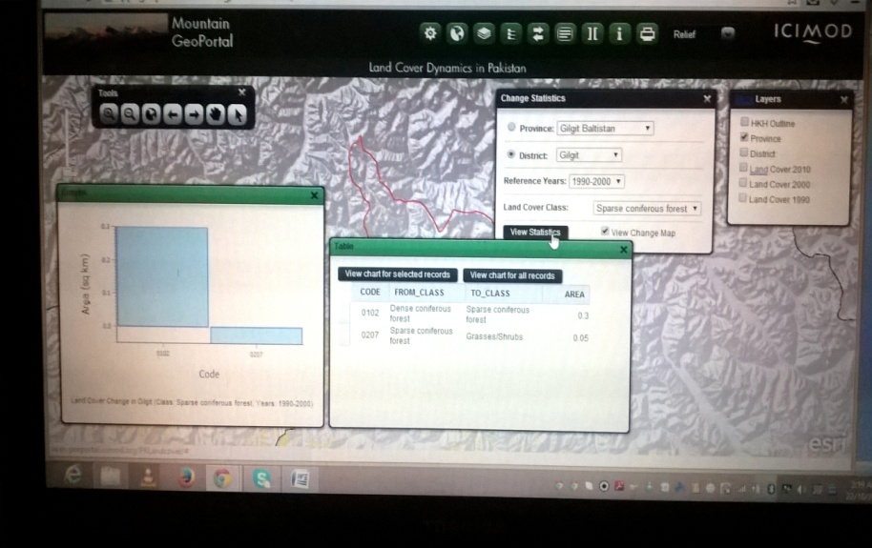

Figure 1: ICIMOD’s Mountain Geoportal

## **8.3 Capacity Building and Training**

Pakistan has organized and conducted several capacity building and training workshops since 2009 to develop and enhance the human capacity on REDD+ but training to the right person has always been an issue. Most of the provinces are building their capacities on adhoc basis by giving trainings to the staff hired on project basis or to the staff without having any relevant understanding or academic or professional background. During provincial meetings conducted for the CBNA and the working group meetings all the provinces have strongly recommended that clear TOR’s should be developed to ensure the trainings to the regular professional staff with relevant background and experience. It is also recommended that TOT training workshops should be arranged at national level to develop master trainers who will further train relevant staff of their respective forest departments. The following REDD+ relevant areas have been identified where capacity building and trainings are required;

* + - 1. International Policy Context on REDD+
      2. Field based inventory methods
      3. Satellite based inventory methods
      4. Statistics for forest carbon accounting
      5. Knowledge of IPCC guidelines for LULUCF and AFOLU sector
      6. Communication (reporting) to the UNFCCC

The short term trainings have low impact in building the capacities especially on the technical elements of REDD+ MMRV. It is recommended to initiate academic certificate course (at least of one month) integrating all the above mentioned training areas.

## **8.4 Role of NGO’s and Private Sector**

As suggested by UNFCCC in the principles of NFMS for REDD+ MMRV, the NFMS for REDD+ MMRV should have national ownership and the role of partner organizations is limited to technical assessment and capacity building. There are various other government and non-government organizations in the country like PFI, EPA, GCISC, AHKNCRD, SUPARCO WWF-Pakistan, ICIMOD, UNDP, LEAD and IUCN working on different thematic areas (policy, capacity building, targeted support funds, SLMS, GHG-Is etc) relevant to REDD+. Consultative meetings were conducted with the technical representatives/ heads of some of these organizations to assess their potential capacity that could benefit the REDD+ initiatives in Pakistan. These organizations can be approached for their possible contributions in REDD+. The assessment of their capacities is attached as annexure V.

## **8.5 Information on Safeguards**

The past inventories lack information on social and environmental safeguards. In the proposed institutional setup for REDD+ R-PP the REDD+ relevant technical working groups have been established both at national and provincial level. One of the working groups is on “REDD+ relevant safeguards” to ensure that all the relevant safeguards are properly respected and addressed. These working groups can be activated to enhance their knowledge and conduct research on relevant safeguards to extract the required information for better decision making and efficient management strategies. Financial support need to be provided to the working groups enabling them to conduct the research.

## **8.6 Data Verification (Quality Control)**

The transparency was not ensured in the past forest inventories as these inventories were not available for public review and lacks clarity of data verification (quality control). Major problems of data quality (availability, accuracy and reliability) in forest inventories remain unresolved. Issues like lack of data and uncertainty prevail in many cases. To ensure transparency, provincial and national quality control panels with relevant multi stakeholder’s representation could be developed for data verification at multiple levels. Reliability and final approval of the data needs to be linked to the verification processes of provincial and national quality control panels.

# References:

1. Abdul Raqeeb, Syed Moazzam Nizami, Aamir Saleem, Mohammad Hanif. 2014. Characteristics and Growing Stocks Volume of Forest Stand in Dry Temperate Forest of Chilas Gilgit-Baltistan. Open Journal of Forestry.,  4: 231-238 (IF; 0.288)
2. Adnan Ahmad and Syed Moazzam Nizami. 2014. Estimation of Carbon Stocks in Different Land Uses of Kumrat Valley Hindu Kush Region of Pakistan. Accepted in Journal of Forestry Research., 25(3). (IF: 0.882)
3. Adnan Ahmad, Sarwat N. Mirza and S. M. Nizami. 2014. Assessment of biomass and carbon stocks in coniferous forest of Dir Kohistan, KPK. Pak. J. Agric. Sci., 51(2): 35-350. ( IF; 1.29)
4. Ahmad S.S, Abbasi. Q (2011), Assessment of Forest Cover Decline in Pakistan: A GIS Perspective, International Journal of Environmental Science, Volume 2, No.1.
5. Ashraf, M. (1992a) Forest Policy, Tenure, and Legislation. Background Paper for

Forestry Sector Master Plan of Pakistan. Government of Pakistan, Islamabad.

1. Babar et.al (2006), A Critical Analysis of Forest Policies of Pakistan: Implications for Sustainable Livelihoods, Mitigation and Adaptation Strategies for Global Change.
2. Erika et.al (2012), Assessing capacities of non-Annex I countries for national forest monitoring in the context of REDD+, Environmental Science and Policy, Science Direct, Pp 33 – 48, 2012.
3. FAO. (2006). Global Forest Resources Assessment 2005 – Progress towards sustainable forest management. FAO Forestry Paper 147. Food and Agriculture Organization, Rome, Italy.
4. FAO. (2006). National Forest Communication Strategy for Pakistan.
5. FAO. (2007). Brief on National Forest Inventory of Pakistan, Forest Resource Development Service, MAR-SFM Working Paper 25/ 2007, Food and Agriculture Organization of United Nations, June 2007, Rome Italy.
6. FAO. (2009). Asia Pacific Forestry Outlook. Outlook of Pakistan’s Forest, 2009
7. FAO. (2010). Global Forest Resources Assessment 2010. FAO Forestry Paper 163. Food and Agriculture Organization, Rome, Italy
8. FCPF. (2013). Pakistan’s REDD+ Readiness Preparation Proposal.
9. GoP 1992, FSMP 1992. Ried, Collins & Associates, Canada and Silvi consultant Ltd. Sweden.
10. GoP, 2004. National Forest and Range land Resource Assesment Study (NFRRAS), 2004, Pakistan Forest Institute, Peshawar.
11. GoP, 2012, Land Cover Atlas of Pakistan, 2012. Syed Said Badshah Bukhari, Ali Hider, Mohd. Tahir Laeeq, Pakistan Forest Institute Peshawar.
12. Hasan, L. (2008). An Anatomy of State Failures in Forest Management in Pakistan. 23 AGM papers (pp.1-25). Islamabad: Pakistan Society of Development Economics.
13. Hussain, K., (2013). Understanding Policy and Institutional Setup in Context of Pakistan’s REDD+. Proceedings of the meeting on International Expert Group Meeting on Geospatial Information Systems for Multi Scale Forest Biomass Assessment and Monitoring of the Hindu Kush-Himalayan Region. International Centre for Integrated Mountain Development Kathmandu Nepal, December, 2013.
14. Javed. (2011). Mainstreaming Pakistan for Reducing Emissions from Deforestation and Forest Degradation Plus (REDD+): The way forward to Readiness Phase, policy paper series no. 8, September, 2011.
15. Khurshid Alam and Syed Moazzam Nizami. 2014. Assessing Biomass Expansion Factor of Birch Tree Betula Utilis D. DON.Open Journal of Forestry., 4:181-190 (IF; 0.288)
16. Mehreen Abbas, S. M. Nizami, Aamir Saleem, Saeed Gulzar and Irshad A. Khan..2011. Biomass expansion factors of *Olea ferruginea* (Royle) in sub tropical forests of Pakistan. African Journal of Biotechnology.,10(9):1586-1592.
17. Nizami S.M. (2010). Estimation of Carbon Stocks in Subtropical Managed and Unmanaged Forests of Pakistan. Retrieved from <http://prr.hec.gov.pk/Thesis/609S.pdf>
18. Nizami, S.M., S.N. Mirza, S. Livesly, S. Arndt, J.C. Fox, I.A. Khan and T. Mahmood. 2009. Estimating carbon stocks in sub tropical pine (*Pinus roxburghii*) forests of Pakistan . Pak.J.Agric. Sci., 46(4): 266-270.(IF: 1.240).
19. PFI. (2007). Evaluation of Forest Monitoring, Assessment and Reporting Systems in Pakistan, Pakistan Forest Institute, 2007
20. Proceedings of National Consultation Workshop on SEPC for REDD+ Safeguards, 2012.
21. Proceedings of 1st Working Group Meetings on NFMS, 2013
22. Proceedings of 2nd Working Group Meetings on NFMS, 2013
23. Proceedings of national consultation workshop in NFMS, 2014
24. Qamer F.M., Abbas, S., Saleem, R., Shehzad, K., Iqbal. A., (2010). Forest Cover Change Assessment using Satellite Images in Swat and Shangla Districts, NWFP, Pakistan. WWF – Pakistan, Lahore.
25. Qamer et.al. (2010). Land Cover Change Analysis of Selected HKH Regions of Pakistan. International Centre for Integrated Mountain Research (ICIMOD), Nepal and World Wide Fund for Nature (WWF), Pakistan, 2010.
26. Syed Moazzam Nizami. 2012. Assessment of the carbon stocks in sub tropical forests of Pakistan for reporting under Kyoto protocol. J.For.Res. 23(3): 377-384 (IF:0.882)
27. The Daily Jang. (2010). Increase in forest area is not possible without amending the Forest Act, Rawalpindi, April 01, 2010
28. The Daily Nation. (2010). Need to revamp forest resources, Islamabad, Money plus, April 26, 2010.
29. The State of Forests in Pakistan through a Pressure-State-Response Framework, Working Paper Series No. 82, 2002
30. UNFCCC. (2003). Pakistan’s Initial National Communication on Climate Change November, 2003.
31. UNFCCC, 2009. Methodological guidance for activities relating to reducing emissions from deforestation and forest degradation and the role of conservation, sustainable management of forests and enhancement of forest carbon stocks in developing countries. Decision 4/CP.15. Available at: http://unfccc.int/resource/docs/2009/cop15/eng/11a01.pdf#page=11.
32. UNFCCC, 2010. Outcome of the work of the Ad Hoc Working Group on long-term Cooperative Action under the Convention – C. Policy approaches and positive incentives on issues relating to reducing emissions from deforestation and forest degradation in developing countries; and the role of conservation, sustainable management of forests and enhancement of forest carbon stocks in developing countries. UNFCCC COP 16 Cancun Available at: http://unfccc.int/files/meetings/cop_16/application/pdf/cop16_lca.pdf.
33. Wani, B.A. (2005). National Forest Policy Review, Ministry of Environment Pakistan.
34. WWF – P. (2013). Draft Report, District Wise Forest Cover Assessment of Pakistan. International Centre for Integrated Mountain Research (ICIMOD), Nepal and World Wide Fund for Nature (WWF), Pakistan, 2010.
35. WWF – P. (2013). Land Cover Change Analysis of Murree Forest Division. World Wide Fund for Nature (WWF), Pakistan, 2013.
36. Yusuf. M. (2009), Legal and Institutional Dynamics of Forest Management in Pakistan

# Annexure – I: Participants Attendence Sheet of Provincial Meetings

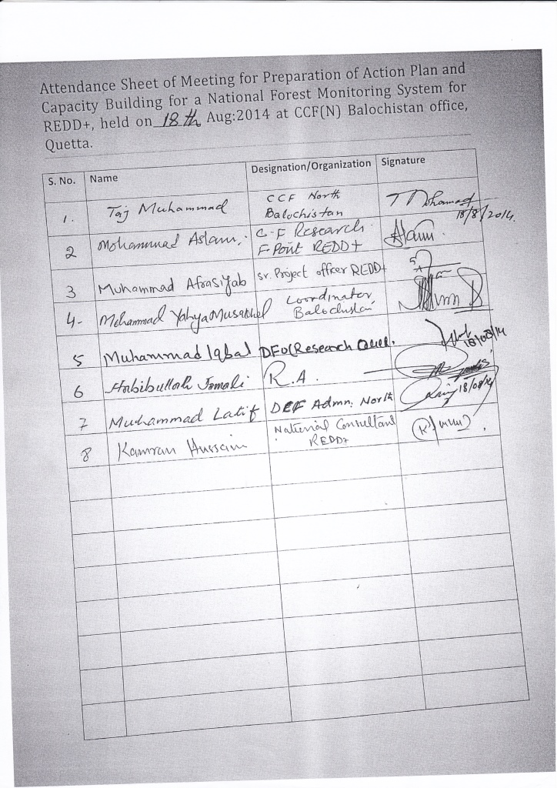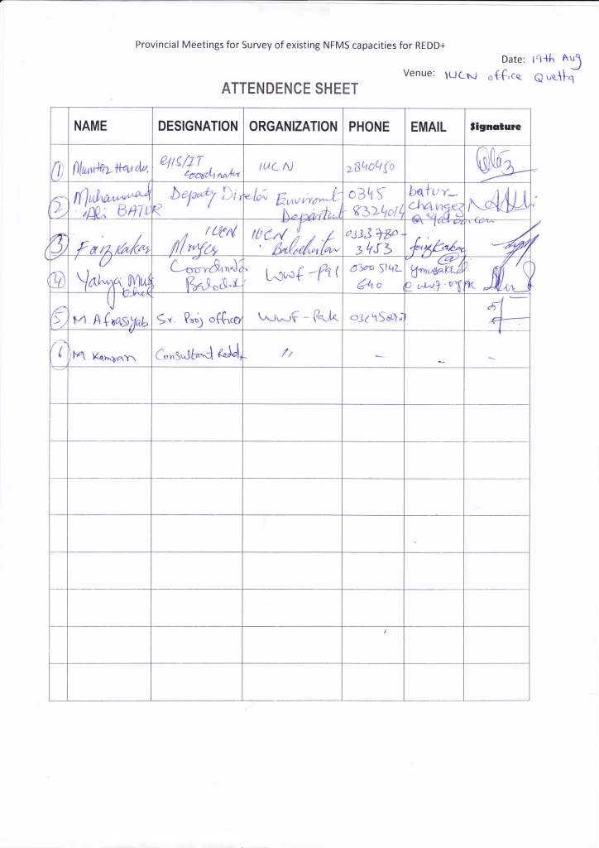

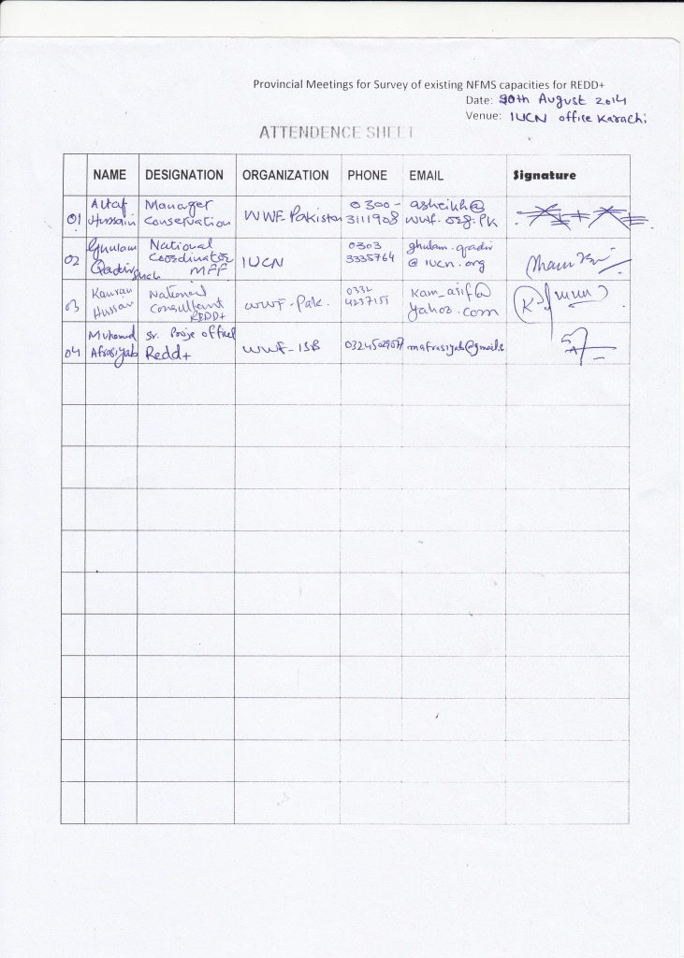

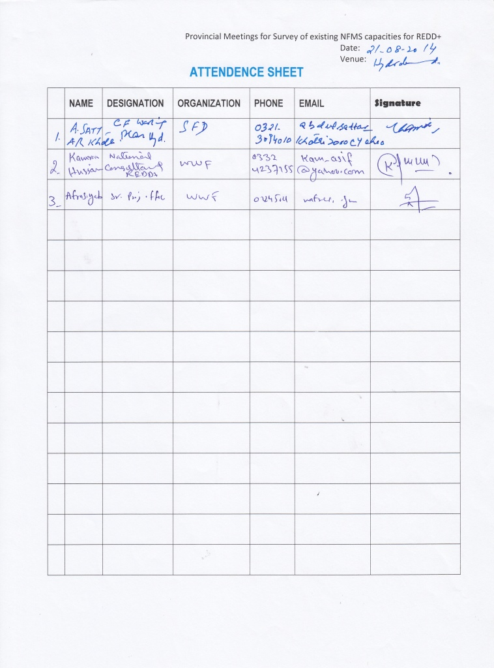 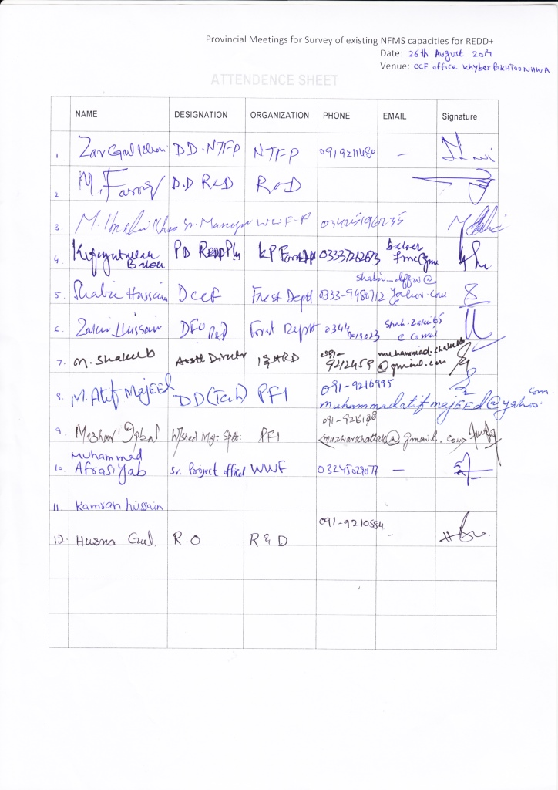 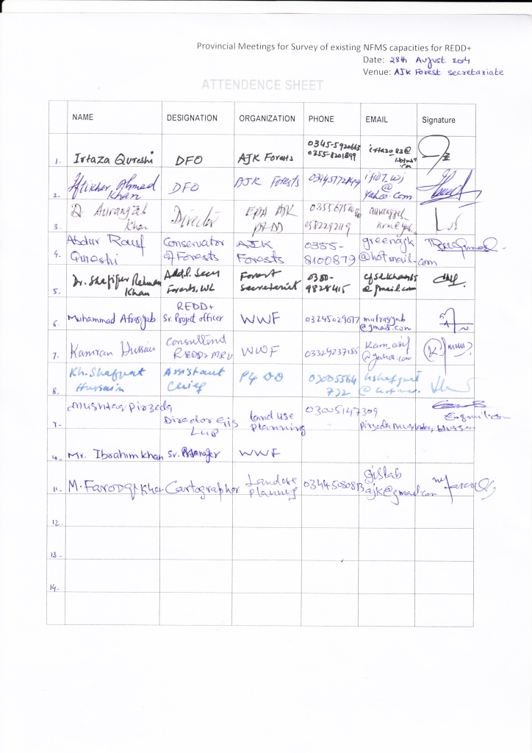 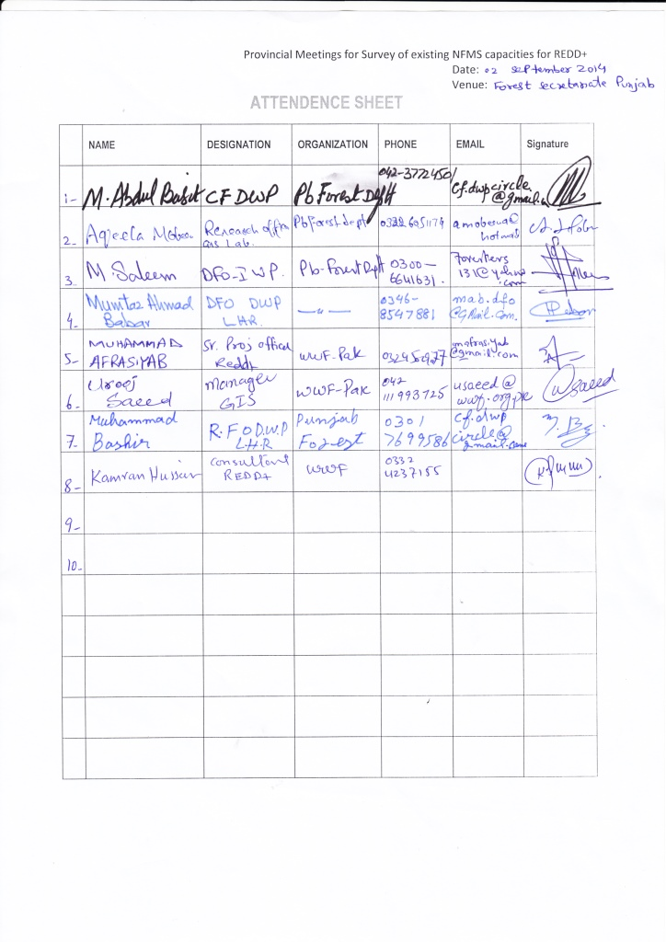 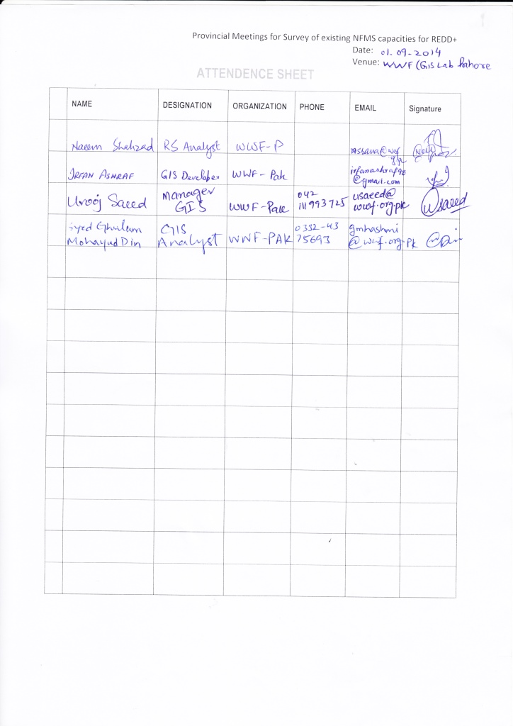

# Annexure – II: Checklist for CBNA for NFMS for REDD+ MMRV

***Component 1: Satellite Land Monitoring System (SLMS)***

***Sub-component 1.1: Data Availability and Accessibility***

**Q. 1 Is the data regarding satellite based forest monitoring available in the province/ territory?**

1. Yes 2. No

(If your answer is “Yes” then go to 1.1 - 1.8)

**1.1 What type of data is currently available (please tick and give additional required details)?**

(i) GT Sheets (ii) Satellite Images

Scale: ______________________________ Sensor: ___________________________

Year: ______________________________ Temporal Resolution: ________________

Format (digital or analogue):____________ Spatial Resolution: __________________

Spectral Resolution: _________________

Spatial Coverage: ___________________

Interpretation Procedure (Pixel or object based):

______________________________________

(iii) Aerial Photographs (iv) Land use/ Forest Cover Maps

Year: ______________________________ Year: _____________________________

Format (Digital or analogue): ___________ Format (Digital or analogue): __________

Scale: _____________________________ Land use Classification Scheme: ________

__________________________________

(v) Other (Please specify): ________________

**1.2 How the above data is acquired?**

(i) Acquired from freely available web domains at global level (please specify): ________________________________

(ii) Procured from national institutions having requisites (please specify the name of institution and costs incurred to acquire the data): _______________________________________________________________________________

(iii) Procured from international institutions having requisites (please specify the name of institution and costs incurred to acquire the data): ________________________________________________________________________________

**1.3 Is there any definitions on forest or other land use were followed for SLMS?**

1. Yes (if yes then tick the relevant box below) 2. No

* Country specific definitions (please give details with justification in a separate paper)
* IPCC Definitions (please provide reference?)
* Others (FAO, World Bank etc) please specify?

**1.4 Has any methodological standards followed?**

1. Yes (if yes then please tick the relevant box and give details) 2. No

* IPCC standard methodology (19996 2000 GPG LULUCF 2006Guidelines )
* Others (please specify) ______________________________________________________________________________________________

**1.5 Is there any agreement at national or provincial level on the standard methodology used for SLMS?**

1. Yes (if yes, please specify either national or provincial) 2. No

**1.6 Are the uncertainties addressed and/or reduced?**

1. Yes (if yes then tick which uncertainty parameters are addressed) 2. No

* Data pre-processing
* Ground truthing
* Verification of accuracy through error matrix

**1.7 Is the data accessible?**

1. Yes (if yes then tick the relevant box below) 2. No

* The data is accessible within the department in digital format
* The data is accessible within the department published in the form of papers, reports etc
* The data is accessible with other organization in digital format

(Please specify the name of institution): ______________________________________

* The data is accessible with other institution published in the form of papers, reports etc

(Please specify the name of institution): ______________________________________

**1.8 How would you rank your organization regarding data availability and accessibility?**

1. (Low) 2. (Average)

3. (Advanced)

***Sub-Component 1.2: Technical Capabilities (Equipment and Logistics)***

**Q. No. 2 Do you have the technical capabilities required for the satellite based forest monitoring system?**

1. Yes 2. No

(If “Yes” then go to 2.1 – 2.5)

**2.1 Have you made any institutional arrangements for Satellite based forest monitoring system?**

1. Yes 2. No

(if yes please give separate details about institutional arrangements with roles and responsibilities)

**2.2 Is there any digital lab with GIS/ RS facility established in your organization?**

1. Yes 2. No

(If yes please tick which equipments and tools are available at the lab)

* High definition computer machine to store heavy data
* High speed internet connection
* Licensed Software
* Web hosting service
* Web domain
* High accuracy handled GPS system
* Field equipment for ground truthing

**2.3 Are there other potential institutions (Govt., NGO’s, academic etc) with relevant technical capabilities?**

1. Yes 2. No

(if yes please specify the names of the relevant institutions)

1. Government 2. NGO’s 3. Academia

__________________ ______________ ___________________

__________________ ______________ ___________________

__________________ ______________ ___________________

**2.4 Is there any system of networking with other relevant institutions?**

1. Yes 2. No

(if yes please give separate details)

**2.5 How would you rank your organization regarding technical capabilities?**

1. (Low) 2. (Average)

3. (Advanced)

***Sub – Component 1.3: Human Capacity to Process (analyse) Information Related to SLMS***

**Q.No.3 Do you have the human capacity to process (analyse) information related to SLMS?**

1. Yes 2. No

(If “Yes” then answer 3.1, 3.2 and 3.3)

**3.1 Do you have the adequate human resource with the knowledge and understanding of relevant national/ international negotiations and decisions?**

1. Yes 2. No

(If “Yes” then tick the appropriate box)

* Knowledge of International UNFCCC negotiations and decisions relevant to REDD+ MRV
* Knowledge and understanding of IPCC guidelines and guidance (GPG-LULUCF 2003, and 2006 guidelines)
* Knowledge of national REDD+ implementation strategy and objectives

**3.2 Do you have the expertise in spatial and temporal analysis and use of modelling tools?**

1. Yes 2. No

(If “Yes” then tick the appropriate box)

* Understanding of DD drivers and factors
* Expertise and human resources accessing, processing and interpretation of multi-data remote sensing imagery for forest changes (GIS/ RS experts)
* Approach for dealing with technical challenges of image interpretation (cloud cover, geo referencing, missing data, topographic and elevation factors etc)
* Expertise to use GPS system in the field for ground truthing

**3.3 How would you rank your organization regarding human capacity to process (analyse) information related to SLMS?**

1. (Low) 2. (Average)

3. (Advanced)

***Sub-component 1.4: Human capacity for the preparation of reports from the SLMS***

**Q.No.4 Do you have the adequate human capacity for the preparation of reports from SLMS?**

1. Yes 2. No

(If “Yes” then answer 4.1and 4.2)

**4.1 Which capacities and human resource currently available?**

* Professional report writing skills

Non 1-3 4-6 6-9 10 and above

* Capacity to review, consolidate and integrate the existing data and information on SLMS

Non 1-3 4-6 6-9 10 and above

* Understanding of UNFCCC and IPCC reporting requirements (prescribed guidelines, formats and procedures of reporting to designated organizations

non 1-3 4-6 6-9 10 and above

* Capacity to review, consolidate and integrate the existing data and information on SLMS

Non 1-3 4-6 6-9 10 and above

* Capacity to transform image analysis into reports

Non 1-3 4-6 6-9 10 and above

**4.2 How would you rank your organization regarding human capacity for the preparation of reports from the SLMS?**

1. (Low) 2. (Average)

3. (Advanced)

***Sub-component 1.5:******Capabilities related to data verification (quality control and quality assurance)***

**Q.No.5 Do you have the capabilities related to data verification (quality control and quality assurance)**

1. Yes (If “Yes” then answer 5.1and 5.2) 2. No

**5.1 Specify which capabilities are currently available?**

* Expertise on the application of statistical methods to quantify, report and analyze uncertainties for all relevant information (i.e. area change, change in carbon stocks etc.) using, ideally, a sample of higher quality information.
* Understanding of error sources and uncertainties in the assessment process
* Data infrastructure, information technology (suitable hard/software) and human resources to maintain and exchange data and quality control

**5.2 How would you rank your organization regarding Capabilities related to data verification (quality control and quality assurance)?**

1. (Low) 2. (Average)

3. (Advanced)

***Sub-component 1.6: Training Facilities***

**Q. No. 6 Are training facilities available in the province?**

1. Yes 2. No

(If “Yes” then answer 6.1, 6.2 and 6.3)

**6.1 What training facilities are currently available?**

* Any training unit/ cell
* Local Experts/ Trainers on SLMS (please provide number _____)
* Budget allocations for staff training
* Relevant Training Equipments

**6.2 Are there other institutions with relevant training facilities in the province?**

1. Yes 2. No

(If “Yes” then please specify the names of the institutions)

1. _______________________________
2. _______________________________
3. _______________________________
4. _______________________________

**6.3** **How would you rank your organization regarding training facilities?**

1. (Low) 2. (Average)

3. (Advanced)

***Sub-component 1.7: Areas of Improvement***

**Q.No. 7 Based on the information provided above, please specify the areas of improvement.**

|  |  |  |  |  |  |
| --- | --- | --- | --- | --- | --- |
| Data availability and accessibility | Technical capabilities (equipment and logistics) | Human capacity for processing (analysis) information related to SLMS | Human capacity for the preparation of reports fro SLMS | Capabilities relating to data verification (quality control and quality assurance) | Training facilities |
| □ 1. -------------  □ 2. -------------  □ 3. -------------  □ 4. -------------  □ 5. -------------  □ 6. ------------ | □ 1. -----------------  □ 2. -----------------  □ 3. -----------------  □ 4. -----------------  □ 5. -----------------  □ 6. ----------------- | □ 1. ---------------------  □ 2. ---------------------  □ 3. ---------------------  □ 4. ---------------------  □ 5. ---------------------  □ 6. --------------------- | □ 1. ----------------------  □ 2. ----------------------  □ 3. ----------------------  □ 4. ----------------------  □ 5. ----------------------  □ 6. ---------------------- | □ 1. -------------------  □ 2. -------------------  □ 3. -------------------  □ 4. -------------------  □ 5. -------------------  □ 6. ------------------- | □ 1. ---------------  □ 2. ---------------  □ 3. ---------------  □ 4. ---------------  □ 5. ---------------  □ 6. --------------- |

**Q. No. 8 Do you need the support to fulfil the gaps regarding SLMS?**

1. Yes 2. No

(If “Yes” then tick the type of support needed and expand in each option the sub-component for which the support is required)

1. Financial 2. Administrative 3. Technical

_________________ ___________________ ___________________

_________________ ___________________ ___________________

**8.1 What mechanisms do you require by which the support could be delivered? Also specify the sub-component of SLMS)**

1. Specific expertise 2. Guidelines 3. Workshop

__________________ ___________________ ___________________

__________________ ___________________ ___________________

4. Direct funding 5. Other (specify)

___________________ ___________________

___________________ ___________________

**8.2 Do you have an estimation of the funding required? Also specify the sub-component of SLMS against each option.**

1. Yes (provide estimate for each sub-component below) 2. No 3. Require support to estimate the funding

* Data available and accessible ______________________________________________________________________
* Technical capabilities (equipment and logistics) _______________________________________________________
* Human capacity for processing (analysis) of the information related to the SLMS _______________________________
* Human capacity for the preparation of reports from the SLMS ______________________________________________
* Capabilities related to data verification (quality control and quality assurance) _______________________________
* Training facilities _______________________________________________________________________________

**8.3 Who will be the beneficiaries from the support?**

1. Indigenous/ local communities/ people 2. Civil Societies 3. Government Institution

4. Others (specify

***Component 2: National Forest Inventory (NFI)***

***Sub-component 2.1: Data Availability and Accessibility***

**Q. 1 Is the data on provincial/ national forest inventory available in the province/ territory?**

1. Yes 2. No

(If your answer is “Yes” then go to 1.1 - 1.8)

**1.1 What was the purpose of forest inventory?**

1.Biomass estimation for the whole forest areas in the province/ territory

2. Biomass estimation for specific forest types (please specify the types of forest) ---------------------------

3. Carbon estimation for the whole forest areas in the province/ territory

4. Carbon estimation for specific forest types (please specify) --------------------------------------------------

5. Others (please specify) -----------------------------------------------------------------------------------------------------

**1.2 What data collection methods/ techniques were used?**

1. Complete forest inventory measuring different parameters of all the trees

2. Sampling (Simple Random Stratified Systematic )

3. Plot configuration for measuring the trees of specific variable (diameter, height) class . Please also specify the plot design (rectangular , circular or square )

4. Plot configuration for measuring the trees of all variable (diameter, height) class . Please also specify the plot design (rectangular , circular or square )

**1.3 What parameters or variables were measured during the inventory?**

* Diameter at breast height
* Height of the tree
* Tree Volume
* Basal area
* Tree crown cover
* Carbon stock of a tree
* Other (please specify)

**1.4 Does the forest inventory follow the required UNFCCC/ IPCC guidance related to NFI?**

1. Yes 2. No

(If your answer is “Yes” then specify and tick the guidance criteria followed)

* Division of forest land into sub categories of “forest land remaining forest land” and “other land converted to forest land”
* Stratification of sub-categories based on forest type, specie, ecological zone, topography etc
* Agreement on definitions, reference units, monitoring variables, inventory methods and framework (please provide details separately if available)
* Details on forest area and carbon stock change with its link to the drivers of change (deforestation and degradation)
* Data on different carbon pools (above ground biomass, below ground biomass, dead organic matter, litter and soil) and consideration of impact on these different pools.
* Data on firewood removals, timber harvesting, harvested wood products.
* Detailed inventory in areas of forest change for REDD+ actions

**1.5 Are allometric equations and expansion factors available for specific forest areas and/ or tree species of province/ territory?**

1. Yes 2. No

(If your answer is “Yes” then specify forest type and/ or specie for which allometric equations and BEFs/ BCEFs are available)

* Forest Types:_______________________________________________________________________________________
* Species: ___________________________________________________________________________________________

**1.6 Have the uncertainties been reduced by considering UNFCCC and IPCC guidelines?**

1. Yes 2. No

(If your answer is “Yes” then specify and tick which uncertainties have been addressed)

* Uncertainties during the design and configuration of field sample plots
* Uncertainties during the taking measurements with equipments
* Uncertainties during compilation of data and application of statistical procedures
* Uncertainties related to data propagation from plot to strata and whole area

**1.7 Is the relevant data accessible?**

1. Yes (if yes then tick the relevant box below) 2. No

* The data is accessible within the department in digital format
* The data is accessible within the department published in the form of papers, reports etc
* The data is accessible with other organization in digital format

(Please specify the name of institution): ______________________________________

* The data is accessible with other institution published in the form of papers, reports etc

(Please specify the name of institution): ______________________________________

**1.8 How would you rank your organization regarding data availability and accessibility?**

1. (Low) 2. (Average)

3. (Advanced)

***Sub-Component 1.2: Technical Capabilities (Equipment and Logistics)***

**Q. No. 2 Do you have the technical capabilities required for the Forest Inventory System?**

1. Yes 2. No

(If “Yes” then go to 2.1 – 2.5)

**2.1 Have you made any institutional arrangements for forest inventories?**

1. Yes 2. No

(if yes please give separate details about institutional arrangements with roles and responsibilities)

**2.2** **Are field equipments/ tools required for forest inventory available?**

1. Yes 2. No

(If “Yes” then tick the appropriate box)

* GPS
* Base maps
* Measurement units
* Field equipment to establish permanent sample plots, Collect leaf, litter and herbs/ grass, collect soil sample and measure tree parameter (diameter, height, etc)

**2.3 Are there other potential institutions (Govt., NGO’s, academic etc) with relevant technical capabilities?**

1. Yes 2. No

(if yes please specify the names of the relevant institutions)

1. Government 2. NGO’s 3. Academia

__________________ ______________ ___________________

__________________ ______________ ___________________

__________________ ______________ ___________________

**2.4 Is there any system of networking with other relevant institutions?**

1. Yes 2. No

(if yes please give separate details)

**2.5 How would you rank your organization regarding technical capabilities?**

1. (Low) 2. (Average)

3. (Advanced)

***Sub – Component 1.3: Human Capacity to Process (analyse) Information Related to NFI***

**Q.No.3 Do you have the human capacity to process (analyse) information related to *NFI?***

1. Yes 2. No

(If “Yes” then answer 3.1, 3.2 and 3.3)

**3.1 Do you have the adequate human resource with the knowledge and understanding of relevant national/ international negotiations and decisions?**

1. Yes 2. No

(If “Yes” then tick the appropriate box)

* Knowledge of International UNFCCC negotiations and decisions relevant to REDD+ MRV
* Knowledge and understanding of IPCC guidelines and guidance (GPG-LULUCF 2003, and 2006 guidelines)
* Knowledge of national REDD+ implementation strategy and objectives

**3.2 Do you have the expertise in forest inventories?**

1. Yes 2. No

(If “Yes” then tick the appropriate box)

* Understanding of processes influencing terrestrial carbon stocks
* Understanding of DD drivers and factors
* Expertise and human resources for in-situ data collection of all required parameters and data processing
* Approach for dealing with technical challenges of sample designs and plot configuration in the field
* Expertise to use GPS system in the field

**3.3 How would you rank your organization regarding human capacity to process (analyse) information related to NFI?**

1. (Low) 2. (Average)

3. (Advanced)

***Sub-component 1.4: Human capacity for the preparation of reports from the NFI?***

**Q.No.4 Do you have the human capacity for the preparation of reports from NFI?**

1. Yes 2. No

(If “Yes” then answer 4.1and 4.2)

**4.1 Which capacities and human resource currently available?**

* Professional report writing skills

Non 1-3 4-6 6-9 10 and above

* Capacity to review, consolidate and integrate the existing data and information on NFI

Non 1-3 4-6 6-9 10 and above

* Understanding of UNFCCC and IPCC reporting requirements (prescribed guidelines, formats and procedures of reporting to designated organizations

non 1-3 4-6 6-9 10 and above

* Capacity to review, consolidate and integrate the existing data and information on NFI

Non 1-3 4-6 6-9 10 and above

* Capacity to transform field data and information into reports

Non 1-3 4-6 6-9 10 and above

**4.2 How would you rank your organization regarding human capacity for the preparation of reports from the NFI?**

1. (Low) 2. (Average)

3. (Advanced)

***Sub-component 1.5:******Capabilities related to data verification (quality control and quality assurance)***

**Q.No.5 Do you have the capabilities related to data verification (quality control and quality assurance)?**

1. Yes 2. No

(If “Yes” then answer 5.1and 5.2)

**5.1 Specify which capabilities are currently available?**

* Expertise on the application of statistical methods to quantify, report and analyze uncertainties for all relevant information (i.e. plot configuration, use of equipment, data compilation, error estimation and data propagation) etc.) using, ideally, a sample of higher quality information.
* Understanding of error sources and uncertainties in the assessment process
* Data infrastructure, information technology (suitable hard/software) and human resources to maintain and exchange data and quality control

**5.2 How would you rank your organization regarding Capabilities related to data verification (quality control and quality assurance)?**

1. (Low) 2. (Average)

3. (Advanced)

***Sub-component 1.6: Training Facilities***

**Q. No. 6 Are training facilities available in the province?**

1. Yes 2. No

(If “Yes” then answer 6.1and 6.3)

**6.1 What training facilities are currently available?**

* Any training unit/ cell
* Local Experts/ Trainers on NFI (please provide number _____)
* Budget allocations for staff training
* Relevant Training Equipments

**6.2 Are there other institutions with relevant training facilities in the province?**

1. Yes 2. No

(If “Yes” then please specify the names of the institutions)

1. _______________________________
2. _______________________________
3. _______________________________
4. _______________________________

**6.3** **How would you rank your organization regarding training facilities?**

1. (Low) 2. (Average)

3. (Advanced)

***Sub-component 1.7: Areas of Improvement***

**Q.No. 7 Based on the information provided above, please specify the areas of improvement.**

|  |  |  |  |  |  |
| --- | --- | --- | --- | --- | --- |
| Data availability and accessibility | Technical capabilities (equipment and logistics) | Human capacity for processing (analysis) information related to SLMS | Human capacity for the preparation of reports fro SLMS | Capabilities relating to data verification (quality control and quality assurance) | Training facilities |
| □ 1. -------------  □ 2. -------------  □ 3. -------------  □ 4. -------------  □ 5. -------------  □ 6. ------------ | □ 1. -----------------  □ 2. -----------------  □ 3. -----------------  □ 4. -----------------  □ 5. -----------------  □ 6. ----------------- | □ 1. ---------------------  □ 2. ---------------------  □ 3. ---------------------  □ 4. ---------------------  □ 5. ---------------------  □ 6. --------------------- | □ 1. ----------------------  □ 2. ----------------------  □ 3. ----------------------  □ 4. ----------------------  □ 5. ----------------------  □ 6. ---------------------- | □ 1. -------------------  □ 2. -------------------  □ 3. -------------------  □ 4. -------------------  □ 5. -------------------  □ 6. ------------------- | □ 1. ---------------  □ 2. ---------------  □ 3. ---------------  □ 4. ---------------  □ 5. ---------------  □ 6. --------------- |

**Q. No. 8 Do you need the support to fulfil the gaps regarding NFI?**

1. Yes 2. No

(If “Yes” then tick the type of support needed and expand in each option the sub-component for which the support is required)

1. Financial 2. Administrative 3. Technical

_________________ ___________________ ___________________

_________________ ___________________ ___________________

**8.1 What mechanisms do you require by which the support could be delivered? Also specify the sub-component of NFI)**

1. Specific expertise 2. Guidelines 3. Workshop

__________________ ___________________ ___________________

__________________ ___________________ ___________________

4. Direct funding 5. Other (specify)

___________________ ___________________

___________________ ___________________

**8.2 Do you have an estimation of the funding required? Also specify the sub-component of NFI against each option.**

1. Yes (provide estimate for each sub-component below) 2. No 3. Require support to estimate the funding

* Data available and accessible ______________________________________________________________________
* Technical capabilities (equipment and logistics) _______________________________________________________
* Human capacity for processing (analysis) of the information related to the NFI _____________________________
* Human capacity for the preparation of reports from the NFI ____________________________________________
* Capabilities related to data verification (quality control and quality assurance) _______________________________
* Training facilities _______________________________________________________________________________

**8.3 Who will be the beneficiaries from the support?**

1. Indigenous/ local communities/ people 2. Civil Societies 3. Government Institution

4. Others (specify

***Component 3: Green House Gas (GHG) Inventory***

***Sub-Component 3.1 Data Availability and Accessibility***

**Q.1 Are green house inventories ever conducted in the province/ territory?**

1. Yes 2. No

(If your answer is “Yes” than answer 1.1 to 1.9)

**1.1 The GHG inventory was carried out for:**

* Emissions by sources
* Removals by sink categories
* Both emissions by sources and removals by sinks
  1. **Which gases were reported in the inventory?**

_______________________________________________________________________________________________________

**1.3 Identify the Land Use Categories for which GHG inventory data were collected?**

* IPCC Land use categories (Forest Land, Crop Land, Grass Land, Wetland, Settlements, Other Land)
* Others (please specify) _______________________________________________________________________________________________________

**1.4 Are there any standard definitions (forest, land use categories etc) adopted for GHG Inventory?**

1. Yes (if yes then tick the relevant box below) 2. No

* Country specific definitions (please give details with justification in a separate paper)
* IPCC Definitions (please provide reference?)
* Others (FAO, World Bank etc) please specify?

**1.5 Has any methodological standards followed?**

1. Yes (if yes then please tick the relevant box and give details) 2. No

* IPCC standard methodology (19996 2000 GPG LULUCF 2006Guidelines )
* Others (please specify) ______________________________________________________________________________________________
  1. **Has Key Category been identified?**

1. Yes (if yes then please give details) 2. No

**______________________________________________________________________________________________________________________________________________________________________________________________________________**

**1.7 Which method has been used for GHG inventory?**

* + Gain Loss Method (please justify the reason to choose the method) _____________________________________________________________________________________________
  + Stock Difference Method (please justify the reason to choose the method) _____________________________________________________________________________________________

**1.8 Is the data accessible?**

1. Yes (if yes then tick the relevant box below) 2. No

* The data is accessible within the department in digital format
* The data is accessible within the department published in the form of papers, reports etc
* The data is accessible with other organization in digital format

(Please specify the name of institution): ______________________________________

* The data is accessible with other institution published in the form of papers, reports etc

(Please specify the name of institution): ______________________________________

**1.9 How would you rank your organization regarding data availability and accessibility?**

1. (Low) 2. (Average)

3. (Advanced)

***Sub-Component 3.2 Technical Capabilities***

**Q.No.2 Are there institutional, legal and procedural arrangements made for GHG inventory?**

1. Yes 2. No

(If yes than answer 2.1 to 2.6)

* 1. **Is National/ Provincial single entity designated to deal with GHG inventory?**

1. Yes (if yes, please specify) 2. No

* 1. **Are roles and responsibilities allocated to all relevant entities/ organizations to perform specific functions of Planning, Preparation and Management for National Inventory System**

1. Yes 2. No

(If yes, please mention the entities with allocated responsibilities in a separate paper)

* 1. **Are MoUs, Laws, Decrees and/ or Agreements have been made between entities to give legal authority to perform specific functions (please provide details if any)**

1. Yes 2. No

(If yes, please provide relevant details)

**2.4 Is there any agreement at national and/ or provincial level on the standard methodological procedures to be followed for GHG inventory?**

1. Yes 2. No

(If yes, please provide relevant details)

**2.5** **Are the financial resources, facilities and required equipments available with the designated entity to perform the GHG inventory?**

1. Yes 2. No

(If yes, please provide relevant details)

**2.6 How would you rank your organization regarding technical capabilities?**

1. (Low) 2. (Average)

3. (Advanced)

**Note: The rest of the sub-components i.e. Q.No 3 to Q.No.7 are also relevant to component 1(SLMS) and component 2 (NFI). However, the need assessment for the first two sub-components of GHG inventory could be responded by answering the following questions.**

**Q. No. 8 Do you need the support to fulfil the gaps regarding GHG?**

1. Yes 2. No

(If “Yes” then tick the type of support needed and expand in each option the sub-component for which the support is required)

1. Financial 2. Administrative 3. Technical

_________________ ___________________ ___________________

_________________ ___________________ ___________________

**8.1 What mechanisms do you require by which the support could be delivered? Also specify the sub-component of GHG)**

1. Specific expertise 2. Guidelines 3. Workshop

__________________ ___________________ ___________________

__________________ ___________________ ___________________

4. Direct funding 5. Other (specify)

___________________ ___________________

___________________ ___________________

**8.2 Do you have an estimation of the funding required? Also specify the sub-component of GHG against each option.**

1. Yes (provide estimate for each sub-component below) 2. No 3. Require support to estimate the funding

* Data available and accessible ______________________________________________________________________
* Technical capabilities (equipment and logistics) _______________________________________________________
* Human capacity for processing (analysis) of the information related to the GHG _______________________________
* Human capacity for the preparation of reports from the GHG ______________________________________________
* Capabilities related to data verification (quality control and quality assurance) _______________________________
* Training facilities _______________________________________________________________________________

**8.3 Who will be the beneficiaries from the support?**

1. Indigenous/ local communities/ people 2. Civil Societies 3. Government Institution

4. Others (specify

***Component 4: National Communication (NC)***

***Sub-component 1: Preparation Method and Regularity***

**Q.No.1 Are national/ provincial arrangement in place for the preparation of NC?**

1. Yes 2. No

(If yes, give details of national arrangements)

**1.1 Since Pakistan submitted its first NC in 1993, is there any regularity in the preparation of NC?**

1. Yes 2. No

(If yes, give details how regular the NC is prepared)

**1.2 How would you rank your organization regarding preparation methods and regularity?**

1. (Low) 2. (Average)

3. (Advanced)

***Sub-component 2: Task Force***

**Q.No.2 Is there any task force established with specific roles and responsibilities for the preparation of NC?**

1. Yes 2. No

(If Yes, give details about human and financial resources available with the task force)

(If No, than give information if relevant experts are identified and available in the country in government organizations, NGOs, universities and/ or individuals)

**2.1 How would you rank your organization regarding task force on NC?**

1. (Low) 2. (Average)

3. (Advanced)

***Sub-component 3: Analysis of Areas for Improvement***

**Q.No.3 Identify the areas of improvement for the preparation of NC.**

**1. ______________________________________________________________________________________________**

**2. ______________________________________________________________________________________________**

**3. ______________________________________________________________________________________________**

**Q. No. 4 Do you need the support to fulfil the gaps regarding NC?**

1. Yes 2. No

(If “Yes” then tick the type of support needed and expand in each option the sub-component for which the support is required)

1. Financial 2. Administrative 3. Technical

_________________ ___________________ ___________________

_________________ ___________________ ___________________

**4.1 What mechanisms do you require by which the support could be delivered? Also specify the sub-component of NC)**

1. Specific expertise 2. Guidelines 3. Workshop

__________________ ___________________ ___________________

__________________ ___________________ ___________________

4. Direct funding 5. Other (specify)

___________________ ___________________

___________________ ___________________

**4.2 Do you have an estimation of the funding required? Also specify the sub-component of NC against each option.**

1. Yes (provide estimate for each sub-component below) 2. No 3. Require support to estimate the funding

* Preparation method and regularity ______________________________________________________________________
* Task force _________________________________________________________________________________________
* Other (if any) _______________________________________________________ _______________________________

**4.3 Who will be the beneficiaries from the support?**

1. Indigenous/ local communities/ people 2. Civil Societies 3. Government Institution

4. Others (specify

# Annexure – III: Provincial Need Assessment for National Forest Monitoring System for REDD+ MMRV

|  |  |  |  |  |  |  |  |  |
| --- | --- | --- | --- | --- | --- | --- | --- | --- |
| **Aspects** | **Province/ Territory** | **Direct Funding** | | **Technical** | | | **Administrative**  **(human resource, regulation, management control and framework, institutional arrangements)** | **Remarks** |
| **Estimated** | **Require Support to Estimate** | **Specific Expertise**  **(consultant, regular staff hiring)** | **Guidelines** | **Training Workshops** |
| **Data Availability and Accessibility** | GB |  | √ |  | √ |  |  | * Estimates are required for LiDAR Imagery * Require guidelines to develop an archive system to ensure data availability and accessibility * The forest carbon based inventory data need to be carried out at tier 3 level as per the IPCC guidelines * Allometric equations need to be developed * Reference Emission Levels need to be developed at provincial level |
| AJK |  | √ |  | √ |  |  | * Estimates are required for high resolution data (0.5 m) for the whole province and LiDAR Imagery for areas of deforestation * Require guidelines to develop an archive system to ensure data availability and accessibility * The forest carbon based inventory data need to be carried out at tier 3 level as per the IPCC guidelines * Allometric equations need to be developed * Reference Emission Levels need to be developed at provincial level |
| KPK |  | √ |  | √ |  |  | * Estimates are required for high resolution data (0.5 m) for the forest areas showing change trends and LiDAR Imagery for areas of deforestation * Require guidelines to develop an archive system to ensure data availability and accessibility * The forest carbon based inventory data need to be carried out at tier 3 level as per the IPCC guidelines * Allometric equations need to be developed * Reference Emission Levels need to be developed at provincial level |
| Punjab |  | √ |  | √ |  |  | * Estimates are required for high resolution data (0.5 m) for the whole province * Require guidelines to develop an archive system to ensure data availability and accessibility * The forest carbon based inventory data need to be carried out at tier 3 level as per the IPCC guidelines * Allometric equations need to be developed * Reference Emission Levels need to be developed at provincial level |
| Sindh |  | √ |  | √ |  |  |
| Baluchistan |  | √ |  | √ |  | √ | * Estimates are required for high resolution data (0.5 m) for the whole province * Require guidelines to develop an archive system to ensure data availability and accessibility * Need administrative support regarding institutional arrangements and regulations to control over data management * The forest carbon based inventory data need to be carried out at tier 3 level as per the IPCC guidelines * Allometric equations need to be developed * Reference Emission Levels need to be developed at provincial level |
| FATA |  |  |  |  |  | √ |
| **Technical Capabilities** | GB |  | √ |  |  |  |  | * Direct funding is required to purchase following Inventory equipment. * Rela-scope, Clinometers, Vertix, Differential GPS, Denso-meter, Digital cameras with GPS e.t.c * GIS software’s(E-Cognition, Arc GIS), high definition computers, Server with solar panels and batteries * Operational charges for field data collection * Mobile GIS * Iron Rods |
| AJK |  | √ |  | √ |  | √ | * Direct funding is required to purchase following Inventory equipment. * Rela-scope, Clinometers, Vertix, Differential GPS, Denso-meter, Digital cameras with GPS e.t.c * GIS software’s(E-Cognition, Arc GIS), high definition computers, Server with solar panels and batteries * Operational charges for field data collection * Mobile GIS * Iron Rods * GIS lab need to be functional, enhanced and strengthened * High data storage computer machine required * Need guidelines regarding logistic arrangements * Management framework need to be defined |
| KPK |  | √ |  |  |  |  | * Direct funding is required to purchase following Inventory equipment. * Rela-scope, Clinometers, Vertix, Differential GPS, Denso-meter, Digital cameras with GPS e.t.c * GIS software’s(E-Cognition, Arc GIS), high definition computers, Server with solar panels and batteries * Operational charges for field data collection * Mobile GIS * Iron Rods |
| Punjab |  | √ |  | √ |  |  | * Direct funding is required to purchase following Inventory equipment. * Rela-scope, Clinometers, Vertix, Differential GPS, Denso-meter, Digital cameras with GPS e.t.c * GIS software’s(E-Cognition, Arc GIS), high definition computers, Server with solar panels and batteries * Operational charges for field data collection * Mobile GIS. * Iron Rods * Need guidelines regarding logistic arrangements |
| Sindh |  | √ |  | √ |  |  | * Direct funding is required to purchase following Inventory equipment. * Rela-scope, Clinometers, Vertix, Differential GPS, Denso-meter, Digital cameras with GPS e.t.c * GIS software’s(E-Cognition, Arc GIS), high definition computers, Server with solar panels and batteries * Operational charges for field data collection * Mobile GIS. * Iron Rods * High storage computer machines are required * GIS Lab need to be functional, enhanced and strengthened * Management Framework need to be defined |
| Baluchistan |  | √ |  | √ |  | √ |
| FATA |  | √ |  | √ |  | √ | * Need support to estimate funding to purchase field equipment for forest carbon based inventory and to establish GIS lab with all relevant equipment necessary for SLMS, NFI and GHG * Guideline are needed to design management framework and logistic arrangements |
| **Human Capacity to Process and Analyze Information related to SLMS, NFI and GHG** | GB |  |  | √ |  | √ |  | * Consultant trainers are required to train the staff * The human capacity needs to be strengthened through field oriented REDD+ relevant trainings on SLMS, NFI and GHG * Specific training on LIDAR image processing and biomass estimation with reference to IPCC. * Training on new cost effective and recommended image processing Softwares. * Training on Mobile GIS and differential GPS. * Training on modern Forest inventory approaches * GIS programming & analysis/interpretation trainings. * Training on development of Reference Emission Levels |
| AJK |  |  | √ |  | √ |  |
| KPK |  |  |  |  | √ |  |
| Punjab |  |  | √ |  | √ |  |
| Sindh |  |  | √ |  | √ |  |
| Baluchistan |  |  | √ |  | √ |  |
| FATA |  |  | √ |  | √ |  |
| **Human Capacity to Report on the Information related to SLMS, NFI and GHG** | GB |  |  |  |  | √ |  | * Practice oriented trainings on UNFCCC/ IPCC reporting requirements to report on the information related to SLMS, NFI and GHG |
| AJK |  |  | √ |  | √ |  | * Consultant trainers are required to train the staff * Practice oriented trainings on UNFCCC/ IPCC reporting requirements to report on the information related to SLMS, NFI and GHG |
| KPK |  |  |  |  | √ |  | * Practice oriented trainings on UNFCCC/ IPCC reporting requirements to report on the information related to SLMS, NFI and GHG |
| Punjab |  |  |  |  | √ |  |
| Sindh |  |  | √ |  | √ |  | * Consultant trainers are required to train the staff * Practice oriented trainings on UNFCCC/ IPCC reporting requirements to report on the information related to SLMS, NFI and GHG |
| Baluchistan |  |  | √ |  | √ |  |
| FATA |  |  | √ |  | √ |  |
| **Data Verification (Quality Control and Quality Assurance)** | GB |  |  |  | √ | √ | √ | * Guidelines are required to establish quality control and quality assurance mechanism * Trainings on statistical procedures to estimate error sources and uncertainties in the inventory process as per IPCC guidelines |
| AJK |  |  |  | √ | √ | √ |
| KPK |  |  |  | √ | √ | √ |
| Punjab |  |  |  | √ | √ | √ |
| Sindh |  |  |  | √ | √ | √ |
| Baluchistan |  |  |  | √ | √ | √ |
| FATA |  |  |  | √ | √ | √ |
| **Training Facilities** | GB |  | √ | √ |  | √ |  | * Provincial REDD+ Cells should be strengthened with a committed regular staff to impart local trainings on SLMS, NFI and GHGs * Require estimates for direct funding for capacity building and training of the regular staff of newly created working plan division and REDD+ cell |
| AJK |  | √ | √ |  | √ |  | * Provincial REDD+ Cells with a committed trained staff need to be established and strengthened to impart local trainings on SLMS, NFI and GHGs * Require estimates for direct funding for capacity building and training on REDD+ |
| KPK |  | √ | √ |  | √ |  | * Provincial REDD+ Cells with a committed trained staff need to be established and strengthened to impart local trainings on SLMS, NFI and GHGs * Require estimates for direct funding for capacity building and training on REDD+ * Funding would be allocated to HRD Directorate of KP Forest Department for local training in forest inventory and statistical analysis software to FD staff and community |
| Punjab |  | √ | √ |  | √ |  | * Provincial REDD+ Cells with a committed trained staff need to be established and strengthened to impart local trainings on SLMS, NFI and GHGs * Require estimates for direct funding for capacity building and training on REDD+ |
| Sindh |  | √ | √ |  | √ |  |
| Baluchistan |  | √ | √ |  | √ |  |
| FATA |  | √ | √ |  | √ |  |

# Annexure – IV: Pictures of Provincial Meetings and Provincial GIS laboratories

1. **Meetings with Provincial Government Organizations**

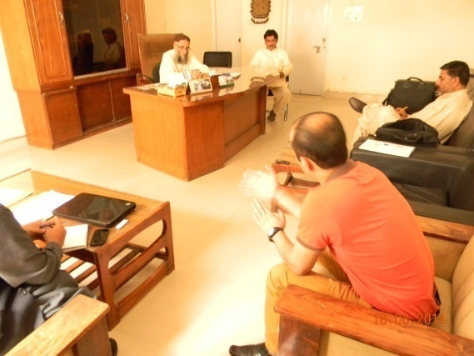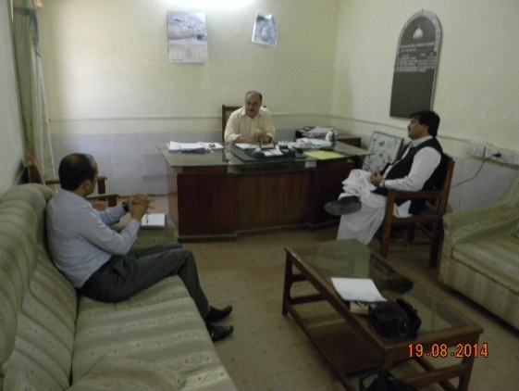

**Provincial Meetings with Baluchistan Forest Department**

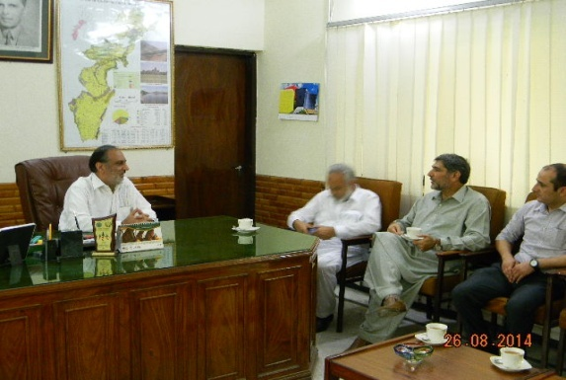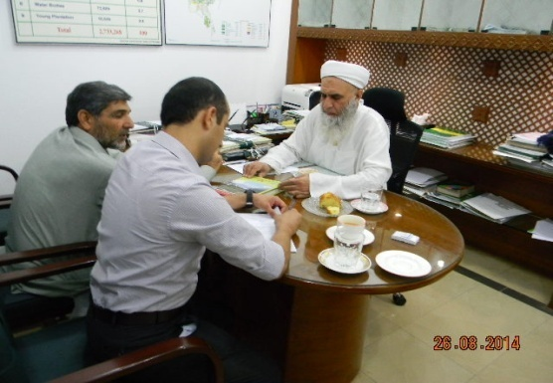

**Meetings with Conservator FATA and Chief Conservator Khyber Pakhtunkhwa**

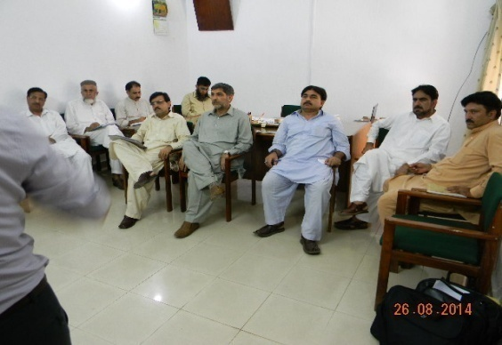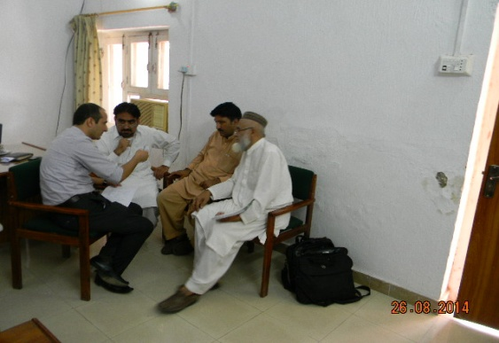

**Group Exercise with Forest Department of Khyber Pakhtunkhwa**

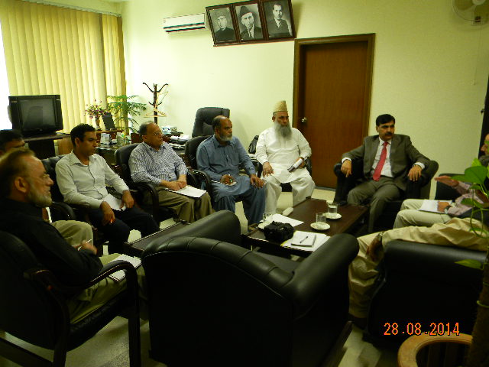

**Meeting with Secretary Forests of AJK**

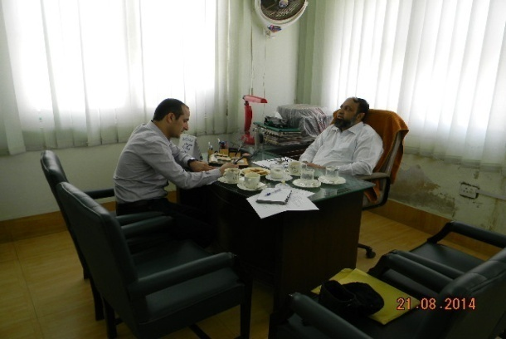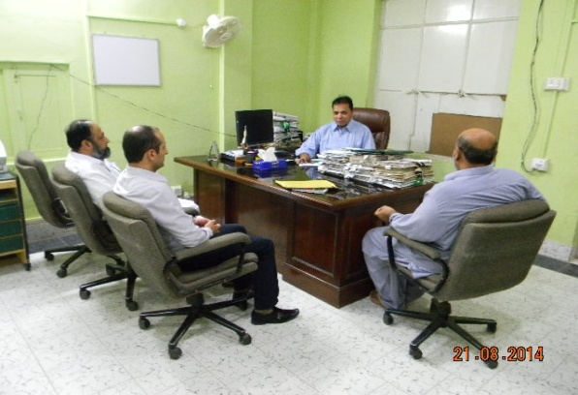

**Meetings with Conservator Working Plan and DFO Direction of Sindh Forest Department**

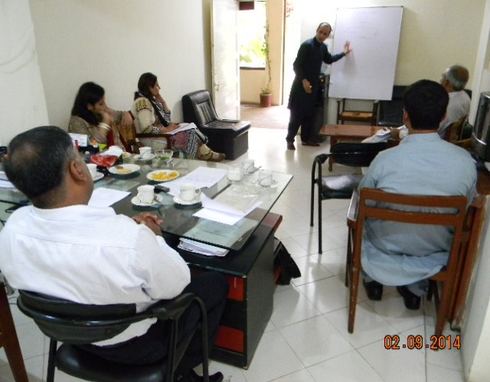 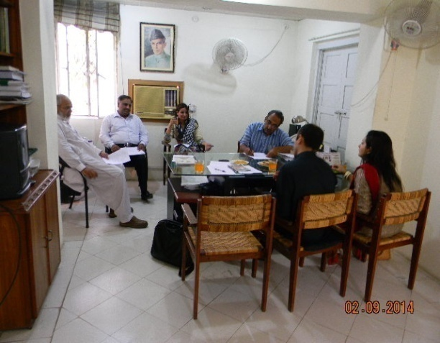

**Meeting with Conservator, DFO and GIS Expert of Forest Working Plan Division Punjab**

1. **Provincial Meetings With Other Relevant Organizations**

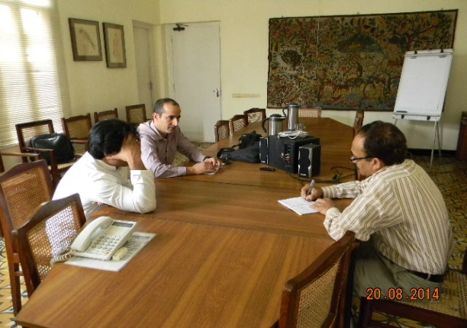 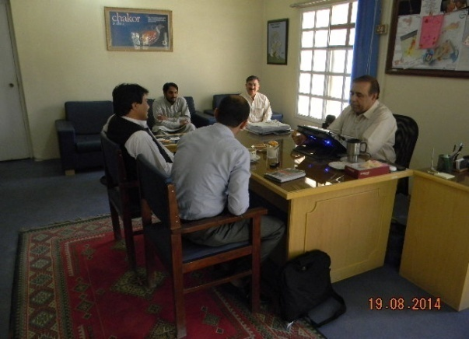

**Representatives of WWF and IUCN Karachi Representatives of IUCN and EPA Baluchistan**

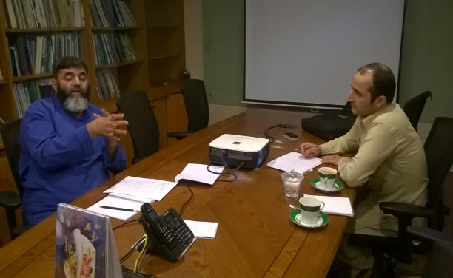 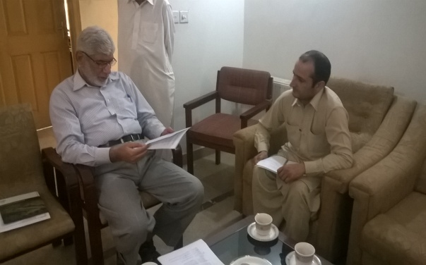

**Meeting with General Manager LEAD Meeting with Representative of GISC**

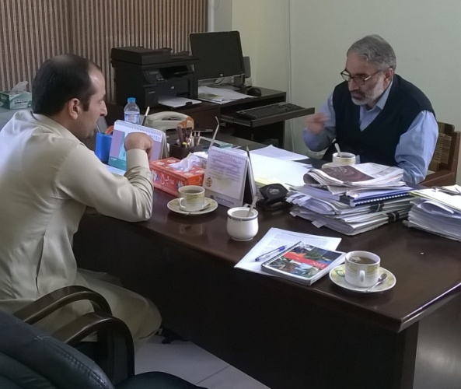

**Meeting with Director General EPA**

1. **Pictures of GIS Labs of Provincial Forest Departments**

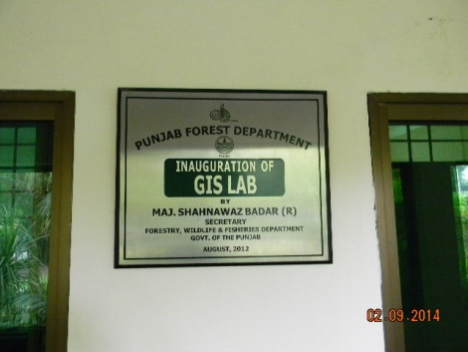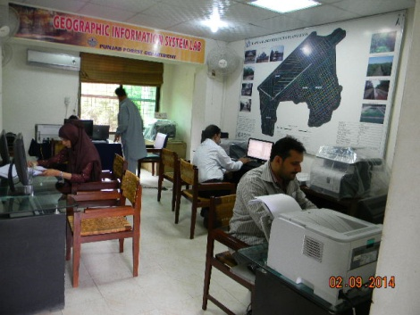

**GIS Lab of Punjab Forest Department (Lahore Office)**

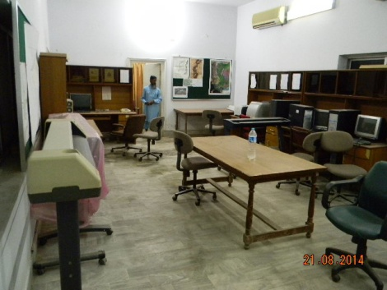 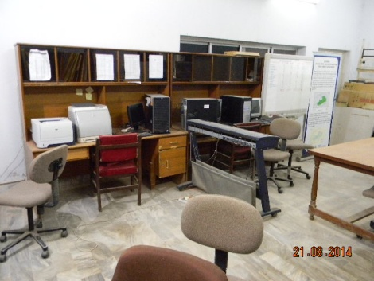

**GIS Lab of Sindh Forest Department (Hyderabad Office)**

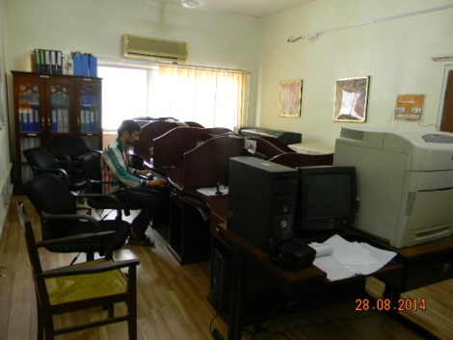 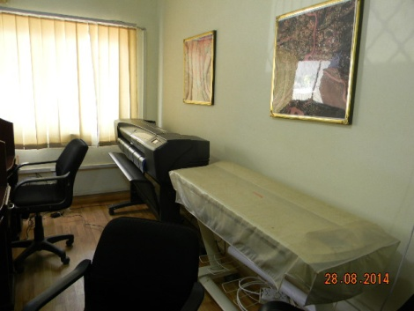

**GIS Lab of AJK Forest Department (Muzaffarabad Office)**

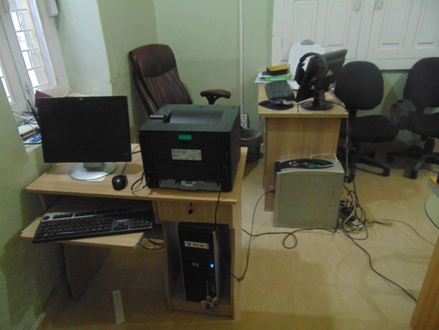 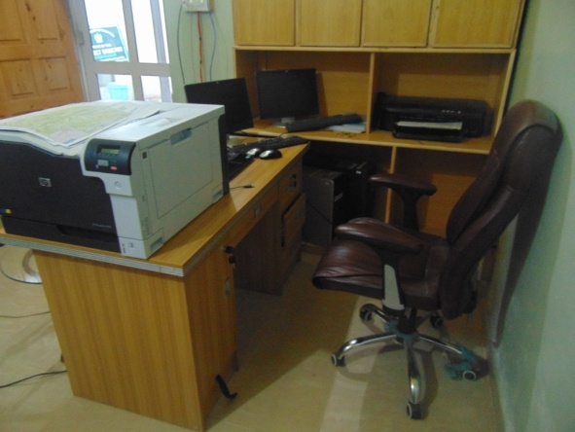

**GIS Lab of Gilgit-Baltistan Forest Department (Gilgit Office)**

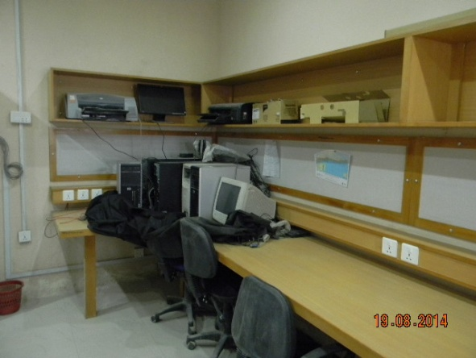 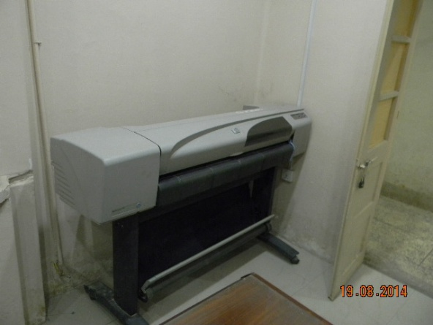

**GIS Lab of Baluchistan Forest Department (Quetta Office)**

1. **GIS Laboratories of Other Relevant Provincial Organizations**

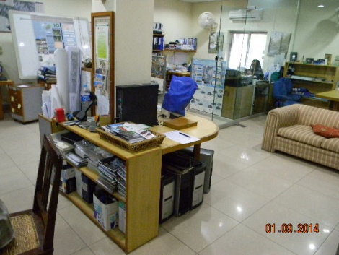 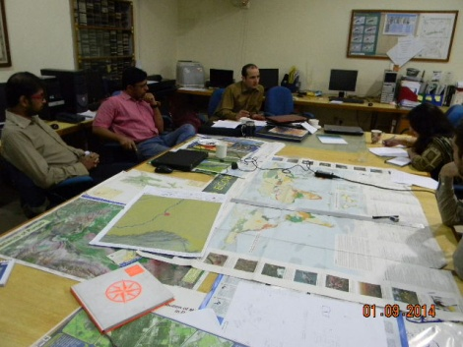

**GIS Lab of WWF-Pakistan (Lahore Office)**

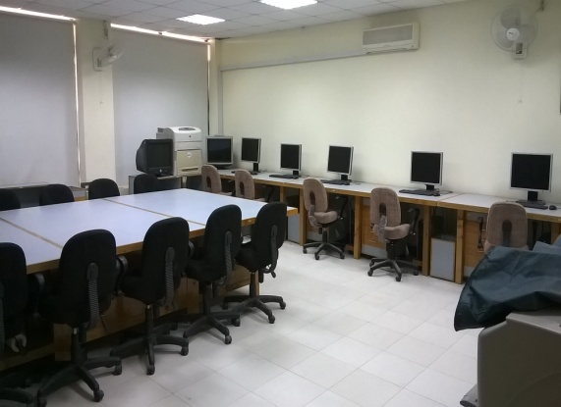 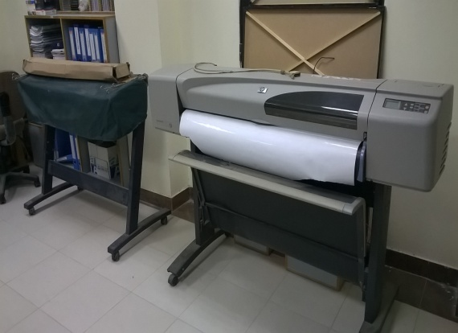

**GIS Lab of EPA (Islamabad Office)**

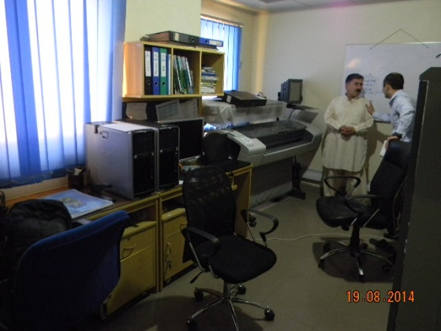 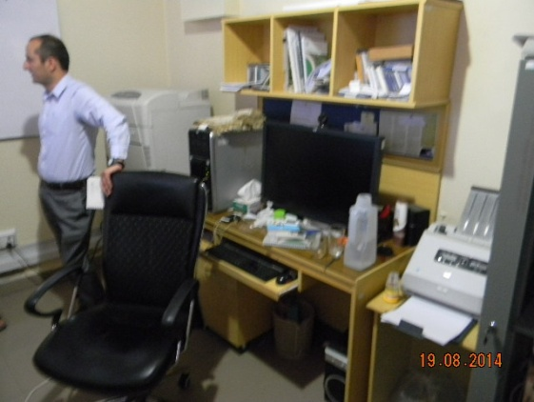

**GIS Lab of IUCN (Quetta Office)**

# Annexure – V: Capacity Assessment of other Relevant Government and Private Sector Institutions for REDD+ MMRV

|  |  |  |  |  |  |
| --- | --- | --- | --- | --- | --- |
| **Institution** | **Indicators** | **Satellite Land Monitoring System** | **National Forest Inventory** | **Green House Gas Inventory** | **OTHER** |
| PFI | DAC | **Average.** (Landsat (30 m ) and SPOT (2.5 m) covering whole Pakistan | **Low.** (Only small scale research based studies are available in analogue form) | Do not exist |  |
| TC | **Average.** A well equipped GIS Lab is established with all necessary equipments and logistics required to conduct Satellite based inventories. | **Average**. (Equipment and logistics are limited to training purposes only. PFI does not conduct forest inventory on large scales). | Do not exist |  |
| HR - T | **Average.** | **Low.** (Adequate for conventional forest inventories and limited for carbon based forest inventories) | Do not exist |  |
| HR - R | **Low.** Limited Knowledge of UNFCCC Decision/ IPCC reporting guidelines | **Low.** Limited Knowledge of UNFCCC Decision/ IPCC reporting guidelines | Do not exist |  |
| TF | **Average.** Training facilities related to SLMS are being provided on request of provinces or project need basis. | **Average.** PFI is the only academic and training institution is the country that offers field oriented bachelor and masters degree courses in forestry. Almost all the professional forestry staff in the country is graduated from PFI. | Do not exist |  |
| EPA | DA | **Average.** EPA prepared Environmental Atlas of Pakistan in 2014. Land use/ land cover maps are developed for Pakistan and provinces/ regions which included forests, agriculture land, snow and ice, rocky and sandy areas and water logging and salinity. The principle data set for this atlas were LANDSAT satellite imageries (30 m) of the year 2000, 2005 and 2010. The data is available both in digital and analogue form with in the office of DG EPA. | Do not Exist | **Low. (**Limited to Air Quality Monitoring) |  |
| TC | **Average.** GIS lab has been established at Office of DG EPA Islamabad with current following capacity:   * desktop computers * Two plotters * One scanner * Two printers * Heavy server machine to store heavy data. | Do not Exist | Do not Exist |  |
| HR - T | **Low.** The Lab is currently not functional due to lack of technical human capacity | Do not Exist | **Low** |  |
| HR - R | **Low.** Limited Knowledge of UNFCCC Decision/ IPCC reporting guidelines | Do not Exist | Do not exist |  |
| TF | **Low**. (The GIS can be used for training purposes if strengthened) | Do not Exist | Do not exist |  |
| WWF – Pakistan | DA | **Average.** (The data currently available with WWF-P is attached as annexure VI). | Do not exist | Do not Exist |  |
| TC | **Advance**. (A very well equipped GIS lab has been established in 2001 with the following current capacity.   * desktop computer * Plotters * Scanners * Printers * Photo copier Machines * MB Internet * Heavy Server Machine | Do not Exist | Do not Exist |  |
| HR - T | **Advance** | Do not Exist | Do not Exist |  |
| HR - R | **Low.** (Limited Knowledge of UNFCCC Decision/ IPCC reporting guidelines) | Do not exist | Do not exist |  |
| TF | **Average.** (WWF – P has been working in very close coordination with the provincial forest departments on capacity building and technical support related to Satellite based land monitoring since 1997-1998. Currently 4 high professional trainers to impart trainings on SLMS are available ) | Do not exist | Do not Exist |  |
| GCISC | DA | Do not exist | Do not exist | **Average**. (GCISC has conducted GHG-I for emissions by sources and removals by sinks in specific areas. The data was collected from IPCC land use categories following the IPCC GPG for LULUCF and 2006 Guidelines. The inventory was carried out using Gain and Loss method for three gases i.e. Carbon dioxide, Methane and Nitrous Oxide The data is accessible within the department published in the form of papers, reports etc. |  |
| TC | Do not exist | Do not exist | **Average** |  |
| HR-T | Do not exist | Do not exist | **Average** |  |
| HR-R | Do not exist | Do not exist | **Low.** (Limited Knowledge of UNFCCC Decision/ IPCC reporting guidelines) |  |
| TF | Do not exist | Do not exist | Do not exist |  |
| SUPARCO | DA | **Advance** (The satellite data available with SUPARCO is SPOT (2.5m – 10m) and Pleiades (0.6 m). Land use/ forest cover maps were developed which is accessible within the institution published in the form of papers, reports etc) |  |  |  |
| TC | **Advance** | Do not exist | Do not exist |
| HR-T | **Advance** | Do not exist | Do not exist |
| HR - R | **Average** (Limited knowledge of UNFCCC decisions and IPCC guidelines) | Do not exist | Do not exist |
| TF | * **Advance** * Presently, a fully fledged [**Institute of Space Technology (IST)**](http://www.ist.edu.pk/) is functioning at Islamabad for providing training in space related fields at national level. IST currently conducts degree programmes and training courses in fields related to space technology, with the long term objective of becoming a world class graduate and post graduate institute in space technology. | Do not exist | Do not exist |
| ICIMOD | **DA** | **Advance** | **Average** | **Average** | Target Support Funds |
| **TC** | **Advance** | **Average** | **Average** |
| **HR-T** | **Advance** | **Average** | **Average** |
| **HR-R** | **Advance** | **Average** | **Average** |
| **TF** | **Advance** (ICIMOD - Nepal introduced  [SERVIR-Himalaya initiative](http://geoportal.icimod.org/NAE/NewsDetail.aspx?NewsID=249), based in ICIMOD Head office Nepal  to improve environmental decision-making in [the Hindu Kush-Himalaya (HKH) region](http://www.icimod.org/v2/bull3/index.php/cms2/magic/view_old?page=43) through dissemination and analysis of earth observation information to strengthen ICIMOD’s capabilities as an established regional resource center on geospatial information and earth observation applications for the HKH region) | **Average** (Expert trainers are available for carbon based forest inventories) | **Average** |
| **DA**: Data availability  **TC**: Technical Capability  **HR-T:** Human resource to process and analyse information  **HR-R:** Human capacity to report on the information  **TF:** Training facilities | | | | | |

# Annexure – VI: List of National Satellite Data Available in WWF-Pakistan’s GIS Lab

|  |  |  |  |  |  |  |  |  |
| --- | --- | --- | --- | --- | --- | --- | --- | --- |
| **S.No.** | **Province** | **Area** | **Category** | **District** | **Satellite 1** | **Satellite 2** | **Setellite3** | **Satellite 4** |
| (2,1, 0.5)m | 2.5 m | 15 m | 30 m |
| 1 | **AJK** | Sundhan Gali Game Reserve | Game Reserve |  |  | SPOT | ASTER | LANDSAT |
| 2 | Machiara | National Park | Muzaffarabad |  | SPOT | ASTER | LANDSAT |
| 3 | Nar | Game Reserve |  |  |  | ASTER | LANDSAT |
| 4 | Gala | Game Reserve |  |  |  | ASTER | LANDSAT |
| 5 | Ghamot | National Park | Neelum |  |  | ASTER | LANDSAT |
| 6 | Pir Lasorha | National Park | Sudhnoti |  |  | ASTER | LANDSAT |
| 7 | Toli Pir | National Park | Poonch |  |  | ASTER | LANDSAT |
| 8 | Deva Vatala | National Park | Bhimber |  |  | ASTER | LANDSAT |
| 9 | Mahasheer National Park | National Park |  |  |  |  | LANDSAT |
| 10 | **Balochistan** | Bund Khush Dil Khan | Wildlife Sanctuary | Killa Abdullah |  | SPOT | ASTER | LANDSAT |
| 11 | Wam | Game Reserve | Ziarat |  | SPOT |  | LANDSAT |
| 12 | Zawar Khan | Game Reserve | Quetta |  | SPOT |  | LANDSAT |
| 13 | Ziarat Juniper | Wildlife Sanctuary | Ziarat |  | SPOT |  | LANDSAT |
| 14 | Shinawari | Game Reserve |  |  | SPOT |  | LANDSAT |
| 15 | Sasnamana | Wildlife Sanctuary |  |  | SPOT |  | LANDSAT |
| 16 | Astola Island | Unclassified | Gwadar |  |  | ASTER | LANDSAT |
| 17 | Buzi-Makola | Wildlife Sanctuary | Gwadar |  |  | ASTER | LANDSAT |
| 18 | Dureji | Wildlife Sanctuary | Lasbela |  |  | ASTER | LANDSAT |
| 19 | Pasni Coastline | Unclassified | Gwadar |  |  | ASTER | LANDSAT |
| 20 | Zangi Nawar | Game Reserve | Chagai |  |  | ASTER | LANDSAT |
| 21 | Jiwani Beaches | Unclassified |  |  |  | ASTER | LANDSAT |
| 22 | Ormara Beaches | Unclassified |  |  |  | ASTER | LANDSAT |
| 23 | Kachau | Wildlife Sanctuary |  |  |  | ASTER | LANDSAT |
| 24 | Hingol | National Park | Awaran |  |  | ASTER | LANDSAT |
| 25 | **Gilgit-Baltistan** | Nar/Ghoro Nallah | Game Reserve | Baltistan |  | SPOT | ASTER | LANDSAT |
| 26 | Satpara | Wildlife Sanctuary | Baltistan |  | SPOT | ASTER | LANDSAT |
| 27 | Basho | Community Game Reserve |  |  | SPOT | ASTER | LANDSAT |
| 28 | Deosai Plains | National Park | Baltistan |  | SPOT | ASTER | LANDSAT |
| 29 | Askor Nullah | Game Reserve | Diamir |  |  | ASTER | LANDSAT |
| 30 | Astore | Wildlife Sanctuary | Diamir |  |  | ASTER | LANDSAT |
| 31 | Baltistan | Wildlife Sanctuary | Baltistan |  |  | ASTER | LANDSAT |
| 32 | Chashi/Bawaster | Game Reserve | Ghizer |  |  | ASTER | LANDSAT |
| 33 | Danyor Nallah | Game Reserve | Gilgit |  |  | ASTER | LANDSAT |
| 34 | Kargah | Wildlife Sanctuary | Gilgit |  |  | ASTER | LANDSAT |
| 35 | Kilik/Mintaka | Game Reserve | Gilgit |  |  | ASTER | LANDSAT |
| 36 | Naltar | Wildlife Sanctuary | Gilgit |  |  | ASTER | LANDSAT |
| 37 | Nazbar Nallah | Game Reserve | Ghizer |  |  | ASTER | LANDSAT |
| 38 | Pakora | Game Reserve | Ghizer |  |  | ASTER | LANDSAT |
| 39 | Sherqillah | Game Reserve | Ghizer |  |  | ASTER | LANDSAT |
| 40 | Tangir | Game Reserve | Diamir |  |  | ASTER | LANDSAT |
| 41 | Khyber | Community Game Reserve |  |  |  | ASTER | LANDSAT |
| 42 | Bar | Community Game Reserve |  |  |  | ASTER | LANDSAT |
| 43 | Ghulkin | Community Game Reserve |  |  |  | ASTER | LANDSAT |
| 44 | Bunji | Community Game Reserve |  |  |  | ASTER | LANDSAT |
| 45 | Doian | Community Game Reserve |  |  |  | ASTER | LANDSAT |
| 46 | Dashkin / Mushkin / Turbulin | Community Game Reserve |  |  |  | ASTER | LANDSAT |
| 47 | Yasin | Community Game Reserve |  |  |  | ASTER | LANDSAT |
| 48 | Pasu | Community Game Reserve |  |  |  | ASTER | LANDSAT |
| 49 | Gulmit | Community Game Reserve |  |  |  | ASTER | LANDSAT |
| 50 | Minapin | Community Game Reserve |  |  |  | ASTER | LANDSAT |
| 51 | Sakwar | Community Game Reserve |  |  |  | ASTER | LANDSAT |
| 52 | Jutial | Community Game Reserve |  |  |  | ASTER | LANDSAT |
| 53 | Barmas | Community Game Reserve |  |  |  | ASTER | LANDSAT |
| 54 | Sikandar Abad | Community Game Reserve |  |  |  | ASTER | LANDSAT |
| 55 | Jafar Abad | Community Game Reserve |  |  |  | ASTER | LANDSAT |
| 56 | Hussain Abad | Community Game Reserve |  |  |  | ASTER | LANDSAT |
| 57 | Shimshal | Community Game Reserve |  |  |  | ASTER | LANDSAT |
| 58 | Central Karakoram | National Park | Baltistan |  |  | ASTER | LANDSAT |
| 59 | Handrap Shandhoor | National Park | Ghizer |  |  | ASTER | LANDSAT |
| 60 | Khunjerab | National Park | Gilgit |  |  | ASTER | LANDSAT |
| 61 | **ICT** | Kathar | Game Reserve | Islamabad | High Resolution | SPOT | ASTER | LANDSAT |
| 62 | Islamabad | Game Reserve | Islamabad |  | SPOT | ASTER | LANDSAT |
| 63 | Islamabad2 | Wildlife Sanctuary | Islamabad |  | SPOT | ASTER | LANDSAT |
| 64 | Lohi Bher Forest | Wildlife Sanctuary | Islamabad |  | SPOT | ASTER | LANDSAT |
| 65 | Margalla Hills | National Park | Islamabad |  | SPOT | ASTER | LANDSAT |
| 66 | **Khyber Pakhtunkhwa** | hussianzai | Community Game Reserve | D. I. Khan | High Resolution |  | ASTER | LANDSAT |
| 67 | Sheikh Sultan | Community Game Reserve | Tank | High Resolution |  |  | LANDSAT |
| 68 | Ayubia | National Park | Abbottabad | High Resolution | SPOT | ASTER | LANDSAT |
| 69 | Saif-ul-Maluk | National Park | Mansehra | High Resolution | SPOT | ASTER | LANDSAT |
| 70 | Shiekh Badin | National Park | Lakki Marwat | High Resolution |  | ASTER | LANDSAT |
| 71 | Babar | Community Game Reserve | D. I. Khan |  | SPOT | ASTER | LANDSAT |
| 72 | Bagra | Game Reserve | Haripur |  | SPOT | ASTER | LANDSAT |
| 73 | Begusht | Community Game Reserve | Chitral |  | SPOT | ASTER | LANDSAT |
| 74 | Darban Kalan | Private Game Reserve | D. I. Khan |  | SPOT |  | LANDSAT |
| 75 | Gehrait | Community Game Reserve | Chitral |  | SPOT | ASTER | LANDSAT |
| 76 | Goleen Gol | Community Game Reserve | Chitral |  | SPOT | ASTER | LANDSAT |
| 77 | Goleen Gol | Game Reserve | Chitral |  | SPOT |  | LANDSAT |
| 78 | Jhandar Abdul Sattar | Private Game Reserve | D. I. Khan |  | SPOT | ASTER | LANDSAT |
| 79 | Kaighah Nullah | Community Game Reserve | Kohistan |  | SPOT | ASTER | LANDSAT |
| 80 | Madaklasht | Community Game Reserve | Chitral |  | SPOT | ASTER | LANDSAT |
| 81 | Mang | Game Reserve | Haripur |  | SPOT | ASTER | LANDSAT |
| 82 | Mankial | Community Game Reserve | Swat |  | SPOT |  | LANDSAT |
| 83 | Manur | Community Game Reserve | Chitral |  | SPOT | ASTER | LANDSAT |
| 84 | Michen Khel | Community Game Reserve | D. I. Khan |  | SPOT | ASTER | LANDSAT |
| 85 | Musazai | Private Game Reserve | D. I. Khan |  | SPOT | ASTER | LANDSAT |
| 86 | Pind Hashim Khan | Game Reserve | Haripur |  | SPOT | ASTER | LANDSAT |
| 87 | Rakh Malik Banaras Khan | Private Game Reserve | Haripur |  | SPOT | ASTER | LANDSAT |
| 88 | Rakh Nadir Khan | Private Game Reserve | Haripur |  | SPOT | ASTER | LANDSAT |
| 89 | Rakh Raja Gustasap Khan | Private Game Reserve | Haripur |  | SPOT | ASTER | LANDSAT |
| 90 | Rakh Saeed Taj Muhammad | Private Game Reserve | Haripur |  | SPOT | ASTER | LANDSAT |
| 91 | Rakh Sultan Mohammad Khan | Private Game Reserve | Haripur |  | SPOT | ASTER | LANDSAT |
| 92 | Rakh Syed Ali Shah | Private Game Reserve | Haripur |  | SPOT | ASTER | LANDSAT |
| 93 | Rakh Tiyal | Private Game Reserve | Abbottabad |  | SPOT | ASTER | LANDSAT |
| 94 | Tooshi Gol | Game Reserve | Chitral |  | SPOT | ASTER | LANDSAT |
| 95 | Tooshi Shasha | Community Game Reserve | Chitral |  | SPOT | ASTER | LANDSAT |
| 96 | Zarkani | Game Reserve | D. I. Khan |  | SPOT |  | LANDSAT |
| 97 | Broghil | National Park | Chitral |  | SPOT | ASTER | LANDSAT |
| 98 | Chitral Gol | National Park | Chitral |  | SPOT | ASTER | LANDSAT |
| 99 | Qurambar | National Park |  |  | SPOT | ASTER | LANDSAT |
| 100 | Agram Basti | Wildlife Sanctuary | Chitral |  |  | ASTER | LANDSAT |
| 101 | Alam Gang | Community Game Reserve | Kohat |  |  | ASTER | LANDSAT |
| 102 | Amluk Banr | Community Game Reserve | Buner |  |  | ASTER | LANDSAT |
| 103 | Arkari | Community Game Reserve | Chitral |  |  | ASTER | LANDSAT |
| 104 | Baga hills | Community Game Reserve | Swabi |  |  | ASTER | LANDSAT |
| 105 | Balyamin | Game Reserve | Hangu |  |  | ASTER | LANDSAT |
| 106 | Banda Lakkana | Community Game Reserve | Karak |  |  | ASTER | LANDSAT |
| 107 | Barh | Community Game Reserve | Swat |  |  | ASTER | LANDSAT |
| 108 | Battal | Community Game Reserve | Mansehra |  |  | ASTER | LANDSAT |
| 109 | Besak | Community Game Reserve | Swabi |  |  | ASTER | LANDSAT |
| 110 | Bhan | Community Game Reserve | Swat |  |  | ASTER | LANDSAT |
| 111 | Boraka | Wildlife Sanctuary | Kohat |  |  | ASTER | LANDSAT |
| 112 | Cherat | Wildlife Park | Nowshera |  |  | ASTER | LANDSAT |
| 113 | D.I. Khan Waterfowl | Wildlife Reguge | D. I. Khan |  |  | ASTER | LANDSAT |
| 114 | Dara Tang Mouza Chowki jand | Community Game Reserve | Lakki Marwat |  |  | ASTER | LANDSAT |
| 115 | Darmalak | Game Reserve | Kohat |  |  | ASTER | LANDSAT |
| 116 | Darwazai Banda | Community Game Reserve | Kohat |  |  | ASTER | LANDSAT |
| 117 | Dhandidal Khel | Community Game Reserve | Karak |  |  | ASTER | LANDSAT |
| 118 | Dhoda | Game Reserve | Kohat |  |  | ASTER | LANDSAT |
| 119 | Dhok Dheri | Private Game Reserve | Kohat |  |  | ASTER | LANDSAT |
| 120 | Dhok Loharan | Private Game Reserve | Kohat |  |  | ASTER | LANDSAT |
| 121 | Dowrro/Algada | Community Game Reserve | Kohat |  |  | ASTER | LANDSAT |
| 122 | Drabo Kach | Private Game Reserve | Kohat |  |  | ASTER | LANDSAT |
| 123 | Drish Khel | Community Game Reserve | Karak |  |  | ASTER | LANDSAT |
| 124 | Drosh Gol | Game Reserve | Chitral |  |  | ASTER | LANDSAT |
| 125 | Garu Amankot | Community Game Reserve | Mardan |  |  | ASTER | LANDSAT |
| 126 | Garyalla Karmar | Community Game Reserve | Mardan |  |  | ASTER | LANDSAT |
| 127 | Gehrait Gol | Game Reserve | Chitral |  |  | ASTER | LANDSAT |
| 128 | Ghurzandi | Game Reserve | Kohat |  |  | ASTER | LANDSAT |
| 129 | Gurlangi | Community Game Reserve | Kohat |  |  | ASTER | LANDSAT |
| 130 | Indus River | Game Reserve | D. I. Khan |  |  | ASTER | LANDSAT |
| 131 | Jabbar | Game Reserve | Kohat |  |  | ASTER | LANDSAT |
| 132 | Jatta Ismail Khel | Community Game Reserve | Karak |  |  | ASTER | LANDSAT |
| 133 | kachai Marai | Game Reserve | Kohat |  |  | ASTER | LANDSAT |
| 134 | Kalinjar | Game Reserve | Haripur |  |  | ASTER | LANDSAT |
| 135 | Kamar | Community Game Reserve | Karak |  |  | ASTER | LANDSAT |
| 136 | Kandar Dam | Unclassified | Kohat |  |  | ASTER | LANDSAT |
| 137 | Kheshki Reservoir | Unclassified | Nowshera |  |  | ASTER | LANDSAT |
| 138 | kingar Gali | Game Reserve | Buner |  |  | ASTER | LANDSAT |
| 139 | Kohi Barmool | Community Game Reserve | Mardan |  |  | ASTER | LANDSAT |
| 140 | Kohi Dara | Community Game Reserve | Mardan |  |  | ASTER | LANDSAT |
| 141 | Kotal | Wildlife Park | Kohat |  |  | ASTER | LANDSAT |
| 142 | Lakki Crane Refuge | Wildlife Reguge | Lakki Marwat |  |  | ASTER | LANDSAT |
| 143 | Mahal Kalu | Community Game Reserve | Mardan |  |  | ASTER | LANDSAT |
| 144 | Mahodand (Kalam) | Game Reserve | Swat |  |  | ASTER | LANDSAT |
| 145 | Makhnial | Game Reserve | Mansehra |  |  | ASTER | LANDSAT |
| 146 | Malugul Dhand | Unclassified | Lakki Marwat |  |  | ASTER | LANDSAT |
| 147 | Manglot | Wildlife Park | Nowshera |  |  | ASTER | LANDSAT |
| 148 | Manshi | Wildlife Sanctuary | Mansehra |  |  | ASTER | LANDSAT |
| 149 | Marchungi | Game Reserve | Kohat |  |  | ASTER | LANDSAT |
| 150 | Maroba | Game Reserve | Nowshera |  |  | ASTER | LANDSAT |
| 151 | Mohib Banda | Community Game Reserve | Nowshera |  |  | ASTER | LANDSAT |
| 152 | Nanser Kuhay | Community Game Reserve | Buner |  |  | ASTER | LANDSAT |
| 153 | Nizam Pur | Game Reserve | Nowshera |  |  | ASTER | LANDSAT |
| 154 | Palsala Dhanaka | Community Game Reserve | Mansehra |  |  | ASTER | LANDSAT |
| 155 | Pungi Banda | Community Game Reserve | Hangu |  |  | ASTER | LANDSAT |
| 156 | Punjpir | Community Game Reserve | Swabi |  |  | ASTER | LANDSAT |
| 157 | Purit Gol/Chitral Chinar | Game Reserve | Chitral |  |  | ASTER | LANDSAT |
| 158 | Qalandar Abad | Game Reserve | Abbottabad |  |  | ASTER | LANDSAT |
| 159 | Rakh Rafaqat Shah | Private Game Reserve | Haripur |  |  | ASTER | LANDSAT |
| 160 | Rakh Sardaran | Game Reserve | Haripur |  |  | ASTER | LANDSAT |
| 161 | Rakh Sarkar Mouza Momin Mughala Khel | Community Game Reserve | Bannu |  |  | ASTER | LANDSAT |
| 162 | Rakh Topi | Game Reserve | Kohat |  |  | ASTER | LANDSAT |
| 163 | Resi/Toi Banda | Game Reserve | Kohat |  |  | ASTER | LANDSAT |
| 164 | Shamshtoo | Game Reserve | Nowshera |  |  | ASTER | LANDSAT |
| 165 | Shamshukai | Community Game Reserve | Karak |  |  | ASTER | LANDSAT |
| 166 | Sharqi Baizai Mian Khan | Private Game Reserve | Mardan |  |  | ASTER | LANDSAT |
| 167 | Shawaki Chukhtoo | Game Reserve | Karak |  |  | ASTER | LANDSAT |
| 168 | Shehzadi Banda | Community Game Reserve | Kohat |  |  | ASTER | LANDSAT |
| 169 | Shewa Karmar | Community Game Reserve | Swabi |  |  | ASTER | LANDSAT |
| 170 | Sori Malandri | Community Game Reserve | Mardan |  |  | ASTER | LANDSAT |
| 171 | Sumari Bala | Community Game Reserve | Kohat |  |  | ASTER | LANDSAT |
| 172 | Takwara(Hathala) | Community Game Reserve | D. I. Khan |  |  | ASTER | LANDSAT |
| 173 | Tanda Dam | Wildlife Park | Kohat |  |  | ASTER | LANDSAT |
| 174 | Teri,lsak kumari | Game Reserve | Karak |  |  | ASTER | LANDSAT |
| 175 | Thanedarwala | Game Reserve | Karak |  |  | ASTER | LANDSAT |
| 176 | Thath Solhan | Community Game Reserve | D. I. Khan |  |  | ASTER | LANDSAT |
| 177 | Togh Mangara | Wildlife Park | Kohat |  |  | ASTER | LANDSAT |
| 178 | Togh Mangara | Game Reserve | Kohat |  |  | ASTER | LANDSAT |
| 179 | Totalai | Game Reserve | Buner |  |  | ASTER | LANDSAT |
| 180 | Ustarzai Payan | Community Game Reserve | Kohat |  |  | ASTER | LANDSAT |
| 181 | Village Musabad Gandi Khan Khel | Community Game Reserve | Lakki Marwat |  |  | ASTER | LANDSAT |
| 182 | Village Paher Khel Thall | Community Game Reserve | Lakki Marwat |  |  | ASTER | LANDSAT |
| 183 | Lulusar & Dodipath | National Park | Mansehra |  |  | ASTER | LANDSAT |
| 184 | Lukki Crane Refuge | Wildlife Refuge |  | High Resolution |  | ASTER | LANDSAT |
| 185 | Bilyamin | Game Reserve |  |  |  | ASTER | LANDSAT |
| 186 | Chirat | Game Reserve |  |  |  | ASTER | LANDSAT |
| 187 | Dhoda Paya | Game Reserve |  |  |  | ASTER | LANDSAT |
| 188 | Shewaki-Chukhtoo | Game Reserve |  |  |  | ASTER | LANDSAT |
| 189 | Sudham | Game Reserve |  |  |  | ASTER | LANDSAT |
| 190 | Tari/Isak Khumari | Game Reserve |  |  |  | ASTER | LANDSAT |
| 191 | Dera Ismail Khan Water F | Wildlife Refuge |  |  |  | ASTER | LANDSAT |
| 192 | **Punjab** | Chashma Barrage | Wildlife Sanctuary | Mianwali | High Resolution |  | ASTER | LANDSAT |
| 193 | Chumbi-Surla | Wildlife Sanctuary | Chakwal | High Resolution |  |  | LANDSAT |
| 194 | Harnoli Reserve Forest | Unclassified | Mianwali | High Resolution |  | ASTER | LANDSAT |
| 195 | Jahlar Lake | Wildlife Sanctuary | Khushab | High Resolution | SPOT | ASTER | LANDSAT |
| 196 | Khabbeke Lake | Wildlife Sanctuary | Khushab | High Resolution | SPOT | ASTER | LANDSAT |
| 197 | Kundian Plantation | Wildlife Sanctuary | Mianwali | High Resolution |  | ASTER | LANDSAT |
| 198 | Sodhi | Wildlife Sanctuary | Khushab | High Resolution | SPOT | ASTER | LANDSAT |
| 199 | Taunsa Barrage | Wildlife Sanctuary | Muzaffargarh | High Resolution |  | ASTER | LANDSAT |
| 200 | Ucchali Lake | Game Reserve | Khushab | High Resolution | SPOT | ASTER | LANDSAT |
| 201 | Hamoli Reserve Forest | Wildlife Sanctuary |  | High Resolution |  | ASTER | LANDSAT |
| 202 | Chinji | National Park | Chakwal | High Resolution | SPOT | ASTER | LANDSAT |
| 203 | Murree Kotli Satian | National Park |  | High Resolution | SPOT | ASTER | LANDSAT |
| 204 | Bajwat | Wildlife Sanctuary | Sialkot |  | SPOT | ASTER | LANDSAT |
| 205 | Bhagat Reserve Forest | Wildlife Sanctuary | Toba Tek Singh |  | SPOT |  | LANDSAT |
| 206 | Bhon Fazil | Game Reserve | Gujranwala |  | SPOT | ASTER | LANDSAT |
| 207 | Daulana | Game Reserve | Jhang |  | SPOT |  | LANDSAT |
| 208 | Ghandak Dhoro | Wildlife Sanctuary | Rahim Yar Khan |  | SPOT | ASTER | LANDSAT |
| 209 | Kamalia Plantation | Wildlife Sanctuary | Toba Tek Singh |  | SPOT |  | LANDSAT |
| 210 | Machu / Inayat Reserve Forest | Unclassified | Leiah |  | SPOT | ASTER | LANDSAT |
| 211 | Mitha Tiwana Plantation | Wildlife Sanctuary | Khushab |  | SPOT | ASTER | LANDSAT |
| 212 | Shorkot Forest Plantation | Wildlife Sanctuary | Jhang |  | SPOT |  | LANDSAT |
| 213 | Tehra Plantation/Jallo Park | Wildlife Sanctuary | Lahore |  | SPOT | ASTER | LANDSAT |
| 214 | Thal-I | Game Reserve | Khushab |  | SPOT |  | LANDSAT |
| 215 | Thal-II | Game Reserve | Bhakkar |  | SPOT |  | LANDSAT |
| 216 | Thal-III | Game Reserve | Leiah |  | SPOT | ASTER | LANDSAT |
| 217 | Bajwat | Game Reserve |  |  | SPOT | ASTER | LANDSAT |
| 218 | Machu Plantation | Wildlife Sanctuary |  |  | SPOT | ASTER | LANDSAT |
| 219 | Abbasia | Game Reserve | Rahim Yar Khan |  |  | ASTER | LANDSAT |
| 220 | Bahawalpur Plantation/Bahwalpur | Wildlife Sanctuary | Bahawalpur |  |  | ASTER | LANDSAT |
| 221 | Bhakkar Forest Plantatio | Wildlife Sanctuary | Bhakkar |  |  | ASTER | LANDSAT |
| 222 | Bheni | Game Reserve | Sheikhupura |  |  | ASTER | LANDSAT |
| 223 | Bhono | Game Reserve | Lahore |  |  | ASTER | LANDSAT |
| 224 | Chak Kotora Reserve Fore | Wildlife Sanctuary | Bahawalpur |  |  | ASTER | LANDSAT |
| 225 | Changa Manga Plantation | Wildlife Sanctuary | Kasur |  |  | ASTER | LANDSAT |
| 226 | Cholistan-III | Unclassified | Rahim Yar Khan |  |  | ASTER | LANDSAT |
| 227 | Daphar Reserve Forest | Wildlife Sanctuary |  |  |  | ASTER | LANDSAT |
| 228 | Depalpur Plantation | Wildlife Sanctuary | Okara |  |  | ASTER | LANDSAT |
| 229 | Diljabba-Domeli | Game Reserve | Jhelum |  |  | ASTER | LANDSAT |
| 230 | Fatah Major Forest Plantation | Wildlife Sanctuary | Bhakkar |  |  | ASTER | LANDSAT |
| 231 | Head Islam/Chak Kotora | Game Reserve | Bahawalnagar |  |  | ASTER | LANDSAT |
| 232 | Head Qadirabad | Game Reserve | Gujranwala |  |  | ASTER | LANDSAT |
| 233 | Indo-Pak Border-I | Game Reserve | Kasur |  |  | ASTER | LANDSAT |
| 234 | Jalalpur Sharif Forest | Wildlife Sanctuary | Jhelum |  |  | ASTER | LANDSAT |
| 235 | Jauharabad Reserve Fores | Wildlife Sanctuary | Khushab |  |  | ASTER | LANDSAT |
| 236 | Kalabagh Game Reserve | Private Game Reserve | Mianwali |  |  | ASTER | LANDSAT |
| 237 | Kharar Lake | Wildlife Sanctuary | Okara |  |  | ASTER | LANDSAT |
| 238 | Kheri Murat | Game Reserve | Attock |  |  | ASTER | LANDSAT |
| 239 | Kot Sabzal | Game Reserve | Rajanpur |  |  | ASTER | LANDSAT |
| 240 | Kotla Issan Reserve Fore | Wildlife Sanctuary | Muzaffargarh |  |  | ASTER | LANDSAT |
| 241 | Kundal Rakh | Wildlife Sanctuary | Jhelum |  |  | ASTER | LANDSAT |
| 242 | Namal Lake | Game Reserve | Mianwali |  |  | ASTER | LANDSAT |
| 243 | Rahri Bungalow | Game Reserve | Rahim Yar Khan |  |  | ASTER | LANDSAT |
| 244 | Rajan Shah Plantation | Wildlife Sanctuary | Leiah |  |  | ASTER | LANDSAT |
| 245 | Rakh Ghulaman | Wildlife Sanctuary | Bhakkar |  |  | ASTER | LANDSAT |
| 246 | Rasool Barrage | Game Reserve | Mandi Bahauddin |  |  | ASTER | LANDSAT |
| 247 | Walhar Reserve Forest | Wildlife Sanctuary | Rahim Yar Khan |  |  | ASTER | LANDSAT |
| 248 | Cholistan | Game Reserve |  |  |  | ASTER | LANDSAT |
| 249 | Daman Reserve Forest | Wildlife Sanctuary |  |  |  | ASTER | LANDSAT |
| 250 | Inayat Reserve Forest | Wildlife Sanctuary |  |  |  | ASTER | LANDSAT |
| 251 | Lal Suhanra | National Park | Bahawalpur |  |  | ASTER | LANDSAT |
| 252 | **Sindh** | Dosu Forest | Game Reserve | Shikarpur | High Resolution | SPOT | ASTER | LANDSAT |
| 253 | Hala | Game Reserve | Sanghar | High Resolution |  | ASTER | LANDSAT |
| 254 | Indus River # 2 | Game Reserve | Sukkur | High Resolution | SPOT | ASTER | LANDSAT |
| 255 | Khadi | Wildlife Sanctuary | Hyderabad | High Resolution | SPOT | ASTER | LANDSAT |
| 256 | Khairpur Game Reserve | Unclassified | Khairpur | High Resolution | SPOT | ASTER | LANDSAT |
| 257 | Khat Dhoro | Wildlife Sanctuary | Khairpur | High Resolution | SPOT | ASTER | LANDSAT |
| 258 | Kinjhar (Kalri) Lake | Wildlife Sanctuary | Thatta | High Resolution | SPOT | ASTER | LANDSAT |
| 259 | Kot Dinghano | Wildlife Sanctuary | Nawabshah | High Resolution |  | ASTER | LANDSAT |
| 260 | Miani Dhand | Wildlife Sanctuary | Hyderabad | High Resolution | SPOT | ASTER | LANDSAT |
| 261 | Tando Mitha Khan | Game Reserve | Sanghar | High Resolution |  | ASTER | LANDSAT |
| 262 | Cut Munarki Chach | Wildlife Sanctuary | Thatta |  | SPOT | ASTER | LANDSAT |
| 263 | Deh Jangisar | Game Reserve | Thatta |  | SPOT | ASTER | LANDSAT |
| 264 | Deh Jangisar | Game Reserve | Thatta |  | SPOT | ASTER | LANDSAT |
| 265 | Deh Khalifa | Game Reserve | Thatta |  | SPOT | ASTER | LANDSAT |
| 266 | Drigh Lake | Wildlife Sanctuary | Dadu |  | SPOT | ASTER | LANDSAT |
| 267 | Gullel Kohri | Wildlife Sanctuary | Thatta |  | SPOT | ASTER | LANDSAT |
| 268 | Hadero Lake | Wildlife Sanctuary | Thatta |  | SPOT | ASTER | LANDSAT |
| 269 | Hilaya | Wildlife Sanctuary | Thatta |  | SPOT | ASTER | LANDSAT |
| 270 | Keti Bunder North | Wildlife Sanctuary | Thatta |  | SPOT | ASTER | LANDSAT |
| 271 | Langh (Lungh) Lake | Wildlife Sanctuary | Larkana |  | SPOT | ASTER | LANDSAT |
| 272 | Majiran | Wildlife Sanctuary | Thatta |  | SPOT | ASTER | LANDSAT |
| 273 | Marho Kohri | Wildlife Sanctuary | Thatta |  | SPOT | ASTER | LANDSAT |
| 274 | Mirpur Sakro | Game Reserve | Thatta |  | SPOT | ASTER | LANDSAT |
| 275 | Mohahat Dero | Wildlife Sanctuary | Naushahro Feroze |  | SPOT | ASTER | LANDSAT |
| 276 | Munarki | Wildlife Sanctuary | Thatta |  | SPOT | ASTER | LANDSAT |
| 277 | Norang | Wildlife Sanctuary | Thatta |  | SPOT | ASTER | LANDSAT |
| 278 | Sadnai | Wildlife Sanctuary | Thatta |  | SPOT | ASTER | LANDSAT |
| 279 | Shah Lanko | Wildlife Sanctuary | Dadu |  | SPOT | ASTER | LANDSAT |
| 280 | Takkar | Wildlife Sanctuary | Sukkur |  | SPOT | ASTER | LANDSAT |
| 281 | Keti Bunder South | Wildlife Sanctuary |  |  | SPOT | ASTER | LANDSAT |
| 282 | Bijoro Chach | Wildlife Sanctuary | Thatta |  |  | ASTER | LANDSAT |
| 283 | Deh Akro-II | Wildlife Sanctuary | Khairpur |  |  | ASTER | LANDSAT |
| 284 | Deh Sahib Saman | Game Reserve | Sanghar |  |  | ASTER | LANDSAT |
| 285 | Dhoung Block | Wildlife Sanctuary | Jacobabad |  |  | ASTER | LANDSAT |
| 286 | Gulsher Dhand | Wildlife Sanctuary | Sanghar |  |  | ASTER | LANDSAT |
| 287 | Haleji Lake | Wildlife Sanctuary | Thatta |  |  | ASTER | LANDSAT |
| 288 | Hawks Bay/Sandspit Beach | Wildlife Sanctuary | Karachi West |  |  | ASTER | LANDSAT |
| 289 | Hub Dam | Wildlife Sanctuary | Malir |  |  | ASTER | LANDSAT |
| 290 | Khanpur | Unclassified | Ghotki |  |  | ASTER | LANDSAT |
| 291 | Khipro Forest | Game Reserve | Sanghar |  |  | ASTER | LANDSAT |
| 292 | Mahal Kohistan | Wildlife Sanctuary | Dadu |  |  | ASTER | LANDSAT |
| 293 | Mando Dero | Game Reserve | Ghotki |  |  | ASTER | LANDSAT |
| 294 | Nara | Game Reserve | Khairpur |  |  | ASTER | LANDSAT |
| 295 | Nara Desert | Wildlife Sanctuary | Khairpur |  |  | ASTER | LANDSAT |
| 296 | Pai Forest | Game Reserve | Sanghar |  |  | ASTER | LANDSAT |
| 297 | Sahib Samo | Game Reserve | Sanghar |  |  | ASTER | LANDSAT |
| 298 | Samno Dhand | Wildlife Sanctuary | Sanghar |  |  | ASTER | LANDSAT |
| 299 | Surjan, Sumbak, Eri and | Game Reserve | Dadu |  |  | ASTER | LANDSAT |
| 300 | Kirthar | National Park | Dadu |  |  | ASTER | LANDSAT |