Proceedings of the

Validation Workshop of the Pakistan’s National Forest Monitoring System (NFMS) Action Plan
  - 26th August 2015
  - at
  - FAO Conference Hall Islamabad

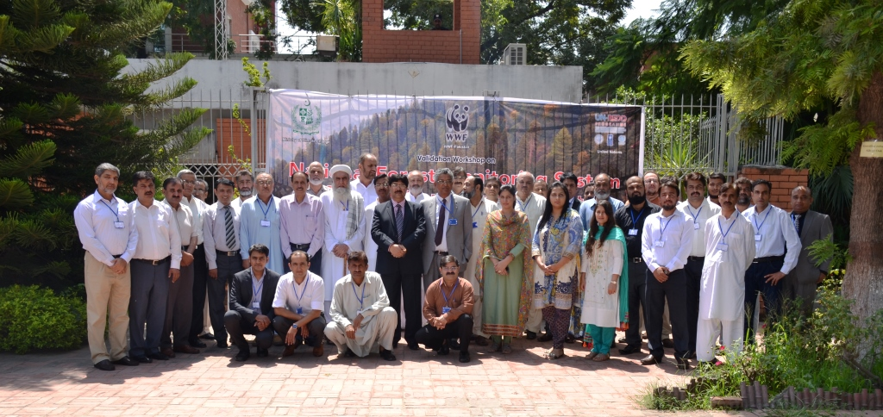

Contents
Background 2
Orientation Workshop on NFMS Action Plan 2
Capacity Based Need Assessment for NFMS 3
Training on Satellite Land Monitoring System (SLMS) 3
Training on Greenhouse gas inventory and estimation of emission factors 3
Reactivation of the NFMS Working Group 4
Sharing of Draft NFMS Action Plan 5
Objectives of the Workshop 5
Workshop Participants and Agenda 5
Summary of the Workshop Programme 5
Inaugural Session 5
Presentation of the NFMS Action Plan 6
IMPLEMENTATION OF THE NFMS 9
Question Answer & Discussion Session 14
Presentation on the Monitoring Function 15
Question Answers & Discussion Session 16
Group Work Session 16
Workshop’s recommendations 19
Annex I Workshop Sign-in Sheet 20
Annex II 25
NFMS Action Plan Validation Workshop, Pakistan 25
Annex III-a 27
Annex III-b 28
Annex III-C 29
Annex III-D 30
Annex IV 31

Background
The Government of Pakistan is implementing REDD+ under obligations of Cancun Agreement of UNFCCC. Presently a project titled “Preparation of Action Plan and Capacity Building for a National Forest Monitoring System (NFMS) for REDD+” is being implemented by WWF-Pakistan under the overall supervision and guidance of the Office of Inspector General Forests (OIGF) to take the REDD+ preparation further and help Pakistan to develop a robust transparent National Forest Monitoring System. Under its two outputs, WWF-Pakistan conducted following activities in order to draft the Pakistan’s National Forest Monitoring System Action Plan:

Orientation Workshop on NFMS Action Plan

WWF-Pakistan, the Office of Inspector General Forests (OIGF) and UN-REDD/ FAO conducted an Orientation Workshop on Preparation of Action Plan and Capacity Building for National Forest Monitoring System (NFMS) for REDD+ on March 20, 2014 for the key National and Provincial stakeholders of REDD+ and the development of an Action Plan.

Capacity Based Need Assessment for NFMS
The National Consultant and WWF-Pakistan’s REDD+ project team developed detailed methodology for conducting CBNA for NFMS, assessment of methodology for spatial analysis of forest cover change and assessment of data availability for LULUCF GHG inventory. Draft reports on “Assessment of REDD+ MRV methodologies” and “Review of UNFCCC decisions and IPCC guidance and guidelines relevant to NFMS for REDD+ MMRV” were shared in July 2014. The national consultant and the project team visited relevant departments and organizations in KP, Punjab, Sindh, Balochistan, Gilgit Baltistan, FATA, AJK and Islamabad from July 24th to Sep 02nd 2014 and conducted individual interviews and focused group discussions regarding capacities, data availability and existing methodologies their gaps and needs. CBNA report was shared with UN-REDD, MoCC and WWF-Pakistan’s team on November 05th, 2014. The report also included standard methodology for spatial assessment of forest cover change.

Training on Satellite Land Monitoring System (SLMS)
WWF-Pakistan, UN-REDD/FAO and the Ministry of Climate Change (MoCC) conducted a five-days training on “Use of advanced tools and technologies to monitor deforestation and forest degradation for developing a SLMS for REDD+ in Pakistan” during October 13-17, 2014 at the National Centre for Rural Development (NCRD) Islamabad. The training was attended by 35 participants from the provincial forest departments, Pakistan Space and Upper Atmosphere Research Commission (SUPARCO), Urban Unit Lahore, university of Arid Agriculture Rawalpindi, University of Haripur, National University of Science and Technology (NUST) Islamabad, WWF-Pakistan and NCRD.

Training on Greenhouse gas inventory and estimation of emission factors
WWF-Pakistan, UN-REDD and the Ministry of Climate Change (MoCC) conducted 3 days training on Greenhouse Gas-Inventory and Emission Factors estimation for the AFOLU/LULUCF sector in Pakistan on March 10-12, 2015. The primary objective of the training was to build capacity of national staff on the greenhouse gas inventories and focused on the estimation of emission factors for Forestry, Agriculture and Land Use Changes, following the diverse suite of capacities in Pakistan. The training was attended by 25 participants from the provincial forest departments, Pakistan Space and Upper Atmosphere Research Commission (SUPARCO), Urban Unit Lahore, Global Change Impact Studies Centre (GCISC), National University of Science and Technology (NUST) and IUCN Pakistan.

Reactivation of the NFMS Working Group
The REDD+ Working Group for NFMS/ MRV, established under the previous phase, was reactivated for the development of the NFMS action plan. The TOR’s of the NFMS Working Group were updated. The third meeting of the NFMS Working Group was conducted on October 17th, 2014. The participants discussed findings of the field data collected during the CBNA for NFMS and reviewed the findings with recommendations and filling of any missing information. The fourth meeting of NFMS WG was conducted on 3-4 December 2014 in which the drafting of NFMS Action Plan was formally started and tasks were assigned to the members of each sub-group. The NFMS Working Group was subdivided into 4 subgroups in the following manner:-
- Subgroup 1: Contextual chapters (chapters 1, 2, 3 & 4), cross-cutting activities and Monitoring function (chapters 5, 6, 7, 8 & 10 related to cross-cutting activities)
- Subgroup 2: SLMS (chapters 5, 6, 7, 8 & 10 related to SLMS)
- Subgroup 3: NFI (chapters 5, 6, 7, 8 & 10 related to NFI)
- Subgroup 4: GHG-I (chapters 5, 6, 7, 8 & 10 related to GHG-I)
The NFMS working group met for the fifth time to complete the first draft of NFMS Action Plan on January 15-16, 2015 in Islamabad. Key decisions were made during the meeting and institutional arrangement for the NFMS was discussed. A focus group meeting on validation of institutional arrangement for NFMS was held at the WWF Pakistan office in Islamabad on Feb 17, 2015. The meeting was chaired by Mr. Nazar Shah, Secretary Environment Government of Khyber Pakhtunkhwa and attended by representatives from Pakistan Forest Institute (PFI), Ministry of Climate Change Islamabad, Civil society and WWF- Pakistan. The proposed structure of the Institutional Arrangement for the National Forest Monitoring System (NFMS), specifically the role of Pakistan Forest Institute (PFI) as the national focal institute, was discussed. Moreover it was decided that structure would be made part of the NFMS Action Plan and would be shared with provincial forest departments for their final endorsement during the national validation workshop. The Sixth meeting of the NFMS Working Group for completing the drafting process of the NFMS Action Plan was conducted on March 17-18, 2015. The working group started work on draft 2.0 NFMS Action Plan during the meeting. WWF-Pakistan compiled and submitted Draft 2.0 National Forest Monitoring system (NFMS) Action Plan to UN-REDD on May 29, 2015. WWF-Pakistan, NFMS working group and UNREDD started working on the draft 3 NFMS Action Plan during June 2015 by communicating through telephone calls, Skype meetings and emails. Draft 3.0 NFMS AP was finally compiled after the inputs of UNREDD and NFMS working Group and submitted to UNREDD on 21 July 2015.

Sharing of Draft NFMS Action Plan
WWF-Pakistan shared the final Draft NFMS AP to the general public for comments and feedback on July 30th, 2015 at WWF web portal.

Objectives of the Workshop
The primary objective of the workshop was the validation of the NFMS Action Plan.

Workshop Participants and Agenda
WWF-Pakistan conducted Validation Workshop for NFMS AP in FAO Conference hall, Islamabad on August 26, 2015. Forty participants comprising of senior officials from government, members of non-governmental organizations and civil society, academic experts, researchers, members of development partners and donors, among others participated in the validation process. Detailed list of the participants and agenda of the workshop are attached as Annex I and II respectively.

Summary of the Workshop Programme

Inaugural Session
The workshop formally started at 9:00 am with recitation of the Holy Quran. The representatives of WWF-Pakistan, Ministry of Climate Change and UN-FAO welcomed the participants.
Syed Mahmood Nasir, Inspector General Forests delivered his opening speech. He appreciated the interest shown by the participants in the workshop and emphasized on the importance of National Forest Monitoring System in Pakistan. He referred to several countries progressing towards achieving the goal of monitoring and reporting of the greenhouse gases. He also stressed on the improvement of the education system of key institution/universities of Pakistan and indicated the importance of revision of the forestry courses with inclusion of advanced modules of REDD+. He concluded his speech with high hopes that the progressive work on REDD+ would continue.
Nasar hayat, Assistant FAO representative (Programmes) in his welcome speech appreciated the role of WWF-Pakistan and office of IGF in progressing towards REDD+ readiness. He encouraged the participants to work on the final draft of the NFMS action plan in order to validate it and completion of the entire process. For this he advised all to formulate a unanimous agreement on the NFMS Action Plan. Secretary forests Balochistan, Mr. Khuday-e-raheem also shared his experiences and progressive works of the Balochistan Forest Department in the recent afforestation/reforestation activities.
The speeches were followed by a formal introduction of all the participants and consequently Mr. Muhammad Ibrahim Khan invited the chief guest of the workshop, Prof. Dr. Rai Niaz Khan to deliver his speech. Prof. Dr. Rai Niaz Khan shared his joy to be a part of a very useful and innovative workshop. He shared his experience of travelling around the world mentioning the kind of lush green forests other countries have. He hoped that with the promotion of REDD+ in Pakistan the forest cover of Pakistan can be significantly increased. He praised the role of all the government and non-government organizations who are working hard to implement REDD+ and NFMS in Pakistan.
With the opening of the workshop Mr. Muhammad Ibrahim Khan presented the objectives of the workshop. The primary objective of the workshop was validation of the NFMS Action Plan whereas the specific objectives are as under:
- To share the NFMS AP with the participants
- To get feedback from the stakeholders on the NFMS AP;
- To discuss and build consensus on the institutional arrangements for the NFMS AP implementation;
- To agree on further steps on the implementation of the NFMS AP;

The first presentation was delivered by Dr. Shahzad Jehangir, DIGF on the National Forest Monitroing System in the context of REDD+. The detailed presentation is available as Annex III (a).
Mr. Inamullah Khan, REDD+ Coordinator for Pakistan’s RPP briefed the participants on the progress towards implementing RPP in Pakistan for REDD+ and shared a work plan of activities.
Muhammad Afrasiyab, Senior Project Officer REDD+ gave an overview of the NFMS AP development process in Pakistan. He briefly described the phased approach towards building the capacities of the national stakeholders and the parallel progressive work of the NFMS Working group in drafting of the NFMS Action Plan. The details are available in the annex III (b).

Presentation of the NFMS Action Plan
Muhammad Ibrahim Khan presented the NFMS Action Plan. He highlighted the hard work of the NFMS Action Plan development team and explained each section of the NFMS AP as under:

Objectives of the NFMS
  - Generate reliable data and information to formulate, monitor and adjust national forest policies;
  - Inform interested stakeholders on the forest status and to report to international conventions, such as the Rio Conventions.
  - Monitor progress towards sustainable forest management in Pakistan.

Objectives of the action plan
  - To adopt and implement institutional arrangements with clear roles and responsibilities for the implementation of the NFMS;
  - To monitor the forest resources of Pakistan for their sustainable management;
  - To develop and establish a transparent NFMS for REDD+ according to the COP’s decisions and IPCC guidelines;
  - To establish a national database and web portal for ensuring quality, transparency and accessibility of information related to the forest sector;
  - To report to international conventions

NFMS Action Plan development methodology
- Orientation workshop on NFMS;
- Establishment of a national NFMS working group;
- CBNA and capacity building in SLMS and GHG-I
- Drafting and review of the draft NFMS AP;
- Meetings with the key institutions regarding institutional arrangements;
- Sharing of the draft NFMS AP through WWF-Pakistan’s website;
- National Validation Workshop

National Circumstances
- Introduction and background;
  - The forestry sector (Forest types, area, legal categories etc.);
  - Biodiversity;
  - Forest policies;
- Drivers of deforestation and forest degradation (review);
  - Pakistan Forest Program;
  - District Level Consultation Workshops for REDD+, 2013;
  - Report on CBNA for NFMS, 2014
- Policies and measures to address drivers of deforestation and forest degradation (drivers, existing policies and measures to address these drivers and proposed policies and measures)

Institutional arrangement for the implementation of the NFMS AP
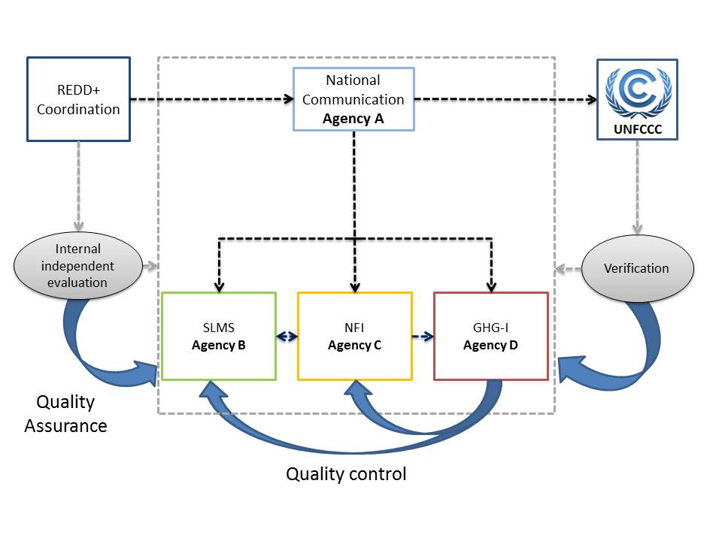

NFMS Development
- NFMS development phases;
  - Phase1 – Readiness-year-1 and 2:
  - This phase includes necessary planning and preparations for developing the NFMS. This includes (but not limited to):
    - Identification and selection of suitable methods, tools and techniques according to the UNFCCC and IPCC guidelines;
    - Synchronization and adjustment of these methods, tools and techniques according to the existing ones;
    - Capacity building and technology transfer regarding recommended/selected methods, tools and techniques for the NFMS;
    - Defining policies, legal measures and institutional arrangements for the implementation of the NFMS.
  - Phase 2 - Results-based demonstration activities (piloting phase)-Year-2 and 3:
    - Pilot testing in provinces;
    - Monitoring function to provide information in land use and land use changes in these sites to test and refine the SLMS;
    - Also includes capacity building to prepare for phase 3
  - Phase 3 - Extension of NFMS to national level (Year-3 and 4):
    - Tested methods, tools and structures will be finalized and extended to monitor the REDD + activities at national level;
    - Capacity building will also be going to keep the respective professionals ready for the coming assignments
- Funding arrangements (to be sorted out after the workshop):
  - National allocations
  - Provincial allocations
  - Donors funding (R-PP, UN-REDD and proposals for other donors)

CAPACITY ASSESSMENT
- This section is based on the CBNA done during the project;
- Capacity of national and provincial level organizations for the implementation of
  - Satellite Land Monitoring System (SLMS),
  - National Forest Inventory (NFI),
  - Greenhouse Gas Inventory (GHGI) and
  - Monitoring function of the NFMS
- Available data, technical, human and hardware capabilities to implement the NFMS
- Gaps and resources needed to implement the NFMS in a sustainable way

IMPLEMENTATION OF THE NFMS

Component 1: Institutional arrangement
Output 1.1: Institutional framework for implementation of the NFMS is established
Activity 1.1.1: Establish the technical units;
  - Legal preparedness
  - Stakeholders consultation
  - Identification of mandate and responsibilities of the technical units
  - Enact institutional arrangements
  - Operationalization of the technical units (including regular meetings)
Activity 1.1.2: Set up participatory process;
  - Stakeholders mapping
  - Identification of roles and responsibilities
  - Implication of young professionals
Activity 1.1.3: Clarification of mandates within the technical units;
  - Identification of mandates to implement the NFMS
  - Definition of lines of communication
  - Promulgation of mandates and lines of communication
Activity 1.1.4: Promulgation of institutional arrangements

Output 1.2: The funding arrangements are defined
Activity 1.2.1: Inventory of available and needed funding
  - Identification of necessary resources to implement the NFMS
  - Inventory of available funding
  - Gap analysis
Activity 1.2.2: Development of a resource mobilization strategy
  - Development of a resources mobilization strategy
  - Identify donors
  - Strategy implementation
Activity 1.2.3: Clarification of financial arrangements
  - Assess the process required for a transition to a sustainable self-financing arrangement and develop a timeline for its implementation
  - Stakeholders consultation for the funding allocation mechanism
  - Proposal of funding allocation mechanism and proposal for its implementation
Activity 1.2.4: Promulgation of financial arrangements
  - Organization of a validation workshop to formally adopt the funding allocation mechanism
  - Official enactment of financial arrangements

Component 2: SLMS
Output 2.1: The technical capacities are reinforced;
Activity 2.1.1: Establish SLMS laboratory;
  - Allocation (renovation) of office space for SLMS laboratory
  - Purchase of office supplies and equipment
Activity 2.1.2: Select and recruit technical staff
Activity 2.1.3: Train technical staff
  - Training on UNFCCC’s requirements for reporting on land use changes
  - Training on basic RS/GIS techniques, open source software (e.g. Collect Earth, Geospatial toolkit and Terra Amazon), monitoring afforestation, deforestation and forest degradation
Activity 2.1.4: Centralization of existing data
  - Facilitate data sharing agreement between relevant institutions
  - Harmonization of all existing remote sensing and field data
  - Development of a robust database management system
Activity 2.1.5: Characterize satellite images for forest monitoring;
  - Assess the impact of available images for forest stratification, monitoring of deforestation and forest degradation
  - Recommendations for the development of forest stratification, the monitoring of deforestation and forest degradation and for the monitoring of REDD+ activities
  - Purchase very high resolution imagery according to needs
Activity 2.1.6: Stratification of forest cover
  - Consultative meeting in each province for the further categorisation of forest types and LCCS classes
  - Presentation and approval of the LCCS legend
  - Stratification of forest cover
Activity 2.1.7: Produce a guidance document on the methodology to monitor land use and forest cover changes
  - Definition of intact, fragmented and degraded forest
  - Development of a methodology for the monitoring of land use and forest cover changes (including the tools to be used)
  - Development of QA/QC procedures
  - Publication of methodology and guidelines for data collection, analysis, QA/QC, reporting and dissemination
Output 2.2: The SLMS is operational (Land use and forest cover changes are measured)
Activity 2.2.1: Historical analysis of land use and forest cover changes
  - Validation of the reference year (T0)
  - Assessment of historical land use and forest cover changes
  - QA/QC
  - Projection of the FREL/FRL (according to national circumstances)
Activity 2.2.2: Monitoring of land use and forest cover changes
Pre-processing of satellite images
  - Assessment of land cover changes
  - Assessment of forest cover changes
  - Results publication in the form of a comprehensive report
Activity 2.2.3: Elaboration and validation of the global report of the SLMS
  - Drafting of SLMS report
  - Stakeholders review
  - Publication on the NFMS web portal

Component 3: NFI
Output 3.1: The technical capacities are strengthened
Activity 3.1.1: Establish and equip national and provincial laboratories
  - Identify office space for national and provincial NFI labs
  - Purchase of equipment for the national laboratory (PFI)
  - Strengthening of the existing laboratories in provincial forest departments
  - Maintenance of the equipment
Activity 3.1.2: Capacity building
Activity 3.1.3: Centralization of existing data
  - Design centralized and provincial database system
  - Identify all data holders
  - Facilitate data sharing agreement between relevant institutions
  - Collection and harmonization of all existing remote sensing and field data
  - Development of a robust database management system
Output 3.2: The NFI is designed
Activity 3.2.1: Validate the national definition of forest
  - Develop criteria and indicators easily measurable in the field
  - Organize a validation workshop for the definition of forest and legally adopt the national definition of forest
Activity 3.2.2: Conceptualize the multipurpose NFI
  - Identify the global and specific objectives of the NFI
  - Identify the criteria and indicators to monitor
  - Identify the bio-physical and socio-economic variables of interest
  - Identify the frequency of field measurements
Activity 3.2.3: Develop the multipurpose NFI methodology
  - Assessment of forest areas (through remote sensing tools)
  - Develop the sampling design (sampling methodology, number and distribution of sample plots, design and layout of sample plots)
  - Develop the measurement protocols
  - Draft the multipurpose NFI methodology, including financial proposal and share with partners
  - Test the methodology in the field and implement a national workshop to validate the methodology
Activity 3.2.4: Develop the field manual
  - Review of literature and draft the field manual
  - Test the field manual in the field and formally adopt the field manual
Output 3.3: The NFI is implemented
Activity 3.1.1: Train technical staff on NFI methodology
  - Identification of trainers from provincial forest departments
  - Training of trainers on NFI methodology, including field protocols for the development of allometric equations
Activity 3.1.2: Operational planning
  - Field work planning
  - Purchase and security of needed equipment
Activity 3.1.3: Recruitment and training of field teams
  - Identification of team leaders
  - Recruitment of field teams
  - Training of field teams
Activity 3.1.4: Collection of field data
Activity 3.1.5: Data processing
  - Centralization and data encoding
  - Analysis of samples of soil and litter
  - Data processing
Output 3.4: The data are analysed and the results are disseminated
Activity 3.4.1: Data analysis and reporting
  - Development of data management system
  - Development and implementation of quality control
  - Documentation of the data analysis system
  - Final report writing
  - Publication and dissemination of the results
Activity 3.4.2: Dissemination of information
  - Documentation of methods and data collection for forest monitoring
  - Development of a template for data sharing agreement
  - Development of a web-based platform for data sharing among national stakeholders
  - Publication of the results on the NFMS web portal

Component 4: GHG-I
Output 4.1: The technical capacities are strengthened
Activity 4.1.1: Establishment of the GHG-I national laboratory
  - Identify office space for national GHG-I labs
  - Purchase of equipment for the national laboratory (GHG-I)
  - Maintenance of the equipment
Activity 4.1.2: Recruitment of the technical staff
  - National-level call for applications
  - Screen and test of candidates
  - Select and recruit most appropriate candidates
Activity 4.1.3: Capacity building
  - Training on GHG Inventory methodologies
  - Training on GHG-I data management and estimates preparation from AD and EF (data quality, data gaps, data consistency, data sources, quality control and assurance)
  - Training on reporting
Output 4.2: The GHG-I is compiled
Activity 4.2.1: Develop the GHG-I methodology
  - Draft the GHG-I methodology
  - Comments and improvements from stakeholders
  - National workshop to validate the methodology
Activity 4.2.2: Data centralization and estimation of GHG emissions/removals
  - Collect AD and EF
  - Data entry in the LULUFC/ALU (or other related) software
  - Preliminary analysis and evaluation of results
  - Estimation of GHG emissions/removals
Activity 4.2.3: Quality assurance and quality control
  - Plan Quality Management
  - Perform Quality assurance
  - Control Quality
Activity 4.2.4: Assess uncertainties of GHG estimates
  - Evaluation of uncertainties and verification of representative sample of field measurements
  - Approaches to estimate uncertainties
Activity 4.2.5: Development and finalization of the national GHG-I report
  - Develop and share draft report on GHG-I (with stakeholders for their comments)
  - Incorporate the stakeholders comments
  - Share the improved draft for independent review
  - Incorporate the independent reviewer’s comments and finalize the report
Activity 4.2.6: Submit the national GHG-I report

Component 5: Monitoring Function
Output 5.1: The scope and objectives of forest monitoring are identified
Activity 5.1.1: Identify the scope and objectives of forest monitoring
  - Participatory discussion on the scope and objectives of forest monitoring
  - Identification of expected outcomes of forest monitoring
  - Identification of variables to be recorded
  - Identification of responsibilities to be assigned
Activity 5.1.2: Identification of information needs
  - Assessment of available information and information needs
  - Translation of information needs into indicators to be monitored
Activity 5.1.3: Identification of indicators to be monitored
  - Identification of indicators to monitor progress towards sustainable forest management
  - Identification of indicators to monitor results of REDD+ policies and measures
Output 5.2: The methodology and tools for forest monitoring are defined
Activity 5.2.1: Identify monitoring methods and tools
  - Identify approaches to forest monitoring (remote sensing, field approaches, community-based approaches, etc.)
  - Assess existing forest monitoring tools and define the tools needed
  - Define the tools needed to monitor identified criteria and indicators for REDD+ policies and measures
  - Assess synergies between existing and new tools (SLMS, NFI, etc.)
  - Harmonize existing and new tools in a comprehensive methodology for forest monitoring
Activity 5.2.2: Formally adopt monitoring methods and tools
  - Report on forest monitoring methods and tools
  - Assign responsibilities for forest monitoring
  - Formally adopt forest monitoring methods, tools and responsibilities
Output 5.3: The technical capacities are reinforced
Activity 5.3.1: Hire technical staff for the monitoring unit
  - Develop TORs of the required staff
  - Hire or post full time staff through an open competitive process
Activity 5.3.2: Capacity building
  - Establish and equip national lab
  - Development of a robust database management system
  - Technical capacity building
Activity 5.3.3: Develop and launch the NFMS web portal
  - Design web portal (layout, functions, data, etc.)
  - Train web portal operators
  - Define technical parameters for server device (server, internet connection, logistics, server room power) and procure
  - Conduct a national workshop to present the web portal
Consider/incorporate public comments and adjust/set parameters for the web interface
Output 5.4: The NFMS is operational
Activity 5.4.1: Forest monitoring
  - Data collection and analysis
  - Information generation, reporting and dissemination
  - Publication of information on the NFMS web portal
  - Report to international conventions and commitments
Activity 5,4.2: Quality control by the NFMS Unit
  - Develop QC protocols
  - Implement QC protocols
Activity 5.4.3: Quality assurance by an independent third party
  - Develop QA protocols
  - Identify and hire relevant third party for the QA
  - Implement QA protocols
Activity 5.4.4: Periodic revisions and adjustments of the NFMS design

Estimated budget (k US $)
Component | Year-1 | Year-2 | Year-3 | Year-4 | Total
1. Institutional framework | 86.1 | 51.4 | 41 | 3.8 | 182.3
2. SLMS | 591.6 | 373.2 | 153.9 | 146.9 | 1265.6
3. NFI | 992.7 | 329.1 | 249.7 | 131 | 1702.5
4. GHG-I | 149.7 | 131.4 | 88.9 | 94.4 | 464.4
5. Monitoring function | 279.7 | 84.8 | 54.6 | 54.6 | 473.7
G. Total | 2099.8 | 969.9 | 588.1 | 430.7 | 4088.5

Question Answer & Discussion Session
Miss Urooj, GIS Manager raised a question regarding the strength of the REDD+ steering committee in the institutional arrangements for implementing the NFMS. Dr. Shahzad informed that the REDD+ steering committee, headed by the secretary Ministry of Climate Change, consists of 21 members also including the provincial secretary forests and chief conservator forests. Muhammad Ibrahim Khan further elaborated the role of each organization in the proposed institutional arrangements of NFMS during three phases of implementation. In a plenary discussion the participants further advised that the implementation process should be started as soon as possible with the demonstration/pilot projects during which the efficiency of the implementing organization can also be assessed for future decisions.

Presentation on the Monitoring Function
After the tea break Ben Vickers, Regional Programme officer REDD+, delivered his presentation on the Monitoring Function of the NFMS. He started with a clarification on the technical difference between the MRV and Monitoring function of the NFMS and the evolution of latest concepts. The “monitoring” function of the NFMS is primarily a domestic tool to allow countries to assess a broad range of forest information, including in the context of REDD+ activities.

The monitoring function can be implemented through a variety of methods and serve a number of different purposes, depending on national circumstances, but in the UN-REDD Programme context it focuses on the impacts and outcomes of 1) demonstration activities carried out during the second phase of REDD+ and 2) national policies and measures for REDD+ in the third phase of REDD+.
The MRV function for REDD+, on the other hand, refers to the estimation and international reporting of national-scale forest emissions and removals. It is based on three main components, or ‘pillars’: 1) the satellite land monitoring system (SLMS); 2) the national forest inventory (NFI); and 3) the national GHG inventory. The SLMS and the NFI pillars are used to provide inputs into the third pillar – the forest sector component of the GHG inventory. Countries must progressively develop and operationalize these three pillars over the three phases of REDD+, and align them with the monitoring function, so that by the third phase of REDD+ they have a fully functional NFMS. He also explained that the monitoring function of NFMS has no defined structure and depends more on the national circumstances instead there is a defined structure of MRV components in the NFMS.

He also gave a brief presentation on the FREL/FRLs (Forest Reference Emission Levels/Forest Reference Levels. Forest Reference Emission Levels and Reference Levels (RELs/RLs) are “benchmarks” for assessing countries’ performance in implementing REDD+ activities. Countries implementing REDD+ activities under the UNFCCC will need to develop their RELs/RLs and submit them to the UNFCCC. These will then be used to measure the effectiveness of each country’s policies and measures related to REDD+. The detailed presentation is available as annex III (c).

Question Answers & Discussion Session
Dr. Moazzam, Assistant Professor Arid University asked a question if afforestation/reforestation and agroforestry could change the reference emission levels in future. Ben Vickers emphasized that the countries should have clarity on the national definition of forests.
Syed Mahmood Nasir, IGF invited the participants for an open discussion on the arrangements of the key institutions and their roles in the NFMS Action Plan. After a thorough discussion it was agreed that the process should continue and there must be a clear role of the key organizations. The participants unanimously agreed that the mandates should be allocated after the validation of the NFMS Action Plan.
After the lunch break Mr. Ijaz from GCISC presented a historical overview of the greenhouse gas inventories conducted by Pakistan. The presentation is available as annex III-(e).

Group Work Session
After the presentations, participants were engaged in discussion in break-out groups to which they were self-assigned, discussing namely the following;
Component 2 (Satellite Land Monitoring System)
Component 3 (National Forest Inventory)
Component 4 (Greenhouse Gas Inventory)
Components 1&5 (Institutional framework and Monitoring function)
The groups were self-facilitated and rapporteurs presented the outcomes of discussions using the template provided. Individuals from the NFMS AP development team were present at each of the break-out groups as resource persons.
Based on the presentations and following plenary discussions, the recommendations for the finalization of the document are as follows (for outputs and outcomes where no comments were made or revision proposed, these are not mentioned in the matrix below).

Outputs and activities | Type of comments (correction, addition, deletion, amendment) | Comments | Response by the NFMS team
Component 1 and 5: Institutional framework and Monitoring function
Institutional framework for NFMS AP implementing (page 17 and 18)
 | Addition on page 17 in the organogram and in the text | REDD Management and coordination board (as an additional body in the list of institutions – paragraph 2, page 18) with representatives from all provinces (FDs and other associated Government and Non-Government Organizations), and MoCC with rotating chair from provincial FDs including territories (AJK, GB and FATA). The OIGF will act as secretariat of the board with REDD Coordinator as secretary. | Incorporated
 | Agreed with the rest of institutional framework of NFMS implementation with PFI having the lead role |  | Maintained
 | Addition on page 18 | Develop provincial REDD Steering Committees and REDD cells with secretariats in respective Forest Departments. Add this under the text of Provincial FDs on page 18. | Incorporated
Output 1: The institutional framework is established (Page 39-42)

Activity 1.1: Establishment of the technical units | Addition (as a new activity) | Develop TORs for the REDD/ NFMS management and coordination board and notify. Add as a new activity. | Added
 | Correction | Formalisation instead of legal preparedness | Corrected
Activity 1.2: Setting up of participatory process | Addition | Stakeholders mapping (at provincial level) | Added
Component 2: Satellite Land Monitoring System (SLMS)
Output 1: The technical capacities are reinforced (Page 43-46)

Activity 1.2: Select and recruit technical staff | Replace | Replace ‘MS degree’ with Minimum requirement M.Sc. (sixteen years of education) | Replaced
Activity 1.4 : Centralisation of existing data | Addition | Add to last paragraph: Academia, researchers and relevant institutions etc | Added
Activity 1.5 : Characterize satellite images for forest monitoring | Addition | Add at the end of the second paragraph:  In addition to these datasets, images (SPOT, QuickBird, GeoEye etc.) acquired from other departments/organisations through MoU will also be part of the system | Added
Output 2 : The SLMS is operational (Land use and forest cover changes are measured) (Page 46-47)
Activity 2.1 : Historical analysis of land use and forest cover changes | Addition | Please add in the brackets at the end of first paragraph: Deforestation, forest degradation and land use changes, instead of only land conversion | Added
Activity 2.2: Monitoring of land use and forest cover changes | Addition | Add at the end of first paragraph: Biennial monitoring of hotspots (10% of the forest area of each province) | Added
Component 3: National Forest Inventory (NFI)
Output 1: The technical capabilities are strengthened (Page 48-55)

Activity 1.1: establish and equip national and provincial laboratories | Addition – first in sub-activity box | Selection and retention of competent team is required before the selection of office space | Added
Activity 1.2: Capacity Building | Addition – end of paragraph 1 | The trainers should be identified and retained in the respective divisions/ departments to ensure sustainability | Added
Activity 1.3: Centralization of existing data | Addition – end of paragraph 1 | Standardisation of the data and methodology should be ensured, according to IPCC guidelines | Added
Output 2 : The NFI is designed (Page 50-52)
Activity 2.2: conceptualize the multipurpose NFI | 2.2 (S.A 3) addition | For socio-economic variables, REDD+ safeguards should be followed | Added
Activity 2.3: Develop the multipurpose NFI methodology | Agreed | Rephrasing of word « test » with « Pilot study ». (SA 6) | Rephrased
Output 3 : The NFI is implemented (Page 52-54)

Activity 3.1: Train technical staff on NFI methodology | Addition 3.1 (SA 1) | Add ‘and other related departments’ | Added
 | Addition 3.1 (SA 2) | The trainers should be from forest departments as well | Added
Activity 3.2: Operational planning | Addition (3.2) para. | The word « academia » may be added to the first sentence of the 2nd paragraph | Added
Activity 3.4: Collection of field data | Add to end of second paragraph | Collection of data should be carried out through existing forestry field staff. | Added

Workshop’s recommendations
- The NFMS Action Plan would be considered validated along with necessary modifications/editions/deletions in the form of response matrix with inputs from each sub-group whereas the sign-in sheets would be considered as approval by the participants of the Workshop.
- The follow up meetings would be conducted by Ministry of Climate and the institutions with key roles in the NFMS would be assigned the mendates.

Annex I Workshop Sign-in Sheet
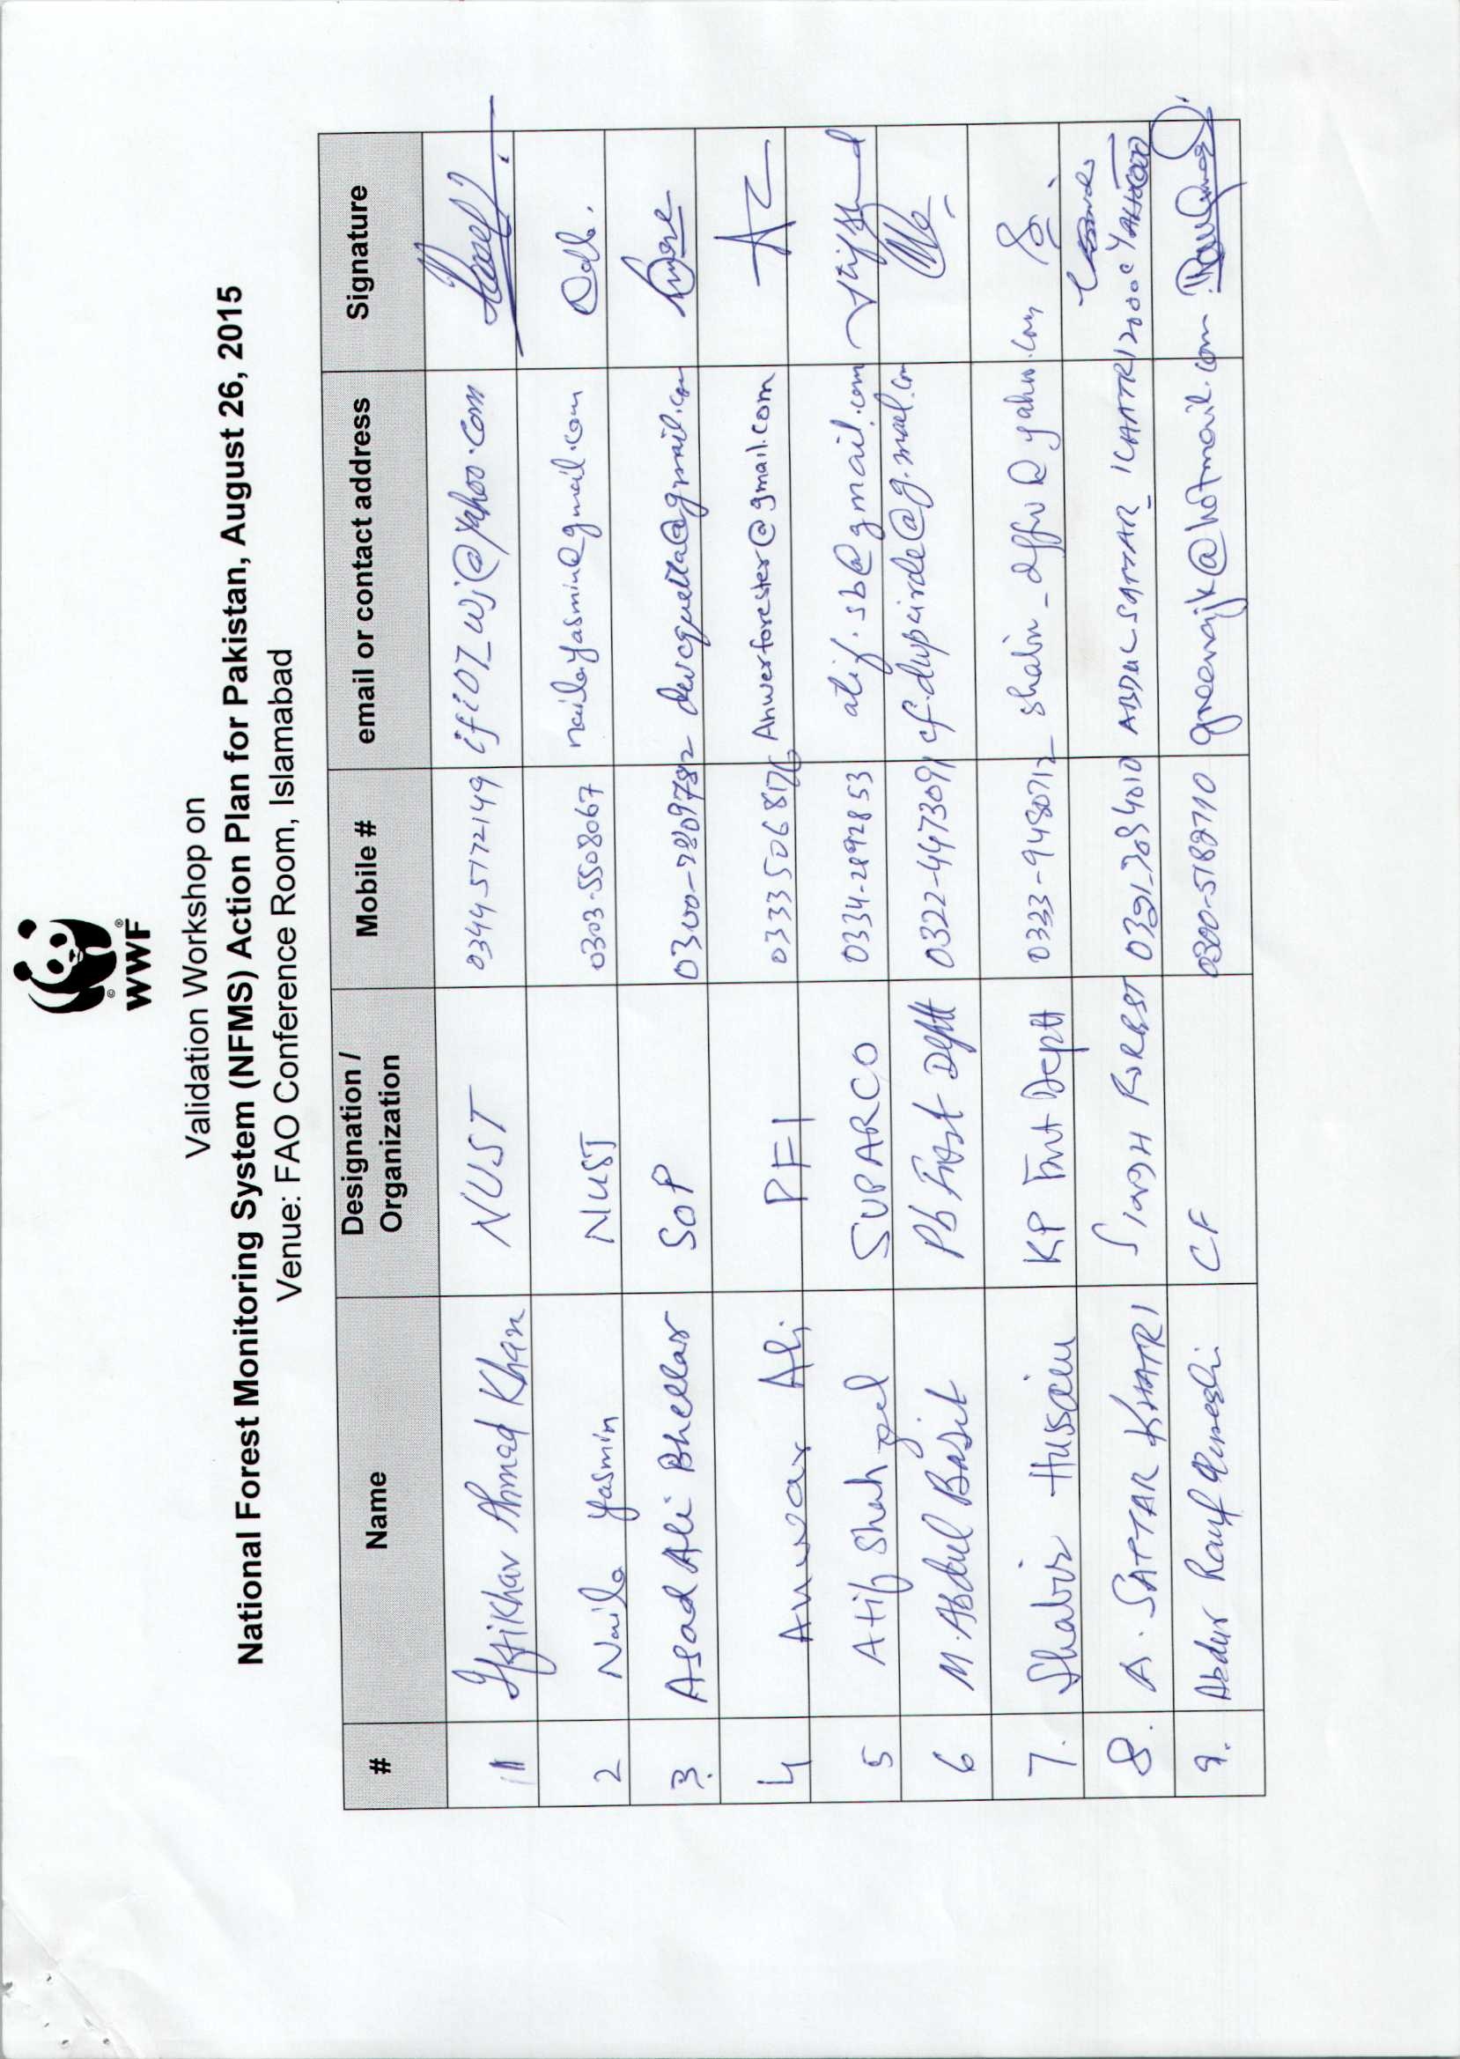
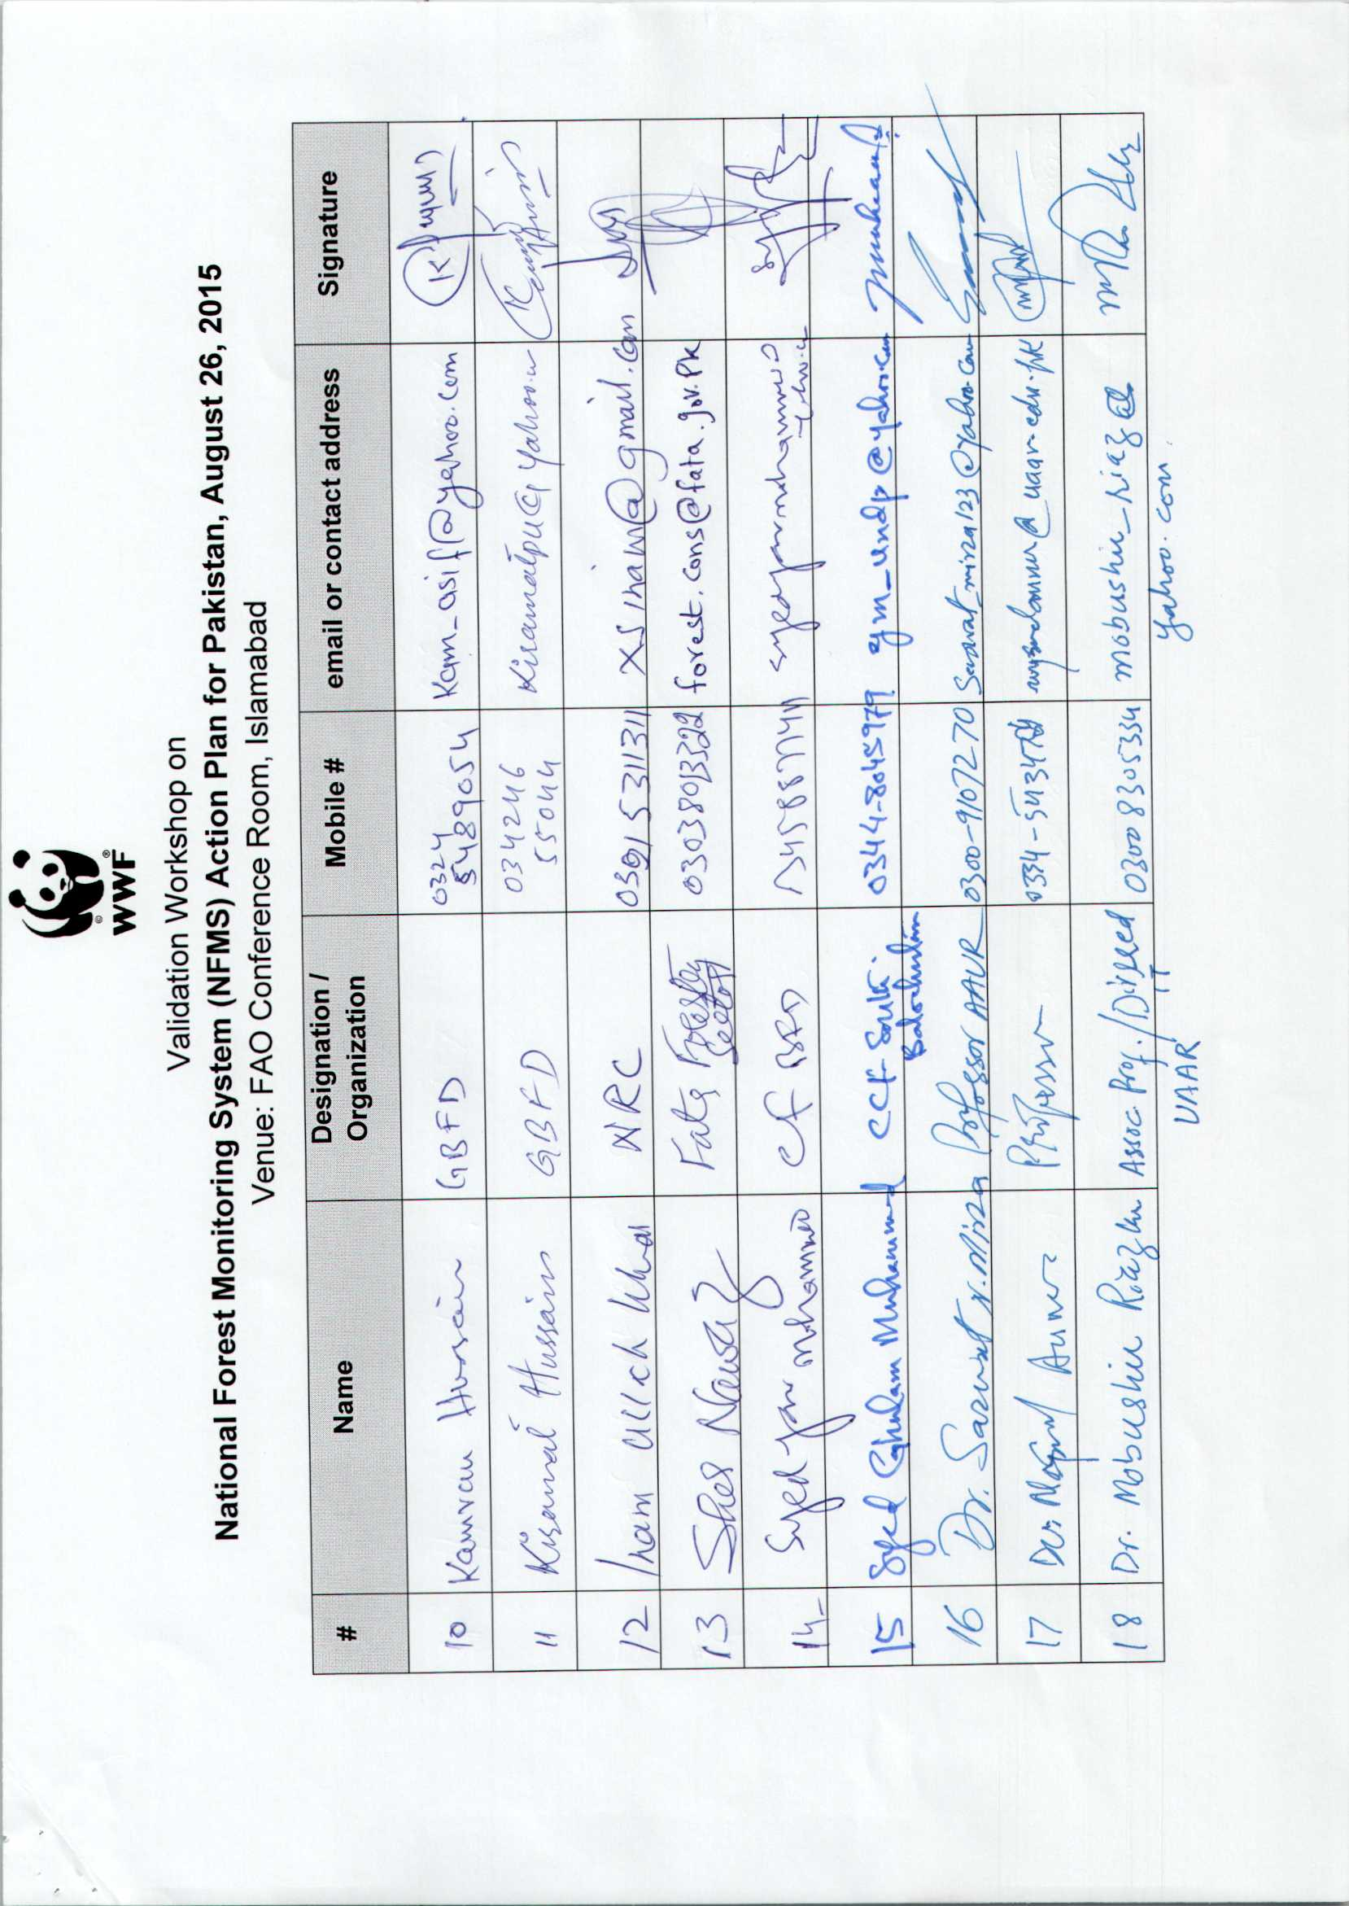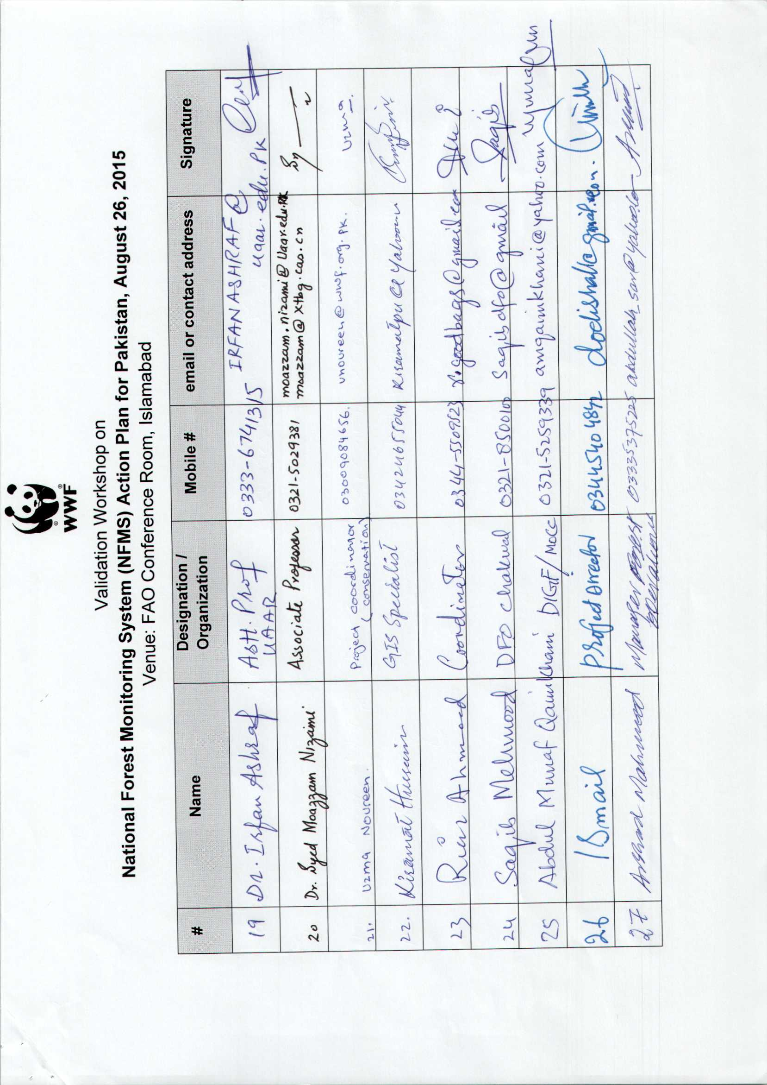
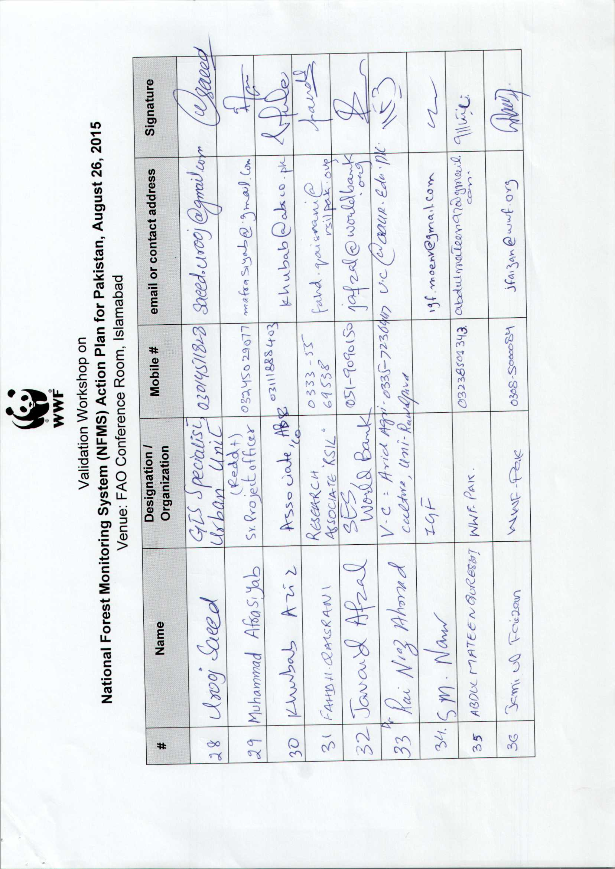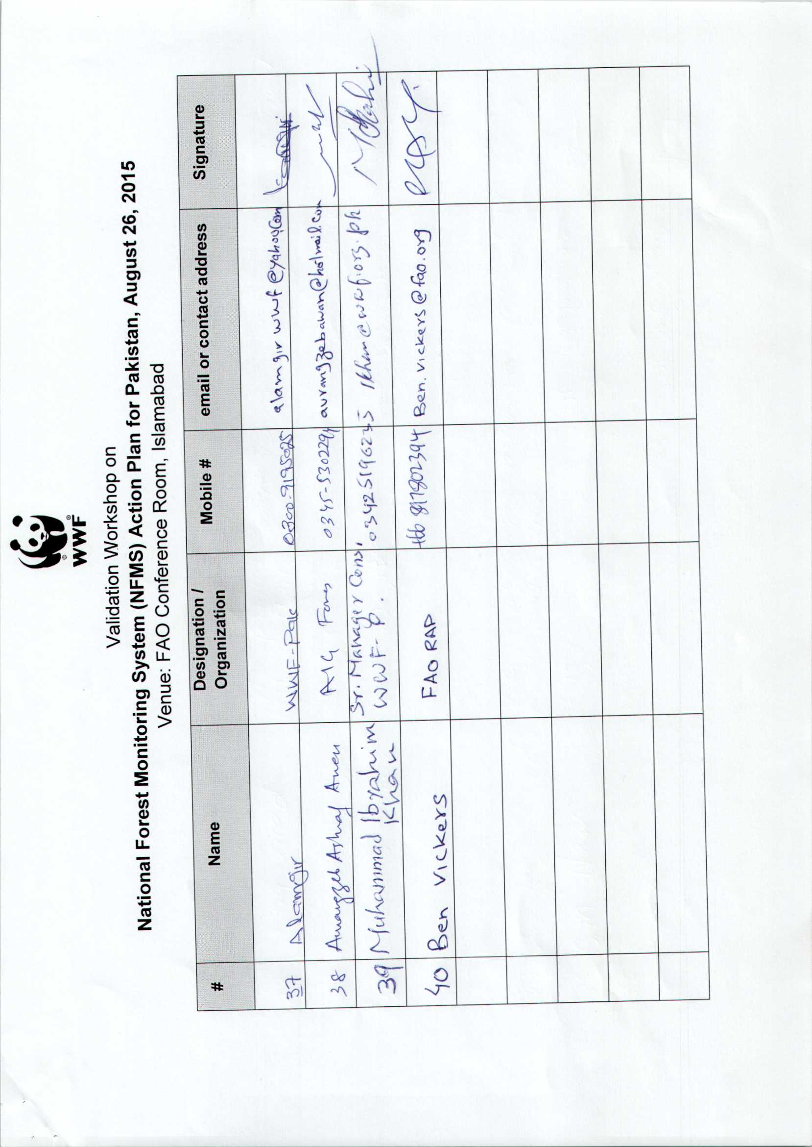

Annex II

NFMS Action Plan Validation Workshop, Pakistan
Wednesday 26th August 2015,
FAO conference room, Islamabad
Session Plan (Agenda) |  | Facilitation
Session 1 : Introduction
08 :30-09 :00 | Registration | WWF
09:00 – 09:20 | Welcome address by OIGF  Speech by FAO representative  Speech by Vice Chancellor Arid University | IGF  Nasar Hayat  Prof. Dr. Rai Niaz Ahmad
09:20 – 09: 30 | Workshop objectives and methodology and Workshop participants Introduction | Muhammad Ibrahim Khan
Session 2 : Introduction to the NFMS
09:30 – 09:40 | National Forest Monitoring System in the context of REDD+ | Dr. Shahzad Jehangir
09:40 – 09:45 | Progress of RPP implementation | Inam-ullah Khan/REDD+ Advisor
09:45 – 10:00 | An overview of NFMS Action Plan drafting Process in Pakistan/ Voluntary contributions of the NFMS Working Group (WG) in NFMS Action Plan drafting process | Afrasiyab/Anwar Ali
10:00 - 10:30 | Overview and content of the NFMS AP for Pakistan; Main components  - Institutional framework  - SLMS  - NFI  - GHG-I  - Monitoring function | Muhammad Ibrahim Khan
10:30 – 10:40 | Group Photo Session
10:40 – 11:00 | Tea Break
11:00 – 11:30 | Introduction to monitoring function of NFMS and to Forest Reference Levels (FRLs) | Ben Vickers
Session 3 : Implementation of the NFMS
11:30 –11 :45 | Capacity Based Need Assessment of the National Forest Monitoring System in Pakistan; Gaps analysis | Kamran Hussain
11 :45– 12 :00 | Greenhouse Gas Emission Inventory of Pakistan 2012: Some Preliminary Results | Muhammad Ijaz/GCISC
12 :00- 13 :00 | Proposed Institutional arrangements for NFMS Action Plan Plenary discussions on Institutional arrangement | Syed Mahmood Nasir
13 :00 -14 :00 | Lunch
Session 4: Validation Exercise
14 :00 –15:00 | Validation of NFMS AP contents: Parallel Group Work |  |  |  |  |  |  | Introduction by Ben Vickers  Facilitators :  OIGF/WWF
 | Component 1: Institutional Framework |  | Component 2 : SLMS | Component 3 : NFI | Component 4 : GHG-I | Component 5: Monitoring function
15 :00 – 15 :30 |  | Presentations by each thematic sub group
15 :30 -16 :00 |  | Tea Break
16 :00 – 16 :20 |  | Response from NFMS team and validation statement |  |  |  |  | All stakeholders/ Ben Vickers
16 :20 – 16 :45 |  | Closing remarks and Vote of thanks |  |  |  |  | Dr. Ghulam Akbar/ Syed Mahmood Nasir/Syed Nazar Shah (Sec. Env. KP)

Annex III-(a) Presentation by Dr. Shahzad Jehangir
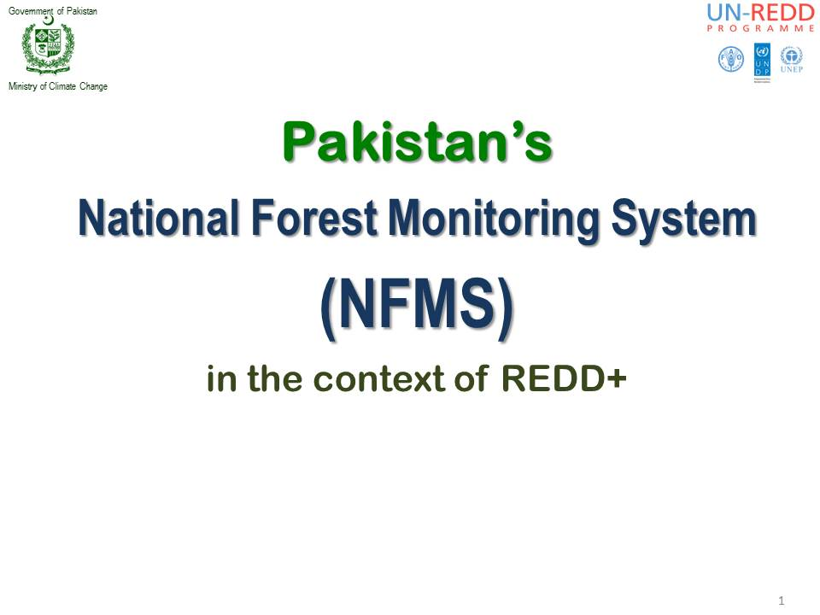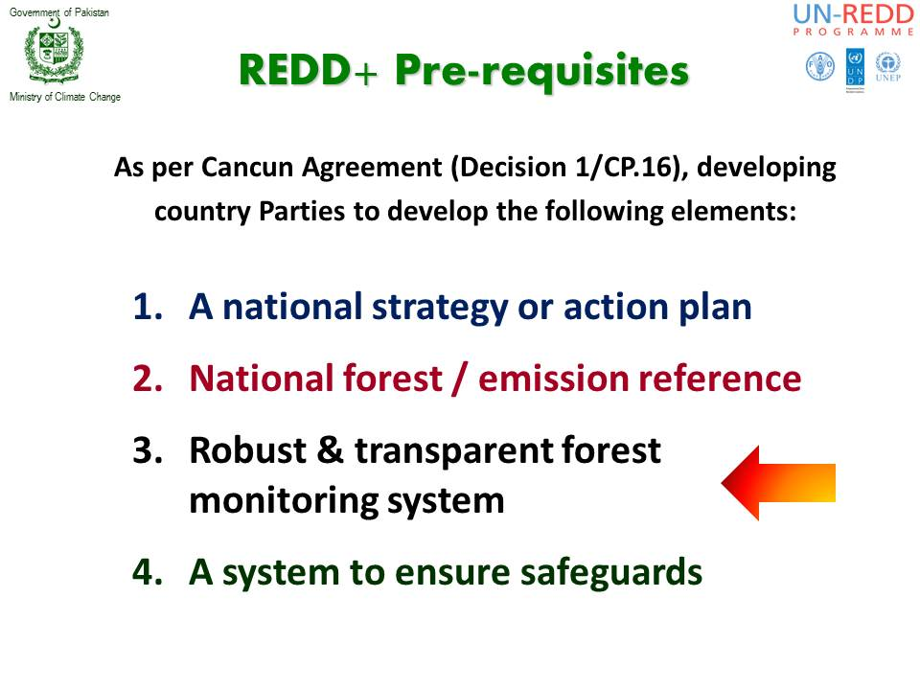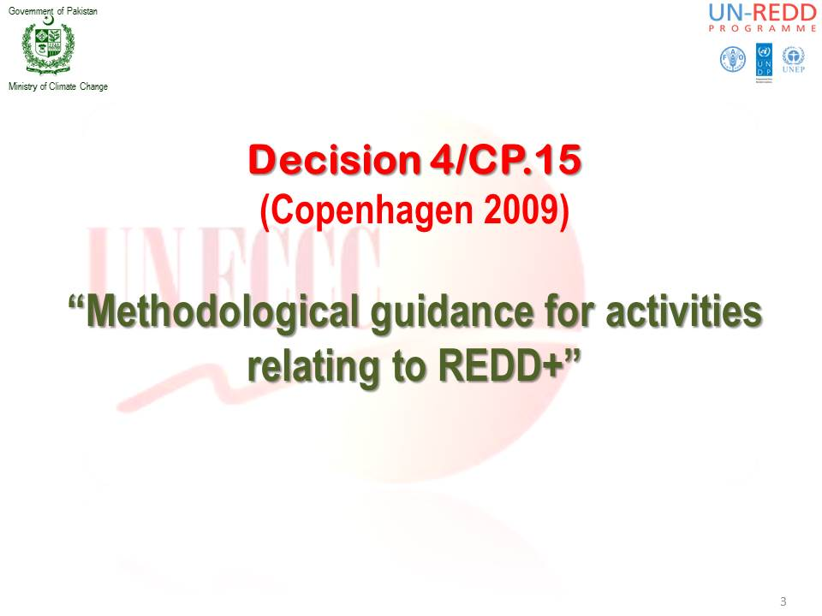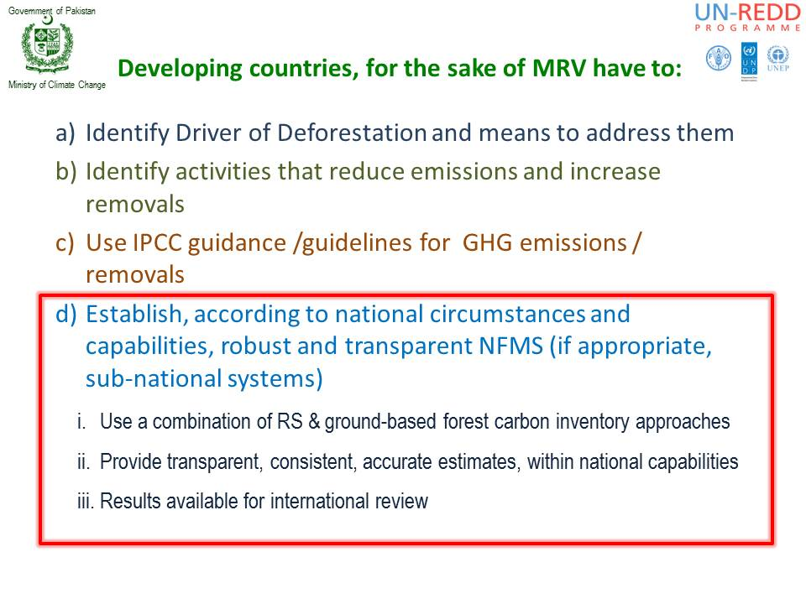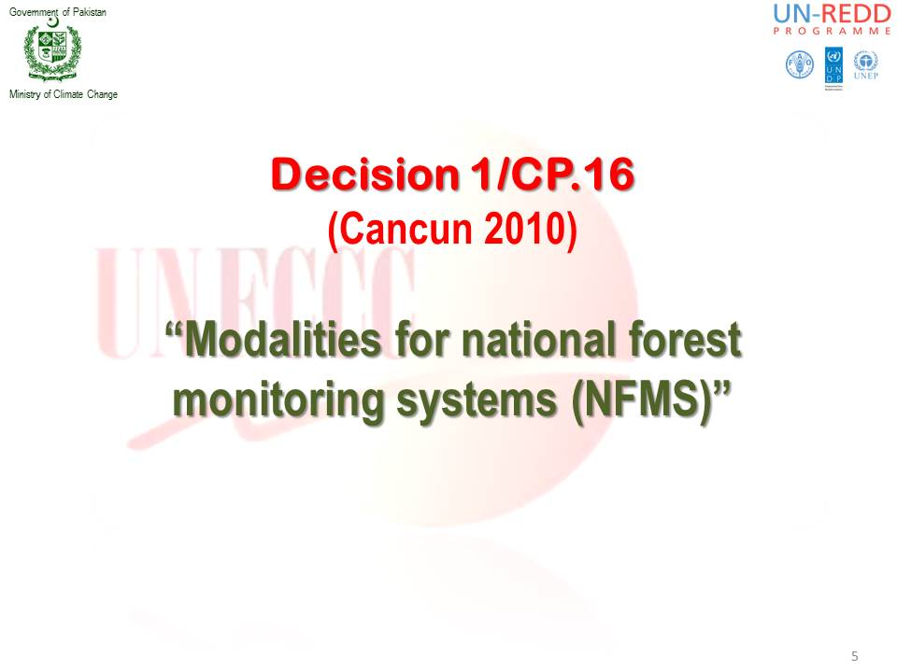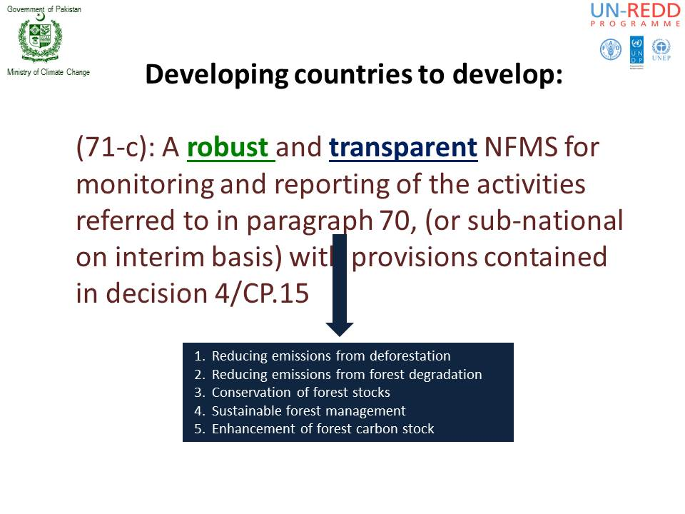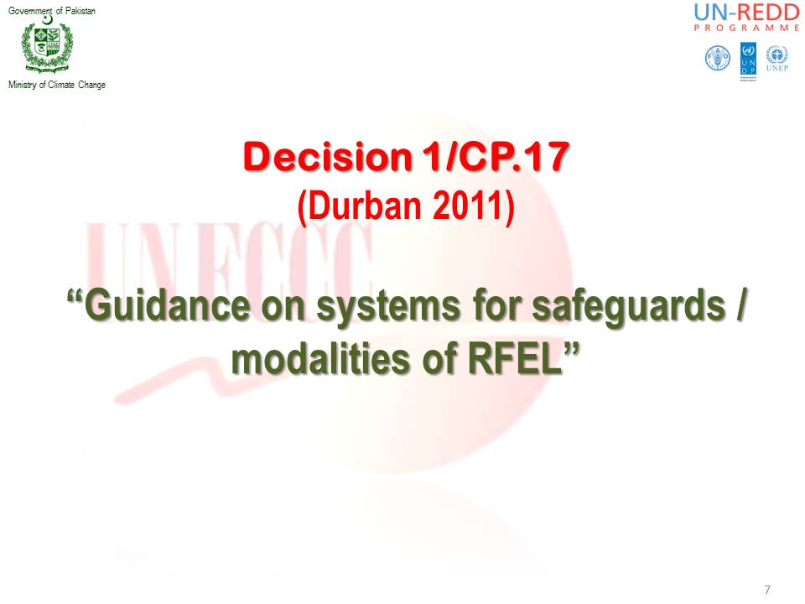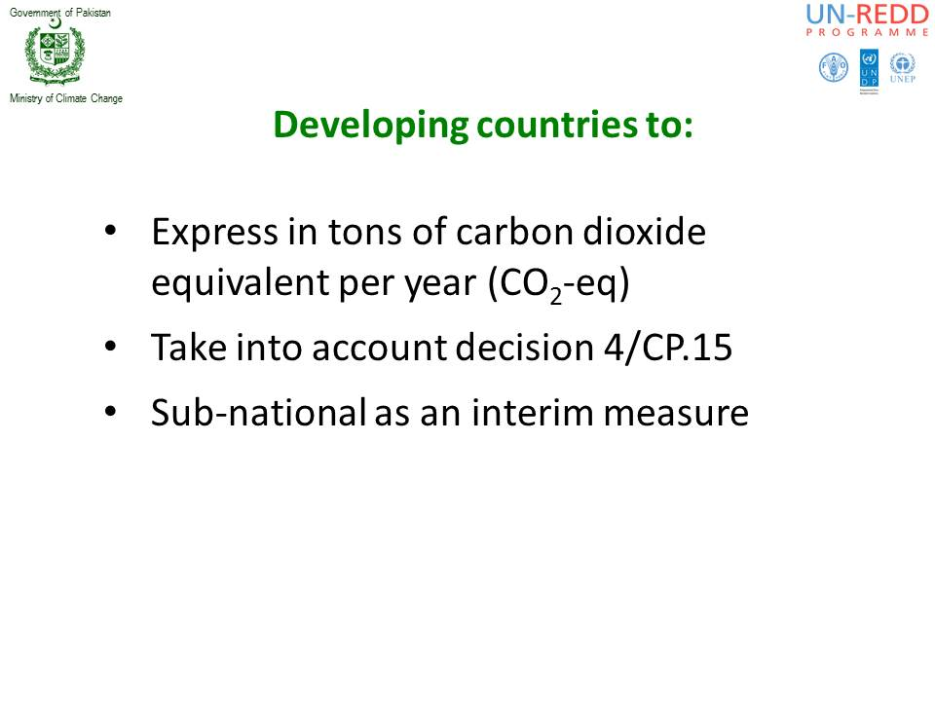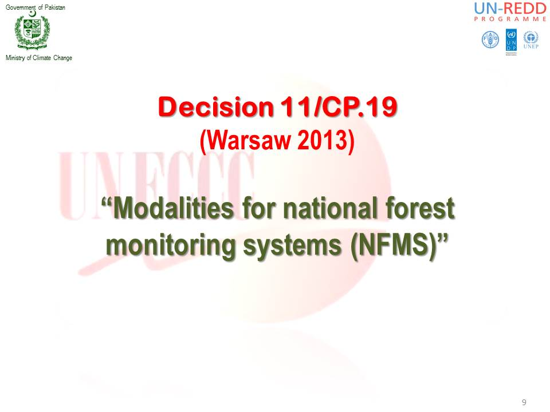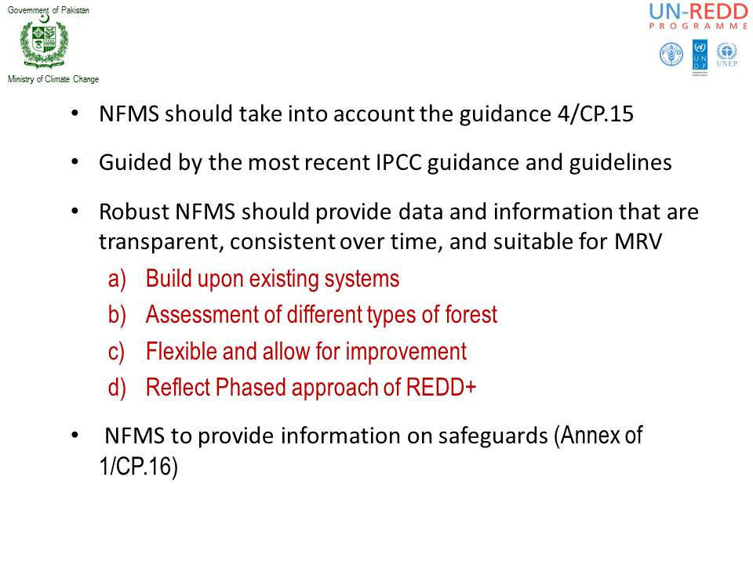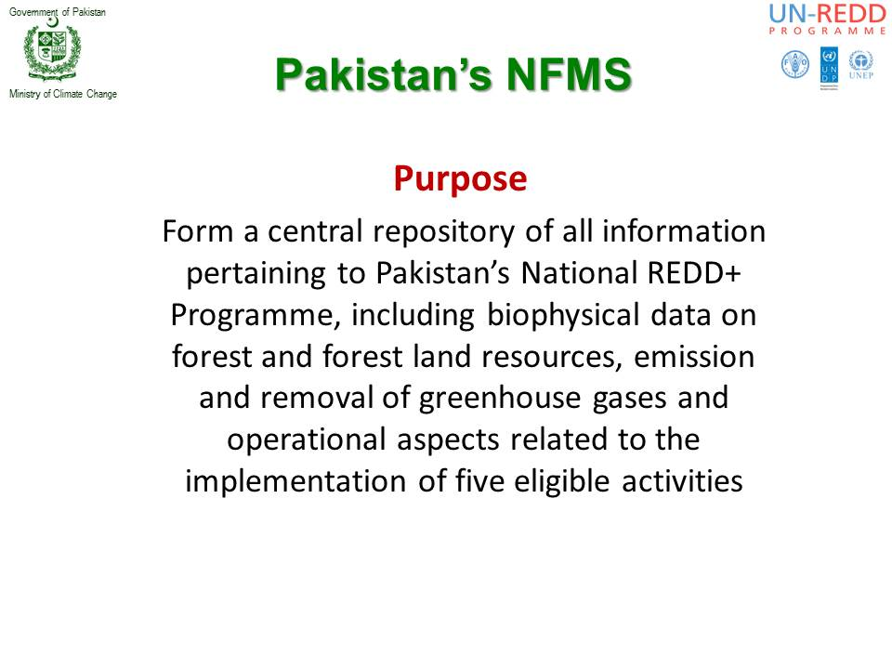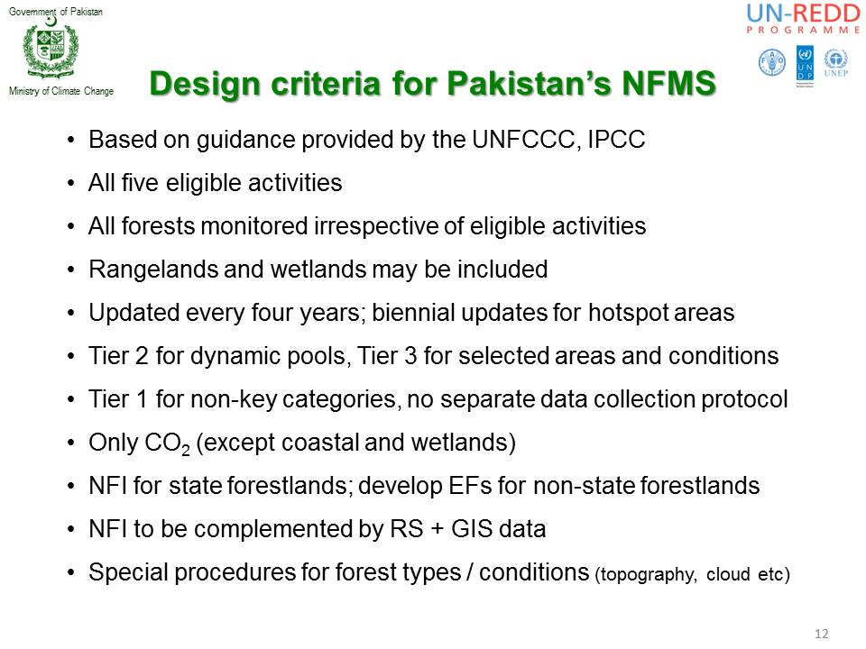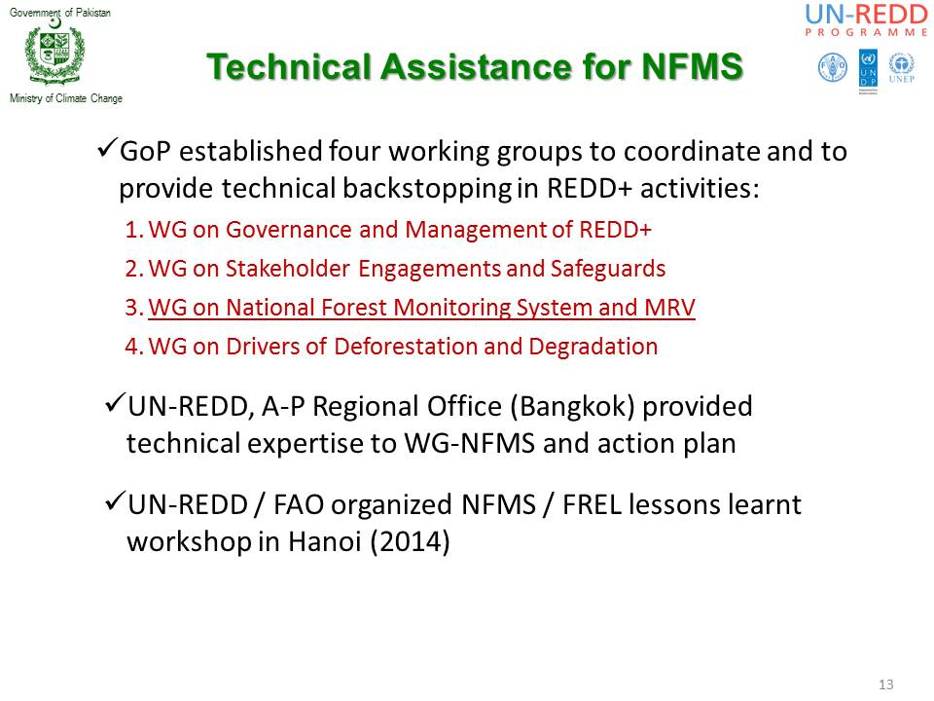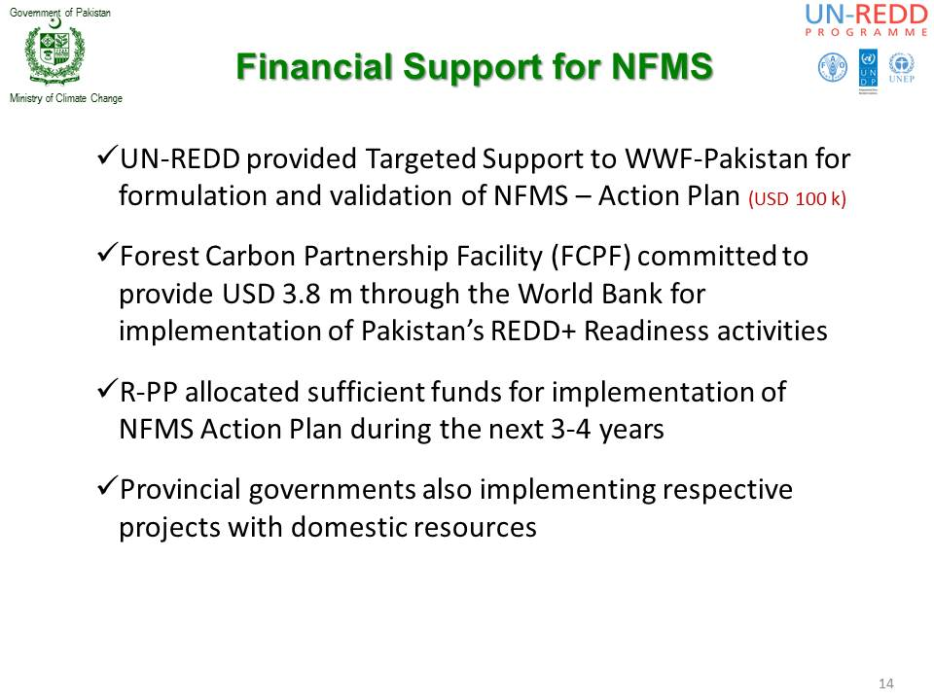

Annex III-(b) Presentation of Muhammad Afrasiyab
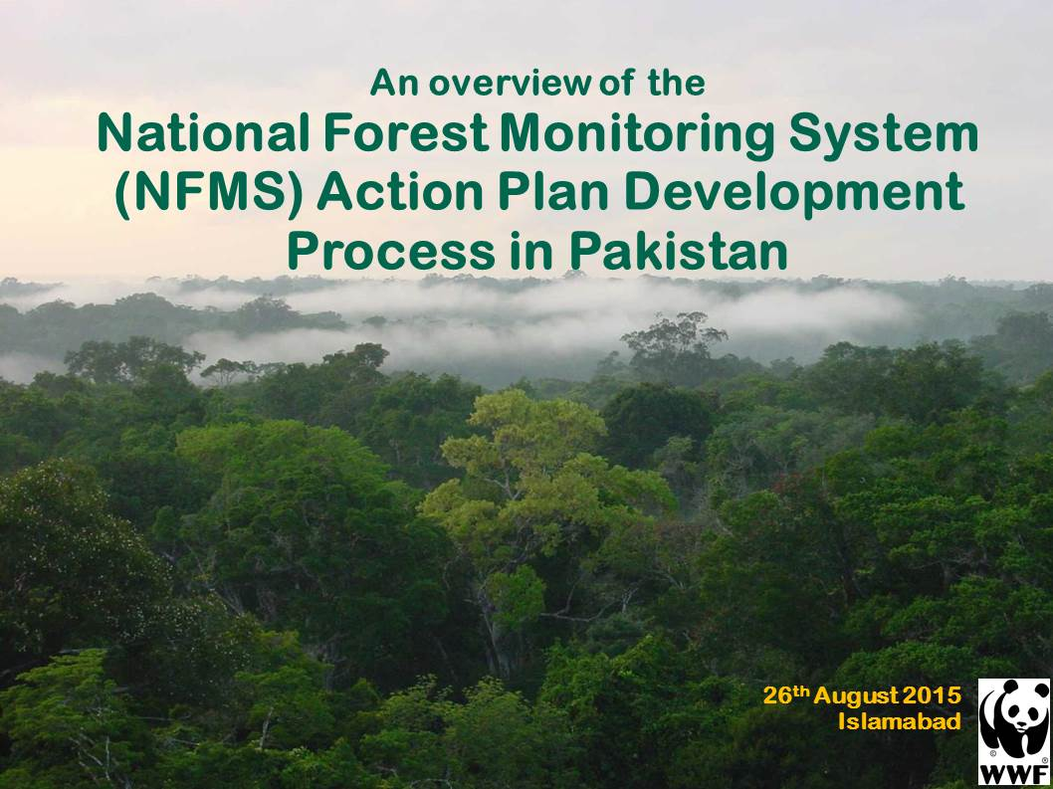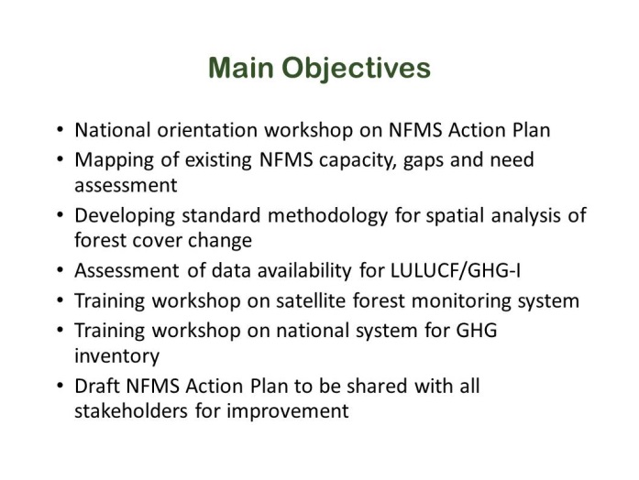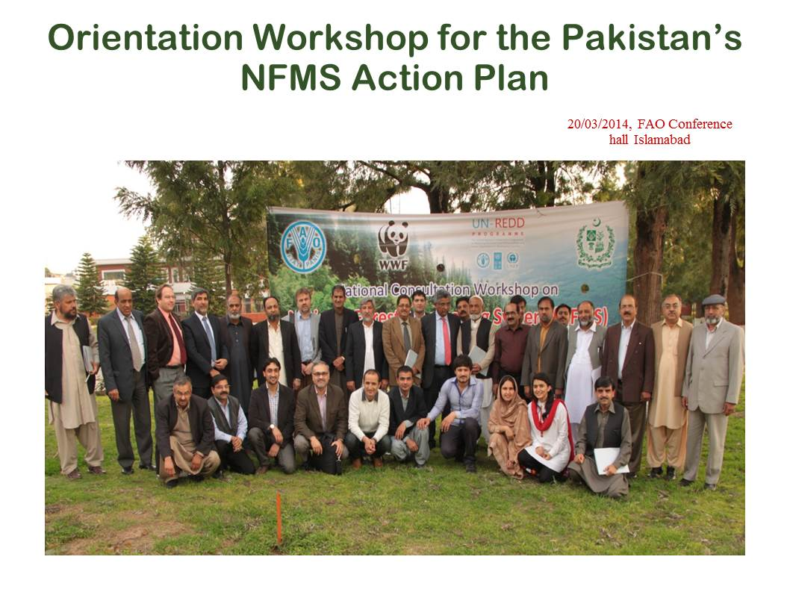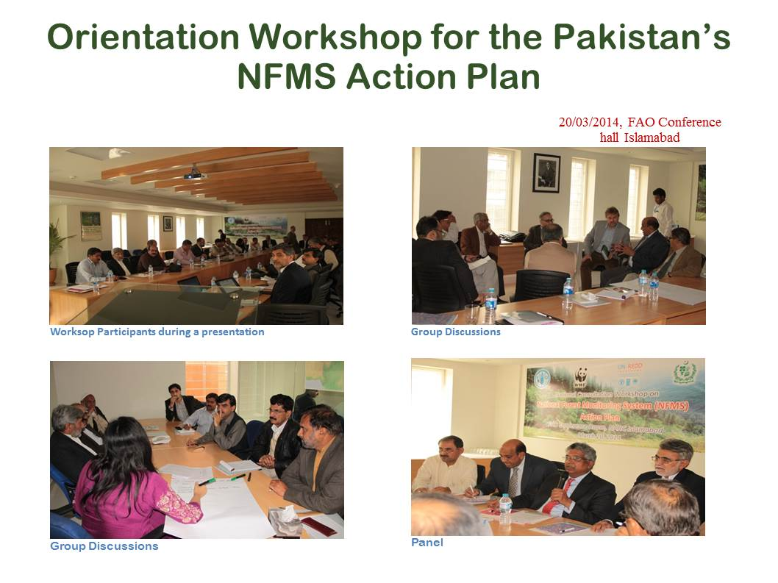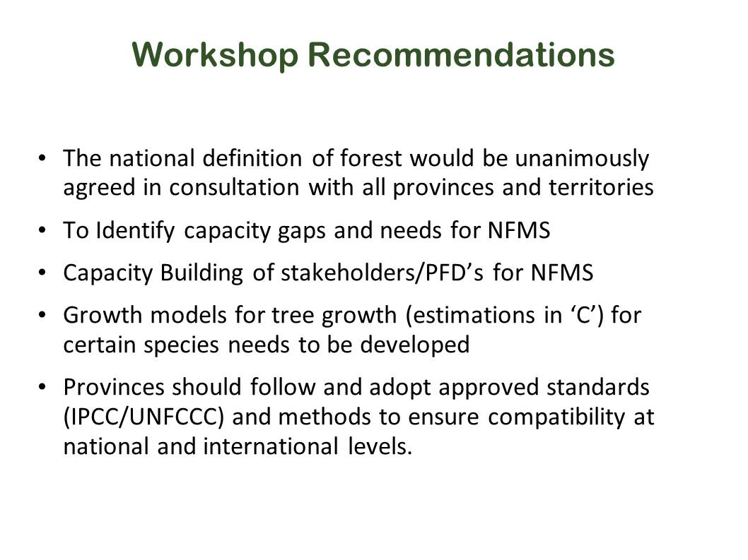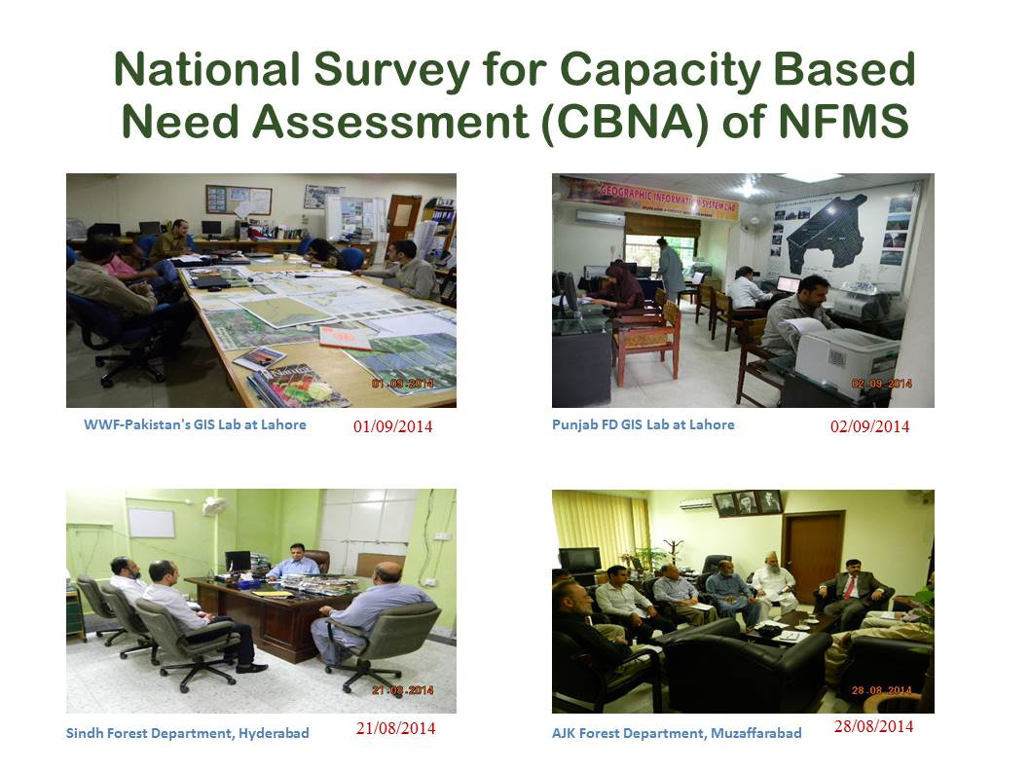

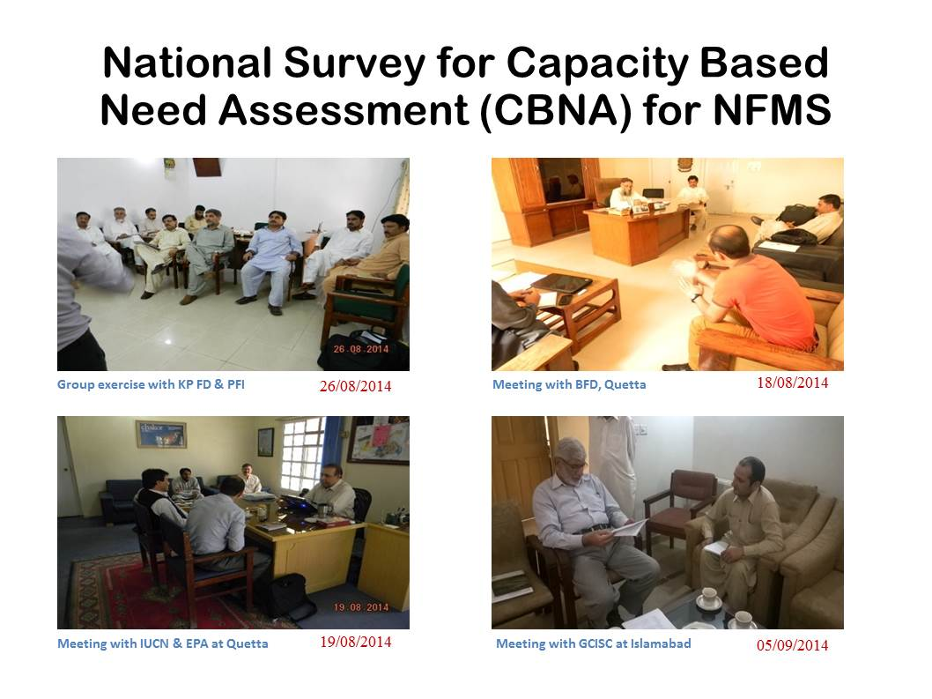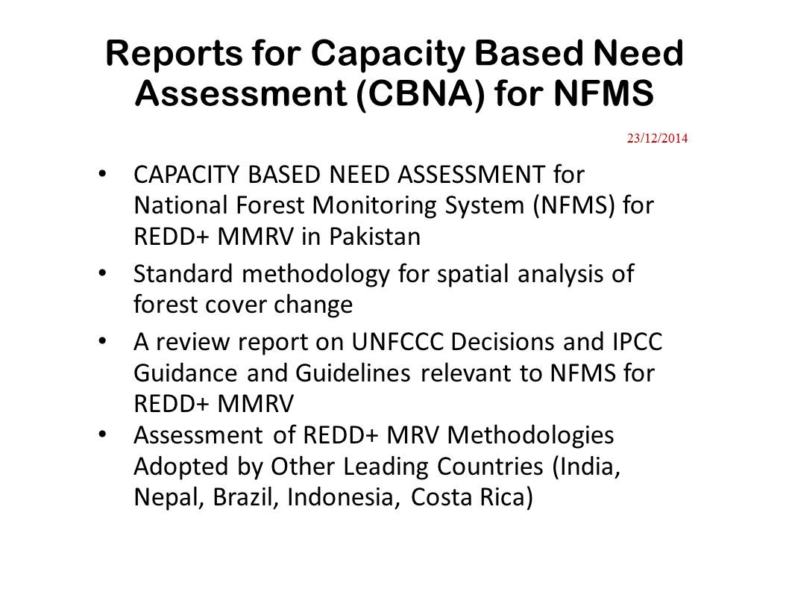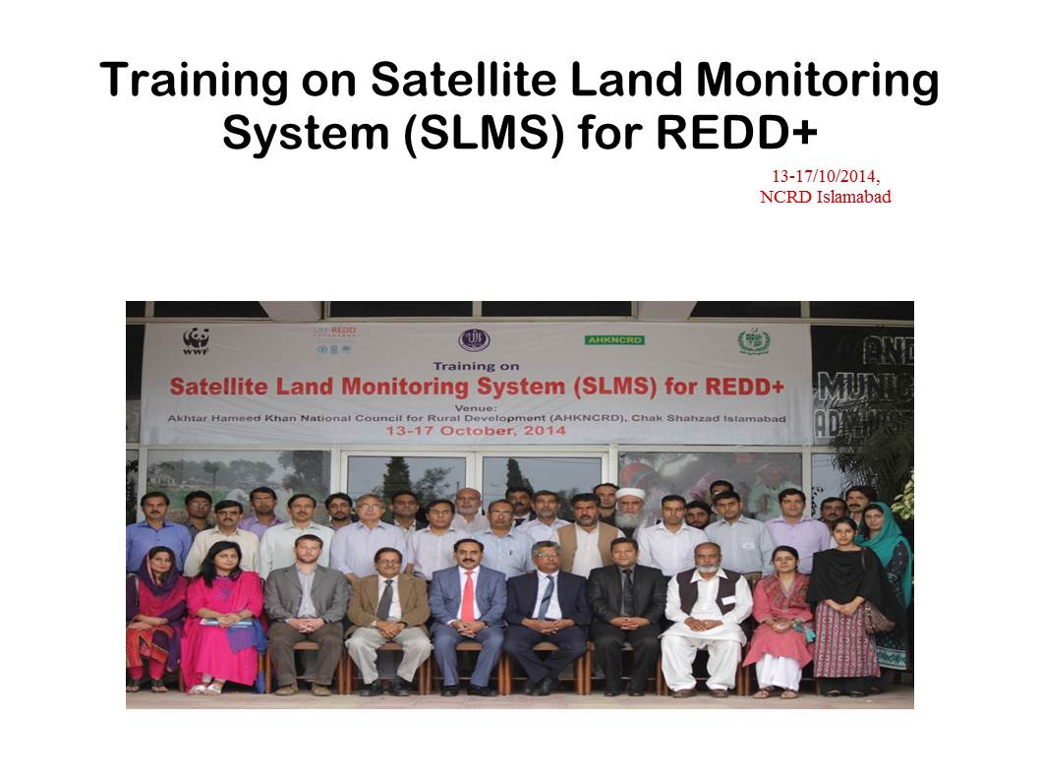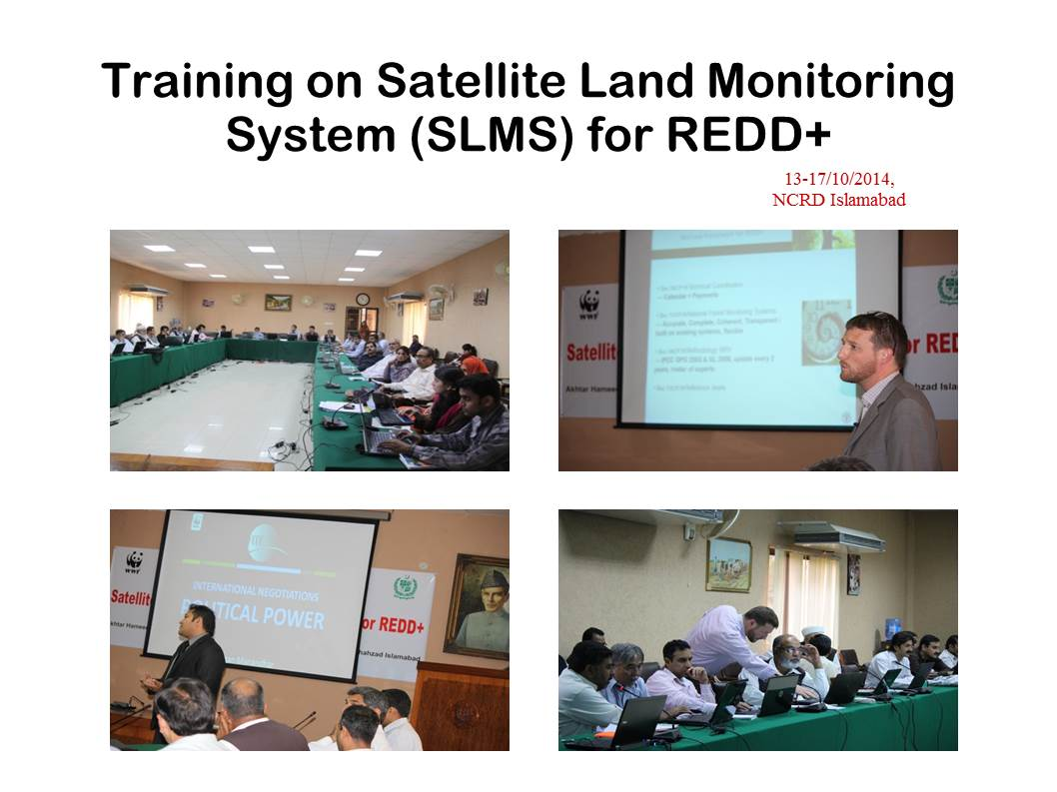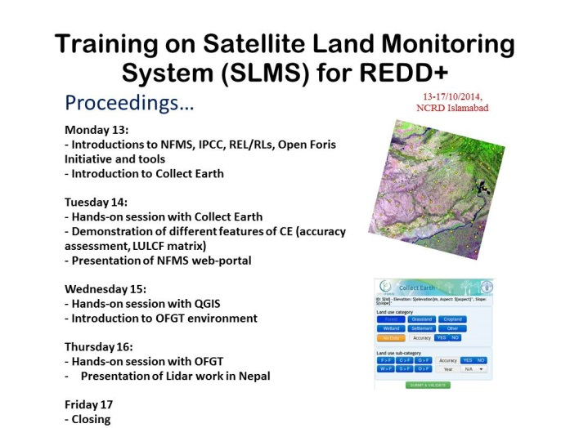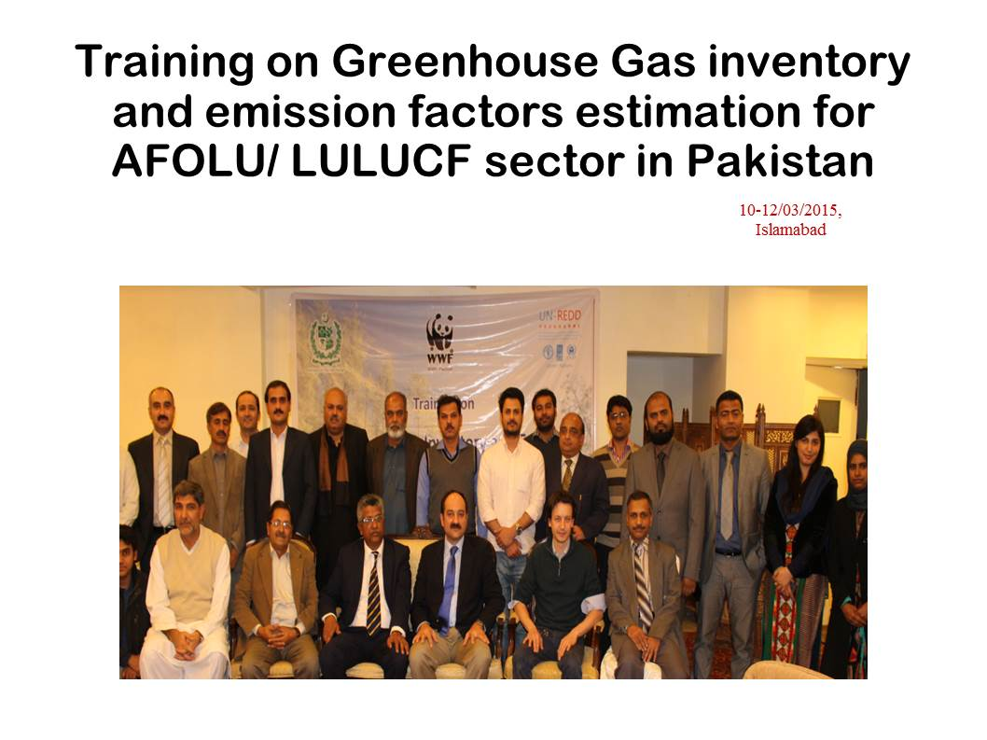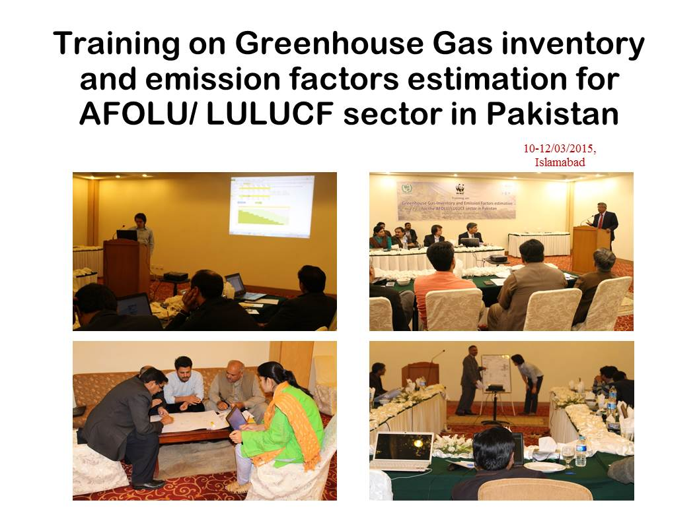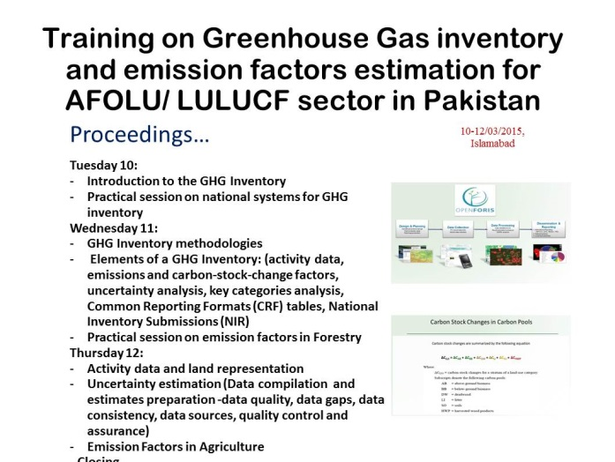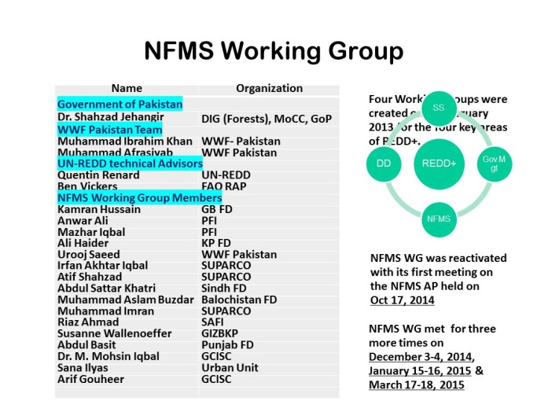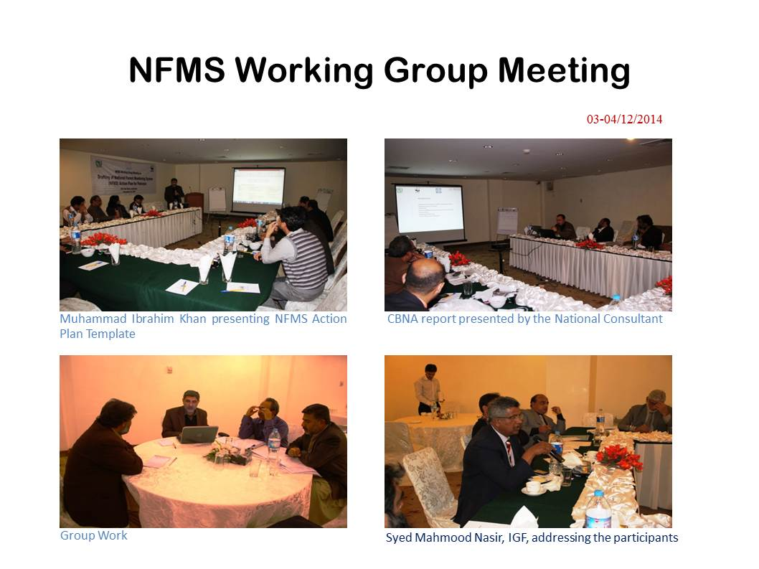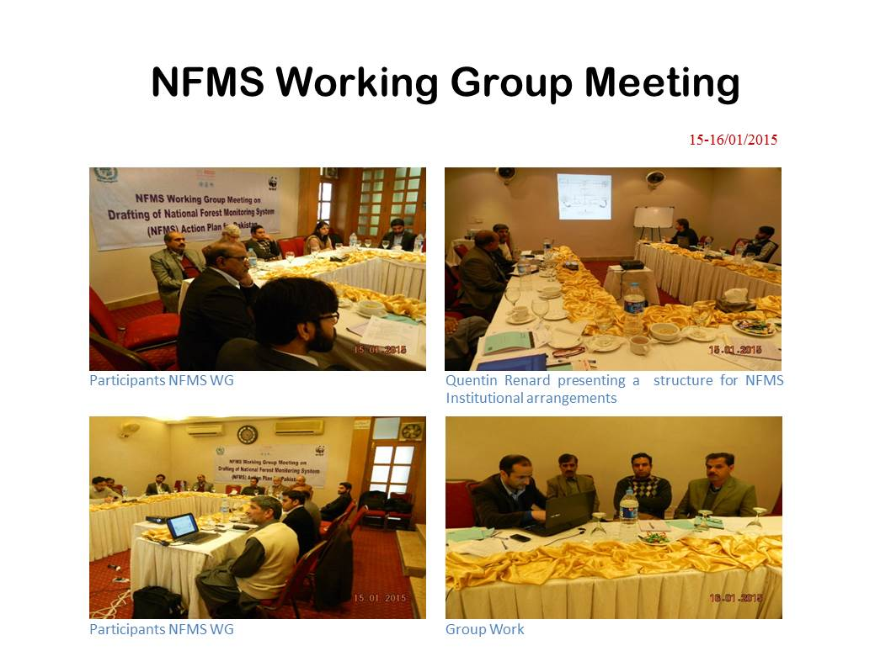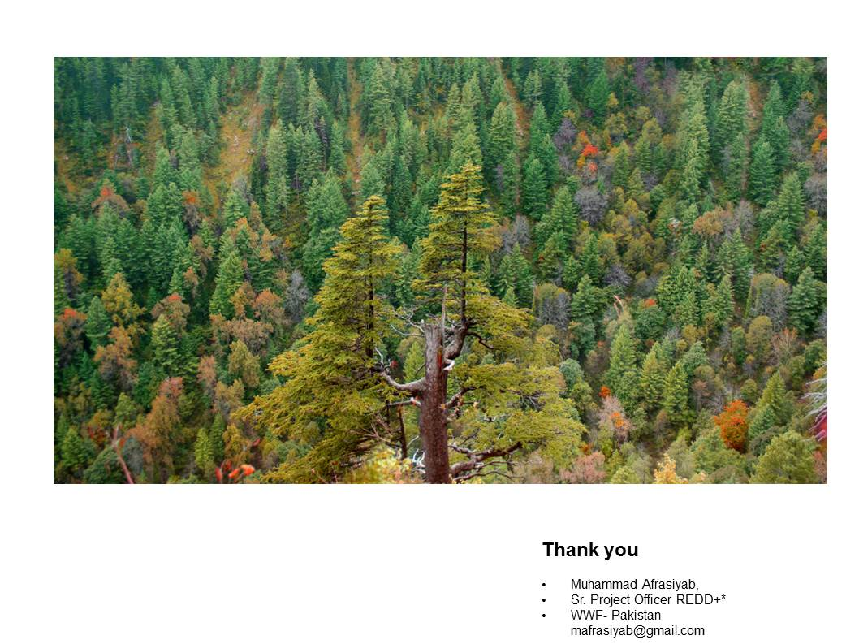

Annex III-(C) Presentation by Ben Vickers
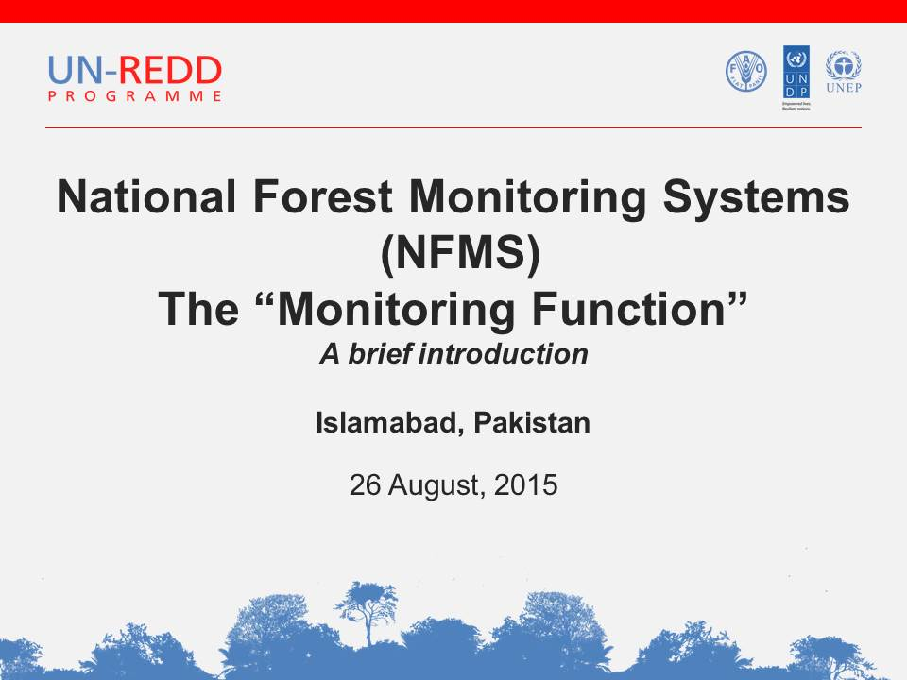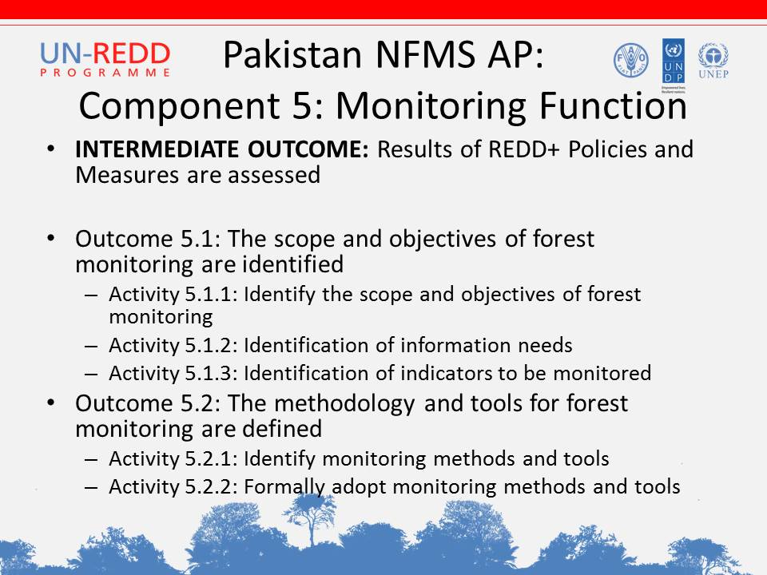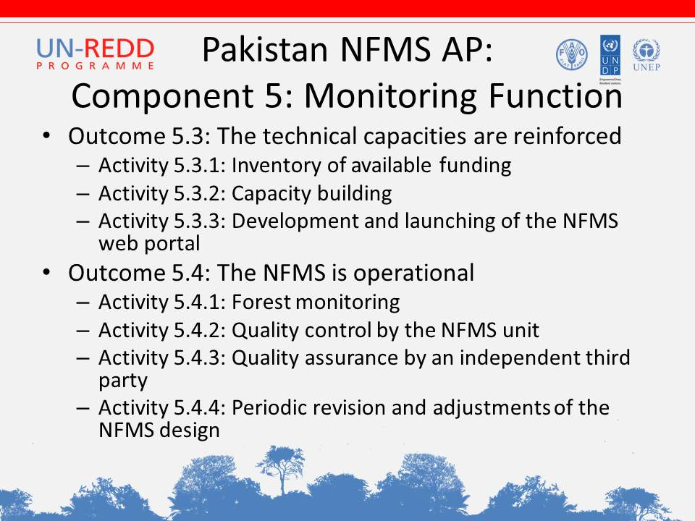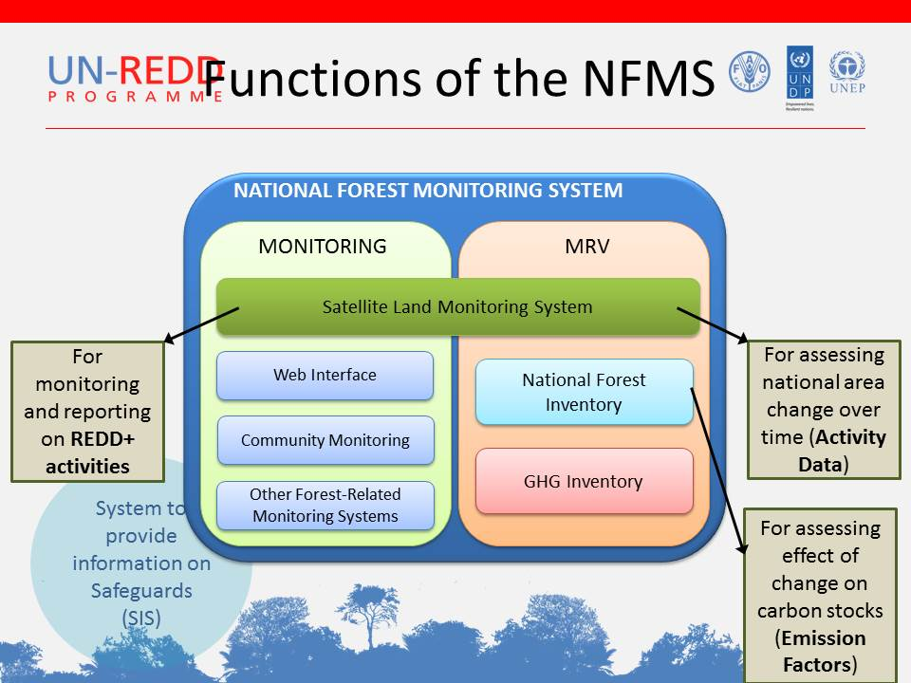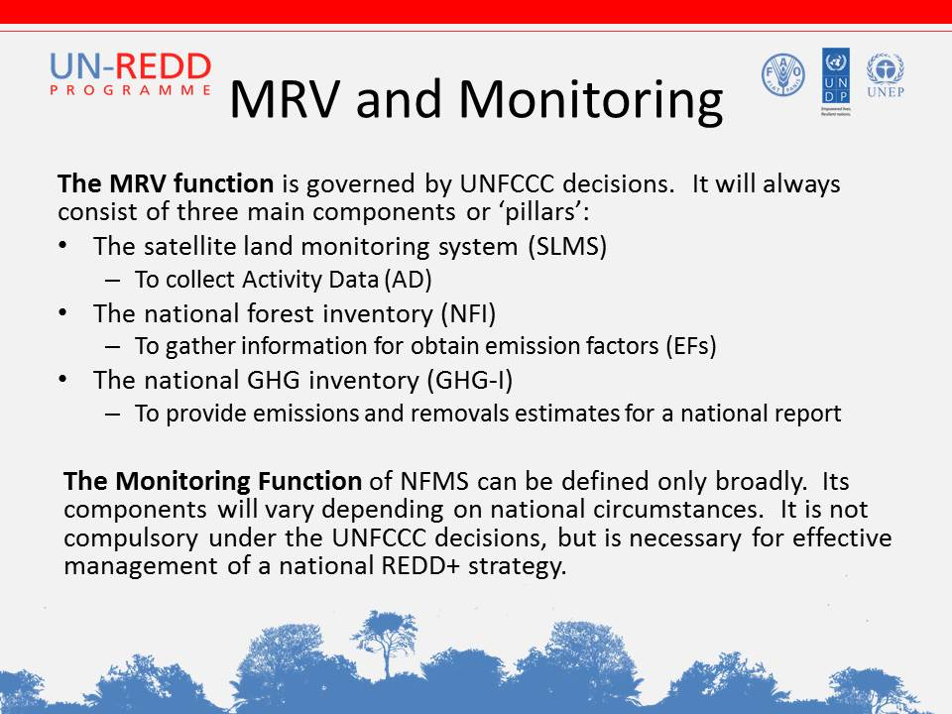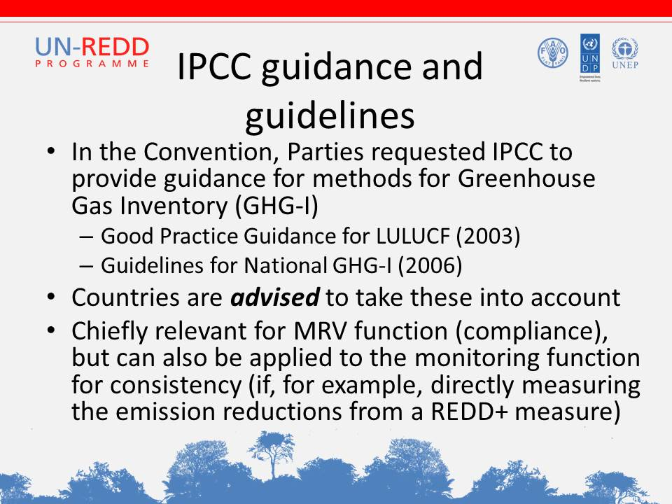
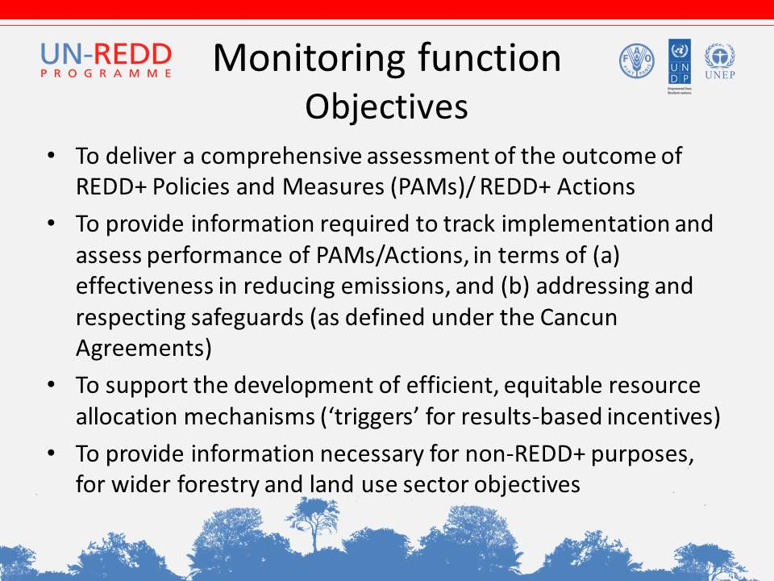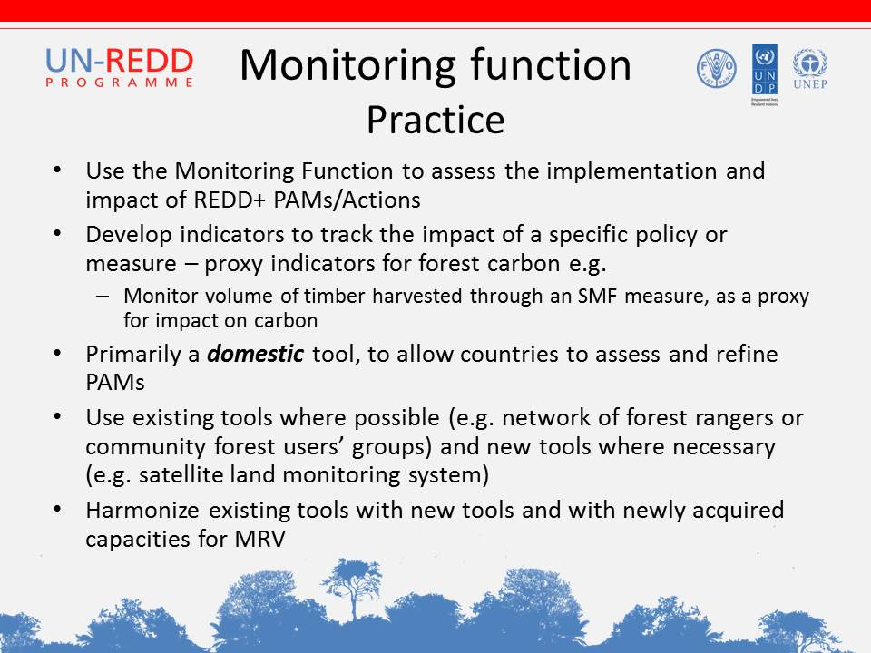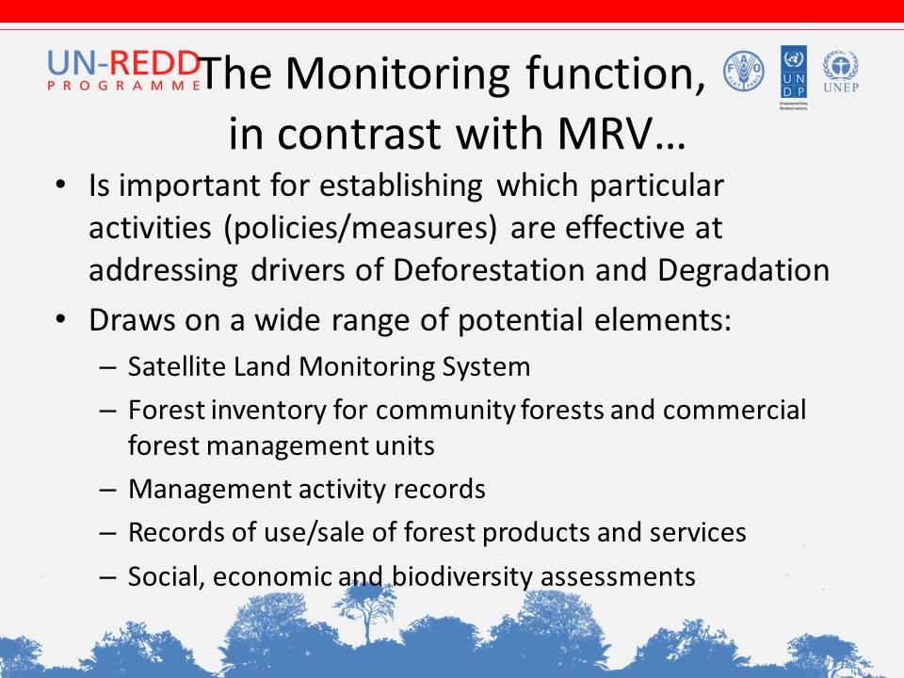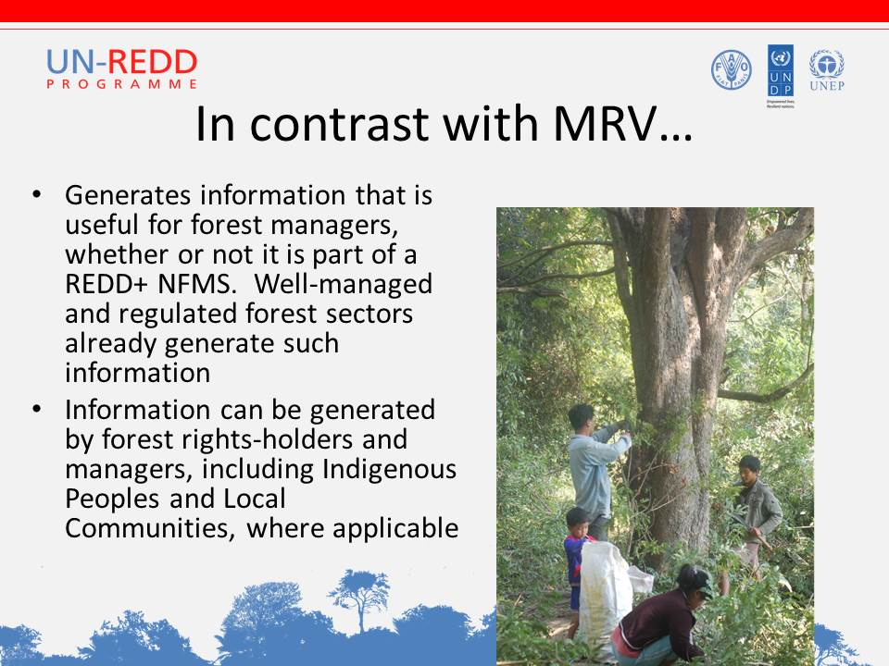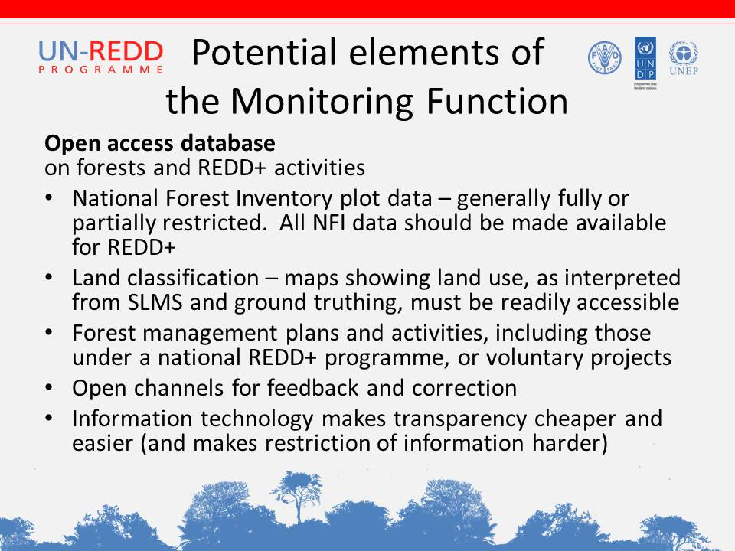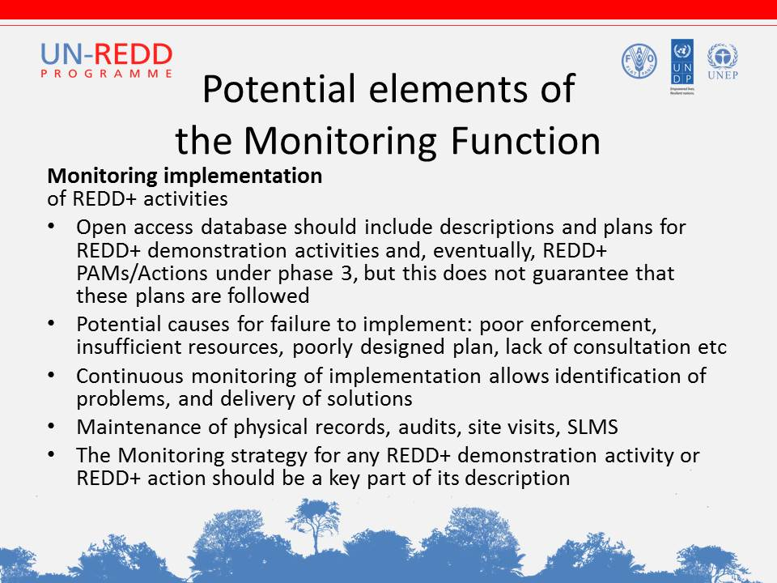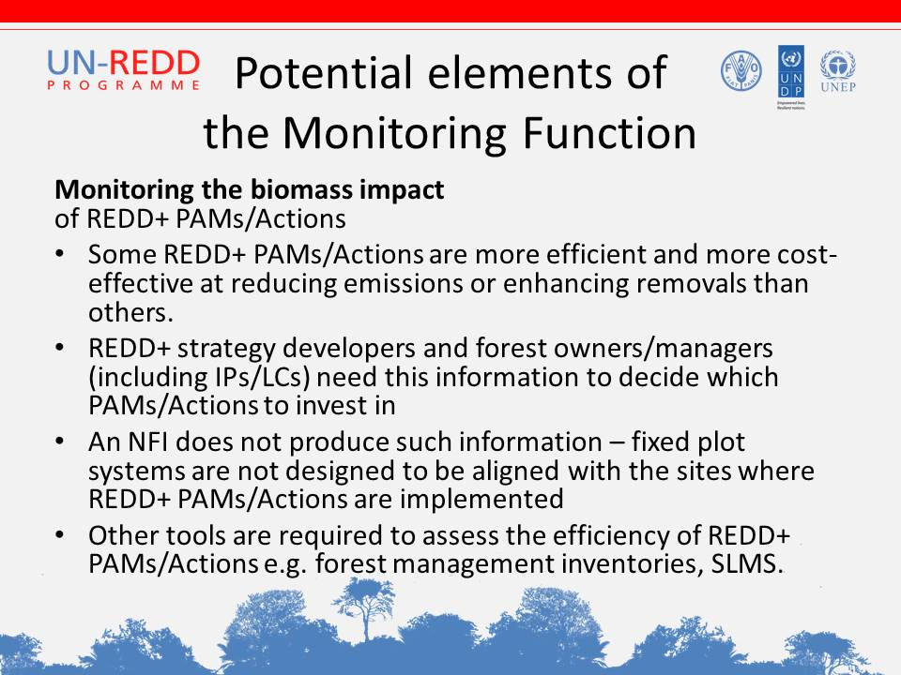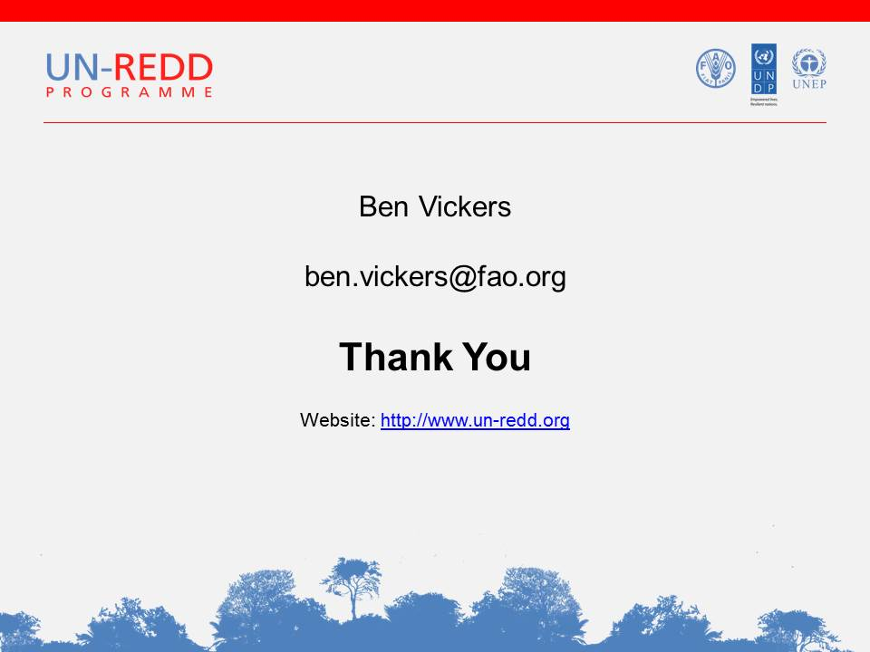

Annex IV Pictures of the event
