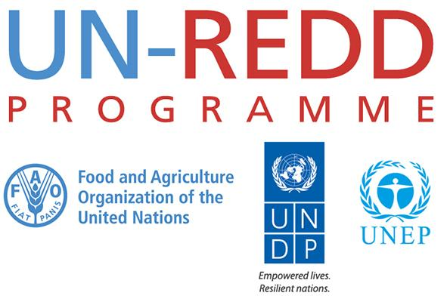

Agenda & Notes – 7 April 2016

Communications/ Knowledge Management Working Group monthly call

Working Group:
- Chair: Jennifer Ferguson-Mitchell
- KM Specialist: Patrick Breard
- Agency focal points: Denise Martinez (FAO), Jaime Webbe (UNEP), Aziyade Poltier (UNDP), Tim Boyle (UNDP)
- Support: Maddie West

Present: Patrick Breard, Jaime Webbe, Aziyade Poltier, Maddie West

Not present: Jennifer Ferguson-Mitchell; Denise Martinez; Tim Boyle

Agenda items:

- General welcome / agenda review-- (PB)

- Review of last call action items
- Secretariat: share draft copy of the “Impact” fact sheet whenever available
Not yet available.
- Agencies: Updating of glossary to coordinate with technical teams, as such, as each agency reviews and contributes to the glossary in coordination with the technical teams that each leads on.
Maddie to check with Jennifer on changes to process
SCG would like to be involved for safeguards terms
- UNDP: Will share key topics (UNDP’s UN-REDD key topics) for celebrities
In progress, messages still need to be defined, this needs to come from the group.
- Secretariat: find suitable date for next Regional KM specialists reporting in Comms/KM WG meeting next week
Done; calls took place 3 and 1 week ago, next meeting may be end of April or early May when reporting first quarter.
- Secretariat: add a discussion item to the next RKMS / Comms/KM WG meeting on processes for requesting financial support for Comms/KM from the regions to the Comms/KM WG, and then up to MG.
Still pending availability of financial resources
- UNDP: Follow-up with Africa on videos
We have footage but the films are not finished, still need fine-tuning. Ela has provided all materials, and the final edition will be finalized in Nairobi and Geneva.

- Updates on upcoming (next 30 days) Comms/KM activities and/or products being produced (Group, as relevant):
  - Global:
-New website being developed by secretariat as UNEP is taking down DNN sites in June. Maddie will consult with KM/comms colleagues in about 1 month for input. Will be very simple, clean site with topline messaging, driving traffic to the Workspace for most information.

  - FAO: not present

  - UNDP:
-Supporting tweet campaign on Equator prize
-Working on videos

  - UNEP:
-Jaime has shared a list of UNEA events linked to REDD+.
-2 media roundtables: UNEP proposing that these are co-branded with UN-REDD to highlight work on illegal logging, REDD+ financing, TBD.
-UN-REDD or REDD+ not included in UNEA resolutions.

- Any Other Business:
  - Resource mobilization events sheet- please fill out any information you might have by next Thursday.

Action Items:

- To discuss UNEP media roundtables
- Maddie to shared website plan when ready
- Jennifer and Maddie to share impacts document draft when ready
- Jennifer to support UNDP tweet campaign
- All to send any info they might have on resource mobilization leads
- Mihaela will be back in May but part time and focusing on REDD+ Academy

