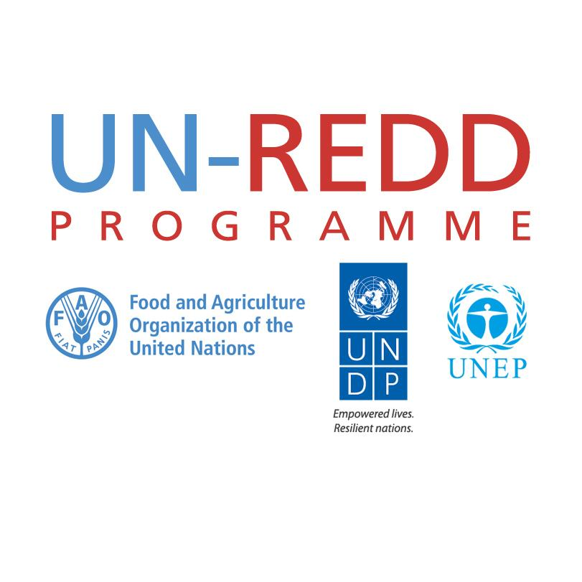

**Bi-monthly regional KM specialists reporting-in meeting with Comms/KM Working Group**

**Agenda and Meeting Notes**

**16 March 2016 – 3:00pm-4:00pm CET**

**Participants:**

Comms/KM Working Group:

* KM Specialist: Patrick Breard (Call Chair)
* Agency Comms/KM focal points: Jaime Webbe (UNEP), Tim Boyle (UNDP),

Regional KM Specialists:

* Heang Thy (AP), Ela Ionescu (Africa), Patricia Toquica (LAC)

**Not present:**

* Jennifer Ferguson-Mitchell, Communications Officer
* Maddie West, Communications/KM Associate
* Aziyade Poltier (UNDP)
* Denise Martinez (FAO)

**Agenda items:**

1. **Outcomes of the meeting in Oslo from a KM perspective**

* Comms and KM will be important this year to showcase the results of the programme. Focus on collecting and disseminating evidence of impact should remain a priority.
* Comms/KM support will have to be delivered this year even if geographic scale of the programme evolves.
* There may be an opportunity for regional Comms/KM activities to receive seed funds from the programme through a request submitted to the Management Group. Such proposals would need to be reviewed, screened and prioritized by Comms/KM WG before going to the MG. A brief note describing the process and criteria for such review could be developed. However additional information would be needed to ascertain the feasibility and possible outcomes:
  + What may be the likelihood that proposals approved by the Comms/KM WG get funded?
  + What would be a realistic size for the financial envelops availed to Comms/KM activities? Are proposals to be submitted individually (agencies/regions)? Ideally they should be consolidated.
  + What would be the timeline for submitting proposals and receiving funds?

These points should be clarified before starting to develop any sort of guidance note.

1. **Presentation of the regional KM work plans**

* **Asia Pacific**: Work plan based on needs assessments. Drafted with inputs from RTA and agencies. Activities include face-to-face and remote Comms/KM support. Budget remains unclear but some funding secured from FCPF for one event on REDD+ Finance. As for the other activities subject to resources, they will be replaced with online based support or small scale regional events and/or in-country supports if funding is not found. However a priority remains to look for additional funding through bi/multilaterals in the region.
* **LAC**: Work plan drafted with inputs from RTA and agencies. Comms/KM activities are demand based and therefore difficult to plan precisely.. Collaboration with technical areas -e.g. Safeguards- may provide room to mainstream Comms/KM support as part of technical activities. Collaboration between regions -e.g. Webinars on technical areas- will be another means to provide support.
* **Africa**: Work plan drafted with inputs from RTA and agencies. Comms/KM budget 2016 originates primarily from countries through a cost recovery mechanism. This is the result of Comms/KM being mainstreamed in national programmes last year. Comms/KM activities include knowledge products and face-to-face and online knowledge sharing.

**Action items:**

* Confirm opportunity for receiving funding from MG and clarify scale and timeline (Patrick).
* Review and comment each other work plans as appropriate (all).
* Information / experience on mainstreaming Comms/KM in national programmes and using cost recovery mechanism for financing missions to be shared (Ela to Patricia) .
* Next meeting 31 March to review final work plans and a.o.b.
* Minutes to be circulated. Deadline for comments next Tuesday. Will be posted mid of next week.