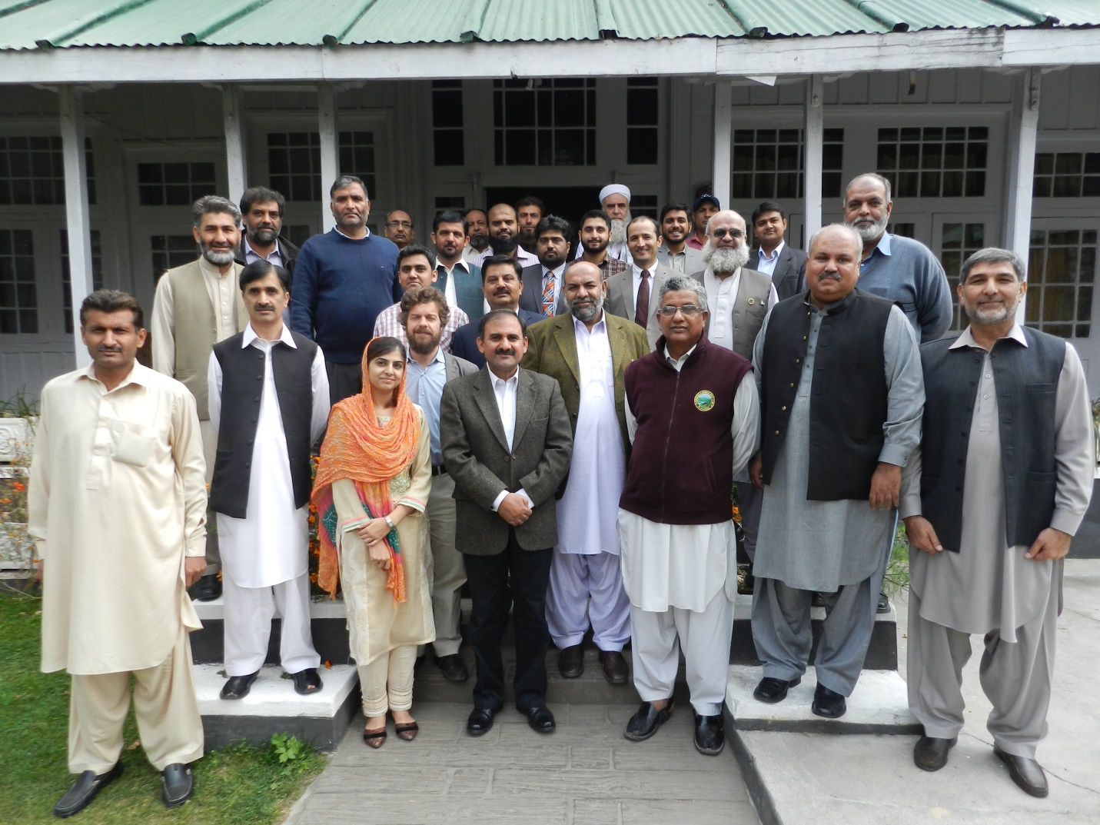
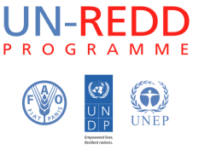

Training Workshop on National Forest Inventory Principles

October 13-16, 2015

Mukshpuri Hotel Donga Gali, Pakistan
  - Training Report

Contents
Day-1 3
Inaugural Speech by IGF 3
Provinces progress in REDD+ Process 3
Tabular Exercise 4
Day 2 5
Presentations of Marco Piazza 5
Group Activity 5
Day 3 5
Field Exercise supervised by FAO resource person (Marco Piazza). 5
Day 4 5
Closing Session 5
Remarks by the Participants 5
Distribution of Certificates 6
Closing Speech and Vote of thanks 6
Annexes: 7
Annex A: Agenda: 7
Annex B: Attendance Sheet (Scanned file attached) 9
Annex C: Presentations 10

Day-1

Inaugural Speech by IGF

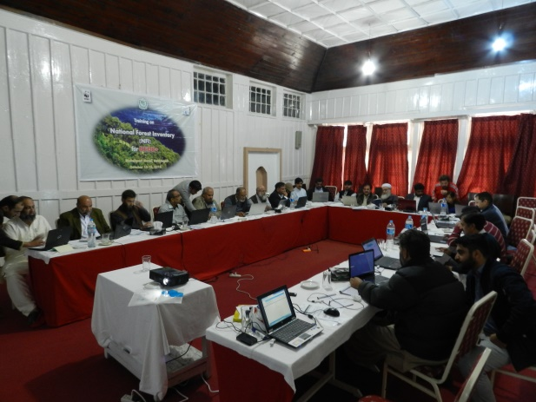
Syed Mahmood Nasir (IGF) in his opening speech welcomed the participants. He enlightened all about Continuous environmental degradation particularly of forests has resulted in untold repercussions in many places around the globe and ensured that Pakistan is no exception with an alarming rate of deforestation. Most developing countries, including Pakistan, have embarked on progressive deforestation and degradation of natural resources in spite of various corrective interventions and efforts by government.
The global forests, including that of Pakistan, have tremendous value for sequestering CO2, the main constituent of greenhouse gas and to create a financial value of the standing forests in the newly introduced carbon market concepts. There is therefore the need to design our forest inventory, as mentioned by IGF, so as to monitor forest health and resources and to produce financial benefits for the poor who depend on the forest for their livelihood.
Deliberations in a series of Conference of Parties of UNFCCC from COP 11 to the latest COP 20 at LIMA in December last year, made significant progress towards REDD+ (Reducing Emissions from Deforestation and Forest Degradation) mechanism and the establishment of Green Fund to finance sustainable environmental mitigation and climate change adaptation programmes.
Syed Mahmood Nasir further emphasized that Pakistan has also actively performed in the readiness phase of REDD+ however a lot more good work needs to be done. Followed by a series of efforts by the REDD+ Implementing team NFI training considered as an important benchmark in getting ready for dealing with Deforestation and forest degradation using advance tools and technologies. Once capacity is developed and base line data is generated, a robust system can be formulated for the creation of a complete and seamless forest inventory system to be used for various purposes such as environmental management and planning, sustainable development and conservation of biodiversity and agro-forestry systems.
Syed Mahmood Nasir said that Ministry of Climate Change is highly dedicated to achieve the goal of sustainable management of our forests.

Provinces’ progress on REDD+ Process

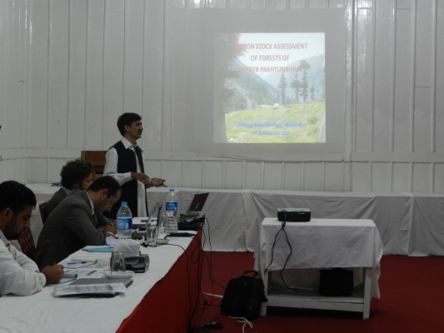
In this workshop, each province REDD+ focal persons shared a brief presentation on past achievements in initiating REDD+ process. PFI shared a pilot study on measuring above ground carbon stocks that later can be used by any other province. Punjab has conducted a complete study on above and below ground biomass of natural forests and irrigated rangeland. Sindh has prepared Forest management plan and is looking ways for carbon stock assessment in riverine and mangrove forests, rangeland and irrigated plantation. They do not have topographical issues like in KPK that is the main hindrance of accessing stock for measurements. All other provinces demand technical assistance from PFI. AJK and KPK possess similar terrain conditions by which differentiating between conifers and mixed forest on elevation basis is a big trouble for both. Gilgit Baltistan region occupies 80% of all forests including forests of AJK and FATA.
SUPARCO Karachi occasionally offers training workshops for enhancing GIS capability; Sindh Govt. showed interest in getting a nationally accepted and standardized method for carbon stock measurement. Marco Piazza (FAO) suggested to review UN FAO designed universal system to streamline their own national inventory setup. He endorsed that national level inventory exercise is important to consider in fragmented forest setup of Pakistan.

Tabular Exercise
After this session on REDD+ progress in provinces, Mr. Ibrahim initiated an interesting tabular exercise to derive a summarized picture of provinces’ progress and gaps they are encountering. He asked questions on Inventory establishment, procedure followed, designed Data collection forms, recruited trained personals, purchased equipment or any other mentionable activity in this context. AJK, Sindh, Punjab and KPK have established forest inventory units. PFI established first inventory in 1992. KPK is claiming for potential growth requirement in statistical models. Fixed sample size is a great difficulty for varied terrain slopes of hilly areas. Staff transfer or turnover is the prominent obstacle for weak performance in capacity building. Sindh pointed out advanced skills are needed to replace tedious manual processing. Forest management system/forest guards have not been deployed in FATA since 1.5 years of its commitment to REDD+. Hence FATA is highly intended to adopt its methods. In comparison, KPK possess highly established labs. Internationally presentable baseline data has been prepared in its lab capacity. Although FATA has no formal setup and recruitment of skilled personnel is on its way, but holds strong commitments of harnessing primitive knowledge of indigenous people.
AJK discussed first working plan of 10-15 years duration designed to harvest forest and satisfy global demands of forest cover providing that timber, medicinal, ornamental plants to forest dependent communities. In some areas, access to plantation at border side was prohibited. AJK has a managed set up for analyzing progress in forest sector. Low density forest area is allocated to reforestation sector and wildlife departments are managing intact forests.
Riaz Ahmed SDPI Consultant, national resource person, gave a thought provoking presentation on Civil Society perspective in Climate Change resilience.
The FAO resource person presented the course’s context, objectives and structure as well as a first presentation on key aspects and main principles of a Forest inventory at the national level. Presentations included: Brief history and main NFI principles; Experiences in Monitoring of Forest Resources at FAO; FAO-NFMA Video.
The day continued with presentations from the Provinces on their experiences in forest monitoring. PFI (Pakistan forest institute) also presented their current and on-going work. These presentations proved to be very informative because Forestry in Pakistan is a matter dealt mainly at the provincial level with little exchange of information. The training workshop provided a fertile platform for informing each other on their respective current work.

Day 2

Presentations of Marco Piazza

Group Activity
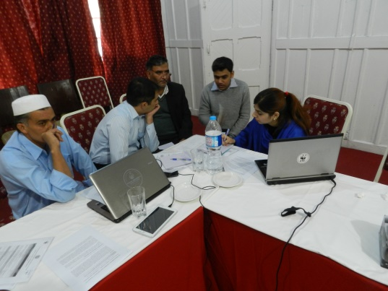
Marco Piazza conducted a group exercise on stakeholders’ identification in REDD+ process. Every group shared a comprehensive list with great interest.
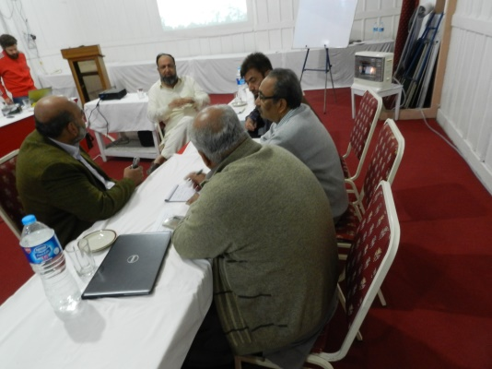
The whole day was dedicated to technical presentations and group exercises on a range of topics related to NFI: Policy aspects, Implementation and Organization, Observation and Measurements, etc. The FAO resource person facilitated a brainstorming exercise for each topic with positive results, in particular encouraging a “paradigm switch” toward approaching forest monitoring as a national level endeavour. In particular fruitful discussion emerged on the following: capacity assessment in forest monitoring at provincial level; types of “policy questions” that an NFI should be able to address; list of stakeholders that are likely to play a role in a NFI. The package of Open Foris tools was also presented with a more in depth presentation on Collect (Desktop and Mobile). Many of the participants showed great interest and requested further training on OF.

Day 3

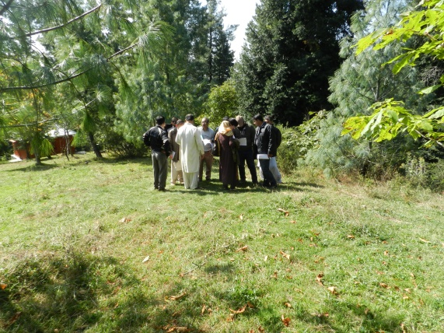
Field Exercise supervised by FAO resource person (Marco Piazza).
The participants were divided into four groups. Each group was given coordinates, a plot layout and field forms for data collection. A number of issues were raised and discussed, from plot design to proper use of forest mensuration tools and measurements protocols. The field exercise allowed the participants to have a direct experience with forest mensuration. Great emphasis was placed on field methodology protocols and the need to define a harmonized methodology at the national level.

Day 4

Closing Session
Closing Session After the recitation of Holy Quran, Mr. Ibrahim Khan gave a brief over view of the training session conducted and also paid thankful regards to Marco Piazza.

Remarks by the Participants
Participants shared their remarks on the training program.
• Mr. Anwar Ali from Pakistan Forest Institute (PFI) appreciated the overall training and showed interest in practicing openforis software for further studies
• Mr. Inamullah suggested to conduct another workshop to exclusively comprehend every component of OpenForis as in two days span, participant could merely get familiarity with interface.
• Mr. Atif Shahzad, Assistant Manager SUPARCO expressed his satisfaction over the content of the training and told that the training was very useful and easy to understand.

Distribution of Certificates
The certificates of the training were awarded to the participants of the training by Mr. Ibrahim, Mr. Inamullah and Mr. Aureng Zeb Ashraf Awan.

Closing Speech and Vote of thanks
Mr. Aurang Zeb Ashraf Awan, in his closing speech thanked the participants and the international trainer Marco Piaza for making the training useful. He welcomed the role of young professional in promoting REDD+ in Pakistan. He showed full confidence over the acceptability of REDD+ project in Pakistan and insisted the participants to get fully prepared during the REDD+ implementation phase to meet their international commitments.

Annexes:

Annex A: Agenda:
Training Workshop on National Forest Inventory Principles
October 13-16, 2015
Mukshpuri Hotel Donga Gali, Pakistan
Final Agenda
Date | Programme | Resource person
Day 1 – Tuesday October 13th

Session 1: Opening Session
09:00-09:30 | Registration of Participants | WWF Pakistan team
09:30-09:35 | Recitation of the Holy Quran
09:35-10:05 | Welcome speech by  Syed Mahmood Nasir, IGF, MoCC
10:05-10:15 | Presentation of the content and objectives of the training | Marco Piazza
10:15-10:30 | Introduction of participants and their expectations | All
10:30-10:45 | An overview of the REDD+ preparatory phase in Pakistan | Muhammad Ibrahim Khan
10:45-11:00 | Tea Break and Photo session
Session 2: Forest Monitoring Experiences in Pakistan
11:00-11:15 | Past experiences of forest inventories and monitoring at national level | Mr. Aurangzeb Awan, AIGF, MoCC
11:15- 13:00 | Past experiences of forest inventories and monitoring at Provincial level (Any other experience in forest monitoring including academic work, REDD+, future work and contribution to NFMS Action Plan). | Provincial Focal Points REDD+
13:00-14:00 | Lunch Break
Session 3: Introduction to National Forest Inventories
14:00-14:30 | Brief history and main NFI principles  Monitoring of Forest Resources at FAO  NFMA Video | Marco Piazza,
14:30-15:15 | Forest Carbon inventory in Khyber Pakhtunkhwa: Findings from an ongoing project on "Carbon Stock Assessment of Forests of Khyber Pakhtunkhwa" executed by Pakistan Forest Institute, Peshawar | Anwer Ali
15:15-15:30 | Tea Break
15:30-16:00 | Civil society perspective on forestry conservation | Mr. Riaz Ahmad
Day 2 – Wednesday October 14th

Session 4: National Forest Inventory Training Modules
9:00-10:45 | - NFI & Policy Influence: background and objectives of NFIs and their relation to national policy. + discussion and group work  - Organization and Implementation: options and issues related to organizing and implementing a NFI.+ discussion and group work | Marco Piazza
10:45-11:00 | Tea Break
11:00 – 13:00 | - Observation and measurements: methods for collecting information, observation units and variables.  - Open Foris Collect & Collect Mobile: demo and installation (Survey schema, Software installation, survey summary)
13:00-14:00 | Lunch Break
14:00-15:15 | - Open Foris Continued
15:15-15:30 | Tea Break
15:30-16:00 | - Data collection through interviews: methods for collecting forest related socio-economic data through interviews. + discussion and group work
Day 3 – Thursday October 15th

Session 5: Survey Design and Field exercise
09:00-09:30 | Introduction to a simple survey schema;  Demonstration of Tablet supported data collection in the field | Marco Piazza
09:30-13:00 | Field exercise – plot layout, data collection in the forest, data entry (paper form and tablet) | Marco Piazza/Anwer Ali
13:00-14:00 | Lunch Break in the field
15:00-16:00 | Field Exercise Debriefing – Data Entry/ Data Management | Marco Piazza/Anwer Ali
Day 4 – Friday October 16th

Session 6: Debriefing and Evaluation
09:00-10:45 | Continued Data Entry/ Data Management | Marco Piazza
10:45-11:00 | Tea Break
11:00-11:30 | Workshop evaluation
Session 7: Workshop conclusion
11:30-11:45 | Workshop Overview | Muhammad Ibrahim Khan
11:45-12:00 | Distribution of certificates & Closing Remarks | Syed MahmoodNasir (IGF)

Annex B: Attendance Sheet (Scanned file attached)

Annex C: Presentations

