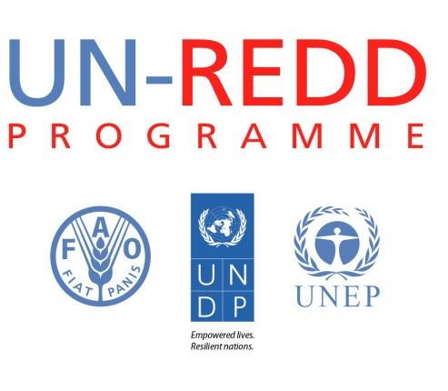

Awareness Video on Corruption Risks in REDD+
UN-REDD Programme, June 2013

This video is a UN-REDD Programme and UNDP informational video clip using a technique called 'illustrative storytelling'. It combines a mixture of graphics and whiteboard animation to captivate the audience regarding REDD+ and the importance of transparency and accountability to its success. It is targeted to raise awareness and encourage collaboration among anti-corruption practitioners, climate change/REDD+ experts, civil society and private sector partners.

1. Download it by clicking here: https://creativello.box.com/s/w02zknska9xqjnsf2ehz

Or

2. Watch it online on Youtube here:
http://youtu.be/TRVZ8I5oRbM

