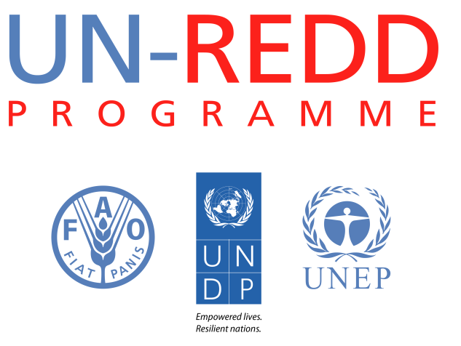
The role of Freedom of Information in REDD+ Case study : Kenya
UN-REDD Programme- May 2013

General context on access to information
Article 35 of Kenya’s Constitution provides that “[e]very citizen has the right of access to information held by the State; and information held by another person and required for the exercise or protection of any right or fundamental freedom … The State shall publish and publicise any important information affecting the nation”. There has been some litigation around this provision, which has affirmed that citizens (but not non-nationals) may rely directly on it to request access to information from public bodies, even in the absence of implementing legislation (there is no Freedom of Information Law). This affirms the principle that, subject to narrow exceptions, all information held by Kenya’s public bodies is publicly accessible.
World Bank research reports that in practice, access to information is restricted, including as follows:
- Section 3 of the Official Secrets Act criminalises the possession of unauthorized government information and the unauthorised provisioning of government information
- Section 52 of the Penal Code allows the government to prohibit the publication of any document
- Section 131 of the Evidence Act allows ministers to withhold information during the course of court proceedings if they believe publication would be “prejudicial to the public service”
- Under Section 18 of the National Assembly (Powers and Privileges) Act, the President may prohibit any public officer from providing any information to Parliament
Kenya has also indicated that it is joining the Open Government Partnership and has pledged to enact freedom of information legislation. The government has stated that “is in the process of drafting a freedom of information law. The draft bill meets most of the criteria for an effective Access to Information (ATI) law, scoring 114 out of a maximum 150 on the Right to Information (RTI) Legislation progressive ATI law.” The draft FOI Bill is currently under consultation.
Progress has also been booked around Kenya’s open data project, driven partly by Kenya’s desire to become a regional leader in ICT, and the setting up of Kenya’s Open Government and Open Data Working Group. The Open Data Project seeks to make government data freely available through a single web portal. Through this, the aim is to make key government data freely available to the public. The 2009 census, national and regional expenditure, and information on key public services are among the first datasets to have been released.
Transparency and Access to Information in environment, forest, REDD+ or other relevant programmes
Kenya’s main government agency responsible for providing information on climate change is the ministry of the environment. Its website lists the national climate change policy, from 2010. This cites poor access to information on climate change issues as one of the main compounding problems in formulating and implementing the strategy. A number of channels are identified to disseminate information more effectively, including through the media and infotainment programming, and the policy states that “key priority areas will be improving national coordination of information through enhancing packaging and expediting timely dissemination”. Kenya’s National Climate Change Action Plan, presented in November 2012, highlights the provision of climate change information to rural communities as among the priorities. A National Climate Change Secretariat has been established with the assistance of UNDP’s Africa Action Plan Programme as the lead agency. There is, however, as yet no information available on the implementation on any of these programmes or whether the information is reaching target groups in the population. According to the UN FCCC clearing house, as January 2013 Kenya had not yet submitted its Second National Communication reporting on the implementation of Article 6, on public access to climate change information.
Kenya’s forestry laws include some transparency requirements, as well as an overall obligation to engage in consultation. For example, the accounts of the Forest Management and Conservation Fund must be published; and consultation engaged in before forest land is exchanged for private land or before the adoption of a management plan. The Kenya Forest Service website has been designated as the central point of access. At present this carries only a limited set of information, although Kenya’s REDD+ RPP has reportedly been drafted in thorough consultation with affected communities and mentions “[t]ransparency, accountability and public participation” as “building blocks”.
In its most recent REDD+ update report, Kenya indicates that “[o]ptions for implementation including those for tracking and information systems for bringing transparency in R-PP implementation and conflict resolution and grievance management mechanisms [are] to be tested…up to 2013 and beyond 2013.” Its R-PP proposes a web-based “information clearinghouse” for all REDD+ knowledge and data.
Kenya is also at the early stages of receiving “targeted support” on anti-corruption under the UN-REDD “Support to National Actions” programme, which seeks to assess the priority REDD+ corruption risks and mitigation measures, and develop a capacity strengthening plan for Kenya’s forest Services, the Ethics and Anti-Corruption Commission, and civil society partners.

This document is extracted from the UN-REDD Report titled “Ensuring inclusive, transparent and accountable national REDD+ systems: the role of freedom of information” : http://bit.ly/15uF7ys
Constitution of Kenya, Rev. 2010
As reported on FreedomInfo.org: http://www.freedominfo.org/2012/03/kenyan-court-limits-access-right-to-citizens/
As reported by the World Bank’s Public Accountability Mechanisms website: https://www.agidata.org/pam/ProfileIndicator.aspx?c=104&i=9949
See http://www.opengovpartnership.org/countries/kenya.
Freedom of Information Bill, 2012: http://cickenya.org/sites/default/files/bills/Freedom%20of%20Information%20Bill%20Revised%2010%20th%20Jan%2C2012%20%281%29.pdf
https://opendata.go.ke/
As reported on https://opendata.go.ke/page/about
http://www.environment.go.ke/wp-content/documents/complete%20nccrs%20executive%20brief.pdf.
At p. 20.
See http://cdkn.org/wp-content/uploads/2012/12/Kenya-Climate-Change-Action-Plan_Executive-Summary.pdf, p. 11.
The Forests Act, 2005, Act no. 7 of 2005
Sections 21, 29 and 35
See http://www.kenyaforestservice.org/index.php?option=com_content&view=article&id=114&Itemid=137 . Only a few documents can be found on the website. The revised RPP document on the website has been uploaded in a corrupted format. The only REDD+ newsletter that has been published is two years out of date.
As described in Kenya’s RPP, August 2010, p. 15
Kenya REDD Readiness Progress Fact Sheet, June 2012, p. 2: http://www.forestcarbonpartnership.org/fcp/sites/forestcarbonpartnership.org/files/Documents/PDF/June2012/Kenya%20FCPF%20Readiness%20Progress%20Sheet_June%202012.pdf.
Kenya, revised R-PP, August 2010, p. 29: https://www.forestcarbonpartnership.org/fcp/node/70

