Stakeholder consultation workshop on REDD+ Roadmap in Kathar, Sagaing Region
Town Auditorium, Kathar
AGENDA
Opening Session | Opening Speech delivered by H.E. U Than Htaik, Minister for Ministry of Mining and Forestry, Sagaing Region
 | Key Note Presentation about REDD+ by Dr. Thaung Naing Oo, Deputy Director, Forest Department
Presentation Session | The REDD+ Readiness Roadmap Development Process  Roadmap Session 1: Management of REDD+ Readiness | Dr. Thaung Naing Oo  UN-REDD Programme Focal Point  Deputy Director, Forest Department
 | Roadmap Session 3: Development and selection of REDD+ Strategies | Dr. Rosy Ne Win, Staff Officer, Forest Department
 | Roadmap Section 2: Stakeholder Consultation and Participation  Roadmap Section 4: Implementation Framework and Safeguards | Mr. Nanda Win Aung, Staff Officer, Forest Department
 | DISCUSSIONS
Group discussion Session | Group Discussion (Two Groups)
 | Presentation of results of Group Discussion
CLOSING SESSION | Closing Speech by U Nyunt Aung, Deputy Director, Sagaing Region, Forest Department

Introduction
With the support of the UN-REDD Programme Targeted Support, Forest Department organized two National Workshops and four Stakeholder Consultation Workshops in four State and Regions. The support aims to cover the extra cost of organizing the national consultation process. The objective of UN-REDD Targeted Support is to help in reviewing and validation Myanmar’s draft REDD - Plus Readiness Roadmap through a multi-stakeholder national consultation process.
Due to time constraints and the logical challenges linked to the start of the raising season, four (4) Regional Workshops were organized within two months (May – June 2013) as follow: -
- Bago Region at Bago on 30th May, 2013 attended (63) participants and opening address by Regional Minister of Mining and Forestry.
- Shan State at Taungyi on 5th June, 2013 attended (71) participants and opening address by Chief Minister of Shan State.
- Ayeyarwady Region at Bogalay on 11th June, 2013 attended (65) participants and opening address by Regional Minister of Mining and Forestry.
- Sagaing Region at Kather on 18th June, 2013 attended (71) participants and opening address by Regional Minister of Mining and Forestry.

OPENING SESSION: Opening Ceremony
The opening and welcome speech was delivered by H.E. U Than Htaik, Regional Minister for Ministry for Mining and Forestry, Sagaing Region. The Minister mentioned that Sagaing Region is one of the Regions which has the highest forest cover in Myanmar. He also highlighted that forests in this Region contributed significantly to the national economy as well as socioeconomic development of the local communities. “Expansion of agricultural land including sugar cane plantation, mining, other land use activities and illegal logging caused serious deforestation in this region” he added in his speech. He also stressed that watershed conservation and soil erosion of functions of forests especially along the Ayeyawaday and Childern Rivers which are two biggest rivers in Myanmar and over 70 percent of the total population depending on the rivers for their livelihoods, agriculture and transportation. He remind to try hard for forest reservation process for the forest areas which are not yet under the Permanent Forest Estate (PFE) for the time being. He strongly supported REDD+ and welcome the initiative of REDD+ in Myanmar. Accordingly, he committed to make every possible measures for REDD+ within the framework of sustainable forest management. He appreciated Forest Department and UN-REDD Programme for this kind of initiative of REDD+ for multiple benefits.
Key Note Presentation was made by Dr. Thaung Naing Oo, Deputy Director, Forest Department after the Opening Speech addressed by Regional Minister. Dr. Thaung Naing Oo briefly explained about the climate change and its impacts, the role of forests in mitigating climate change, background of REDD+, its objectives, concepts, mechanisms and elements of REDD+ framework. The purpose of this key note presentation was to make policy brief about REDD+ expecting to receive political supports for the implementation of REDD+ readiness activities.
The Regional Consultation Workshop was attended by (71) participants; Roadmap (draft) presented by Resource Persons and received initial feedback on the first draft of the Roadmap. List of participants can been seen in ANNEX 1.

PRESENTATION SESSION

Presentation session was Chaired by U Soe Myint, Regional Minister for Ministry of Mining and Forestry, Ayeyawady Region. There were three presentations in the Regional Consultation Workshop. The Roadmap is composed of 6 Sessions and detailed power point presentation files are attached in ANNEX 2. Due to the limited time, Session 5 REL/RL and Session 6 MRV were not presented. The following sessions of REDD+ Roadmap were presented:

No. | Presentation Topic | Resource Persons
1. | The REDD+ Readiness Roadmap Development Process  Roadmap Session 1: Management of REDD+ Readiness | Dr. Thaung Naing Oo  UN-REDD Programme Focal Point  Deputy Director, Forest Department
2 | Roadmap Session 3: Development and selection of REDD+ Strategies | Dr. Rosy Ne Win, Staff Officer, Forest Department
3 | Roadmap Section 2: Stakeholder Consultation and Participation  Roadmap Section 4: Implementation Framework and Safeguards | Mr. Nanda Win Aung, Staff Officer, Forest Department

At the end of the Presentation sessions, the floor was open for Q&A as well as for discussions. The followings are the major discussion points for the above mentioned presentations:

DISCUSSION SESSION
Presentation by Dr. Rosy Nay Win
Q1. How can we make sure transparency in Myanmar?
A: Dr. Thaung Naing Oo: Myanmar government give attention to transparency and the government commitment on international mechanism such as EITI ( Extractive Industry Transparency Initiative) is a good example of the attempt to promte transparency in Myanmar. Forest department also welcome CSOs to take part in promoting this together for REDD+.
Group Discussion on Stakeholder Consultation and Safeguards
- How can we ensure effective consultation and participation of 1) Women and 2) Ethnic Minority Groups?

- There are ethnic minorities in the region such as Kachin and Lisu who do not understand Burmese language well. Communities also do not trust to those who cannot speak their language. Therefore, it is better to find someone who can translate in their language in order to build trust when explaining the government activities to the communities.

- For women participation, it has two parts. First is for the housewife in cities, they need to know how to reduce energy in daily life whereas women in rural areas need awareness on reducing fuel wood by using A1 energy efficiency stove.

- Giving out handouts and pamphlets are also good ways to reach the communities with relevant information.

- In general, ethnic minorities are simple people who rely on forest products for their daily needs and they have good practices in taking care of the forest in a sustainable way. Therefore, this kind of good sample communities should be rewarded so that other communities will follow those good practices for better implementation of REDD+.

- Studying on good case study and TV program on education and awareness are good approaches for effective participation of the communities especially women and ethnic minorities in REDD+. Belu Ganan village tract can be one good case study in Kathar region.

- At the moment, there is limited knowledge on REDD+ at community level and if needed for more participation, there should have more awareness raising program in the regional and local levels.

- Generally, in the communities, mean are collecting bamboo and women are making baskets or hats to sell it for income. If women can get support such as revolving fund or micro finance, this can be helpful as livelihoods for forest user groups to take part actively in REDD+.

- Religious leaders such as church leaders also play important role in encouraging communities for sustainable forest management in some ethnic communities of Kathar. Therefore, it is also a good way to do awareness raising through them to get active participation.

- The children of ethnic minorities usually study up to primary level and then went back to communities and rely their livelihoods back in the forest. Therefore, giving awareness since school time is also important.

- When community has enough income from livelihoods, when communities know the program well, when they have enough education and where there is peace and stability in the region, there can have effective participation from the communities.

- Who should be able to benefit from REDD+ (Where does the money go)?

- Benefit sharing should depend on the contribution that everyone has to make either at national level or regional level government body.

- Those who has to take direct responsibility in REDD+ should benefit from it.

- There are cases in implementing community forestry that sometimes benefit sharing can be resulted in conflicts when the roles are not clear in the beginning of the discussion. Therefore, enough consultation to understand responsibility and benefits before the work start is the best approach.

- There are communities that have great difficulty in transportation and if they are provided with good road or bridges, they might be interested to contribute back in forest management of their communities for REDD+ program.

- What are the potential risks of REDD+ implementation in Myanmar?

- There are private companies that took the forest land and indeed used it for gold mining. It is because when the land is registered in mining, the cost is very high. Therefore, the company made a trick by registering at forest department, however, did the mining and let the register money be the fine when their project is finished. Thus, negotiation over the management of land among related ministries is very important and if not this can be an immense barrier for successful implementation of REDD+.

- There will have risk, if there is no law enforcement.

- The permission to plan teak is tricky as it need to submit to the head quarter not the decision at regional level. If permission is given to plan teak and get the benefit as their own at local level more freely, there will have more local groups who might be interested to do plantation. Now, it is limited to three acres per households.

- When people are interested to do plantation out of preserved forest areas, it is difficult to give permission.

- There are some commercial crops successfully done in forest areas and this got credit from other ministry, however, it is a kind of loss for forest department as the plantation is done in preserved areas. Therefore, it is important to have good land use planning among ministries.

- Without the active participation from the communities, it is difficult to manage at local levels. Therefore, it is important to inform well before implementation.

- Some policy and law should be updated depend on the changes in the country to help support in reducing the risks of REDD+ implementation.

- There should have one strong institution at regional level to manage REDD+ implementation. If not, it will not be effective by only manage at the national level.

- If there is no alternative livelihood for those who rely their income from cutting log and fuel wood, there is a risk to REDD+ program.

CLOSING SESSION
On behalf of Director of Forest Department, Sagaing Region, the closing remark was addressed by U Nyunt Aung, Deputy Director, Sagaing Region, Forest Department. In his Closing Speech, he expressed his sincere thanks to all participants for very active participation in consultation workshop. He explained about the forest conservation and reforestation, combating illegal logging, sustainable forest management and public awareness campaign in the Region. He also suggested line ministries, NGOs, civil societies, FUG and local communities to participate forest conservation together with Forest Department. He invited private sectors, NGOs and local communities to work closely together with Forest Department particularly in private plantation establishment and community forestry. He also invited to implement REDD+ pilot project in Kathar District or some where in Sagaing Region in order to promote forest conservation activities and develop awareness raising about role of forests in climate change mitigation and adaptation.

ANNEX I
List of participants at Regional Consultation Workshop at Bogalay, Ayeyawady Region

Participants from Ministry of Environmental Conservation and Forestry
No. | Name | ရာထူး | ဌာန
1. | U Nyaunt Aung | Deputy Director | Forest Department (Monywa)
2. | Dr. Thaung Naing Oo | Deputy Director | Forest Department
3. | U Min Htut | Assistant Director | Forest Department (Kathar)
4. | U Win Tun | Staff Officer | Forest Department (Kathar)
5. | U Swe Than | Staff Officer | Forest Department (Pin Lal Buu)
6. | U Thein Than Tun | Staff Officer | Forest Department (Wontho)
7. | Dr. Rosy Ne Win | Staff Officer | Forest Department
8. | U Zaw Zaw Naing | Staff Officer | Forest Department
9. | U Nay Myo Aung | Staff Officer | Forest Department (Vanmout)
10. | U Nanda Win Aung | Staff Officer | Forest Department
11. | U Tan Khan | Assistant Manager | Myanma Timber Enterprise (Kathar- West)
12. | U Min Naing | Staff Officer | Forest Department (Htee Chaint)
13. | U Soe Lin Aung | Staff Officer | Forest Department (Inntaw)
14. | U Kyaw Oo | Range Officer | Forest Department (Kathar)
15. | U Mg Mg Soe Wae | Range Officer | Forest Department (Kawlinn)
16. | U Win Tin | Range Officer | Forest Department (Kathar)
17. | U Saw Tin Win | Range Officer | Forest Department (Inntaw)
18. | U Aung Chaing | Range Officer | Forest Department (Inntaw)
19. | U Kyaw Myint | Range Officer | Forest Department (Pin Le Buu)
20. | U Min Htinn naw | Range Officer | Forest Department (Kathar)
21. | U Aung Aung | Timber Ranger | Myanma Timber Enterprise (West Kathar)
22. | U Ba Won Maing | ချောင်းအုပ် | Myanma Timber Enterprise (West Kathar)
23. | U Own Ko Ko Win | Ranger | Forest Department (Kathar)
24. | U Thaw Zin Tun | Ranger | Forest Department (Vann mout)
25. | U Soe Naing | Ranger | Forest Department
26. | U Aung Naing Soe | Ranger | Forest Department (Kathar)
27. | U Moe Ko Ko | Ranger | Forest Department (kathar)

Participants from line Ministries
No. | Name | Position | ဌာန
1. | U Myo Thein | Assistant Director | Planning Department
2. | U Chi Maung | Staff Officer | Information and Public Relation Department (Kathar)
3. | Daw Khin Myat Moe | Staff Officer | Department of Agriculture
4. | U Zaw Oo | Staff Officer | Planning Department (Kather)
5. | U Ye Min Aung | Township Administrator | General Administrative Department
6. | U Zaw Min Htiet | Township Administrator | General Administrative Department
7. | U Htay Aung | Deputy Township Administrator | General Administrative Department
8. | U Aung Myint Thein | Deputy Township Administrator | General Administrative Department
9. | U Win Naing | Staff Officer | Settlement and Land Record Department

Participants from NGOs, Civil Society, Political Party and Media

No. | Name | ရာထူး | ဌာန
1. | Daw Khin Moe Kyi | Training Coordinator | RECOFTC, Yangon
2. | U Moe Thaung | Chairman | ကြံစိုက်ပျိုးထုတ်လုပ်သူများအသင်း(Kathar)
3. | U Tin Win | Administrator | Pa Lway village
4. | U Nyaunt Oo | Chairman | ကြံစိုက်ပျိုးထုတ်လုပ်သူများအသင်း (Inndayant village)
5. | U Bo Win | Committee Member | ပြည်ခိုင်ဖြိုး(Khthar)
6. | U San Shein | Hluttaw Representative | (Inntaw)
7. | U Aung Than Oo | Hluttaw Representative | (Kawlinn)
8. | U Tin Myint | Hluttaw Representative | (Inntaw-2)
9. | U Myint Kyaw | Hluttaw Representative | (Pin Le Buu)
10. | U Nyo Hmaing | Hluttaw Representative | (Vann mout)
11. | U Aung Shwe | Hluttaw Representative | (Vann mout)
12. | U Sein Kyaing | Hluttaw Representative | (Htee Chaint)
13. | U Win Khant Soe | NGO | (Htee Chaint)
14. | U Myo | Administrator | Seinn Young So (Kathar)
15. | U Kyaw Myo Tun | Administrator | Seinn Young So (Kathar)
16. | U Soe Lwin | Administrator | Seinn Young So (Kathar)
17. | U Myint Tin | Administrator | Seinn Young So (Kathar)
18. | U Mya Win | Administrator | Seinn Young So (Kathar)
19. | U Wai Zin | Administrator | Htee Chaint Network
20. | U Nyi Min Latt | Administrator | Htee Chaint Network
21. | U Kyaw Moe Lwin | Administrator | Htee Chaint Network
22. | U Tin Aung | Administrator | Htee Chaint Network
23. | U Mya Thein | Officer-in charge | Agarwood Plantation, private (Kawlinn)
24. | U Thet Tun Aung | Officer-in charge | Agarwood Plantation, private း(Kathar)
25. | U Chit Ngwe | Officer-in charge | Agarwood Plantation, private (Kawlinn)
26. | U Tun Lwin | စက်ရုံမှူး | Great Wall (Htee Chaint)
27. | U Than Tin | ဒုတိယစက်ရုံမှူး | Honda (Myanmar)
28. | U Sai Lu Min | Reporter | (Kawlinn)
29. | U San Lwin Min | Reporter | -
30. | U Tun Win | Local people | (Kathar)
31. | U Than Chaung | Local people | (Kathar)
32. | U Myint Oo | - | Thapyaypin village (Kathar)
33. | Naw Heldar Tun | Programmme Staff | POINT
34. | Daw Mime Thida Aye Kyaw | Programmme Staff | POINT
35. | Daw Lan Khan Swan | Programmme Staff | Spectrum

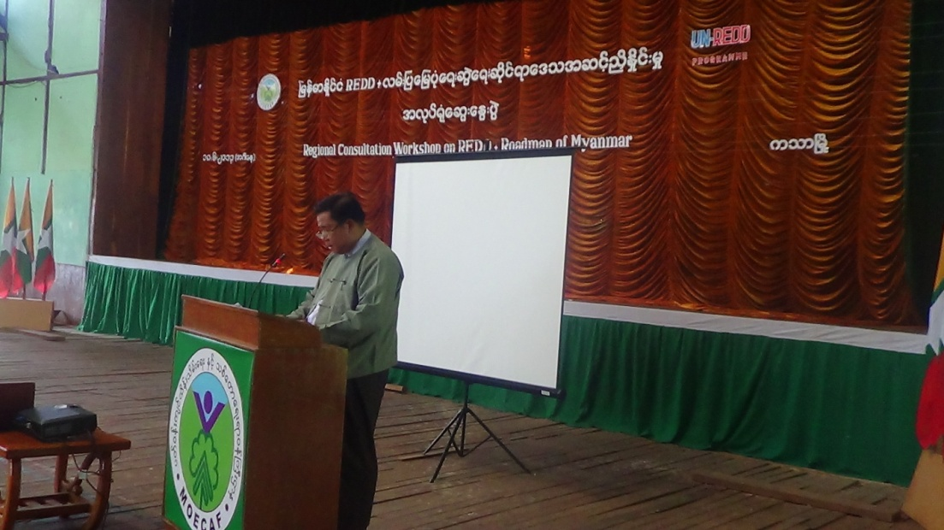

H. E. U Than Htaik, Regional Minister for Ministry of Mining and Forestry delivering Opening Speech
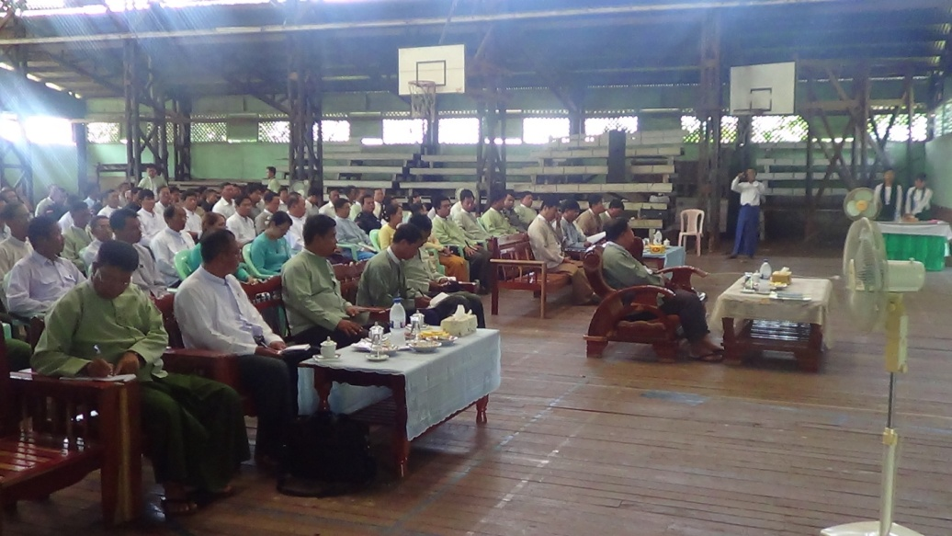

Participants attending Regional Workshop

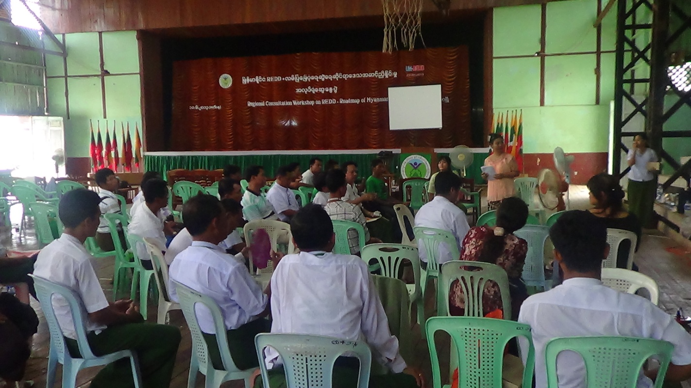
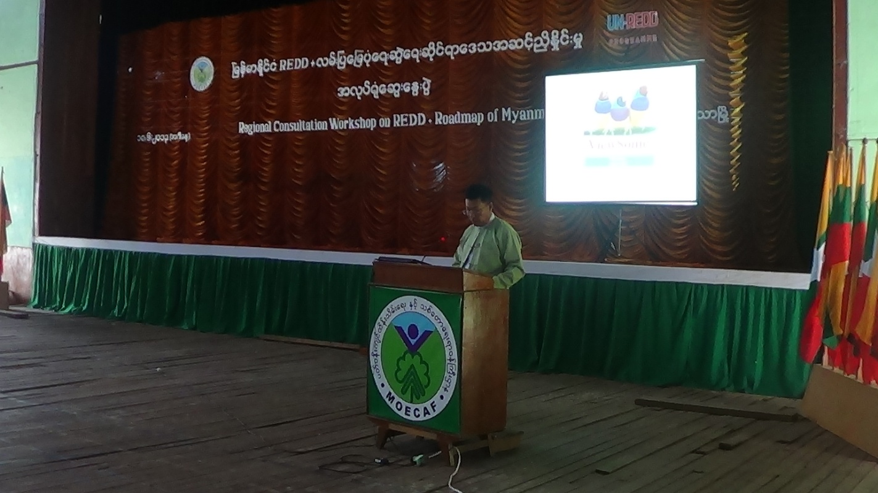
Group Discussion

Closing speech delivered by U Nyunt Aung, Deputy Director, Sagaing Region, Forest Department

