Consolidated Report on Initial National Consultation Workshop on REDD+ Roadmap, Nay Pyi Taw
AGENDA
Opening Session | Opening Speech delivered by H.E. Deputy Minister U Aye Myint Maung, MOECAF
Presentation Session | The REDD+ Readiness Roadmap Development Process  Roadmap Session 1: Management of REDD+ Readiness | Dr. Thaung Naing Oo  UN-REDD Programme Focal Point  Deputy Director, Forest Department
 | Roadmap Session 5: Developing a Forest Reference Emission Level and Forest Reference Level (REL/RL)  Roadmap Session 6: Developing a National Forest Monitoring System | Dr. Myat Su Mon, Assistant Director, RS/GIS Session, Forest Department
 | Roadmap Session 3: Development and selection of REDD+ Strategies | Dr. Rosy Ne Win, Staff Officer, Forest Department
 | Roadmap Section 2: Stakeholder Consultation and Participation  Roadmap Section 4: Implementation Framework and Safeguards | Mr. Nanda Win Aung, Staff Officer, Forest Department
 | DISCUSSIONS
Group discussion Session | Three Groups Discussion
 | Presentation of results of Group Discussion
CLOSING SESSION | Closing Speech by Deputy Director General, Forest Department

Consolidated Report on Initial National Consultation Workshop on REDD+ Roadmap, Nay Pyi Taw

Introduction
The UN-REDD Programme “Support to National Actions – Global Programme Framework Document 2011 – 2015” had created a specific window for technical & financial support to member countries. As a result of a visit to Myanmar by Mr. Erik Solleim, Former Nowegian, Minister for Environment and International Development, Norway expressed interests in providing support for the REDD - Plus Readiness process in Myanmar. In October 2012, during a mission of the Union Minister of Ministry of Environmental Conservation and Forestry (MOECAF) to Oslo, the Norwegian government further indicated their intension to invest in Myanmar’s REDD-Plus Readiness process, through the implementation of the Roadmap.
With the supports of Norwegian Government through RECOFTC and UN-REDD Programme, three working groups with representatives from government line ministries, civil societies, NGOs and private sector, were formed and four working group meetings were held once a month during December 2012 – March 2013. As a result, REDD+ Roadmap and National Strategies (draft) were developed with the technical supports of UN-REDD Programme.
The UN-REDD Programme provided Targeted Support to cover the extra cost of organizing the national consultation process. The objective of UN-REDD Targeted Support is to help in reviewing and validation Myanmar’s draft REDD - Plus Readiness Roadmap through a multi-stakeholder national consultation process.
An Initial National Consultation Workshop (A multi-stakeholder workshop) was held at Ingyin Hall of Forest Department MOECAF, Nay Pyi Taw on 14th May, 2013.

OPENING SESSION: Opening Ceremony
The opening and welcome speech was delivered by H.E. U Aye Myint Maung, Deputy Minister for MOECAF. In his speech, H. E. U Aye Myint Maung clearly indicated that the role of forests in mitigating climate change. He also stressed that the restored forests will be resilient to climate change impacts while enhancing ecosystem services such as: i) increased food supply; ii) soil stabilization/erosion control (including decreased dam siltation); iii) soil fertility; iv) maintained/increased water quality; v) carbon sequestration; vi) maintained/increased water supply; vii) increased river flow for irrigation; and viii) increased hydro-electric power generation. The presence of climate-resilient forests will play an important role in stabilizing degraded areas and the communities within them through providing a buffer against climate extremes. Along with it, Excellency also expresses that REDD+ is an innovative approach and REDD+ has been perceived as a quick and cheap option for taking early action toward limiting global warming to 2 C. He also mentioned about the REDD+ activities such as reducing emissions from deforestation and forest degradation, forest conservation, sustainable management of forests and enhancement of forest carbon stock (afforestation and reforestation). More importantly, he also recognized the importance of stakeholder consultation process and involvement of all relevant stakeholders including indigenous people (local communities) in the REDD+ roadmap formulation processes. Finally, he strongly suggested to scale up the stakeholder consultation process, mainstream REDD+ and climate change mitigation activities into the national forest programme, promote forest governance and forest management system, invite indigenous (local communities) to participate the process, to improve technical and policy process for land and resource tenureship and to mobilize financial and technical supports for the implementation of REDD+ Roadmap. Last but not least, on behalf of Union Minister for MOECAF as well as on his own behalf, Deputy Minister expressed his sincere thanks to Norwegian Government, UN-REDD Programme and RECOFTC for technical and financial supports.
The Initial National Consultation Workshp was attended by (73) participants; Roadmap (draft) presented by Resource Persons and received initial feedback on the first draft of the Roadmap. List of participants can been seen in ANNEX 1.
PRESENTATION SESSION

Presentation session was Chaired by U Khin Maung Oo, Director, Planning and Statistics Division and U Bo Ni, Director, Watershed Conservation Division of the Forest Department. There were four presentations in the Initial National Consultation Workshop. The Roadmap is composed of 6 Sessions and detailed power point presentation files are attached in ANNEX 2. The followings are the 6 sessions of REDD+ Roadmap:

No. | Presentation Topic | Resource Persons
1. | The REDD+ Readiness Roadmap Development Process  Roadmap Session 1: Management of REDD+ Readiness | Dr. Thaung Naing Oo  UN-REDD Programme Focal Point  Deputy Director, Forest Department
2. | Roadmap Session 5: Developing a Forest Reference Emission Level and Forest Reference Level (REL/RL)  Roadmap Session 6: Developing a National Forest Monitoring System | Dr. Myat Su Mon, Assistant Director, RS/GIS Session, Forest Department
3 | Roadmap Session 3: Development and selection of REDD+ Strategies | Dr. Rosy Ne Win, Staff Officer, Forest Department
4 | Roadmap Section 2: Stakeholder Consultation and Participation  Roadmap Section 4: Implementation Framework and Safeguards | Mr. Nanda Win Aung, Staff Officer, Forest Department

At the end of the Presentation sessions, the floor was open for Q&A as well as for discussions. The followings are the major discussion points for the above mentioned presentations:

Sr. No. | Questions | Questions raised by
1 | How can we get benefits from REDD+? How will you share REDD+ benefits (carbon credit)? | Private companies, NGOs, Civil Societies,
2 | How can we get involve REDD+ activities? | Private companies, NGOs, Civil Societies,
3 | How do you identify priorities to address major drivers of deforestation and forest degradation? | Media, NGOs
4 | What is the next step of REDD+ roadmap? | Officials from MOECAF
5 | How is your plan to scale up the awareness raising and capacity building about REDD+ | Officials from MOECAF and NGOs
6 | Could you please briefly explain about current status of REDD+ readiness activities being implemented in Myanmar? | Media, NGOs

The resource persons responded to the above questions as follows:

Sr. No. | Response to the Questions | Responded by
1 | In Myanmar, benefit sharing system has not been developed. REDD+ mechanism is not yet fully in place so that we cannot say exactly about benefit distribution system. But we can firmly say that REDD+ is performance-based payment system. Benefit from REDD+ is not only “carbon credit or money”, we can enjoy other co-benefits such as enhancing biodiversity, soil conservation, water regulations, income generation of rural communities and rural development. | Dr. Thaung Naing Oo
2 | In our REDD+ readiness roadmap, we already identified the role of each and every stakeholders. | Mr. Nanda Win Aung
3 | We identified major drivers of deforestation and forest degradation through brain storming among technical working groups and based on the experiences of Forest Department | Dr. Rosy Ne Win
4 | After organizing stakeholder consultation workshops, we will submit to MOECAF for adoption of the REDD+ roadmap and will submit to Norwegian Government through UN-REDD Programme for financial supports for implementation. | Dr. Thaung Naing Oo
5 | Through the on-going REDD+ pilot demonstration projects, we have been scaling up our awareness raising and capacity development about REDD+. | Dr. Thaung Naing Oo
6 | In addition to REDD+ roadmap formulation activities in cooperation with UN-REDD Programme, Forest Department has been implementing REDD+ Capacity Building Projects with the support of ITTO and Korea Forest Service. | Dr. Thaung Naing Oo

COMMENTS UPON PRESENTATIONS

Dr Min Htut Yin- Assistant Residence Representative, UNDP

The impact ranking for drivers of deforestation and forest degradation are based on the group members´ perception and available data from reliable sources should also be considered to ensure the data validity as well as evidence factor. The facilitator or members of the technical working group task force or a lead writer should make clear the data are correct in consultation with respective line Ministries for instance, mining area in forested area. Beside, the illegal logging rate and future trend should also be validated using triangulation method from different sources like Government, NGOs and local communities and third independent parties. The seizure of illegal timber reports generated from Divisions and States should also be collected and feed into the roadmap report and that would be also evidence based data to avoid argumentation and repercussion if arisen in future.

U Khin Maung Oo, Director, Planning and Statistics Department, MOECAF

U Khin Maung Oo, Director, Planning and Statistics Department, MoECAF added a bit more comments in this regard. The data on legally over harvested timbers has been portrayed based on the comprehensive data from Planning and Statistics Department, MoECAF. It can be said that overharvesting in the legal aspect is quite strong on the basis of available data. The complementary discussion should also be made regarding legally overharvesting timber such as in the border area and compute appropriately to obtain the sound data. Although it may be difficult to acquire illegally harvested timer data precisely, the discussion should be gone though how to obtain and compute this illegally overharvested data as well.

Dr Kyaw Tint , Director General (Retired), Chairma of ECCDI NGO and MERN NGO Networks

He commented that some weakness in implementing the Myanmar selection system (MSS) on ground is recognized. Nonetheless, MSS itself has some flaws and needs to be modified. For instance, MSS is designed to exploit the surplus yield by extracting the timber that meets certain girth limit, supposed above 6 feet 6 inches, however, felling all trees that have certain girth limit do not reflect to the real selection system nowadays even though it could be proper in the past. Additionally, the selection system in Myanmar mainly focuses on teak (Tectona grandis) extraction has been implied in the above similar way and there are not enough trees left to catch up the constant yield every year nowadays. Because it seems that the forest stand left over are without any care as the felling will go on every 30 years regardless of tree species composition, girth varieties, and stand structure. All trees that meet certain girth limit will be fell and fell again. Basic criteria taken into account are whether the designated compartments have enough trees to be extracted in the sustainable way considering the stand structure, species composition and diameter (girth) limits. This is why MSS needs to be reconsidered and reviewed for any improvement or modification. Another point is gap planting in natural forest has been undertaken and counted as the natural forest after 40 years lapse. Management plan should be drawn for plantations and natural forest in separation instead of mixing together. Timber certificate is designed to sell the timers legally in the international market. So there should be standards and guidelines for legality and traceability in line with the sustainable forest management. Community based system should also be encouraged to enlist the their participation in forest management providing them education and awareness as well as the rights and responsibilities and change their attitude that managing these forests will in turn yield real benefit to them. Another critical point is to change the mindset of the staffs from Forest Department, for instance, technocracy, the foresters believe that only the foresters can manage the forest and if handed over to the local communities, the forest status will decline. This kind of attitude should be changed and place the trust on local communities and manage the forest in cooperation with the local communities who should also be given training and technical support till they are capable to initiate and implement the forest management activities.

Daw Naw Ei Ei Min, Specturm

Daw Naw Ei Ei Min from spectrum gave comments on future trends of major drivers section where firewood consumption will increase in future. The energy efficiency plans have been formulated in the realm of energy poverty in Myanmar recently. In this context, promotion of rural renewable energy plays an important role such solar energy which even can be used for cooking and small scale business such as making jiggery from palm tree. If all concerned stakeholders from Government to UNDP and NGOs collaborate together to increase the use of renewable energy and technology, the firewood demand could be remained the same even the firewood demand may not decrease in future.

GROUP DISCUSSION SESSION

Participants were split into three groups for the discussion of 3 topics, namely, (Group 1) Preparing REDD+ Management Process and Institutionalization, (Group 2) National Strategies and Policy, and Group 3 Stakeholder Engagement and Safeguards.

FINDINGS OF GROUP DISCUSSION

Mr. Myint Hlaing (Consultant, UNDP), Facilitator of the Group

Group discussion focuses on the drivers and strategies on deforestation and forest degradation. Three questions were raised during the group work discussions regarding drivers and strategies of deforestation and forest degradations- i) to rank deforestation and forest degradation drivers, to add any other important drivers, and ii) to review the impacts on future trends of deforestation and forest degradation, iii) to discuss main activity packages (past, present and new programmes) and policy measures inside and outside the forestry sector

The group discussed the first question regarding with the drivers for deforestation and forest degradation in six forest types- dry forest, coastal forest, tropical evergreen forest, mixed deciduous forest, hill and temperate forest and indaing forest.

The forest status in some forest type remained the same in the period of 2000 and 2010 and even the forest cover increased a little, for instance, tropical evergreen forest and hill-temperate forest cover from 16% of the total to 17.22% and from 26% to 26.88% respectively. A participant stressed that this forest cover change may have to be reassessed or show the evidence how they were computed. Regarding the drivers of forest degradation, the group agreed with over exploitation of forest timber legally and illegally which is ranked as impact number 1. However, overharvesting of fuel wood and charcoal should be ranked as second instead of 6 and expansion of agriculture should be ranked as 3 instead of 4. Similarly, mining area should be collected from respective Ministries and deduct from the existing forest area and ranked again accordingly based on the result. Finally, the group agreed to review the data ranked again on the basis of available data, reliable literature and in consultation with correspondent officers from line Ministries.

Regarding the future trends for major drivers of deforestation and forest degradation, decreasing trend of illegal over exploitation in next five years or a decade was not agreed by the participants since it would depend on stable political conditions especially in border area rather than central plain land. This is why the trend for this is projected as remained the same despite the government has been initiating improvements in transparency, accountability and good governance systems (for instance, Extractive Industry Transparency Initiative). However, the decreasing trend for legal over exploitation was reached to the agreement due to the policy changes and some measures, for instance, log export banned, to undertake reducing deforestation and forest degradation. Regarding with overharvesting of firewood and charcoal, the increasing trend of this impact in future could be halted with improved energy efficient cook stove and universal access to energy by means of promoting household and community level renewable energy efficiency such as solar panel, mini hydro power, biogas and liquid biodiesel fuel and so on along with the introduction of appropriate technology to maximize the existing natural resources.

In relation to the main potential candidate strategies, activities packages and policy measures were discussed and reviewed based on the context of the drivers that impact on REDD+ mechanism. To resolve over exploitation of legal timbers, the group supports to do pre and post harvesting inventory to comply with AAC plus modification of Myanmar selection system in line with existing forest conditions. In order for implementing CF programs more smoothly and rapidly, the existing CF instructions should be reviewed and legalization should be given closer attention to enact the CF law, market led CF approach to compliment the livelihoods of rural communities and permission of selling the CF products quickly form one place to another, and so on were recommended. Shifting cultivation accounting for about 23% of the total land should be stabilized by injecting technical and financial investments in cooperation with NGOs and UN agencies and other development partners. Training and awareness campaigns will also be useful to strengthen the capacity of local communities while they are provided rights and responsibilities to benefit from the forest produce such as NTFP, agro-forestry, home-stead garden and so on. Implementing universal access to energy should be promoted more with higher intensity to counteract the shortage of energy such as heating and lighting in rural area which in turn will support the livelihood activities and improvement in small scale business. The policy measures so far presented based on the last four months technical working group discussions are agreeable relative to development of National certification standards for timber extraction, CF and agro-forestry program, export logging ban, stabilizing shifting cultivation and expansion of permanent forest estate (PFE) up to 40% of the total land area, developing ESIA standards, procedures and guidelines, imposing systematic taxation system on carbon counts, intensification of mechanized and improved technologies for agricultural productivity, and implementation of biomass removal from submerged hydro power area, and so on. The consultation meetings will be held in subsequent regional workshops and closing national consultation workshop with the emphasis on these findings in order to validate the elements with the consensus of multi-stakeholders in each region and divisions.

Dr Maung Maung Than comments on results of Group discussion:

It might be better if military settlement is put under the urbanization and settlement together instead of having placed stand alone. Regarding policy drivers, there are two sides called demand and supply whereas what can be done more or changed from demand side could also be a factor to be paid close attention rather than concentrating on supply side. For instance, providing land lease 30 years is not enough to rehabilitate and subsidies could be another element to reinforce for environmental rehabilitation.

Dr Min Htut Yin comments on results of Group discussion:

To review the data and contents of the environment conservation books published by UNEP 2010, that includes pressures, drivers, impact and responses regarding environmental conservation. This would also provide consistent data instead of gathering the same data from different sources.

CLOSING SESSION

Closing Ceremony

Closing remarks were addressed by U Zaw Win, Deputy Director General of the Forest Department. In his Closing Speech, he congratulated REDD+ Roadmap Technical Working Groups for successful formulation of REDD+ Roadmap with great efforts. He also express his appreciation to Norwegian Government and UN-REDD Programme for financial and technical supports. Deputy Director General also explained the progress of REDD+ roadmap formulation as well as other REDD+ demonstration activities. He pointed out that REDD+ activities are very much in line with the national and sectoral reform processes and there are many potential benefits from REDD+. Therefore, he urged MOECAF and relevant stakeholders to pay more attention on REDD+ readiness process and to participate along the REDD+ readiness preparation process. In conclusion, he mentioned many policy, legal and technical strength of Myanmar to implement REDD+ readiness and suggested to scaling up capacity building and awareness raising activities along the REDD+ readiness process.

ANNEX I: List of participants
ကနဦးအမျိုးသားအဆင့် ညှိနှိုင်းမှုအလုပ်ရုံဆွေးနွေးပွဲတက်ရောက်သူများစာရင်း

Participant from UN-REDD Programme
No. | Name | Position | ဌာန
1. | Mr. Bruno Commaert | Myanmar REDD+ Roadmap Coordinator | UN-REDD Programme

Participants from Ministry of Environmental Conservation and Forestry
N0. | Name | Position | ဌာန
1. | U Zaw Win Myint | Director | Forest Research Institute
2. | U Myo Lwin | Deputy Director | Dry Zone Greening Department
3. | Dr. Thaung Naing Oo | Deputy Director | Planning and Statistics Division
4. | Dr. Khin Maung Sint | Manager | Myanma Timber Enterprise
5. | U Nyunt Maung | Assistant Director | Planning and Statistics Division
6. | Dr. Myat Su Mon | Assistant Director | Planning and Statistics Division
7. | U Win Naing | Assistant Director | Planning and Statistics Division
8. | U Myint Thein Khaing | Assistant Director | Planning and Statistics Division
9. | U Hlaing Min Maung | Assistant Director | Planning and Statistics Department
10. | U Aung Aung Myint | Assistant Director | Planning and Statistics Division
11. | Daw Wai Wai Than | Assistant Researcher | Forest Research Institute
12. | Dr. Naing Zaw Tun | Assistant Director | Nature Conservation and Wildlife Division
13. | Dr. Nyaunt Khaing | Assistant Lecturer | University of Forestry
14. | Dr. Rosy Ne Win | Staff Officer | Planning and Statistics Division
15. | U Nanda Win Aung | Staff Officer | Watershed Management Division
16. | Dr. Tin Zar Kwal | Staff Officer | Forest Research Institute
17. | U Nyan Hlaing | Staff Officer | Planning and Statistics Division
18. | U Phone Htut | Staff Officer | Planning and Statistics Division
19. | U Zaw Zaw Naing | Staff Officer | Natural Forest and Plantation Division
20. | U Moe Aung | Staff Officer | Planning and Statistics Division
21. | Dr. Chaw Caw Sein | Assistant Lecturer | University of Forestry
22. | Dr.Toe Toe Aung | Staff Officer | Planning and Statistics Division
23. | U Zaw Min Tun | Staff Officer | Forest Research Institute
24. | U Bily Ne Win | Researcher-2 | Forest Research Institute
25. | Daw Thida Swe | Researcher-2 | Forest Research Institute
26. | Daw Phyu Phyu Swe | Researcher-2 | Forest Research Institute
27. | Daw Khin Thida Tun | Staff Officer | Forest Research Institute
28. | Daw Nyo Mee Tun | Range Officer | Trainning and Research Division
29. | U Pyae Soe Aung | Range Officer | Nature and Wildlife Conservation Division
30. | U Pyae Phyo Maung | Range Officer | Planning and Statistics Division
31. | U Nay Lin Tun | Range Officer | Planning and Statistics Division
32. | U Thant Sin Aung | Demonstrator | University of Forestry

Participants from line Ministries, Bago Region
No. | Name | Position | ဌာန
1. | Dr. Maung Maung Thein | Director | Department of Agicultural Research
2. | U Chon Hlaing Win | Deputy Director | Settlement and Land Record Department
3. | U Own Than | Deputy Director | Attorney General’s Office
4. | U Htay Hlaing | Assistant Director | Land Survey Department
5. | U Thaung Oo | Assistant Director | Department of Industrial Planning
6. | U Thaung Nyaunt | Assistant Director | Department of Rural Development
7. | Daw Nilar Zin | Assistant Director | Department of Mines
8. | Dr. Tun Thein | Staff Officer | Department of Fisheries
9. | U Than Shwe | Staff Officer | Energy Planning Department

Participants from NGOs, Civil Society, Political Party and Media
No. | Name | Position | ဌာန
၁။ | Dr. Min Htut Yin | Assistant Representative | United Nations Development Programme
2. | Mr. Anthony Neil | Programme Officer | Economically Progressive Ecosystem Development Group (EcoDev)
3. | U Sein Thet | Project Coordinator | ITTO-REDD+ Project
4. | Dr. Kyaw Tint | President | Ecosystem Conservation and Community Development Initiatives (ECCDI)
5. | U Kyaw Thinn Latt | Landscape Coordinator | Wildlife Conservation Society (WCS)
6. | U Sit Bo | General Secretary | Forest Resource Environment Development and Conservation Association (FREDA)
7. | Daw Aye May Shwe | General Secretary | Environmental Conservation and Livelihood Outreach Foundation (ECLOF)
8. | U Maung Maung Thein Phe | Vice President | Rakhine Coastal Region Conservation Association (RCA)
9. | Daw Khay Mar San | Programme Officer | Swanyee Development Foundation (SDF)
10. | U Kyaw Min Thein | Programme Coordinator | Social Vision Services (SVS)
11. | U Su Tin | Chairman | Social Vision Services (SVS)
12. | U Win Sein Naing | Chairman | Mangrove Services Network (MSN)
13. | U Thiha Kyaw | Coordinator | Mangrove Services Network (MSN)
14. | U Khin Maung Latt | Branch Office Coordinator | Metta Development Foundation
15. | U Thint Tun | Chairman | Marine Science Association of Myanmar (MSAM)
16. | Daw Naw Ei Ei Min | Programme Coordinator | Spectrum
17. | Daw Naw Sar Warr | Programme Officer | Spectrum
18. | U Aung Kyin | Advisor | Ever Green Group (EGG)
19. | U Khin Maung Htay | Board of Director | Renewable Energy Association Myanmar (REAM)
20. | U Si Thu Lwin | Chairperson | MEET
21. | Dr. Maung Maung Than | Country Programme Coordinator | Regional Community Forestry Training Center (RECOFTC)
22. | U Sein Myint | Programme Coordinator | Adventist Development and Relief Agency (ADRA)
23. | U Thiri Tin | Forestry Specialist | Adventist Development and Relief Agency (ADRA)
24. | U Aye Thiha | Director | Royal Tree Services Co.Ltd
25. | U Kyaw Oo | Consultant | Shalom
26. | U Aung Htan | Project Manager | Shalom
27. | U Myo Ko Ko | Director | Point
28. | U Aung Ko Thet | National Fund | FAO, United Nations Development Programme
29. | U Myint Hlaing | Consultant | United Nations Development Programme (UNDP)
30. | U Khaing Htoo | Reporter | Union Daily Journal
31. | Daw Su Hlaing Tun | Reporter | Myanmar Times Journal

ANNEX II: Power point presentations

ANNEX III: Photos

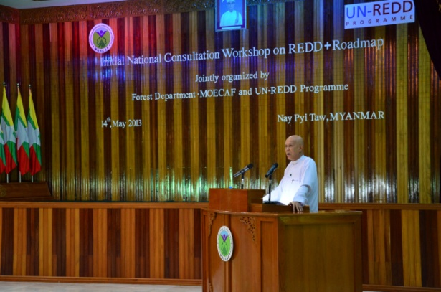
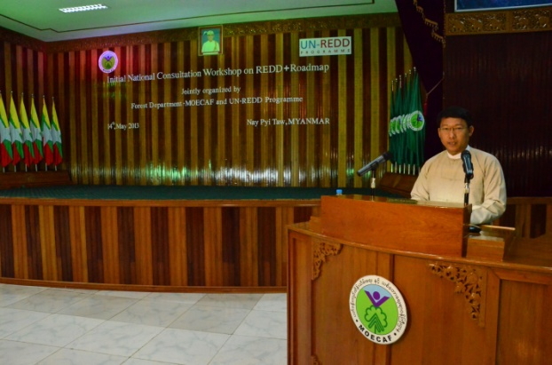

Opening Speech by Deputy Minister H.E. U Aye Myint Maung (left) and Dr. Min Htut Yin, Assistatant Resident Representative, UNDP (right)
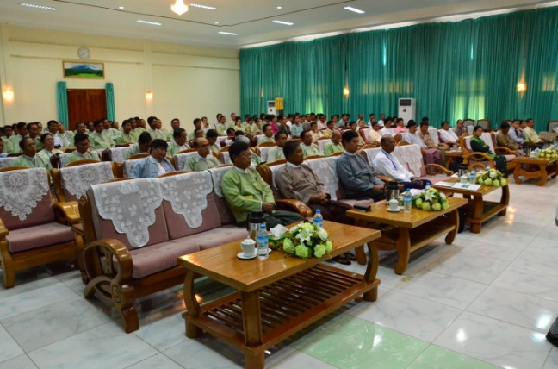
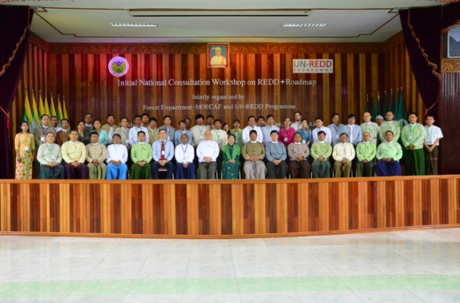
Opening Ceremony – Group Photo

