OUTCOMES & MINUTES OF THE GEO FOREST CARBON
TRACKING MEETING HOSTED BY GOOGLE

20th and 21st October 2009
Google, London

MEETING OUTCOMES

Action | Description | Status or due date
 | General
1 | Google and FCT Co-Leads to discuss potential of the Android technology for the in-situ data needs, under FAO leadership | Dec 2009
2 | GEOSEC to connect Google and GEO-BON to discuss the potential of the Android technology for their purposes | Dec 2009
3 | Google and GOFC-GOLD to develop the discussion on avoiding loss of Landsat historical archives at receiving stations around the world | Dec 2009
4 | Josef Kellndorfer to confirm the date of the proposed science meeting of GEO FCT at Woods Hole (planned for April 2010) | End October 2009
 | Dataset Specification
5 | Stephen Ward will consult with GEOSEC, Co-Leads and GOFC-GOLD to finalise responsibilities for GEO FCT Dataset Specification | ASAP
 | Standards & Protocols Documents
6 | Lief Kastdalen to lead development of the GEO Satellite Interoperability & Methods document v1.0 – including an experts writing meeting (funding offered by Norway) | Early 2010
7 | Linda Heath, FAO and others to scope out contents of the GEO In-situ Methods document | Nov 2009
 | Processing commitments
8 | Giovanni Rum will circulate the note on proposed processing responsibilities for the 2009 GEO FCT Dataset and GEOSEC will broker confirmation of the roles | 30 October 2009
 | ND & VS activities
9 | Michael Brady to circulate full contact details of the Points of Contact within each of the NDs | 30 October 2009
10 | Michael Brady and Giovanni Rum to work with co-leads to secure letters of confirmation from relevant governments for their roles as GEO NDs | End 2009
11 | Michael Brady to circulate a template to gather ND VS descriptions and to coordinate population and compilation of these | End 2009
12 | Evie Merethe-Hagen to compile descriptive texts and images for the VS information in the portal | End Nov 2009
13 | Michael Brady to circulate the ND orientation information (Presentation plus ND Guidance document) to the ND PoCs | End 2009
 | CEOS Data Requirements
14 | Inputs to Per-Erik for the CEOS presentation are required urgently | 29 October 2009
15 | Frank Martin Seifert to lead development of the 2010 GEO FCT Data Requirements document draft to share with CEOS | 1 December 2009
16 | FCT Co-Leads and GEOSEC to discuss and finalise the short-list of NDs to be added in 2010 and to ensure consideration given to UN REDD pilot countries | End Nov 2009
17 | Frank Martin, Ake, Dirk, Josef, Per-Erik, and Alex are asked to support inputs by 29th October on the selection of 10 priority sites for inclusion in the CEOS document | 29 October 2009
18 | Frank-Martin and GEOSEC to convey to USGS the request that they increase the frequency of Landsat acquisitions over the verification sites | November 2009
 | Portal
19 | GEOSEC to coordinate with Google to develop the script for an animated demo of the FCT portal | Nov 2009
20 | Frank Martin to provide missing satellite metadata for the portal | Nov 2009
21 | Ake, Tom, Giovanni and Michael to work with Simon on logo/credit issues in the portal | Nov 2009
22 | Simon to work with relevant contacts on VS definition issues and other portal content issues | Nov 2009
23 | George and Simon to schedule a GEO-VI portal preparedness call | Before GEO-VI

MEETING MINUTES

Welcome and Opening Remarks
Rebecca Moore of Google welcomed participants to Google. Jose Achache of GEO added his welcome. He recalled the high level discussions of the previous two days and noted that the Google meeting days are intended to be working discussions on technical details.

Recap of the PRP meeting
Giovanni Rum summarised the outcomes of the meeting yesterday. He confirmed the establishment of the NDs; the CEOS communiqué; the links to GOFC-GOLD and IPCC guidelines; there are around 25 countries involved in the task at present – and a high % of the tropical forest is covered already; the suitability of the GEO framework was confirmed; satellite data sets acquired in 2009 are an achievement in themselves that may well serve other applications; additional countries will be added in 2010; GEO is a good framework to work with NGOs; the vision for an operational system was discussed confirming it's a network of national systems with global components relating to satellite data and processing; GEO will be the certifying authority for the relevant standards and protocols to be adopted by participating national agencies in implementation; the FAO definition of forests was seen as the default unless national definitions are in place; the linkage of forest data with biomass and carbon is seen as a longer term option; there is a willingness of GEO participants to help build capacity on National Forest Inventories; support structures will be developed to assist the participating countries; in support of this the notion of global satellite data products was confirmed, and support for processing of national forest data products.
Alex asked for clarification on the role of the Hubs. Jose asked to clearly identify the functionalities required and then to define the relevant structures.

Google activities in Forest Carbon and wider
Rebecca Moore outlined the Google efforts in this domain. She explained the Open Data Kit on the Android mobile OS and explained the collaboration with the Univ. Washington. She showed a visualisation of deforestation using Google Earth. Jose hoped that the technology could be further assessed in support of the GEO FCT effort; he noted that the PRP meeting had concluded that the in-situ data be under the leadership of FAO. He recommended that GEO BON people also look at the utility of the Google Android technology for their purposes.
Rebecca demonstrated the time slider function of the Google Earth visualisation technology showing deforestation in Rondonia using Landsat data. Curtis suggested it would be valuable to link to the dataset archives to include as many available data as possible. He noted that the US archive is open and free and that there is much more data at the various archives around the world. He noted that the data is being lost since it is on old media at different receiving stations. The US is offering to reach out to the receiving stations and process and return the data but this is complicated by past commercial dimensions. Curtis suggested that Google could play a role in stopping the loss of the historical imagery. Rebecca indicated that they would be willing to look into this.
Rebecca repeated the presentation from the PRP meeting on Google’s ambition to host datasets and algorithms in support of Forest MRV systems. She indicated that there have been discussions with various countries for Google to show a global proof of concept at COP-15. She hoped that Google could have support from GEO in getting models and datasets included in their MRV prototype. Curtis asked if Google was thinking yet beyond the tropics – and Rebecca confirmed that the pilots are focused on tropical areas but there is no reason why this could not be expanded to anywhere in the world.
Jose noted that this work is very similar to the GEO FCT portal and concept of supplying information and datasets in support of national reporting commitments. Stephen Briggs expressed concern about open supply of data and models to people who may not be qualified in their application. Stephen suggested that the GEO task is more aimed at national reporting – whereas the Google effort is broader, intended to support many applications, including perhaps national reporting. Rebecca indicated that there will be clear constraints on the scope and applicability of each algorithm or dataset. Jose indicated that the broader Google vision has a lot in common with the broader GEOSS vision, seeking to apply FCT results to other domains. He hoped that Google and GEO could avoid duplication in future efforts. David Singh suggested that GEO can apply a level of standardisation and QA; whereas Google is able to provide the more public-oriented popular service and branding that Google is able to provide.
Rebecca noted that protected datasets, such as NFIs, could be uploaded for use by countries like Guyana, but that they could be kept private.
Curtis explained that GOFC-GOLD has extensive experience in developing best practices for the kinds of reporting in question. One of the biggest obstacles to the implementation is in agreeing approach. He suggested that the Google approach could find one solution. Stephen Briggs noted that the GEO system will be different, as the validated and authorised and treaty-compliant information and data repository.
Luis Solorzano expressed the hope that GEO and Google could bring increased harmonisation and governance to the application of the remote sensing data to the information needs. He asked whether GEO is in a position to control the required standards.
Rebecca wanted to stress the scientific nature of the Google effort. It is not a consumer-oriented product.
Alex suggested we consider the Google effort as part of an R&D test-bed behind the more specific and urgent GEO FCT efforts. Alex suggested that this would be a good environment to test new algorithms and datasets and to explore their operationalisation. Giovanni suggested to engage the NDs more closely in the Google development efforts and to include Peru as a new ND to cover the scope of the Google pilot. Per-Erik reminded that criteria exist for selection of the NDs and Peru should meet these.

2009 Management Plan
Stephen Ward presented more or less the same content as at the Clarence House meeting. Refer to the presentation slides.

National Demonstrators review
Michael Brady presented on the role and status of the National Demonstrators within the FCT effort:
- To show rapid progress in the run-up to COP-15 in Copenhagen, the Task seeks to demonstrate this capability initially at national scales – in a number of selected countries (called here “National Demonstrators”) spanning different continents;
- These demonstrations are intended to show the feasibility of inclusion of satellite-based forest monitoring information as compliment to forest-inventory-based and/or ecosystems modelling of carbon emissions, in future national carbon accounting systems;
- He referred to the criteria for consideration as a National Demonstrator, including (where applicable), long-term involvement of external donor country /organization for capacity building, field measurement and satellite data acquisition and analysis, and monitoring system implementation;
Michael identified the coordinated demonstrator activities:
- FCT description and data inventory (ongoing)
- Delineation of forest area (complete)
- Acquisition of current Earth observation data (ongoing)
- Identification of Verification Sites (ongoing)
- Site description and data collection (initiated)
- Global processing, ND processing support, ND processing
- Data dissemination through task portal
He explained the status of the Mexico ND by way of example. He explained the role of the verification sites:
- Development of algorithms, methods and strategies for validation and verification of observations at national level;
- Ecosystem/carbon model parameterisation;
- VS locations are requested to be covered on a monthly/bi-monthly basis during the remainder of 2009 and early 2010.
The current list was shown:
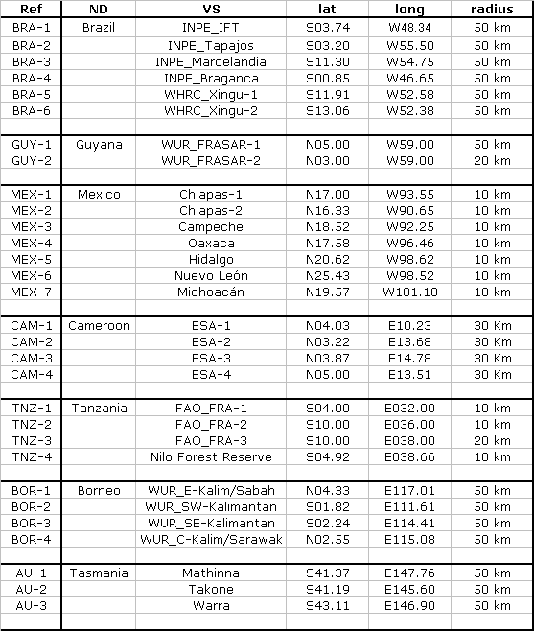

The status of the Mexican sites was explained. Michael noted that the National Demonstrator Guidance document needs to finalised.

Satellite data acquisition status
Frank Martin Seifert reported on the CEOS data acquisition coordination efforts. He noted that the CEOS response to the GEO FCT Data Requirements for 2009 was just issued 15th October 2009. The basic story is:
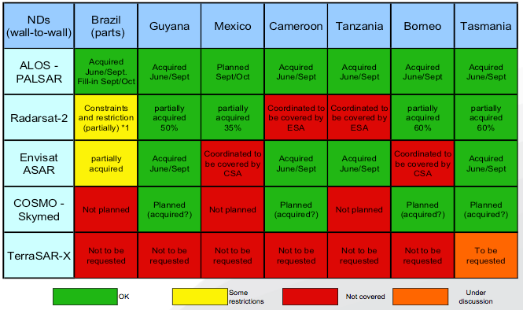
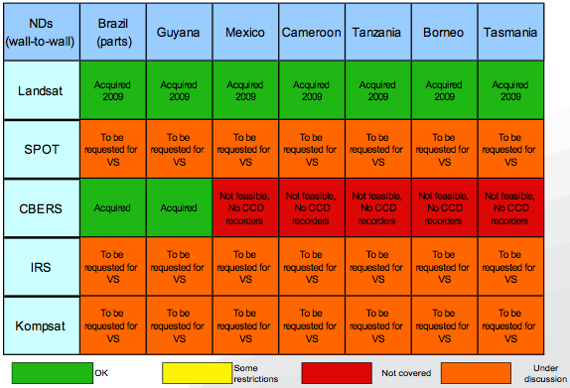

He suggested that CEOS agencies expect the 2010 FCT Data Requirements in late November in draft.
Frank commended the space agencies on their impressive data acquisition results and encouraged the FCT task to make the most of the opportunity. He showed the status of the verification sites and thanked Mexico, Wageningen Univ and others for their inputs. Frank confirmed that the VS list was finalised a week ago (30 sites) and that he would like to prioritise 10 sites within these to send to CEOS and the commercial providers.
Ake Rosenqvist suggested that we need to specify exactly what will occur at the VS and using what data.
Jose hoped that statistics on what % of the CEOS data acquisitions had already been processed could be included in the GEO-VI presentation of Gary to show that the data is already being applied.

National Demonstrators Guidance Document
Alex Held presented on the status of the document and detailed the criteria and benefits for the National Demonstrator applicants. He showed the list of candidate NDs for 2010: Colombia; Peru; DR Congo; Cambodia; Japan (Hokkaido). Per Erik queried the lack of the 9 REDD pilot countries on this list. Alex suggested there has been a lack of donor support for these countries. Per Erik suggested that more effort needs to go on coordinating with the REDD countries and searching for commonalities in approach. Michael Brady expressed concern that we need to better establish the existing NDs before adding more – as discussed in the Clarence House meeting. Alberto Sandoval noted that all the UN REDD and World Bank countries are assembled in Washington DC next week and he offered FAO to explain the status of the GEO task and the role of the NDs. Per Erik suggested that the GEO task should be staying abreast of the UN REDD efforts and keeping in touch with their progress. Michael Brady noted that the necessary support from a donor is required for a candidate ND country to join the GEO task.

GEO FCT Portal
Simon Ilyushchenko presented the status of the portal using the presentation provided by George Dyke. Simon explained the background to the Portal as a means of managing reporting on data acquisitions and in communicating results. He encouraged feedback to the development team so that the portal is in the right shape for GEO-VI. The portal is at portal.geo-fct.org. Simon explained the basic structure, content and navigation of the site. Simon gave a live tour of the portal showing various datasets, acquisition coverages etc. Simon explained the plan for deployment for GEO-VI, incorporating feedback from London meetings. For 2010 and beyond a number of features are considered, including integration with data acquisition and processing functions of the FCT task. Background information and descriptive text and images can be and should be added, as well as video and multi-media materials.
Stephen thanked Simon for the huge effort and queried whether Google will continue to support this activity. Simon and Rebecca confirmed that they would and that they understood the meeting conclusions as indicative of a close relationship between the Google MRV ambitions and the FCT Portal effort. Curtis Woodcock hoped that the portal effort could evolve to become a deforestation hotspot alert system.
The question of the satellite data restrictions was raised and the need to protect certain of the data types.
Stephen suggested that a brief animation would be helpful to communicate the portal and project to a wider, senior audience who may be unlikely to personally explore its features.

Data processing
Alex Held gave a brief presentation on the specification of the 2009 GEO FCT Dataset. He recalled that Approach 3 of the IPCC Lands Methods (agreed to be the GEO task target) would require spatially explicit information (wall-to-wall time-series monitoring of land use change). He showed the technical requirements based on the GOFC-GOLD Sourcebook for typical forest change and routine monitoring:
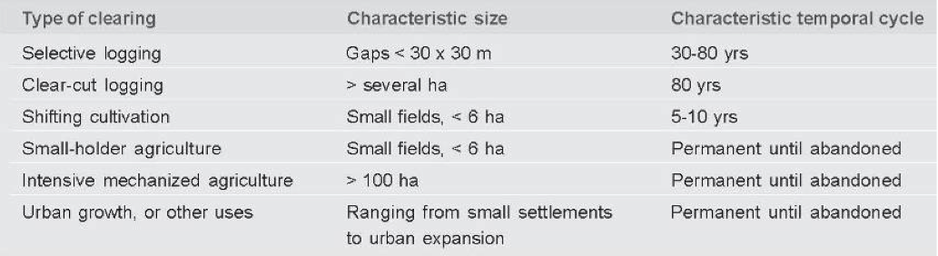
Alex recalled the UNFCCC framework definition of forest and deforestation adopted for implementation of Article 3.3 and 3.4: Minimum forest mapping area: 0.05 to 1 ha max; Potential to reach a minimum height at maturity in situ of 2-5 m; Minimum tree crown cover (or equivalent stocking level): 10 to 20 %. Therefore we need: National level Forest Change information (wall-to-wall) to avoid ‘leakage and to report at national + sub-national + project levels.
Alex advocated a pixel-based land cover change approach that requires sub-pixel mapping accuracy between years. He suggested the product needs for each ND are: annual, orthorectified, terrain illumination-corrected mosaics, optical and SAR integration, forest cover change information products at medium resolution (best available <50m), with sub-pixel accuracy.
Time-Series, wall-to-wall, 25 m resolution:
Horizon-1: Annual Forest, Non-Forest trends and associated accuracy metrics (as far back as possible via available archives (LTM, SPOT, …). National forest ‘map’ based on Optical/SAR complementarities (if desired by ND’s). Verification datasets.
Horizon-2: Forest Degradation (& trends). Land-use (e.g. agriculture, shifting cultivation, plantations, native forest ), Forest class: secondary forest (eg after fire or after agriculture); Softwood, hardwood, native, Plantation type mapping pre- and post-1990. Sparse woody perennial cover
Curtis suggested to analyse certain areas for each of the NDs to see what can be done. It was noted that the intention of the task is to stick to area coverage products initially and to progress to carbon estimation at a later date.

Progress planning – splinter groups
Stephen Ward proposed to dedicate the remainder of the London meeting time to the progression of the priorities facing the GEO task in 2009, through a number of small side group discussions in parallel. These topics and groups were agreed as follows (with discussion leads shown):
- #1: Specify the 2009 GEO FCT Datasets: The basic results to be shown for the Nods, using radar, optical and in-situ data (Alex Held & Martin Herold);
- #2: Secure commitments for the processing of the 2009 dataset for each of the 7 Nods (Giovanni Rum);
- #3: Specify validation site activities (in support of #1?) and to allow VS short-list to be finalised urgently: identify & secure in-situ data requirements (Michael Brady);
- #4: Progress the GEO Standards and Protocols documents: Satellite Interoperability & Processing Methods; Ground Measurements, Inventory & Model Cal-Val for FCT (Leif Kastdalen)
- #5 Draft the 2010 GEO FCT Data requirements for CEOS (Frank-Martin Seifert)
- #6 Ready the Portal for GEO-VI and COP-15 (Simon Ilyushchenko)
The decisions and actions agreed on each of these topics are summarised below.

GEO FCT Dataset specification
Martin Herold summarised the splinter group progress as follows:
Common statements:
Different countries/ecosystems require different combinations of satellite and other data
Key objective of task to fill potential data gap of global satellite coverage for forest monitoring
Interoperability working on several levels:
- Coordinated observations and processing
- Joint analysis and interpretation
- Product combination and synergy
Objective to move from 3 to 1 – key process that requires R&D and lessons learnt from demonstrators
Both importance of national-specific datasets and information, and for consistent (global) analysis
2 sets of specifications:
- Satellite and in-situ data for forest activity data
- Methods and procedures for carbon stocks and emission factors
- ?Potentially, uncertainty analysis and impact on assessment and reporting …
Definition of satellite data products:
- Time-series data of pre-processed observation products for national demonstrators:
  - Mining and utilization of historical archived data
  - Minimum requirement of annual coverage starting 2009
  - Validation of data products
  - Notes:Ancillary data; Time-series of individual scenes versus annual mosaics
- Monitoring of forest area change for national demonstrators using the available observations and aiming at annual activity data estimates for using IPCC GPG approach 3
  - Statistical accuracy assessment based on robust approaches and best practices
- Benchmark forest map (and updates) using synergy of optical and SAR data, i.e. on request from national demonstrators and beyond
  - Statistical accuracy assessment based on robust approaches and best practices
- Constantly improving best practice guideline on how to use existing space assets for forest carbon tracking supporting MRV purposes based on experiences from demonstrations
There was some discussion as to whether GOFC-GOLD might establish a Working Group dedicated to the continued specification of the GEO dataset. The discussion was inconclusive.

Satellite Interoperability & Processing Methods Document
Leif Kastdalen summarised the splinter group progress as follows in outlining the document:
- Time-series data of pre-processed observation products for national demonstrators:
  - Preprocessing goal:
Set of minimum requirements for interoperability
- GLS 2005 as global reference spatially (as starting point)
- SRTM as global reference spatially for Radar (currently), use national datasets if appropriate, use consistent reference over time
- Ancillary data
- Time-series of individual scenes versus annual mosaics
- Mining and utilization of historical archived data
- Minimum requirement of annual coverage starting 2009

  - Optical data pre-processing
Best practices for each sensor
Built upon existing outline
  - SAR data pre-processing
Best practices for each sensor
Built upon existing outline
  - Validation and comparison of data products
Procedures to evaluate that minimum requirements are met

- Monitoring of forest area change for national demonstrators using the available observations and aiming at annual activity data estimates using IPCC GPG approach 3
  - Statistical accuracy assessment based on robust approaches and best practices

- Benchmark forest map (and updates) using synergy of optical and SAR data, i.e. on request from national demonstrators and beyond
  - Statistical accuracy assessment based on robust approaches and best practices

- Constantly improving best practice guideline on how to use existing space assets for forest carbon tracking supporting MRV purposes based on experiences from demonstrations
It was noted that this is rather different from the existing document outline. Leif Kastdalen confirmed that he was willing to take on the coordination of development of this document. Per-Erik confirmed that he would aim to provide funding for an intensive writing meeting involving the key technical experts from GOFC-GOLD, WHRC etc. Leif subsequently circulated a plan of action including contributions from GOFC-GOLD (Curtis, Martin), WHRC (Josef), Wageningen (Dirk), FAO (Erik), and CSIRO (Peter, as follows:
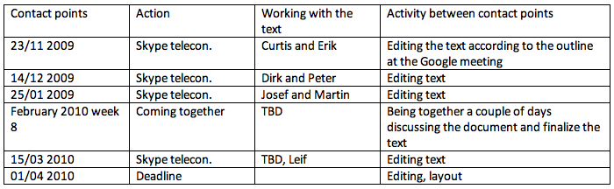

2009 GEO FCT Dataset Processing Commitments
Giovanni Rum the splinter group progress as follows:
NEED TO SEE THE MATRIX

Giovanni summed up on the matrix of commitments and will provide a note on processing responsibilities by 30th October for review by the task participants.

Validation site activities
Michael Brady summarised the splinter group progress as follows:
- The term Verification Site needs further definition - concern that it implies sufficiency for national level coverage; we need to convey multi purpose nature of sites (activity data & CBM), including:
  - Demonstrate verification information needs and activities for RS forest product (activity data)
  - Demonstrate CalVal information needs and parameterization for carbon modelling (stocks and fluxes)
- Full contact details for each of the current NDs are being compiled. Michael will circulate (end October);
- A template is being prepared to gather ND VS descriptions. Michael will circulate and coordinate development of a complete set in cooperation with the ND PoCs (end December); Evie will look after adding descriptive texts and images for the VS in the portal ahead of GEO-VI;
- Michael will circulate the Presentation he has prepared in support of ND orientation to ND PoCs (end October); the ND Guidance document will follow later and Michael will coordinate its conclusion and distribution to current and candidate NDs (end December);
- The Task should seek written confirmation from each ND confirming support of the relevant government agency (as Tanzania has done).
Current state of the ND PoCs was shown (with responsible FCT personnel):
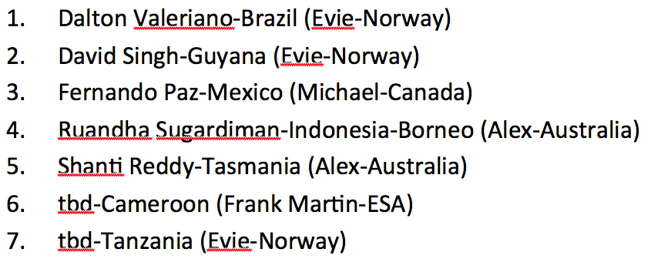
2010 CEOS Data Requirements
Frank-Martin Seifert presented the splinter group progress as follows:
- The FCT Presentation at CEOS Plenary 3-5 Nov 2009 will be delivered by Per-Erik, with preparation by Ake, Frank Martin, Per-Erik – inputs due 29th October 2009;
- Version 1 of the 2010 CEOS Data Requirements will be prepared by 1st December (prior to COP) and V1.1/2.0 by mid-May 2010 after the proposed FCT meeting in March/April;
- Frank-Martin will be the document coordinator, with Ake leading the SAR elements and Tom & Frank leading the optical elements;
- The strategy for the NDs was summarised as:
- SAR: Jan/Feb 2010 repetition of summer 2009 campaign
Jun/Aug 2010 repetition of summer 2009 campaign amended with lesson learned
- Optical: refinement of sensor requirements; preference Jan/Feb – but window open until Oct 2010 (Nov/Dec for gap filling) for one cloud free composite;
- FCT should be conservative with addition of new NDs (after Data Summit, not for Winter 2009/10); co-leads are asked to nominate candidates for new NDs in 2010 – by 20 November 2009;
- On the selection of priority verification sites: Frank Martin, Ake, Dirk, Josef, Per-Erik, and Alex are asked to support inputs by 29th October on the selection of 10 priority sites (from the 30) for which processing results should be guaranteed for April 2010 and availability of ground truth data is confirmed;
- CEOS agencies will be asked to investigate the archives for full tropical belt coverage for 1990, 1995, 2000 (+/- 1 year) and annually from 2005 onwards; Frank Martin will coordinate development of a spreadsheet with corner coordinates of scenes from CEOS agencies by 31 March 2010 (for report at SIT-26);
- The science meeting in April 2010 should address: results over verification sites; interoperability of data sets: Optical – Optical, SAR – SAR, Optical – SAR; long-term acquisition strategy; input to update of “FCT Data Requirements 2010” doc; Josef is asked to confirm the proposed dates of the FCT science meeting by end October 2009;
Curtis suggested that USGS be requested to increase the frequency of their acquisitions over the verification sites. Frank showed the proposed priority sites from the larger list. Per-Erik queried about the radius of the verification sites and Frank agreed to check and revise the data to aim for 20km radius. Simon pointed out that the Borneo sites stray into Malaysian territory.
It was agreed that substantial progress towards the 2009 GEO FCT results is essential for the April science meeting. Frank suggested that CEOS agencies need to be informed soon as to where to transmit data. Josef cautioned against high expectations for results at the proposed April meeting. Alex committed to having a full coverage of SAR and optical data for Tasmania by next April. Alex hoped that he would be able to work with Dirk for Borneo datasets in time for April.
Giovanni will circulate the table of processing responsibilities to the parties in the table and ask for comments and issues to be raised. He suggested that he expected by April the processing should be underway and there will be scientific results from the verification sites. And that after that meeting the project should go to production – the 2009 results should not take too long into 2010 to produce. Alex asked whether Norway could fund a European team to handle processing for those NDs where it has a stake. Per-Erik suggested that he needs to discuss with ESA, NSC, JRC and others. Some processing contracts may be required. Martin Herold encouraged synergy with FRASAR efforts. He suggested that it is important to get requests from the ND governments in order to gain official support from donor countries.

GEO FCT Portal
Simon Ilyushchenko presented the splinter group progress in defining actions as follows:
- Create a script, collect materials for a public-facing tour of portal content (Giovanni, Matthew);
- Provide missing satellite metadata (Frank Martin);
- Confirm logo size/placement (Ake, Tom, Giovanni, Michael Brady);
- Clarify Borneo site placement (Frank Martin, Dirk);
- Clarify Tasmania site coordinate mismatch (Alex);
- Better interface with USGS website: fetch orbit/row metadata, use bulk downloader (Simon, Tom Holm);
- Provide English translations of Mexico in-situ and REDD data (Fernando);
- Expand portal document content, organize workflow (George, Evie);
- Schedule a final phone call a few days before GEO-VI, after which the changes to the portal and visualization should be frozen (George & Simon).
Portal-advisors@geo-fct.org has been set up to provide discussion forum on the portal conclusion ahead of the GEO-VI. Alex was asked to clarify the location of the Tasmania verification sites – Alex will check.

Summing up and next steps
Stephen Ward thanked the splinter group leads and contributors for their efforts during the day and undertook to provide a complete list of actions for the way ahead as soon as possible. He noted that the team needs strengthened technical leadership and suggested that the GEOSEC director could have a role in appealing for that. He suggested that definition of the 2009 FCT Dataset is extremely urgent and this must be prioritised over other activities.
Giovanni Rum added the thanks of GEOSEC for the contributions to the meeting, and thanks to Google for being a generous host.

List of Participants
- Charlotte Cawthorne, Prince’s Rainforests Project
- Jose Achache, GEO Secretariat
- Giovanni Rum, GEO Secretariat
- Michael Williams, GEO
- Gary Richards, Dept. Climate Change, Australia
- Alex Held, CSIRO, Australia
- Stephen Ward, GEO task management
- Per-Erik Skrovseth, Norway
- Leif Kastdalen, Norway
- Evie Merethe-Hagen, Norway
- Stephen Briggs, ESA
- Frank-Martin Seifert, ESA
- Tom Holm, USGS
- Josef Kellndorfer, Woods Hole Research Center
- Michael Brady, Canadian Forest Service
- Linda Heath, US Forest Service
- Rebecca Moore, Google
- Kataneh Sarvian, Google
- Simon Ilyushchenko, Google
- Dirk Hoekman, Univ. Wageningen
- Fernando Paz Pellat, Mexico
- Luis Solorzano, Moore Foundation
- Alberto Sandoval Uribe, FAO
- David Singh, Conservation International
- Martin Herold, GOFC-GOLD
- Curtis Woodcock, GOFC-GOLD
- Ake Rosenqvist, JAXA
- Erik Lindquist, FAO
- Matt Waldrem, Univ. Leicester

