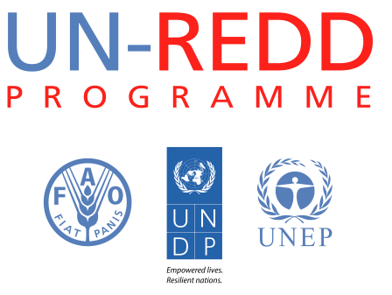

Management response [Country] [final or mid-term] evaluation
UN-REDD PROGRAMME
DATE

Introduction

- Evaluation is an important management tool for lesson-learning, accountability and enhancing the performance of a programme. In order for it to play its role, programme management needs to carefully consider the recommendations an evaluation provides as a basis for decisions on the programme’s future. To understand the utility of the evaluation conducted and what action the programme will take on its recommendations, programmes will submit a formal Management Response to the evaluation.

Format of the Management Response

- The Management Response should comment on the utility of the report and illustrate the programme’s position on the evaluation’s recommendations. It contains the following sections:
- Overall response to the evaluation: In this section, Management presents its overall views on the evaluation report’s findings and conclusions, and its utility to the programme.
- Response by recommendation: In this section, Management should address each recommendation, discussing them in the order presented in the evaluation report. This should be done in the format of the Management Response matrix below and include: the recommendation number and text; a statement and a comment on whether the recommendation is accepted fully, partially, or rejected; action to be taken; the responsible unit(s) for action on the recommendation, and timeframe for implementation. In the case of a partially accepted or rejected recommendation, the reasons should be fully presented.

Responsibilities and procedures

- The UN-REDD Secretariat National Programme Coordinator administers the preparation and review processes for the Management Response. The Coordinator will formally request that the document be prepared, identify the UN agency Country Office that will have overall responsibility for coordinating its formulation and for providing clearance on it, and provide the date by which the Management Response is due.
- In preparing Management Responses, consultations should take place with and inputs sought as necessary from all of the parties to whom the evaluation recommendations were addressed, i.e. in all of the participating UN agencies and at country, regional and Headquarters levels.
- Once the Management Response has been completed, the evaluation departments of the three UN agencies, which constitute the Evaluation Management Group for the UN-REDD programme and global evaluations and that liaise with the UN-REDD Secretariat Coordinator, will ensure that the Management Response meets the required standards of comprehensiveness and clarity.
- The UN-REDD Secretariat and the participating evaluation departments will upload the Management Response on their websites as annexes to the evaluation report.

Management Response
UN-REDD National Programme Final Evaluation
Date of evaluation:
Prepared by: Position: Unit/Bureau:
Cleared by: Position: Unit/Bureau:

Overall comments: (use additional space if necessary)

Evaluation Recommendation | Management response  Accepted, partially accepted or rejected and comment on the Recommendation  (a response of partially accepted or rejected must be accompanied by a justification) | Follow-up action to be taken on recommendations  The information should include:  A. Any actions taken on recommendations since the final report and before the issuance of the Management Response  B. Actions to be taken from the Management Response onwards | Timeframe (expected implementation and completion dates) | Unit(s) responsible for Implementation
Recommendation 1:
Recommendation 2:
Recommendation 3:
Recommendation 4:
Recommendation 5:
Recommendation 6:
(Add additional rows if necessary)

