Consolidated Report on Final National Validation Workshop on REDD+ Roadmap,
Nay Pyi Taw
AGENDA
Opening Session | Opening Speech delivered by H.E. U Aye Myint Maung, Deputy Minister, Ministry of Environmental Conservation and Forestry | Deputy Minister
 | Congratulatory Remarks by Dr. Tint Lwin Thaung, Executive Director, RECOFTC | ED, RECOFTC
Presentation Session | - The REDD+ Readiness Roadmap Development Process  - Lessons learned during 4 Regional Workshops and the way forward for REDD+ roadmap | Dr. Thaung Naing Oo  UN-REDD Programme Focal Point  Deputy Director, Forest Department
 | - Roadmap Session 3: Development and selection of REDD+ Strategies  - Summary of comments made by 4 Regional Workshops | Dr. Rosy Ne Win, Staff Officer, Forest Department
 | - Roadmap Section 2: Stakeholder Consultation and Participation  - Roadmap Section 4: Implementation Framework and Safeguards  - Summary of comments made by 4 Regional Workshops | Mr. Nanda Win Aung, Staff Officer, Forest Department
 | DISCUSSIONS
Group discussion Session | - Group Discussion (Two Groups) upon comments made by Regional Workshops
 | - Presentation of results of Group Discussion
CLOSING SESSION | Closing Speech by Dr. Nyi Nyi Kyaw, Director General of the Forest Department | Director General

Consolidated Report on Final National Validation Workshop on REDD+ Roadmap, Nay Pyi Taw

Introduction
The UN-REDD Programme “Support to National Actions – Global Programme Framework Document 2011 – 2015” had created a specific window for technical & financial support to member countries. As a result of a visit to Myanmar by Mr. Erik Solleim, Former Nowegian, Minister for Environment and International Development, Norway expressed interests in providing support for the REDD - Plus Readiness process in Myanmar. In October 2012, during a mission of the Union Minister of Ministry of Environmental Conservation and Forestry (MOECAF) to Oslo, the Norwegian government further indicated their intension to invest in Myanmar’s REDD-Plus Readiness process, through the implementation of the Roadmap.
With the supports of Norwegian Government through RECOFTC and UN-REDD Programme, three working groups with representatives from government line ministries, civil societies, NGOs and private sector, were formed and four working group meetings were held once a month during December 2012 – March 2013. As a result, REDD+ Roadmap and National Strategies (draft) were developed with the technical supports of UN-REDD Programme.
The UN-REDD Programme provided Targeted Support to cover the extra cost of organizing the national consultation process. The objective of UN-REDD Targeted Support is to help in reviewing and validation Myanmar’s draft REDD - Plus Readiness Roadmap through a multi-stakeholder national consultation process.
An Initial National Consultation Workshop (A multi-stakeholder workshop) was held at Ingyin Hall of Forest Department MOECAF, Nay Pyi Taw on 14th May, 2013. Likewise, Final National Validation Workshop on REDD+ was also held on 25th June, 2013 in Nay Pyi Taw.

OPENING SESSION: Opening Ceremony
Opening Ceremony was attended by H. E. U Aye Myint Maung, Deputy Minister, MOECAF and Dr. Daw Thet Thet Zin, Deputy Minister, MOECAF. The opening speech was delivered by H.E. U Aye Myint Maung, Deputy Minister for MOECAF. In his speech, H. E. U Aye Myint Maung recalled the Regional Consultation Workshops on REDD+ Roadmaps which were held during May and June 2013 in Bago Rgiona, Shan State, Ayeyawady Region and Sagaing Region. He also highlighted that stakeholder engagement and consultation process in REDD+ Roadmap formulation is of crucial important in order avoids undesirable conflicts among stakeholders as well as to receive their feedbacks and comments upon roadmap. He also mentioned that on behalf of MOECAF, he is proud of organizing such kinds of consultation workshops in the 4 Regions and State as well as National Works in Nay Pyi Taw. He also pointed out the high interest of stakeholders to REDD+ roadmap that Chief Minister of Shan State and Regional Ministers of Mining and Forestry of the Regional Governments attended the at least Opening Ceremony and delivered the Opening Speech. In addition, Excellency added that our four Regional Consultation Workshops were received significant attentions, interests and supports from the respective Region becasue Chief Minister and Regional Ministers were also listened Key Note Presentations about REDD+ and Roadmap. Another indicator of interest is that stakeholders are very diverse and they are not only government line ministries but also from political parties, parliament members, UN agencies, NGOs, civil societies, private sector, forest user group, indigenous people, media and so on. Excellency also recalled most common questions about “benefit distribution and how we receive benefits from REDD+” raised by stakeholders during the Regional Workshops. In this regards, Excellency pointed out and strongly encourage REDD+ Roadmap Working Group Members to take into account the stakeholder’s interests and to design REDD+ for benefits of the local communities and stakeholders. Excellency also mentioned about structure of Roadmap and its contents. More importantly, Excellency strongly encouraged that REDD+ Roadmap should not be “Paper Tiger” and it should be implemented with momentum in line with national and international framework in cooperation with international organizations.
Last but not least, on behalf of Union Minister for MOECAF as well as on his own behalf, Deputy Minister expressed his sincere thanks to Norwegian Government, UN-REDD Programme and RECOFTC for technical and financial supports. Excellency also congratulated REDD+ Core Unit of Forest Department and REDD+ Roadmap Working Group for tireless efforts for the accomplishment of REDD+ roadmap. Excellency wishes all the best and great success in implementing REDD+ roadmap.
Congratulatory Remarks was delivered by Dr. Tint Lwin Thaung, Executive Director of the RECOFTC. He expressed his sincere appreciation to Ministry of Environmental Conservation and Forestry for very active cooperation in formulating REDD+ Roadmap. He also informed that there are many positive responses and interests of Norwegian Government in supporting REDD+ roadmap implementation. He also committed that RECOFTC will continue support REDD+ process in Myanmar especially for Capacity Building. Finally, he appreciated Forest Department and REDD+ Roadmap working group for their great supports and efforts for REDD+ roadmap formulation process.

The Final National Consultation Workshop was attended by (77) participants; Roadmap and summary of comments given by four Regional Workshops were presented by Resource Persons. List of participants can been seen in ANNEX 1.
PRESENTATION SESSION

Presentation session was Chaired by U Bo Ni, Director, Watershed Conservation Division of the Forest Department. There were three presentations in the Final National Consultation Workshop. The Roadmap is composed of 6 Sessions and detailed power point presentation files are attached in ANNEX 2. The followings are the presentations programme of the Workshop:

Presentation Session | - The REDD+ Readiness Roadmap Development Process  - Lessons learned during 4 Regional Workshops and the way forward for REDD+ roadmap | Dr. Thaung Naing Oo  UN-REDD Programme Focal Point  Deputy Director, Forest Department
 | - Roadmap Session 3: Development and selection of REDD+ Strategies  - Summary of comments made by 4 Regional Workshops | Dr. Rosy Ne Win, Staff Officer, Forest Department
 | - Roadmap Section 2: Stakeholder Consultation and Participation  - Roadmap Section 4: Implementation Framework and Safeguards  - Summary of comments made by 4 Regional Workshops | Mr. Nanda Win Aung, Staff Officer, Forest Department
 | DISCUSSIONS

At the end of the Presentation sessions, the floor was open for Q&A as well as for discussions. The followings are the major discussion points for the above mentioned presentations:

- Dr. Thaung Naing Oo Presentation on REDD+ Road Map

Q: U Tun from Myanmar Timber Enterprise (MTE): What can REDD+ contribute for villagers? According to the experience from the workshop in Bhutan arranged from FAO, it is discussed that there is a need to give alternative fuel to communities. If not, how can we stop the villagers from cutting trees?
Comments: Can we use “Media” instead of “Electronic Consultation” under Develop Stakeholder Consultation Guidelines?
A: Almost all regional consultation came up with discussion on what are the benefits to local communities. Here, benefits can be varied depend on the regions or countries. There will have working group on benefit distribution under the REDD+ task force. For short term, it will be fund based as the market based mechanism is not yet functioned in the global market which will be a long term process. The pilot project is started in Taungoo District and everyone is welcomed to study the progress there.

Q: U Maung Maung Thein Pe’ from Rakhine Environmental Conservation Group: What do you mean by regional workshop? Is it up to village level? Since there is a lot of land grabbing, there are many areas where the land is no longer in the hand of local communities. How REDD+ take into account of the forest areas which are not owned by the local communities?

A: Amidst the transition period of the country, Forest Department tried the best to come up with such road map plan in detail. In doing so, there is timeframe to finish the task under the funding from five donor organizations and all need to finish by the end of June. All the regional workshops were done weekly and around 90 to 100 participants took part in active discussion in each and every Workshop. We also have criteria to select the four regions such as accessibility, high forest cover, high deforestation and security etc. All regional workshops, we invited different stakeholders including community forestry forest user groups, farmers association etc. We also invite media and NGO network to let the information reach to village level. It is important that all are needed to play different roles together for REDD+ and we welcome all to work together in the future. We also tried our best in updating law and policy relevant for communities.

Chairman, U Bo Ni also added that REDD+ is part of climate change program and Forest Department is also working on other parallel activities to keep up the good work on environmental conservation and combat climate change under the commitment to UNFCCC.

- Dr. Rosy Nay Win Presentation on Drivers of Deforestation

Q: U Ye Htun Htun from Ministry of Agriculture and Irrigation: What is the evaluation on the future trend on the use of fuel wood? How can it be reduced?

The presentation based on the discussion at regional level. The possible solution may be to establish community fuel wood plantation areas for village use.

Q: U Ye Htun Htun from Ministry of Agriculture and Irrigation, This is a good project with well plan and good intension and purposes. Will REDD+ cover the whole country? Is it too ambitious? There are many activities included in this and is this too wide and deep? How much funding and How many years?

A: Thanks for the complimentary. There is no exact commitment on funding. We try our best on relevant measure needed.

Q 2. Dr. Maung Maung Than from RECOFTC, I am interested in Kathar discussion. In my opinion, on job training such as forest field school will be useful to be part of capacity building on sustainable forest management.
A: Thank You for the comments.

Q 3. U Aung Thu Ya, Director General of Ministry of Planning and Statistics,

We can see the propotion of wood production in different regions in different years and since they are not balanced it is difficult to negotiatate. Remaining permit for logging is moved to other states such as Kayar, Kayin and Chin. Some area droped in logging rate whereas eg. Chin is increased a lot.

Q4: Director General Dr. Nyi Nyi Kyaw

In every developing country, there is a need to extract natural resources for the development of the country. However, the trends are changing at the moment along with climate change negotiation. Our country is a bit late to response on this and this is the chance to get lesson learned from other and to act upon the needs.
We will ban the export of log. We do jointly with police and other relevant government body. The use of fuel wood can be increased as the energy need for daily cooking is about 60% of population. The trend of reducing it cannot solve at the moment if energy is not enough with other alternatives at the moment.

There is no forestry training in Maw Bi, Pa Thein Gyi and Pyin Oo Lwin, but to open training school is at the moment only can reach to the staff. In the future, training will be opened in Ka Thar and Shwe Bo. Mobile training are also started and tired to reach to local communities as well.
Moreover, Environment Conservation Training will be initiated as well soon.In addition, nursery program are started in state and division along with awareness raising and special talk.Both conservation and management of well use is needed.
District Forest Management plan is done every 10 years and there are annual plan for where to extract log. There is the whole year country target with calculation done. Because of peace, we can extract log in state now. So there is increased no.When looking at the whole country level, we go to the area where is abundant of remaining forest to log and reduce the logs in areas with less tress. Sustainable forest management will help support in the future more.

- Presentation by Nanda Win Aung

Q: Dr. Maung Maung Than: Since the lands of the country are owned by the state, discussion on who should benefit is good, but how can it be shared or do it practically? It is stated in Taunggyi discussion that no grievance mechanism is one risk. The country already have grievance mechanisms such as through judiciary system, parliamentary system and thus please include this in further discussion.
A: What we mean here is if there is no proper grievance mechanism for REDD+ there is a risk. It does not mean that there is no grievance mechanism in Myanmar.
Q: U Tun from Myanmar Timber Enterprise (MTE): how about including family forestry which can regarded as individual property?
A: There are two parts in CF. Common management at local level and individual management with 5 arces or more so that the community has to take responsibility to have ownership sense.
Closing remarks of the Chairman
There is a long way to go and now in first phase. Even with this state, we are proud that we can do well a lot. Two more phases will come soon. The first phase is preparing for the following phase. It is found out that capacity building is crucial in every work. Therefore, a lot more on that is needed to do such as coming up with IEC materials. REDD+ mechanism is part of UNFCCC climate change mitigation. There are a lot more commitments that we have made and need to come up with activities. All of them need to do at the same time to be effective. Thanks.
Afternoon Session (1pm – 4:30 pm)
For afternoon session, group discussion on Stakeholder Consultation and safeguards is led by Naw Ei Ei Min and Saya Nanda Win Aung from 1 pm to 3pm. There are 25 participants for the group discussions on stakeholder consultation and safeguards. The suggestion for the three discussion points are as follow;

Group Discussion on Stakeholder Consultation and Safeguards

- Develop Stakeholder Consultation Guidelines

- There is Wash Technical Worksing group coming up after Nargis Cyclone. It composed of all relevant government, INGOs, NGOs and local groups with a monthly regular meeting. Therefore, if REDD TWGs include all relevant stakeholders with regular meeting, it would be functioning.
- To include REDD cell at regional levels so that it can link up the national TWGs.
- According to WCS experience now in initiating for four townships in Naga areas, the invitation should be strong enough to participate as a “must” to regular meetings, not volunteer or occasionally to have effective consultation.

- Development and validation of National FPIC Guidelines

- Who will do FPIC? It will be the role for NGO to play between government and local communities through capacity building so that both side is ready for negotiation when REDD+ come into action.
- Good facilitators are important to be able to mobilize the communities
- RECOFTC will publish Facilitation Guide Book.
- To take lesson learned from local example and adapt to country context for FPIC guidelines
- Need to discuss more of its components in detail later since FPIC is new to country context
- To include situation analysis before National FPIC guidelines
- FPIC is non-binding but without it there will not have good price for carbon credit and this is one incentive for the developer to include FPIC in REDD+.
- FPIC will not finish with one dialogue, but need to go details on participatory resource mapping, also giving information on EIA, SIA, thus, it will take time.
- Sharing information should be well prepared to present full information o communities.
- Eg of Case Stduy. In Rakhine, Kyaut Phyu Special Economic Zone, FPIC is requested by CSOs but it is not responsed by both government and private sectors. Later, the information given from CSO and private sector are different and resulted uprising of community over the economic zone.
- At the moment, FPIC is only taken into consideration by the forest department and not other ministries. Communities in REDD+ means forest user groups. For those communities that are far from forest and not rely on forest might be difficult to take part in REDD+. If individual is interested in the government can support for the process but there should have enough areas to calculate carbon.

- Development of the REDD+ Social and Environmental Safeguards system and grievance mechanism

- Safeguard is also non-binding but to reduce social and environmental impact, safeguard is important.
- Safeguard can be a framework at national level and regional safeguard should adapt to local situation.
- Before pilot project come, there should have strong safeguard.
- How to ensure anti-corruption along with safeguard and grievance mechanism because what matter is attitudes of people rather than system. UN also has UNCAC that also discuss on REDD+ implementation to make sure for anti-corruption.
- REDD+ in Myanmar seem pioneer in paying attention to safeguard and thus it is important to come up with successful pilot case studies so that other can follow.
- What if there is no carbon market coming up? What we hope from REDD+ is not only money but also reforestation, reducing deforestation, capacity building and sustainable forest management, therefore, there is no loss even there is no money coming from carbon credit.

Tea Break (3 pm -3:30 pm)
Presentation on Discussions ( 3:30 pm -4:30 pm)
The presentations are chaired by U Bo Ni, Director of Watershed Division of the Forest Department
- Presentation by Myint Hlaing

- Presentation by Naw Ei Ei Min
No comments and questions.

CLOSING SESSION

Closing remarks were addressed by Dr. Nyi Nyi Kyaw, Director General of the Forest Department. In his Closing Speech, he congratulated REDD+ Roadmap Technical Working Groups for successful formulation of REDD+ Roadmap with great efforts. He also expressed his appreciation to Norwegian Government, RECOFTC and UN-REDD Programme for financial and technical supports. He urged MOECAF and relevant stakeholders to pay more attention on REDD+ readiness process and to participate along the REDD+ readiness preparation process.

Director General also stated that he is very proud of accomplishment of REDD+ roadmap and series of stakeholder consultations that will lead to successful implementation of REDD+ roadmap. He also strongly suggested to prepare REDD+ R-PP or Project Proposal for financial supports in implementing REDD+ roadmap. In this regards, Forest Department of the Ministry of Environmental Conservation and Forestry committed to continue the adoption process of REDD+ roadmap. He also highlighted Myanmar’s policy trend of favoring and promoting forest conservation, green economy green growth, stakeholder consultation, E/SIA, FLEG-T, EITI and C&I for SFM. He also said that we also need to link REDD+ Road map with the country policy and law and relevant mechanism. He suggested to deign REDD+ project to have maximum benefits in terms of social, economical, ecological aspects.

In his conclusion, Director General proudly mentioned forestry sector reform strategies within the framework of national reform process that supported strengthening many policy, legal and technical aspects to implement REDD+ readiness. To the end, Dr. Nyi Nyi Kyaw, Director General of the Forest Department urged to scaling up capacity building and awareness raising activities along the REDD+ readiness process. Director General expressed his gratitude to Norwegian Government, UN-REDD Programme and RECOFTC for all supports. He concluded his remarks by appreciation REDD+ Core Unit of Forest Department and Technical Working Group of REDD+ Roadmap formulation.

ANNEX I: List of participants

Participants from Ministry of Environmental Conservation and Forestry
No. | Name | Position | ဌာန
1. | U Zaw Win Myint | Director | Forest Research Institute
2. | U Bo Ni | Director | Watershed Management Division
3. | Dr. San Oo | Director | Environmental Conservation Department
4. | U Myo Lwin | Deputy Director | Dry Zone Greening Department
5. | Dr. Thaung Naing Oo | Deputy Director | Planning and Statistics Division
6. | U Nyaunt Aung | Deputy Director | Forest Department (Sagaing Region)
7. | Dr. Khin Maung Sint | Manager | Myama Timber Enterprise
8. | U Aung Aung Myint | Assistant Director | Planning and Statistics Division
9. | U Tet Toe | Assistant Director | Forest Department (Nay Pyi Taw)
10. | U Maung Maung Soe | Assistant Director | Forest Department (Taunggyi Township)
11. | U Aye Than | Assistant Director | Forest Department (Mandalay Region)
12. | U Thein Shwe | Assistant Director | Forest Department (Taungoo)
13. | U Khin Maung Win | Assistant Director | Forest Department
14. | U Win Naing | Assistant Director | Watershed Management Division
15. | Dr. Naing Zaw Tun | Assistant Director | Nature and Wildlife conservation Division
16. | Dr. Rosy Ne Win | Staff Officer | Planning and Statistics Division
17. | U Nyan Hlaing | Staff Officer | Planning and Statistics Division
18. | U Phone Htut | Staff Officer | Planning and Statistics Division
19. | U Nanda Win Aung | Staff Officer | Watershed Management Division
20. | U Moe Aung | Staff Officer | Planning and Statistics Division
21. | U Zaw Zaw Naing | Staff Officer | Natural Forest and Plantation Division
22. | Dr. Toe Toe Aung | Staff Officer | Planning and Statistics Division
23. | Daw Zin Myo Thu | Staff Officer | Planning and Statistics Division
24. | Dr. Tin Zar Kyal | Staff Officer | Forest Research Institute
25. | Dr. Chaw Chaw Sein | Staff Officer | Forest Research Institute
26. | Daw Khin Thida Tun | Staff Officer | Forest Research Institute
27. | U Pyae Soe Aung | Range Officer | Nature and Wildlife conservation Division
28. | Daw Nyo Mee Tun | Range Officer | Tranning and Research Development Division
29. | U Pyae Phyo Maung | Range Officer | Planning and Statistics Division
30. | U Nay Lin Tun | Range Officer | Planning and Statistics Division
31. | U Bily Ne Win | Assistant Researcher-2 | Forest Research Institute
32. | Daw Thida Swe | Assistant Researcher-2 | Forest Research Institute

Participants from line Ministries
No. | Name | Position | ဌာန
1. | U Aung Myint Than | Director | Planning Department
2. | U Chun Hlaing Win | Deputy Director | Settlement and Land Record Department
3. | U Own Than | Deputy Director | Attorney General’s Office
4. | U Thaung Oo | Assistant Director | Department of Industrial Planning
5. | U Thaung Nyaunt | Assistant Director | Department of Rural Development
6. | U Ko Latt | Assistant Director | Land Survey Department
7. | Dr. Ye Tun Tun | Senior Researcher Assistant | Department of Agricultural Research
8. | U Yan Naing Aung | E.E | Department of Mines
9. | Dr.Oakkar Soe | Researcher | Livestock Breeding and Veterinary Department
10. | U Tun Thein | Researcher | Department of Agricultural Research
11. | Dr. Tun Thein | Staff Officer | Department of Fisheries
12. | U Sit Aung Latt | Staff Officer | General Administrative Department
13. | Daw Han Swe | Staff Officer | Department of Meteorology and Hydrology
14. | U Than Shwe | Staff Officer | Energy Planning Department

Participants from NGOs, Civil Society, Political Party and Media

No. | Name | Position | ဌာန
1. | Dr. Thint Lwin Thaung | Executive Director | RECOFTC
2. | Dr. Maung Maung Than | Country Programme Coordinator | RECOFTC
3. | U Kyaw Moe Aung | Consultant | RECOFTC
4. | U Maung Maung Thein Phe | Vice President | Rakhine Coastal Region Conservation Association (RCA)
5. | U Kyaw Min Thein | Program Coordinator | Social Vision Services (SVS)
6. | U Tin Tun | Chairman | Marine Science Association of Myanmar
7. | Daw Naw Ei Ei Min | Program Coordinator | Spectrum
8. | Lain Khan Summ | Program Staff | Spectrum
9. | Say Hay Htoo | Program Staff | Spectrum
10. | Daw S Kyaut Jar | Program Staff | POINT
11. | U Myo Ko Ko | Director | POINT
12. | U Khin Maung Htay | C.E.C | Renewable Energy Association Myanmar (REAM)
13. | U Khin Maung Soe | C.E.C | Renewable Energy Association Myanmar (REAM)
14. | U Saw Dowarr | Programme Officer | United Nations Development Programme (UNDP)
15. | U Myint Hlaing | Consultant | United Nations Development Programme (UNDP)
16. | U Kyaw Thin Latt | Programme Officer | Wildlife Conservation Society (WCS)
17. | U Shwe Thein | Coordinator | Care Myanmar
18. | Daw Tin Su Su Mar | Facilitator | DFIT (PyoePin)
19. | U Thiri Tin | Forestry Special List | Adventist Development and Relief Agency (ADRA) Myanmar
20. | Daw Yin Kyi | Chairman | Myanmar Women’s Development Association
21. | Daw Thiri | Member | Myanmar Women’s Development Association
22. | U Tun Maung | C.E.C | Myanmar Forest Products and Timber Merchants Association
23. | U Kyaw Soe | General Manager | Phyo Si Thu Co.ltd
24. | U Khin Maung Latt | National Sector Coordinator | Metta Development Foundation
25. | U Aung Myo Thant | Reporter | Sky Net
26. | Daw Wai Yan Moe Myint | Reporter | The Union
27. | Daw Ei Phyu Mon | Reporter | Seven Days News
28. | Daw Zar Ni Tun | Reporter | The Voice
29. | Daw Aye Chan Moe | Reporter | Union Daily News

ANNEX II: Power point presentations

ANNEX III: Photos

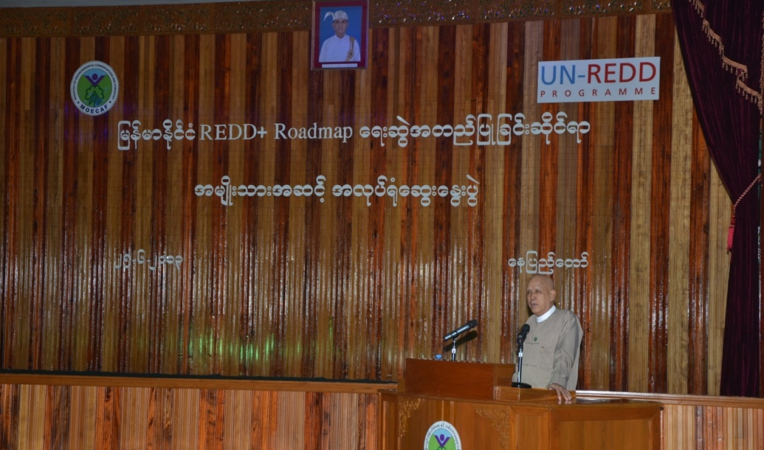

Opening Speech by H.E. U Aye Myint Maung, Deputy Minister, MOECAF

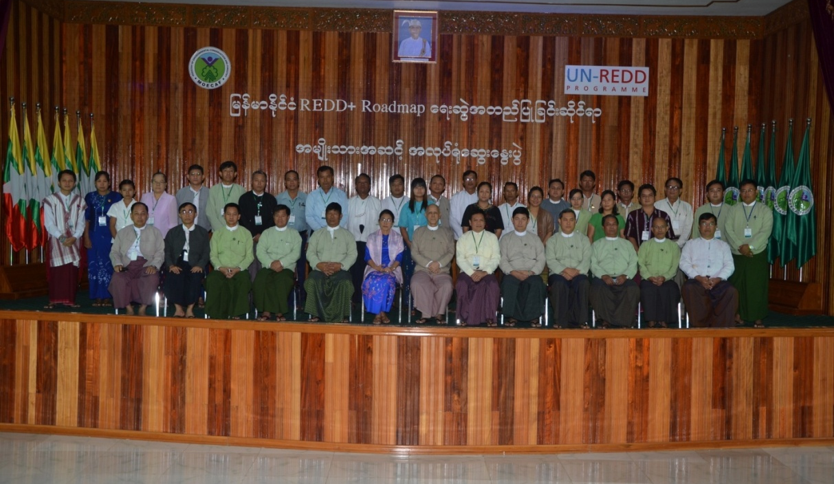

Opening Ceremony – Group Photo

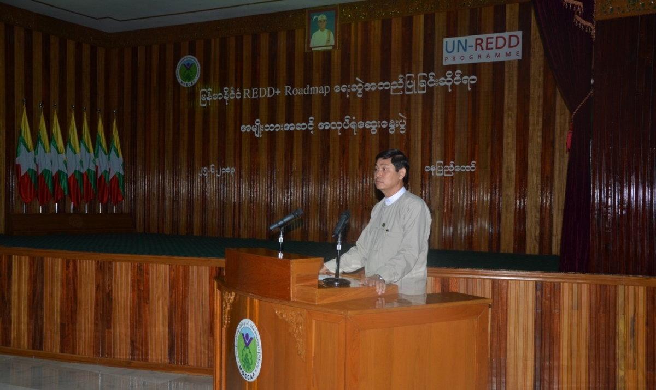

Closing Remark by Dr. Nyi Nyi Kyaw, Director General of Forest Department

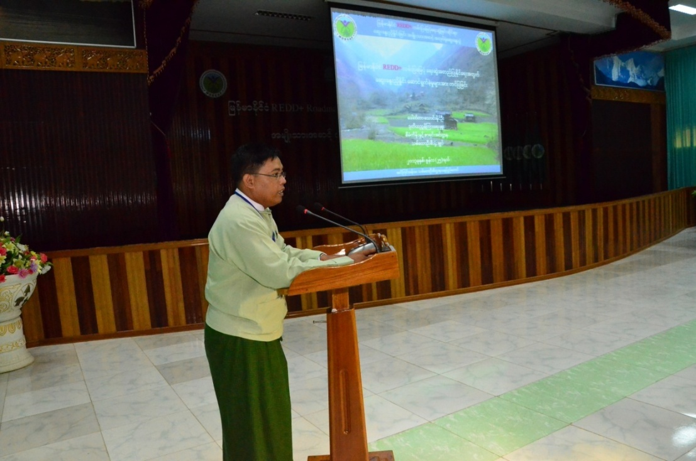

Presentation by Dr. Thaung Naing Oo, Deputy Director, Forest Department
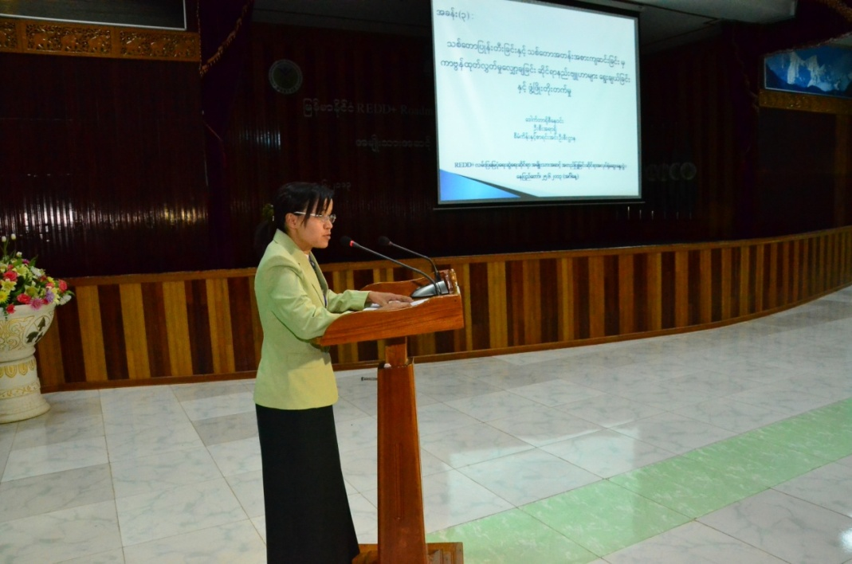

Presentation by Dr. Rosy Newin, Staff Officer, Forest Department

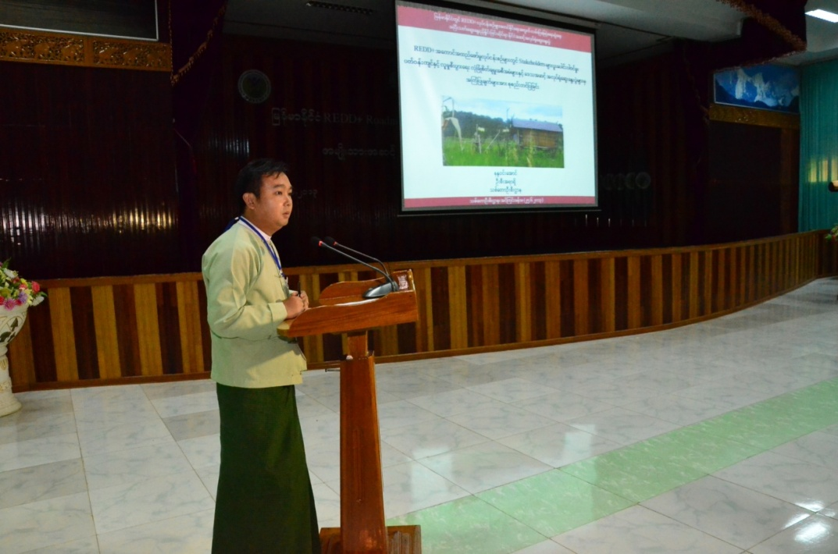
Presentation by U Nanda Win Aung, Staff Officer, Forest Department

