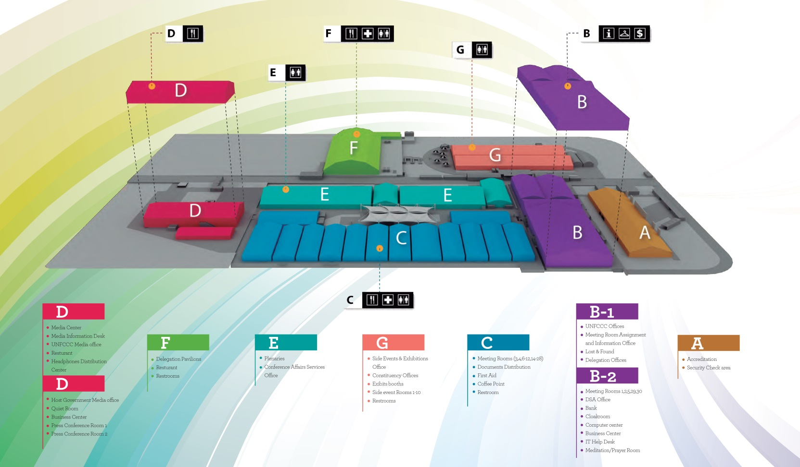

**Connect with us: www.un-redd.org  /unreddprogramme  @unredd**

**Looking Forward: REDD+ post 2015** **• Machu Picchu Room • Building G • 18:30-20:00** **• Monday, 8 December 2014**

**Connect with us: www.un-redd.org  /unreddprogramme  @unredd**

**Looking Forward: REDD+ post 2015** **• Machu Picchu Room • Building G • 18:30-20:00** **• Monday, 8 December 2014**

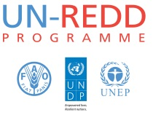****

**Monday, 8 December 2014 • 18:30 – 20:00 • Machu Picchu Room**

**Monday, 8 December 2014 • 18:30 – 20:00 • Machu Picchu Room**

**Monday, 8 December 2014 • 18:30 – 20:00 • Machu Picchu Room**

**Looking Forward: REDD+ Post 2015**

**High-level COP20 side event on the post-2015 role of forests and REDD+ to fight climate change and catalyse sustainable development – and a new 2016-2020 UN-REDD Programme strategy**

**Forests are now overwhelmingly acknowledged as fundamental to fighting climate change** – the Warsaw Framework for REDD+ was finalized – world leaders endorsed the New York Declaration on Forests – 56 countries are now UN-REDD Programme partners – in response to this momentum and to meet the advancing needs of forest countries, the UN-REDD Programme is developing a strengthened 2016-2020 strategy that will: prioritize country needs to meet key UNFCCC decisions related to REDD+, build the capacity of developing countries to deliver REDD+ results-based actions and realize results-based payments for REDD+, expand the REDD+ knowledge base and South-South cooperation

Within this context, **panel members will share their perspectives on REDD+ as a catalyst for sustainable development and the 2016-2020 role of the UN-REDD Programme**.

**Moderator/Keynote:**

**Helen Clark**, Administrator for the United Nations Development Programme and Chair of the United Nations Development Group

**Panel:**

* **Achim Steiner**, UNEP Executive Director and UN Under-Secretary-General
* **H.E. Ephraim Kamuntu**, Minister of Water and Environment, Uganda
* **H.E. Maria Cristina Morales Palarea,** Minister of Environment, Paraguay
* **Eduardo Rojas-Briales**, FAOAssistant Director-General and Head of the Forestry Department
* **Per Fredrik Pharo**, NICFI Director, Norway
* **Vicky Tauli-Corpuz**, UN Special Rapporteur on the Rights of Indigenous Peoples
* **Mario Boccucci**, Head of UN-REDD Programme Secretariat

**Looking Forward: REDD+ Post 2015**

**High-level COP20 side event on the post-2015 role of forests and REDD+ to fight climate change and catalyse sustainable development – and a new 2016-2020 UN-REDD Programme strategy**

**Forests are now overwhelmingly acknowledged as fundamental to fighting climate change** – the Warsaw Framework for REDD+ was finalized – world leaders endorsed the New York Declaration on Forests – 56 countries are now UN-REDD Programme partners – in response to this momentum and to meet the advancing needs of forest countries, the UN-REDD Programme is developing a strengthened 2016-2020 strategy that will: prioritize country needs to meet key UNFCCC decisions related to REDD+, build the capacity of developing countries to deliver REDD+ results-based actions and realize results-based payments for REDD+, expand the REDD+ knowledge base and South-South cooperation.

Within this context, **panel members will share their perspectives on REDD+ as a catalyst for sustainable development and the 2016-2020 role of the UN-REDD Programme**.

**Moderator/Keynote:**

**Helen Clark**, Administrator for the United Nations Development Programme and Chair of the United Nations Development Group

**Panel:**

* **Achim Steiner**, UNEP Executive Director and UN Under-Secretary-General
* **H.E. Ephraim Kamuntu**, Minister of Water and Environment, Uganda
* **H.E. Maria Cristina Morales Palarea,** Minister of Environment, Paraguay
* **Eduardo Rojas-Briales**, FAOAssistant Director-General and Head of the Forestry Department
* **Per Fredrik Pharo**, NICFI Director, Norway
* **Vicky Tauli-Corpuz**, UN Special Rapporteur on the Rights of Indigenous Peoples
* **Mario Boccucci**, Head of UN-REDD Programme Secretariat