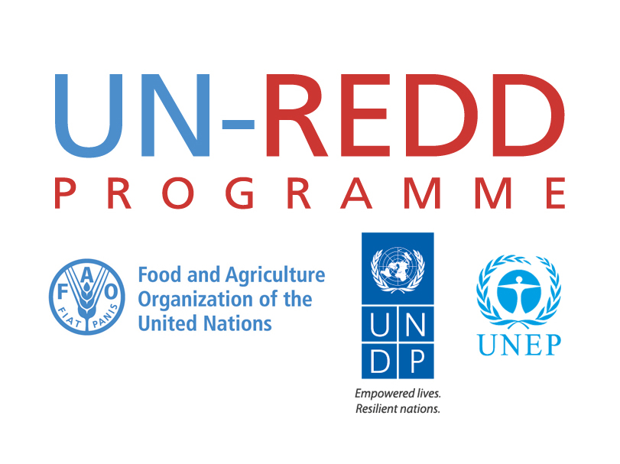

(Draft) Detailed Moderator Agenda

UN-REDD Programme Side Event: World Forestry Congress

Tuesday, 8 September 2015

Venue: World Forestry Congress, (Room TBD)
Time: 18:15 – 19:30 (no events are currently planned in the room after 20:00)

Moderator: TBD: Mette Løyche Wilkie (moderator), Director, Division of Environmental Policy Implementation at UNEP, OR Eduardo Mansur, Director, Forest Assessment, Management and Conservation Division at FAO.

Panel will
include: UN:
- Moderator TBD
- Mario Boccucci, Head of UN-REDD Programme Secretariat

Developed Countries:
- TBD: European Commission representative OR Norway representative

Forest Countries:
- Ecuador: representative TBD
- TBD: Ivory Coast OR other African country – representative TBD

IP/CSO:
- Joseph Goko Mutangah, Member UN Permanent Forum on Indigenous Issues (please confirm name/title)

Crisis communications awareness:
(Please note any political sensitivities related to this even that the moderator should be made aware of.)

Side Event flow:
The 75 minutes will be divided into 6 broad sections:
- Mario Boccucci welcomes everyone and introduces TBD as moderator – 2 minutes
- TBD, moderator, introduces panel – invites Mario to start with introduction to strategy -- 4 minutes
- Mario shares an introduction to the key elements of the 2016-2020 UN-REDD Programme Strategic Framework – 8 minutes
- TBD, moderator, delivers a 10-minute keynote speech
- Other panelists give 5-minute speech each: 1 x Developed country, 2 x developing country, 1 X IP. (Note: Mario will remain on panel table to be available to address any questions that may arise related to the UN-REDD Programme – and to support the moderator) -- 20 minutes
- 2-3-minute interventions from the floor: (Please provide information on anticipated speakers for interventions). Approx. 15 mins
- Q&A session moderated by TBD with questions from audience, including media, and panelists responding. Approx. 13-minute (can be reduced if previous speakers run long)
- Brief closing remarks from moderator – 2-3 minutes

Detailed run of event

participants of the UN-REDD Programme side event are being advised to arrive at 18:00.

Pre start schedule timing:

- Mario greets panel members and ensures all are seated and briefed on format. Panel seating is as follows from left to right looking at stage: Mario Boccucci, moderator, developing country representatives, developed country representative, IP representative. (Note: Mario is seated adjacent to moderator to provide direct support as needed throughout the event).

- As interpretation services have been organized, event attendees will need to collect a headset at the entrance of the room. This could take some time, depending on process. The headsets will be handed out by a person from the WFC event management team. We should expect that people will be filing into the room on a rolling basis as they collect their headsets. This may continue into the official start of the event.

- Note: There will be no powerpoint presentations during this event

Event timing:

Minute 00-01: Lights dim. Announcement made for people to get seated

02-03: Mario Boccucci, Head of the UN-REDD Programme Secretariat, welcomes participants to the session and introduces TBD as moderator and keynote speaker:
- Distinguished colleagues, ladies and gentlemen, it is my pleasure to welcome you to the important side event of UN-REDD Programme on the post-2015 role and vision for the UN-REDD Programme “Looking Forward: REDD+ post 2015”.
- I would like to introduce our moderator and keynote speaker for this event, TBD, (note title)

04-07: TBD introduces panel, outlines event flow
- Thank you Mario, it is an pleasure to be here today to moderate this important event
- Our session today comprises a panel of distinguished speakers representing the range of stakeholders involved in reducing emissions from deforestation and forest degradation – and important partners and stakeholders of the UN-REDD Programme.
- Representing the important perspective of developing forest countries, we are pleased to have representation from Latin America and the African continent: (name of rep) from Ecuador and (TBD)– both of whom have extensive experiences to share with us today from their countries and regions.
- We are also pleased to have with us (name and title of developing country rep) – The government of (TBD) is a leading supporter of forest countries on their pathway to sustainable development through REDD+, as well as a leading and continued donor of the UN-REDD Programme, for which we are grateful.
- Representing one of the stakeholder groups critical to the success of REDD+ is Joseph Goko Mutangah, Member of the UN Permanent Forum on Indigenous Issues. We are privileged to have Joseph joining us today and thank him for representing the global perspectives of indigenous peoples.
- I am also pleased to be representing here today the collaborating UN agencies of the UN-REDD Programme – FAO, UNDP and UNEP.
- We have gathered this distinguished group of REDD+ stakeholders together today to discuss how REDD+ as an innovative financial incentive mechanism is poised to catalyze sustainable development, and the role of the 206-2020 UN-REDD Programme to support the realization of this vision.
- I will be asking each panel member to present their perspective on these issues, following which we will have interventions from the floor.
- To set the stage for today’s event, I would like to invite Mario Boccucci, Head of Secretariat for the UN-REDD Programme to provide us with an introduction to the new 2016-2020 UN-REDD Programme Strategic Framework.

08-15: Mario provides introduction to key elements of 2016-2020 UN-REDD Programme Strategic Framework
- (need to add talking points)

16-25: TBD, moderator delivers keynote speech.
- Thank you Mario for that valuable introduction which helps to frame the dialogue for today’s event.
- As Mario has outlined, the 2016-2020 Strategic Framework for the UN-REDD Programme is designed to be forward-looking, to meet evolving REDD+ needs, and to do so with a distinct “country-led” approach.

- Delivery of keynote speech with below talking points: (Please review and provide feedback on below)
  - Forests are now overwhelmingly acknowledged as fundamental to fighting climate change.
  - UNEP’s perspective on importance of forests to mitigate climate change – citing the UNEP Emissions Gap report 2014
  - Potential in REDD+ to close the emissions gap. An effort to restore 15 per cent of degraded forests worldwide could give us emission reductions of 1 Gt CO2e per year, providing much needed ‘breathing space’ to decouple economic growth from resource depletion and from carbon emissions.
  - Encouraging how much progress has been made on REDD+:
    - Major steps were taken at COP19 to develop the framework for REDD+ (Warsaw Framework for REDD+) and at the June 2015 Bonn SBSTA meeting – creating the guidance necessary for countries to move one step closer to realizing results-based payments for results-based actions related to reducing forest emissions
    - Dozens of leaders from governments, the private sector, NGOs, CSOs/IPs and others have signed the New York Declaration on Forests – showing the strongest global momentum to date on this issue.
    - AND, there are now 61 partner countries in the UN-REDD Programme.
  - REDD+ has also begun to demonstrate additional benefits. National debates on REDD+ have already triggered important governance improvements. Progress on Free, Prior and Informed Consent has implications far beyond REDD+.
  - Need for strong and clear pledges for finance for REDD+ to maintain the momentum of countries.
  - REDD+ as a Sustainable Development tool – Green Economy
  - Forest ecosystem services form the backbone of many developing and developed country economies
  - Coordination across different sectors is necessary and possible.
  - Also requires an informed dialogue at the country level between all key stakeholders
  - The UN-REDD Programme has built the platform where this dialogue can happen.
  - Looking forward the UN-REDD Programme’s strategy and operations have been strengthened to support these increased country needs. Post-2015, the Programme will prioritize:
    - Country needs to meet the UNFCCC REDD+ requirements and guidance
    - UN delivering as one
    - Building the capacity of developing countries to deliver REDD+ results-based actions and realize results-based payments
    - Expanded Knowledge Management base and South-South cooperation

- (applause)

- Thank you very much…

- I would now like to invite our distinguished developing forest country partners to share their perspectives.

- Ecuador has…. (please provide key interesting REDD+ recent achievements related to Ecuador and progress in the Latin America region that the moderator can use to introduce the speaker).

- Please let me now invite (name of rep) to share her/his country’s experiences.

26-30: TBD, Ecuador (5 minute speech) (please expand talking points below as is relevant)
- Ecuador’s perspective on importance of forests to mitigate climate change
- REDD+ as a Sustainable Development tool -- importance to Ecuador and link to the national agenda
- Value of UN-REDD Programme in 2016-2020 to support Ecuador to meet UNFCCC requirements so that the country can benefit from results-based payments for results-based actions.

34: TBD, moderator
- Thank you (name/title of Ecuador rep) for sharing Ecuador’s perspective and for highlighting the value of REDD+ and the UN-REDD Programme to Ecuador.
- The experiences of forest countries are incredibly valuable to the process of building REDD+.
- Our next forest country represented here this evening, (name of country), has actively progressed REDD+ in Africa.
- We are very pleased to have (name/title) to share (name of country)’s perspectives, and how the UN-REDD Programme can support the country as it continues to progress towards REDD+.

35-39: TBD, (second developing country) (5 minute speech) (please expand talking points below as is relevant)
- (name of country)’s perspective on importance of forests to mitigate climate change
- REDD+ as a Sustainable Development tool -- importance to (name of country) and link to the national agenda
- Value of UN-REDD Programme in 2016-2020 to support (name of country) to meet UNFCCC requirements so that the country can benefit from results-based payments for results-based actions.

40: Helen Clark

- Thank you (name of rep) for sharing (name of country)’s REDD+ experiences with us this evening. These experiences are very important to the UN-REDD Programme as it strengthens is “country-needs” based approach.

- I would now like to invite (name, title of developed country rep) to share (country name) perspective on these issues – and to address the questions:
  - On REDD going forward -- why should we still be optimists?
  - On REDD going forward – what should be our focus?
  - How is the new 2016-2020 UN-REDD Programme poised to support this process?

41-45: TBD, developed country rep (5 minute speech)
- (name of country)’s perspective on importance of forests to mitigate climate change and why we should still be optimistic for REDD+, and going forward, what should be our focus.
- Role and opportunities for 2016-2020 UN-REDD Programme to support this process.

46: TBD, moderator
- Thank you (name) for sharing (country name)’s perspective and for highlighting the value of REDD+ to developing countries and Sustainable Development, as well as the vision (country name) has for REDD+ going forward. It is inspiring to hear (name of country)’s continued commitment to REDD+ and the UN-REDD Programme.

- Now is our opportunity to hear from one of the most valuable of REDD+ stakeholder groups, the indigenous peoples community.

- I would like to invite Joseph Goko Mutangah, Member UN Permanent Forum on Indigenous Issues to share with us the important role that indigenous people play in using forests to fight climate change and how the UN-REDD Programme has and can continue to support the voices of indigenous peoples on REDD+.

47-51: Joseph Goko Mutangah (5 minute speech)
- Important role of indigenous peoples in REDD+ process
- The inclusion of indigenous peoples within the UN-REDD Programme – including their role on the UN-REDD Programme’s Policy Board.
- Value of UN-REDD Programme in 2016-2020 to support indigenous peoples as they engage on REDD+ issues.

52: TBD, moderator
- Thank you Joseph for highlighting the important role indigenous peoples play in realizing REDD+, and for sharing with us examples of this.

- I would now like to invite comments from the audience and notice that (name and affiliation of person making intervention) and (name and affiliation of person making intervention) are in the room. As two of the pioneer countries on REDD+ may I call on you to open this interaction? (3 minutes each) -- 6 minutes.

53-58: lead interventions

(name of person) (name of person )
Photo of person for easy reference
Photo of person for easy reference

59-67: Moderator will then moderate a maximum of short- interventions from the audience:
- 3-minute interventions from the floor: (three other speakers TBD) -- 9 minutes

68-73: As time allows, the Moderator will then moderate a Q&A between the audience and the panel.
- Thank you to all for sharing your perspectives and experiences with us.
- I would now like to give audience members the opportunity to ask questions to our distinguished panel.

Note: A floating microphone will be available (as per conference organizers) and will be coordinated from the floor. Mario can advise the Moderator on whom to select from the audience for the questions, as well as assist on directing questions to panel members. Mario will also be available to answer any questions as relevant. Mario will also be watching the clock and keeping to the time schedule for this session, and cue the Moderator as necessary.
74-75: The Moderator will then thank the panel and attendees for their participation and close the event.
- Please join me in thanking our distinguished panelists, and our audience participants for their thoughtful and insightful questions and comments. I think today’s panel illustrated a strong example of the many different REDD+ experiences that exist, and how by bringing these experiences together, that we can all work together to ensure that REDD+ provides real value for countries.
- Before we close, I would like to recognize the bold and generous support that donor countries, especially (name of donors present), have provided to REDD+ through the UN-REDD Programme and other channels. And of course we recognize the courage and dedication of forests countries that are working towards REDD+ - we are impressed and thankful for your leaderships and your hard work.
- Of course, as Joseph so eloquently reminded us, many of the world’s remaining forests are standing thanks to the commitment of indigenous peoples. They are such a central part of the solution that no discussion on forests should happen without them.
- Much hard work remains to be done, but there is no way to limit global warming to two degrees Celsius without addressing deforestation and forest degradation – so this work that all of us here are doing is crucial.
- And as most of our panelists have highlighted, the 206-2020 role of the UN-REDD Programme will increase in importance, as more and more forest countries embark on the road to REDD+ and to develop the capacity to deliver results-based actions and realize results-based payments.
- So, thank you again, and we look forward to hearing more thoughtful dialogue on REDD+ throughout the remaining days of the World Forestry Congress.

