**USING SPATIAL INFORMATION TO SUPPORT DECISIONS ON SAFEGUARDS AND MULTIPLE BENEFITS FOR REDD+**

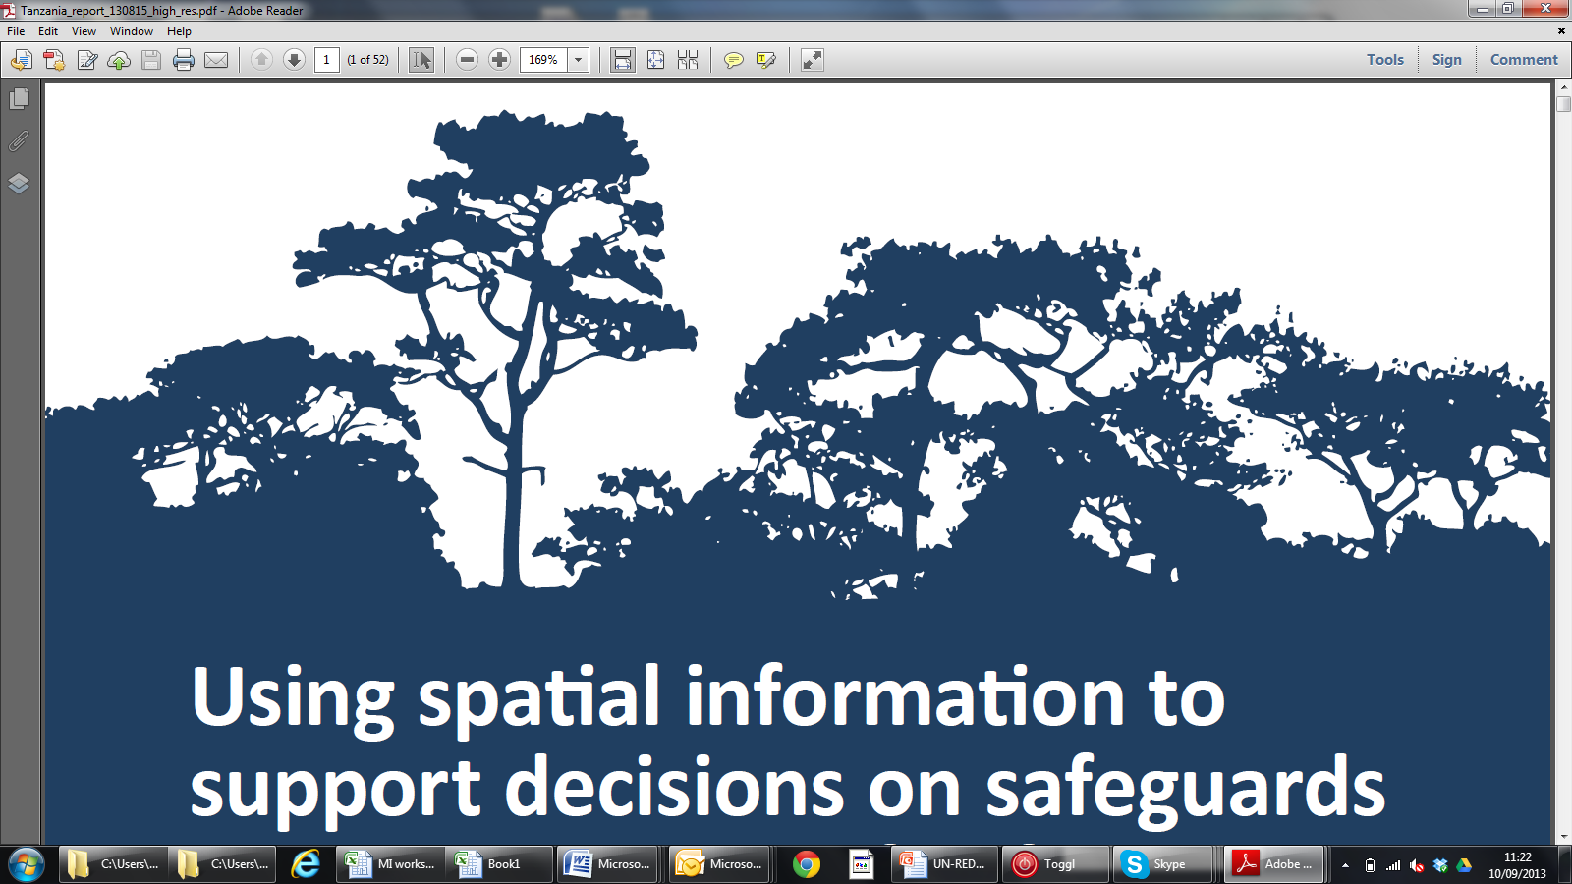

the un-redd spatial decision support

framework tool:

How to modify or add a new tool step

A tool to aid the prioritization of land areas for REDD+,

based on potential economic gain and additional benefits



The UN-REDD Programme is the United Nations Collaborative initiative on Reducing Emissions from Deforestation and forest Degradation (REDD) in developing countries. The Programme was launched in September 2008 to assist developing countries prepare and implement national REDD+ strategies, and builds on the convening power and expertise of the Food and Agriculture Organization of the United Nations (FAO), the United Nations Development Programme (UNDP) and the United Nations Environment Programme (UNEP).

The United Nations Environment Programme World Conservation Monitoring Centre (UNEP-WCMC) is the specialist biodiversity assessment centre of the United Nations Environment Programme (UNEP), the world’s foremost intergovernmental environmental organisation.  The Centre has been in operation for over 30 years, combining scientific research with practical policy advice.

**Prepared by Corinna Ravilious**

**(DRAFT January 2017)**

**Copyright:** UNEP

**Disclaimer:** The contents of this report do not necessarily reflect the views or policies of UNEP, contributory organisations or editors. The designations employed and the presentations of material in this report do not imply the expression of any opinion whatsoever on the part of UNEP or contributory organisations, editors or publishers concerning the legal status of any country, territory, city area or its authorities, or concerning the delimitation of its frontiers or boundaries or the designation of its name, frontiers or boundaries. The mention of a commercial entity or product in this publication does not imply endorsement by UNEP.

We welcome comments on any errors or issues. Should readers wish to comment on this document, they are encouraged to get in touch via: [ccb@unep-wcmc.org](mailto:ccb@unep-wcmc.org).



Contents

1. Introduction 1

2 The graphical modeler 1

2.1 Creating your own geoprocessing models 1

2.1.1 Making a simple model 1

2.1.1.1 Defining your analysis steps 1

2.1.1.2 Setting up and saving the model file 3

2.1.1.3 Adding the steps 4

2.1.1.4 Running your model 11

3 How to create the new spatial planning tool for Cambodia and add in the processing steps (using the 3rd party workflow plugin) 13

3.1 Creating the Tool 13

3.1.1 Adding the steps 14

3.1.2 Adding the help text 16

3.1.3 Running the Tool 16

# 

# Introduction

REDD+ has the potential to deliver multiple benefits beyond carbon. For example, it can promote biodiversity conservation and secure ecosystem services from forests such as water regulation, erosion control and non-timber forest products. Some of the potential benefits from REDD+, such as biodiversity conservation, can be enhanced through identifying areas where REDD+ actions might have the greatest impact using spatial analysis.

Open Source GIS software can be used to undertake spatial analysis of datasets of relevance to multiple benefits and environmental safeguards for REDD+. Open-source software is released under a license that allow software to be freely used, modified, and shared (<http://opensource.org/licenses>). Therefore, using open source software has great potential in building sustainable capacity and a critical mass of experts, even with limited financial resources.

This Global REDD+ Spatial Decision Support Tool is a flexible tool that has been developed in QGIS using Graphical Modeler and a third party plugin[1] that adds workflow functionality to Processing. The graphical modeler allows you to create complex models using a simple and easy-to-use interface, whilst the workflow plugin allows you to string the processing tasks together and provide step-by-step instructions within the user interface. This tutorial provides instructions on how to modify and add new workflows to the tool so that it can be adapted to country specific purposes.

# The graphical modeler

The Graphical model provides an easy-to-use interface which allows users to string together groups of geoprocessing tasks into a single geoprocessing model. For example, in an analysis that requires the running a large number of sequential analysis steps, this can be very useful for stringing together groups of processes to reduce the number of steps and make it quicker and easier to run. This also makes it easier for undertaking repeat analysis and documenting the method that was used.



1. The graphical model is accessed from the main menu bar under **Processing>>Graphical Modeler**
2. 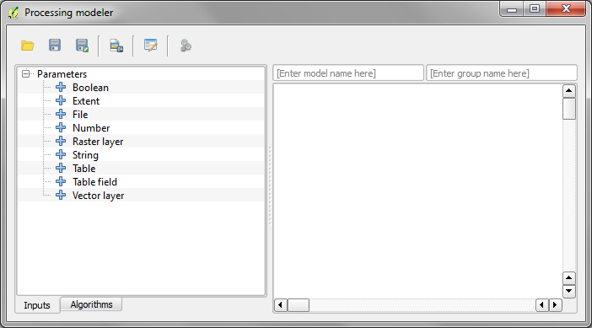The processing modeler window appear showing a panel on the left hand side with 2 tabs (**Inputs** and **Algorithms**) and a **canvas** on the right hand side

## Creating your own geoprocessing models

### Making a simple model

#### Defining your analysis steps

Before you start an analysis it is important to think about the **objectives** and the **spatial logic** behind **what you want to achieve** i.e. what analysis steps do I need to take in order to run the analysis to meet the objectives? If your analysis **involves running a number of geoprocessing tools** you may want to use the graphical modeler to string the steps together to create a single geoprocessing model. This will enable you to create one tool running multiple steps.

Once you have worked out the the logic you can think about what tools within the QGIS toolbox are needed to undertake the task. A worked example is provided below to demonstrate the stages required from the thought process through to building and running a model of the steps.

***EXAMPLE*** *- If we are trying to create a spatial layer* ***defining forest areas at risk from the driver ‘Small-scale use: Cassava’*** *how might we create that layer?*

**To keep it simple (for this training exercise only), we will define the analysis with the following** **assumptions. That is, under a BAU scenario:**

* the objective for this example analysis is to maintain current natural forest (i.e. not thinking about afforestation/reforestation)
* that commune level yield data are available and those communes that already have some Cassava production will be affected by the driver Cassava in the future (in reality this might not be the case
* for Economic Land concessions with cassava listed as an intent, the whole concession will become cassava in the future

**So with these assumptions what data do we need?**

* Communes dataset containing current crop yields for cassava
* Economic Land Concessions dataset indicating those where the intent cassava production.
* Dataset of natural forest or a landcover dataset from which to select out the relevant forest classes.

**So what are the spatial steps required to undertake the analysis?**

1. Select from Communes dataset where cassava yield > 0
2. Select from Economic Land Concessions Data
3. Merge the selected communes and selected land concessions into a single file.
4. Dissolve any internal boundaries to make a simple layer
5. Select out natural forest from landcover dataset
6. Clip natural forest to merged vector

**\*\*\*\*\*IMPORTANT NOTE:** *This is just a very simplistic example of defining the spatial extent for a particular driver for a specified REDD+ action using a data driven approach. It is a demonstration for generating a SIMPLISTIC workflow within the QGIS graphical modeler and DOES NOT represent a final workflow for creating your driver layers.*

*The final spatial logic for developing the layer is likely to be much more complex and may not even necessarily be developed in QGIS but development using a more sophisticated dedicated software for environmental modeling of land-use change.* *Actual delineation of driver extent may alternatively be based entirely on stakeholder input from driver analyses workshops rather than driven by data or a combination of a stakeholder and data driven approach.\*\*\*\*\**

#### Setting up and saving the model file

Before you start creating your new model it is a good idea to give the model a name and a group name. **The model name will be the name of your tool and the group name will define how QGIS groups your models in the QGIS processing Toolbox (see illustration left)**. E.g. you may prefer to have a single group in which to store all the models you create in QGIS or you may prefer to have a number of groups to store models being used for a particular project or theme.

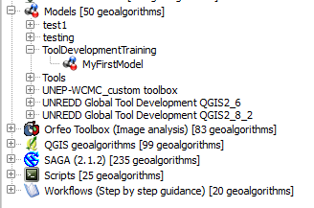

Group name

Model name

1. In the **[Enter model name here]** box give your 1st model a name e.g. **MyFirstModel**
2. In the **[Enter group name here]** box define a group to store your models e.g. **ToolDevelopmentTraining**
3. Click the **save** button

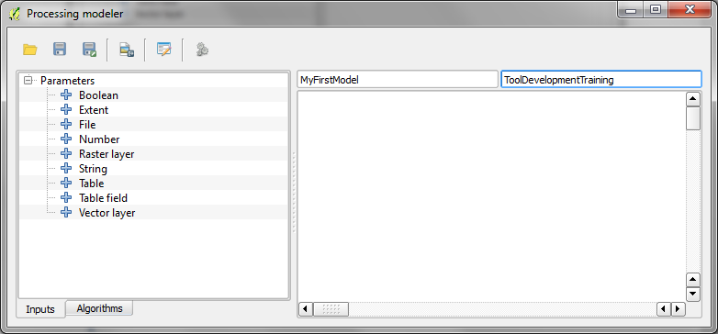

1. As it is the first time you have hit save, QGIS will take you to your **…\.qgis2\processing\models** folder where all user defined models are saved. e.g. C:\Users\corinnar\.qgis2\processing\models

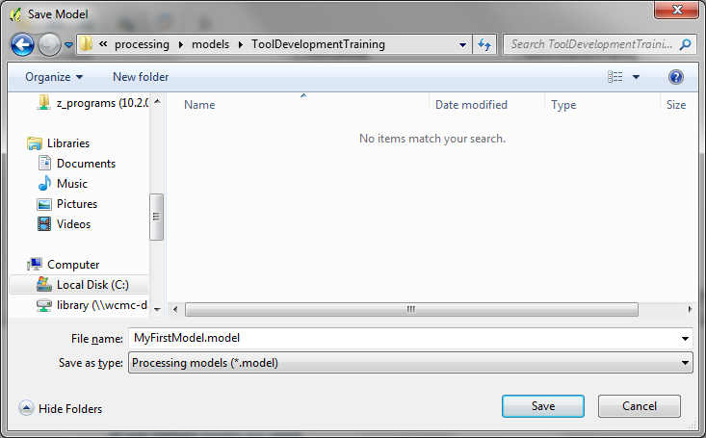**Create a subfolder** with the same name as the **group** and save the **model** with the **same name given in the graphical**.

**modeler interface** . This will help you to know which model file belongs to which model you see in the graphical modeler interface.

1. 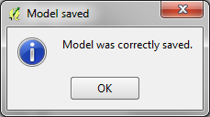A window will appear telling you that the model has been correctly saved. **Click OK**

*The next time you click the save button it will save the edits to you model to that file*

#### Adding the steps

The next step is to decide which geoprocessing algorithms are required for each step.

1. Click on the **Algorithms tab** in the left hand panel. See that it looks exactly like the processing toolbox. In here you can search for tools in exactly the same way. Search for **‘Select’** as for step 1 of our workflow we want to use a vector select function to:

*Select from Communes dataset where cassava yield > 0*

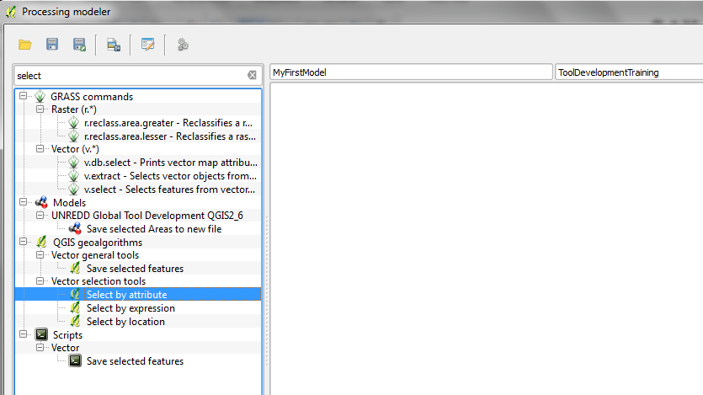

1. Double-click on the **‘Select by Attribute’** tool
2. On the screen that appears see that the parameters required for this tool are:-

* Input Layer
* Selection Attribute
* Operator
* Value
* Output

The tool looks similar but not identical to the screen you would see if you were just running the tool on its own rather than adding it to the graphical modeler

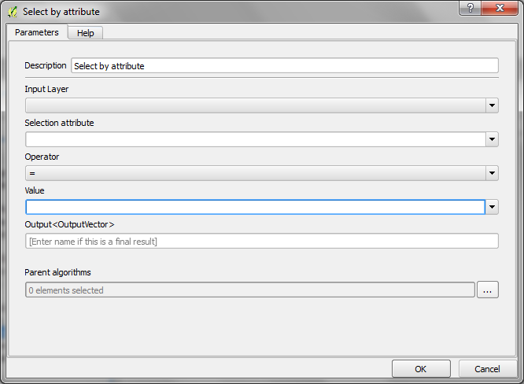

You should see the screen as shown **above**

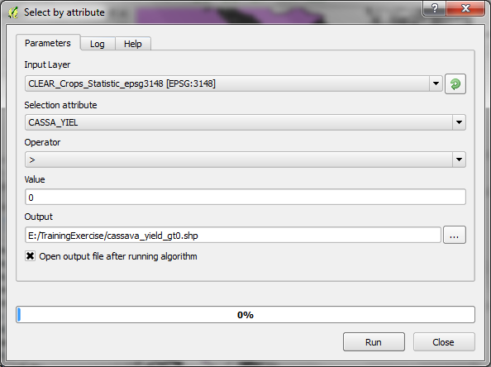If you were to run it this algorithm in the normal way by finding and running the tool from the processing toolbox it would look like the screengrab **below**

See that the required parameters are the same but in the graphical modeler you cannot navigate to a vector layer to select the data.

1. Click **OK**

A message will pop up saying:

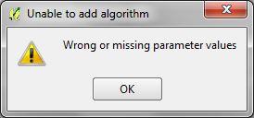

This is because you are not running the tool but using the algorithm to make a new tool and you have not told it what the input parameters are.

1. Click OK to close the error message.  **Make a note of the parameters required** and think about what sorts of inputs they are - if you click on the **help** button it will tell you the requirements:

* Input Layer – *the vector layer to process*
* Selection Attribute – *an attribute field from the vector layer* *on which perform the selection.*
* Operator – *a drop down menu containing operators such as =, >, < etc*
* Value – *the value relating to the attribute field*
* Output – *a new output vector dataset*
* Parent algorithms*- This parameter allows you to define the order in which algorithms are executed, by explicitly defining one algorithm as a parent of the current one, which will force it to be executed before it.*

1. At this stage click **Cancel** to close the algorithm as the **parameters (inputs to the tool) need to be added first** before the algorithm can be added to the graphical modeler canvas.
2. 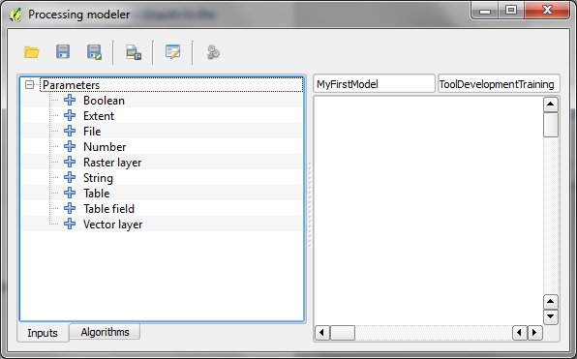Click on the **inputs tab** at the bottom of the left hand panel
3. 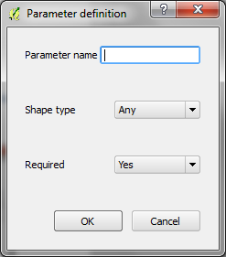Double-click on Vector layer or Drag and drop Vector Layer into the canvas area
4. A **parameter definition** window will pop up for you to define the **name** of vector layer input, the type and whether it is a required input
5. 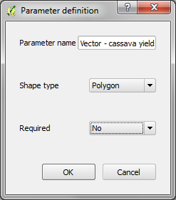Fill out the parameter definition (the name text is the text that will appear on the user screen when executing your tool.
6. Click **OK** and see that the Vector Layer input has been added to the canvas

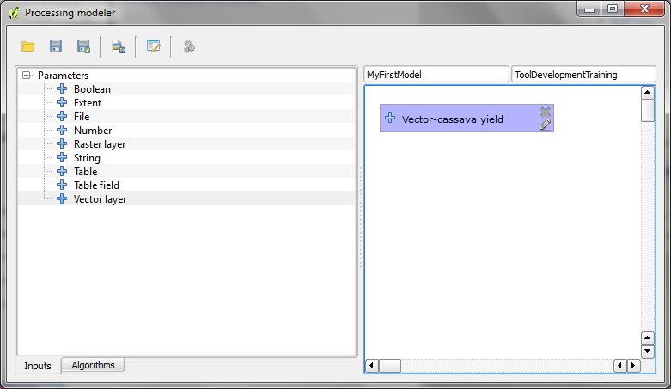

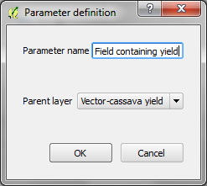

1. Add the rest of the parameter

* Selection Attribute – *an attribute field from the vector layer* *on which perform the selection.*

Double-click on **Table field**

Give the parameter a **name**

**Click OK**

1. 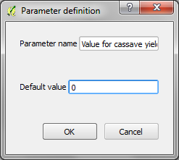 Ignore operator for now as it does not require a parameter as it was a dropdown list in the algorithm
2. Value – *the value relating to the attribute field*

The value in this case is a number as the yield field contains numeric data. The algorithm is actually expecting a string so double-click on the String parameter and make the default value 0. Output – *a new output vector dataset*

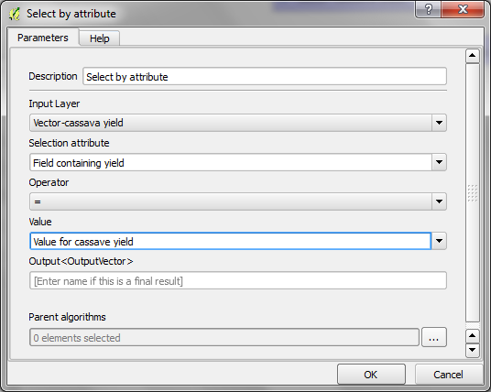

1. Now the **Algorithm** can be added. Double-click on the select by attribute algorithm and link it to the parameters you have just added
2. 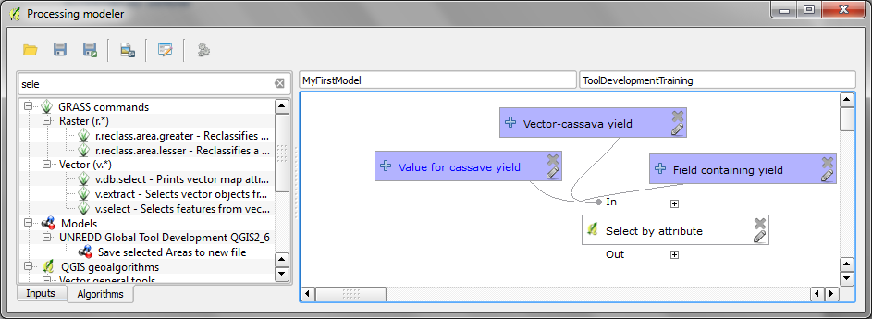Click OK. You have created the first step of your tool. It should look something like the screengrab below

Next add the algorithm for the second step ‘Selecting Economic Land Concessions where Cassava production is listed as an intent’.

1. Again this requires the **‘Select by Attribute’** tool so you need to add

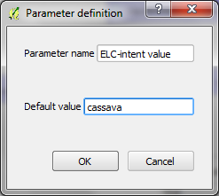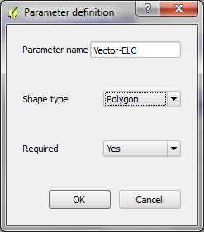**Vector layer, Table Field and a String** parameters

1. 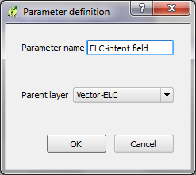Add the **‘Select by Attribute’ and link the parameters the the ones you created above**

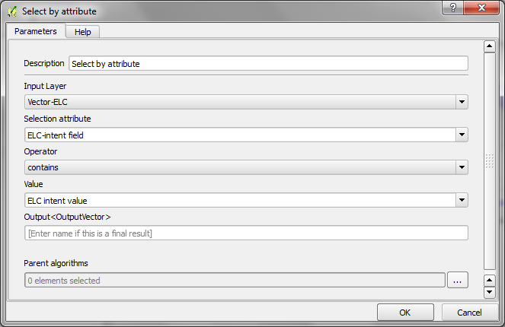

1. Change the Operator to **contains.**  Click **OK.**
2. 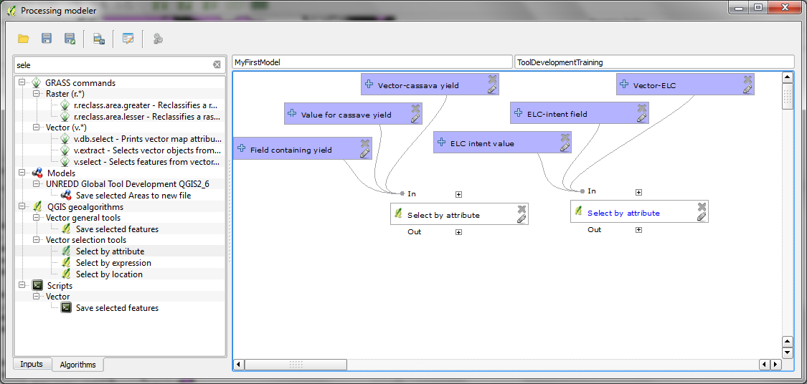Arrange the diagram by dragging and the elements and click the **Save button** to save
3. Notice that both algorithms are called select by attribute. Edit the tool step in the tool by **right click on select by attribute>>edit.** Change the description to **Select by attribute (vector - cassava yield)**
4. Edit the 2nd step in the tool by **right click on select by attribute>>edit.** Change the description to **Select by attribute (vector - ELC)**
5. Next add the algorithm for the third step to merge the selected communes and selected land concessions into a single new vector layer.
6. 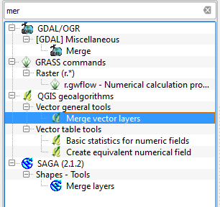Click on the **Algorithms** tab and **Search the Merge vector layers** tool. Double-click on the **Merge vector layers** tool to open it to check what parameters are required.
7. 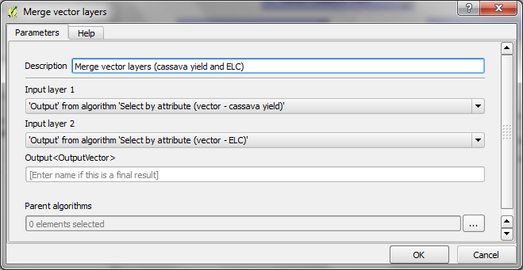See that it only requires 2 inputs and we don’t need to add any new input parameters as the **input parameters are the output parameters from the previous 2 steps**. Fill out the tool as below.

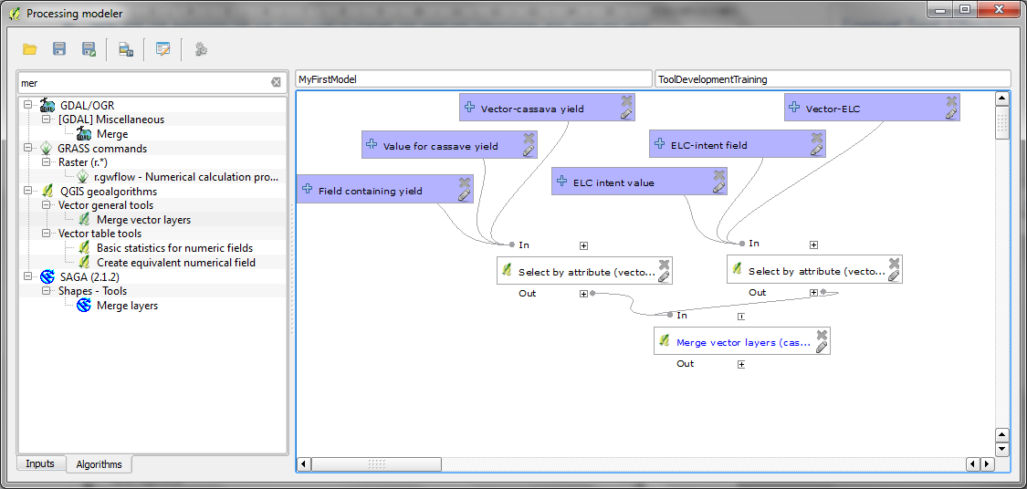The workflow should look similar the screengrab below:

1. Next **Add the remaining steps** to the workflow in the same way and **when finished save and close your model**

* Dissolve any internal boundaries to make a simple layer
  + (hint: use tool **Dissolve (all polygons)**
* Select out natural forest from landcover dataset
  + Hint: (presuming the forest layer is a raster) use tool **r.mapcalculator** with a formula to select out the forest classe. E.g. if the landcover rast (A) has forest class 1 and 2 then the formula is **if(A>2, null(), A)** i.e this means if the values are greater than 2 make the values in the output raster 1 otherwise leave them the same as they were in raster
* Clip natural forest to merged vector
  + (Hint: Use tool **Clip Raster by Mask Layer**)

Your final model should look similar to the screengrab below:

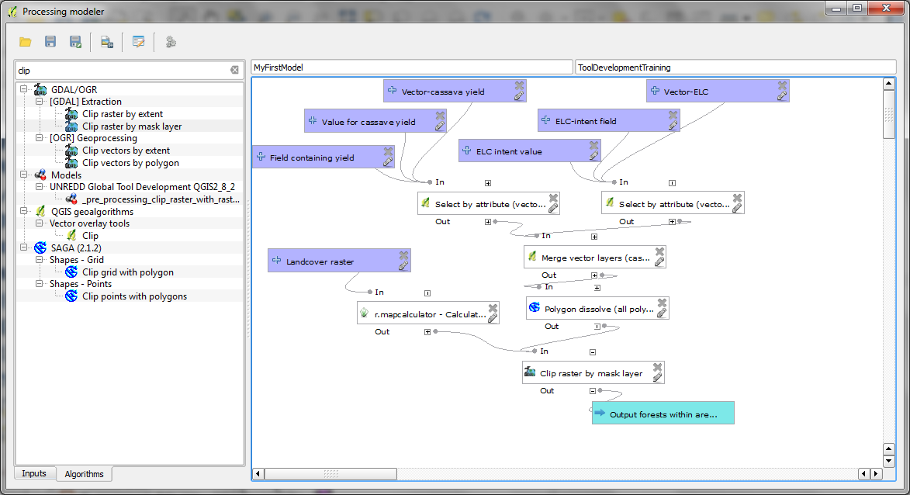

#### Running your model

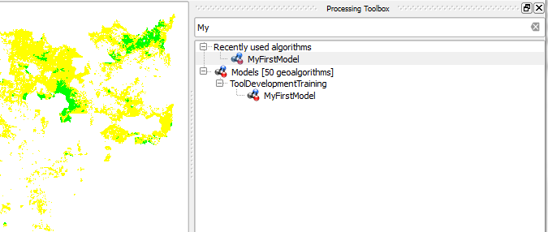You should have now saved your model and closed the graphical modeler. The next step is to run your new tool. It will run 6 steps all within one tool. You can search for your own models in exatly the same way as other tools within the processing toolbox.

* 1. Search for **My** in the processing toolbox and it will find your model
  2. Double click on it in the same way you would any of the normal QGIS tools.

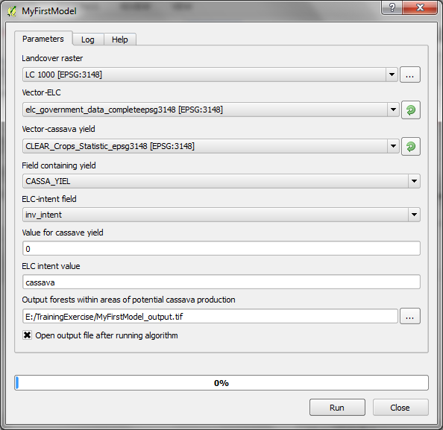

Now you have completed the example think about the different drivers and how you would go about creating a spatial layer for mapping the potential distribution of each of the drivers

In your groups think about:

1. Can they be mapped using a data only approach?
2. If yes, what data are needed to map the potential areas at risk from each driver? and is the data available?
3. If no, what other approaches are available (e.g. complex modelling, stakeholder workshops)?
4. What plans/methods does Cambodia have to undertake driver analyses?

# How to create the new spatial planning tool for Cambodia and add in the processing steps (using the 3rd party workflow plugin)

## Creating the Tool

* 1. In the **processing toolbox** expand the **Workflows** tool and expand **Tools**
  2. We will create a new tool for Cambodia so double-click on **Create a new workflow**
  3. A new window will appear.

*You will see that* ***it looks similar*** *to both the processing toolbox and the graphical modeler.*

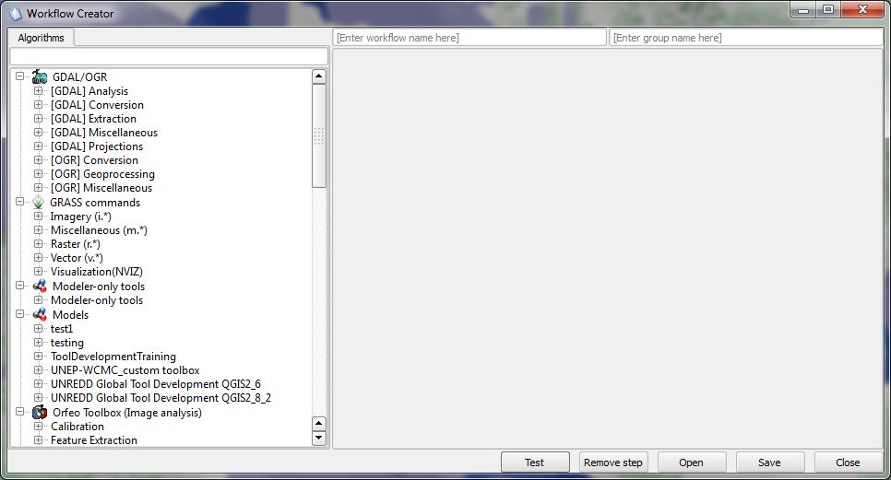

*The left hand panel contains the list of algorithms that can be run and the right hand panel is currently empty with buttons at the bottom. These are the buttons that will let you move from step to step within the tool.*

* 1. Enter a workflow name new workflow name

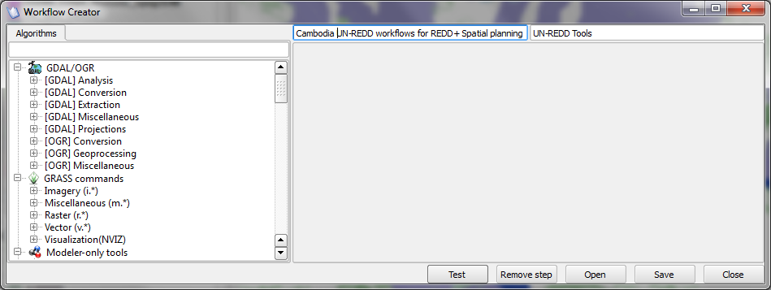e.g. **Cambodia UN-REDD workflows for REDD+ Spatial planning**

* 1. Enter a groupnamee.g. **UN-REDD Tools**
  2. Click the save button and save the workflow tool in the default folder

C:\Users\.....\.qgis2\python\plugins\processing_workflow\workflows, saving the file with a similar name to the workflow e.g. **Cambodia_UNREDD_workflows_for_spatialplanning_150611.workflow.** *It is helpful to put a date at the end as you may at a later date want to save a new version of the tool and keep this one as a backup.*

* 1. 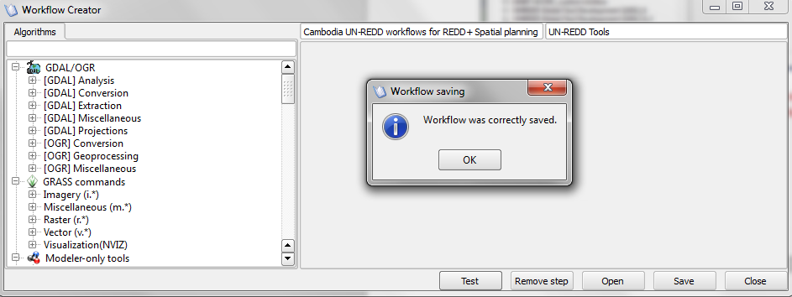A window will pop up saying that it was correctly saved. Click OK to close the window

*You are now ready to add the content to the tool*

### Adding the steps

You will see that all the processing tools are available for you to add as individual steps and you could create your tool by adding each step individually. However how that we have learnt how to create models of multiple steps one tool we can chose to pick up those tools that we created.

* 1. We will start by adding the 1st step from the global tool. Expand the **Models>>UNREDD Global Tool Development QGIS2_8_2** in the left hand panel and double click on **1. Read the help document**

*You now have the first step in the Cambodia workflow. You will see that all the parameters that were defined when creating the step appear on the right hand screen (see screen grab below)*

*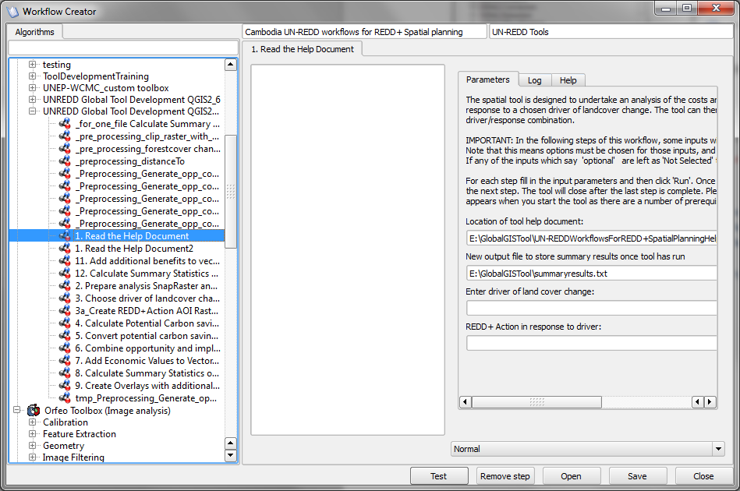There is now an additional white panel in the middle this is where the help text will go. We will add this later. For now we will add more steps to the workflow*

1. Double click on the next step you want to add. E.g. **2. Prepare analysis SnapRaster and VectorResultsGrid**

See that it appears as a 2nd tab in the workflow tool

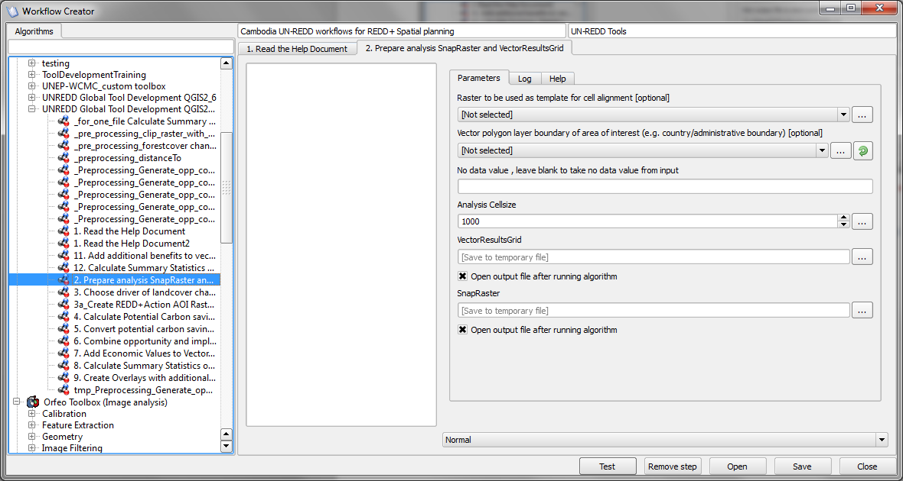

*There is one thing to note – if you have a step that you want to run multiple times on different files you can set individual steps to run in batch mode by changing the Normal to Batch in the tab at the bottom of the screen.*

1. You can keep adding steps in this way until you have all the steps for the analysis that you want your tool to undertake. Make sure you **click save** regularly to save the changes you are making

### Adding the help text

Adding in the help text is easy. You can just type or copy and paste from your documents. However if you wish the text to be nicely formatted (as in the global tool you need to have html wrappers around it.

* 1. Use the English html template on the USB stick and copy and paste the relevant Khmer text from the training materials.

<b><font size="5" face="Calibri"color="#9F000F">REDD+ SPATIAL DECISION SUPPORT TOOL </b></font>

<p><b><font size="5" face="Calibri"color="#9F000F">To aid the prioritization of land areas for REDD+, based on potential economic gain and additional benefits.</p>

<p><b><font size="4" face="Calibri"color="#9F000F">(DRAFT 05 June 2015)</b></font></p>

<b><font size="4" face="Calibri"color="#9F000F">OVERVIEW</b></font>

…….

………

* 1. Save the workflow

*See that you now have a Cambodia version of the Global tool which you will need to test by running it with your data.*

### Running the Tool

* 1. Double-click on the tool to run it and follow the instructions that you have placed in the left hand panel for each step.

END

1. The plugin is part of the Water Observation Information System (WOIS) developed under the TIGER-NET project funded by the European Space Agency as part of the long-term TIGER initiative aiming at promoting the use of Earth Observation (EO) for improved Integrated Water Resources Management (IWRM) in Africa. Copyright (C) 2014 TIGER-NET (www.tiger-net.org)