Stakeholder consultation workshop on REDD+ Roadmap in Bogalay, Ayeyawady Region
Town Hall, Bogalay
AGENDA
Opening Session | Opening Speech delivered by H.E. U Soe Myint, Minister for Ministry of Mining and Forestry, Ayeyawady Region
 | Key Note Presentation about REDD+ by Dr. Thaung Naing Oo, Deputy Director, Forest Department
Presentation Session | The REDD+ Readiness Roadmap Development Process  Roadmap Session 1: Management of REDD+ Readiness | Dr. Thaung Naing Oo  UN-REDD Programme Focal Point  Deputy Director, Forest Department
 | Roadmap Session 3: Development and selection of REDD+ Strategies | Dr. Rosy Ne Win, Staff Officer, Forest Department
 | Roadmap Section 2: Stakeholder Consultation and Participation  Roadmap Section 4: Implementation Framework and Safeguards | Mr. Nanda Win Aung, Staff Officer, Forest Department
 | DISCUSSIONS
Group discussion Session | Group Discussion (Two Groups)
 | Presentation of results of Group Discussion
CLOSING SESSION | Closing Speech by U Zaw Win, Director, Ayeyawady Region, Forest Department

Introduction
With the support of the UN-REDD Programme Targeted Support, Forest Department organized two National Workshops and four Stakeholder Consultation Workshops in four State and Regions. The support aims to cover the extra cost of organizing the national consultation process. The objective of UN-REDD Targeted Support is to help in reviewing and validation Myanmar’s draft REDD - Plus Readiness Roadmap through a multi-stakeholder national consultation process.
Due to time constraints and the logical challenges linked to the start of the raising season, four (4) Regional Workshops were organized within two months (May – June 2013) as follow: -
- Bago Region at Bago on 30th May, 2013 attended (63) participants and opening address by Regional Minister of Mining and Forestry.
- Shan State at Taungyi on 5th June, 2013 attended (71) participants and opening address by Chief Minister of Shan State.
- Ayeyarwady Region at Bogalay on 11th June, 2013 attended (65) participants and opening address by Regional Minister of Mining and Forestry.
- Sagaing Region at Kather on 18th June, 2013 attended (71) participants and opening address by Regional Minister of Mining and Forestry.

OPENING SESSION: Opening Ceremony
The opening and welcome speech was delivered by H.E. U Soe Myint, Regional Minister for Ministry for Mining and Forestry, Ayeyawady Region. In his speech, the Minister highlighted the importance of forests particularly the mangrove in preventing natural disasters such as tropical cyclones, floods, nutrient cycling, food security, biodiversity and other ecosystem services including high capacity of carbon sequestration. He also clearly pointed out the rapid rate of deforestation of mangrove forests in Ayeyawady delta and its negative impacts to the agricultural sectors as well as local communities. He recalled the Cyclone Nargis which was seriously strike in Ayeyawady delta in 2008 and over 100,000 people were dead. Excellency strongly recommended to take the opportunity of REDD+ mechanism to conserve existing natural mangrove forests and to rehabilitate degraded mangrove forests with people’s participation. Finally, Excellency express his appreciation to the Forest Department for choosing Ayeyawady Region particularly Bogalay in order to organize Regional Workshop on REDD+. His appreciation also went to all participants from line Ministries, representatives from political parties, and representatives of parliament members, NGOs, civil societies, media, forest user groups, and local communities for participating this Regional Workshop. He committed to give high attention for the participation and supporting of REDD+ in the future.
Key Note Presentation was made by Dr. Thaung Naing Oo, Deputy Director, Forest Department after the Opening Speech addressed by Regional Minister. Dr. Thaung Naing Oo briefly explained about the climate change and its impacts, the role of forests in mitigating climate change, background of REDD+, its objectives, concepts, mechanisms and elements of REDD+ framework. The purpose of this key note presentation was to make policy brief about REDD+ expecting to receive political supports for the implementation of REDD+ readiness activities.
The Regional Consultation Workshop was attended by (55) participants; Roadmap (draft) presented by Resource Persons and received initial feedback on the first draft of the Roadmap. List of participants can been seen in ANNEX 1.

PRESENTATION SESSION

Presentation session was Chaired by U Soe Myint, Regional Minister for Ministry of Mining and Forestry, Ayeyawady Region. There were three presentations in the Regional Consultation Workshop. The Roadmap is composed of 6 Sessions and detailed power point presentation files are attached in ANNEX 2. Due to the limited time, Session 5 REL/RL and Session 6 MRV were not presented. The following sessions of REDD+ Roadmap were presented:

No. | Presentation Topic | Resource Persons
1. | The REDD+ Readiness Roadmap Development Process  Roadmap Session 1: Management of REDD+ Readiness | Dr. Thaung Naing Oo  UN-REDD Programme Focal Point  Deputy Director, Forest Department
2 | Roadmap Session 3: Development and selection of REDD+ Strategies | Dr. Rosy Ne Win, Staff Officer, Forest Department
3 | Roadmap Section 2: Stakeholder Consultation and Participation  Roadmap Section 4: Implementation Framework and Safeguards | Mr. Nanda Win Aung, Staff Officer, Forest Department

At the end of the Presentation sessions, the floor was open for Q&A as well as for discussions. The followings are the major discussion points for the above mentioned presentations:

DISCUSSION SESSION
- How can we ensure effective consultation and participation of 1) Women and 2) Ethnic Minority Groups?
- There should have good policy and good facilitation when sharing about REDD+ to women and ethnic minorities.

- For ethnic minorities who earn their living from farming, exact information with confirmed promise on benefit sharing should be given to get active participation.

- To give awareness training on the value of forest and trees to increase participation on REDD+

- To give awareness to know the policy and to act righteously

- For women, not only plantation is taking part in REDD+ but also reducing fuel wood use of using A1 energy efficiency stove is also part of REDD+ contribution.

- To promote FPIC in the region if women and ethnic minorities are to participate.

- To come with law and policy relevant to REDD+.

- Who should be able to benefit from REDD+ (Where does the money go) ?

- Not only forest and tree plantation but also farming and agriculture sectors should have benefit.

- There should also have consideration for those who are squatter or illegal tenant in the areas and heavily rely their livelihoods in the forest.

- The benefit should be differentiated between those who stay there temporarily and those who live permanently by having policy on that.

- For mangrove areas, the communities that live nearby should have benefit from it.

- Those who are interested to conserve the forest and plantation of trees should get benefits.

- Those who take part in REDD+ directly or indirectly can have benefits from it accordingly.

- How about thouse who reduce fuel wood use and use of A1 stove?

- How about private sector from regional level?

- What are the potential risks of REDD+ implementation in Myanmar?

- There can have risks in places with gender discrimination or language barriers and risks can be different depend on the regions.

- Risk can take place if there is no understanding on the roles and rights by stakeholders as well as not regular consultation and follow up with them.

- When there is no alternative livelihoods and transparency, there will have risks

- For those who implement REDD+, if they are not justice and righteous, there will have risks.

- If the information are not given in priority and in time, there will have risks.

- When REDD+ is not well understood by the local communities, there will have weak implementation of REED+.

- When the project cannot deliver exact benefits there can have risks of losing trust and who can responsibility on this?

CLOSING SESSION
The closing remark was addressed by U Zaw Win, Director, Ayeyawady Region, Forest Department. In his Closing Speech, he expressed his sincere thanks to all participants for very active participation in consultation workshop. He also urged line ministries, NGOs, civil societies, FUG and local communities to participate forest conservation together with Forest Department. He echoed that the important role of forests and mangrove for many aspects. He also highlighted the efforts of Forest Department in conserving mangrove and reforestation activities after Cyclone Nargis. He also call for NGOs, civil societies and private sectors to invest in forest plantations and to contribute forest conservation in Mangrove areas. Finally, he committed to implement all possible measures for forest conservation and sustainable forest management in integrating with REDD+.

ANNEX I
List of participants at Regional Consultation Workshop at Bogalay, Ayeyawady Region

Participants from Ministry of Environmental Conservation and Forestry
No. | Name | Position | ဌာန
1. | U Zaw Win (5) | Director | Forest Department (Pathein)
2. | Dr.Thaung Naing Oo | Deputy Director | Forest Department
3. | U Khin Maung Lwin | Assistant Director | Forest Department(Myaung Mya)
4. | U Soe Lwin | Administrator | Main Ma Hla Kyun Sanctury
5. | U Kan Htun | Staff Officer | Forest Department (Bokalay)
6. | U Myo Naing | Staff Officer | Forest Department (Pharpone)
7. | Dr.Rose Ne Win | Staff Officer | Forest Department
8. | U Zaw Zaw Naing | Staff Officer | Forest Department
9. | Dr.Toe Toe Aung | Staff Officer | Forest Department
10. | U Moe Zaw Aung | Staff Officer | Forest Department(Myaung Mya)
11. | U Kyaw Nyaunt | Township Staff Officer | Forest Department (Mawlamyaingkyun)
12. | U Pyae Phyo Aung | Range Officer | Forest Department (Pharpone).
13. | U Zaw Htoo Aung | Range Officer | Main Ma Hla Kyun Sanctury
14. | U Nay Lin Tun | Range Officer | Forest Department
15 | U Pyae Phyo Maung | Range Officer | Forest Department

Participants from line Ministries
No. | Name | Position | ဌာန
1. | U Khin Maung Soe | Assistant Engineer | Township Municipal Committee
2. | U Kyaw Thu Ya | Township Engineer | Myanmar Electrical Power
3. | Daw Myint Myint San | Staff Officer | Township Court
4. | U Zaw Lwin | Staff Officer | Agricultural/Bank
5. | U Ye Myat Htun | Staff Officer | Co-Operative Department
6. | Daw Khin Swe Win | Staff Officer | Co-Operative Department
7. | U San Aung | Lawyer | ခရိုင်ဥပဒေရုံး
8. | Daw Aye Aye Yi | Lawyer | မြို့နယ်တရားဥပဒေရုံး
9. | U Saw Ba Naing | Staff Officer | Planning Department
10. | U Aung Thi Ha Cho | Staff Officer | Settlement and Land Record Department
11. | Dr.Thi Ha Myo | Staff Officer | Livestock Breeding and Veterinary Department
12. | U Khin Maung Zin | Manager | Trade Promotion
13. | Daw Yi Yi Myint | Staff Officer | Information and Public Relation Department
14. | U Aye Ko Ko Su | Staff Officer | Immigration and National Registration Department
15. | Dr.Nyi Nyi Naing Lwin | Assistant Doctor | 100 Beds Public Hospital
16. | U Saw Zayar Moe | Deputy Staff Officer | GNI
17. | Daw Khin Chaw Su | Assistant Staff Officer | Department of Fisheries
18. | Daw Ohn Mya | Member | Myanmar Women’s Development Association
19. | Daw Hnin Win Than | Member | Myanmar Women’s Development Association
20. | Daw Khin Mar Aye | Member | Myanmar Women’s Development Association
21. | Daw Thin Thin | Member | Myanmar Women’s Development Association
22. | U Aung Hla Myo | Deputy Staff Officer | DOA

Participants from NGOs, Civil Society, Political Party and Media
No. | Name | Position | ဌာန
1. | U Ba Myaing | Chairman | Community Forest(Htaungyitan)
2. | U Aye Khaing | Secretary | Community Forest(Gawdu)
3. | U Khaing Phone | Secretary | Community Forest(Yangon)
4. | U Myo Aung | T.C | United Nations Development Programme (UNDP)
5. | U Myo Win Oo | T.C | Economically Progressive Ecosystem Development Group (EcoDev)
6. | U Kyaw Nyunt | Project technician | Economically Progressive Ecosystem Development Group (EcoDev)
7. | Daw Sandar Oo | Vice Chairman | မတူကွဲပြားခြင်းနှင့် ငြိမ်းချမ်းရေးပါတီ
8. | Daw Kyout Kyout Khaing | Administrator | GRET
9. | U Nyount Wai | Chairman | (၈၈) မျိုးဆက်ကျောင်းသားဟောင်းများ
10. | U Tin Hla | Secretary | (၈၈) မျိုးဆက်ကျောင်းသားဟောင်းများ
11. | U Pauk | Chairman | အမျိုးသား
12. | U Man Phae Win | Secretary | တ.စ.ည ပါတီ
13. | U Khin Win | Committee | တ.စ.ည ပါတီ
14. | Daw Kay Mar Myint | Township Executive | ခေတ်သစ်ပြည်သူ့ပါတီ
15. | U San Myint | Township Executive | ခေတ်သစ်ပြည်သူ့ပါတီ
16. | U San win | Township Executive | ခေတ်သစ်ပြည်သူ့ပါတီ
17. | U Hla Myint | Project Manager | Swanyee Development Foundation (SDF)
18. | U Khin Maung Chit | S.H | NLD (Bogalay)
19. | U Htay Lin | Project Coordinator | Mangrove Service Network
20. | U San Maung | Technical Adivisor | Mangrove Service Network
21. | U Pyue | District(Information) | NLD
22. | U Zaw Aung | District(Information) | NLD
23. | U Naing Lin Htet | Area Coordinator | Metta Development Foundation
24. | U Thein Maung | Area Coordinator | Metta Development Foundation
25. | U Thaung Naing Htay | Manager | Private
26. | U Yu Lwin | Member | Community Forest
27. | U Lin Htin | Program Officer | ​ Metta Development Foundation
28. | U Maung Maung Tar | Local People | Bogalay Township

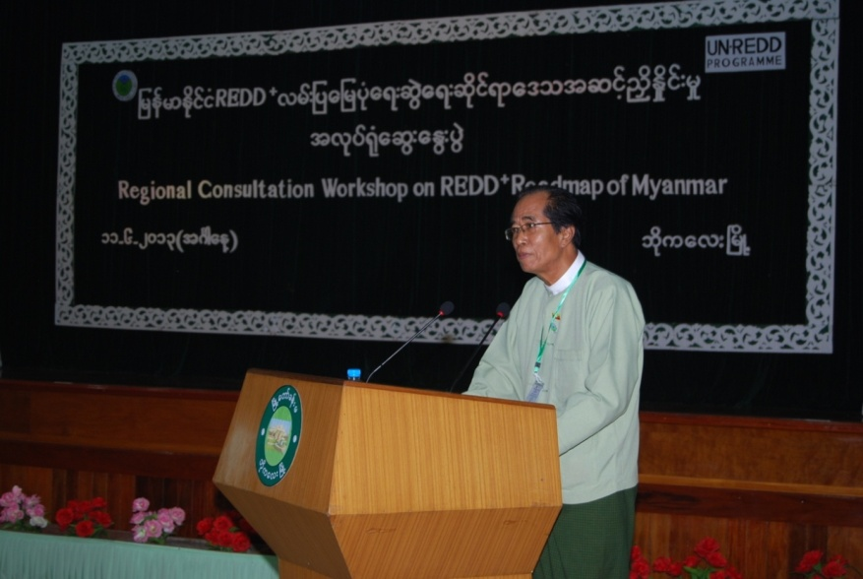

H. E. U Soe Myint, Regional Minister for Ministry of Mining and Forestry delivering Opening Speech
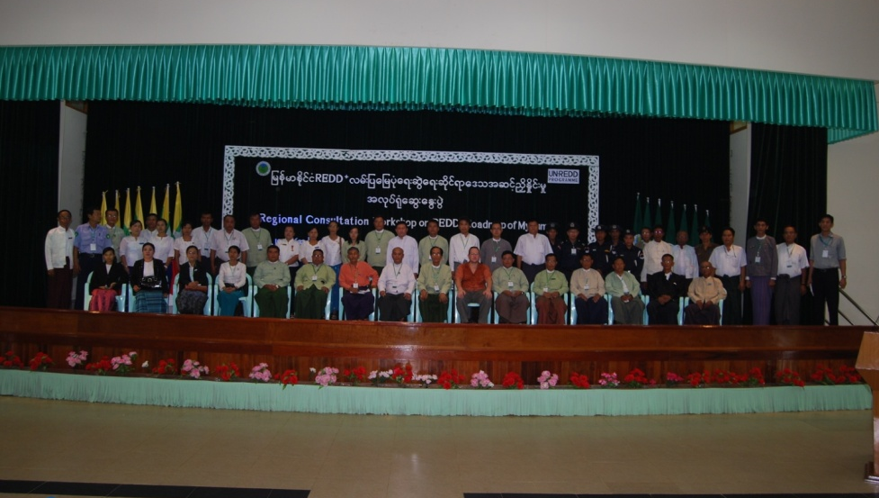

Group Photo
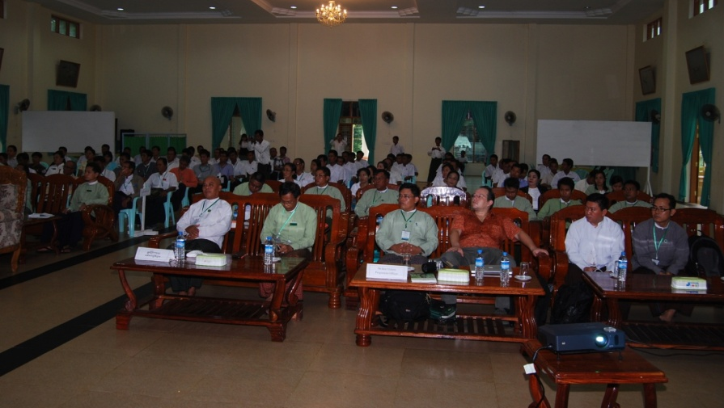

Participants

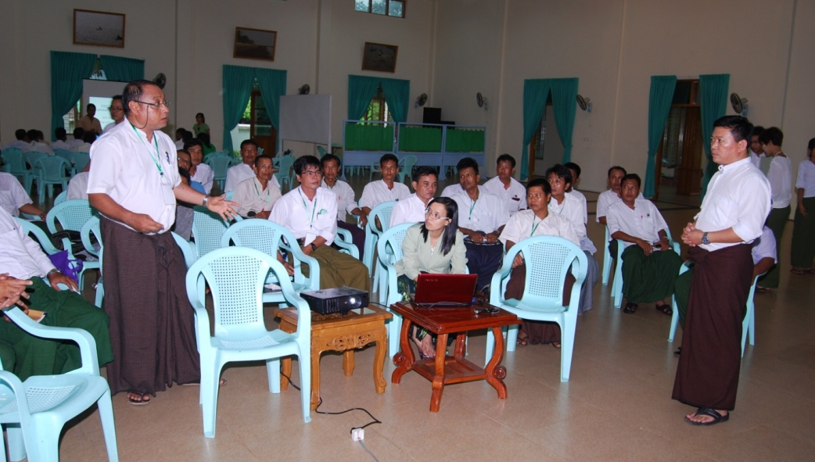

Group Discussion
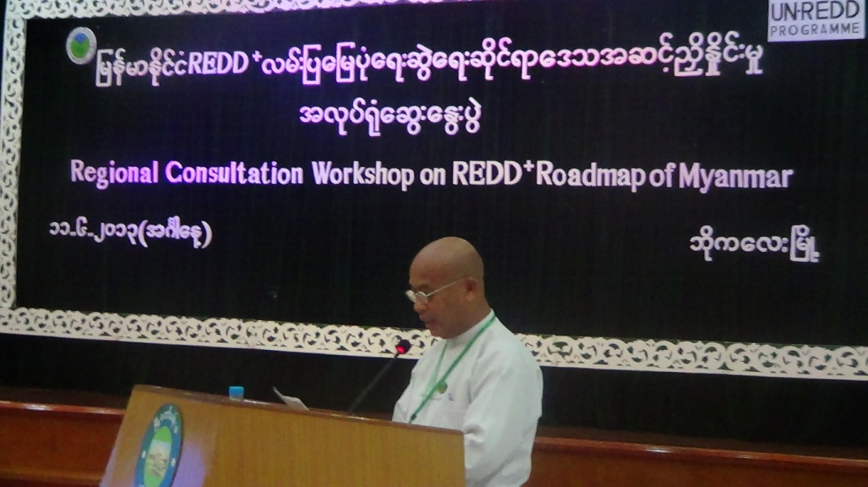

U Zaw Win, Director, Ayeyawady Region, Forest Department delivering Closing Remark

