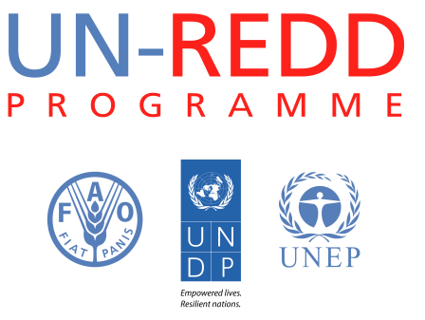
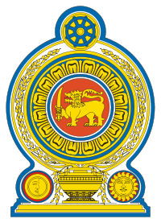
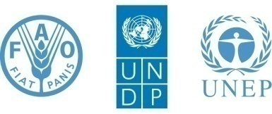

Stakeholder Awareness Baseline Survey
Sri Lanka UN-REDD Programme
31 October 2014
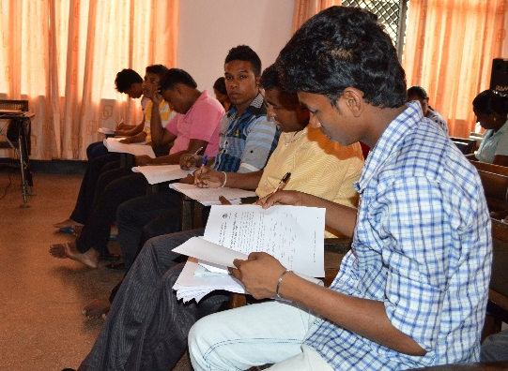
Colombo, Sri Lanka

Table of Contents

1. Introduction 5
2. Methodology 6
3. Results on basic information, perceptions of their knowledge about climate change,
REDD+, UN-REDD Programme 6
4. Results on series of questions; Climate Change, REDD+ and Deforestation 9
5. Responses by different stakeholders on their preference to be involved with Sri Lanka REDD+ 15
References 16

The UN-REDD Programme, implemented by FAO, UNDP and UNEP, has two components: (i) assisting
developing countries prepare and implement national REDD strategies and mechanisms; (ii) supporting the development of normative solutions and standardized approaches based on sound science for a REDD instrument linked with the UNFCCC. The programme helps empower countries to manage their REDD processes and will facilitate access to financial and technical assistance tailored to the specific needs of the countries.

The application of UNDP, UNEP and FAO rights-based and participatory approaches will also help ensure the rights of indigenous and forest-dwelling people are protected and the active involvement of local communities and relevant stakeholders and institutions in the design and implementation of REDD plans.

The programme is implemented through the UN Joint Programmes modalities, enabling rapid initiation of programme implementation and channeling of funds for REDD efforts, building on the in-country presence of UN agencies as a crucial support structure for countries. The UN-REDD Programme encourage coordinated and collaborative UN support to countries, thus maximizing efficiencies and effectiveness of the organizations’ collective input, consistent with the “One UN” approach advocated by UN members.

Contacts:

Nishantha Mallawaarachchi
Sri Lanka UN-REDD Programme Management Unit
Food & Agriculture Organization of the United Nations (FAO)
419/1, Pannipitiya Road, Pelawatta, Battaramulla
Sri Lanka.
Email: Nishantha.Mallawaarachchi@fao.org

Citation

Sri Lanka UN-REDD Programme (2014) Stakeholder Awareness Baseline Survey, UN-REDD Programme, Colombo, Sri Lanka.

Disclaimer

This report is not authoritative information sources – it does not reflect the official position of FAO, UNDP, UNEP, and should not be used for official purposes. As part of the UN-REDD Programme, this report provides information related to the activities of the UN-REDD Programme in Cambodia. In case readers find any errors in the document or would like to provide comments for improving their quality, they are encouraged to get in touch with one of the above contacts.

List of figures and tables

No table of figures entries found.
List of tables

No table of figures entries found.

Acronyms

Introduction

Sri Lanka is a signatory to the UN Framework Convention on Climate Change (UNFCCC). The Government under the leadership of Ministry of Environment and Renewable Energy, seeks to maximize Sri Lanka’s contribution in addressing climate change by increasing the resilience of its people and its eco systems through adaptation measures, and by decreasing the intensity of climate change itself through mitigation measures. The climate change policy of Sri Lanka’s goal is to adapt to and mitigate climate change impacts within the framework of sustainable development. Sri Lanka’s forests, remnants of a unique ancient civilization, includes 2 million hectares. They can make a significant contribution to both adaptation and mitigation of climate change. Ministry of Environment and Renewable Energy seeks to develop a national strategy for Reducing Emissions from Deforestation and forest Degradation, plus conservation, sustainable management of forests and enhancement of forest carbon stocks (REDD+). Thus, Sri Lanka’s national programme under the United Nations Collaborative Programme on Reducing Emissions from Deforestation and Forest Degradation in Developing Countries (UN-REDD) is an important initiative in supporting REDD and REDD+ readiness activities. Since effective implementation of REDD+ requires the full and effective participation of all stakeholders. Not only is this self-evident, based on decades of experience with natural resource management projects around the world, but it is required as one of the “Cancun safeguards”. Effective engagement can only occur with stakeholders who are aware of the issue on which their engagement is required. Consequently, awareness raising is a pre-requisite to effective engagement.

Awareness raising is an essential priorities to create the framework conditions for a successful REDD+ readiness process. There is a great need to enhance existing awareness, address major challenges through communication and to facilitate effective and informed stakeholder engagement. Some of the major challenges includes:

- Confused understanding of the REDD+ and the Sri Lanka UN-REDD National Programme.
- Sri Lanka UN-REDD National Programme is seen as a forestry project and therefore concerns only the Forest Department.
- High expectations for activities to happen on the ground, during the current- REDD+ readiness phase.
- Expectations among general public to gain economic benefits than relying on social and other benefits of REDD+ collective action.
- Lack of understanding and agreement on the optimum forest cover for Sri Lanka and how REDD+ will contribute in achieving national development goals.

Since efficient awareness raising must be based on an assessment of which stakeholder groups require increased awareness on which topics, the Programme Management Unit (PMU) developed a questionnaire adopting a similar version developed by the REDD+ Cambodia Programme and translating into local one of the major languages. This questionnaire was distributed among various stakeholders—participants those who attended Sri Lanka UN-REDD Programme events organised by the PMU and the Forest Department (FD). Taking advantage different stakeholder groups those who participated for such events, this assessment was conducted from February to September 2014.

Methodology

The assessment questionnaire included basic information on respondents’ connection with the Sri Lanka UN-REDD Programme, stakeholder group and their position or occupation. Four questions designed to assess participants’ perceptions of their knowledge about climate change, REDD+, UN-REDD Programme and their interest in being engaged in different aspects of REDD+ Readiness. Also questionnaire included series of questions (15 questions) to which participants were asked to answer “True”, “False”, or “Don’t know”. Participants were asked to identify to what aspect of aspects of the Sri Lanka REDD+ Programme they would like to participate in. Respondents were invited to provide their sex, age but not the name or other identical data. Data entry of questionnaires was administered Mr. Nishantha Mallawaarachchi, Communications Officer, Sri Lanka UN-REDD Programme. Ms. Keiko Nomura, Programme Officer (UN-REDD), of the United Nations Environment Programme Regional Office for Asia and the Pacific (UNEP/ROAP) provided data analysis, following in which Mr. Nishantha Mallawaarachchi compiled this report.

Results on basic information, perceptions of their knowledge about climate change, REDD+, UN-REDD Programme

A total of 160 submissions were considered as used for analyses, received from different stakeholder group shown in the following chart:

As respondents indicated their occupational position, 15 were belonged to the category of Director/Senior Manager positions. 29 were Deputy Director/ Assistant Managers, 8 were Chairman, 2 Company/Business Owners, 5 were Researchers, 2 were Consultant/Advisors, and 2 others were Coordinator/Coordinating Secretary, and, 7 Officer/Management Assistants, while 38 were Technical Officers. Thirty one were belonged to the “other” category and 14 did not filled this section. Out of 160 submissions 108 (71 percent) questioners were filled by male respondents whilst 44 were (29 percent) were identified to be female respondents.
The average age was 42 years for all respondents.

Average scores for indicated respondents perceptions as follows:

With an overall score of 6 participants provided their responses to the question of “How much do you feel you know about Climate Change in general” by different stakeholder groups as follows:

With an overall score of 5.2, they have indicated their feeling on the awareness about REDD+ in general as shown in the chart below:

Overall scored was 5.3 for the “How much do you feel you know about the Sri Lanka UN-REDD Programme?”

With an overall score of 4.5, stakeholders indicated that they are being involved in the Sri Lanka UN-REDD/REDD+ Programme as shown below:

Results on series of questions; Climate Change, REDD+ and Deforestation

Respondents were asked to indicate Yes, No or Don’t Know for 15 questions. The first question was “According to your understanding, Climate Change issues are very much relevant to Sri Lanka?” Among the respondents 95 percent (95%) indicated “Yes” as their answer, 4 % as “No” and 1 % as “Don’t Know”.

Eighty four percent (84 %) believe that “REDD+ is an approach to reduce the impacts of climate change” where 7 % won’t, 6 percent is unsure (indicated as ‘Don’t know’) and 2 percent did not answer. However some participants did not receive this questions as it was not included in the initial questionnaire.

There were 3 questions on forest destruction, major causes and its relevance with REDD+ and if Sri Lanka implement REDD+ whether or not it will mean no more trees can be cut. Analysis shows 90 % believe that “Destroying forests is a major cause of climate change” but 6 percent believe it is not. Two percent says they do not know the answer and two percent did not answered.

Twenty One percent believe that shifting cultivation as a major cause of deforestation. Sixty three percent believe shifting cultivation is not a major cause of deforestation. Thirteen percent indicated that they don’t know the answer and 3 percent did not answered this question.

Respondents were asked if Sri Lanka implements REDD+, whether or not will mean no more trees be cut or they do not know the answer. Nineteen percent indicated “Yes” as the answer and 62 % as “No”. Eighteen percent don’t know the answer and 2 percent did not provide a response to this question.

Responses by different stakeholders on their preference to be involved with Sri Lanka REDD+

References

The Climate Change Secretariat of Sri Lanka (2013). “Climate Change Policy”. 23 December 2013. <http://www.climatechange.lk/Documents/Climate_Change_Policy/Climate_Change_Policy_English.pdf>
Sri Lanka REDD+ Readiness Preparation Proposal (2012), UN-REDD Programme.
Stakeholder Awareness Baseline Survey (February 2014). REDD + Cambodia Taskforce Secretariat.

