Stakeholder consultation workshop on REDD+ Roadmap in Bago, Bago Region
Shwe Wa Tun Hotel, Bago
AGENDA
Opening Session | Opening Speech delivered by H.E. U Kyaw Htay Regional Minister for Ministry of Mining and Forestry, Bago Region
 | Key Note Presentation about REDD+ by Dr. Thaung Naing Oo, Deputy Director, Forest Department
Presentation Session | The REDD+ Readiness Roadmap Development Process  Roadmap Session 1: Management of REDD+ Readiness | Dr. Thaung Naing Oo  UN-REDD Programme Focal Point  Deputy Director, Forest Department
 | Roadmap Session 3: Development and selection of REDD+ Strategies | Dr. Rosy Ne Win, Staff Officer, Forest Department
 | Roadmap Section 2: Stakeholder Consultation and Participation  Roadmap Section 4: Implementation Framework and Safeguards | Mr. Nanda Win Aung, Staff Officer, Forest Department
 | DISCUSSIONS
Group discussion Session | Group Discussion (Two Groups)
 | Presentation of results of Group Discussion
CLOSING SESSION | Closing Speech by U Kyaw Kyaw Lwin, Director, Bago Region, Forest Department

Introduction
With the support of the UN-REDD Programme Targeted Support, Forest Department organized two National Workshops and four Stakeholder Consultation Workshops in four State and Regions. The support aims to cover the extra cost of organizing the national consultation process. The objective of UN-REDD Targeted Support is to help in reviewing and validation Myanmar’s draft REDD - Plus Readiness Roadmap through a multi-stakeholder national consultation process.
Due to time constraints and the logical challenges linked to the start of the raising season, four (4) Regional Workshops were organized within two months (May – June 2013) as follow: -
- Bago Region at Bago on 30th May, 2013 attended (63) participants and opening address by Regional Minister of Mining and Forestry.
- Shan State at Taungyi on 5th June, 2013 attended (71) participants and opening address by Chief Minister of Shan State.
- Ayeyarwady Region at Bogalay on 11th June, 2013 attended (65) participants and opening address by Regional Minister of Mining and Forestry.
- Sagaing Region at Kather on 18th June, 2013 attended (71) participants and opening address by Regional Minister of Mining and Forestry.

OPENING SESSION: Opening Ceremony
The opening and welcome speech was delivered by H.E. U Kyaw Htay, Regional Minister for Ministry of Mining and Forestry of Bago Region. Regional Minister expressed his gratitude to all participants from line Ministries, representatives from political parties, representatives of parliament members, NGOs, civil societies, media and local communities for participating this Regional Workshop.

In his speech, he said that the importance role of forests in mitigating climate change. He also recognized the contributions of forests and ecosystem services. He also said that the presence of climate-resilient forests will play an important role in stabilizing degraded areas and the communities within them through providing a buffer against climate extremes. He welcomed and appreciated Forest Department for the introduction of REDD+ readiness preparation in Myanmar and he is very proud of having huge forest area in Bago Region, which is a heart of Myanmar and the biggest watershed area of major rivers in Myanmar. He pointed out that deforestation and forest degradation was very serious in Bago Yoma Region, and strong urged to take every possible remedial measures including REDD+ to restore forest ecosystem. Finally, he called upon coordination and cooperation among government agencies, NGOs, civil societies, local communities for REDD+ and to undertake stakeholder consultations for deeply understanding REDD+ as well as among stakeholders.
Key Note Presentation was made by Dr. Thaung Naing Oo, Deputy Director, Forest Department after the Opening Speech addressed by Regional Minister. Dr. Thaung Naing Oo briefly explained about the climate change and its impacts, the role of forests in mitigating climate change, background of REDD+, its objectives, concepts, mechanisms and elements of REDD+ framework. The purpose of this key note presentation was to make policy brief about REDD+ expecting to receive political supports for the implementation of REDD+ readiness activities.
The Regional Consultation Workshop was attended by (61) participants; Roadmap (draft) presented by Resource Persons and received initial feedback on the first draft of the Roadmap. List of participants can been seen in ANNEX 1.

PRESENTATION SESSION

Presentation session was Chaired by U Kyaw Kyaw Lwin, Director, Bago Region, Forest Department. There were three presentations in the Regional Consultation Workshop. The Roadmap is composed of 6 Sessions and detailed power point presentation files are attached in ANNEX 2. Due to the limited time, Session 5 REL/RL and Session 6 MRV were not presented. The followings sessions of REDD+ Roadmap were presentd:

No. | Presentation Topic | Resource Persons
1. | The REDD+ Readiness Roadmap Development Process  Roadmap Session 1: Management of REDD+ Readiness | Dr. Thaung Naing Oo  UN-REDD Programme Focal Point  Deputy Director, Forest Department
2 | Roadmap Session 3: Development and selection of REDD+ Strategies | Dr. Rosy Ne Win, Staff Officer, Forest Department
3 | Roadmap Section 2: Stakeholder Consultation and Participation  Roadmap Section 4: Implementation Framework and Safeguards | Mr. Nanda Win Aung, Staff Officer, Forest Department

At the end of the Presentation sessions, the floor was open for Q&A as well as for discussions. The followings are the major discussion points for the above mentioned presentations:

Questions for Dr. Rosy Nay Win Presentation
Q 1. What is the different between Scrubland and Indaing Forest? Is Scrubland included in REDD+? What is A1 Stove?
A. Dr. Rosy Nay Win: Scrubland is not accounted in the REDD+ since they are not regarded as the forest.
A: The person in charge from Bago forest dept answered that A1 Stove is a stove designed to reduce up to one third of the use of fuel wood in cooking. In Phyu Township, Bago Division, there is one who is skillful to make A1 Stove and it only cost 1000 to 1500 Kyats. Both the government and some non-government organizations that can afford the funding to distribute for free, has already distributed up to 1000 A1 Stove in Phyu, Bago and Tharyarwaddy. The village that can afford also ordered to buy with 1200 Kyats.
Q2. What does it means that agriculture is the drivers for deforestation and reducing agri lands to save the forest since agriculture is the country’s priority to improve the country’s income?
- Dr. Rosy Nay Win: Agriculture expansion is No 4 reasons for deforestation. Instead of increasing agriculture lands, the use of technology for improved yields can be the solution. It is acknowledged that there are conflicting interests over the use of land and there will have more discussions in depth in the future for this.
- Dr. Thaung Naing Oo continued the discussion that since the permanent forest is less than 40% up to now, increased the areas of forest is also an important measure to be taken. The wording on this can be changed so as not to have negative impacts on both forestry and agriculture dept.
Q3. Comments from one local NGO representatives : It is important to have SWOT analysis on the REDD+ strategy to have effective road map that can be useful for local, regional and national levels.
- Dr. Rosy Nay Win: Thanks for the comments.
- Dr. Thaung Naing Oo: SWOT analysis including social and environment safeguards are already included in the road map during the six months meetings of working group at national level.
Questions for U Nanda Win Aung
Q1. Who will do the implementation?
A: U Nanda Win Aung: Everyone can take part in the preparation stage and give inputs on the relevant stakeholders. Safeguards will be ensured under the REDD+ Task force office.
Q2: Where in Myanmar that REDD+ will implement?
A: U Nanda Win Aung: Places where there is high deforestation and degradation will be the target for REDD+. There are five steps to define places of deforestation and forest degradation. All the projects will follow National safeguard as well.
Q3: Will REDD+ be implemented in the whole country?
A: Saya Nanda Win Aung: The main intension of REDD+ is to protect deforestation and forest degradation. Carbon emission is calculated for many different sectors and the net sequence emission will be calculate and the REDD+ areas can be defined based on that.
Q4: Will everyone ( every stakeholders) take part in REDD+?
A: Nanda Win Aung: There is no discrimination. The more people can take part, the better REDD+ is.
Dr. Thaung Naing Oo: It is true that REDD+ is intended for the whole country. However, due to limited funding and technology, it cannot be implemented the whole country at once. Therefore, REDD+ will give priority to the place where there is highest deforestation and it will be National level account system. There are some stakeholders who show their interest to take part in REDD+ and depend on their skills, each and everyone can contribute in REDD+ at different roles.
Following that Bago regional in charge from Forest Department also explain the forest date and status of the regions to get overview and understanding of the areas.
Summary: Forest resource assessment has done 3 times up to 2010 in Myanmar. Bago region has up to 40% forest cover. Forest Dept give permission for agro forestry for the communities. Community Forestry is also established by giving roles and responsibility to the communities. In addition, forest department support the local needs by building schools and hiring teachers for the communities and as a response all the 68 students from that school will plan a tree each with their name as a social contribution program.

GROUP DISCUSSION SESSION
Participants were divided into two groups for detailed discussion about REDD+ Roadmap. Group 1 discussed about Major Drivers of Deforestation and Forest Degradation and REDD+ Strategies. Group 2 discussed about stakeholder engagement and safeguard. Group 1 was facilitated by U Myint Hlaing (UNDP) and Group 2 was facilitated by Daw Naw Ei Ei Min and her colleagues from Spectrum. The results of discussions and major questions raised during the group discussion were as follows:
GROUP I.
1st Question- Group Discussion Findings Generated from First Question (Drivers cause Forest Degradation and Deforestation)
The annual targeted amounts of teak and hardwood productions are approximately over 20 thousands and 100 thousands ton respectively in Bago Region. The farmers normally practice the shifting cultivation inside the reserved forest in this region even though this practice may present outside the reserved forest in Shan and Kachin State. About 66, 000 acres of shifting cultivation exist at present in Bago region according to the Divisional Forest Officer. While about 120 thousand ton of teak and hardwood are permitted to be extracted meanwhile 90 thousand ton of firewood and charcoal production is permitted to be produced in Bago region. In comparing to these two activities, the trees required to be fell to meet the targets are substantially different, e.g, only 10 thousands trees would be required to cut in order to get 12, 000 ton of timber meanwhile about 90 thousand trees will be required to cut down to achieve the 90 thousand ton of targeted amount of charcoal. Besides, illegal extraction of timber for charcoal produces aggravates the forest degradation with no inclusion of local communities who make charcoal for home consumption. In short, the charcoal production in terms of legal and illegal activity weighs more than the overexploitation of logging. In his computation, the entire population of the country, approximately 60 million, would need 20 million tons of trees annually for firewood and charcoal produces due to the lack of alternative access to heat and lighting. Legally extracted timber is only about 1.2 million ton targeted per year. This is why forest degradation due to the firewood and charcoal need would be ranked as the biggest impact in Bago region. One comment is that not only firewood and charcoal, but also poles and posts for housing are highly demanded by the growing population as shown in the table below (yellow color).
Charcoal making, as main driver in Bago Region, is widely recognized as the largest impact on forest degradation. The people living in and around the forest cut down the trees ruthlessly using the mechanized chainsaw even undersized poles and posts for charcoal produces. The illegal loggers have aimed to fell the merchantable size meanwhile the charcoal makers cut all trees even including very small stems (4-5 cm in diameter) that are attributed to forest degradation and forest losses seriously and the combined effect (illegal logging and charcoal making) exacerbates the destruction of forest. Owing to the illegal charcoal makers, every single day the forest area loss is tremendous that should be controlled rigorously. Providing the permission of commercial charcoal production has been an underpinning point that leads to the legally and illegally unbridled felling of trees, poles, posts and small stems. As a result, charcoal making is ranked as the largest driver for forest degradation and deforestation. On the other hand, firewood collection by local residents could not affect on the forest decline immediately as they collect and cut the branches, decayed poles and posts and trees grown in the farmland for household consumption. REDD+ would not have succeeded if the charcoal making have been permitted anymore in this region.
Both legally and illegally over-exploitation of timber exists in Bago region. It is an imperative task to restore the forest ecosystem and not to squander the forest anymore in this region. There are two ways of extractions, either executed by the State authorized Institution called Myanmar Timber Enterprise or by contracting to the private company in terms of bidding system. Since after 1988, deforestation and degradation in Bago region has been undergoing at an alarming rate. Even though the deforestation rate was not remarkably high before 1988, it rose very sharply and quickly after 1988. Although the legal timer extraction exercised by the State authority is acceptable, the oversight and supervision of the Forest Department on the Company´s extraction work is rather weak. Illegal timber exploitation is quite well known in this region as well. Indispensable thing to stop illegal logging is to strictly monitor and oversee the every single step of procedures and impose stricter law enforcement on timber exploitation which will support to ensure the implementation of REDD+ readiness mechanism. The emergence of REDD+ mechanism will ensure to bring back the forest into the original status quo and reduce the carbon dioxide emission. Myanmar Greening Network also highlighted that charcoal making is the most serious issue in Bago region as they have all records with evidence with high accuracy, they will disclose this information to the Forest Department and other concerned stakeholders to stop illegal charcoal making.
After all, charcoal and firewood harvesting is ranked as the highest impact on forest degradation which is followed by the over exploitation of logging (legal and illegal) activity. Then, shifting cultivation in Bago region is ranked as third biggest negative impact on forest degradation.
Agricultural expansion is ranked as the fourth largest impact after overharvesting of firewood, logging and unstable shifting cultivation for Bago Region. Development of dam construction ranked as 5, followed by the military settlement (6), infrastructure development (7) mining and urbanization corresponds to (8) and (9) respectively indicate that the economic development is Bago region is much more given as a priority for Bago Region. This region is also strategically located in the central plain land and economically also feasible and accessible. Overgrazing, forest fire and pest are ranked as 10, 11, and 12 respectively in terms of damaging and degrading on the mixed deciduous forest. These are also relatively less impact compared to the development activities in Bago Region. As the storm may occur at times at the low lying area of Sittaung River, the impact is ranked as thirteen on forest degradation. Since there is no aquaculture development in this region, its impact is the least and not so remarkable.

2nd Question - Group Discussion Findings Generated from Second Question (Future Trend for Major Drivers of Deforestation and Forest degradation)

The future trend for drivers of deforestation and forest degradation, the findings observed from the National level consultation meetings are quite relevant to the events occurring in the Bago Region. The only exception is that overexploitation (legal) will increase in Bago region because the demand from increasing population will pressurize on the forest along with policy changes to eradicate the illegal logging. With the exception of different order of impact ranking, for instance, “overexploitation of charcoal and firewood (including poles and posts for housing for local population) has the biggest negative impact on the forest decline and degradation”, the future trend on deforestation and forest degradation are very similar to the National Level findings.

3rd Question- Group Discussion Findings Generated from Third Question (Activities and Strategies inside and outaide the Forestry sector)

In order for implementing REDD+ projects, the effective control, rigorous monitoring system and law enforcement on overexploitation of timber is first and foremost important in Bago region. REDD+ project would not have been possible to succeed without the support of stricter oversight and monitoring as well as law enforcement imposition on both illegal and legal logging.
Permission to charcoal making should be banned in Bago region to reduce the forest degradation and such action will contribute to recovering and restoring the forest condition in this region where the climate, edaphic and soil fertility conditions are favorable to naturally regenerate the natural forest resources if the area is well reserved and untouched.
Taking into account the community forestry, the baseline data for the agricultural land, forested land and existing demography, the demands of this population and so on at the local, regional and national level should be well planned and implemented. In addition, to make sure ownership sense, clear boundary and precise land use pattern should be developed meaning land use planning and policy first must be formulated and promulgated. 30 years master plan drawn up by the Forest Department will largely support to implement the socio economic development and environmental conservation activities including the CF plantation establishments.
When implementing CF, decentralized nursery development should be devolved to local communities to promote their capacities, to encourage income generation, and to increase the self-help initiative and decision making and so on. Finally the local communities will be able to establish nurseries and plantations themselves and sell the surplus to the nearby villages and/or others to earn the income and can be used this monetary as revolving fund for long term development.
Along with the increasing population, the encroached and expanded agricultural farming has been rising gradually inside the reserved forest. The high productivity with the same area (intensify double or triple yield) should be designed, subsidized, technically transferred, and encouraged to stop expanding the farming area inside the reserved forest. Consequently it is suggested that the correlation between population growth and deforestation rate, population growth and firewood and basic needs and so on should be researched and well documented.
The private companies that applied for the land lease from several hundreds to thousand acres for plantation are granted however they do not perform the establishment of plantations. Unless the private companies establish the plantations, these granted lands should be withdrawn and provide to the local communities with some subsidies for forest regeneration and agro-forestry activities. The local communities should be provided training, seedlings, agricultural conservation practices, and some material inputs to maintain the forest and meet their livelihood requirements at the same time.
The private companies should replant the trees where they extract the timbers from to compensate the environmental decline that occur readily nowadays because timber extraction area left unplanted. This should be imposed and monitored with greater attention. Tree planting in the timber extraction site by private companies should also be done in time yearly.
It is irreversible to forested land and agricultural land where the mining activity has extracted for the sake of any minerals because the land was uprooted and excavated leaving a big deep hole and top soil is also totally disappeared. Mining exists in some part of the Bago region and at one village, the local communities lost their community forestry plantations due to the excavation for minerals. So community forestry instruction should be translated into the Community Forestry Law as early as possible to support the land and tree tenure for poor rural communities who are targeted, beneficiary and partners in implementing the environmental conservation and REDD+ readiness mechanism.
The storm is often subject to jeopardize to those who live in the low land area, especially at the conjunction and Bay of Sittaung River where green belt plantations or strip plantations should be established to protect from the storm and big waves as well as restore the habitat ecosystem.
The high demand for firewood, charcoal, poles and post is one of the main drivers causing the forest degradation in Bago Region since the rapidly increasing number of populations place the pressure on the forest, and trees and timbers. Law enforcement could not be the best solution to impose on the local communities who are pro poor and disproportionately dependent on the natural forest resources. On the other hand, there should be alternative substitute or a sound plan how to meet the basic needs of the poor rural communities such as firewood, minor forest products and other forest related produces in terms of village supply plantation, community forestry plantations, homestead garden, agro-forestry plantations, sloping agricultural land technology (SALT) and so on. All of these activities will lead to improve both rural livelihood and environmental conservation at the same time which will support to the REDD+ development for short and midterm as well as long term.

GROUP II: Group Discussion on Stakeholder Consultation and Safeguards
- How can we ensure effective consultation and participation of 1) Women and 2) Ethnic Minority Groups?
In Bago Division, there are ethnic minority groups such as Karen, Chin, Shan and Pa-o.
The discussions are as follows:
- Women play a key role in housework especially in rural areas. The use of fuel wood is one of the main reasons for deforestation. Therefore, if women are given awareness to reduce the use of fuel wood and provided with energy efficiency stove, this can help support to conserve the forest. It is good to encourage people to plant the useful trees such as trees that bears fruits in their compound to promote tree plantation at community levels.
- It is also a good way to highlight the different religious teaching on environmental conservation so that communities will take part the program with more interest and responsibility.
- In order to have effctive participation of women, study trip to successful REDD+ implementation areas both domestic and international should be arranged.
- To assist support women and ethnic minorities in health sector where they will need most help.
- To give alternative livelihoods for forest user groups
- To encourage agro-forestry system
- For effective participation, continuous awareness raising and capacity building is needed for women and ethnic minorities.
- It is better if the program are arranged with local languages.
- Short story. Short dram and pamphlets are also useful IEC materials for awareness raising.
- Taking part with ethnic festivals will be a good approach to have joint program on awareness raising and trust building.
- Not only for women and ethnic minorities, special attention should be given to the children as well since they are the future generation of the country.

- Who should be able to benefit from REDD+ (Where does the money go)?

- For benefit sharing some discussed that those communities who has proper land title should benefit from REDD+ program. However, it is also mentioned that although the communities has less than 50 households, they should have benefit as well.
- Those who are doing community forestry at local levels should get the benefits.
- To include national level development program in REDD+ as part of benefit sharing.
- All relevant government sectors and organizations who are working for REDD+ should benefits from REDD+ program.
- In order to benefit all from REDD+ finance, there should have specific law and regulations for benefit sharing mechanism and information on this should be shared to all for awareness raising.
- This is a benefit for the climate, natural resources and the country in doing good job on selling carbon.

- What are the potential risks of REDD+ implementation in Myanmar?

- Language can be one of the barriers to communicate well with communities.
- There can have potential land issues or land ownership problems.
- Local communities will not understand their roles and benefit from REDD+ can be a risk of not fully taking part in REDD+.
- There is a risk for forest user groups if their livelihoods are not given alternatives.
- Natural disaster such as forest fire and storms can be a kind of risk for REDD+.
- If illegal logging continues or if there is no strong law enforcement, this can be the risk of REDD+ implementation.
- National development projects such as road, bridge, dam and mining can be conflict of interest in REDD+.
- If there is not enough funding to implement REDD+ or cost and benefits of REDD+ are not balanced, there is a risk for REDD+.
- Measuring carbon can be too technical to some extent.
- There is a risk in REDD+ without transparency.

CLOSING SESSION
The closing remark was addressed by U Kyaw Kyaw Lwin, Director, Forest Department, Bago Region. In his Closing Speech, he expressed his sincere thanks to the Regional Government for supporting Regional Workshop to be successfully organized in Bago. He also thanks to REDD+ Core Unit and Technical Working Group for selecting Bago Region to host Regional Workshop. Regional Director also expressed his gratitude to all participants from line Ministries, representatives from political parties, representatives of parliament members, NGOs, civil societies, media and local communities. He requested all relevant stakeholders and participants to continue to support and strengthen cooperation and coordination for REDD+ readiness activities as well as for development of forestry.

List of participants at Regional Consultation Workshop at Bago, Bago Region
Participants from Ministry of Environmental Conservation and Forestry
No. | Name | Position | Organization
1. | U Kyaw Kyaw Lwin | Director | Forest Department (Bago)
2. | U Gyun Htun Oo | Assistant Director | Forest Department (Bago)
3. | U Aung Myo Oo | Assistant Manager | MTE (Southern part of Bago Division)
4. | U Maung Maung Lwin | Manager | MTE (Southern part of Bago Division)
5. | U Win Maung (2) | Assistant Manager | MTE (Southern part of Bago Division)
6. | U Moe Tint (2) | Assistant Director | Forest Department (Tharyarwady District)
7. | U Khaing Nyunt | Staff Officer | Forest Department (Oaktwin Township)
8. | U Kyaw Thein Win | Staff Officer | Pyay Township
9. | U Thein Naing Kwe | Staff Officer | Dike Oo Township
10. | U Kyaw Win Sein | Staff Officer | Forest Department (Nyaung Lay pin Township)
11. | U Saing San Thein | Staff Officer | Forest Department (Shwegyin Township)
12. | U Kyaw Min Thant | Staff Officer | Forest Department (Thaegone Township)
13. | U Nyaunt Win | Staff Officer | Forest Department (Kyauktakar Township)
14. | U Min Aung kyaw Oo | Range Officer | Bago Rgion
15. | U Myo Lwin | Range Officer | Bago Region
16. | U Saw Lwin | Range Officer | Pantaung Township

Participants from line Ministries, Bago Region
No. | Name | Position | Organization
1. | Dr.Khin Mar Win | Deputy Staff Officer | Livestock Breeding and Veterinary Department
2. | Daw Khin Ma Ma | Staff Officer | Agriculture (Bago Region)
3. | U San Kyaw | Staff Officer | Department Of Meteorology and Hydrology
4. | U Kyaw Thu Ya | Staff Officer | Township Planning(Bago Region)
5. | U Thant Zin Htun | Assistant Director | District Planning
6. | Daw Cho Cho Htar | Assistant Lawyer | Department of Law (Bago Region)
7. | U Aye Myint | Staff Officer | Fire Services Department
8. | U Win Maung | Deputy Staff Officer | Department Of Agriculture
9. | Dr.The The Nwe | Staff Officer | Livestock Breeding and Veterinary Department (Bago Township)
10. | Daw Khin Mar Kyaing | Superintendent | General Administrative Department (Bago Township)
11. | U Thein Aung | Staff Officer | Red cross(Bago Region)

Participants from NGOs, Civil Society, Political Party and Media
No. | Name | Position | Organization
1. | U Ma Yan La Aung | Site Manager | Metta Development Foundation
2. | Daw Aye Thein | Accountant | Htay Family(Private Forest Plantation)
3. | Daw Khin Moe Kyi | Programme Manager | RECOFTC
4. | U Win Khaing | Secretary | USDD
5. | U Sein Win | General manager | KMAFE
6. | U Myint Sein | A.M.G | KMAFE
7. | U Myo | Luttaw Representative | Division
8. | U Win Htun Myint | Luttaw Representative | Division
9. | U Nay Win | Committee Member(Division) | တ.စ.ည
10. | Dr.Saw Sae Ku | A.G.S | Bago Association
11. | U Saw Nay Htoo | Youth Director | Bago Association
12. | U Han Win Hlaing | Manager | Unive
13. | U Htun Win | Manager | Unive
14. | U Khin Zaw | Manager | Plantation Co., Ltd.
15. | U Nyaunt Aung | Manager | Myanmar Maha Htun Company Private Teak Plantation
16. | Saw Mar Mu Kaw | Member | KYDG
17. | U San Sum | Assistant Pastor | Church at Bago Region
18. | Daw Nae Sal Ay Ywar | Member | Korean Youth Development Group (KYDG)
19. | Daw Naw Zu Zu | Member | Korean Youth Development Group (KYDG)
20. | U Aye Min Thu | A.G.M | NRDC
21. | U Aung Moe Min | Assistant Manager | Nay Won Myat
22. | U Sein Thaung | Manager | NRDC
23. | U Nyaung Hlaing | Assistant Manager | NRDC
24. | U Aung Thu | Student | Department of RS and GIS  Dagon University
25. | U Htet Oo Kyaw | Director | Myanmar Mobile Institute
26. | Daw Aye Aye Khaing | Parliament Member | Bago Region
27. | U Hla Myint | Parliament Member | Bago Region
28. | U Ko Ko | Parliament Member | Bago Region
29. | U Soe Thein | Parliament Member | Bago Region
30. | U Myo Myin | EC member | National League for Democracy Party (NLD)
31. | U Aye Cho | EC member | National League for Democracy Party (NLD)
32. | U Tun Win | EC member | National League for Democracy Party (NLD)
33. | U Hla Myint | Parliament Member | Union Solidarity and Development Party, Bago Region
34. | U Sein Hlaing Bo | Chairman of Journal and Media | Bago Region
35. | U Than Htay | Committee Member(Region) | Union Solidarity and Development Party, Bago Region
36. | U Aung Myo Oo | Assistant Manager | Myanma Timber Enterprise (Bago Region-south)

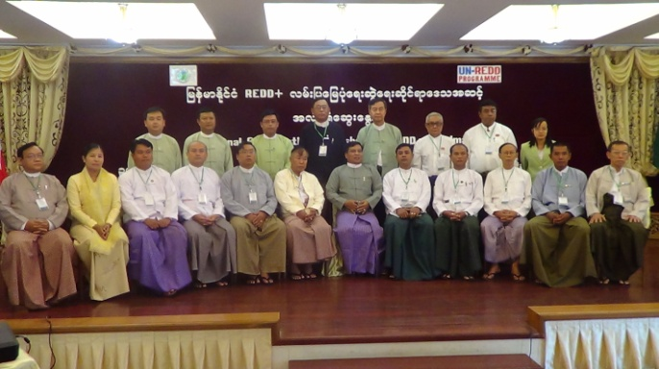
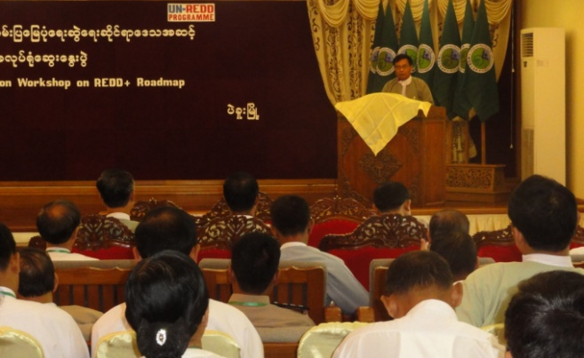
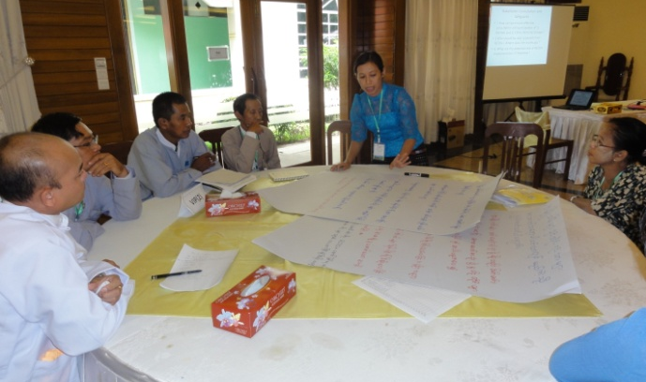
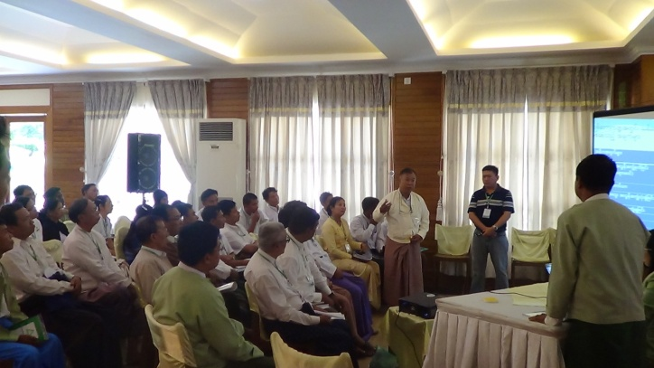
Opening Speech by U Kyaw Htay, Regional Minister for Ministry of Mining and Forestry, Bago Region

