UNITED NATIONS DEVELOPMENT PROGRAMME  BDP/EEG - MISSION REPORT SUMMARY  Date: 20 Oct. 2014 |  |  |  | 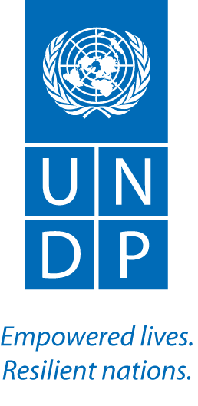
Name: Joel Scriven, UN-REDD |  | Tel No. +66909656748
Approved Mission Itinerary:  BKK-Phnom Penh-BKK |  | List of Annexes:
Inclusive Travel Dates: |  | Key counterpart(s) in each location:
2-5 Feb 2015 |  | - UNDP CO (Claire Van der Vaeren, Setsuko Yamazaki, Napoleon Navarro, Enrico Gaveglia, Chhum Sovanny, Moeko Saito-Jensen)  - REDD+ Taskforce Secretariat (Sovanna Nhem, Kimhy Lun, Mathieu Van Rijn, Saret Nhem)
Purpose/Objectives of Mission

The objectives of this mission, undertaken with the UNDP REDD+ Principal Technical Advisor, Tim Clairs, were to:
- Introduce UNDP-CO and REDD+ Taskforce Secretariat (RTS) staff, and government counterparts (in the Forest Administration (FA) and Ministry of Environment (MOE)), to the new UNDP REDD+ regional technical advisor for Cambodia;
- Support planning for the FCPF/UN-REDD Programme Executive Board Committee (PEB) and 2015 FCPF implementation;
- Receive updates on the status of Cambodia’s REDD+ readiness, particular in relation to the National REDD+ Strategy.

Context

Cambodia is one of two countries in the Asia-Pacific region for which UNDP has been invited to be the Delivery Partner for the World Bank’s Forest Carbon Partnership Facility (FCPF). The FCPF Cambodia project document, which is based on the joint REDD+ readiness roadmap used also by the UN-REDD National Programme, was signed in December 2013. The FCPF Inception Workshop took place in March 2014. Implementation in 2014 focused on delivery of the UN-REDD National Programme (NP), the UNDP component of which is now completed. 2015 is a key year for FCPF delivery.

Summary of Mission Activities/ Findings

The key results of the mission were:

- Meetings were held and agreement reached with CO staff to discuss FCPF implementation arrangements and work plans for 2015.
- RTS staff shared key 2014 achievements (UN-REDD and FCPF) and 2015 work plans.
- Meetings were held with government counterparts (in Ministry of Environment and the Forest Administration) to discuss and agree on technical support modalities from UNDP and priorities for implementation in 2015. Noted from these meetings was a general sense of support for a project-based approach to REDD+ implementation – possibly based on misconceptions of the full implications of this approach vis implementation of REDD+ under the UNFCCC.
- Introduction meetings were held with partners in JICA-funded technical advisory positions within the Forest Administration.
- A meeting was held with FAO regarding the delivery of Outcome 4 (on national forest monitoring system and forest reference (emission) levels) – the proposal document to be shared by FAO for review/comment.

Follow up actions:  - FAO: share proposal for implementation of Outcome 4.  - Scriven: review and provide feedback on: proposal by fisheries for demonstration activity in mangroves and flooded forests, and FAO proposal for outcome 4 implementation.  - Scriven: provide technical support to the CO for the implementation of FCPF including through the coordination of support from global UNDP REDD+ advisors, with immediate focus on the national REDD+ fund, safeguards information system and grievance redress mechanism.  - Scriven: provide information to the government, through the CO, on the differences between project-based and national approaches to REDD+ implementation. |  |  | Distribution List:  - Tim Clairs, UN-REDD UNDP PTA  - Moeko Saito Jensen, UNDP CO  - Anupam Bhatia, CTA

