UNITED NATIONS DEVELOPMENT PROGRAMME  BDP/EEG - MISSION REPORT SUMMARY  Date: 28 September 2013 |  |  |  | 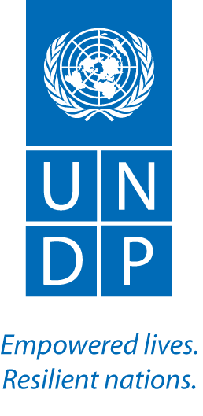
Name: Aki Kono  UN-REDD UNDP RTA |  | Tel No.
Approved Mission Itinerary:  BKK- Phnom Penh – BKK |  | List of Annexes:
Inclusive Travel Dates: |  | Key counterpart(s) in each location:
27 Sept 20133 |  | - Dr. U Sirita, Deputy Director, Forest Administration  - Jeannette Gurung, WOCAN  - Over 35 participants
Purpose/Objectives of Mission
To organize with WOCAN the National Forest Dialogue: Exclusion/Inclusion of Women in REDD+.
Context
WOCAN, UN-REDD and the USAID-funded Lowering Emissions in Asia’s Forest (LEAF) project are collaborating under the Joint Initiative for Women’s Inclusion in REDD+. Building on the findings of the joint regional scoping study, WOCAN and UN-REDD are conducting a national level research in Cambodia. A draft national study report is now ready, and an expert dialogue was organized in the country to validate its findings and to formulate detailed recommendations based on the findings. In November, those recommendations will be presented to the country’s REDD+ policy makers for their consideration.

Summary of Mission Activities/ Findings

About 35 participants (50% men) from a range of government institutions, local communities and development partner organizations attended the workshop. Dr. U Sirita, Deputy Director General, Forestry Administration opened and closed this one day workshop, and her commitment and leadership on this issue was apparent as she actively participated in the whole event. Both the male and female participants were very actively exchanging their views, and community participants raised many relevant points. This workshop was jointly facilitated by Jeanette Gurung of WOCAN and Aki Kono.

In the morning, the participants were asked to validate the findings of the report on factors causing women’s inclusion in Cambodia. In the afternoon, the participants were asked to consider, match and prioritize the barriers validated in the morning and potential solutions discussed in the report to produce a framework of key recommendations for the Nov workshop with key REDD+ policy makers. The following table shows the selected priority barriers and solutions at the policy and community levels.

Barrier | Best Practice (solution to be scaled up)
Policy and Institutions
- Cultural norms  - (1) Lack of recognition for women as stakeholders  - (2) Inadequate gender disaggregated data  - (2) Lack of financial commitment  - (2) Lack of women’s representation | - Female leadership and champions  - Women in networks and federations  - Gender disaggregated analysis and planning
Local communities
- Too few women leaders and role models  - Lack of income generation opportunities  - Lack of women’s representation  - Cultural norms | - Women in networks and federations  - (1) skills building  - Female leadership and champions  - Ensuring women’s representation and participation

Follow up actions:  - WOCAN to complete the recommendation section of the national report based on the outcome of this workshop  - UN-REDD NP in Cambodia to organize a workshop with key REDD+ policy makers to consider the national report findings and recommendations.  - UN-REDD NP to support the implementation of supported recommendations. |  |  | Distribution List:  - Tim Boyle, UN-REDD UNDP RTA  - UNDP UN-REDD

