UNITED NATIONS DEVELOPMENT PROGRAMME  BDP/EEG - MISSION REPORT SUMMARY  Date: 4th April 2013 |  |  |  | 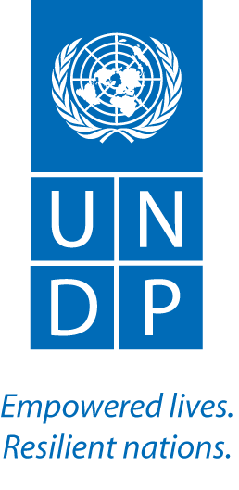

Name
Estelle Fach, UN-REDD/UNDP

Approved Mission Itinerary:
Geneva- Torino- Geneva
Inclusive Travel Dates: |  | Key counterpart(s) in each location:
14-18 April 2013 |  | UNODC, UNDP and UNSSC colleagues
Purpose/Objectives of Mission
Receive training of trainers on integrating anti-corruption in UNDAF
Summary of Activities/ Findings

Training of trainers
- Training has been developed jointly by UNODC and UNDP with the UN System Staff College and is targeting UN country teams (UNCTs)
- Trained to deliver a 2.5 day training that covers sessions on the following topics : introduction to anti-corruption, the corruption/development nexus, anti corruption and the global, regional and national normative frameworks, the value of the UN Convention Against Corruption, the UNDAF process, Country analysis, linking analysis with results and addressing challenges in anti corruption programming. Each session was received once and delivered by the trainees the next day.
- Emphasis on presentation and facilitation skills – with practical exercises to convey complex content without powerpoints, and individual feedback on attitude, knowledge, time management and communication skills.
- Now part of a pool of trainers who may be called on, once a year, to deliver this training to requesting UNCTs embarking on developing or revising their UNDAF
- The Training Resource Guide, facilitation tips and presentations are available upon request.

Next steps:

- UNODC and UNDP teams will revisit the resource tool kit, taking into account the comments and input received by participants during the ToT
- UNDP and UNODC will discuss with DOCO about the results of the ToT and the availability of a new certified pool of experts to provide training on anti-corruption in the UNDAF processes.
- UNDP and UNODC will explore with DOCO the possibility to fund at least three roll out training in the first year.

Bilateral side meetings
- UNODC (Candice) had advice on consultants for DRC anti-corruption work and interested in collaboration
- UNDP CO Kenya governance head (Sheila Ngatia) willing to commit some staff time to support to be expected on targeted support – modalities to be discussed
- UNDP Philippines (Emmanual Buendia) reiterated interest in following the TS anti corruption work.

Follow up actions:  - Estelle to send suggestions to revise the training manual by 10 May  - Estelle/ Tsegaye to examine Bhutan, Kenya UNCAC self-assessment “beyond the minimum” for their relevance to REDD+ and links with REDD+ Targeted Support work by 8 May  - Estelle to distribute material on “how to deal with challenges in anti-corruption programming” to regional teams by 25 April  - Estelle to follow up with Josep on consultant for DRC work |  |  | Distribution List:  UN-REDD team (global and regional)  UNDP PACDE Team  Note that the BTOR will also be place on the UN-REDD workspace, access restricted to UN staff

