UNITED NATIONS DEVELOPMENT PROGRAMME  BDP/EEG - MISSION REPORT SUMMARY  Date: 9 July 2013 |  |  | 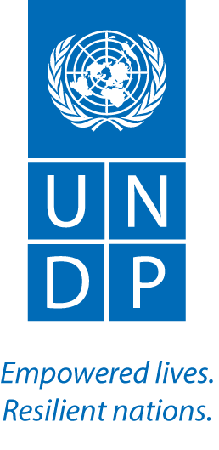
Name: Tim Boyle, UN-REDD |  | Tel No. +66819005402
Approved Mission Itinerary:  BKK-Phnom Penh -BKK |  | List of Annexes:
Inclusive Travel Dates: |  | Key counterpart(s) in each location:
13-14 June, 2013 |  | - CMB: UNDP CO (Moeko Saito-Jensen, Sovanny Chhum)  - CMB: REDD+ Task Force Secretariat (Chea Sam Ang)  - CMB: Secretariat staff (Kimhy Lun, Peter Iversen)
Purpose/Objectives of Mission
To assist the CO in conducting an ICA as a contribution to the R-PP Assessment Note

Context
UNDP’s due diligence process in preparation for implementation of the R-PP requires an assessment of risks and issue likely to be encountered in implementation. The Oslo governance Centre has recently developed guidance on “Institutional and Context Analysis”, which provides an objective approach to assessing such risks, and offers a useful tool as part of the due diligence process. However, as the Cambodia CO had no prior experience of applying ICA, they requested my support in undertaking an ICA for REDD+ in Cambodia.

Summary of Mission Activities/ Findings
Most of the work was conducted with Moeko Saito-Jensen, a JPO who has recently arrived at the CO. With Moeko, we conducted a number of interviews (e.g., with Kimhy Lun and Sovanny Chhum) on informal institutions affecting decision making in the forest sector in Cambodia and also reviewed reports on formal institutions. Moeko took responsibility for preparing a report on institutions and stakeholders.

A meeting was held with the National Programme Director, Chea Sam Ang, to discuss various issues, including follow-up to the recent mid-term review, and possible modifications to implementation arrangements to overcome current barriers associated with poor FA-GDANCP relations. (Note … subsequently, the DG of GDANCP issued a decision completely replacing the GDANCP team working on UN-REDD. Immediately afterwards, contracts which had been blocked for months by GDANCP inaction were approved for signature, and at the first meeting of the Secretariat team following the changes, concept papers/ToRs for 8 activities were approved immediately, compared with none that had been approved in the previous several months).

A meeting was held with Peter Iversen, Senior Technical Advisor to UN-REDD, to discuss work planning for Q3, including plans for safeguards and benefit distribution work..
Follow up actions:  - Moeko to complete ICA draft, for review  - TB to incorporate ICA into R-PP Assessment Note  - Follow-up on Q3 work planning |  |  |  | Distribution List:  - Tim Clairs, UN-REDD UNDP PTA

