UNITED NATIONS DEVELOPMENT PROGRAMME  BDP/EEG - MISSION REPORT SUMMARY  Date: 9/4/2013 |  |  | 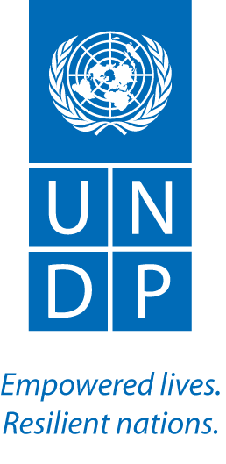
Name: Tim Boyle, UN-REDD |  | Tel No. +66819005402
Approved Mission Itinerary:  Bangkok-Thimphu-Bangkok |  | List of Annexes:
Inclusive Travel Dates: |  | Key counterpart(s) in each location:
3-5 Apr., 2013 |  | - RGoB: Jigme Tenzin; Sigyel Delma, WMD  - CO: Karma Rapten/Tashi Dorji  - Consultant: Nedrup Tshering
Purpose/Objectives of Mission
To assist in implementation of Targeted Support to RGoB
Context
UN-REDD support to Bhutan has been well-coordinated across agencies, and integrated with other initiatives. A request from the RGoB for targeted support was received in May, 2012, consisting of $40k from UNDP, $40k from FAO, and $25k from UNEP. The UNDP CO is also providing funding of approximately $60k over 18 months, and funding is available from PEI for work on benefit distribution. UNDP TS funds are being used for an assessment of corruption risks, benefit distribution options, and together with UNDP TRAC funds, to support the development of a National REDD+ Strategy for Bhutan. A national consultant has been hired for this purpose.

Summary of Mission Activities/ Findings
Initial discussions with RGoB (WMD) and the CO focused on the recent accession of Bhutan to the FCPF, and the condition imposed by the FCPF PC that new countries submit an R-PP by July 31st, 2013. It was recognized that, since an R-PP would incorporate much of the information that will subsequently be useful for a National REDD+ Strategy (for example, analysis of drivers), and because Bhutan has asked UNDP to be its Delivery Partner for the FCPF, there was a strong justification for re-aligning the consultant’s work with preparation of the R-PP. Consequently, the mission focused on developing a new workplan for the national consultant with the goal of completing an R-PP by July 31st, 2013.

Discussions were also held with WMD on activities to be undertaken up to and including July in order to strengthen the R-PP. These include:
- Mobilizing the existing Technical Working Group to support the R-PP preparation process
- Dzongkhag-level awareness raising activities on CC, REDD+ and the role of forests
- Organizing a national stakeholder consultation process to review the contents of the R-PP

In a meeting with Chencho Norbu, Director General, DoFPS, the DG emphasized the importance of REDD+ and its relevance to Department of Forest & Park Services. REDD + is strongly reflected in the 11th Plan document of the DoFPS.

The DG mentioned that the Department was aware of FCPF and has already directed WMD to take lead in preparing the R-PP in consultation with other relevant agencies. Since the dateline for submission is July 31st, 2013, the Department would support the idea of having R-PP first and then strategy later from the consultant hired with UN-REDD TS funds.

Regarding the change in deliverables of the hired consultant, DG instructed WMD to work with procurement section of AFD and make necessary changes. He also instructed the consultant and WMD to start with the process immediately by looking in to the template of the R-PP and come up with work plan along with the information that might be required. The work plan should have clear time schedule for proper monitoring so as to meet the July 31st dateline.
Follow up actions:  - Discuss with FAO (Scriven) possible contributions to Components 3 and 4 (completed – FAO will prepare these components, with a mission likely in early June)  - Utilize the FPIC repository to identify awareness raising materials that can be easily adapted for use in Bhutan  - Finalization and submission of R-PP |  |  |  | Distribution List:  - Tim Clairs, UN-REDD UNDP PTA

