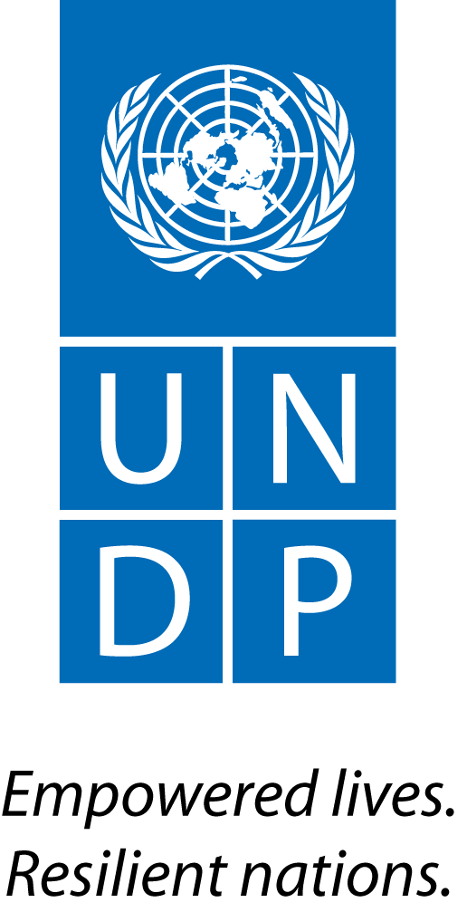 |  | Back to Office Report  Submitted by Aki Kono, UN-REDD  Title Regional Technical Advisor  Date submitted 28 Aug 2014
1. Practice area: BDP/EEG
2. Mission period (incl. of travel days) From: 5 – 8 August 2014
3. Type of mission:  Technical backstopping and workshop |  | 4. Clients  Forest Department, UN-REDD PMU, FAO and UNDP COs Sri Lanka
5. Purpose of mission: programme implementation oversight.  7. Mission members  Aki Kono, UNDP UN-REDD RTA, Ben Vickers, FAO UN-REDD RTA, and Till Neef, CTA |  | 6. Documents, materials, resources  - Draft institutional review report  - Progress report/PPT on study of drivers of D&D  - ToR for government assessment  - Internal review ToR  - Brown bag lunch PPT
8. Costs
UNDP/UN-REDD global budget
9. Brief summary of the mission

The purpose of this mission was to: i) ensure that the team undertaking the study on drivers of deforestation and forest degradation was provided with necessary guidance and direction during the implementation ; and ii) take care of other matters related to the National Programme activities led by UNDP to ensure timely, logical and well-sequenced output delivery.

Study on Drivers of Deforestation and Forest Degradation

The local university team recruited to undertake this study reported on their progress. During the presentation and discussion, preliminary findings were presented by the team. The north central and eastern parts of the country have seen the most negative changes, and key drivers have been linked to agricultural expansion and hydroelectric dam constructions. Also, several issues related to the spatial data availability, scale of analysis (local vs national), definition of home garden, political factors, etc. were discussed, and specific approaches to those issues were agreed. The team plans to deliver their first draft by mid-September, and the final draft is expected by mid-Oct. Despite the initial difficulties and misunderstandings, the university team seems to be well on track.

CBR

A short discussion with Ms. Shireen Samarasuriya, GEF Small Grant Programme National Coordinator took place. The meeting was also attended by Ramitha Wijethunga, CO Programme Officer and Till Neef, CTA. The meeting confirmed that the issue we faced earlier regarding the procedures and ways in which the Country Plan for CBR should be prepared was primarily based on a simple misunderstanding as a result of miscommunication. Both sides now agree that having the CTA develop a skeleton of the Country Plan is strategic and considered a time saving measure. Shireen requested the CTA to help come up with a highly prescriptive document that would help the National Committee avoid any disputes and confusions during the selection process. She also stressed that the CP will be a living document thereby any necessary strategic alignments might be made later as and when appropriate (ie. alignments with PAMs).

Institutional Review Report and Stakeholder Workshop

This work has been let by FAO together with CTA. The draft report produced by the team seems only partially complete when compared against the ToR. The main shortcomings include a lack of capacity assessment reference points, and biased selection of institutions reviewed. The stakeholders during the validation meeting also pointed out similar weaknesses. The team will now address these shortcomings in the next version of the report.

Internal Review

The ToR for the proposed internal review were discussed during the regular quarterly update session attended by the NPD, senior FD staff, PMU, senior managers of FAO and UNDP, RTAs and CTA. The confusion on the objective of this review was discussed and clarified. The objective is to ensure operational effectiveness and efficiency of the Sri Lanka UN-REDD National Programme to deliver expected key results in a highly relevant and timely manner. However, some understood this to be an external evaluation. Also, the role and responsibilities of independent facilitator was discussed and agreed.

Other issues
- Participated in the interviews for the national expert position for the Roadmap work as a panel member.
- Organized a brownbag lunch like session on REDD+ and UN-REDD with the FAO and UNDP staff members.
- Reviewed Outcome 4 related activities and packaging options with the CTA, FAO and PMU
- Worked with the CTA on ToR for governance assessment and REDD+ fund management.
- Discussed with the NPD regarding the possibility of organizing a workshop on water related issues with other partners to discuss, among others, about REDD+ in the context of water scarcity and management, as it is one of the most critical environmental issues in Sri Lanka. This is to increase awareness among policy makers across land use and economic sectors and their support for REDD+ and its linkages with other key environmental and social issues. This is currently planned for Dec or Jan next year.

11. Follow up action matrix
Action to be taken | By whom |  | Expected completion date
ToR for governance assessment and fund management to be finalized | Till and Aki |  | Early September
Internal review official approval to FAO/UNDP | NPD |  | Mid-August
Internal review report revised draft | Till, Ben and consultants |  | September
First draft of D&D study report | University team |  | Mid-September
Final draft of D&D study report | University team |  | Mid-October
Water conference idea note | Nalin |  | Mid-October
12. Distribution List
UNDP UN-REDD

