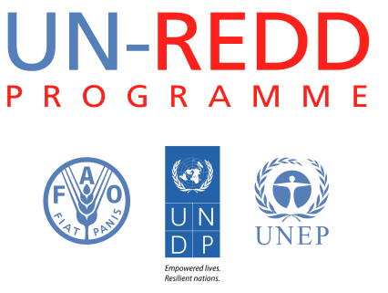
Engaging with the Private Sector and Private Sector Finance to Achieve REDD+
CONCEPT NOTE

I. Summary
Objective | To facilitate the phase out of deforestation and forest degradation from productive and financial supply chains. It will achieve this by (i) identifying necessary incentives, levers and enabling conditions for supply chain actors to adopt widely recognized good agricultural practices and, (ii) by identifying financial instruments and mechanisms to channel private-sector finance and investment from conventional into sustainable land-use activities and REDD+.
Expected results | - Raised awareness and behavioral shifts: developing critical information and knowledge on REDD+ risks and opportunities that can improve private sector decision making on REDD+ and catalyze transformational change.  - Policy and regulation: formulate, advance, and support the installment of the policy, regulatory and institutional frameworks and enabling conditions required to effectively engage private sector productive and financial supply chains in REDD+.  - Capital mobilization: supporting the mobilization of private capital along productive supply chains by improving the risk-return profiles of key REDD+ activities and developing investment instruments that allow investors to reduce the ‘forest footprint’ of their investments.
Level of intervention | Global: conceptual work, advocacy, and global partnerships  National: Indonesia, Ghana or Côte d'Ivoire, Paraguay or Colombia
Related work area, as defined in the UN-REDD Programme Strategy | Private sector engagement  REDD+ in a Green Economy  (The proposal relates to Outcome 6 “Green economy transformation and REDD+ strategies and investments are mutually reinforcing” and Output 4.5 “Private sector engagement in REDD+ readiness and broad stakeholder consensus on private sector engagement is built” of the Support to National REDD+ Action: Global Programme Framework 2011-2015 (SNA).
Total concept duration | 1 January 2014 - 31 December 2015 (24 months)
Total concept amount | US$ 4,895,250
Total amount requested | US$ 3,584,500 for activities to be undertaken until 31 December 2014.

II. Background
Forests provide tremendous value, yet the world’s forested areas continue to decrease. Forest-related activities captured by traditional economic measures are predominantly extractive and often involve conversion to other types of land use. The causes of deforestation and forest degradation are complex and interconnected, involving various sectors of the economy and multiple actors yet the largest single driver of deforestation remains the production of agricultural commodities. Current rates of deforestation and forest degradation can threaten economic progress and human well-being, which are dependent on healthy forest ecosystems, which provide shelter, food, timber and non-timber forest products, jobs, medicine, water, climate regulation and energy to more than one billion people.
The UN-REDD Programme was created in 2008 to assist developing countries to build capacity to reduce emissions from deforestation and forest degradation and to participate in a future REDD+ mechanism. As part of this, the Programme will support selected countries in their efforts to engage the private sector to achieve REDD+.
The private sector is a key actor in both development trajectories and resource use. They account for around 60% to 70% of both global GDP and jobs and have a material role to play in deforestation and forest degradation globally. Changing private sector behavior and land-use practice is therefore critical to the success of REDD+. Increases in global population, wealth, and the resulting changes in consumption patterns will considerably intensify the pressure on land and the forest frontier in the coming decades. This suggests that the role of the private sector in the global land-use economy will increase, not decrease. Conclusive empirical evidence is lacking, yet the lack of private sector engagement and investment in ‘forest-friendly’ activities to date implies that in the prevailing economic paradigm it is generally more profitable in the short-term to include deforestation in financial and productive supply chains than to exclude it.
Two broad groups of private sector actors are key to the success of REDD+, yet have hitherto been marginal to the REDD+ process. These are the private actors in ‘forest risk’ agricultural commodity supply chains and private sector financial institutions. These stakeholders are often the primary agents of change in many forest landscapes: they are key actors in current patterns of deforestation-based land-use (both planned and unplanned with wide-ranging environmental and social impacts) yet they are also integral to the success of REDD+. They can be a source of investment, implementation and innovation in the transition to a green economy and the reasons for focusing on these two broad private sector groups is expanded on below:
- Engagement with major commodity market players—producers, processors, traders, retailers— is imperative in order to define and implement effective land-use legislation / regulation (including incentives and sanctions), better management practices, and appropriate environmental and social standards. Yet, while increasing market demand for responsible agricultural products (through platforms such as the Consumer Goods Forum (CGF) or the different roundtables on sustainable commodities) has already brought some change on the ground and benefits for agricultural communities, it is also necessary to build capacities at the country level, increase market access and provide support for financial mechanisms and policies if good agricultural practices are to be widely adopted in producer countries.
- Engagement with financial intermediaries is also critical given the enabling role of investment and finance in REDD+ and its interaction with land use change and commodity supply chains. Most physical land-use activities that directly or indirectly impact the forest, such as timber extraction, cattle ranching, the production, trade and distribution of soft commodities, require one or more enabling financial transactions (such as provision of a grant, loan or equity investment) or services (such as different types of insurance or fund management). The scale of existing capital flows into the drivers of deforestation is vast relative to anticipated REDD+ funds. Despite enormous financial assets in the global capital markets, a range of factors has limited deploying these assets towards REDD+. Unless deforestation is phased out of the ‘financial economy’, it will be extremely challenging to address deforestation in the ‘physical economy’.
Engaging the private sector is a means to an end to effectively transform private sector behavior and practice in land use. The magnitude of the challenge to slow, halt and reverse deforestation and forest degradation is such that an unprecedented reconfiguration of the productive and financial supply chains will be required to achieve REDD+. The ‘systemic nature’ of unsustainable land-use patterns, and the resulting need for approaches and solutions that are equally ‘systemic’, have received relatively little attention in the global debate on REDD+ compared to other topics such as Measurement, Reporting and Verification (MRV) or the development of safeguards.
The UN-REDD Programme has increased its focus on the private sector over the past twelve months though such work as clarifying the role of the private sector in REDD+ and articulating how REDD+ can contribute to the transition to a green economy. However, in order to build on these foundations, a package of activities needs to be defined whereby practical interventions at the global and national levels bring the productive and financial supply chains into the global and national REDD+ dialogue. Given their work with the relevant supply chains and extensive private sector networks, UNEP Finance Initiative (UNEP FI) and the UNDP Green Commodities Facility (GCF) are uniquely positioned to address these challenges. This document sets out a proposed approach.

III. Results framework and theory of change
This proposal aims to contribute to the phase out of deforestation and forest degradation from productive and financial supply chains. (See Figure 1 below on the linkages between the physical and the financial economy underlying forest-risk commodities trade, and REDD+ financing). It will achieve this by (i) identifying necessary incentives, levers and enabling conditions for supply chain actors to adopt sustainable agricultural practices and, (ii) by identifying financial instruments and mechanisms to channel private sector finance and investment, away from conventional, and into sustainable land-use activities and REDD+.
The proposal builds on the comparative advantages of the UNEP FI and the UNDP GCF, under the auspices of the UN-REDD Programme, to address the single largest driver of deforestation (the production of agricultural commodities), and to facilitate private sector finance and investments into REDD+ and sustainable forest management and utilization. The proposal focuses largely on agricultural commodity production through both the ‘physical economy’ (production and consumption) and the ‘financial economy’ (financial transactions and services) simultaneously, capitalizing on the fact that global production and trade of key agricultural commodities is highly concentrated both in terms of producers/traders, and is enabled to varying degrees by the finance sector. This proposal seeks to address the well-documented issue that agricultural and private sector finance stakeholders, who are critical to the ultimate success of REDD+, have largely been marginal to the REDD+ debate so far. The proposal focuses on three pilot countries in 2014-2015, with a view to scale up to ten countries for a second phase in 2015-2020.
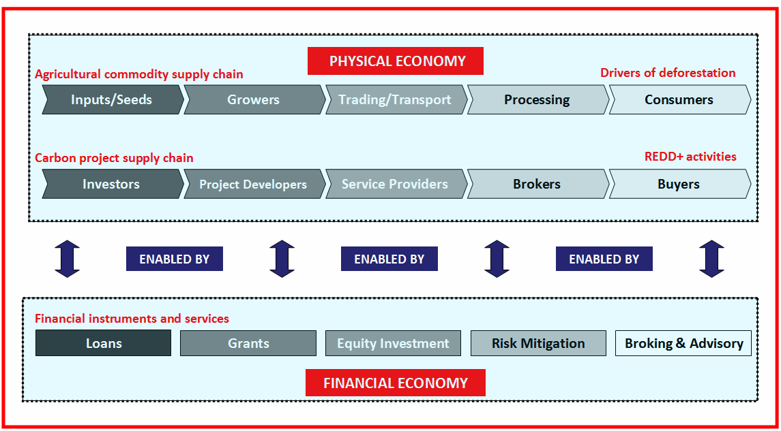
Figure 1: The relationship between the 'physycal economy' and the 'financial economy'.
A programme of work has been designed that addresses issues related to three barriers to achieve REDD+: awareness and behavioral failures; policy failures; and capital failures. (See Table 1 below). The outputs expected from the implementation of this package are presented below (full description of activities in Annex I):
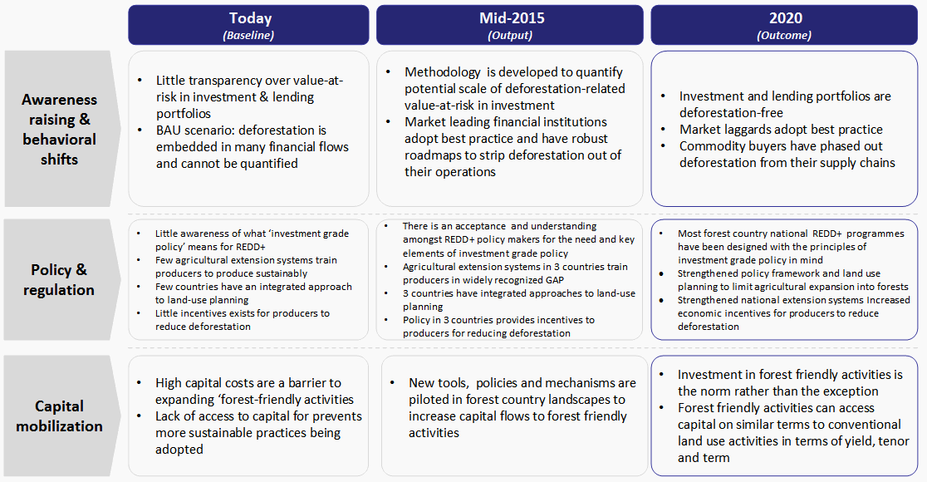
Table 1: Theory of Change
Expected Result 1 – Awareness raised and behavioral shifts: developing critical information and knowledge on REDD+ risks and opportunities that can improve private sector decision making on REDD+ and catalyze transformational change
Indicative Activities
- Examining the finance and economics of REDD+ from a country perspective and building a robust business case for the involvement of the private sector in REDD+ in the selected countries, identifying investment shortfalls and opportunities for the private sector. This will in turn inform the development of investment plans for REDD+ implementation.
- Providing information that allows investors and companies to reduce their exposure to deforestation in their investment portfolios and supply chains. This will be done by identifying the ‘hidden’ financial risks which are currently not quantified by the financial community yet to which stakeholders are exposed to through financial or commercial relationships. This will contribute to the development of a methodology to measure hidden ‘value at risk’ related to direct or indirect deforestation exposure in institutional equity investment portfolios based on exposures and holdings in publically listed companies.
- Developing a series of innovative communications products (in multiple languages) that demystify the private sector and private sector finance with a view to narrowing the ‘perception gap’ that currently exists between public and private sectors actors.
- Engagement with commodity buyers - supermarkets, brands, manufacturers, traders and banks – that purchase and finance forest-risk commodities from selected countries, in order to influence supplier and producer behavior. The corporate engagement will assist participating companies to develop corporate policies to reduce deforestation, and identify associated investments in sourcing areas. As part of achieving this outcome, the initiative will work with individual companies, industry associations, notably the Consumer Goods Forum, the different roundtables on sustainable commodities, the Tropical Forest Alliance 2020 and the World Cocoa Foundation.
Expected Result 2 - Policy and regulation: formulate, advance, and support the installment of the policy, regulatory and institutional frameworks and enabling conditions required to effectively engage private sector productive and financial supply chains in REDD+
Indicative Activities
- Analyzing and examining the extent to which favorable enabling conditions or ‘investment grade policy’ are in place to attract investment and finance into sustainable land use activities and supply chains in selected countries; identifying key bottlenecks and providing recommendations on opportunities for intervention.
- Supporting the establishment and operation of National Commodity Platforms for forest-risk commodities within the Ministries of Agriculture (or a more suitable government agency). Setting up specific task forces focused on deforestation, convening all producers and supply chain stakeholders, to bring the agricultural sector and international supply chains into dialogue and focusing activity on the issue of deforestation. This will facilitate the other activities below.
- Strengthening policy frameworks and land use planning to limit agricultural commodity expansion into forests. This will be backed up by recommendations to reform national laws that may still promote deforestation from commodity production and expansion. This may include introducing new laws to recognize High Conservation Value forests, or changing land use categories so that forests are not available for plantation concessions. Land use planning will be in conjunction with the large producers and buyers to assist in development and implementation of the land use plans in key commodity producing landscapes.
- Strengthening national agricultural extension systems of Ministry of Agriculture to train producers to produce sustainably and not deforest. Working within government agricultural extension agencies to expand their focus beyond conventional agriculture practices for the targeted commodities to promote good agricultural practices and environmental sustainability (including reducing deforestation) in priority landscapes at the agricultural frontier. The agricultural extension systems themselves will be assessed and systemic and institutional awareness over deforestation raised and capacity to tackle the issue strengthened. Private sector extension officers from traders, exporters and buyers, will be connected to and coordinated with Ministry of Agriculture extension services to provide farmers and enterprises with more efficient public-private extension services. Training to be provided to government extensionsists will include: GAP, REDD+, legal compliance, watershed management and improved access to markets.
- Increasing economic incentives for producers to reduce deforestation. Complementing the land use planning and agricultural training by working with the relevant institutions to provide an array of economic incentives to farmers to reduce their interest to expand into forested areas. These may include a combination of the following:
  - Targeting of positive incentives, as appropriate within the national REDD+ frameworks, to forest landowners at agricultural frontiers.
  - Provision of public policy-based incentives such as subsidies on equipment and technology to improve their production practices. This will be particularly relevant to sustainable cattle and the introduction of silvopastoral systems.
  - Strengthened enforcement of forest law to recue illegal activity in protected forest areas.
  - Water payments to producers connected to the conservation of forests in important upper watershed areas.
  - Connecting buyers for certified products to producers, through the National Commodity Platforms. This can also include innovative marketing campaigns to promote “deforestation free” commodities.
- Engaging with the Green Climate Fund and convening representatives from the finance sector to ensure that the Green Climate Fund and particularly its Private Sector Facility are fit-for-purpose to deliver efficiently, effectively and equitably on REDD+ at the required scale.
Expected Result 3 – Capital mobilization: supports the mobilization of private capital along productive supply chains by improving the risk-return profiles of key REDD+ related activities and developing investment instruments that allow investors to reduce the ‘forest footprint’ of their investments
Indicative Activities
- Analyzing the feasibility of, and developing recommendations for, the creation of in-country finance delivery mechanisms for scaling up long term financing for agricultural smallholders in three UN-REDD countries. This will include specific implementation plans for pilots in each country with a focus on gender equitable financing considerations.
- Examining the application of the Social Impact Bond (SIB) model to REDD+ and forest landscapes (so establishing the feasibility of an ‘Environmental Impact Bond’ or EIB). Exploring the relevance of the model to environmental finance, identifying possible eligibility principles and criteria and identifying diverse case studies to explore different potential revenue streams and structures.
- Developing three ‘zero net deforestation’ equity indexes. These investment products will facilitate the transition of investment from portfolios with a high exposure to deforestation to portfolios with a low exposure to deforestation. They will also help develop a financial ‘track record’ - which is of significant importance to investors - for ‘best in class’ companies.
Risks
As with any proposal of this nature, there are various risks and uncertainties that might impact this proposal during the period of implementation. Some risks that could possibly affect components of the proposal, along with potential ways to mitigate them are outlined below:
- Risk: a lack of institutional and personnel continuity at the country level might impact project delivery.
  - Risk mitigation: activities will be structured with a broad involvement of relevant personnel both in forest countries and in any other relevant geographies to ensure that there is institutional continuity despite unforeseen changes in personnel involved in the projects.
- Risk: resistance to engage with private sector among some REDD+ stakeholders.
  - Risk mitigation: activities will be structured to involve and engage a broad stakeholder base and ensure relevant on-going in-country initiatives of both the UN-REDD Programme and other appropriate actors are leveraged.
- Risk: that there is insufficient engagement from private sector actors.
  - Risk mitigation: both UNEP FI and UNDP GCF have very broad networks of formal and informal private sector partners. This should ensure that there is sufficient private sector involvement even if due to unforeseen circumstances the initial choice of partners is not able to engage in the projects.

IV. Management arrangements and partnerships
The work will be coordinated by the UN-REDD Programme under the leadership of the UNEP Finance Initiative, based in Geneva, and with the UNDP Green Commodities Facility based in Panama as the key implementing partner. Other partners will be brought in as needed including private sector actors. UNEP FI and UNDP GCF will lead on global work with their respective sectors, finance and productive, to ensure the private sector partnerships and tools are in place to support change on the ground. Pilot country activities will be led by UNDP, with joint UNEP/UNDP teams supporting developing countries in key project activities.
As shown in Figure 2, below, the project will contribute to the overall work streams on Private Sector Engagement and REDD+ in a Green Economy (Output 4.5 and Outcome 6, respectively, of the Support to National REDD+ Action: Global Programme Framework 2011-2015 (SNA)).
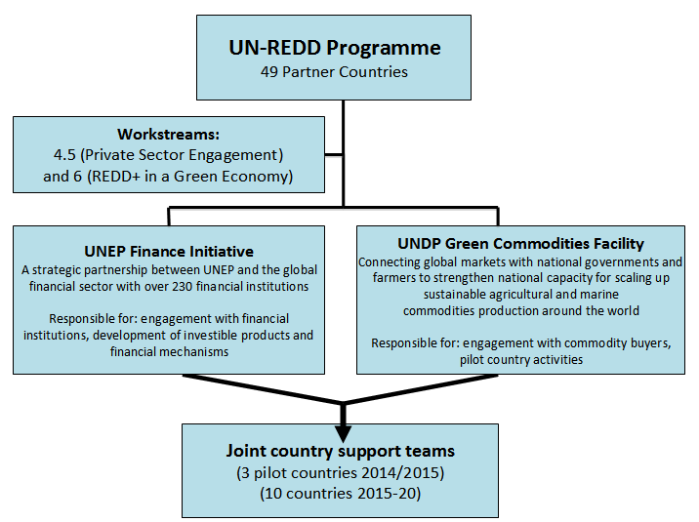
Figure 2. Organizational structure
The UNEP Finance Initiative is a 20-year-old partnership between UNEP and over 230 financial institutions globally, representing the banking, insurance, and investment sectors. UNDP’s Green Commodities Facility has been working since 2009 to connect global markets, including major companies, with national governments and farmers to strengthen national capacity for scaling up sustainable agricultural commodities production around the world. This combination of skills, resources and access to key partners creates a unique platform with both global and national presence in addition to strong links to both the public and private sectors.
A Steering Committee will be formed by the UN-REDD Programme with UNEP, UNDP, donors and two representatives of the private sector to jointly oversee and coordinate activities, progress and results. UNEP and UNDP will then lead the management of their respective activities within the project.
A consortium of partners will be put together to work on specific activities, each bringing their comparative advantages. For example, in the work focused on the productive supply chains, NGOs assisting farmers might work in tandem with think tanks to develop in-depth analysis required to engage national governments, different supply chain actors and other REDD+ stakeholders. UNDP’s corporate partners, such as Mondelez and IKEA, will also be heavily engaged on supply chain management activities. In addition, leading actors in the finance and environment field will be partners in the delivery of finance-related activities. Actors might include: UNEP FI signatories (230 predominantly private financial institutions), leading international law firms with a strong environmental/REDD+ practice, leading private sector initiatives such as the Cambridge Programme for Sustainability and the Natural Capital Declaration, international organizations such as the Global Mechanism and World Bank, as well as relevant specialist companies such as communications firms, Environmental Social and Governance (ESG) research firms and ratings agencies.
Corporate engagement at the global level for actors involved in productive supply chains will be done in close collaboration with the Consumer Goods Forum and other relevant industry associations including the roundtables on sustainable commodities. Linkages and synergies with the work of the Tropical Forest Alliance 2020 will be explored.
Lessons learnt from other ongoing UN-REDD Programme and UNEP FI projects on REDD+ will be sought, including from a project in partnership with the Global Canopy Programme to examine the feasibility of developing an Interim Forest Finance Facility (IFFF) to stimulate private sector investment in REDD+ and sustainable land use activities.
Synergies with and lessons learnt from relevant GEF projects will also be sought, for example with the ongoing UNEP project ‘Greening the Cocoa Industry’ (2011-2016, US$ 15 million) in collaboration with Rainforest Alliance, which aims to change production practices in major cocoa producing countries and business practices in cocoa and chocolate companies, and to reduce deforestation and forest degradation, and restore productive forest landscapes. It is expected that this approach is extended to other forest-risk commodities in GEF VI, and the project will work closely with the UNEP and UNDP GEF teams on a harmonized and mutually reinforcing approach.

V. Monitoring and Evaluation
While an initiative that aims to change the behavior of a wide array of private sector actors will be difficult to monitor, certain indicators have been developed. Results in addressing the drivers of deforestation by engaging the private sector will not be fully in control of the project as effectively addressing these drivers requires complex market transformations and a significant reconfiguration of the productive and financial supply chains.
The outputs will contribute to:
- Improve private sector decision making on REDD+.
- Establish the policy, regulatory and institutional frameworks as well the enabling conditions required to effectively engage private sector productive and financial supply chains in REDD+.
- Mobilize private capital along productive supply chains by improving the risk-return profiles of key REDD+ related activities and developing investment instruments that allow investors to reduce the ‘forest footprint’ of their investments.
Additionally, as per UNDG guidelines for joint programming on resources for monitoring, 5% of the implementation budget has been allocated for monitoring and evaluation costs and is included in the budget of the concept note on “Results Based Management – Managing for Results”. A mid-term and final evaluation of the project will be undertaken.

VI. Indicative Results Framework
Outcome | Output | Agency | Indicative Activity | Indicative Timeline |  |  |  |  |  |  |  | Indicative budget (Q1 -Q4 2014)  (US$) | Indicative budget (Q1 -Q4 2015)  (US$) | Indicative budget (Q1 2014 -Q4 2015) (US$)
 |  |  |  | 2014 |  |  |  | 2015
 |  |  |  | Q1 | Q2 | Q3 | Q4 | Q1 | Q2 | Q3 | Q4
Expected Result 1: Awareness raising and behavioral shifts: developing critical information and knowledge on REDD+ risks and opportunities that can improve private sector decision making on REDD+ and catalyze transformational change | 1. A report examining the economics of REDD+ from a country perspective and building a robust business case for the involvement of the private sector in REDD+ in the selected countries, identifying investment shortfalls and opportunities for the private sector which in turn inform the development of investment plans for REDD+ implementation | UNEP and UNDP | Conduct an economic assessment of the business case for REDD+ in three countries  Convene three national expert workshops to validate results from research  Develop the investment plan for implementation for three countries  (Hire international and national consultants to assist coordinator) |  |  |  |  |  |  |  |  | 300,000 |  | 300,000
Result 1 (cont) | 2. A methodology to measure hidden ‘value at risk’ related to direct or indirect deforestation exposure in institutional equity investment portfolios based on exposures and holdings in publically listed companies | UNEP | Identification of risk categories related to deforestation in supply chains and development of methodology to measure hidden ‘value at risk’  (Partnership agreement with Carbon Tracker) |  |  |  |  |  |  |  |  | 200,000 | 100,000 | 300,000
 | 3. Three written briefs and three short (five minute) animated videos in multiple languages explaining the basics of the private sector and private sector finance for REDD+ professionals | UNEP | Identification of thematic priorities related to private sector in REDD+, research for the development of briefs and videos  Engage with local media  (Hire international consultant to assist coordinator in the development of briefs, hire animation company for the development of videos) |  |  |  |  |  |  |  |  | 150,000 |  | 150,000
Result 1 (cont) | 4. Engagement of commodity buyers (traders, manufacturers and retailers) at global level to develop joint strategies at country level to align supply chains to be deforestation free | UNDP |  |  |  |  |  |  |  |  |  | 225,000 | 112,500 | 337,000
Subtotal, Result 1 |  |  |  |  |  |  |  |  |  |  |  | 875,000 | 212,500 | 1,087,500
Expected Result 2: Policy and regulation: formulate, advance, and support the installment of the policy, regulatory and institutional frameworks and enabling conditions required to effectively engage private sector productive and financial supply chains in REDD+ | 5. A legal, economic and financial analysis of the broad regulatory framework, fiscal policy, subsidies/sanctions and tax code selected countries in the context of REDD+ with a specific focus on the impacts on at least one relevant ‘forest-risk’ commodity supply chain per country. | UNEp | Analysis of the regulatory framework and fiscal policies to understand the extent to which they are compatible with REDD+  (Hire three national analysts/consultants to assist coordinator in in-country legal analysis) |  |  |  |  |  |  |  |  | 200,000 |  | 200,000
Result 2 (cont) | 6. National Commodity Platforms within Ministries of Agriculture established and operational, with stakeholders from the supply chains convened and connecting to UN REDD activities to discuss, plan and collaborate to reduce deforestation from productive supply chains | UNDP | Setting up National Commodity Platforms and specific task forces focused on deforestation within them |  |  |  |  |  |  |  |  | 600,000 | 300,000 | 900,000
 | 7. Strengthened policy framework and land use planning to limit targeted agricultural commodity expansion into forests | UNDP |  |  |  |  |  |  |  |  |  | 300,000 | 150,000 | 450,000
Result 2 (cont) | 8. Strengthened national agricultural extension systems of Ministry of Agriculture to train producers to produce sustainably and not deforest | UNDP | Work within government agricultural extension agencies to expand their focus beyond conventional agriculture practices for the targeted commodities to promote GAP in priority landscapes at the agricultural frontier  Connecting and coordinating private sector extension officers from traders, exporters and buyers with Ministry of Agriculture extension services to provide farmers with more efficient public-private extension services |  |  |  |  |  |  |  |  | 300,000 | 150,000 | 450,000
Result 2 (cont) | 9. Increased economic incentives for producers to reduce deforestation – To complement the land use planning and agricultural training by working with the relevant institutions to provide an array of economic incentives to farmers to reduce their interest to expand into forested areas. | UNDP | Development of an options assessment of possible incentives to reduce deforestation for each of the selected countries |  |  |  |  |  |  |  |  | 250,000 | 125,000 | 375,000
 | 10. A series of briefings analyzing how public finance mechanisms, such as the GCF can be designed, set up, and operated to effectively support REDD+ activities and providing recommendations based on input from private finance institutions | UNEP | Convene at least three global high-level workshops |  |  |  |  |  |  |  |  | 100,000 |  | 100,000
Subtotal, Result 2 |  |  |  |  |  |  |  |  |  |  |  | 1,750,000 | 725,000 | 2,475,000
Expected Result 3: Capital mobilization: supports the mobilization of private capital along productive supply chains by improving the risk-return profiles of key REDD+ related activities and developing investment instruments that allow investors to reduce the ‘forest footprint’ of their investments. | 11. An analysis and implementation plan for scaling up long term financing (>1 year) to agricultural smallholders in at least three UN-REDD Programme countries including an assessment of the gender dimensions of the implementation plan | UNEP and UNDP | Development of options assessment for the creation of a finance facility  (Hire international consultant) |  |  |  |  |  |  |  |  | 275,000 | 137,500 | 412,500
Result 3 (cont) | 12. Feasibility study examining the application of the Social Impact Bond (SIB) model to REDD+ and forest landscapes (an ‘Environmental Impact Bond’ or EIB). The study will explore the relevance of the model to environmental finance, suggest eligibility principles and criteria and use diverse case studies to explore different potential revenue streams and structures. | UNEP | Analysis of feasibility of using SIB for REDD+ and forest landscapes |  |  |  |  |  |  |  |  | 300,000 | 150,000 | 450,000
 | 13. Three ‘zero net deforestation’ equity indexes that track commonly used, mainstream indexes, with a considerably smaller ‘forest footprint’. | UNEP | Development of methodology for constructing the indexes |  |  |  |  |  |  |  |  | 150,000 |  | 150,000
Subtotal, Result 3 |  |  |  |  |  |  |  |  |  |  |  | 725,000 | 287,500 | 1,012,500
Subtotal, Results 1-3 |  |  |  |  |  |  |  |  |  |  |  | 3,350,000 | 1,225,000 | 4,575,000
Indirect support costs (7%) |  |  |  |  |  |  |  |  |  |  |  | 234,500 | 88,750 | 323,250
TOTAL |  |  |  |  |  |  |  |  |  |  |  | 3,584,500 | 1,310,750 | 4,895,250

Annex I: Approaches and interventions of the different project components
Awareness raised and behavioral shifts
1. The Business Case for REDD+
What: A report examining the finance and economics of REDD+ from a country perspective and building a robust business case for the involvement of the private sector in REDD+ in the selected countries, identifying investment shortfalls and opportunities for the private sector. The analysis will inform the development of investment plans for REDD+ implementation.

Why: while a strong economic case for REDD+ at the global level exists, there is a need to articulate a business case for REDD+ from a country and private sector perspective with concrete recommendations for investment and a roadmap for implementation.

Who (partners/contractors): UN-REDD, UNEP FI, UNDP GCF partnering with Vivid Economics, PwC or McKinsey Global Institute.
Results: (i) A strong business case for REDD+ at the national level in three partner countries is built and (ii) Draft investment plans for the three selected countries are prepared and considered at the national level
2. Uncovering hidden risk in forest risk commodity supply chains- equity portfolios
What: Providing information that allows investors and companies to reduce their exposure to deforestation in their investment portfolios and supply chains. This will be done by identifying the financial risks to which investors are exposed through their exposure to deforestation in the supply chains of the companies they own and invest in. This will contribute to the development of a methodology to measure hidden ‘value at risk’ related to direct or indirect deforestation exposure in institutional equity investment portfolios based on exposures and holdings in publically listed companies.
Why: Understanding and measuring risk is a powerful lever for change. It is a precondition for disclosure and ultimately the reduction of exposure to deforestation. The work of the Carbon Tracker group on quantifying the risks associated with ‘unburnable carbon’ in portfolios of listed equities has had huge impact over the past few years. HSBC estimates that many of the top 200 fossil fuel companies globally could be at risk of a 40-60% fall in their share price under a tighter environmental policy environment. This has contributed to surge in divestment by many global investors which damages corporate brands and increases their cost of capital. A similar body of work has not yet been carried out for the risks related to deforestation embedded in the operations of publically listed companies.
Who (partners/contractors): UN-REDD, UNEP FI, EnviroMarket, Natural Capital Declaration, CFA UK and ESG research firms would contribute to devising a robust methodology (leveraging work already done by groups such as Carbon Tracker) to enable an credible approximation of financial forest-related value at risk based on available country, corporate and proxy data.
Results: Adoption or endorsement of methodology by leading financial institutions or umbrella organizations
3. ‘Smart Communications’- demystifying finance
What: Three written briefs and three short (five minute) animated videos in multiple languages explaining the basics of the private sector and private sector finance for REDD+ professionals.
Why: A ‘perception gap’ exists between the private sector and other actors in REDD+ that needs to be bridged.
Who (partners/contractors): UN-REDD, UNEP, UNEP FI and UNEP FI signatories with specialist communications partners (such as the animation specialists, Cognitive Media).
Result/outcome: Greater awareness of the potential of private sector investments to support REDD+ is built amongst policymakers and other relevant REDD+ stakeholders in selected countries
4. Engagement of commodity buyers
What: Engagement of commodity buyers - supermarkets, brands, manufacturers, traders and banks – that purchase and finance the commodities from the selected countries, in order to influence supplier and producer behavior.

Why: To encourage corporate buyers to offer various incentives and support to producers in their efforts to shift to sustainable commodity production practices.

Who (partners/contractors): UN-REDD, UNDP Green Commodities Facility. As part of achieving this outcome, the initiative will work with individual companies, industry associations, notably the Consumer Goods Forum and the World Cocoa Foundation.

Result/outcome: Companies identified, engaged and partnerships developed, with dialogue initiated for (i) corporate policies to phase out deforestation from their supply chains (ii) corporate engagement in country level strategies
Policy and Regulation
5. Regulatory frameworks to attract REDD+ investment (carbon-linked and sustainable supply chains)
What: A legal, economic and financial analysis of the broad regulatory framework, fiscal policy, subsidies/sanctions and tax code selected countries in the context of REDD+ with a specific focus on the impacts on at least one relevant ‘forest-risk’ commodity supply chain per country.
Why: A key driver of investment decisions is the business climate of the ‘target’ investment country. This analysis will examine the extent to which favorable conditions or ‘investment grade policy’ are in place to attract investment into sustainable land use activities and supply chains in the context of UN-REDD countries and examine where some of the key opportunities and bottlenecks lie.
Who (partners/contractors): UN-REDD, UNEP FI and leading national or international law firms.
Result/outcome: Production related taxes, subsidies and other fiscal instruments are reviewed at the national level
6. Support the establishment and operation of National Commodity Platforms within the Ministries of Agriculture
What: Set up specific task forces focused on deforestation, convening all producers and supply chain stakeholders, to bring the agricultural sector and international supply chains into dialogue and focusing activity on the issue of deforestation. (this will facilitate activities 7, 8 and 9).
Why: Task forces are needed to increase production and trade of sustainable commodities in order to reduce conversion of forests into farmland, increase biodiversity within productive landscapes, improve water management, reduce ecological and carbon footprint of production, protect food security and ensure sustainable livelihoods for rural communities affected by supply chains.
Who (partners/contractors): UN-REDD, UNDP Green Commodities Facility with commodities producers, traders, and buyers, to liaise and strategize with the public and private extension services; the financial entities providing credit to agriculture and fisheries; national government entities with a mandate over production and environment; municipalities and institutions involved with land use planning.
Result/outcome: A National Commodity Platform is established and operational in at least 2 countries and supporting REDD+ efforts.
7. Strengthened policy framework and land use planning to limit agricultural expansion into forests
What: Strengthening policy frameworks and land use planning to limit agricultural expansion into forests backed up by recommendations to reform national laws that may promote deforestation from commodity production and expansion.
Why: Ambiguity involving land tenure and generally weak capacity of land registries undermine efforts to conserve forested areas, providing virtual open access to forests for agricultural producers and cattle ranchers, additionally, There are often national laws and policies which incentivize deforestation, such as those dating back to times when governments (and banks) required land clearance to demonstrate use and ownership. There are also laws, which do not adequately define forests, and are opening up forests for plantation concessions when they should be held for conservation purposes. Reforms of these laws can have a profound impact across a country on future plantation concessions and targeting of production areas. The implementing partner will work at a national and landscape level to strengthen the effectiveness of the national policy and regulatory frameworks and land use planning tools to zone and limit agricultural expansion into forested areas targeted for conservation.
Who (partners/contractors): UN-REDD, UNDP Green Commodities Facility with relevant departments within Ministries of Agriculture.
Result/outcome: Land use plans and relevant regulations are identified in each country (eg legal riparian forest conservation or forest set aside areas) with recommendations made for reforming them.
8. Strengthened national extension systems in three UN-REDD partner countries
What: Strengthened national agricultural extension systems of Ministry of Agriculture to train producers to produce sustainably and not deforest – to work with government agricultural extension agencies to expand their focus beyond conventional agriculture practices for the targeted commodities to promote GAP and environmental sustainability (including reducing deforestation) in priority landscapes at the agricultural frontier.
Why: To have a significant impact, hundreds of thousands of farmers may need to be trained in key geographic areas. Yet, even some of the more promising approaches to agricultural extension, such as the farmer field school model, typically reach many fewer farmers and also tend to be expensive, with costs of $50-100 per farmer for a week of training. Given the limited capacity of Ministry of Agriculture extension systems to promote GAP to assist smallholder farmers to increase productivity on existing land, innovation is needed to improve the financial viability and effectiveness of national extension systems, through partnerships with the private sector involved in the supply chains so that adequate scale and continuity in delivery of training can be achieved. Training to be provided to government extensionists will include: GAP, REDD+, legal compliance, watershed management and improved access to markets.
Who (partners/contractors): UN-REDD, UNDP Green Commodities Facility.
Result/outcome: A strategy for strengthening agricultural extension is developed in at least 2 countries so that it contributes to reduced deforestation
9. Increased economic incentives for producers to reduce deforestation
What: Working to with relevant institutions to examine a possible array of economic incentives to farmers to reduce their interest to expand into forested areas. These may include a combination of the following:
- Targeting of positive incentives, as appropriate within the national REDD+ frameworks, to forest landowners at agricultural frontiers;
- Provision of public policy-based incentives such as subsidies on equipment and technology to improve their production practices. This will be particularly relevant to sustainable cattle and the introduction of silvopastoral systems;
- Strengthened enforcement of forest law to recue illegal activity in protected forest areas;
- Water payments to producers connected to the conservation of forests in important upper watershed areas;
- Connection of market buyers for certified products to producers, through the National Commodity Platforms. This can also include innovative marketing campaigns to promote “deforestation free” commodities.

Who (partners/contractors): UN-REDD, UNDP Green Commodities Facility.

Result: In at least two countries a package of options for economic incentives for farmers to reduce deforestation has been developed e.g. PES, certification, REDD+ payments

10. Influencing global public finance mechanisms
What: Engaging with the Green Climate Fund and convening representatives from the finance sector to ensure that the Green Climate Fund and particularly its Private Sector Facility are fit-for-purpose to deliver on REDD+ at the required scale.
Why: Global public budgets are strained after repeated financial crises in recent years. This increases the necessity that scare global resources are allocated in a strategic manner to maximize the volumes of private sector investment these public funds leverage. Many of these public finance mechanisms, such as the Green Climate Fund (GCF) are in the early stages of development and are seeking input into design, structure and process.
Who (partners/contractors): UN-REDD, UNEP FI and economic consultancies such as Vivid Economics.
Result/outcome: The design of the GCF and other public finance mechanisms considered is fit for purpose to channel private sector finance and investment capital for REDD+ activities.
Capital Mobilization
11. Meeting the long-term financing needs of smallholders
What: An analysis and implementation plan for scaling up long term financing (>1 year) to agricultural smallholders in at least three UN-REDD Programme countries including an assessment of the gender dimensions of the implementation plan.
Why: Smallholders will increasingly play a significant role in global agricultural supply chains. Smallholder production is often characterized by low yields, poor market linkages and little access to finance. One of the largest obstacles to positive, sustainable change for smallholders is the provision of finance, and the smallholder financing market is undeveloped, fragmented and undercapitalized. Most finance available to smallholders is short term (<1 year) trade finance with little long term finance for vital capital expenditure like machinery or tree renovation. Empirical evidence suggests that increased provision of long term finance could have considerable benefits for livelihoods while simultaneously taking pressure off the forest frontier.
Who (partners/contractors): UN-REDD, UNEP FI, UNDP Green Commodity Facility, UN-REDD Programme Partner Countries, FAO, Impact Investors, Dalberg, ICRAF, EcoAgriculture Partners.
Result/outcome: A strategy for scaling up small holder finance is developed in at least two of the selected countries
12. Environmental Impact Bond (EIB) feasibility study
What: Feasibility study examining the application of the Social Impact Bond (SIB) model to REDD+ and forest landscapes (an ‘Environmental Impact Bond’ or EIB). The study will explore the relevance of the model to environmental finance, suggest eligibility principles and criteria and use diverse case studies to explore different potential revenue streams and structures.
Why: SIBs have generated tremendous interest in the world of social finance since the first bond was issued in 2010. The model is based on the cost-effective delivery of results or outcomes, rather than activities and creates an innovative platform based on flexibility and incentives for multiple actors to work together. The model has been applied to social finance, is currently being examined for broader development outcomes (HIV prevention, low-cost schooling etc.) but its application to environmental issues remains unexplored. The SIB model has many interesting features that are relevant to REDD+ including:
- Aligning interests of investors, service providers, governments & donors toward effective delivery of results, not activities;
- Leveraging private sector skills, investment and management to improve quality of services and increase efficiency;
- Enabling experimentation, innovation and learning;
- Providing up-front financing to service providers enabling them to participate more easily in results-based contracts;
- Increasing public confidence in aid, because risks can be transferred to investors and tangible results can be identified.

Who (partners/contractors): UN-REDD, UNEP FI, Global Mechanism, Accenture, Cambridge Programme for Sustainability, Danone Livelihoods Fund, SNS Asset Management, World Bank.
Result/outcome: A process to issue a pilot environmental impact bond for REDD+ is initiated with development financial institutions and private financial institutions.
13. Zero net deforestation equity indexes
What: Three ‘zero net deforestation’ equity investment indexes that track commonly used, mainstream indexes, however, with a considerably smaller ‘forest footprint’. A smaller forest footprint is achieved by listing and/or overweighting companies that feature best practice in the area of deforestation (for instance companies with public ‘zero net deforestation’ commitments) and by de-listing and/or underweighting companies that do not.
Why: widespread inertia in the mainstream of capital markets is a result of investors ‘sticking’ to the markets and companies they ‘know’ (‘herd behavior’). For a variety of reasons (including the measurement of performance and investment mandates) investors avoid deviating from proven benchmarks (indexes); this inertia keeps investment patterns from shifting from ‘business-as-usual’ to ‘zero net deforestation’. An avenue that investors can take to reduce portfolio exposure to ‘deforestation risks’ without having to deviate far from common benchmarks involves the establishment of ‘zero net deforestation’ investment indexes in the largest financial markets. These new indexes would track existing indexes but increase exposure to ‘forest-friendly’ companies and decrease exposure to ‘forest-unfriendly’ companies. The tracking error would be within the tolerance of large institutional investors but the forest footprint of the new index would be considerably lower than that of the existing, underlying benchmark.
Who (partners/contractors): UN-REDD, UNEP FI in partnership with one of the following: Standard & Poors, FT, Natural Capital Declaration, MSCI, UNEP WCMC.
Result/outcome: At least one of the three 'zero net deforestation' indexes has been launched as is available for commercial investment.

Pilot countries.
The work areas are: Measurement, Reporting and Verification (MRV); Governance; Stakeholder Engagement; Multiple Benefits and Safeguards; Transparency and Accountability; and, Green Economy.
This package of activities requires a budget of US$ 3.58 million. It will build on existing funds secured depending on the pilot countries selected. For example UNDP’s Green Commodities Facility (GCF) has already raised US$500,000 from the private sector for sustainable palm oil in Indonesia.
Kissinger at al (2012). Drivers of Deforestation and Forest Degradation: A Synthesis Report
Sukhdev, P. (2012) New Economics Foundation blog
These include policy distortions and uncertainties, real or perceived risks, the lack of investment track records and the higher capital intensity of many green investments relative to conventional investments.
UN-REDD Programme (2013) The Role of the Private Sector in REDD+: the Case for Engagement and Options for Intervention.
UN-REDD Programme (2013) Integrating REDD+ into a Green Economy Transition: Opportunities and Challenges.
Social Finance defines Social Impact Bonds as, “a form of outcomes-based contract in which public sector commissioners commit to pay for significant improvement in social outcomes (such as a reduction in offending rates, or in the number of people being admitted to hospital) for a defined population.”
Outcomes according to the Support to National REDD+ Action: Global Programme Framework 2011-2015 (SNA): Outcome 6: Green economy transformation and REDD+ strategies and investments are mutually reinforcing; and Output 4.5: Private sector engagement in REDD+ readiness and broad stakeholder consensus on private sector engagement is built.
The draft Framework will be embedded in the overall SNA Monitoring Framework 2013-2014.
5% of this amount for monitoring and evaluation costs is included in the separate concept notes on “Results Based Management – Managing for Results” (SNA Outcome 8).

