UNITED NATIONS DEVELOPMENT PROGRAMME  BDP/EEG - MISSION REPORT SUMMARY  Date: 13 March 2013 |  |  |  | 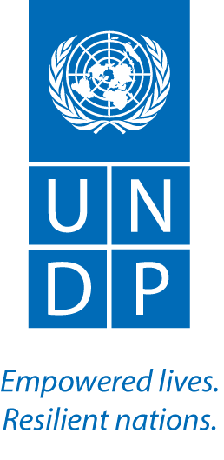

Name
Aki Kono, UN-REDD/UNDP/GEF EBD
With Lucy Emerton, Consultant
Approved Mission Itinerary:  Bangkok/Ulaanbaatar/Bangkok |  | List of Annexes:
Inclusive Travel Dates: |  | Key counterpart(s) in each location:
17 – 24 April 2013  (excluding travel) |  | Location: Ulaanbaatar, Mongolia  UN Organizations  - Sezin Sinanoglu, UN Resident Coordinator, Mongolia  - Thomas Eriksson, UNDP DRR, Mongolia  - Bunchingiv Bazartseren, UNDP CO Environment Team Leader  - Razi Latif, UNEP PEI Regional Advisor  - Asad Naqvi, UNEP, Economic Affairs Officer  Key Government Officials met during the mission:  - Mr. Jamsran Batbold, State Secretary of MoEGD (Political FP of UN-REDD)  - Mr. Tsesed Banzaragch, Director, Division of Forest Conservation and Reforestation Management, MoEGD (Operational FP of UN-REDD)  - Other national and development partners, including the CDM National Bureau (MEGD), Ministry of Economic Development, Mongolian Academy of Science and FAO.
Purpose/Objectives of Mission
This mission is to organize a validation workshop for the findings from the current work in understanding the economic value of land-use sectors and related public financing flows, and to discuss with REDD+ stakeholders based on the findings to identify policy-level goals for the forest sector in the context of national development.

The secondary objective is to handle to the Roadmap finalization process.
Context

Mongolia became a member of the UN-REDD Programme in June, 2011. Since then, the country has made REDD+ Readiness a national priority, as indicated in Mongolia's proposed nationally appropriate mitigation actions (NAMAs) and Second National Communication to the UNFCCC. On this basis, the UN-REDD Programme is assisting Mongolia to prepare its National REDD+ Readiness Roadmap, which will set out the detailed activities that the country will implement to prepare for full national REDD+ implementation. An advanced draft of the Roadmap document was developed between 2011 and 2012 by UNDP and FAO. This draft now requires revision and editing work to produce the final version. In order to initiate the implementation of the Roadmap, the government has requested UNDP/UN-REDD to provide Targeted Support to help secure the forest sector financing and basic operational capacity at the institutional level through the following three steps:

- Understanding the economic value of land-use sectors and related public financing flows;
- Assessment of entry points and strategic options to support forest sector financing and policy implementation; and
- Development of strategies to: i) strengthen policy implementation; and ii) make the forest sector a priority.

This is to ensure strong national ownership and effective capacity absorption during the Readiness phase.

The work under the first step is currently being finalized. This mission was to organize a validation workshop on the study findings and to set a stage for the next step in this TS. This mission was conducted with Lucy Emerton, environmental economist, who has been engaged to help with technical activities in the first two steps of the work.

The key activities delivers and items discussed during this mission were
- Provision of updates to the State Secretary, Ministry of Environment and Green Development (MEGD)
- Ecosystems valuation training for MEGD (based on request by the Govn’t)
- Stakeholder validation of the forest sector valuation findings and way forward
- Identification of key direction for ICA – using the valuation findings to leverage increased financing and cross-sectoral coordination and collaboration
- Roadmap finalization/initializing the implementation and government budget allocation (discussion with Mr. Banzragch), and the participation in the UN-REDD Policy Board meeting and Global Symposium on REDD+ in a Green Economy
- Discussion on the possibility of linking up with the Poverty and Environment Initiative (PEI) and use of valuation results in the Country Office programming - the UNEP Green Economy and PEI teams were also visiting Mongolia, and therefore, had a joint meeting to discuss the possibility of future collaboration.
Summary of Mission Activities/ Findings

- Key messages from the State Secretary and Director of the Forest Division, MEGD

Government of Mongolia will launch the Green Development Strategy at the World Environment Day (the 5th of June), which will be supported by UNEP and will be attended by Achim Steiner.

REDD+ Readiness Roadmap should be aligned with the Green Development Strategy, as the forest sector has been identified as one of the key sectors for achieving green development.
- Mr. Bat-Ochir Gantulga, Director of General, Department of Policy Implementation to attend the UNEP REDD+ in a Green Economy Symposium in Indonesia.
- State Secretary might attend the UN-REDD Policy Board meeting.
- As soon as the REDD+ Readiness Roadmap is finalized in June, the ministry will propose the Roadmap to be included in the next regular budget cycle (2015). Meanwhile, some small budget lines managed by the Minister could be used to finance small activities.
- In order for the Roadmap to be included in the next annual budget proposal by MEGD, an approval from the Ministry of Finance is required, and for that, clear donor co-financing commitments need to be indicated. There is not special budget category under which the Roadmap can be considered.
- The Roadmap will be finalized by June and submitted to MEGD for its formal endorsement – it is currently being cleaned up by a FAO consultant.

- Ecosystem valuation training/validation of the forest sector valuation findings
- A half day training on ecosystem valuation was conducted, immediately prior to the validation workshop on the findings of the forest sector valuation work, based on the request by MEGD to provide a training opportunity to the MEGD forestry staff.
- This training event resulted in lively discussions on data collection methodologies, data management and harmonization across the ministries, departments and divisions, needs for long-term capacity building through the formal education system, and most importantly on how to use the valuation findings to influence relevant sectoral policies and practices to ensure SFM and green development.
- The validation workshop was attended by the State Secretary of MEGD, various staff members of MEGD and other ministries, and independent experts.
- Key discussions revolved around the date quality, and how to use the valuation findings to leverage both political and donor support to mainstream the forest sector into the broader planning process, and to establish effective working relationships with other sectors that affect and are affected by the forest sector.
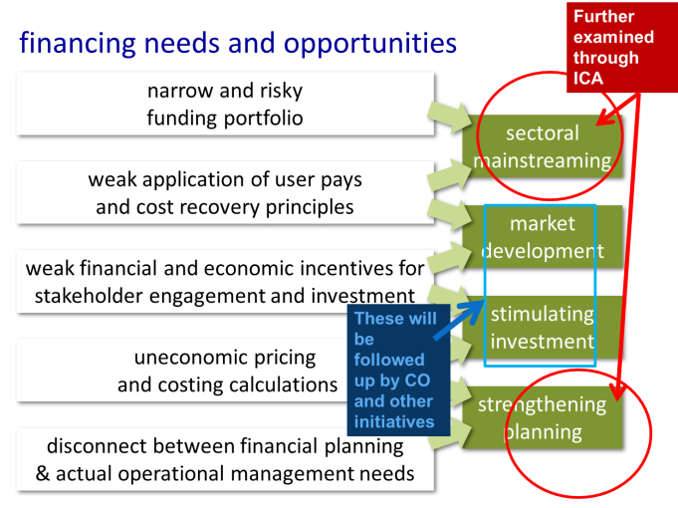
- Actions identified by the participants included economic diversification of the forest sector, strengthening the role of forest sector in the green development agenda, better understanding of key opportunity costs and benefits of alternative land and resource use practices, a review of subsidies to stimulate more sustainable and diverse investments, a better understanding of economic losses caused by illegal activities and poorly formulated policies, a need for integrated land use planning, also looking at socio-economic and biodiversity benefits at the landscape level, and a need for the forest sector to work more closely with the agriculture sector to address drivers of land use change while diversifying economic opportunities, etc.
Figure 1: Focus Areas of ICA

- Identification of key direction for ICA

Once this report is finalized in May, we will move into the next step - looking at a political economy of the forest sector and its relationships with other sectors at the national level. The report identifies four recommended areas of action (as shown in Figure 1). This TS initiative will focus on the first and last recommendations as they are more relevant to the key objective this work to increase financing and operational capacity for the REDD+ Readiness Roadmap implementation, particularly in relation to Outcome One. The political economy analysis will then be followed up by capacity development framework design and implementation, expected to begin in August.

Meanwhile, the recommendations on market development and stimulating investment might be taken up by others such as the PEI Initiative and FAO’s GEF SFM project.

- Partnership opportunities
- The UNRC and UNDP DRR are very keen to use the results of this valuation study to mainstream the forest sector into its local governance and green development support activities.
- The CO wants PEI to focus on local governance issues, and therefore, the recommendations on market development and stimulating investment might be good entry points.
- Mongolia is a partner country of UNEP’s Partnership for Action on Green Economy, and as the forest sector has been identified as one of the key sectors for green development by the Government, this present an opportunity for UNEP to play a role in linking REDD+ to the green economy work in Mongolia
- FAO’s GEF SFM project is currently under preparation, and the report from the valuation work has been shared with the lead consultant so that the recommendations from the valuation work could also be incorporated into the GEF project.
- GIZ is involved in the Economics of Ecosystems and Biodiversity (TEEB) in Mongolia, and they might be able to provide further support in this area.
- The UNDP-Japan Partnership Fund has indicated that they might be able to provide additional $350,000 to help with the implementation of the Roadmap. The Country Office will prepare and submit a concept note.

Follow up actions:  - Finalization of the Roadmap  - Review and finalization of the valuation study  - Start-up of ICA  - Transition to the capacity development step with the UNDP Regional Capacity Development team  - Additional resource mobilization |  |  | Distribution List:  - Tim Clairs, UN-REDD UNDP PTA  - Elspeth Halverson  - Dina Hajj  - Berta Pesti

