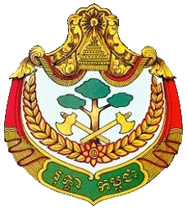 | 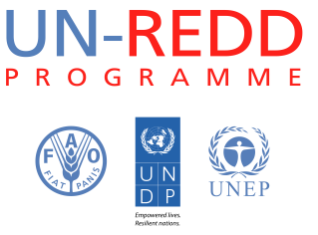 | 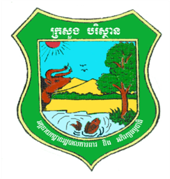

UN-REDD sixth Programme Executive Board Meeting
12th December 2013, Sofitel Phnom Penh Phokeethra Hotel, Phnom Penh, Cambodia
Tentative Agenda
Time | Description | Speaker | Facilitator
13:45 - 14:00 | Registration |  | Secretariat
14:00 - 14:10 | Welcoming Remarks | - Ms. Claire Van der Vaeren
14:10 - 14:20 | Opening Remarks | - H.E. Chheng Kimsun
14:20 - 14:40 | Follow up from previous PEB meeting:  - Progress against the 5th PEB decisions ( document 1)  - Report on compliance with the SOP (document 2)  - The new indicators for the Results Framework (document 3)  - Report on implementation of UN-REDD communication strategy (document 4) | - Mr. Lun Kimhy  - Ms. Pan Thida  - Mr. Lun Kimhy  - Ms. Heang Thy | Secretariat
14:40- 15:00 | Progress update  - Progress and achievements in 2013 (document 5)  - Priority activities in 2014 (document 6) | - Mr. Lun Kimhy  - Ms. Pan Thida | Secretariat
15:00- 16:00 | Request for comment/decision:  - Approve concept papers on expansion mandate of PEB to oversee all REDD+ readiness initiatives in Cambodia ( document 7)  - Approve proposal for technical review (document 8)  - Approval of AWP 2014 (document 9) | - Mr. Peter Iversen  - Mr. Peter Iversen  - Mr. Uy Kamal | Secretariat
16:00 -16:40 | Open discussion | - H.E. Chheng Kimsun
16:40 - 17:00 | Closing Remarks | - H.E. Chheng Kimsun  - Ms. Claire Van der Vaeren
17:00 - 18:00 | - Group Photo  - Standing Reception |  | Secretariat

