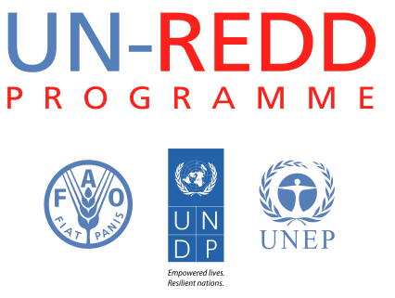
Background note on top-up funding requirements under the Support to National REDD+ Action: Global Programme Framework 2011-2015 (SNA).

Programme Strategy Development
(Top-up amount requested)

I. Summary
Objective | Position the programme for the post 2015 period.
Expected results | - Systematic and detailed lessons learned from the UN-REDD Programme’s first five years to inform a Post 2015 Strategy.  - Timeline and process for revision of the Programme Strategy developed.  - Initial consultations held with the Policy Board and other stakeholders on the Post 2015 Strategy.
Rationale for additional resources required | As the Programme’s existing MoU and Strategy extend until 2015, it is necessary to define arrangements for the Programme from 2016 onwards, building on work and achievements to date. In particular, in order to position the Programme well for the Post 2015 period, it is necessary to revise the Programme Strategy, taking lessons learned to date into account, and developing a common vision to frame the next phase of the Programme.
Level of intervention | Global, regional, and country
Examples of activities in need of additional support | Development of a robust multi-stakeholder process for the preparation of a Post 2015 Strategy, to include:  - Discussion paper with analysis of UN-REDD Programme role in supporting countries beyond 2015, taking into consideration the climate change finance architecture, country needs for making progress in REDD+ implementation and completion of readiness phase, and the linkages of REDD+ and sustainable development objectives.  - Consultations with stakeholders on the Post 2015 Strategy, including during PB11 and 12, which would include facilitating the sponsorship of additional participants to enable fully representative discussions and engagement in the process.  - Development of the Post 2015 Strategy would be supported by contracting a consultant to provide continued external support.  In addition, meeting of the Policy Board Review Working Group.
Related Outcomes of the Support to National REDD+ Action: Global Programme Framework 2011-2015. | Outcome 8 of the Support to National REDD+ Action: Global Programme Framework 2011-2015 (SNA) includes the UN-REDD Programme Strategy, which currently covers the period 2011-2015.
Duration | 24 months
Total amount requested (US$) | US$ 500,000

