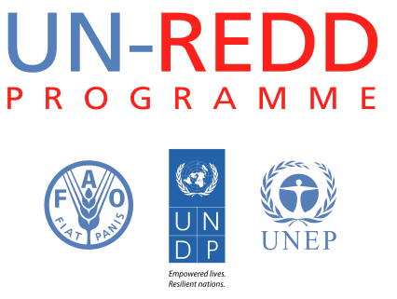
Background note on top-up funding requirements under the Support to National REDD+ Action: Global Programme Framework 2011-2015 (SNA).

Targeted Support
(Top-up amount requested)

I. Summary
Objectives | - Respond to countries’ immediate needs within the country’s REDD+ efforts.  - To support the countries in their formulation of targeted support requests, in monitoring implementation and ensure reporting
Expected results | - Enhance ad hoc response capacity of the UN-REDD Programme to address specific topics and gaps identified by the Programme’s partner countries. Wider use of Programme knowledge and lessons learnt to enable more effective support for specific topics at the country level without undermining other SNA activities.  - Timely delivery of targeted support against outlined objectives of approved requests.
Rationale for additional resources required | Growing demand from countries  There has been a growing demand for targeted support following the approved procedure of assessing the support at the eighth Policy Board Meeting in March 2012. The experience shows that this demand-driven support mechanism under one or more of the UN-REDD Programme’s six work areas is a valuable tool to assist countries in their REDD+ efforts and is useful for bridging the gap between National Programmes and the SNA. It has been a way to provide immediate support not covered through other multilateral or bilateral initiatives or by the National Programme (if a country has one). A number of new countries have become involved in the Programme and engaged in the REDD+ efforts. In line with the programming priorities for the relevant UN-REDD work areas, 27 countries have been supported through targeted support as of August 2013.  Regional and national support to targeted support formulation and implementation  As the scale of the SNA and demand for targeted support have increased, so has the challenge of meeting UN-REDD country- and regional-level human resources for planning and implementing targeted support Additional funds are needed for further technical, operational and monitoring and evaluation support from UN-REDD staff in the context of targeted support.
Level of intervention | Country level.
Examples of activities in need of additional support | - Monitoring and Measurement, Reporting and Verification (M & MRV) training in countries.  - Governance support through Participatory Governance Assessment (PGA) workshops.  - Capacity development of National Funds.  - Backstopping mission by personnel such as short term consultants to support inception workshops in the development of full-fledged workplans and budgets under the approved targeted support.
Related Outcomes of the Support to National REDD+ Action: Global Programme Framework 2011-2015 | Country-specific support, such as targeted support, refers to UN-REDD work areas/SNA Outcomes 1-6.
Duration | 24 months
Total amount requested (US$) | US$ 6 million, divided over the six work areas/SNA Outcomes 1-6.

