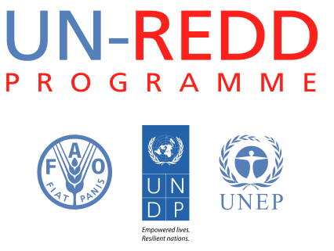
Background note on top-up funding requirements under the Support to National REDD+ Action: Global Programme Framework 2011-2015 (SNA).

Results-Based Management
(Top-up amount requested)

I. Summary
Objective | To ensure that the Programme has the most appropriate framework, tools and mechanisms in place for results-focused quality assurance and monitoring and reporting in order to measure and appraise the impacts of the Programme.
Expected result | Results-based management implemented fully and effectively across the UN-REDD Programme.
Rationale for additional resources required | Additional resources are required for the Programme to develop and implement a fully operational results-based management system and, for example, to respond to the recommendations of the UN-REDD Policy Board at its Tenth Meeting.
Level of intervention | Global, regional and country levels.
Examples of activities in need of additional support | 1) Development of the overarching Monitoring Framework of the UN-REDD Programme in line with the Programme Strategy; 2) Training and follow up for Programme staff and partners to ensure implementation of RBM across the UN-REDD Programme; and, 3) Assessment of tools for monitoring the results of the Programme at the impact level.
Related Outcome and Output of the Support to National REDD+ Action: Global Programme Framework 2011-2015 | Outcome 8: Timely and effective UN-REDD Programme Secretariat services provided to the UN-REDD partner countries, Policy Board and the UN agencies  Output 8.5: The UN-REDD Programme is monitored and evaluated and additional resources are mobilized towards meeting the five-year funding target
Duration | 24 months
Total amount requested (US$) | US$ 150,000

Extract from report (section 2c) from the tenth Policy Board Meeting: “The Policy Board expressed support for the process and added that there is still work to be done on the SNA Monitoring Framework 2013-2014, including the need to add the impact level and long-time effects, make sure that the indicators are measurable, and limit the focus on activities. The Board also encouraged the Secretariat to develop a Programme level monitoring framework”.

