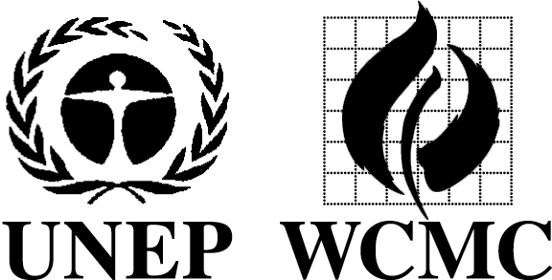 | United Nations Environment Programme  World Conservation Monitoring Centre
MISSION REPORT
Distribution: | Name of person(s) that undertook mission: Valerie Kapos
UN-REDD | Period (including travel days): 16 May - 22 May 2013
 | Projects: 2650.06 UN-REDD;
 | Institution(s) or Meeting(s) and Venue(s): University of Chicago; Macarthur Foundation; UNDP, NY;
 | Main Person(s) contacted: Tara Massad, University of Chicago; John Terborgh, Duke University; David Wilcove, Princeton University; Steve Panfil, Conservation International; Doug Stotz, Corine Vriesendorp, Christy Magerkurth, Field Museum of Natural History; Charles McNeill, Kimberly Todd, Silja Haugland, Jen Laughlin, UNDP
File(s): | Objective(s):  - Present on behalf of Tim Christopherson/UN-REDD at Conserving more than carbon: Valuing biodiversity in a changing world, a symposium hosted by the University of Chicago’s Programme on the Global Environment  - Discuss UN-REDD collaboration, including work on safeguards with UNDP colleagues

Brief summary:
University of Chicago Symposium: This meeting, ‘Conserving more than carbon: Valuing biodiversity in a changing world,’ hosted by the university’s Programme on the Global Environment involved 3 speakers besides myself: John Terborgh (Duke); David Wilcove (Princeton); Steve Panfil (Conservation International). The first two speakers focused very much on academic research in conservation science, while the 3rd addressed experience with projects linked to the voluntary carbon markets (based on a very small sample of verified projects and one more detailed case study). The audience was relatively under-informed about the international context for REDD and the implications of approaching REDD+ planning and implementation from the climate change perspective rather than as a purely conservation driven activity. My presentation was well-received and there was lively discussion. Conversations with the other speakers were stimulating and attendees from the Field Museum proved to be a particularly useful and enthusiastic set of contacts for REDD-related work in Peru, who provided further relevant contacts.

UNDP – There was a good discussion of areas of current work on UN-REDD with Kimberly Todd, Silja Haugland, Nicky Mokhtari, Tsegaye Lemma, and Jen Laughlin. Areas covered included UNDP work on support to national communications on C, governance & corruption risk, gender (Silje’s primary focus now), the workspace, and safeguards & SIS, including the forthcoming targeted support in Costa Rica and attendance at its inception meeting. We also discussed participatory biodiversity monitoring and agreed that it would be important to coordinate on this issue and on participatory monitoring generally. I met briefly with Charles McNeill, who emphasised the importance to UN-REDD of developing appropriate accountability (and linked grievance) mechanisms and stressed that this is also an issue for UNDP in the context of work funded by the GEF

Recommendation(s)/Action(s) to be taken:
Follow up action: | Responsible | Time-frame (by)
Continue dialogue with UNDP on participatory monitoring | VK/BM/LM | ongoing
Work through safeguards group on planning inception workshop for Costa Rica TS on safeguards & SIS | VK/BMM/CE/LM | ongoing

Detailed report [ ] encl. [X ] N/A. | Documents [ ] encl. [ ] list [ ] none | Date 04 June 2013

