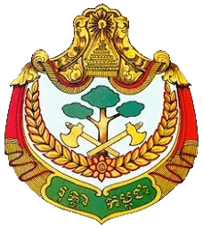 | 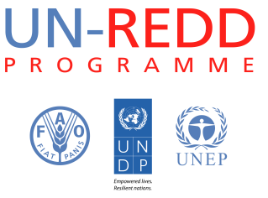 | 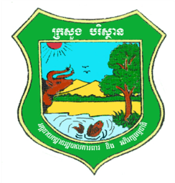
UN-REDD fifth Programme Executive Board Meeting
8th August 2013, Raffles Hotel Le Royal, Phnom Penh, Cambodia
Tentative Agenda
Time | Description | Speaker | Facilitator
13:45 - 14:00 | Registration |  | Secretariat
14:00 - 14:10 | Welcoming Remarks | Ms. Claire Van der Vaeren
14:10 - 14:20 | Opening Remarks | H.E. Chheng Kimsun
14:20 - 15:00 | Follow up from previous PEB meeting:  - Progress against the 4th PEB decisions (see document 1)  - Results of mid-term review (See document 2)  - Priority activities for the rest of 2013 (See document 3)  - MRV consolidated work plan UN-REDD and JICA Technical team | Mr. Khun Vathana | Secretariat
15:00 - 15:30 | Question and Answer
15:30 - 16:15 | Request for comment/decision:  - TOR of the 4 Technical teams (See document 4)  - Invitation to NCCC secretariat to become full member of PEB  - Approval of revised indicators (See document 5)  - Approval of SOP (See document 6) | Mr. Uy Kamal | Secretariat
16:15 -16:45 | Open discussion | H.E. Chheng Kimsun
16:45 -17:10 | Progress update  - CG formulation process (See document 7)  - Concept notes for activities (See document 8)  - TOR of International & National Consultants (See document 9)  - FCPF REDD+ Readiness project (See document 10) | - Miss. Heang Thy  - Mr. Lun Kimhy  - Ms. Moeko | Secretariat
17:10 - 17:20 | Closing Remarks | H.E. Chheng Kimsun  Ms. Claire Van der Vaeren
17:20 - 19:00 | - Group Photo  - Standing Reception | All

