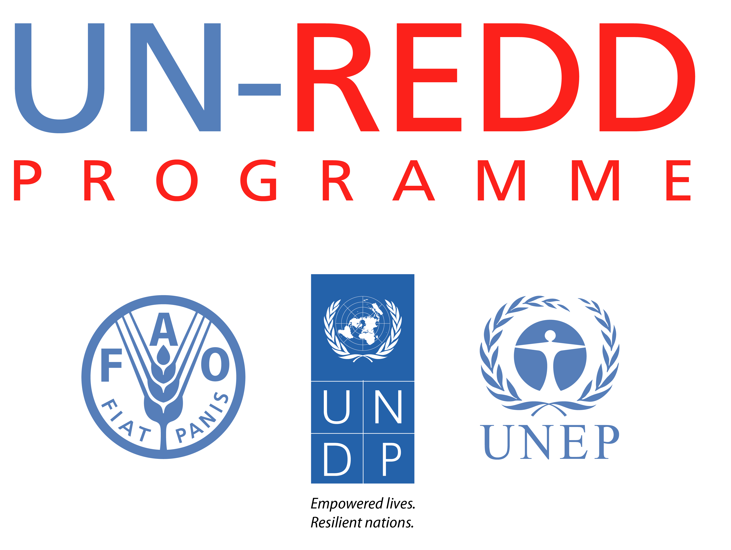
CAMBODIA

CONCEPT PAPER

Title of activity | Seminar on UNFCCC decisions on REDD+ and the possible implications for Cambodia
Outcome/output from Results Framework | Output 1.4d Awareness raising events for key groups within government
Anticipated timing | 22. May 2013
Duration | One day meeting

Objective of activity (one sentence):
To raise awareness of the international negotiations on REDD+ and initiate a discussion about the possible implications for the implementation of REDD+ in Cambodia.

Justification (100 words or less):
The international negotiations on REDD+ sets the frame for how countries should implement and assess results from REDD+. The decision texts are not always clear and can be difficult to read for people which were not part of the negotiation process.
Cambodia will need to take some decision on how to proceed with REDD+ and it will be beneficial if a broader group of key government staff have a good understanding of the UNFCCC decisions and the possible implication for REDD+ implementation.

Approach(400 words or less):
Meetings at a hotel in Phnom Penh with presentations and discussions among participants.
Participants from FA, GDANCP and FiA should be encouraged to attend.
There will be four presentations, two before lunch and two after lunch:
- UNFCCC negotiations
- REDD financing
- UNFCCC REDD guidance
- REDD scale of implementation

Criteria for participation:
Government staff working directly with REDD or with issues closely related to REDD, such as management of forest areas, community forestry, stakeholder involvement, forest monitoring, afforestation etc.
REDD Taskforce Secretariat and possible interested staff from partners such as CAM-REDD.

Suggested number of participants:
FA – 5, GDANCP – 5, FiA – 3, RTS – 5 and partners –3 in total 21​(excluded organizers and facilitators 8)

Key Outputs:
- The meeting together with the presentations

Draft agenda
09.00 – 9.30 | Welcome and short presentation of all participants | VathanaKhun
09.30 - 10.15 | Presentation: UNFCCC negotiations | Peter Iversen
10.15 - 10.30 | Q&A
10.30 – 10.45 | Coffee
10.45 – 11.15 | Presentation: REDD financing | Peter Iversen
11-15 – 12.00 | Discussion on the implication for REDD+ in Cambodia | Lun Kimhy
12.00 – 13.00 | Lunch
13.00– 13.45 | Presentation: UNFCCC REDD guidance | Peter Iversen
13.45 – 14.30 | Discussion on the implication for REDD+ in Cambodia | Lun Kimhy
14.30 – 15.00 | Coffee
15.00 – 15.45 | Presentation: REDD scale of implementation | Peter Iversen
15.45 – 16.30 | Discussion on the implication for REDD+ in Cambodia | Lun Kimhy
16.30​ - 16:40 | End of the seminar | VathanaKhun
The discussions could be either with the all participants together or in smaller groups.

Participant
Institution | People
The Forest Administration officer | 5
The General Direction of Administration for Nature Protection and Conservation officer | 5
The Fisheries Administration | 3
The REDD+ Taskforce Secretariat | 5
Other Partner | 3
Total | 21

Budget (add lines if necessary):
Item | Amount
Personnel (consultants, etc.) | 0
Travel costs – its assumed that all participant will come from Phnom Penh and there will not be any travel costs | 0
Contracts | 0
Facility costs (Meeting room, 2 times coffee and lunch for 21 people) | 600
Supplies: Folder with relevant UNFCCC decisions for each participant (app. 16 pages) and copy all presentations (3 slide per page in total 29 pages) – total 45 pages for each participant | 125
Miscellaneous | 100
TOTAL | 825

Approval:
Approved by NPD | Signature: | Date:

