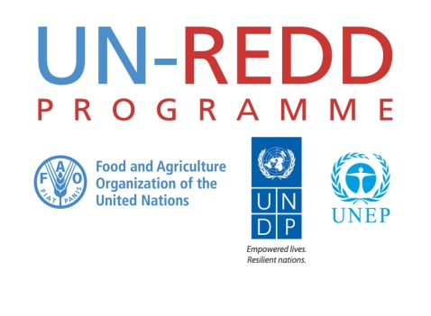

Guidelines on the UN-REDD Collaborative Workspace e-Forums
First draft
UN-REDD PROGRAMME
May 2016
Contents

1. Introduction 3
2. Objectives of online exchanges on UN-REDD forums 3
3. Types of online exchanges 3
4. Workspace discussion areas 4
5. Process and organization of an online exchange 5
6. Roles and responsibilities 7
7. Making it work 9
Annex 1 – Announcement Message 10
Annex 2 – Reminder Message 12
Annex 3 – Launch Message 13

Introduction

The field of REDD+ has grown substantially in the past six years, and continues to evolve. This rapid expansion has generated new knowledge and a global network of REDD+ practitioners eager to learn from fellow colleagues and share good practices and lessons learned.

Online forums are an efficient and cost effective means to harness the collective knowledge of the REDD+ community. The forum capabilities of the UN-REDD Collaborative Workspace can be leveraged by its close to 2000 registered members who share the same interest for REDD+ though bringing diverse experience on all technical areas of the Programme and from 60+ countries.

These guidelines aim to facilitate –and encourage- the use of the discussion capabilities of the UN-REDD workspace with the objectives to elicit lessons learned, foster collaborations, upscale good practices and therefore contribute to improve the efficiency and effectiveness of the Programme. The primary target audiences for these guidelines are the UN-REDD Comms/KM staff and the technical advisors interested in organizing or supporting UN-REDD e-discussions. Workspace members willing to contribute to or follow online exchanges may also benefit from reading these guidelines.

Objectives of online exchanges on UN-REDD forums

Online forums can be used to respond to a large number of business objectives and knowledge needs. Most often they will serve to:
- Enlarge existing social networks by reaching out to the entire UN-REDD Programme community with the perspective to access new knowledge and spur innovation;
- Pro-actively address topics that present difficulties or opportunities to UN-REDD Programme staff and partners, lessening the need to rely on email messages;
- Create a memory of online exchanges thus limiting the need for repetition of similar questions that were already addressed;
- Identify strategic niches and grounding technical documents or events, as well as overall policy development, in country level experience;
- Help creating a stronger sense of community within the Programme and with external stakeholders with a view to strengthen mutual support and partnerships.

Most probably the biggest threat to online forums is email. It requires a certain effort to move out from the email comfort and convenient zone to post a message on a forum. Email can safely remain the preferred tool for online communications unless the following questions raise a doubt:
- Quality: Am I sure I know the best REDD+ experts in the world to answer this question?
- Scope: Am I sure that cross-thematic or national perspectives will not enrich the answers?
- Scale: Am I sure the answers will not benefit anyone else outside the initial list of recipients?
- Time: Am I sure the answer will have a short lifespan and be useless or obsolete in a few weeks?
- Cost: Am I sure it will be a waste of time for most workspace members to review the question and answers?

Types of online exchanges

From a practical standpoint forums are used to trigger different sorts of exchanges. Some of the most common forms of online interactions include:
- Information dissemination: Online forums can be used to forward information with a view to allow members to react and share feedback, for example to comment on a draft paper.
- Query: The forum is used to place a spontaneous call for comparative experience, lessons learned, good practices, best experts and consultants, advice, resource materials, etc.
- E-Discussion: The forum is used to focus and engage members on sharing their perspectives or experience on a specific issue or topic, articulated around a series of key questions.

Additionally different types of face-to-face interactions and online consultations can be conveniently translated into a forum environment. This includes for instance:
- E-Panel: The forum is used to host a discussion between a group of technical experts and practitioners who, after an initial round of exchanges, open the floor to questions and further discussions with all members. This modality is made possible when the forum offers moderation services with a capability to manage messages and to momentarily park them.
- E-Fishbowl: The forum is used as an online modality of the face-to-face fishbowl methodology whereby any member of the audience can, at any time, join the fishbowl discussions while another member leaves voluntarily the fishbowl while the rest of the members attend the conversation. This modality is made possible when the forum offers moderation services with a capability to momentarily park messages.
- E-World Café: Parallel discussions are organized in different forums and aggregated in a plenary forum over the course of a couple of days.
- Chat with Expert Session: The forum is used synchronously for members to ask questions to an expert during a very short period of time –e.g. 2 hours-.
- Helpdesk: The forum is used to channel questions to a staff or a team acting as a support center.

Workspace discussion areas

Two different types of forum areas are offered by the UN-REDD collaborative workspace to allow members to engage in online discussions.

The Discussion forums space has been pre-organized around the outcome areas and activities of the Programme. Workspace members can easily refer to their domain of expertise or a technical topic in order to locate the forum where to retrieve previous exchanges or post a new query. Although these forums relate to different technical communities they are opened to all workspace members, offering an opportunity to broaden inputs and perspectives. The discussion forums are implicitly the space for convening UN-REDD Communities of Practice. | 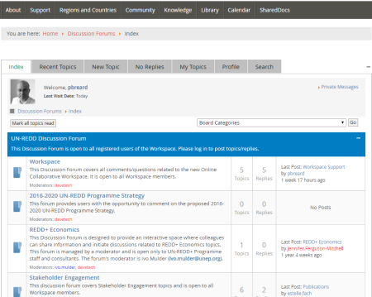

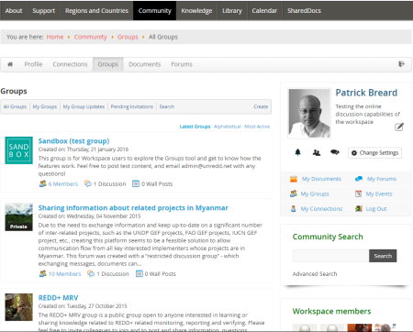 | Alternatively, Workspace Groups come also with a forum capability. These groups are either closed or opened, and tend to focus exchanges on topics narrower than those found in the discussion forums. Conceptually, these groups are spaces to support specific country or project teams, social networks, cross-functional or cross-thematic knowledge sharing activities, etc. They take a different angle from the one presented in the thematic architecture of the global discussions forums, which aim to convene entire communities of practice.

Process and organization of an e-discussion

This section describes in more details the organization of an e-discussion on UN-REDD workspace forums. Usually e-discussions run during 2 to 4 weeks but require a longer period of time to be prepared as exemplified in the following schedule.
Close discussion
Offline moderation
Direct messages to possible contributors
Kickoff discussion
Identify possible contributors
Prepare launch message
Consult TA and decide topic

3 weeks later
4 weeks
D Day weeks
2 weeks
6 weeks

1 week
3 weeks
5 weeks

Online moderation
Refinement questions
Launch reminder
Launch announcement
Identify core group members

From a couple of months up to 6 weeks prior to the launch of the e-discussion the regional KM specialist and a technical advisor should identify the objectives of the discussion and select topics that will focus the exchange. Depending on the context, topics can be derived from the annual work plan, a survey, issues raised but not tackled during a workshop, cross-thematic research, lack of knowledge products, etc. To the extent possible the theme should respond to well identified knowledge gaps among the UN-REDD Programme community as well as to a pool of dispersed experiences that will substantiate forthcoming exchanges. Online discussions are worthwhile when there is a market where to bridge knowledge seekers and knowledge providers. A lack of demand may stall the discussion while a lack of offer may make other modalities of knowledge acquisition more appropriate –e.g. workshop, e-Learning course, Chat with Expert, etc.-. The objectives of the discussion can be considered at the output and outcome levels. Will the exchange lead to a consolidated reply, feed into the development of a knowledge product, stay as a thread without conclusion, etc.? While targeting the development of a knowledge product may incentivize exchanges, it will imply a higher workload during and after the discussion.

During the entire process the technical advisor will act as a resource person and work closely with the regional KM specialist as a ‘guest moderator’ conveying relevant expertise. This expert guest moderator will guide and prompt participation and assist the KM specialist to highlight appropriate resources and suggestions. The KM specialist should ensure that no more than 2-5 days are required to perform this role.

About 5 weeks ahead of the discussion it is a safe practice to identify and approach a core group of up to 5-6 members that may comment the objectives of the exchange, the topic, the round of questions. Members of this group may also be solicited when the discussion is launched and if there is not a spontaneous flow of responses. Their early involvement in the process will make them more likely contributors. This may help to kick-off the discussion with some level of exchange useful to initiate a momentum.

At least 4 weeks ahead of the discussion a launch message must be drafted to announce the e-discussion. This message should highlight the context, the knowledge gap or value proposition, the objectives of the exchange, its organization, the technical setup, call for snowballing participants, and contact persons. A template of such message can be found in annex 1.

The announcement should be launched by the technical advisor 3 weeks prior to the discussion. It should be provided to the UN-REDD Comms/KM Associate in Geneva who will send it by email to all workspace members and ensure that the event is featured in the weekly roundup. Furthermore the regional KM specialist should post an announcement in the workspace and update the workspace calendar.

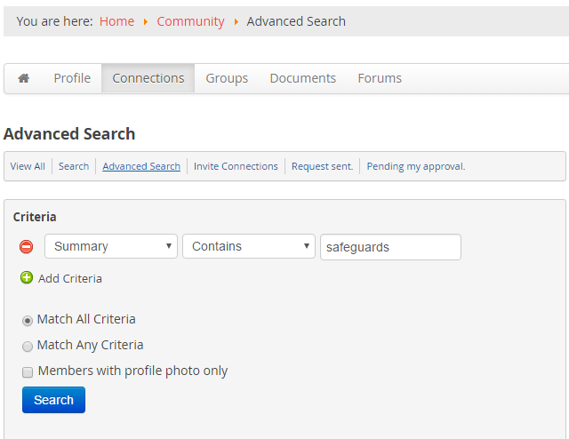
Two weeks before the discussion the KM specialist may use the workspace to identify members who have an experience relevant to the topic or who may bring cross-cutting and innovative perspectives. The advanced search function of the workspace allows for retrieving members per area of REDD+ interest or expertise, location, agency, position, or by searching keywords in their summary profile. Members who have been shortlisted can form a roster for reference during the period of the e-discussion or immediately contacted in order to engage a direct relationship and increase the likelihood of participation. In that case they may also be invited to share names of colleagues who would be interested in joining the discussion to expand the snowball effect and promotion campaign.

A reminder message should be sent one week before the launch of the discussion. This message should present in particular how to turn on email notifications in the workspace groups or forums depending on the workspace area hosting the e-discussion. If notifications are not turned off, members will be able to follow and respond to the discussion but only online. Activating notifications will facilitate the exchanges as members will receive all messages by email and will be able to respond directly from their inbox. Changing the notification setting takes 3 steps and less than 30 seconds. It requires to log in to the workspace and (1) select <Change Settings> on the home page, (2) select <Emails and Notifications>, and (3) just tick email and on-site notifications for <Groups> and <Discussion Forum>. Although it may require some convincing and direct assistance to make members turn on their email notification feature, this will greatly improve participation. The reminder message should be sent by email by the UN-REDD Comms/KM Associate. A template of reminder message is provided in annex 2. Furthermore the regional KM specialist should post an announcement in the workspace and ensure it is channelled through the weekly roundup.

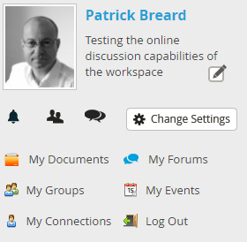  1 | 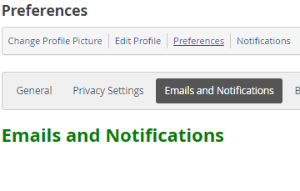  2 | 3

At kick-off, the launch message will provide further background information on the context, objectives and organization of the discussion. The discussion will be launched with a set (4-5) of relevant, specific questions, relating to the topic. The discussion will be structured accordingly. A particular attention is to be placed to the driving questions that must call for comparative experiences, proposals, and ideas. Questions should seek to encourage the exchange of experience as well as get to the heart of practical difficulties and challenges faced by workspace members. Although there is no prescribed recipe, initial questions can refer for instance to the pros and cons, strengths and weaknesses, advantages and disadvantages, specific experiences, etc. The following questions can engage members into sharing proposals, recommendations, etc. The final questions can gather perspectives on the future state, success factors, outcomes and indicators, etc.

The rationale for the discussion (i.e. why are we discussing this now) as well as clear outputs of the discussion (website, concept note, etc.) should be presented in the launch message. A template of launch message is provided in annex 3.

The launch message may recall participants a few good practices when interacting online, such as:
1. Messages should be concise and as much to the point as possible;
2. Participants should write their name and office/unit/country at the end of the messages;
3. Participants should refrain from bringing up an entirely new issue for discussion to avoid the discussion branching off all over the place;
4. Participants should refrain from copying/pasting long sections of brochures or websites in lieu of conveying their own perspective;
5. As a corollary, participants should refrain from promoting their organization but focus on the topic and questions;
6. Participants should not assume everybody knows what they know and that it is irrelevant to share;
7. Disagreements should be managed carefully and respectfully for instance by conveying contradictions in the form of alternate options or contrasting experiences grounded in different contexts;
8. Responses to someone’s message not involving the whole group should be treated outside the forum;
9. Contributions in languages other than English should be allowed if they are an official UN language although the KM specialist may need to post a link to an online translation tool -e.g. Google Translate-;
10. A disclaimer will be added to the forum to indicate that the views expressed are the ones of the members but not necessarily the ones of the UN-REDD Programme or of any other institution.

The launch message can be forwarded by the regional KM specialist to the members of the core group in order to flag that the discussion is now live. Depending on the volume of messages in the first 24h, it may be needed to solicit core group members individually to step in with feedback and contribute an initial message.

Members will be asked to share their experiences, perspectives and questions throughout a three-week period for instance (which can be extended if need be), in which the technical advisor acting as “expert moderator” will raise pertinent topics, respond to technical questions and may contribute to mid-discussion summaries which will help to guide the discussion.

The KM specialist should expect to reach out in advance on an individual basis to invite key persons such as those previously identified in the list of relevant members to join the discussion.

At the end of the period and depending on the initial objectives, the KM specialist jointly with the technical advisor may synthesize the experiences, suggestions and lessons learned.

Moderation of the discussion groups

Discussion groups need continued energy and input. Throughout a network lifecycle effort and focus will vary. In order to sustain discussion groups certain flexibility is needed to reflect the varying need for time and creative resources. The goals and expectations of the members evolve through time and must be identified. Technical areas of the Programme develop new knowledge and new needs. Specific events can trigger opportunities for new exchanges. While e-discussions are an excellent –though demanding- catalyzer for launching a discussion group, on-going moderation is expected to nurture UN-REDD discussion groups. Facilitating discussion groups needs daily attention from the Regional / KM specialists and selected technical advisors. Especially in the start-up period such as immediately after the first e-discussion, this may involve at least 15% of a full-time equivalent position. In a typical, open and long-term panel of discussion forums it is reasonable to plan four to six hours per week for the minimum amount of time required.

As such the involvement of the regional KM specialists and/or KM Specialist would be significantly more than what is required by the sole organization of an e-discussion. It would involve checking in on the discussion forums on an almost daily basis to ensure questions were being responded to by the Technical specialist, documents were being shared, etc. Possible interventions or services provided by the KM specialists could include:
- Maintaining communication with the MG to ensure discussion groups address organizational needs;
- Maintaining communication with technical advisors in order to ensure that the forums address technical needs;
- Contacting country colleagues to identify topics or situations that currently challenge them and work with them to turn issues into an opportunity for online exchanges and support;
- Proposing groups to survey priority knowledge needs to jointly develop an agenda of work;
- Engaging the discussion groups into developing knowledge products that help members to codify and disseminate knowledge;
- Cross-fertilizing with other groups;
- Highlighting exceptional contributions and giving credit to participants for participation and knowledge-building;
- Reminding workspace members of the purpose, objectives, and ground rules of the discussion groups.

Roles and responsibilities

On the basis of the above activities the following roles and responsibilities are proposed.

Role of the Regional KM Specialist:
When organizing and contributing to an e-discussion, the regional KM specialist should expect an involvement that will span over a period of 2 months approximately. The overall tasks of the regional KM Specialist over the e-discussion should entail a workload of up to 8/10 days, with the following activities:
- Provide overall guidance about the e-discussion process and basic support on using the forum capabilities of the workspace;
- Support the technical advisor with the identification of a topic and formulation of discussion questions;
- Provide to the technical advisor examples of launch messages and support the advisor in designing the successive announcement, reminder, and launch messages;
- Liaise with the Comms/KM Associate to send the announcement messages to all workspace members;
- Update the workspace with the announcement messages and calendar;
- Identify workspace members with relevant experience and approach them directly as needed to solicit their participation;
- Support workspace members in turning on email notifications and in using the forum and escalate questions as appropriate to the Comms/KM Associate.
- Collaborate with the technical advisor acting as main discussion moderator to incentivise participation;
- Collaborate with the technical advisor acting as main discussion moderator produce mid-discussion summaries and the final discussion output and address follow-up questions.

On an on-going basis and in order to grow and nurture the discussion groups as a key channel for online collaborations within the UN-REDD Programme and REDD+ community, the Regional KM Specialists should expect spending up to 15% of their time on facilitation of the discussion groups. This would entail tasks such as:
- Support workspace groups in identifying knowledge needs and priorities;
- Support workspace groups in developing a KM strategy or plan based on members’ needs;
- Provide overall guidance about the forum capabilities of the workspace and support members in turning on email notifications;
- Support technical advisors and groups members in using the workspace forums to develop or contribute to the development of knowledge products or any other activities responding to the needs and objectives of the group;
- Support technical advisors and country colleagues in identifying and posting queries or resources;
- Identify workspace members with relevant experience and approach them directly as needed to solicit their participation and to grow a thriving community;
- Escalate questions as appropriate to the Comms/KM Associate.

Role of the Technical Advisor:
The technical advisor acting as moderator of an e-discussion will be involved over a period of approximately 2 months. The overall tasks of the technical advisor should entail a workload of up to 5/6 days as follows:
- Suggest background materials and help articulate the rationale and ‘deliverables’ of the discussion;
- Formulate specific discussion questions so that they encourage the participants to share helpful suggestions and experiences;
- Respond to participants’ particular questions and if discussion lulls, introduce pertinent issues and/or guide the discussion. Where appropriate, useful literature related to the discussion should be shared;
- Personally invite persons with particularly pertinent and relevant experience or ideas to contribute to the discussion;
- Produce mid-discussion summaries and (ii) the final discussion output and address follow-up questions. Synthesis should be a concise, easy-to-use reference which reflects the best judgment, experience and knowledge of the moderator/s and KM Specialist;

On an on-going basis and in order to nurture the discussion groups as a key channel for online collaborations within the UN-REDD Programme and REDD+ community, the technical advisors should expect spending up to 2 hours per week on contributing to discussion groups.

Role of the Comms/KM Associate:
The Secretariat Comms/KM Associate will be involved on an e-discussion over a period of approximately 6 weeks. The overall tasks of the Comms/KM Associate should entail a workload of up to 2/3 days as follows:
- Support the Regional KM Specialist with the technical functioning of the workspace and forums;
- Launch the e-discussion announcement messages by email to all workspace members;
- Produce the weekly roundups where the e-discussion will be promoted;
- Provide advanced support to workspace members on the technical functioning of the workspace and forums.

Role of Workspace Members:
Workspace members involved in an e-discussion should expect a workload of up to 2/3 hours over 6 weeks, as follows:
- Log in to the collaborative workspace to turn on email notifications;
- Review messages and contribute to the discussion with experience and perspectives.

On an on-going basis, workspace members should expect spending up to 1 hour per week to contribute to and benefit from the discussion groups.

Making it work

In lieu of a conclusion some final points to make the most of the UN-REDD online forums:

- Approaching members with whom previous collaborations have occurred will generate higher prospects of participation;
- Driving the entire discussion to the production of a tangible knowledge product may incentivize participation;
- Synchronizing the online forum with email notifications will increase participation;
- Directly acknowledging contributions and sending thank you messages will improve participation in the long run;
- Expectations should be realistic as getting up to 10-15 contributors during the first e-discussions can be perceived as a commendable achievement.

Annex 1 – Announcement Message

Dear colleagues,
Today's global youth population, ranging in age from 15 to 24 years, is an estimated 1.03 billion, or 18 per cent of the people inhabiting the earth. The majority of these young men and women live in developing countries, and their numbers are expected to increase well into the twenty-first century (YWPA2000). In 2015, the population aged 15-24 years in sub-Saharan Africa is expected to reach 200 million. The quality and depth of democracy in the coming years will be shaped by the quality and intensity of participation of young people. Hence, young people must seize real opportunities and space to play a prominent role in their development. To that effect, UNDP is developing a strategy to emphasize and support youth as agents of change for sustainable human development.
The UNDP Youth Strategy is grounded in the realization that youth engage in and can transform areas above and beyond the reach of UNDP and the UN system. In fact, youth can bring transformation everywhere. Therefore the UNDP strategy aims to reflect, among others on the following:
- UN system engagement in relation to youth;
- UNDP mandate with regards to young people –including definition of youth i.e. what is UNDP’s responsibility in helping the youth grow and contribute to human development;
- UNDP’s areas of competence in supporting young people; and
- UNDP strategic priorities with regards to youth for the forthcoming 3-5 years.
Given the thematic and geographical breadth of UNDP’s areas of work, extensive internal consultations and consensus on priority areas of work are crucial for a successful realization of the UNDP Youth Strategy. Thus far, the consultation process has included youth focal points and colleagues supporting youth initiatives at UNDP/HQ (Regional Bureaux, BERA, BDP, BCPR, HDRO, BOM, SSC-SU) and Regional Service Centres. This consultative process draws from the collaborative efforts of various actors - outside the UN system- actively working with youth. We have conducted an initial mapping of actors who will also be part of the consultation process for the UNDP Youth strategy.
We will soon inviting you to engage in developing the first UNDP Youth Strategy through an e-discussion. As a core component of the consultation process, this e-discussion will organized in 3 phases each respectively on:
Phase 1 - The UN/UNDP and Youth – October 15-21
This first phase of the e-discussion will address our understanding of youth; youth policies and challenges; key stakeholders in the field; and clarify what is UNDP's mandate on youth. Specifically we will address the questions below:
1- Youth can be defined in many ways. The United Nations define youth as persons between the ages of 15 and 24. In developing the UNDP Youth Strategy, a key question that requires reflection relates to whom the UNDP youth strategy will / should affect. Does the definition above encompass the population this strategy should focus on?
2- Based on what you think is a correct definition of youth, please share any experiences/information you have on programmes and projects –by other UN agencies, NGOs or other actors- that have been successful at supporting the youth?
3- In your opinion, should UNDP engage with youth, and why? If yes, how?
Phase 2 - Maximizing UNDP for Youth – October 22 - 29
The second phase of the e-discussion will focus on the vision and mission of the strategy; specifically UNDP’s strategic advantages in the context of the UN system and the youth strategy priority areas.
1- Considering other UN agencies’ mandates and activities with youth; as well as the activities of key stakeholders; what are the gaps and threats in this mode of engagement with youth? Where does the UN System need to do more? What is UNDP most suited to do for / with the Youth? What are the areas of synergy and complementarity in the UN System’s engagement with youth?
2- Based on the above, what is UNDP’s niche in working with youth? What should be the main areas of a UNDP strategy for effectively integrating youth into our programming and planning towards sustainable human development.
3- What is the vision and mission that should guide UNDP’s Youth Strategy? What can we define as a success in operationalizing such a strategy?
Phase 3 – Consultation on the zero draft of the strategy – November 3 - November 12
In the third phase of the discussion, we will invite participants to review the first draft of the strategy – which integrates comments shared in the previous 2 phases- and share comments and suggestions to ensure that it successfully and comprehensively integrate youth into UNDP planning and programming.
You will soon be invited to participate in this e-discussion organized in Teamworks and to share your opinion on the questions above. You will also be able to browse all content currently on the space and connect with colleagues interested in youth and development.
Looking forward to your contributions!

Annex 2 – Reminder Message

Dear colleagues,
As announced earlier this month we will invite you next week to engage in developing the first UNDP Youth Strategy through this e-discussion. As a core component of the consultation process, this e-discussion will organized in 3 phases each respectively on:
Phase 1 - The UN/UNDP and Youth – October 15-21
This first phase of the e-discussion will address our understanding of youth; youth policies and challenges; key stakeholders in the field; and clarify what is UNDP's mandate on youth.
Phase 2 - Maximizing UNDP for Youth – October 22 - 29
The second phase of the e-discussion will focus on the vision and mission of the strategy; specifically UNDP’s strategic advantages in the context of the UN system and the youth strategy priority areas.
Phase 3 – Consultation on the zero draft of the strategy – November 3 - November 12
In the third phase of the discussion, we will invite participants to review the first draft of the strategy – which integrates comments shared in the previous 2 phases- and share comments and suggestions to ensure that it successfully and comprehensively integrate youth into UNDP planning and programming.
You are invited to register to this e-discussion by clicking “here” to join the UNDP Youth Strategy space on Teamworks. You will also be able to browse all content currently on the space and connect with colleagues interested in youth and development. Please send an email to dgp-net@groups.undp.org for any issues in joining the space or participating in the discussion.
Looking forward to your contributions!

Annex 3 – Launch Message

Dear colleagues,
Today's global youth population, ranging in age from 15 to 24 years, is an estimated 1.1 billion, the majority of whom live in developing countries. The past 2 years have confirmed the tremendous transformational potential a vibrant and dedicated young population can muster in any corner of the world. Using ICTs, the media and their ingenuity, the youth have emphasized their voices and seized the chance to play an important role in choosing a path for their countries.
Undeniably, the quality of development in the coming years will be shaped by the quality and intensity of participation of young people. Hence, young people need real opportunities and space to play a prominent role in their communities and contribute globally to sustainable human development. To that effect, UNDP is developing a strategy to emphasize and support youth as agents of change for sustainable human development.
The UNDP Youth Strategy is grounded in the realization that youth engage in and can transform areas above and beyond the reach of UNDP and the UN system. In fact, youth can bring transformation everywhere. Given the thematic and geographical breadth of UNDP’s areas of work, extensive internal consultations and consensus on priority areas of work are crucial for a successful realization of the UNDP Youth Strategy.
I invite you to participate in this e-discussion, which represents the first component of the consultation process around the first UNDP Youth Strategy. Phase One of the e-Discussion will take place from 15 October to 21 October. In this phase, we reflect on our understanding of youth; youth policies and challenges; key stakeholders in this area of work; and clarify what is UNDP's mandate on youth. Specifically, based on your experiences and understanding of the realities the youth face, let us consider the below:
1-Youth can be defined in many ways. The United Nations define youth as persons between the ages of 15 and 24. In developing the UNDP Youth Strategy, a key question that requires reflection relates to whom the UNDP youth strategy will / should affect. Does the definition above encompass the population this strategy should focus on? if it doesn't, what would be a better definition?
2-Considering what you think is a correct definition of youth, please share any experiences/information you have on programmes and projects –by other UN agencies, NGOs or other actors- that have been successful at supporting the youth? How have these experiences impacted the youth? What makes them successful initiatives?
3-In your opinion, should UNDP engage with youth, and why? If yes, taking note of the breadth of the UNDP areas of work how can UNDP effectively engage with youth and integrate them into activities to promote and support sustainable human development in their societies'?
4-There are several stakeholders that are working with youth, including international organisations, governmental representatives, civil society organisations and youth-led initiatives and networks, academics and researchers, educators, just to name a few. Based on an initial mapping we have put together a list of global and regional stakeholders who support the youth at different levels. We would like you to complement this initial mapping with other actors whom you think should be included. We will do our best to integrate these into a final list of stakeholders; who will be contacted to take part in a wider consultation process on the UNDP Youth Strategy.
This e-discussion is critical to UNDP’s engagement with and for youth. Contributions and responses submitted will feed directly into the development of the first UNDP Youth Strategy. We strongly encourage you to participate in this e-discussion by submitting your contributions to dgp-net@groups.undp.org or clicking “here” to request an invitation to join the UNDP Youth Strategy space on Teamworks; where you will be able to post your contribution online directly and browse key content relating to the discussion and connect with colleagues interested in youth and development.
We look forward to an engaging discussion and encourage you to participate and share your knowledge and experience preferably, in English, French or Spanish.
Looking forward to your contributions!

