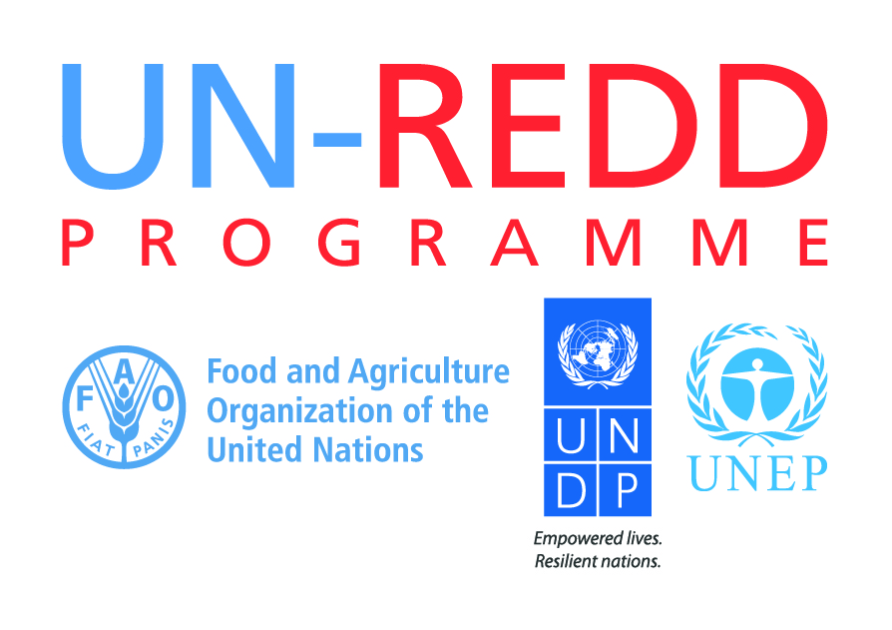

UN Agencies Joint Statement on 2016-2020 Governance Arrangements: as delivered on 10 November at the 15th Policy Board Meeting of the UN-REDD Programme, San Jose, Costa Rica

- The UN collaborating agencies of the UN-REDD Programme are committed to participatory governance and multi-stakeholder involvement, notably in complex policy affairs such as REDD+. We wish to highlight the valuable contributions of the indigenous peoples and civil society organization representatives in the UN-REDD Programme over the years, as we have witnessed in this 15th Policy Board Meeting. This shows the added value of inclusive governance of global programmes and partnerships.

- As the UN-REDD Programme enters a new 2016-2020 phase, in which consolidation is a key objective, its governance structure has needed to be adjusted and refined. In UN practice, governments and inter-governmental bodies are members, while other stakeholders are included as permanent observers. But the essentials of participatory governance in the UN-REDD Programme remain. The Draft 2016-2020 UN-REDD Programme Governance Arrangements information note includes the following statement:

All representatives of the Executive Board have the right to participate fully in the deliberations. Decisions are taken by the members by consensus with due consideration of the recommendations of permanent observers.

- In spite of these evolutions, the new governance keeps the spirit of participatory governance – and the UN agencies will continue to safeguard and implement the principles of inclusive and transparent governance in the UN-REDD Programme, taking into account the views and inputs of indigenous peoples and civil society organizations.

