Financing Strategies for REDD+ - the Quiz!

**TEAM NAME:**

Question 1: Of the follow international provisions on REDD+ finance, which one is not a provision of the UNFCCC?

1. “finance provided to developing country Parties for the full implementation of the activities […] may come from a variety of sources, public and private, bilateral and multilateral, including alternative sources”
2. “invites Parties to promote a public-policy environment that enables private-sector engagement […] in a manner that contributes to the achievement of the objectives of the Convention”
3. “progression of developing country Parties towards results-based actions occurs in the context of the provision of adequate and predictable support for all phases of the actions and activities”
4. “encourages entities financing the activities […], including the Green Climate Fund in a key role, to collectively channel adequate and predictable results-based finance in a fair and balanced manner, taking into account different policy approaches”

Question 2: True or False - the California Cap and Trade Program (also known as the California Carbon Market) accepts REDD+ credits.

* True
* False

Question 3: What is the total amount of funding pledged for REDD+ by the international private and public sector between 2006 and 2014? *2 points*

1. 10 billion USD
2. 5 billion USD
3. 2 billion USD
4. 800 million USD

Question 4: How much is the Green Climate Fund offering to pay for a ton of carbon in the context of its pilot programme for REDD+ result-based payment?

Answer (in USD): ____________________

Question 5: The international body of one of the world’s largest industries recently decided to achieve carbon neutral growth by 2020 and to establish a carbon offsetting scheme. Was it:

1. The International Federation of Agricultural Producers
2. The International Council of Aerospace Industries
3. The International Mining Association
4. The International Civil Aviation Organization

Question 6: This is a list of countries that have made the greatest contributions to the Green Climate Fund to date. Please order them from the highest pledge, to the lowest pledge.

|  |  |
| --- | --- |
|  | Australia |
|  | Canada |
|  | France |
|  | Germany |
|  | Italy |
|  | Japan |
|  | Norway |
|  | Sweden |
|  | United Kingdom |
|  | United States |

Question 7: These are four potential sources of REDD+ finance. For each one, please indicate if they are private or public, and domestic or international.

|  |  |  |
| --- | --- | --- |
|  | Private or Public | Domestic or International |
| The Carbon Fund of the Forest Carbon Partnership Facility (FCPF) |  |  |
| The Annual Budget of the Ministry of Environment |  |  |
| Australia’s Carbon Market |  |  |
| Local companies investing in agroforestry |  |  |

Question 8: Which of the following are means to deliver REDD+ finance?

1. Grants
2. Subsidies
3. Loans
4. Equity investments
5. Bonds

Question 9: One of the terms below does not belong to the terminology of the Green Climate Fund. Which one is it?

1. National Designated Authority
2. Accredited Entity
3. Direct Access Entity
4. Implementing Entity

Question 10: These are the outlines of the donor countries of the UN-REDD Programme. Please name each country.

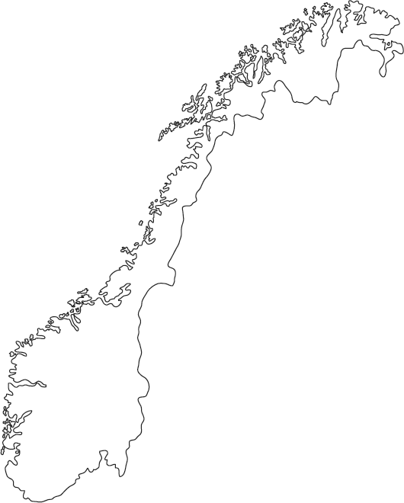 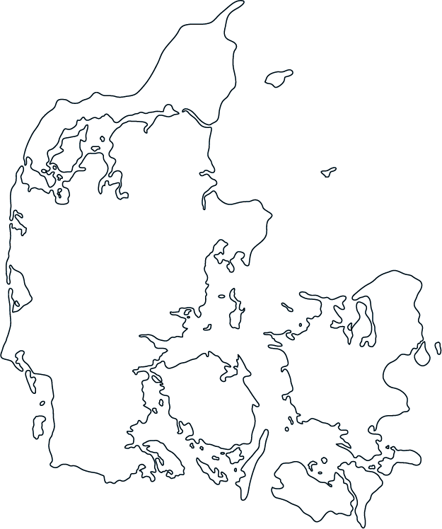 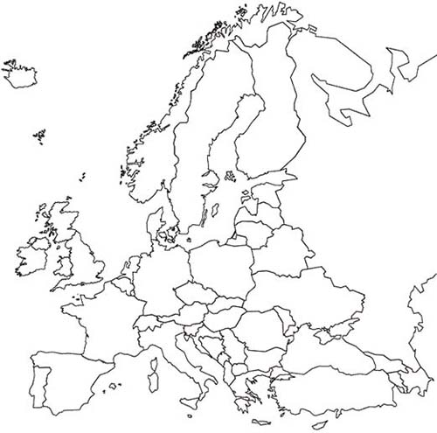

1. _________________ 2. _________________ 3. _________________

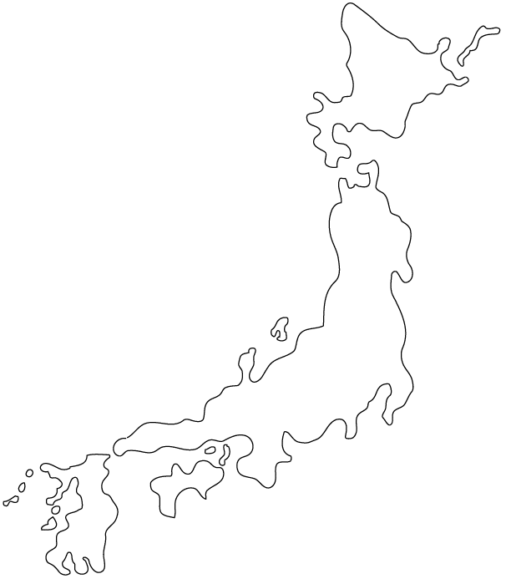 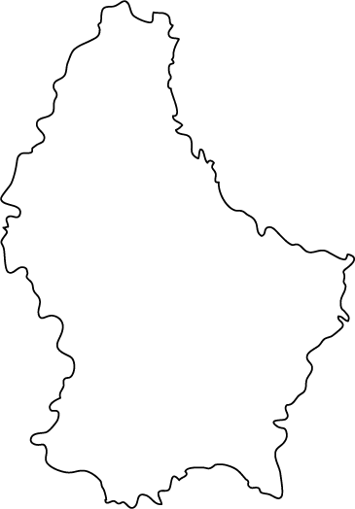 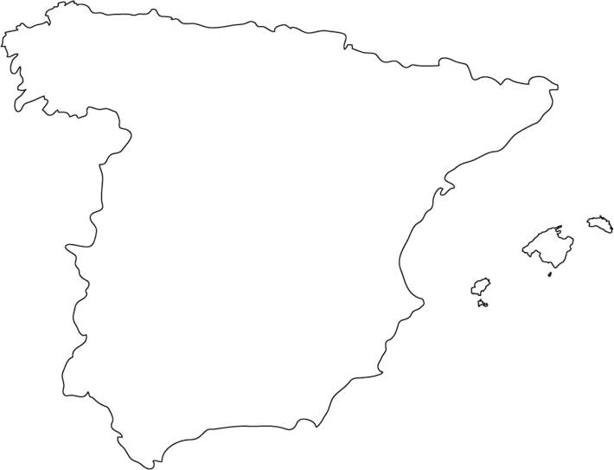

1. _________________ 5. _________________ 6. _________________

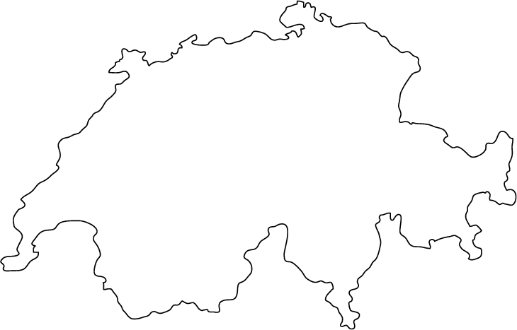

7. ___________________

**Financing Strategies for REDD+ - the Quiz! // Answers**

**Question 1**

Answer b is not a provision of the UNFCCC, it is part of the Decisions adopted by the UNCBD – The UN Convention on Biological Diversity - in relation to the private sector. The UNCDB adopted a range of decisions on the role of the business sector in protecting ecosystems, including forests. See <https://www.cbd.int/business/CBD_Decisions.pdf>

**Question 2**

FALSE - The California Carbon Market does not accept international forest carbon credits today. But the legislation which created the program/market explicitly allows for the potential acceptance of certain international forest carbon credits. And California has already engaged with two jurisdictions for potential supply of international forest carbon credits: the states of Acre, Brazil and Chiapas, Mexico. Realistically it will still be some time before the California programme has the regulations in place to accept REDD+ credits, but it is likely to happen in the future.

**Question 3**

The correct answer is a, and the precise figure is actually 9.8 billion USD, as the total amount of funding pledged for REDD+ by the international private and public sectors between 2006 and 2014.

**Question 4**

The GCF has set a uniform and fixed value of 5USD per ton of carbon for its pilot programme. The call for proposals for the GCF pilot programme on REDD+ result based payments was launched just a few weeks ago, see <http://www.greenclimate.fund/documents/20182/820027/GCF_B.18_06_-_Request_for_proposals_for_the_pilot_programme_for_REDD-plus_results-based_payments.pdf/0691c547-110a-4bee-886b-084664326fe1>

The team with the figure closest to the actual price will win the points.

**Question 5**

The correct answer is d. The International Civil Aviation Organization. About a year ago, the ICAO agreed to establish a market-based mechanism known as the Carbon Offsetting and Reduction Scheme for International Aviation (CORSIA). The CORSIA will allow for the use of certain offset credits for compliance in the program. While criteria on eligible credits have not yet been established, it is expected that international REDD+ credits could be accepted in the mechanism.

**Question 6**

The correct order is the following:

|  |  |  |
| --- | --- | --- |
| 1 | United States | 3 billion USD |
| 2 | Japan | 1,5 billion USD |
| 3 | France | 1.3 billion USD (with the particularity of distinguishing loans and grants, only country to do so with Canada) |
| 4 | United Kingdom | 1,2 billion USD |
| 5 | Germany | 1 billion USD (a bit more) |
| 6 | Sweden | 581 million USD |
| 7 | Canada | 277 million USD |
| 8 | Italy | 267 million USD |
| 9 | Norway | 257 million USD |
| 10 | Australia | 187 million USD |

Source: <https://www.greenclimate.fund/documents/20182/24868/Status_of_Pledges.pdf/eef538d3-2987-4659-8c7c-5566ed6afd19>

**Question 7**

|  |  |  |
| --- | --- | --- |
|  | Private or Public | Domestic or International |
| The Carbon Fund of the Forest Carbon Partnership Facility (FCPF) | Public | International |
| The Annual Budget of the Ministry of Environment | Public | Domestic |
| Australia’s Carbon Market | Private | International |
| Local companies investing in agroforestry | Private | Domestic |

There is a broad range of sources of REDD+ finance, and countries should consider a mix of public, private, domestic and international sources to fund their policies and measures for REDD+ implementation.

**Question 8**

All the answers are correct. REDD+ finance can take several forms. Public finance has been mainly delivered as grants and subsidies, particularly for readiness activities. As countries move towards the investment and implementation stages, financial needs increase along with the opportunities for diversified forms of finance. REDD+ countries look more and more at leveraging the financial and private sectors, and formulate PAMs that include opportunities to invest in profitable alternatives to deforestation, opening the door for loans and equity investments. Several countries are also considering issuing REDD+ bonds, which would involve borrowing on capital markets to support the implementation of PAMs.

**Question 9**

The answer is d. Implementing Entity. There is no such thing as an implementing entity under the GCF terminology, the Fund uses Executing Entity to refer to organizations or institutions that execute, carry out or implement an activity funded by the GCF.

<http://www.greenclimate.fund/gcf101/getting-accredited/accreditation-process#faq-can-an-accredited-entity-also-be-the-nda-focal-point>

**Question 10**

