International Research Symposium 2016

Valuation of Forest Ecosystems and their Services

18th October 2016 - BMICH, Colombo, Sri Lanka
Ministry of Mahaweli Development & Environment

LOGISTICS NOTE

SYMPOSIUM VENUE
The Bandaranaike Memorial International Conference Hall
Bauddhaloka Mawatha, Colombo 00700
Sri Lanka

The BMICH and its surrounding gardens are situated on the Bauddhaloka Mawatha, which is one of the main roads in the residential part of the city of Colombo and covers an area of about 37 acres. It is within easy access from any point of the city.

Distances from:
Colombo International Airport - 32 km (Via Peliyagoda > Dr.Danister De Silva Mawatha > Borella)

International Research Symposium on Valuation of Forest Ecosystems and their Services will be held on Committee Room C at BMICH, Sri Lanka.

TRAVEL ARRANGEMENTS TO SRI LANKA

Sri Lanka UN-REDD Programme will provide air tickets for the selected paper presenters and make necessary visa-on-arrival arrangement. We will not be responsible for any other costs or land travel arrangements associated with this meeting, except supporting documents for obtaining a visa to Sri Lanka.

ACCOMMODATION
All participants are responsible for arranging their own accommodation.

AIRPORT TRANSFER
Usally all visitors to Sri Lanka travel by air; flights arrive at the Bandaranaike International Airport, 35 km north of Colombo City.

Sri Lanka Bandaranaike International Airport
There are different options available for your travel to Colombo when you arrive at the airport. The airport is offers transportation via shuttle, bus, train and taxi services.
If you are unable to find what you are looking for here, please call (094) 11 225 2861.

Options

- Taxi Service
The airport taxi service supervise by the Airport and Aviation Services (SL) LTD operates a counter in the arrival lobby.
Contact no - (94) 11 225 28 61 Extension - 3097

- Public Transport

Direct express-way public busses are available, by which you can reach Colombo (Pettah), central bus stand within 25 minutes. This form of transport is not recommended for first time visitors to Sri Lanka.

- Porter Services
Departing passengers, who wish to obtain the services of porters, could do so at the departure outer porch. A fee has been approved for them by the AASL and they have been advised to offer this service up-to the check-in counters.

LANGUAGE
Sri Lanka has two official languages, Sinhala and Tamil - with English as a link language. Most people have some knowledge of English, and signboards are often in English.

VISA AND ENTRY INFORMATION FOR SRI LANKA

Generally, a foreign citizen who enters Sri Lanka is required to obtain a visa. However, nationals of certain countries do not require a visa prior to arrival if they meet certain visa exemption requirements. Please note that the Sri Lanka UN-REDD programme is arranging visa-on-arrival on behalf of all foreign participants for the International Research Symposium on Valuation of Forest Ecosystems and their Services.

TELECOMMUNICATIONS AND INTERNET SERVICES
Sir Lanka's international country code is + 94.

TIME
Sri Lanka standard time is five and half hours ahead of GMT.

LOCAL CURRENCY, CHANGE AND PAYMENT
The local currency is Sri Lankan Rupees (LKR) and the current exchange rate is approximately LKR 145 per 1 USD. Visa, MasterCard, American Express debit and credit cards are widely accepted and ATMs are readily available in Colombo at the Airport on arrival and near most hotels and shopping centres.

CLIMATE
The climate in Sri Lanka is tropical and consists of distinct wet and dry seasons. The Yala monsoon brings abundant rainfall to the country's western and southern regions from May to September. The island experiences its dry season during December through March. Altogether, the southwest receives around 4000mm of rainfall each year. The Maha monsoon affects northern and eastern Sri Lanka weather and often lasts from October to January, with the dry season usually lasting from May to September. This region receives approximately 1000mm of precipitation annually, significantly less than the other half of the country. There is also an inter-monsoonal period in October and November during which rain and thunderstorms occur frequently across the island.

Generally speaking, upland areas of Sri Lanka are cooler and more temperate, with a yearly average around 16-20⁰C (60-68⁰F), and coastal areas are warmer with average temperatures around 27⁰C (80⁰F). The March-June season experiences slightly higher temperatures (up to 33⁰C/ 92⁰F), while the temperatures in November - January are a few degrees lower (around 24⁰C / 75⁰ at the coast). Sri Lanka weather along the shores is made more comfortable by cooling sea breezes. The surrounding sea remains rather constant at roughly 27⁰C (80⁰F) year-round. Humidity is typically rather high in Sri Lanka, averaging out at around 80% year-round.

For more information please visit www.meto.gov.lk

CLOTHING
For business activities, formal dress is worn at many large hotels, and for conferences. For casual events, light and loose shirts and cotton dresses are the best. Sunglasses and hats/ Umbrella recommended for outdoors during the daytime.

Cotton Clothes are useful at any time of the year but you will need light woollens for the hills and waterproof clothing or an umbrella. Modest dress for women is advisable especially when visiting religious sites. Please note that, shoes must be removed when entering any temple building.

ELECTRICITY
230, 240 volts, 50 cycles AC. if you travel with a laptop computer bring a stabilizer.Some plugs such as cell phone chargers, laptop and notebook adaptors, electric shavers, and digital camera chargers will support most voltages (from 100 volts to 250 volts). However, you should verify the voltage requirements for your appliances before plugging them in to socket in Sri Lanka.

SAFETY
Sri Lanka is now known for being relatively safe. However, precautions should be taken as you would in any other major city. Pay special attention to avoid pickpockets, and try to avoid walking alone late at night. If you have anything stolen, report it to the tourist Police, (a special tourist police setup to look after the needs of tourists. Contact no. + 94 11 238 22 09)

Annexure 1 - Map for the Venue - BMICH

Annexure 1

BMICH - Colombo city routes

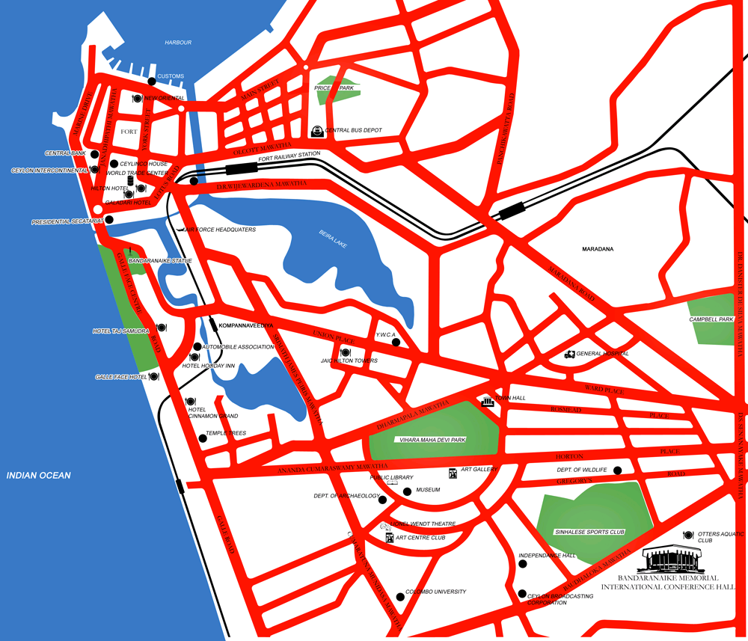

For more information please visit : http://www.bmich.gov.lk/Location.htm

